Assignment No 1

Name – Suraj Kumar

PRN - 240840127041

1 → First prepare the machine with some basic setup

→ update the machine, setup basic network

→ Install and Enable the ssh

→ update the /etc/hosts file.

2. Download the slurm-21.08.8.tar.bz2 package

→ wget https://download.schedmd.com/slurm/slurm-21.08.8.tar.bz2

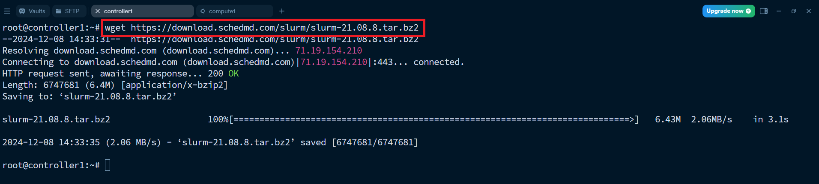

3 → Install all the packages

→ apt install -y build-essential munge libmunge-dev libmunge2 libmysqlclient-dev libssl-dev libpam0g-dev libnuma-dev perl

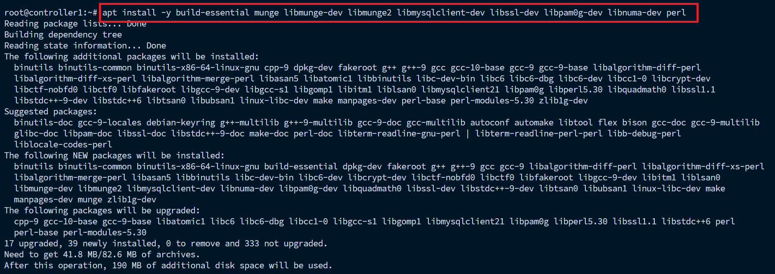

4→ untar the downloaded file

→ tar -xvjf slurm-21.08.8.tar.bz2 slurm-21.08.8/

→ cd slurm-21.08.8

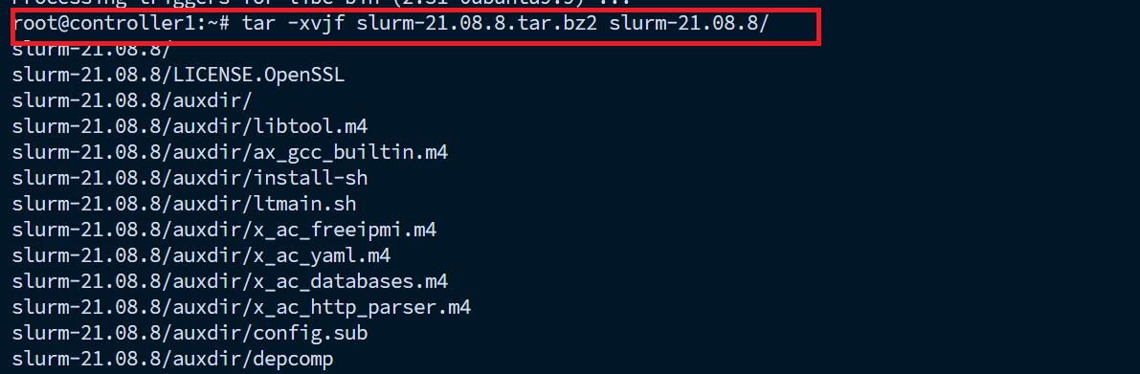

5→ configure the slurm with proper user directory

→./configure --prefix=/root/slurm-21.08.8/ ---> if your are using the normal user then use /home/<user-name>/slurm-21.08.8/

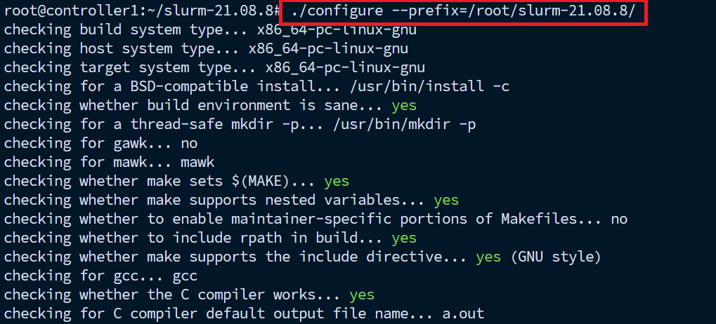

5→ make

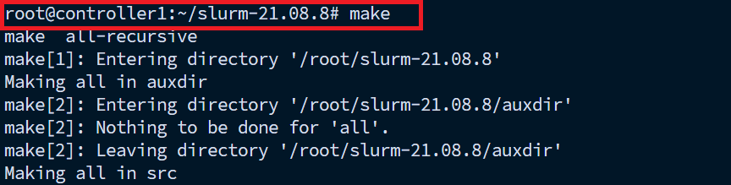

6→ make install



7→ create a munge for authentication and give proper permission.

→ create-munge-key

→ chmod 400 /etc/munge/munge.key

→ scp -r /etc/munge/munge.key <user-name>@compute1:/tmp

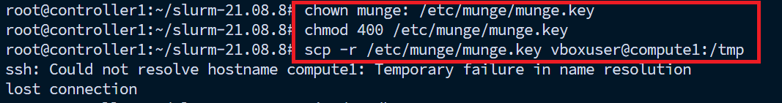

8→ make changes in /etc/hosts

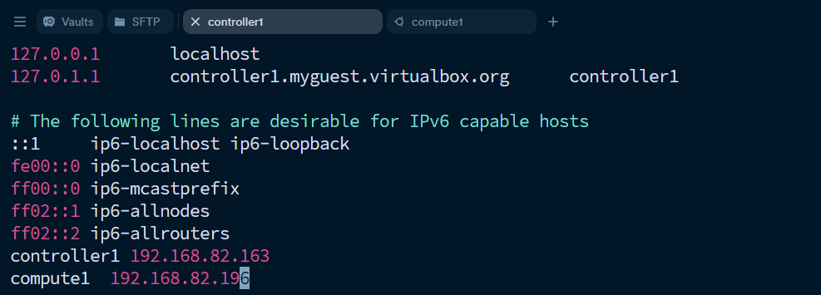

9→ scp munge key to the compute node

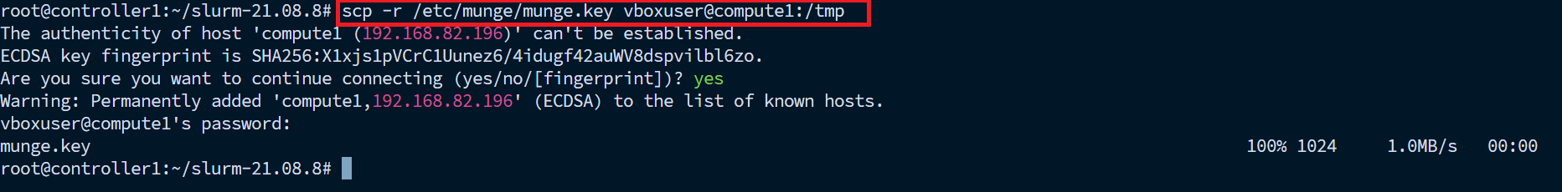

10→ give the own and file permission.

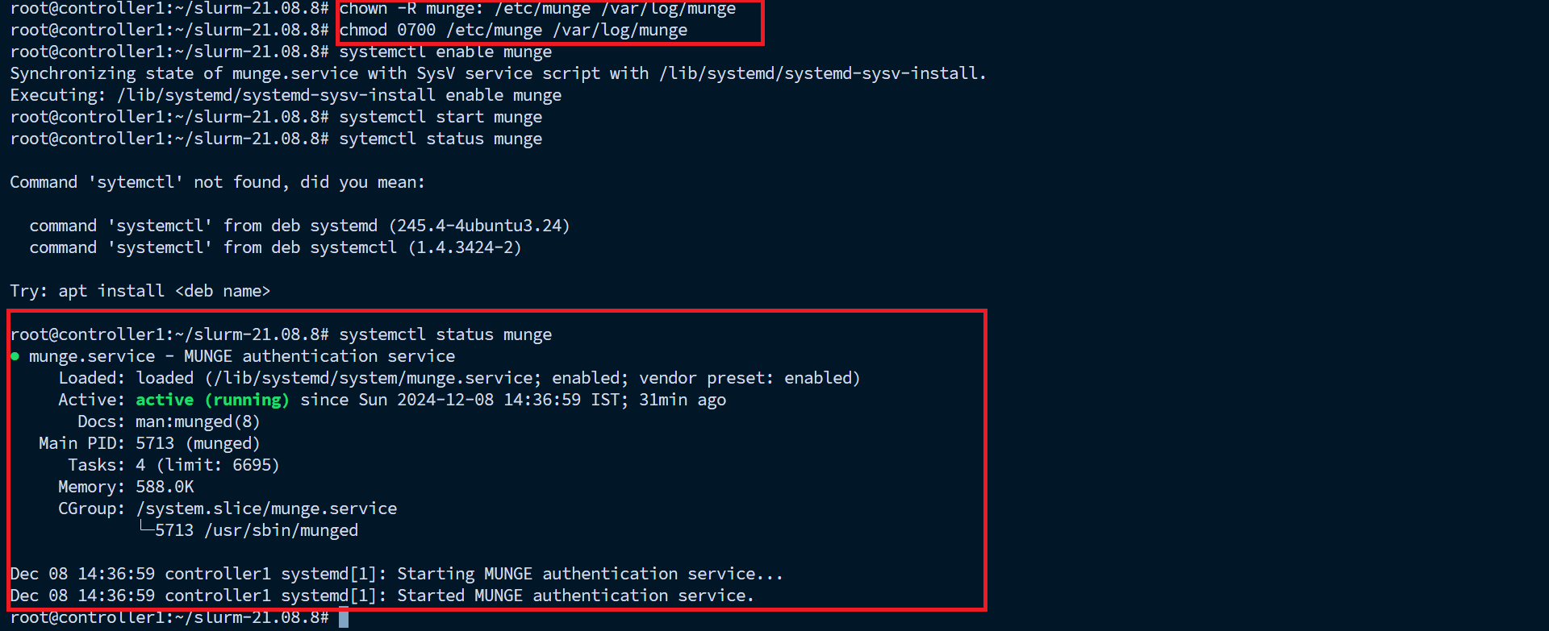

11→ make the changes in slurm.conf file

→ file path /slurm-21.08.8/etc/

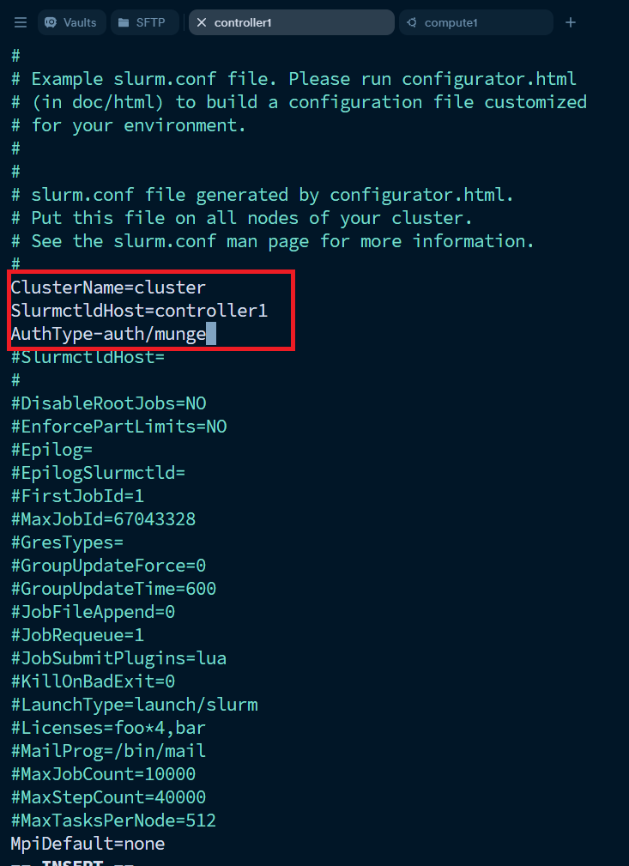

12→ cp slurm.conf.example to slurm.conf first and then make above changes.

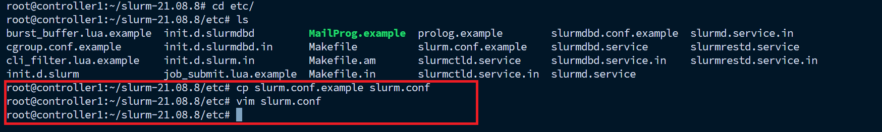

13→ in slurm.conf file make this changes in Accounting storage.

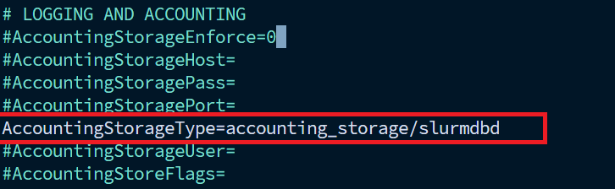

14→ make change is slurm.conf file

→ if you are having many compute node then make entry in this file. Example → Nodename=compute[1-2] CPUs=2 like this.

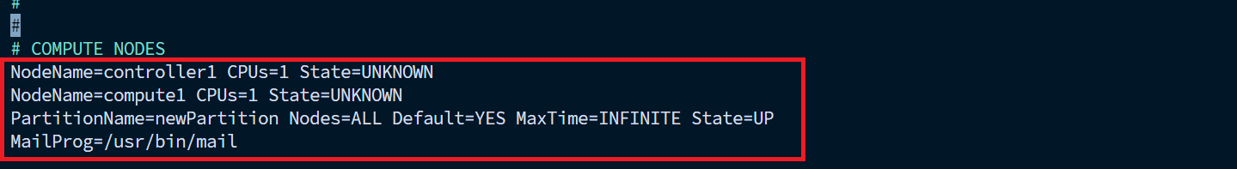

15→ cp slurm.conf file to

→ /etc/slurm/slurm.conf

→ /etc/slurm-llnl/slurm.conf

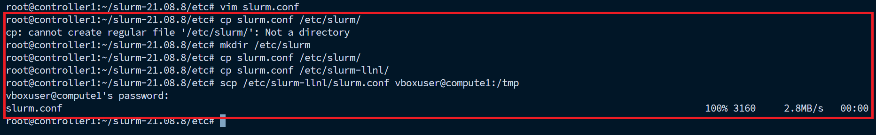

Also send to the compute nodes

→ scp -r slurm.conf test@compute1:/tmp

16→ then install mariadb database for slurm accounting.

→ apt install mariadb-server

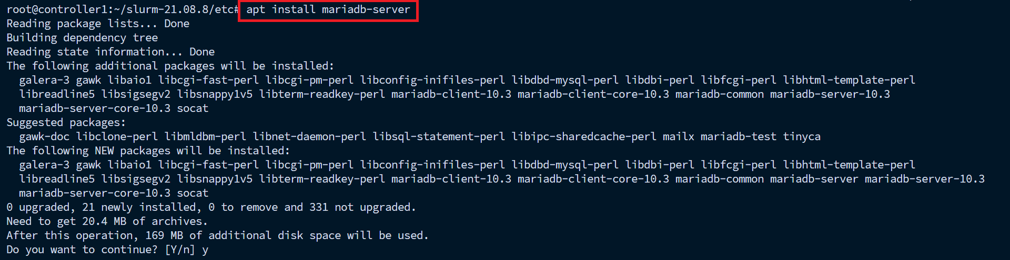

17→ make changes in slurmdbd.conf file

→ /slurm-21.08.8/etc/slurmdbd.conf

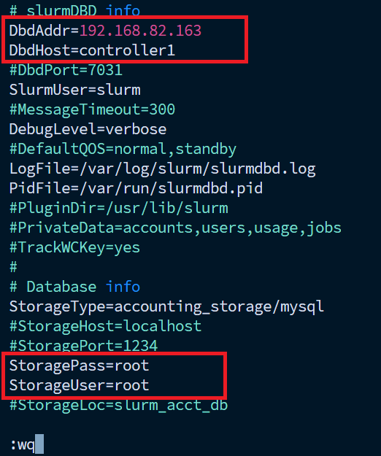

18→ then enter the mysql terminal and the permission for user

→create user 'root'@'controller1' identified by 'root'; --> if you use normal user then instead of root use <user-name>

→grant all privileges on \*.\* to 'root'@'controller1';

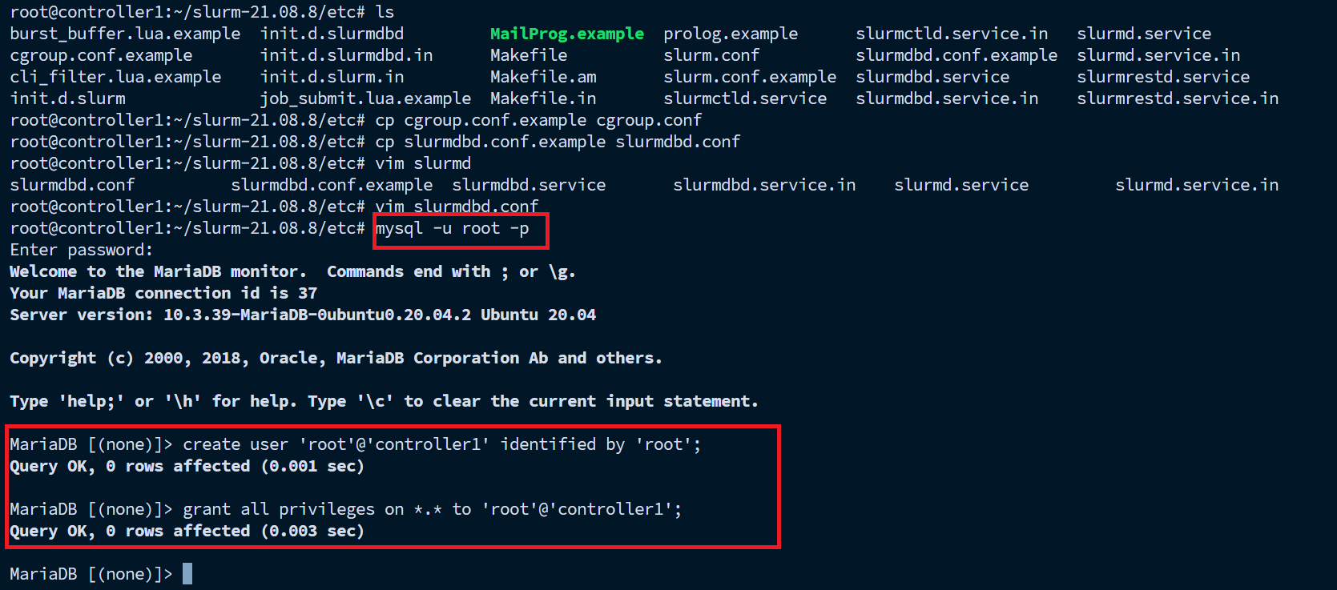

19→ copy slurmctld.service, slurmd.service and slurmdbd.service file to the location /etc/systemd/system/

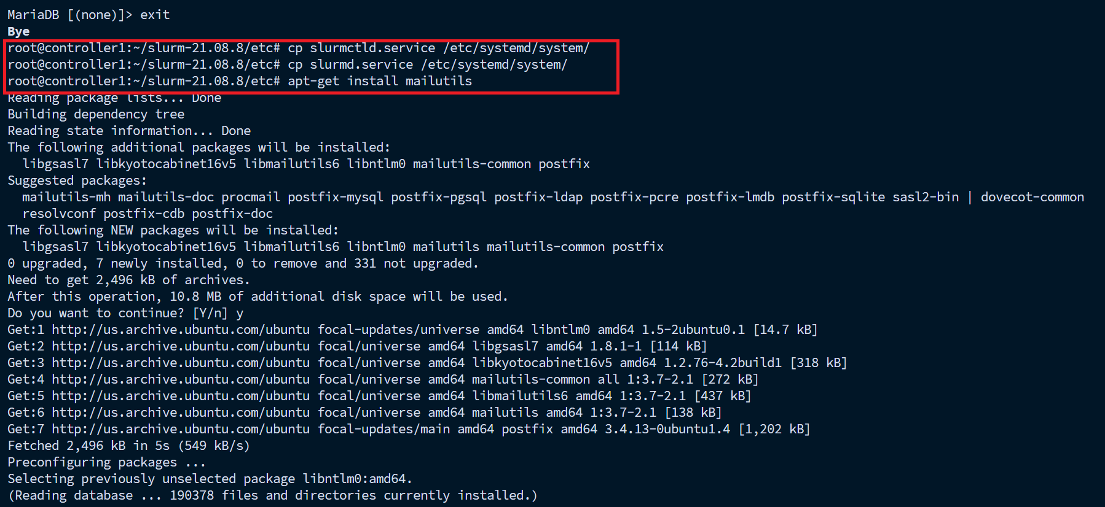

ON COMPUTE NODE

1→ slurm and it packages is same in compute node just difference is slurmd service in compute node

→ cp -r /tmp/munge.key /etc/munge/

→ chown -R munge: /etc/munge /var/log/munge/

→ chmod 0700 /etc/munge /var/log/munge/

→ cp -r /tmp/slurm.conf /root/slurm-21.08.8/etc/

→ cp -r slurmd.service /etc/systemd/system/

→ cp -r /tmp/slurm.conf /etc/slurm/

→ cp -r /tmp/slurm.conf /etc/slurm-llnl/

→ cp -r slurmd.service /etc/systemd/system/

By using this process i make the cluster with 1 controller and 2 compute nodes

1 → check all the services are running and 3 nodes cluster is ready.

Services on controller node

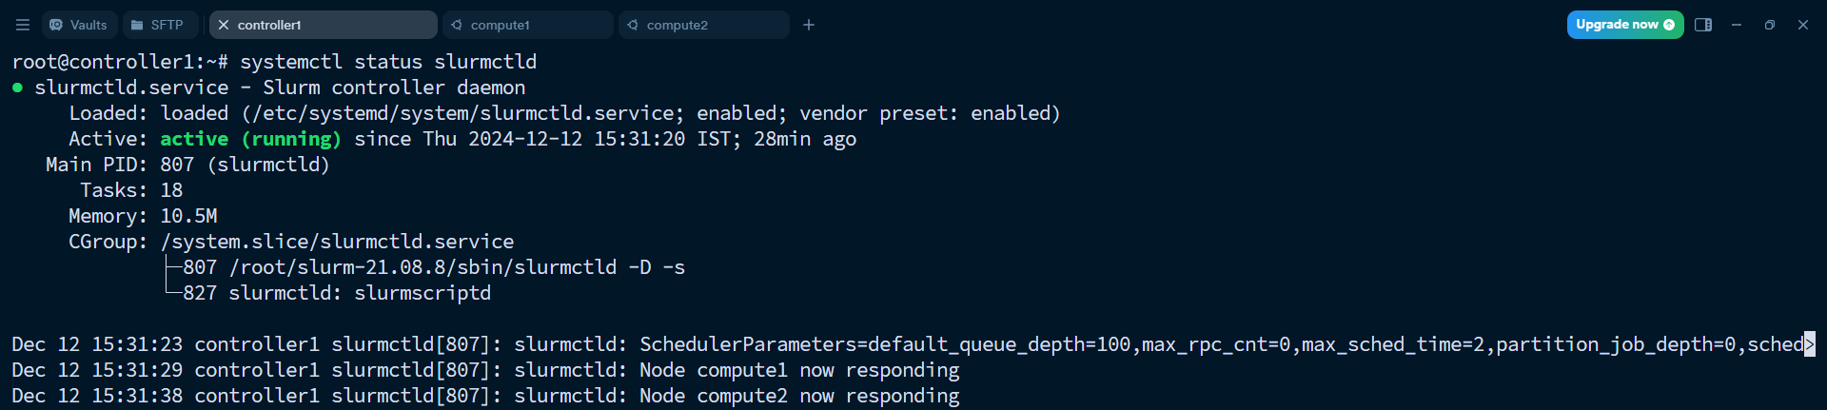

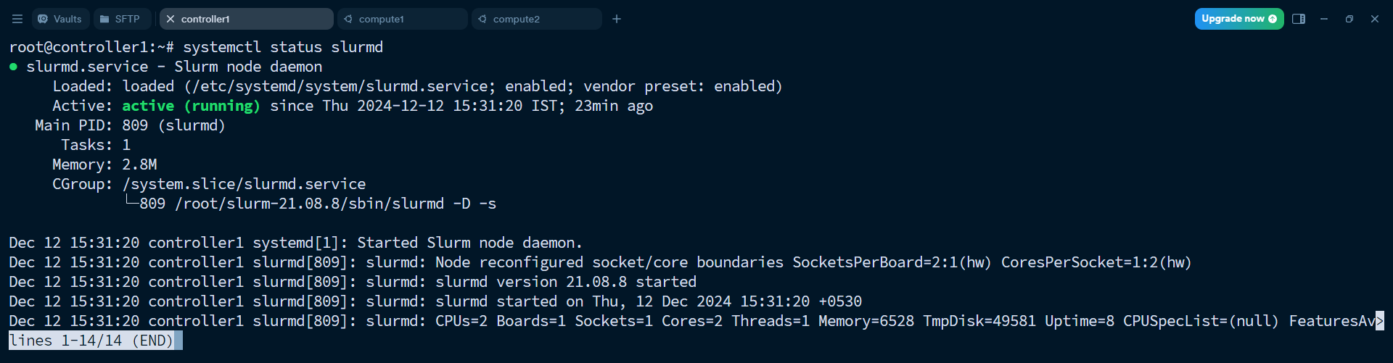

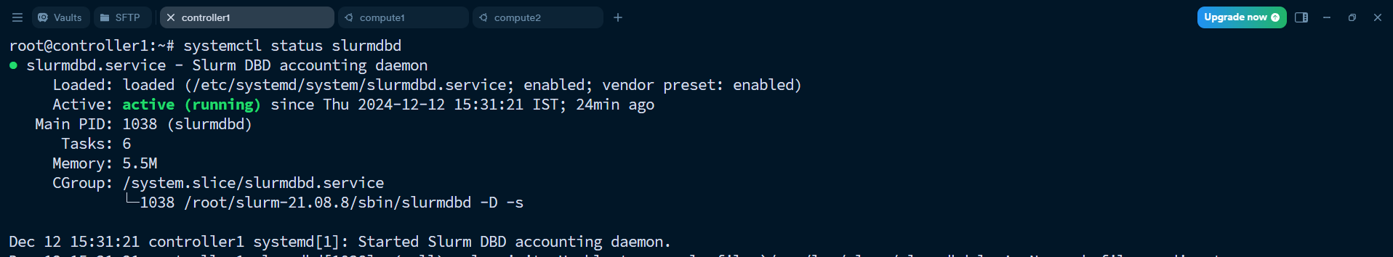

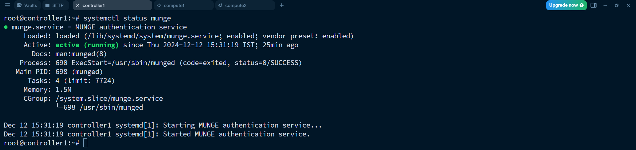

Services on compute node

