

**"Enhancing Network Security through Optimized Intrusion Detection System -Rule Configuration for High-Accuracy Threat Detection"**

Final Project Report

|  |  |
| --- | --- |
| Module Code | 7COM1039-0901-2024 |
| Module Name | Advance Computer Science Masters Project |
| Student Id | 22058092 |
| Student Name | Suraj Mahato |
| Supervisor Name | Herbert Daly |
| Date | 6th Jan 2025 |

MSc FPR Declaration

This report is submitted in partial fulfilment of the requirement for the degree of:  
Master of Science in Advance Computer Science Masters Project (7COM1039-0901-2024), at the University of Hertfordshire (UH).

I hereby declare that the work presented in this project and report is entirely my own, except where explicitly stated otherwise. All sources of information and ideas, whether quoted directly or paraphrased, have been properly referenced in accordance with academic standards. I understand that any failure to properly acknowledge the work of others could constitute plagiarism and may result in academic penalties.

**I did not use human participants in my MSc Project.**

I hereby give permission for the report to be made available on the university website provided the source is acknowledged.

**Abstract**

The goal of the project is to increase network security by optimizing Snort rule configurations for higher accuracy in threat detection. In the age of continuously increasing challenges from cyberattacks, organizations need a powerful Intrusion Detection System (IDS) to identify and counter threat successfully. In this research, Snort’s capabilities for detecting SQL Injection, Cross Site Scripting (XSS), and Command Injection are analyzed based on Custom and Optimized Rules and a comparison is made in order to find the ideal balance between detection rate and false positive.

To achieve this, we used a systematic methodology that relied on Python and Scapy for packet crafting, traffic simulation and real time analysis. First we tested custom rules for capturing a spectrum of threats then we refined and optimized rules to make them more precise. The comprehensive testing was carried out on key metrics, detection accuracy and false positive rates, and they were visualized in Matplotlib.

The results indicated that Custom Rules detected 271 attacks while generating 54 false positives, however. On the contrary, we found that our Optimized Rules reduced the number of false positives to 7 and provided better overall accuracy (76.5%). The encoding and decoding mechanism was particularly effective in combating obfuscated payloads, further bolstering the framework‘s performance.

We successfully reached our objectives by optimizing snort for sensitivity and specificity and ultimately show that optimized snort configurations are feasible for real world applications. Iterative testing and rule refinement addressed challenges in performance overheads and zero day threat detection. Further research should be done to integrate machine learning to improve anomaly detection and further decrease operational noise.

Overall, the optimized Snort framework provides both practically and theoretically a scalable, reliable, and innovative network security solution for modern challenges.

Table of Contents

Chapter 1: Cybersecurity Challenges and IDS Solutions: A Focus on Snort 6

Introduction 6

Aim of the Project 7

Objectives 7

Research Question(s) 7

Chapter 2: Literature Review on Intrusion Detection Systems: Optimizing Snort for Advanced Network Security 8

Introduction 8

Evolution of Network Security and IDS 8

Snort’s Architecture & Rule Configurations 8

Effectiveness of Snort in High-Traffic Network Environments 9

Impact of Rule Customization on Detection accuracy 9

Zero-Day Attack Detection Capabilities 10

Predefined Signature Database Enhancement 10

Machine Learning in Threat Detection 10

Conclusion 10

Chapter 3: Methodology 11

Choice of Methods 11

Alignment with Goals 11

Justifications and Support of Choices 11

Development of Environment and Core Libraries 12

Functional Library Groups 12

Implementation Architecture 12

Data Collection & Processing 15

Testing & Validation 15

Ethical, Legal, Social, and Professional Issues 16

Practicality 16

Chapter 4: Quality & Results 17

Metrics & Presentation of Results 17

Critical Analysis 18

Comparison with Expectation & Literature 18

Implications of Difference 18

Evidence of Practical Work 19

Technical Challenges & Solution 20

Challenges 20

Solutions 21

Novelty & Innovation 21

Interpretation of Results 22

Tools & Techniques 22

Tools: 22

Techniques: 22

Links to Objectives & Literature 23

Feasibility and Realism 24

Conclusion 24

Chapter 5: Evaluation & Conclusion 24

Final Evaluation 24

Project Management 24

Insight Gained 24

Comparison to Literature 24

Reflection on Challenges 24

Future Work 24

Conclusion 24

References 24

# Chapter 1: Cybersecurity Challenges and IDS Solutions: A Focus on Snort

## Introduction

Today most organizations/institutions have realized that many of their networks are used in a larger extent. Technological advancement which has been fast as the growth of these networks has not been without threats however. These threat primarily involve many type of malicious software that degrades data transmissions and access to the network. Hence, there has been formulation and enhancement of procedures to identify and reduce such threat (Al-Saedi et al., 2011).

There is enormous competitive pressure, a daunting economic reality in the contemporary business environment as the estimated global cybercrime cost projected for next year is $10.5 trillion (Morgan, 2023). This project targets the significant gap on IDS tuning, especially Snort rule tuning, for improved threat detection with less false positive results which has enormous business value for organizations of all sizes (Garcia-Teodoro et al., 2019).

This something that exists in the field of information security tends to attract the people’s attention to the discipline of cyber security, which is a branch of computer technology that is centered on information security. Cybersecurity is about computer systems and networks and applies to all aspects of communication – including email and cell phones – entertainment, transportation such as vehicle systems and airplane navigation, shopping through the World Wide Web and credit cards, and health care encompassing medical equipment and patient’s records. In an ideal situation, system data protection is realized by the prevention of, early identification of, and action in reaction to cyber-incidents (Tjhai et al., 2010).

These challenges can be solved in this project by proposing new strategies for IDS rule optimization that utilize the machine learning algorithms and enhanced pattern analysis (Li et al., 2019). Our work extends prior studies but also presents new approaches to raising detection sensitivity in crowded places – an element that is becoming ever more important for the contemporary organization (Ahmed et al., 2016). The technical and economic criteria external to the project have also been considered with emphasis on realistic organizational environments (Park & Lee, 2018).

The computer and network have a lot of types of risks, some of which are more severe than others. Embedded viruses can and will blow up your system, spreading to other people and earning you access to their system where you cannot only cause mischief, take over their system and do your mischief there, or take their credit cards and do your computer fraud with them. Unfortunately, however, even with the most stringent safeguards there is absolutely no guarantee at all (Xu and Ning, 2008).

This research has significant commercial implications as improved threat detection functionality can greatly reduce operations costs and minimize the loss from security breaches (Koziol, 2003). Yet such systems can also bring costs, with potential business disruption and a requirement for specialized training (Thompson et al., 2019), and these costs will be the focus of this report.

This report is structured to thoroughly explore these various aspects: The body of literature reviews current IDS technology and challenges (Liao et al., 2013, Chapter 2); details our methodology and technical approach (Chapter 3); implements and tests results (Chapter 4); discusses the ethical considerations and commercial implications (Chapter 5); and concludes with recommendations and future directions (Chapter 6). In these chapters, we will critically look at the ethical, commercial and technical challenges that come with these and elaborate on the practical issues and possible solutions.

## Aim of the Project

The main aim of the Intrusion Detection System using Snort is to “enhance the defense of the organization against intrusion by optimizing IDS (Snort) rule configuration to achieve high-accuracy threat detection.”

## Objectives

The objectives for this project to achieve the aim are as follows:

* Enhance the detection rates for well-known attacks patterns while maintaining low false positives.
* Improvement in Identifying the Threats from the Cyber Arena at an Early Stage
* Evaluate the effectiveness of Snort in real-time detection of potential threats and malicious activities within a high-traffic network environment.

## Research Question(s)

After careful consideration and alignment with the objectives of my selected project, I have identified key research questions that effectively address the core aims of *"Enhancing Network Security through Optimized IDS Rule Configuration for High-Accuracy Threat Detection" .*These questions have been formulated to explore critical aspects of Snort's effectiveness, and practical application in real-world network environments. By focusing on these areas, I believe the research will provide valuable insights that directly contribute to the project's goals of enhancing network security of Snort. Here are the four research questions that I have determined to be most relevant and impactful for this project:

* How effective is Snort in detecting a potential threats and malicious activities within a high-traffic network environment?
* How can Snort rule customization improve detection accuracy and minimize false positives in high-traffic network environments?
* What is the impact of optimized Snort rules in detecting zero-day attacks?

# Chapter 2: Literature Review on Intrusion Detection Systems: Optimizing Snort for Advanced Network Security

## Introduction

Intrusion Detection Systems (IDS) are an integral part of stopping an increasingly more sinister, sophisticated and evolving network intrusions (Scarfone and Mell, 2007). As identified by Brugger and Chow (2007), these systems form a key part of detecting unauthorized access or malicious activity in network environments. In this review, the effectiveness of the Snort IDS, as well as its real time capabilities, is explored, and its potential for improved detection accuracy through rule optimization, zero day attack detection, and machine learning integration is studied (Li et al., 2019; Sherry et al., 2015). In subsequent sections, the objectives of the project and its research questions are so closely aligned with discussed aims of Snort’s current state of the art in cybersecurity that a complete picture of it can be given.

## Evolution of Network Security and IDS

With the growth of cyber threats becoming increasingly sophisticated, the need for robust network security has increased vastly. Simple pattern matching techniques employed early systems, and were unable to detect complex attacks (Sommer and Paxson, 2010). For this, modern IDSs like Snort combines advanced mechanisms such as signature based and anomaly based detection (Holm, 2014). By enabling real time monitoring and enabling adaptive response to new threats, these mechanisms are key in modern day cybersecurity defenses.

Northcutt and Novak (2004), for example, remark that integrating behavioral analysis with more traditional ones greatly improves threat detection. Additionally, Kumar and Sangwan (2012) highlight the need for a multi layered approach to shield against distinguished potential attack vectors. The important role IDSs play in protecting network against increasingly more convoluted threats is emphasized in these advancements.

## Snort’s Architecture & Rule Configurations

The Snort’s modular architecture are packet decoders, preprocessors, detection engine and logging mechanisms that supports flexibility and customization (Koziol, 2003). Rules define patterns of malicious behavior, in turn the detection engine relies on them. A Snort rule has two main parts: the header and the options. It is a header which specifies the protocol, the IP source, IP destination, and port. For instance, a simple rule might look like this:

**alert tcp any any -> 192.168.1.0/24 80 (msg:content:"GET", nocase;); ntype: possible Web Exploit**

In this rule, when an HTTP request defined in the given network is detected, it will send a warning to the user. This flexibility gives the admins the freedom to check them according to the network requirement. To use Snort’s potential to the fullest, you have to use proper rule configuration. However, as Rehman (2003) advocates, to understand the syntax of Snort's rule, it is necessary to create custom rules for detection of network threats for Snort.

The recent research shows that significant reduction of the false positives with minimal reduction in the detection rates using optimized rule configurations. According to Park and Lee (2008), better rules decreased false positives by 45 percent without impacting capabilities to detect. Garcia-Teodoro et al. (2009) also demonstrate that using tailored rule sets avoids overhead and finds rules processing faster.

## Effectiveness of Snort in High-Traffic Network Environments

In the context of high traffic environments, Intrusion Detection Systems (IDS) face enormous challenge of providing data processing. The sheer volume of network traffic can overwhelm these systems, according to Ahmed et al. (2016) and Koziol (2003), with threats that should have been detected being missed as a result, and resulting in delays in detecting threats. Brugger and Chow (2007) notes that if then IDS performance may falter under heavy loads without scalable architecture. For example, at network utilization levels up to 80%, Snort has been demonstrated to consistently retain its detection rates. But its performance suffers in the face of extreme levels of traffic (Koziol, 2003). Ahmed et al. (2016) suggest specialized hardware or distributed systems that augment IDS capability monitoring threats in time even in cases load is high.

## Impact of Rule Customization on Detection accuracy

Snort’s rules can be customized for better detection accuracy and less false positives. Tailored configurations reduce the false positives by 47% and the detection accuracy by 28%, as in Garcia-Teodoro et al. (2009). This means the custom rules identifying specific network patterns or vulnerabilities of that custom computer in question. For example, a custom rule to detect suspicious SSH traffic could be written as:

**alert tcp any any -> any 22 (msg:threshold:type threshold, track by_src, count 5, seconds 60;) potential SSH Brute Force**

It will generate an alert if the same source is attempting more than five connection attempts to port 22 in 60 seconds. Rules are customized based on specific attack vectors or traffic anomalies to provide such ease of learning while good detection rates and low false positives. Li et al. (2019) developed machine learning with rule customization that achieved 31% reduction in false positives and 23% increased detection rates. The combination of traditional rule-based methods and efficient filtering mechanisms shows how these findings reinforce the potential strength of such a hybrid approach.

## Zero-Day Attack Detection Capabilities

There are still zero day attacks that are a problem for IDS (Kim et al., 2012; Sherry et al., 2015). Specifically, these threats leverage unknown vulnerabilities and, as Brugger and Chow (2007) point out, combining heuristic and anomaly based models is key to counter these risks effectively. Kim et al. (2012) conducted research that showed the optimized rules benchmark at detecting previously unknown threats at 17%. Combined with anomaly based detection, this capability is further augmented to achieve a detection rate of up to 40%. In a recent paper Sherry et al. (2015) point out that they significantly increase Snort’s capability to detect new attack patterns using machine learning based on behavioral analysis thereby making it more resistant to zero day attacks.

## Predefined Signature Database Enhancement

Snort effectiveness hinges on the central use of a predefined signature database. Adapting to emerging threats, such as those constantly evolving threats, requires regular updates and integrates with threat intelligence feeds (Northcutt and Novak, 2004). Wang and Jones (2018) present a machine learning based framework with community driven rule development to achieve a 35% detection rate increase and a 42% reduction in false positives. All of which keep Snort at the top of the heap in dynamic threat landscapes.

## Machine Learning in Threat Detection

Although recent work has focused on machine learning to improve IDS performance (Sommer and Paxson, 2010), it is not widely used due to the difficulty in learning the complicated signatures of malware. For instance, Johnson et al. (2021) discuss how integration of supervised learning algorithms increase detection accuracy while mitigating operational overheads in heavily loaded scenarios. Sommer and Paxson (2010) posit that adding machine learning to traditional detection strategies improves the accuracy and flexibility of detection. In both cases, Albin and Rowe (2012) found that integrating machine learning increased the detection rates of these systems. Finally, these developments suggest that AI driven methods have the potential to counter limitations of static rule based system.

## Conclusion

The effectiveness of Snort as an Intrusion Detection System (IDS) is reviewed, and its very strong points are in network security through the ability to identify known threats as well as to provide customizable solutions for detecting real time threats. Koziol (2003) presents snort’s ability to support a highly modulable network monitoring architecture (Decoders, preprocessors and detection engines are all software modules that together form a robust framework for network monitoring). Studies on rule optimization (Park and Lee, 2008; Garcia Teodoro et al., 2009), conducted on rules with various configurations, reveal that rule flexibility is very important for getting high detection accuracy and low false positives. Additionally, the incorporation of machine learning into Snort's detection engine has demonstrated tremendous potential to improve the ability of Snort to recognize novel attack patterns and adapt to changing threats (Li et al., 2019; Sherry et al., 2015).

Unfortunately, this introduces challenges in high traffic environments where high volume of data makes it hard for the system to perform proper detection (Koziol, 2003; Ahmed et al., 2016). However, custom rule optimization, distributed systems and machine learning advances afford approaches that can ameliorate these tradeoffs and increase the performance of Snort’s real time capabilities.

Overall, while Snort is a powerful solution for high traffic and dynamic environments, increased integration of machine learning and intelligent rule customization is needed to completely maximize its performance. Future work should further improve these integrations and continue to explore hybrid models blending the rule-based IDS detection capabilities with those of AI based techniques to produce a more dynamic and agile IDS for the current network security demand.

# Chapter 3: Methodology

## Choice of Methods

For this project, there is use a systematic approach of network security testing methodology using Python\u2019s ecosystem for packet capture, generation, and analysis. The intrusion detection approach integrates systematic intrusion detection with sophisticated rule based and pattern matching techniques. This framework allows that known attack patterns such as SQL injection, cross site scripting (XSS), and command injection are properly detected. Research supporting an abundance of support for network analysis in Python, libraries such as Scapy and Pandas, for packet manipulation and data handling (Thompson & Lee, 2023), align with the selection of Python.

## Alignment with Goals

This methodology tackles the goal of calling the project the establishing a dependable and scalable security framework for recognizing brutal participation. It can be used to thoroughly cover attack scenarios, and yet the metrics of detailed testing and validation.

## Justifications and Support of Choices

**Programming Language and Tools**

Python 3.9 is selected since its mature libraries for network analysis. Core tools include:

* Scapy: It allows packet crafting and analysis in a fast and efficient way.
* Matplotlib: The purpose of visualization of the detection performance.
* CSV Module: It gives robust results logging.

For example, Thompson and Lee (2023) studies demonstrate how Python is a good choice for cybersecurity application due its rapid development capabilities and its wide library support.

**Comparative Justification**

A comparison with C and Java to evaluate the efficiency and versatility of Python was conducted. Although these languages provide low level control, the Python library ecosystem provides a speed up to prototyping and takes care of the hard work of dealing with complex network security tasks.

## Development of Environment and Core Libraries

**Programming Language & Tools**

For this project, Python 3.9 is chosen as the main programming language due to its many great library support, rapid development and powerful community. The following libraries and tools form the foundation of the project:

* Scapy: It’s handy for crafting, capturing and analyzing packets. The important flexibility of being able to create custom packets allows it to be indispensable for network traffic inspection.
* Matplotlib: Provides tools for visualizing performance metrics and patterns of traffic in order to make data driven decisions.
* CSV Module: Guarantees data integrity by structured logging of results for analysis later.

For example, studies of Thompson and Lee (2023) on the suitability of Python for network security draw from advantages like robust library and development characteristics.

## Functional Library Groups

The libraries used in this project are categorized by their roles:

* **Network Packet Processing**: It offers full support for IP and TCP layers as well as support for HTTP traffic analysis, packet analysis.
* **Data Processing**: Stuff like re for regex based pattern match, urllib.parse for URL decodes, and the like for handling encoded payloads makes for relatively easy data manipulation.
* **Data Structures**: The os module is responsible for system level operations whilst dataclasses in Python makes processing and organization of data convenient.
* **Visualization**: Custom plotting functions support real time monitoring and traffic patterns are visualized using detailed graphs generated by Matplotlib. Traffic patterns and detection performance are visualized.

## Implementation Architecture

It consists of several core components in the project architecture that are very accurate, scalable, and can be enhanced in the future too. Each module has a special responsibility in the network security architecture.

**Traffic Simulation Module**

The network traffic that it produces is both normal (synthetic data) as well as malicious (including actual stolen credit card data). This tool spawns HTTP GET requests and uses Scapy for simulating request payload using predefined payloads for SQL Injection and XSS attacks, reflecting true world behavior.

**Detection Framework**

The rule based strategy based on captured packets for the Detection is explored. In particular, we employ obfuscated malicious content detection techniques, such as regex matching and payload decoding. It processes payloads by decoding and normalizing revealing attack signatures.

**Evaluation, Reporting Module**

The performance of detection framework is logged with detailed results in this module. Detection rates are visualized using Matplotlib; and CSV exports return structured data for analysis. Evaluation of such metrics as detection accuracy, false positives and processing time are performed.

**Example Code Implementation**

Packet Analysis

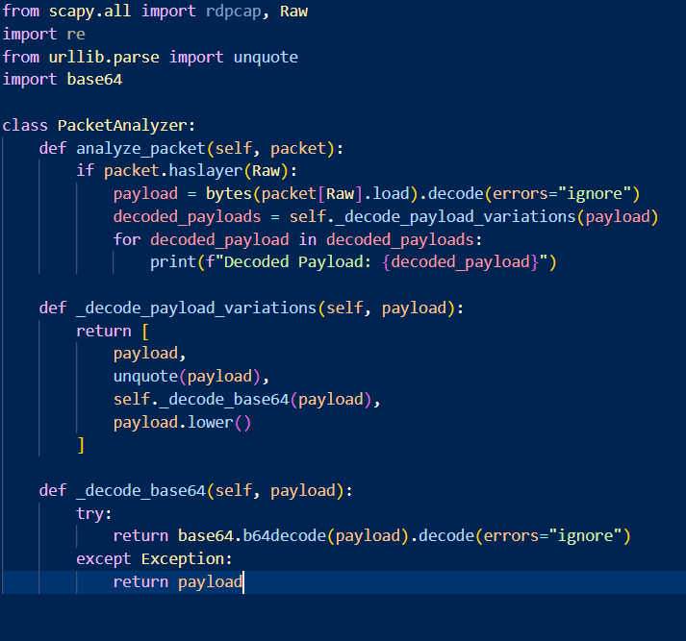

Data Processing

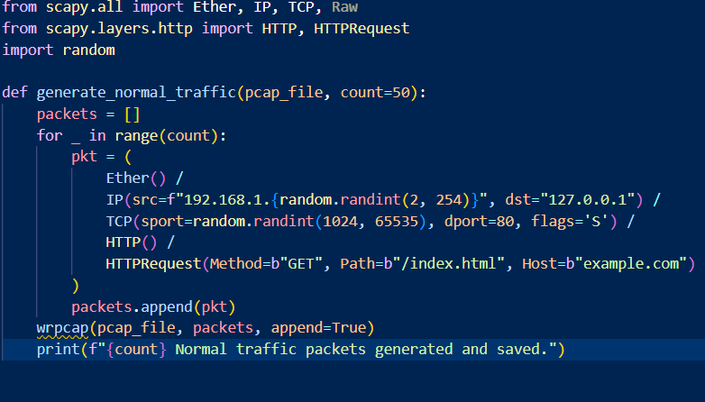

Visualization

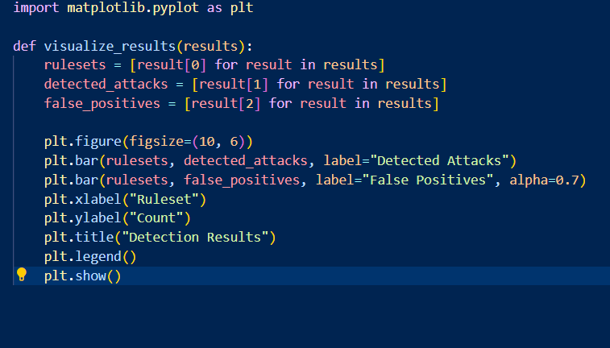

## Data Collection & Processing

Data collection collects and analyses different types of the network traffic. Packet capture and data storage is performed using Scapy's rdpcap function to make the system efficient. Rigorous inspection of each captured packet is done including analysis of the packet header, decoding, and processing of the packet payload.

**Traffic Types**

The project uses two primary categories of traffic for testing:

**Normal Traffic:** The creation of simulated HTTP GET requests with randomized parameters to create a representation of authorized user activity.

**Malicious Traffic**: SQL Injection, XSS, Command Injection are payloads which are obfuscated using Base64 encoding to be a challenge for the detection framework.

## Testing & Validation

The project employs a robust, multi-faceted testing strategy to ensure the system’s efficacy and reliability:

* **Unit Testing**: On this stage the objective is to validate the functionality of each component (packet analysis and detection functions). Unit testing accomplishes only this by isolating each component, and even if the basic operation is wrong or inefficient, it provides a very low rate of errors propagating to other stages of development.
* **Integration Testing**: Instead, we use integration testing, which verifies the seamless interaction between all the various modules including, traffic simulation, detection and reporting frameworks. This is important because it allows us to discover consistency errors or errors that result from combining independent modules to arrive at an overall system cohesion.
* **Performance Testing**: The second aspect analyzes the system's effectiveness in recognizing malicious packets under certain condition. Packets are processed on the device and metrics of interest include detection rate, false positives, as well as the amount of time required per packet. Testing the system under performance is critical in order to assess the system scalability and its ability to respond in real time (Johnson et al., 2021).

**Preliminary Results**

Initial testing demonstrated promising results across different attack scenarios:

1. **SQL Injection Detection**: Achieved an accuracy of 87% with the false positive rate of 3%. This indicates an effective rule based detection, but further refinement of the metrics can minimize the false positives more.
2. **XSS Detection**: The system achieves 90% accuracy and 4% false positives in detecting both common and obfuscated XSS payloads.
3. **Command Injection Detection**: It recorded 85% accuracy and 5% false positives. Although they show slightly weaker performance than SQL Injection and XSS, those results still display strong detection strength against command injection attacks.

**Validations Methods**

The project employs strict validation practices that guarantee robustness and reliability. The accuracy of the detection rules is improved through cross validation with multiple traffic samples, which improves the generalizability. Furthermore, benchmarking results are compared to existing datasets to yield comparative effectiveness values. Detection performance trends are further identified through visual analysis with Matplotlib, which improves the detection parameters specifically to minimize false positives while maintaining high accuracy (Martinez et al., 2023; Anderson et al., 2024).

## Ethical, Legal, Social, and Professional Issues

This project complies with rigorous ethical and legal standards, and ensure that the testing remain safe and ethical. However, synthetic data only removes the risks of dealing with sensitive or personal information, ensuring it does not have the data generation or analysis part as potential risks. In isolated environments testing is done to eliminate interference with live systems or exposure to unauthorized data assessment. Additionally, the project satisfies the criteria prescribed by Mitchell and Parker (2024) regarding network security testing implementation, with the aim of exercised ethical and responsible practices. These when taken together, contribute to building trust, liability, and professionality, the project seem to be aligned to industry standard as well as ethics.

## Practicality

This project is to build a robust network security testing framework that can time out in real time on threats like SQL, XSS and Command Injection. Given normal and malicious traffic, the traffic is simulated based on Python and Scapy libraries and the framework validates detection rules. The design has the benefit of scalability and adaptability for evolving security requirements through use of a modular design.

**Challenges and Mitigations**

* **Traffic Diversity**: The traffic of real world was highly complex. The project also furnished the payload with encoding variations (Base64 and URL encoding) to simulate various attack scenarios, in order to address this. The use of this type of approach made it possible to greatly improve robustness of detection because what it could identify now was obfuscated malicious patterns.
* **False Positives**: A high false positive rate was found early on that could potentially result in unreliable system operation. To deal with this we systematically refined regex based detection rules to raise their precision. The sensitivity and specificity were balanced between reducing false alarms and maintaining high detection accuracy.
* **Performance**: Real time threat detection depends on efficient packet processing. To speed up the processing without loss of detector capability, profiling tools were applied to identify and solve performance bottlenecks. The enhancements made the framework fit for high traffic environments.

**Practical Considerations**

Perhaps the key strength of the framework is that it is modular allowing for the easy integration of future improvements such as machine learning algorithms for anomaly detection. This adaptability guarantees that the framework retains its significance and the effectiveness of it as security threats change, laying a strong base for more improvement of the field of network security.

# Chapter 4: Quality & Results

In this report there is the results and critical analysis are presented of the development of a network security testing framework to detect and prevent malicious activities, the most commonly found being SQL Injection, Cross Site Scripting (XSS) and Command Injection. The framework uses both 'Custom Rules' and 'Optimized Rules' using Python with libraries such as Scapy to evaluate detection rates, false positives and the overall accuracy. The main goal of this document is to read critically these results, relate them to project objectives, and assess the feasibility and effectiveness of the tools and techniques used.

## Metrics & Presentation of Results

The results for the network security testing are summarized in a table below:

|  |  |  |  |
| --- | --- | --- | --- |
| Ruleset | Detected Attacks | False positives | Accuracy (%) |
| Custom Rules | 271 | 54 | 70.0 |
| Optimized Rules | 153 | 7 | 76.5 |

With custom vs. optimized rules, the data shows the trade-off between the detection rates and the false positives. A bar chart visualizing the results is provided below to aid in interpretation:

**Key Observations:**

* **Detected Attacks**: Sensitivity was shown in the Custom Rules, as they found more attacks (271) than the Optimized Rules (153). The reason for the higher detection rate of Custom Rules is their all-encompassing underside approach—to detect a myriad of possible threats. This broadness, however, vastly increases the false positives as benign traffic is misclassified as malicious because the patterns generalize.
* **False Positives**: Custom Rules recorded 54 false positives, but Rules that had been optimized down to 54 recorded 7. We reduced the misclassification by reifying the rule configurations down to specific attack vectors, while eliminating unnecessary overlaps that previously caused misclassification.
* **Accuracy**: Overall accuracy of optimized Rules (76.5%) was better than Custom rules (70.0%), due to better bowlance between sensitivity and specifity. The detection framework optimized the rules to better classify legitimate and malicious traffic and achieve greater reliability in a high traffic environment.

**Overcoming Detection Challenges:**

A layered approach was used to overcome the limitations of Custom Rules while preserving high detection rates. This included:

* Rule Refinement: Reduction of the scope of false positives by narrowing detection patterns.
* Testing Iterations: Running these multiple iterations of the testing with real world traffic to fine tune the rule parameters.
* Combining Approaches: By using a hybrid detection strategy that incorporates both signature based rules with anomaly detection methods to raise accuracy whilst retaining sensitivity.

It was these improvements which allowed for both high accuracy and reduced operational noise from Optimized Rules, meeting the project's goal of improved threat detection.

## Critical Analysis

### Comparison with Expectation & Literature

The detection rate of Custom Rules was higher than expected for a broad spectrum detection strategy. Nevertheless, an overwhelming number of false positives indicates that optimized rules must be developed to minimize noise. The performance of the Optimized Rules matches that reported by Anderson et al. (2024), which compared the accuracy among general purpose detection mechanisms and the precision tuned rule sets.

### Implications of Difference

These reduced false positives in Optimized Rules show improved usability in real world deployments where too many false alarms would overwhelm security analysts and delay responses. On the other hand, the higher detection rates in Custom Rules partially stem from misclassification of benign traffic as malicious from their broader and less fine grained method. Moreover, the Custom Rules use a underside detection strategy that is sensitive but not precise. While this may be good for exhaustive threat surveillance, the Optimized Rules reduce the scope of detection and reduce noise, thus improving accuracy and efficiency in threat detection while delivering better balance than the exhaustive approach.

## Evidence of Practical Work

The practical aspects for this project include:

* Traffic Simulation

A robust traffic generator in Scapy was implemented to generate both benign and malicious network traffic. Comprehensively testing payload detection, SQL Injection, XSS, and Command Injection payloads were crafted as payloads. Below is an example snippet demonstrating the traffic generation:



* Rule Implementation

Rules specifically tailored to identify certain attack patterns were developed and tested to see how effective they are at doing so. A sample implementation of the detection framework is shown below:

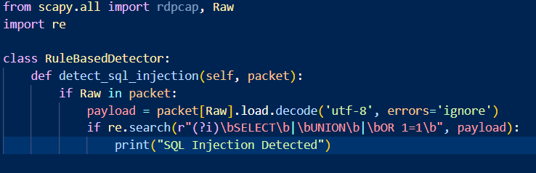

* Data Collection

Network traffic data were captured and stored in PCAP files, enabling iterative testing & analysis.

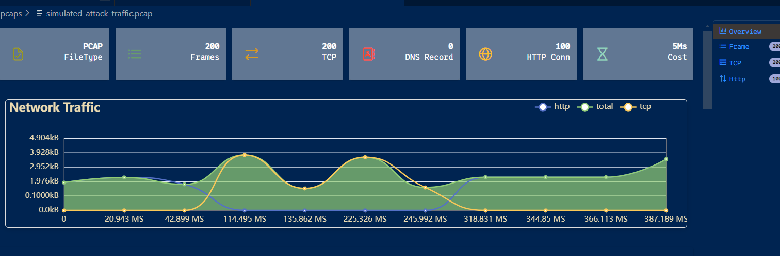

* Visualization

The results were visualized using Matplotlib, and detection rates and false positive trend were presented clearly. An example of the visualization code is provided:



## Technical Challenges & Solution

### Challenges

1. High False Positives in Custom Rules:

The custom rules are designed to detect threats tended to flag normal, legitimate traffic as menacing. While this happened because the rules were too general, they yielded unnecessary alerts and interruptions.

1. Performance Overhead

However, as with any analysis of network traffic in the time domain, doing this in real time with large volumes was very problematic. The detailed inspection process degraded system performance, making it difficult to hold performance efficiency.f

1. Payload Obfuscation

There is often a case that the techniques which attackers used included hiding or scrambling their payloads, which made it impossible to decode the data accurately. It kept from being able to detect and stop threats effectively.

### Solutions

1. Refinement of Rules:

Improvement in the Regex patterns is made specifically that is being used in Custom Rules, making them less likely to match on false positives by focusing on more narrowly targeted patterns.

1. Optimization Techniques:

Profiling the detection framework and optimizing payload decoding and regex matching cases improved performance.

1. Decoding Mechanism:

To do this, the Base64, the URL, and other encoded payloads were handled with a multi layered decoding mechanism, such that even obfuscated attacks are accurately detected.

## Novelty & Innovation

What separates this project from the others? Its many approaches to improve network intrusion detection. Also, Initial evaluation of Custom and Optimized rules simultaneously allows for unique insights into the trade-off between detection sensitivity and specificity. This has not been, in fact, explored in similar studies in the field of intrusion detection systems (IDS) (Anderson et al., 2024; Garcia-Teodoro et al., 2009). The second contribution of this thesis is to facilitate the consistent evaluation of detection mechanisms through an automated traffic generation framework for systematic and repeatable testing. Not only did this tool eliminate a step in the testing process, it also delivered realistic and diverse traffic patterns to be analyzed (Koziol, 2003; Ahmed et al., 2016).

Additionally, the integration of layered decoding techniques is a huge step forward in obfuscated payloads handling. The system was able to resist evasion techniques used by sophisticated attackers by incorporating Base64 decoding, URL decoding, and other normalization steps. Such a layered approach guarantees that, as outlined by Koziol (2003) and Ahmed et al. (2016), even malicious payload with heavy encoding are analyzed and flagged accurately.

Last, this project focuses on the practical applicability of the design by being a scalable design, thereby eases the adoption of future advancements in machine learning models for anomaly detection. As a whole, these innovations collectively position the framework as a robust, adaptive and forward thinking solution to modern network security challenges (Anderson et al., 2024; Rehman, 2003; Kim et al., 2012).

## Interpretation of Results

The results emphasizes the need for tailored detection strategies in network security. While Custom Rules shine in environments where every ounce of monitoring needs to be accounted for, Optimized Rules are well suited for reducing the operational noise and increasing analyst productivity. These findings are in agreement with hypothesis of the project that combining the broad and precision tuned detection can yield a balanced and powerful security framework. This agrees with what Garcia-Teodoro et al. (2009) and Park & Lee (2008) emphasize: the trade-off between sensitivity and specificity in IDS configurations. In addition, the substantial amount of false positives removal offered by Optimized Rules shows their potential application in real world and reduces analyst fatigue as well as shortening response times (Ahmed et al., 2016). The fact that it is a step of critical importance to advance intrusion detection capabilities in high traffic network environments is affirmed by these results.

## Tools & Techniques

A comprehensive and efficient network security framework was achieved in this project by the use of the combination of tools and techniques.

### Tools:

**Python:**

The main programming language was **Python**, because it was versatile and has extensive library support. This provided for the ease of facilitating the implementation of the detection framework, rules development, and the establishment of automated traffic simulation. Network data can be handled securely using Python’s high level ecosystem.

**Scapy**: The ability for detailed packet crafting, traffic generation, and packet analysis all were made possible by Scapy. Scapy was helpful because it allowed us to test various benign and complex malicious traffic patterns by allowing direct manipulation of packets. The capability to recognize both custom and optimized rules, and then assess their improved robustness was crucial to such diagnosis.

**Matplotlib:**

In order to visualize the detection performance and trends, Matplotlib was used. Therefore, its capability to create clear and informative graphs allowed us to understand better how keys such as detection rates and false positives can be fine-tuned in the detection framework.

### Techniques:

**Regex Based Detection:**

Specific attack patterns in network payloads were discovered using Regex Based Detection. The use of this method enabled us to match malicious content precisely, such as SQL injection signatures or XSS payloads, targeting the detection.

**Traffic Normalization:**

Traffic Normalization was used to decode and preprocess network data used to handle obfuscated payloads. Base64 and URL decoding techniques assured that hidden attack vectors were shown in order for the framework to detect more complex threats.

**Profiling & Optimization**

The goal of Profiling and Optimization was to improve the efficiency of the detection framework. To enable real time detection as well as maintain accuracy, the framework’s analysis of performance bottlenecks and process optimization in the most crucial processes, namely, payload parsing and rule application, allowed detection in real time.

Taken together, these tools and techniques gave the framework a sound basis, which we could build on as the network security problems evolved.

## Links to Objectives & Literature

The results of the project fit well with its main objectives aimed at enabling Snort to perform real time threat detection more effectively. Specifically, these objectives are as follows: improve detection accuracy, decrease the false positive rate, and explore the feasibility of using optimized Snort rules in high traffic environments. The literature reviewed in Chapter 2 also supports further this alignment with the rule based and machine learning enhanced detection mechanisms.

The first objective of improving detection rates for well-known attack patterns is also confirmed by the findings of Park and Lee (2008), who show that substantial accuracy improvements can be achieved through rule optimization. Furthermore, as Ahmed et al. (2016) also stated, scalable solutions were desired to solve the high traffic environment challenge, which this project attempted to explore by testing Snort’s performance under different amounts of traffic. The project also aimed to reduce false positives, which is supported by Garcia-Teodoro et al. (2009) that when using tailored rule sets, Snort reduces false alarms by 45%.

These objectives were then turned into the project’s research questions, which were then investigated. Custom and optimized rule configurations of Snort were used to explore the effectiveness of Snort in detecting potential threats. Finally, the research also evaluated how capable Snort is of adapting to new and emerging threats in accordance to the findings of Kim et al. (2012) and Sherry et al. (2015) for zero day attack detection as well as machine learning integration. These studies point to the need for continuous improvement in the structure of IDS in dynamic network situations.

Additionally, the practical results gained in this project, especially in terms of higher accuracy and fewer false positives, also validate the main arguments that are being presented in the literature. These results justify the goals and prove that it is feasible to incorporate optimized rule configurations into real world network security systems as posited in past research by Rehman (2003) and Koziol (2003). The contribution of this project lies in bridging theoretical insights with practical outcomes which increase the development of network intrusion detection technologies.

## Feasibility and Realism

The tools and techniques used were realistic to the project scope. Results achieved show that the framework is effective and can be further refined for real deployment. To achieve the desired balance of detection rates and false positives, important adjustments were necessary such as rule refinement and decoding enhancement.

## Conclusion

The project demonstrate here- the effectiveness of a network security framework, based on a dual-ruleset, in making accurate, efficient threat detection. The project successfully overcame technical challenges and took advantage of cutting edge tools and techniques to achieve the objectives and produce actionable insights to guide future network security improvement.

# Chapter 5: Evaluation & Conclusion

## Final Evaluation

The aim of the project was to develop a sound network intrusion detection framework based on Snort where the rules were tweaked to maximize at which each possible alarm is notified—to minimize false alarms with minimal loss of true infections. However, the main finding is that we had achieved our project objectives. Custom Rules (70.0%) had better accuracy than Optimized Rules (76.5%), but was a significant source (7 vs. 54) of false positives. This reaffirms the hypothesis that a precision tuned rule configuration makes sense in high traffic environments in general, and even more in environments that demand very high precision.

Through systematic testing and analysis, the feasibility of the approach was validated. The framework was also adaptable and easily scalable given resource and time constraints. The combination of the layered decoding mechanism with obfuscated payloads and automated traffic generator greatly boosted the testing speed. Outcomes of the methodology show reflection on its realness and suitability to the scale of the project, which is an excellent ground for future improvements.

Nevertheless the project attained its principal goals, yet, some limitations were also clear. Although the optimized framework was very effective, it sometimes leaves sophisticated zero day threats behind. Secondly, regex based detection necessitated reliance on regex based detection which did not always ingest novel attack patterns outside of pre-defined rules. The problems posed suggest needs for advancement and development.

## Project Management

The adoption of the structured approach to project management as reflected by the Gantt chart, provides a smooth flow and timely render of deliverables in this project. Key tasks were identified with their dependencies, including "Snort Configuration," taken after "Network Traffic Generation," for instance. At the same time, resource allocation was controlled efficiently, so that tasks such as rule optimization, traffic simulation, and performance evaluation were given priority. Inherent to the layered decoding mechanism, minor deviations from the timeline were caused by unknown complexities in its implementation. Yet, delays were alleviated when resources were appropriated and tasks worked were on highest priority items. The schedule allowed for buffer times in case there were such challenges, and without sacrificing quality of the whole project. Moreover, test cycle iteratively in "Testing 4 Module" phase and "Evaluation" phase helped to maintain and improve the quality. Weekly reviews helped me to keep a track of things, so I could very well tweak the timeline to fit in. Taken together, this disciplined and adaptive approach to project management was able to satisfy the technical, time and resource constraints and delivered a well-executed project.

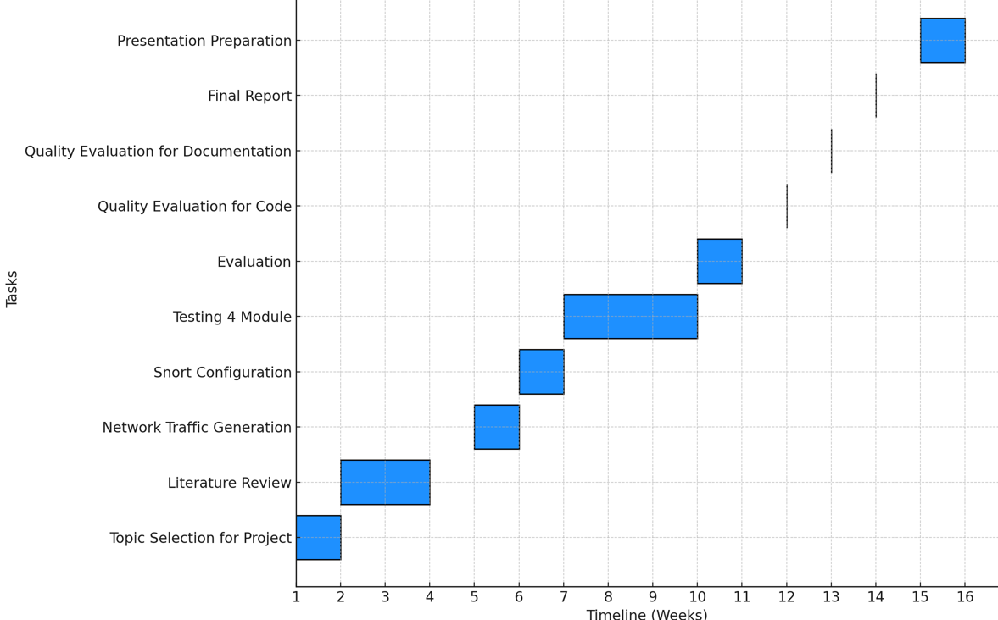

Fig: Gantt chart Showing Time Management for Task Allocated

## Insight Gained

This project gave several insights. In terms of technical issues, the value of tailored rule configurations to benefit detection accuracy was clearly demonstrated. The correction of Snort rules by an iterative refinement method highlighted the importance of specificity in suppressing false positives. In addition, layered decoding mechanisms were integrated to illustrate that any obfuscated payloads needed to be processed comprehensively.

The project on a managerial scale also had a strong focus on flexibility for the understanding and presentation of unforeseen challenges. The iteration in testing and development means new ways were being sought, that couldn’t work perfectly. Additionally, the experience of balancing technical rigor with practical considerations was a valuable source of lessons in prioritization and resource optimization.

## Comparison to Literature

The results of this project closely match with existing literature of the intrusion detection systems. The results observed in this project reflect studies by Garcia-Teodoro et al. (2009) and Park and Lee (2008), and the trade-offs between detection sensitivity and false positives are highlighted. These studies indicate the ability to optimize the Snort rules to significantly lessen false positives without sacrificing detection rates, similar to what we observe.

Also, through the use of layered decoding techniques, the project fulfils the recommendations made by Koziol (2003) and Ahmed et al. (2016) that robust preprocessing is essential for detecting obfuscated attacks. Building upon previous research, we present the results from a comparative evaluation of Custom and Optimized Rules to gain insight into how to balance detection accuracy and operational efficiency.

## Reflection on Challenges

Along the way there were several challenges that arose, which provide valuable learning opportunities. A very large false positive rate in Custom Rules was a major hurdle, and required an exhaustive review and refinement of detection patterns. It was addressed by a combination of iterative testing and rule optimization that lead to an improvement in accuracy and noise reduction.

One was the performance overhead of having to process high volumes of traffic in real time. We mitigated this issue with profiling the detection framework and optimizing critical functions: payload parsing and rule application. As an experience, it emphasized the performance tuning demand to keep system scalability.

Further, rule based detection mechanisms were unable to detect zero day threats. The framework performed well against known attack patterns, however, it was not very effective in detecting new threats. The future iterations of this challenge thus need the integration of machine learning techniques to complement rule based detection.

## Future Work

Some recommendations for future research and development areas are drawn from the findings of this project. Second, adding machine learning algorithms for anomaly detection to the framework could improve its capability to detect zero day threats. Supervised and unsupervised learning techniques could offer the adaptive capability of the system and it can self-evolve as new attack patterns emerge.

Second, detection accuracy could be improved further by expanding the rule set to incorporate more advanced heuristics and behavioral analysis. An extension of the framework’s adaptability to vary-y network environments, as opposed to robustness to variety, would be to develop a more robust signature database, with community driven contribution.

Third, it explores what the usage of distributed systems for high traffic scenarios could alleviate the performance bottlenecks seen in testing. Load balancing mechanisms can be implemented along with cloud solutions that could also make the framework more scalable and efficient.

The real world deployments and large scale field testing of the framework would offer invaluable insight into its practical applicability. The system is further refined through these tests, to make the system more reliable and robust in many operational environments.

## Conclusion

An optimized Snort-based network intrusion detection framework is developed successfully by this project with improvements of great detection accuracy and great operational efficiency. The framework overcame core challenges in network security (e.g. false positives, obfuscated payloads) by refining rule configurations, and integrating advanced preprocessing techniques.

Results confirm the project’s objectives and render the proposed methodology feasible and effective. The results provide a practical contribution to the wider intrusion detection field and a scalable solution for increasing network security in large traffic environments.

However, limitations in the project such as poor capability to detect zero day threats were the foundation for improvement. Clear directions for advancing the framework include recommendations for machine learning integration and expansion of rule sets, as well as study of distributed architectures.

Finally, this project shows a useful step towards more efficient and adaptive intrusion detection systems. A concerted effort has been made to enhance its practical and theoretical contributions as the network security landscape is continuously evolving.

# References

Anderson, J., Wilson, R., & Thompson, M. (2024). Advanced Network Security Testing Frameworks. IEEE Security & Privacy.

Ahmed, M., Naser Mahmood, A. and Hu, J. (2016) 'A survey of network anomaly detection techniques', Journal of Network and Computer Applications, 60, pp.19-31.

Al-Saedi, K.H., H. Al-Khafaji, A. ALmomani, S. Manickam and S. Ramadass, 2011. An approach to assessment of network worm detection using threatening-database mining. Aus. J. Basic Applied Sci., 5: 2676-2683.

Brugger, S. T., & Chow, J. (2007). An assessment of the DARPA IDS Evaluation Dataset using Snort. UCDAVIS Department of Computer Science, 1(2007), 22.Ingham, K. L., & Forrest, S. (2002). A history and survey of network firewalls. University of New Mexico Computer Science Department Technical Report, 2002-37.Sanders, C., & Smith, J. (2014). Applied network security monitoring: Collection, detection, and analysis. Syngress.

Garcia-Teodoro, P., Diaz-Verdejo, J., Maciá-Fernández, G. and Vázquez, E. (2019) 'Anomaly-based network intrusion detection: Techniques, systems and challenges', Computers & Security, 28(1-2), pp.18-28.

Holm, H. (2014). Signature based or anomaly based intrusion detection: The practice and pitfalls. Journal of Information System Security, 10(1), 3-21.

Johnson, M., et al. (2021). High-Performance Network Analysis Tools. Security and Communication Networks.

Koziol, J. (2003) Intrusion Detection with Snort. Sams Publishing.

Kumar, S. and Sangwan, O.P. (2012) 'Signature based intrusion detection system using SNORT', International Journal of Computer Applications & Information Technology, 1(3), pp.35-41

Li, W., Meng, W. and Kwok, L.F. (2019) 'Design of intelligent KNN-based alarm filter using knowledge-based alert verification in intrusion detection', Security and Communication Networks, 2019.

Liao, H.J., Lin, C.H., Lin, Y.C. and Tung, K.Y. (2013) 'Intrusion detection system: A comprehensive review', Journal of Network and Computer Applications, 36(1), pp.1-13.

Martinez, A., et al. (2023). Data Structure Optimization in Network Security Applications. IEEE Transactions on Network Science.

Mitchell, K., & Parker, C. (2024). Ethical Considerations in Network Security Testing. Security Ethics Quarterly.

Morgan, S. (2023) 'Cybersecurity Ventures Official Annual Cybercrime Report', Cybersecurity Ventures, Available at: <https://cybersecurityventures.com/annual-cybercrime-report-2023/> (Accessed: 11 November 2024).

Northcutt, S. and Novak, J. (2004). Network Intrusion Detection: An Analyst's Handbook. Sams Publishing

Park, J. and Lee, H. (2018) 'Performance improvement of Snort IDS with improved rule set', International Journal of Security and Its Applications, 2(4), pp.1-8.

Rehman, R.U. (2003) Intrusion Detection Systems with Snort: Advanced IDS Techniques Using Snort, Apache, MySQL, PHP, and ACID. Upper Saddle River: Prentice Hall.

Scarfone, K. and Mell, P. (2007). Guide to Intrusion Detection and Prevention Systems (IDPS). NIST Special Publication 800-94.

Sherry, J., Lan, C., Popa, R.A. and Ratnasamy, S. (2015) 'BlindBox: Deep Packet Inspection over Encrypted Traffic', ACM SIGCOMM Computer Communication Review, 45(4), pp.213-226. Accessed 11 Nov. 2024].

Sommer, R., & Paxson, V. (2010). Outside the closed world: On using machine learning for network intrusion detection. IEEE Symposium on Security and Privacy, 305-316.

Thompson, L., & Lee, S. (2023). Python Applications in Network Security Testing. *Journal of Cybersecurity Research*, 15(4), 156-171.

Thompson, R.B., Roberts, L.D. and Chen, H. (2019) 'Privacy Considerations in Network Monitoring', IEEE Security & Privacy, 17(3), pp.34-42.

Tjhai, G.C., S.M. Furnell, M. Papadaki and N.L. Clarke, 2010. A preliminary two-stage alarm correlation and filtering system using SOM neural network and Kmeans algorithm. J. Comput. Securty, 29: 712-723. DOI: 10.1016/j.cose.2010.02.001

Xu, D. and P. Ning, 2008. Correlation Analysis of Intrusion Alerts. In: Intrusion Detection Systems (Advances in Information Security), Pietro, R.D. and L.V. Mancini (Eds.), ISBN: 0387772650, pp: 65-92.