

**(An ISO 9001:2015 Certified Institute)**

**29/4 A, 2ND FLOOR, BEHIND TILAK NAGAR METRO GATE NO. 3, TILAK NAGAR, NEW DELHI-18**

**MOBILE: +91-8929250332, +91-9716992246**

**EMAIL: info@multitechinstitute.com**

**Website: www.multitechinstitute.com**

**Mobile eMMC Repairing Course**

**What will you learn in this course?**

* **Fix Hang on Logo Problems**
* **Unlock: FRP, Pattern, Password, PIN**
* **Dead Phone Repair**
* **Data Recovery from Any Phone**
* **Data Recovery from Damage Phone**
* **Fix Auto Restart Problem**
* **Fix Sometimes ON/OFF Problem**
* **Fix Power IC Problems**
* **Fix Charging IC Problems**
* **Fix Network IC Problems**
* **Fix CPU IC Problems**
* **Upgrade RAM & ROM**

**SYLLABUS**

* 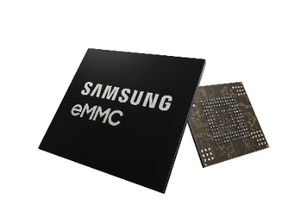**HARDWARE**
* About eMMC
* Which tools use for eMMC repairing
* Type of eMMC chip in phone
* Company Name of eMMC chip
* Types of eMMC BGA socket details
* eMMC chip storage capacity
* 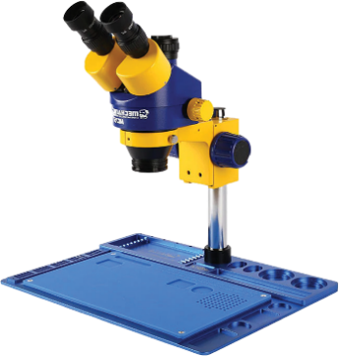How to maintain SMD iron heat for Removing ICs
* How to remove eMMC from PCB
* How Re-ball eMMC
* How to remove White glue pasted IC
* How to remove black pasted IC
* How to clean white & black pasted IC
* How to remove shielded
* How to make print IC
* How to make jumper
* How to Re-ball charging IC, Network IC, CPU IC, Power IC, etc.
* 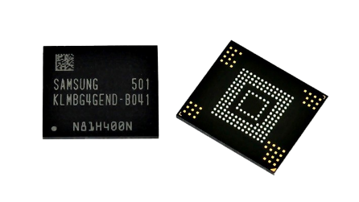**SOFTWARE**
* How to programming of eMMC.
* Which Tools & Software use for eMMC programming.
* How to use UFI Box
* About RAM & ROM
* 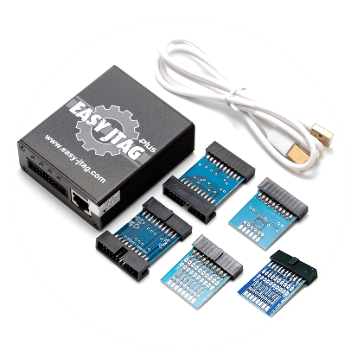How to Upgrade RAM & ROM
* About VCC, VCCQ, CMD, DATO, CLK & GROUND
* How to dead boot repair
* How to Read & Write Dump files.
* How to Read & Write security File.
* How to backup of eMMC.
* What is GP Partition?
* Health Report.
* Nand Test.
* How to Unlock Password, FRP & Mi account.
* 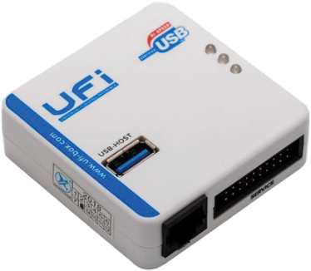What is Partition in eMMC.
* How to flash of eMMC
* What is Read Only one-time programming
* How to Factory reset of eMMC.
* What is eMMC Pinout.
* How to Recovery Data from dead phone.

**CALL FOR FREE DEMO: 8929250332**





Our Repairing Courses

MOBILE | LAPTOP | CCTV | LED TV | PRINTER

MOBILE EMMC | E-RICKSHAW CONTROLLER & CHARGER