

**(An ISO 9001:2015 Certified Institute)**

**29/4 A, 2ND FLOOR, BEHIND TILAK NAGAR METRO GATE NO. 3, TILAK NAGAR, NEW DELHI-18**

**MOBILE: +91-8929250332, +91-9716992246**

**EMAIL: info@multitechinstitute.com**

**Website: www.multitechinstitute.com**

**Laptop Repairing Course**

**What will you learn in this course?**

* **Learn about All Basic Electrinos Parts of Laptop & Desktop**
* **Learn about Complete Schematic Diagram & Board Viewer**
* **Complete Solution of BIOS Programming & Editing**
* **Advance Level Training on BGA Machine**
* **How to use I/O Programmer?**
* **Data & Signal Level Check with DSO/CRO Machine**
* **Laptop & Desktop Assembling and disassembling**
* **GFX to NON-GFX Conversion**
* **All types of Problems Solution for Laptop & Desktop**
* **Latest Generation Motherboard Repairing Tricks**
* **Hidden Trick of Laptop & Desktop Repairing**
* **Signal, Data, Frequency & Clock Level Training**
* **Dead Laptop & Desktop Repairing**
* **Water Damage Laptop & Desktop Repairing**
* **Complete IC Chip Level Training**

**SYLLABUS**

* **Basic Electronics**
* Introduction of (Volt, current, Watt, Ohms)
* 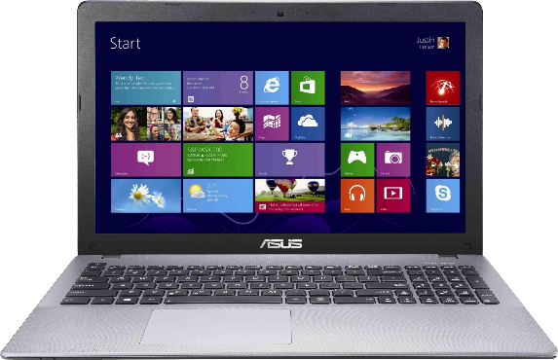Introduction of (AC/DC)
* How to Use Digital Multimeter
* **Identification of Electronics Components**
* Resistor, Capacitor, Transistor, Mosfet, Diode, Crystal, IC,

Transformer, Fuse, Jumper, Thermistor, Switch, Coil etc.

* **Resistor**
* Working Concept of Resistor
* Types of Resistor
* Symbol, Unit, Denoting Letter of Resistor
* Resistor Color Coding Concept
* SMD Resistor Value
* How to test Resistor on motherboard
* **Capacitor**
* 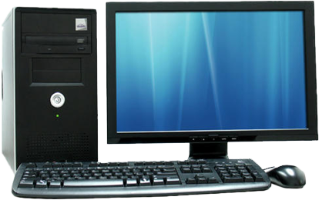What is Capacitor?
* Types of Capacitor.
* What is Symbol, unit and Denoting Letter of Capacitor
* Series and Parallel concept of Capacitor
* Inboard and outboard Capacitor Testing
* **Diode**
* Working Concept of Diode
* How many types of Diode
* Denoting Letter and Symbol of Diode
* Bridge Rectifier Diode Concept
* Testing of all types of Diode on motherboard
* **Transistor**
* 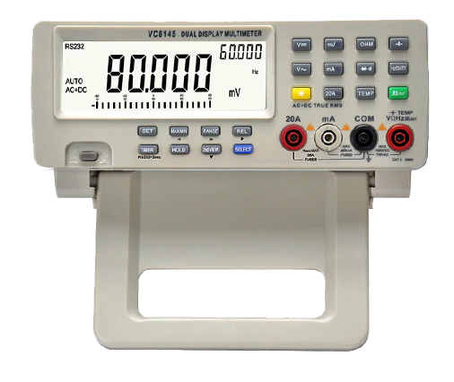Working concept of Transistor on motherboard
* Transistor Types
* What is Symbol and Denoting Letter of Transistor
* SMD and Normal Transistor Identification
* Onboard Testing of SMD and Normal Transistor
* **Coil**
* Identification of Difference types of Coil
* Working of Coil (Inductor)
* Types of Coil
* Symbol, unit, Denoting Letter Concept of Coil
* Ok Testing of all types of Coil
* **Mosfet**
* 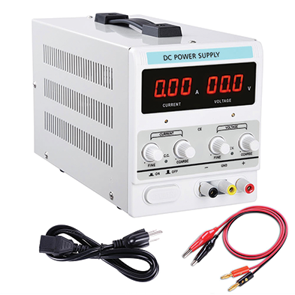Concept of SMD Mosfet
* Working concept of 3 pin, 6 pin, 8 pin Mosfet on motherboard
* Types of Mosfet
* What is Denoting letter and symbol of Mosfet
* Gate, Drain, Source pin Details
* Onboard Testing of all Types of Mosfet
* **IC / Chip**
* Working Concept of IC/Chip
* Identification of Difference Types of IC
* IC ok Testing on board
* **Transformer**
* Working Difference Types of Transformer
* 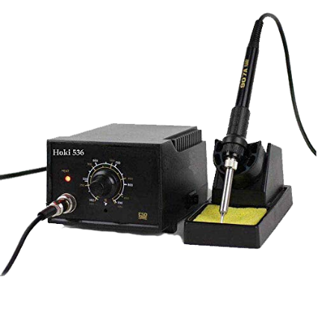Working of Transformer
* Symbol, Denoting Letter Concept of Transformer
* Testing Concept of Transformer
* **Crystal**
* Working Concept of Crystal
* RTC Crystal
* Symbol, unit, Denoting Letter Concept of Crystal
* Testing of Crystal by Multimeter and CRO Machine
* **Fuse**
* Working Concept
* Symbol, Denoting Letter Concept of Fuse
* Testing and Repair Concept of Fuse
* 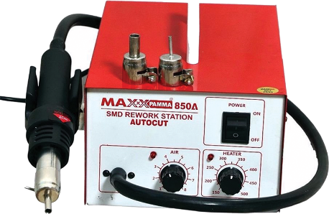**Thermistor**
* Types of Difference Thermistor
* Working of Thermistor
* Testing Concept of Thermistor
* NTC, PTC Thermistor
* **Soldering & De-Soldering Practice**
* How to remove all motherboard components

Like- capacitor, transistor, mosfet, crystal, coil, diode, fuse etc.?

* How to fix all electronics components on motherboard easily?
* How to remove and fix all types of IC/chip from motherboard?
* How to remove and fix all types of port, connector, slot, socket

Like -VGA Port, USB Port, ps2 port, SATA connector, CMOS battery?

* **Tracing of Laptop and Desktop Motherboard**
* Volt in section.
* Step down section
* VRM section
* Ram section
* Chip section (Graphic Section, North Bridge, South Bridge Section)
* Battery section (Charging & Discharging Section)
* 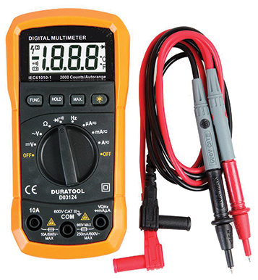I/O (Input-Output) section
* Bios section
* LAN section
* Sound section
* USB section
* VGA section
* SATA section
* 3.3v, 5v section
* 1.2v, 1.8v, 1.5v, 2.5volt section
* Odd section
* LVDS section (LCD & LED Panel and Screen section)
* 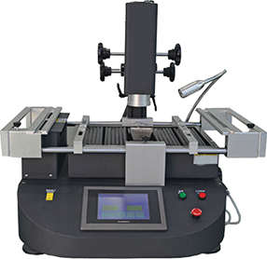Keyboard section
* Clock generator section
* Wi-Fi section
* Fan section
* RTC section
* Soc section
* Adaptor circuit
* Sensor circuit3
* Intel GFX section
* Touch pad section
* Camera section
* SSD section
* GFX Section
* **ASSEMBLING & DISASSEMBLING**
* Desktop Assembling and disassembling (For Fresher Students)
* Laptop Assembling and Disassembling process
* **SMPS Repairing**
* How to check SMPS on and off condition?
* How to check SMPS all voltage supply track?
* How to check and repair 3.3v,5v,12v, -12v, SB 5v, PG 5v, PS 5volt
* 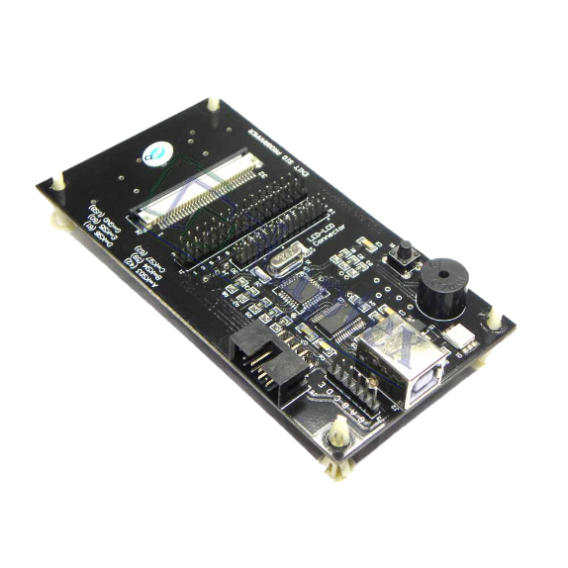SMPS problems repair
* SMPS dead condition repair
* SMPS power drop problem
* SMPS restarting problem
* SMPS suddenly power off problem

* **Adaptor / Charger Repairing**
* How to check adaptor on and off condition?
* How to repair dead condition laptop adaptor?
* How to check adaptor high low voltage problem?
* How to check adaptor shorting problem?
* **Faults Finding and Onboard Solution**
* 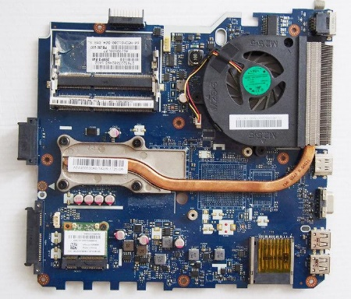No display problem solution
* Dead motherboard problem solution
* Automatic Restarting error repairing
* Hanging problem of laptop and desktop
* Charging & discharging faults of laptops
* Dim screen faults solution
* Automatic off problem & Blue screen
* Date and time error
* Heating faults of laptop and desktop
* 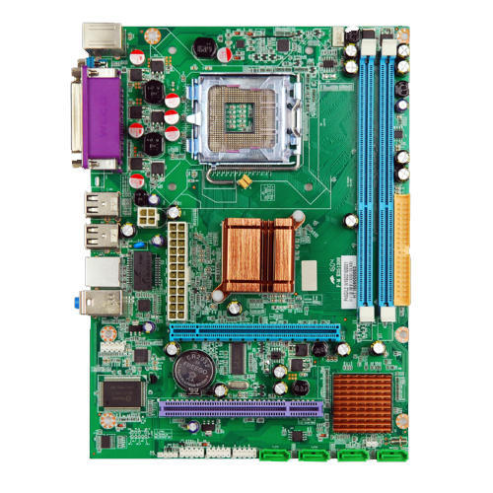Fan not working faults of laptop and computer
* Motherboard Shorting faults
* Linkage problem & USB not working faults
* Hard disk not working
* Error from Webcam (camera)
* Wi-Fi not working problem
* Sound related faults solution
* Network related problem
* Laptop Touch pad not working
* Keyboard not working faults of laptop and desktop
* 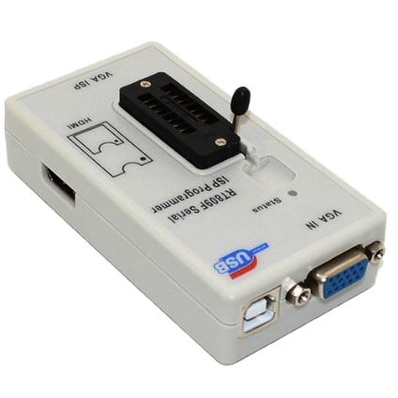Bluetooth and card reader problem
* White screen faults of laptops
* Hinge repair of laptops
* On/off switch related faults
* BIOS password removing method
* **Schematic Diagram Concept of Motherboard**
* 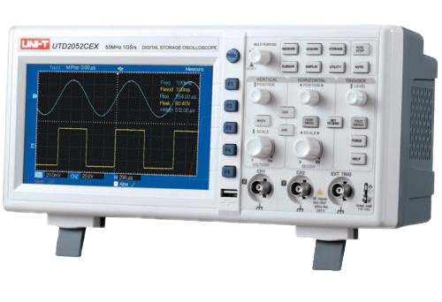Desktop block Diagram of Motherboard
* Laptop block Diagram of motherboard
* Difference Between Laptop & Desktop Block Diagram
* How to download schematic from different website?
* How to read schematic?
* How to read board viewer software?
* **Advance Level Repairing with Machine**
* **BGA MACHINE:** How to work on BGA machine for Chip Re-balling (Graphic chip, PCH chip, North bridge chip, South bridge chip)
* **BIOS PROGRAMMER:** How to use BIOS programmer for reprogramming Laptop bios chip, Desktop bios chip, Lcd, Led TV Bios chips.
* **CRO/DSO MACHINE:** How to use CRO Machine for checking all signal on motherboard like reset signal, clock signal, bios signal and frequency?
* **DC MACHINE:** How to check various voltage from DC Power Supply machine?
* **DIAGNOSTIC CARD:** How to check motherboard problems using diagnostic card?
* **I/O PROGRAMMER:** How to Reprogram I/o chip with ENIT I/O PROGRAMMER
* **SMD TESTER:** How to check all electronics components with SMD TESTER
* **MICROSCOPRE:** How to track and repair motherboard using microscope
* **ENIT MO METER:** How can remove shorting with ENIT MO METER

**CALL FOR FREE DEMO: 8929250332**

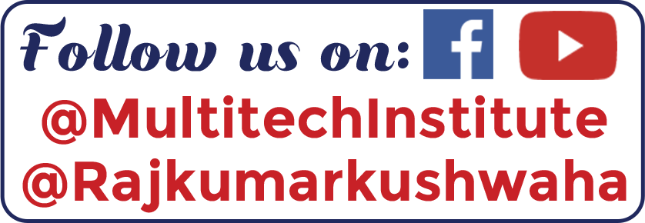



Our Repairing Courses

MOBILE | LAPTOP | CCTV | LED TV | PRINTER

MOBILE EMMC | E-RICKSHAW CONTROLLER & CHARGER