

**(An ISO 9001:2015 Certified Institute)**

**29/4 A, 2ND FLOOR, BEHIND TILAK NAGAR METRO GATE NO. 3, TILAK NAGAR, NEW DELHI-18**

**MOBILE: +91-8929250332, +91-9716992246**

**EMAIL: info@multitechinstitute.com**

**Website: www.multitechinstitute.com**

**Mobile Repairing Course**

**What will you learn in this course?**

* **How to remove and fix All Mobile Components like Charger jack,**

**Mic jack, Camera, speaker, jumper, SIM, Headphone jack etc.**

* **Mobile phone Assembling & Dissembling**
* **Mobile phone fingerprint related problem solution**
* **Water damage mobile phone repair**
* **How to repair and check battery**
* **OCA Machine Training**
* **How to change/remove mobile screen (folder)**
* **All types Mobile screen repair**
* **Mobile camera and circuit tracing and repair**
* **Unlock Any Phone: FRP, Pattern, Password, PIN**
* **Flashing Any Mobile Phone (Android/iPhone)**
* **Software Update (Android/iPhone)**
* **Backup (Android/iPhone)**
* **Practice on All types of Mobile Phone, etc.**

**SYLLABUS**

* **Mobile Hardware Basic Electronics & Practice Class**
* About Mobile Repairing course
* About knowledge of all hardware part of mobile phone
* Soldering & De-soldering of Big electronics Components
* Soldering & De-soldering of Small electronics Components
* 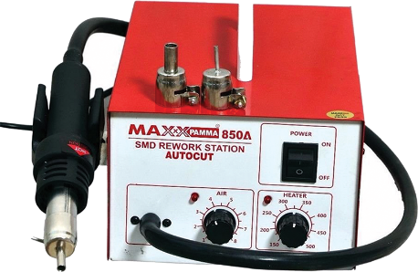How to do Big jumping in Mobile phone
* How to do Small jumping in Mobile phone
* How to do print jumping in Smartphone
* BGA IC Re-balling
* BGA IC Soldering & De-soldering practice
* Charging jack Soldering & De-soldering
* On/off switch jack Soldering & De-soldering
* Headphone jack Soldering & De-soldering
* Mic jack Soldering & De-soldering
* 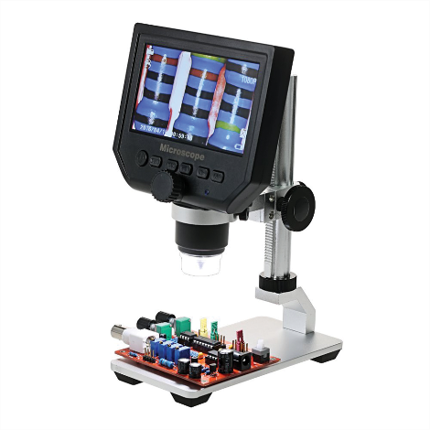Speaker/ringer Soldering & De-soldering
* Camera jack connector Soldering & De-soldering
* Sensor Soldering & De-soldering
* Display jack/connector Soldering & De-soldering
* Memory jack/connector Soldering & De-soldering
* SIM jack/connector Soldering & De-soldering
* Vibrator Soldering & De-soldering
* How to disassemble smartphone
* How to assemble smartphone
* Mobile Phone History
* How to use multimeter
* About Resistor electronic comments
* 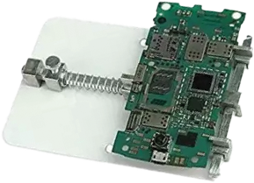About Capacitor
* About Diode Component
* About Coil component
* About transistor components
* About Crystal Component
* About IC Component
* About speaker/ringer Component
* About Mic Component
* 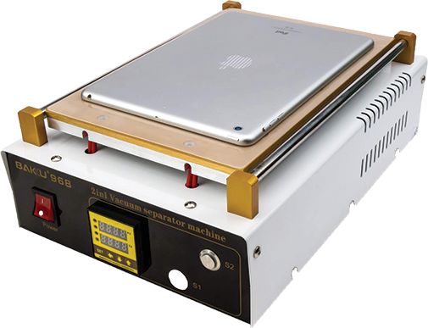About vibrator component
* About switch component
* How to replacement mobile folder
* **Mobile Tracing Class**
* About mobile Tracing class
* All Section in Mobile phone details
* How to use DC power supply machine
* Charging section circuit details
* Sound section circuit details
* Network section circuit details
* 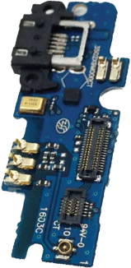On/Off section circuit details
* Camera section circuit details
* Sensor section circuit details
* Mic section circuit details
* Power IC circuit details
* CPU circuit details
* Basic knowledge eMMC chip
* Display section circuit details
* Touch section circuit details
* All other section details
* How to use schematic
* How to tracing section with schematic
* How to download smartphone schematic
* 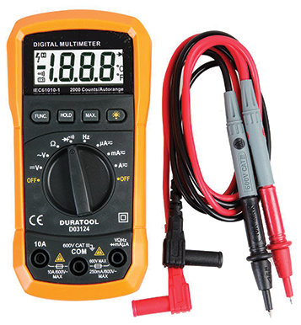About problem in Smartphone and solutions
* Mobile dead problem solution
* No display problem solution
* Charging problem solution
* Light related problem solution
* Camera related problem solution
* Mic related problem solution
* Speaker related problem solution
* On/Off related problem solution
* Sensor related problem solution
* Network related problem solution
* 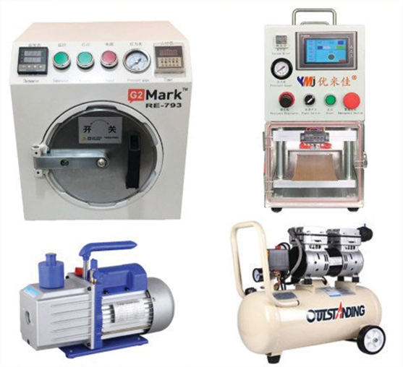SIM related problem solution
* Power IC related problem solution
* Damage phone repairing tips
* Half Shorting repairing
* Full Shorting repairing
* Water damage related phone repairing tips
* How to use touch separator
* How to use oca machine
* **OCA MACHINE TRAINING**
* Overview OCA Machine Tool
* How to remove folder and pasting
* How to separate touch/LCD glass and make comb
* How to remove & change film.

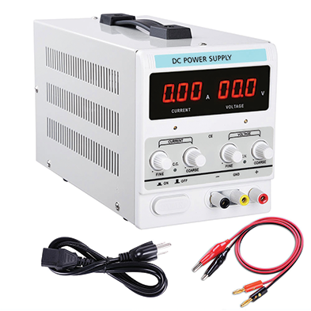

* **Mobile Software Class**
* Introduction of Mobile Software
* Mobile Problem its Reason
* Find Problem Hardware & Software
* Requirement of Mobile Software
* SAMSUNG Mobile Unlocking
* SAMSUNG Tool & File Downloading
* Driver & Software installation
* Identification Types of Files
* 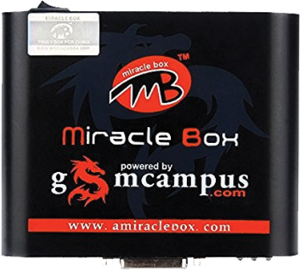SAMSUNG Mobile Flashing by Software
* SAMSUNG Mobile Flashing by Software Box
* SAMSUNG Mobile FRP Unlock
* SAMSUNG Mobile Country Unlock
* iPhone Mobile Software Update Online
* How to use Miracle Box
* How to use z3x Box
* How to use UMT Dongle
* iPhone Flashing Offline
* 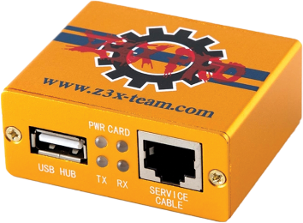iPhone Unlocking
* iPhone Country Unlocking
* iPhone iCloud Unlock
* Blackberry Flashing Online
* Blackberry Flashing Offline
* 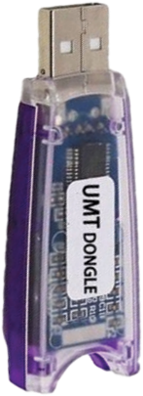Blackberry Unlocking
* All Chinese Mobile Flashing
* Chinese Mobile Unlocking
* Chinese Mobile FRP Unlocking
* Read Pattern Unlock
* Hard reset
* Reset Code Without Data Loss
* Sony Mobile Flashing
* Backup

**CALL FOR FREE DEMO: 8929250332**





Our Repairing Courses

MOBILE | LAPTOP | CCTV | LED TV | PRINTER

MOBILE EMMC | E-RICKSHAW CONTROLLER & CHARGER