

**(An ISO 9001:2015 Certified Institute)**

**29/4 A, 2ND FLOOR, BEHIND TILAK NAGAR METRO GATE NO. 3, TILAK NAGAR, NEW DELHI-18**

**MOBILE: +91-8929250332, +91-9716992246**

**EMAIL: info@multitechinstitute.com**

**Website: www.multitechinstitute.com**

**LED TV Repairing Course**

**What will you learn in this course?**

* **Learn about All Basic Electronics Parts of Normal & Smart LED TV.**
* **Learn about Complete Schematic Diagram of Normal & Smart LED TV.**
* **Complete software Solution of Normal & Smart LED TV.**
* **How to use BIOS RT809F/H Programmer.**
* **How to download free all types of software flash file from website.**
* **Data & Signal Level Checking with DSO/CRO Machine.**
* **Normal & smart LED TV Assembling and disassembling.**
* **How to convert LCD TV to LED TV & Smart TV.**
* **All types of Problems Solution for Normal & Smart LED TV.**
* **Latest Smart/Android Logic Board Repairing Tricks & tips.**
* **Hidden Trick of Normal & Smart LED TV Repairing.**
* **All Section Repairing & Solution of Normal & Smart LED TV.**
* **How to repair Dead Normal & Smart LED TV.**
* **How to Convert Normal TV to Smart/ Android TV.**
* **How to repair hang on Logo problem.**
* **Complete IC Chip Level Training.**
* **How to Repair BACKLIGHT SECTION OF Normal & Smart LED TV.**
* **How to programmer Normal & Smart LED TV with help of Pen drive.**
* **How To repairing and bypass PFC Section.**
* **How to repair No display, white Display, Black display problem.**
* **Horizontal and Vertical line related problem solutions**
* **How to Bypass DC to DC IC in t-con & scaler board**
* **How to repair T-con and Scaler board with hidden tricks.**
* **How to repair No Sound, Bad sound of Normal & Smart LED TV**
* **How to repair remote not working problem Normal & Smart LED TV.**
* **Soldering &De-soldering & Reballing IC and Components.**
* **We provide all LED TV software free for our students.**
* **How to install new android and universal board.**
* **How to install another panel in SONY TV.**
* **How to repair Mirror and mapping problem of Normal/ Smart LED TV.**
* **Understanding and testing voltage regulator.**
* **What is dump file & how to use it.**
* **What is datasheet & how to download from website.**
* **What is service code & service manual.**
* **How to repair Wi-fi problem.**
* **No power Led TV & Smart TV Repair**
* **No Display Led tv & smart TV repair**
* **No picture but sound OK , TV repair**
* **Dim display led tv & smart TV repair**
* **Stand by lighting blinking problem solutions**
* **Led tv & smart tv On/Off & restarting problems solutions**
* **Display broken & damage tv repair**
* **Display Lining (horizontal & vertical) problem solutions**
* **Late tv on problems solutions**
* **Negative (black & white) picture problems solutions**
* **Display spot (dot) problems solutions**
* **Screen lock problems solutions**
* **How to repair all type of remote**

**SYLLABUS**

* 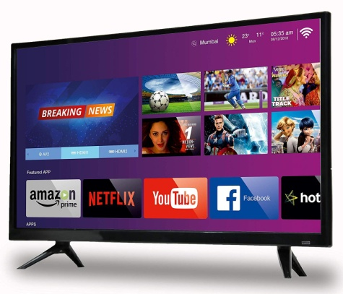**Basic Electronics**
* Introduction of (Volt, current, Watt, Ohms)
* Introduction of (AC/DC)
* How to Use Digital Multimeter
* **Identification of Electronics Components**
* Resistor, Capacitor, Transistor, Mosfet, Diode, Crystal, IC,

Transformer, Fuse, Jumper, Thermistor, Switch, Coil etc.

* **Resistor**
* Working Concept of Resistor
* Types of Resistors
* Symbol, Unit, Denoting Letter of Resistor
* Resistor Color Coding Concept
* 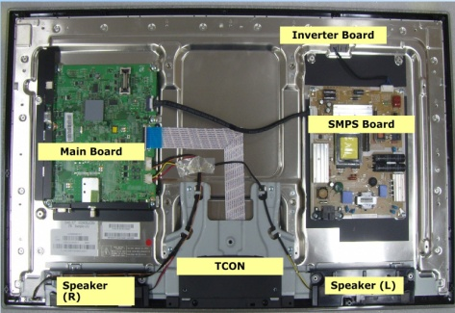SMD Resistor Value
* How to test Resistor on motherboard
* **Capacitor**
* What is Capacitor?
* Types of Capacitors.
* What is Symbol, unit and Denoting Letter of Capacitor
* Series and Parallel concept of Capacitor
* Inboard and outboard Capacitor Testing
* **Diode**
* Working Concept of Diode
* How many types of Diodes ?
* Denoting Letter and Symbol of Diode
* 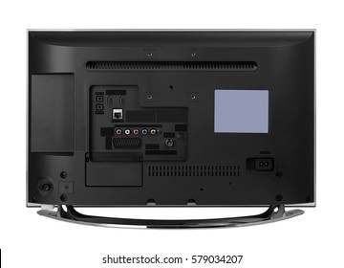Bridge Rectifier Diode Concept
* Testing of all types of Diode on motherboard
* **Transistor**
* Working concept of Transistor on motherboard
* Transistor Types
* What is Symbol and Denoting Letter of Transistor
* SMD and Normal Transistor Identification
* Onboard Testing of SMD and Normal Transistor
* **Coil**
* Identification of Difference types of Coils
* Working of Coil (Inductor)
* 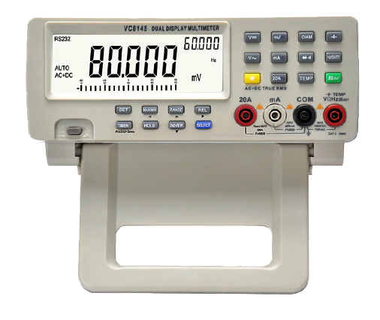Types of Coil
* Symbol, unit, Denoting Letter Concept of Coil
* Ok Testing of all types of Coil
* **Mosfet**
* Concept of SMD Mosfet
* Working concept of 3 pin, 6 pin, 8 pin Mosfet on motherboard
* Types of Mosfet
* What is Denoting letter and symbol of Mosfet
* Gate, Drain, Source pin Details
* Onboard Testing of all Types of Mosfet
* **IC / Chip**
* 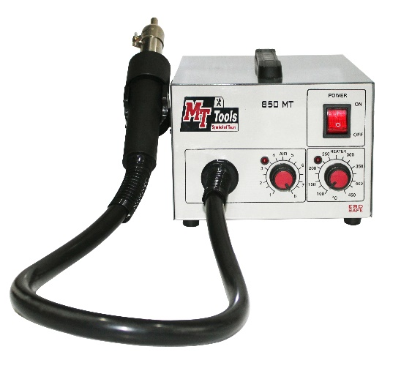Working Concept of IC/Chip
* Identification of Difference Types of IC
* IC ok Testing on board
* **Transformer**
* Working Difference Types of Transformers
* Working of Transformer
* Symbol, Denoting Letter Concept of Transformer
* Testing Concept of Transformer
* **Crystal**
* Working Concept of Crystal
* RTC Crystal
* Symbol, unit, Denoting Letter Concept of Crystal
* Testing of Crystal by Multimeter and CRO Machine
* 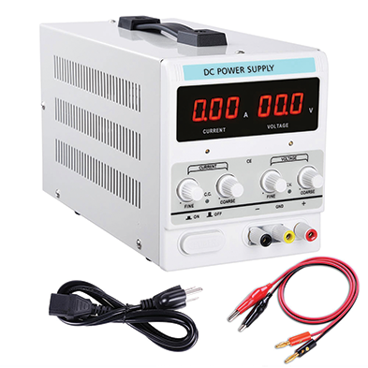**Fuse**
* Working Concept
* Symbol, Denoting Letter Concept of Fuse
* Testing and Repair Concept of Fuse
* **Thermistor**
* Types of Difference Thermistor
* Working of Thermistor
* Testing Concept of Thermistor
* NTC, PTC Thermistor
* **Varistor**
* Types of Difference Varistor
* Working of Varistor
* 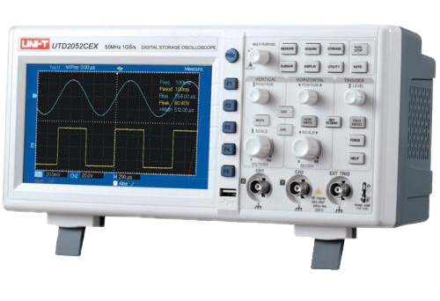Testing Concept of Varistor
* **Soldering & De-Soldering Practice**
* How to remove & sold all types of components in tv

Like- capacitor, transistor, Mosfet, crystal, coil, diode, fuse etc.?

* How to fix all electronics components on motherboard easily?
* How to remove and fix all types of IC/Chip from smart tv board?
* How to remove and fix all types of port, connector, slot, socket
* 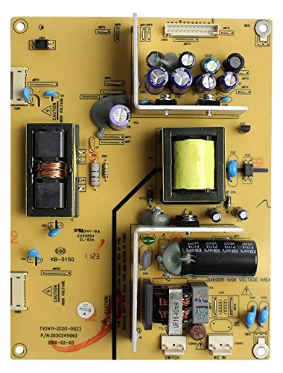**Power Supply (Identify, Working, Tracing, Testing & Repairing)**
* EMI Section
* PFC Section
* STR Section
* Transformer
* Output Secondary Section.
* **Backlight Section (Identify, Working, Tracing, Testing & Repairing)**
* Inverter Section (Use for CCFL)
* Driver Section (Use for LED Bulb)
* **Logic Board (Identify, Working, Tracing, Testing & Repairing)**
* About Voltage details and distribute in Logic board.
* How to check and repair voltage regulator 12v, 5v, 3.3v, 2.5v, 1.8v, 1.2v & 1v.
* Micro controller Chip & Type
* Voltage required for Micro controller
* Micro controller connection with other section
* Micro controller input and output section
* 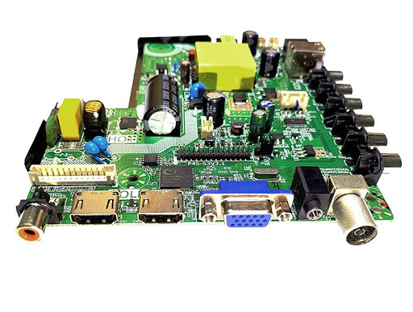Micro controller problem/solution
* BIOS Section
* What is BIOS?
* BIOS Section Voltage Required.
* BIOS Pin out details.
* How to read/write BIOS.
* RAM Section
* Types of RAM
* 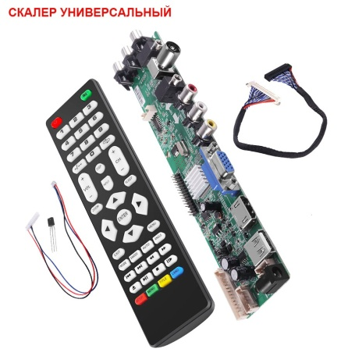RAM Voltage required.
* RAM Section related fault and solution.
* Crystal
* Use of Crystal in LED TV.
* Check Crystal with DSO/ CRO Machine.
* Crystal related fault and solution.
* Connector and Ports (USB, HDMI, VGA, A/V, Earphone jack, R/F)
* Sound Section
* 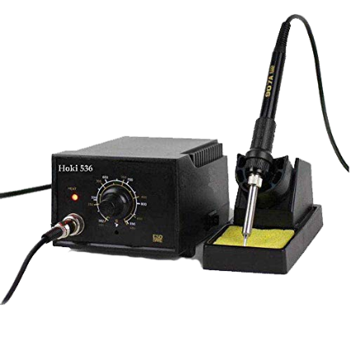Voltage Required
* Amplifier IC Pin details
* Check Speaker
* About Speaker Watts.
* IR and Keypad section
* Voltage required of IR and Keypad section
* IR and Keypad related fault and solution
* Replace IR and Keypad
* WiFi Section (WiFi, Hotspot, Bluetooth)
* WiFi Section voltage required
* 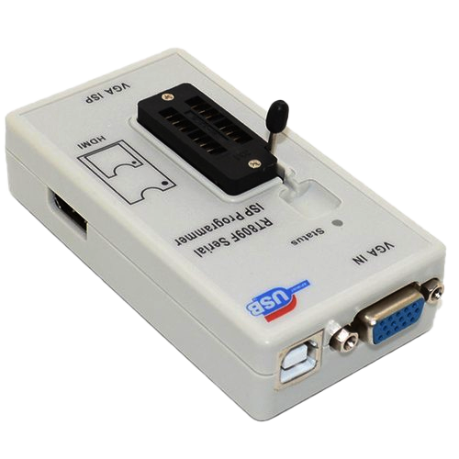WiFi Section related problem and solution
* Install new WiFi module
* GPU Section
* What is GPU?
* GPU section voltage required
* GPU section related fault and solution
* LVDS Section
* How to working LVDS Section
* LVDS Signal and Track
* LVDS Signal testing Onboard and Offboard
* Types and Different of LVDS Cable
* **T- CON and Scaler Board (Identify, Working, Testing, Repairing)**
* Types and Different of T-CON and Scaler Board
* 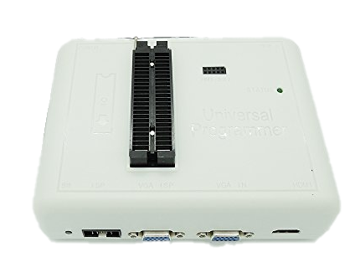Voltage Required and LVDS signal
* T-CON IC
* BIOS IC/Panel ID/Flash IC
* DC to DC IC
* Gamma IC
* Scanner/Level Shifter IC
* Regulator IC
* 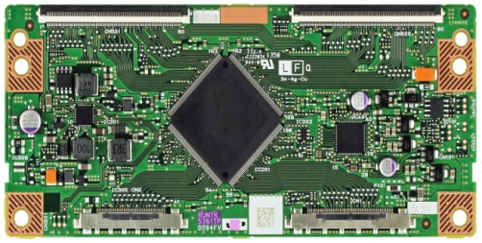FFC/FPC/COF
* Source COF and Gate COF
* Panel
* Panel Diagram and working
* **Advance Level Repairing with Machine**
* **BIOS PROGRAMMER:** How to use BIOS programmer for LCD, LED TV Bios chips.
* **CRO/DSO MACHINE:** How to use CRO Machine for checking all signal on motherboard like reset signal, clock signal, bios signal and frequency?
* **DC MACHINE:** How to check various voltage from DC Power Supply machine?
* **SMD TESTER:** How to check all electronics components with SMD TESTER
* **MICROSCOPRE:** How to track and repair Logic board using microscope
* **BACKLIGHT TESTER:** How to use backlight tester for back light strip & SMD led bulb
* **PANAL TESTER:** How to check display panel with panel tester
* **BOARD TESTER:** How to use board tester with normal & smart tv board
* **BYPASS/MODULER:** how to use & bypass with external modular.

**CALL FOR FREE DEMO: 8929250332**

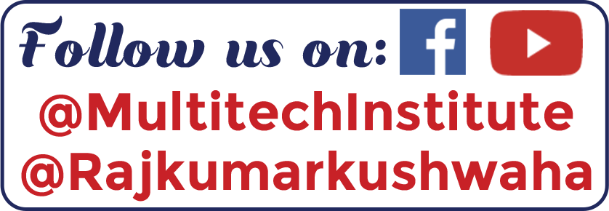

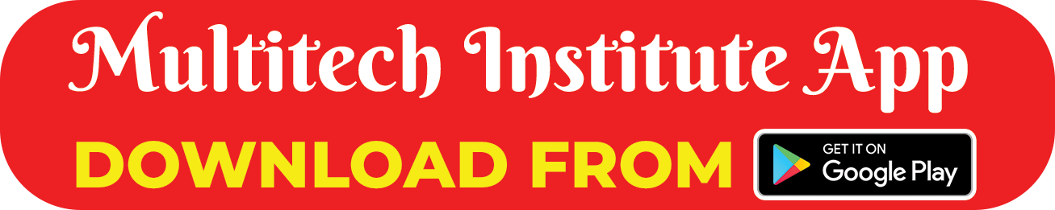

Our Repairing Courses

MOBILE | LAPTOP | CCTV | LED TV | PRINTER

MOBILE EMMC | E-RICKSHAW CONTROLLER & CHARGER