**WHAT is Depth First Search ?**

Depth first search or depth first traversal is a recursive algorithm for

Searching all the vertices of a graph or tree data structure traversal

Means visiting all the nodes of a graph.

A standard DFS implementation plus each vertex of the graph into one of

Two categories:

Visited

Not visited

The purpose of the algorithm is to mark each vertex as visited while

Avoiding cycles.

The DFS algorithm works as follows:

1. Start by putting any one of the graph’s vertices on top of a stack.
2. Take the top item of the stack and add it to the visited list.
3. Create a list of that vertex’s adjacent nodes. Add the ones which aren’t

In the visited list to the top of the stack.

1. Keep repeating steps 2 and 3 until the stack is empty.

For Example:-

graph1={

'A':set(['B','C']),

'B':set(['A','D','E']),

'C':set(['A','F']),

'D':set(['B']),

'E':set(['B','F']),

'F':set(['C','E']),

}

def dfs(graph,node,visited):

if node not in visited:

visited.append(node)

for n in graph[node]:

dfs(graph,n,visited)

return visited

visited=dfs(graph1,'A',[])

print(visited)

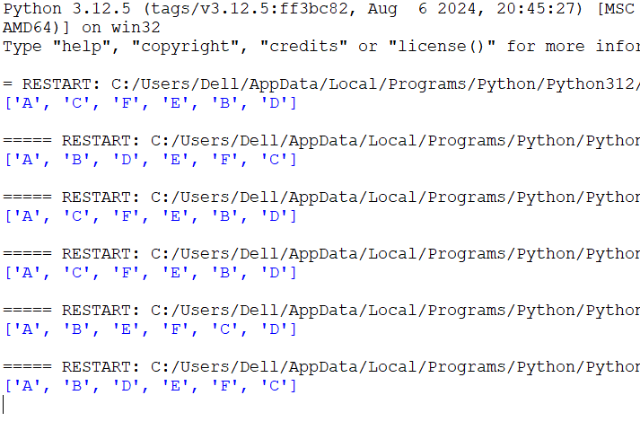

# 

**PRACTICAL:- 1**

graph= {

'B':set(['A','D','E']),

'A':set(['B','F','G']),

'F':set(['A']),

'G':set(['A']),

'D':set(['B']),

'E':set(['H','B']),

'H':set(['E','B']),

}

def dfs(graph,node,visited):

if node not in visited:

visited.append(node)

for n in graph[node]:

dfs(graph,n,visited)

return visited

visited=dfs(graph1,'B',[])

print(visited)

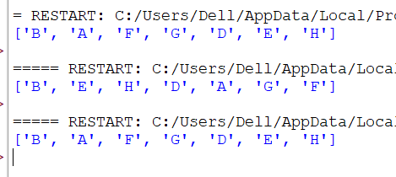

**PRACTICAL 1(B)**

**Breath First Search (BFS)**

graph = {

'A':set(['B','C','D']),

'B':set(['A','E']),

'C':set(['A',]),

'D':set(['A','F','G']),

'E':set(['B','H']),

'F':set(['D','H']),

'G':set(['D']),

'H':set(['E','F']),

}

def bfs(start):

queue = [start]

levels = {}

levels[start] = 0

visited = set([start])

while queue:

node = queue.pop(0)

neighbours = graph[node]

for neighbor in neighbours:

if neighbor not in visited:

queue.append(neighbor)

visited.add(neighbor)

levels[neighbor] = levels[node] + 1

print(levels)

return visited

print(str(bfs('A')))

def bfs_paths(graph, start, goal):

queue = [(start, [start])]

while queue :

(vertex, path) = queue.pop(0)

for next in graph[vertex] - set(path):

if next == goal:

yield path + [next]

else:

queue.append((next, path + [next]))

result = list(bfs_paths(graph, 'A', 'F'))

print(result)

def shortest_path(graph, start, goal):

try:

return next(bfs_paths(graph, start, goal))

except StopIteration:

return None

result1 = shortest_path(graph, 'A', 'F')

print(result1)

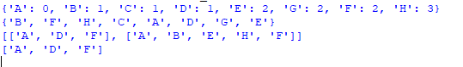

# 

**PRACTICAL:- 2**

**Write a program to simulate 4_Queen / n_Queen problem.**

def is_safe(board, row, col, N):

for i in range(row):

if board[i][col] ==1:

return False

for i, j in zip(range(row, -1, -1), range(col, -1, -1)):

if board[i][j] == 1:

return False

for i, j in zip(range(row, -1, -1), range(col, N)):

if board[i][j] == 1:

return False

return True

def solve_n_queens_util(board, row, N, solutions):

if row == N:

solution = []

for i in range(N):

sol_row = ""

for j in range(N):

if board[i][j] == 1:

sol_row += 'Q'

else:

sol_row += '.'

solution.append(sol_row)

solutions.append(solution)

return

for col in range(N):

if is_safe(board, row, col, N):

board[row][col] = 1

solve_n_queens_util(board, row + 1, N, solutions)

board[row][col] = 0

def solve_n_queens(N):

board = [[0] * N for _ in range(N)]

solutions = []

solve_n_queens_util(board, 0, N, solutions)

return solutions

def print_solutions(solutions):

for idx, solution in enumerate(solutions):

print(f"Solution {idx + 1}:")

for row in solution:

print(row)

print()

if __name__ == "__main__":

N=10

solutions = solve_n_queens(N)

print(f"Found {len(solutions)} solutions for {N}-Queens problem:")

print_solutions(solutions)

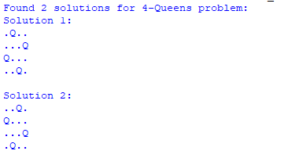

**PRACTICAL 2(B)**

def tower_of_hanoi(n, source , target, auxiliary):

if n== 1:

print(f"move disk 1 from {source} to {target}")

return

tower_of_hanoi(n - 1, source, auxiliary, target)

print(f"move disk {n} from {source} to {target}")

tower_of_hanoi(n -1, auxiliary, target, source)

def tower_of_hanoi_solver(num_disks):

print(f"solving Tower of Hanoi problem for {num_disks} disks:")

tower_of_hanoi(num_disks,'A','C','B')

if __name__=="__main__":

num_disks = 3 # change this to solve for different number of disks

tower_of_hanoi_solver(num_disks)

**OUTPUT:-**

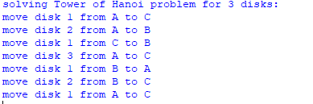

**PRACTICAL 3**

Write a program of water jug problem

capacity = (12, 8, 5)

initial_state = (12, 0, 0)

final_state = (6, 6, 0)

visited = set()

solution_path = []

def get_all_states(state):

if state == final_state:

solution_path.append(state)

return True

if state in visited:

return False

visited.add(state)

a, b, c = state

jugs = [a, b, c]

cap = capacity

for i in range(3):

for j in range(3):

if i !=j and jugs[i] > 0 and jugs[j] < cap[j]:

poured = min (jugs[i], cap[j] - jugs[j])

next_state = list (jugs)

next_state [i] -= poured

next_state [j] += poured

if get_all_states(tuple(next_state)):

solution_path.append(state)

return True

return False

print("solving 3-jug problem...\n")

if get_all_states(initial_state):

solution_path.reverse()

print("solution path:")

for state in solution_path:

print(f"jus A: {state[0]}L, jug B: {state[1]}L, jug C:{state[2]}L")

else:

print("No solution is found.")

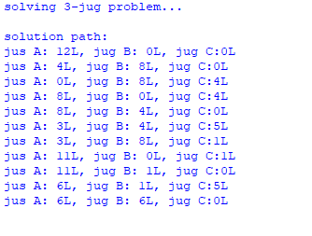

**PRACTICAL 3(B)**

import tkinter as tk

from tkinter import messagebox

root = tk.Tk()

root.title("Tic-Tac-Toe: Player vs AI")

root.resizable(False, False)

board = [""] * 9

buttons = []

player_symbol = "X"

ai_symbol = "O"

game_over = False

win_conditions = [

(0, 1, 2), (3, 4, 5), (6, 7, 8),

(0, 3, 6), (1, 4, 7), (2, 5, 8),

(0, 4, 8), (2, 4, 6)

]

def is_winner(brd, sym):

return any(brd[a] == brd[b] == brd[c] == sym for a, b, c in win_conditions)

def is_draw(brd):

return "" not in brd

def minimax(brd, is_ai):

if is_winner(brd, ai_symbol):

return 1

if is_winner(brd, player_symbol):

return -1

if is_draw(brd):

return 0

scores = []

for i in range(9):

if brd[i] == "":

brd[i] = ai_symbol if is_ai else player_symbol

score = minimax(brd, not is_ai)

brd[i] = ""

scores.append(score)

return max(scores) if is_ai else min(scores)

def get_best_move():

best_score = -float('inf')

move = None

for i in range(9):

if board[i] == "":

board[i] = ai_symbol

score = minimax(board, False)

board[i] = ""

if score > best_score:

best_score = score

move = i

return move

def check_game():

global game_over

if is_winner(board, player_symbol):

status_label.config(text="You Win!")

messagebox.showinfo("Game Over", "You Win!")

game_over = True

elif is_winner(board, ai_symbol):

status_label.config(text="AI Wins!")

messagebox.showinfo("Game Over", "AI Wins!")

game_over = True

elif is_draw(board):

status_label.config(text="It's a draw!")

messagebox.showinfo("Game Over", "It's a draw!")

game_over = True

if game_over:

for btn in buttons:

btn.config(state="disabled")

def ai_move():

if not game_over:

move = get_best_move()

if move is not None:

board[move] = ai_symbol

buttons[move].config(text=ai_symbol, state="disabled")

check_game()

if not game_over:

status_label.config(text="Your Turn (X)")

def on_click(i):

global game_over

if board[i] == "" and not game_over:

board[i] = player_symbol

buttons[i].config(text=player_symbol, state="disabled")

check_game()

if not game_over:

status_label.config(text="AI is thinking...")

root.after(300, ai_move)

def reset_game():

global board, game_over

board = [""] * 9

game_over = False

for btn in buttons:

btn.config(text="", state="normal", bg="SystemButtonFace")

status_label.config(text="Your Turn (X)")

# GUI Setup

frame = tk.Frame(root)

frame.pack(pady=10)

for i in range(9):

btn = tk.Button(frame, text="", width=10, height=3, font=("Arial", 16),

command=lambda i=i: on_click(i))

btn.grid(row=i//3, column=i%3, padx=5, pady=5)

buttons.append(btn)

status_label = tk.Label(root, text="Your Turn (X)", font=("Arial", 14))

status_label.pack(pady=10)

tk.Button(root, text="Reset Game", font=("Arial", 12), command=reset_game).pack(pady=5)

root.mainloop()

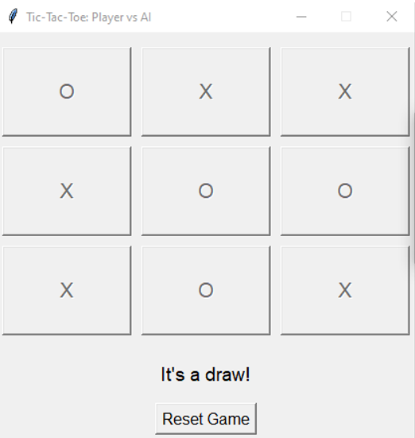



suits = ['Hearts','Diamonds','Clubs','Spades']

ranks = ['2','3','4','5','6','7','8','9','10',

'Jack','Queen','King','Ace']

deck=[f"{rank} of {suit}" for suit in suits for rank in ranks]

print("Original Deck:")

for card in deck:

print(card)

random.shuffle(deck)

print("\nShuffled Deck:")

for card in deck:

print(card)

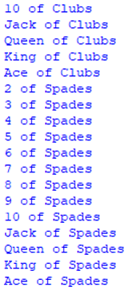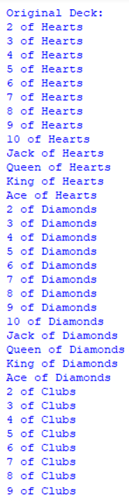

import random

import math

import matplotlib.pyplot as plt

class City:

def __init__(self):

self.x = random.randint(0, 100)

self.y = random.randint(0, 100)

def distance_to(self, other):

return math.sqrt((self.x - other.x)**2 + (self.y - other.y)**2)

def __repr__(self):

return f"({self.x},{self.y})"

def create_route(cities):

route = cities[:]

random.shuffle(route)

return route

def route_distance(route):

distance = 0

for i in range(len(route)):

next_city = route[(i + 1) % len(route)]

distance += route[i].distance_to(next_city)

return distance

def create_population(cities, size):

return [create_route(cities) for _ in range(size)]

def rank_population(population):

return sorted(population, key=route_distance)

def select_parents(population, num_parents):

return population[:num_parents]

def crossover(parent1, parent2):

start = random.randint(0, len(parent1) - 2)

end = random.randint(start + 1, len(parent1) - 1)

child = parent1[start:end]

for city in parent2:

if city not in child:

child.append(city)

return child

def mutate(route, rate=0.01):

for i in range(len(route)):

if random.random() < rate:

j = random.randint(0, len(route) - 1)

route[i], route[j] = route[j], route[i]

return route

def next_generation(population, num_parents, mutation_rate):

ranked = rank_population(population)

parents = select_parents(ranked, num_parents)

children = parents[:]

while len(children) < len(population):

p1 = random.choice(parents)

p2 = random.choice(parents)

child = crossover(p1, p2)

child = mutate(child, mutation_rate)

children.append(child)

return children

def genetic_algorithm(cities, pop_size=100, generation=500, elite_size=10, mutation_rate=0.02):

population = create_population(cities, pop_size)

print("initial best distance:", round(route_distance(rank_population(population)[0]), 2))

for _ in range(generation):

population = next_generation(population, elite_size, mutation_rate)

best = rank_population(population)[0]

print("Final best distance:", round(route_distance(best), 2))

return best

def plot_route(route):

x = [city.x for city in route] + [route[0].x]

y = [city.y for city in route] + [route[0].y]

plt.figure(figsize=(8, 6))

plt.plot(x, y, marker='o', linestyle='-', color='blue')

plt.title("Best TSP Route Found")

plt.xlabel("X Coordinate")

plt.ylabel("Y Coordinate")

for i, city in enumerate(route):

plt.text(city.x + 1, city.y + 1, str(i), fontsize=9)

plt.grid(True)

plt.show()

if __name__ == "__main__":

num_cities = 20

cities = [City() for _ in range(num_cities)]

best_route = genetic_algorithm(cities)

print("\nBest Route:")

for city in best_route:

print(city)

plot_route(best_route)

**PRACTICAL 6(A)**

def alpha_beta(node, depth, alpha, beta, maximizing_player):

if depth == 0 or isinstance(node, int):

return node

if maximizing_player:

max_eval = float('-inf')

for child in node:

eval = alpha_beta(child, depth - 1, alpha, beta, False)

max_eval = max(max_eval, eval)

alpha = max(alpha, eval)

if beta <= alpha:

break

return max_eval

else:

min_eval = float('inf')

for child in node:

eval = alpha_beta(child, depth - 1, alpha, beta, True)

min_eval = min(min_eval, eval)

beta = min(beta, eval)

if beta <= alpha:

break

return min_eval

game_tree = [

[3, 4, 6],

[3, 2, 9],

[0, 1, 4]

]

best_value = alpha_beta(game_tree, depth=3, alpha=float('-inf'), beta=float('inf'), maximizing_player=True)

print("Best value:", best_value)



**PRACTICAL 6(B)**

import random

def hill_climbing(function, x_start, step_size, max_iterations):

current_x = x_start

current_value = function(current_x)

for i in range(max_iterations):

neighbors = [current_x + step_size, current_x - step_size]

neighbor_values = [function(x) for x in neighbors]

max_value = max(neighbor_values)

max_index = neighbor_values.index(max_value)

best_neighbor = neighbors[max_index]

if max_value <= current_value:

print(f"Iteration {i} : No improvement found. Stopping.")

break

current_x = best_neighbor

current_value = max_value

print(f"Iteration {i}: x = {current_x:.4f}, f(x) = {current_value:.4f}")

return current_x, current_value

def objective_function(x):

return -x**2 + 10*x

initial_x = random.uniform(0,10)

step_size = 0.1

max_iters = 100

best_x, best_value = hill_climbing(objective_function, initial_x,step_size, max_iters)

print(f"\nBest Solution: x = {best_x:.4f}, f(x) = {best_value:.4f}")

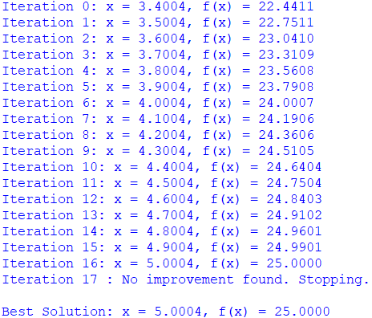

**PRACTICAL 7(A)**

import heapq

def astar(graph, heuristic, start, goal):

open_list = [(heuristic[start], start, [start], 0)]

visited = set()

while open_list:

f, node, path, g = heapq.heappop(open_list)

if node == goal:

return path

if node in visited:

continue

visited.add(node)

for neighbor, cost in graph[node].items():

if neighbor not in visited:

g_new = g + cost

f_new = g_new + heuristic[neighbor]

heapq.heappush(open_list, (f_new, neighbor, path + [neighbor], g_new))

return None

graph = {

'A': {'B': 1, 'C': 3},

'B': {'D': 1, 'E': 5},

'C': {'F': 2},

'D': {'G': 3},

'E': {'G': 1},

'F': {'G': 2},

'G': {}

}

heuristic = {

'A': 7, 'B': 6, 'C': 5,

'D': 4, 'E': 2, 'F': 3,

'G': 0

}

path = astar(graph, heuristic, 'A', 'G')

print("Shortest path:", path)



**PRACTICAL 7(B)**

knowledge_base = {

"Sachin": "Batsman",

"Batsman": "Cricketer",

"Cricketer": "Sportsperson",

"Sportsperson": "Human",

"Human": "Mammal",

"Mammal": "LivingBeing",

"Dog": "Mammal",

"Cat": "Mammal"

}

def derive_predicate (kb, entity, target):

"""

Try to derive if an entity is a kind of target using transitive inference

"""

visited = set()

to_visit = [entity]

while to_visit:

current = to_visit.pop()

if current == target:

return True

if current in kb and current not in visited:

visited.add(current)

to_visit.append(kb[current])

return False

queries = [

("Sachin", "Cricketer"),

("Sachin", "Sportsperson"),

("Sachin", "LivingBeing"),

("Dog", "LivingBeing"),

("Cat", "Sportsperson"),

]

for entity,target in queries:

if derive_predicate(knowledge_base,entity,target):

print(f"{entity} is a {target}")

else:

print(f"Cannot derive that {entity} is a {target}")

**PRACTICAL 8(A)**

# Facts: Gender and Parent relationships

male = {"Ram", "Ravi", "Arjun", "Amit"}

female = {"Sita", "Reena", "Maya", "Neha"}

# parent(child, parent)

parent = {

("Ravi", "Ram"), ("Ravi", "Sita"),

("Reena", "Ram"), ("Reena", "Sita"),

("Arjun", "Ravi"), ("Arjun", "Maya"),

("Neha", "Reena"), ("Neha", "Amit")

}

# Predicates and Rules

def father(x, y):

return (x in male) and (y, x) in parent

def mother(x, y):

return (x in female) and (y, x) in parent

def grandfather(x, y):

return (x in male) and any(father(x, p) or mother(x, p) for p, q in parent if q== x and (y, p) in parent)

def grandmother(x, y):

return (x in female) and any(father(x, p) or mother(x, p) for p, q in parent if q== x and (y, p) in parent)

def siblings(x, y):

return x != y and any((x, p) in parent and (y, p) in parent for _, p in parent)

def brother(x, y):

return (x in male) and siblings(x, y)

def sister(x, y):

return (x in female) and siblings(x, y)

def uncle(x, y):

return (x in male) and any(brother(x, p) for p in male | female if (y, p) in parent)

def aunt(x, y):

return (x in female) and any(sister(x, p) for p in male | female if (y, p) in parent)

def nephew(x, y):

return (x in male) and any((x, p) in parent and (p, y) in parent for p, q in parent)

def niece(x, y):

return (x in female) and any((x, p) in parent and (p, y) in parent for p, q in parent)

def cousin(x, y):

return any(siblings(p1, p2) for (x, p1) in parent for (y, p2) in parent if p1 != p2)

# --- Test cases ---

print("Father of Ravi:", [p for p in male if father(p, "Ravi")])

print("Mother of Arjun:", [p for p in female if mother(p, "Arjun")])

print("Siblings (Ravi, Reena):", siblings("Ravi", "Reena"))

print("Brother of Reena:", [p for p in male if brother(p, "Reena")])

print("Sister of Ravi:", [p for p in female if sister(p, "Ravi")])

print("Uncle of Arjun:", [p for p in male if uncle(p, "Arjun")])

print("Aunt of Arjun:", [p for p in female if aunt(p, "Arjun")])

print("Cousin of Arjun:", [p for p in male | female if cousin(p, "Arjun")])

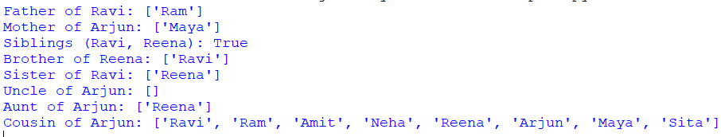

**PRACTICAL 8B**

**def check_associative_addition(a, b, c):**

**return (a + b) + c == a + (b + c)**

**def check_associative_multiplication(a, b, c):**

**return (a * b) * c == a * (b * c)**

**def check_distributive(a, b, c):**

**return a * (b + c) == a * b + a * c**

**def main():**

**a, b, c = 2, 3, 4 # Example values**

**print("=== Demonstrating Algebraic Laws (Numerical) ===\n")**

**print("Associative Law of Addition:")**

**print(f"({a} + {b}) + {c} = {(a + b) + c}")**

**print(f"{a} + ({b} + {c}) = {a + (b + c)}")**

**print(f"Are they equal? {check_associative_addition(a, b, c)}\n")**

**print("Associative Law of Multiplication:")**

**print(f"({a} * {b}) * {c} = {(a * b) * c}")**

**print(f"{a} * ({b} * {c}) = {a * (b * c)}")**

**print(f"Are they equal? {check_associative_multiplication(a, b, c)}\n")**

**print("Distributive Law:")**

**print(f"{a} * ({b} + {c}) = {a * (b + c)}")**

**print(f"{a} * {b} + {a} * {c} = {a * b + a * c}")**

**print(f"Are they equal? {check_distributive(a, b, c)}\n")**

**if __name__ == "__main__":**

**main()**