Looker Contents:
Explore 1
Develop 2
Admin: 3
Bookmarks, recent Dashboards and views 3
Boards 4
Views: 5
Save a look: 5
Explore lookMl: 6
The 4 Key for core analytics concepts: 7

Explore:
In this if we have any query regarding the data set or to share the looks(visualizations and dashboards) we use explore. These are curated by google developers by language called LookMl.
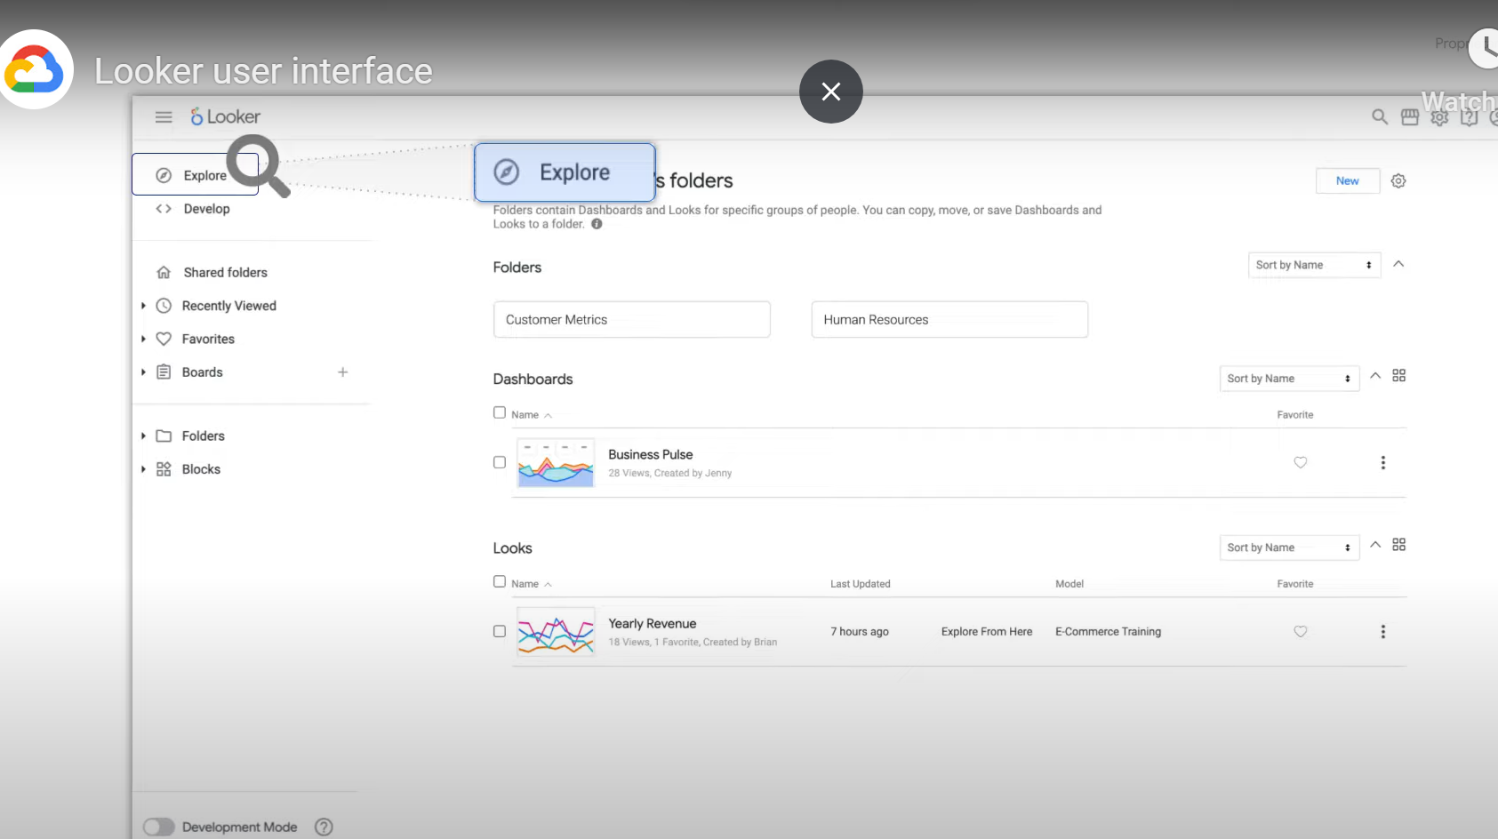

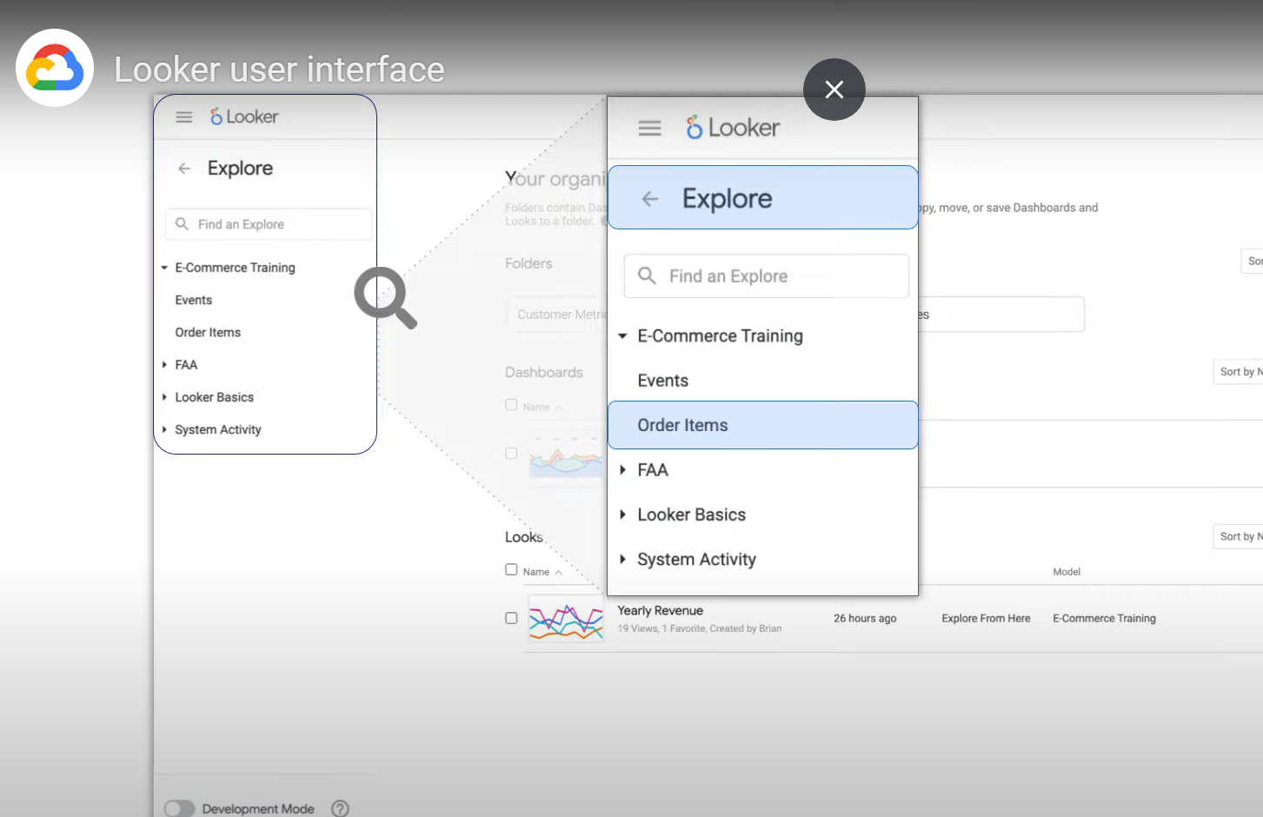

Develop:
These are used by developers to specify which fields should be visible by users/viewers.
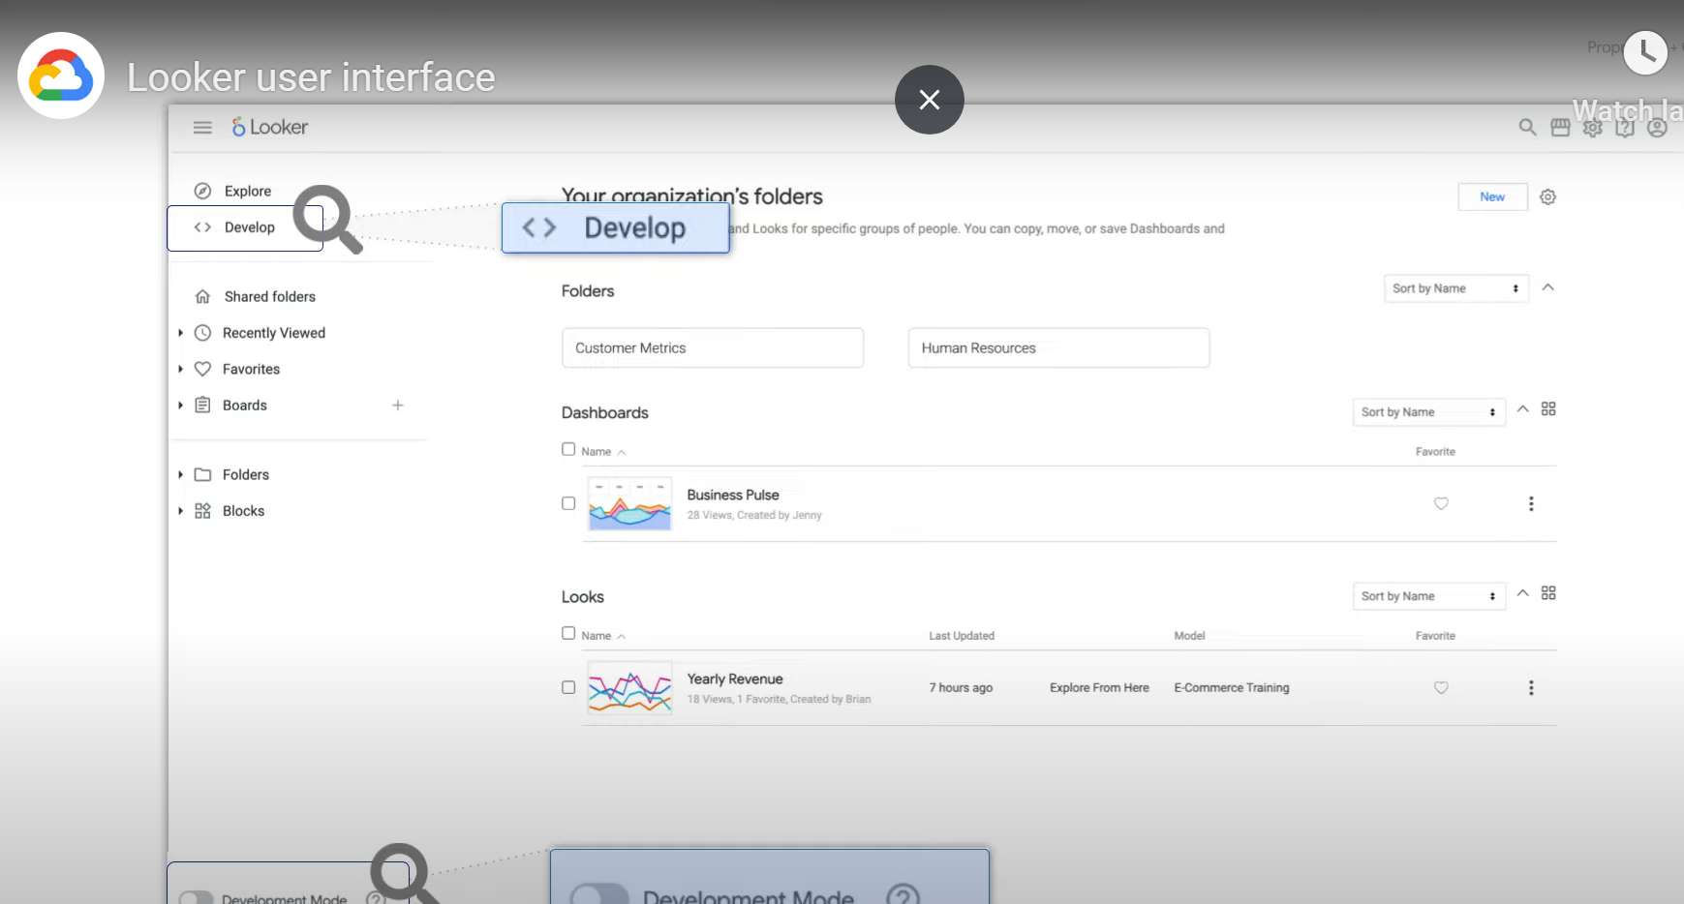
Admin:
These are used by looker admins to define the role for the user. There a several roles like developer , viewer, etc.
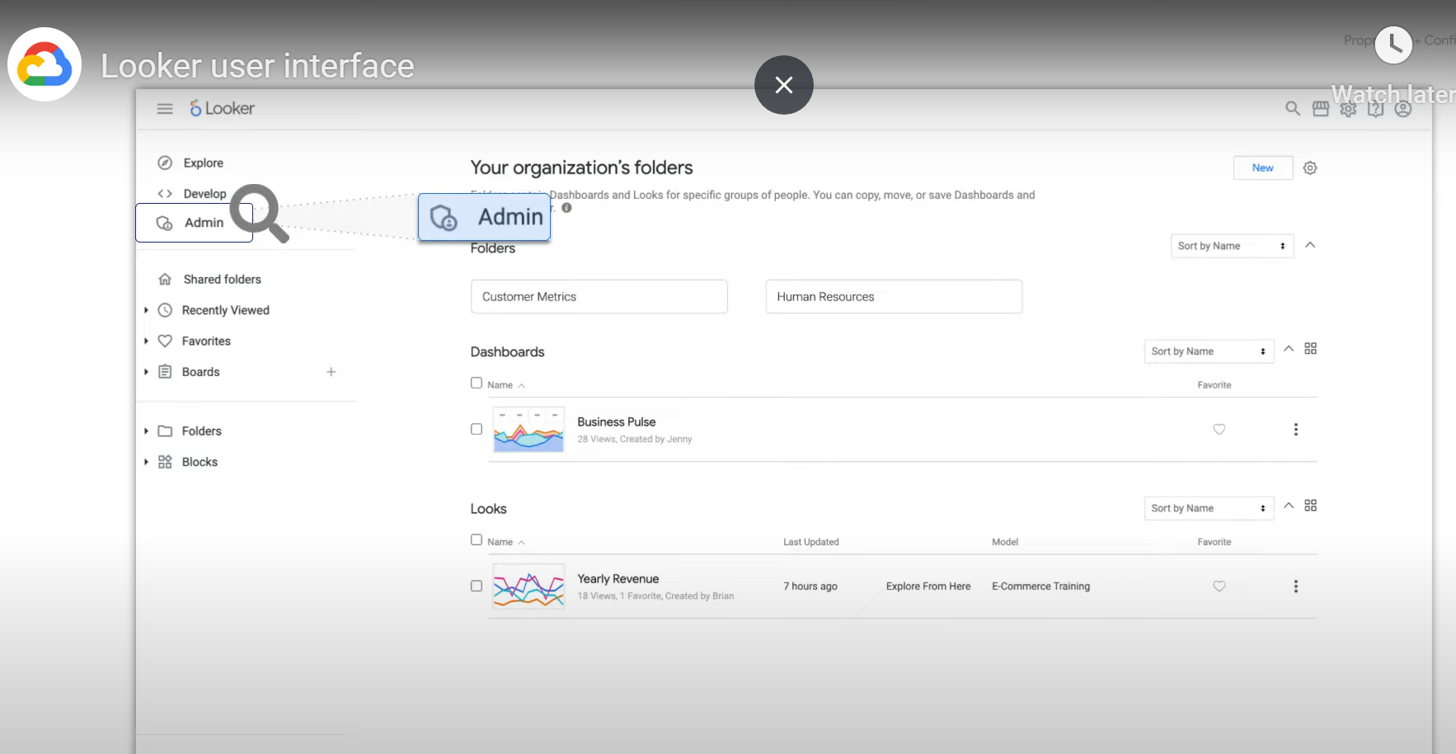

Bookmarks, recent Dashboards and views:
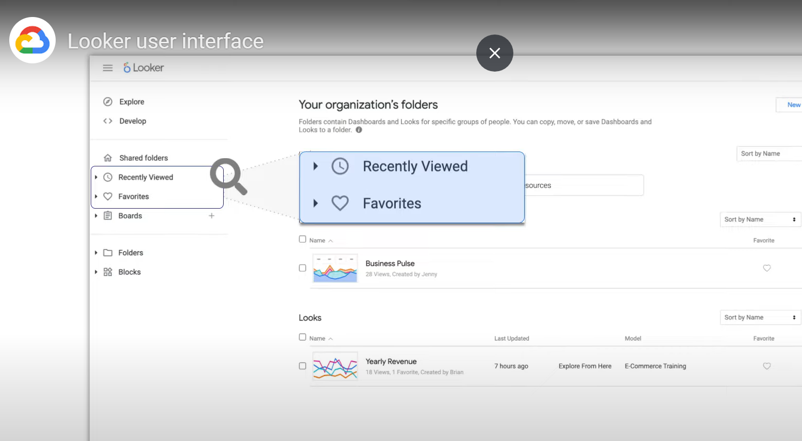

Boards:
Multiple dashboard and looks to share in once we use boards.
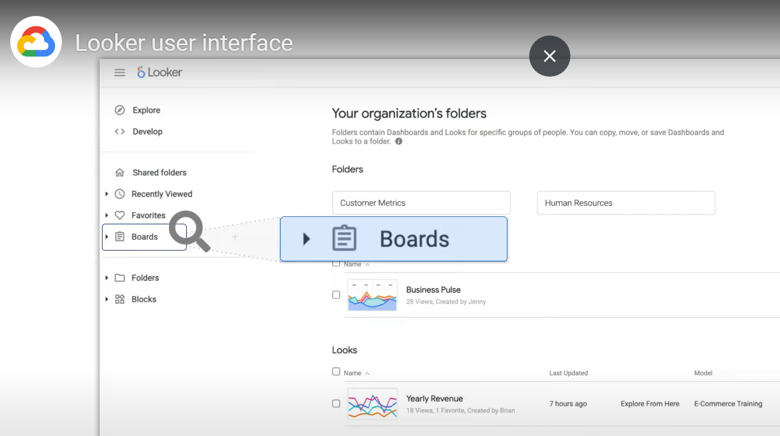

Search for looker instance
Looker market
Admin
Help
account details
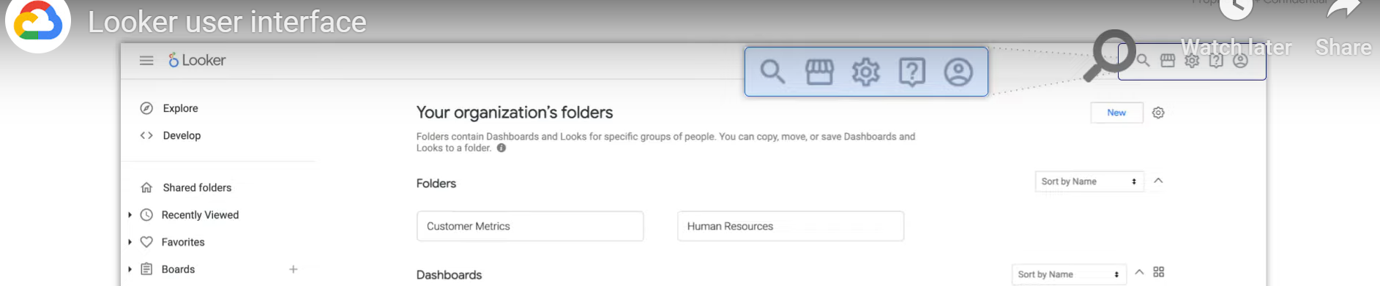

Views:
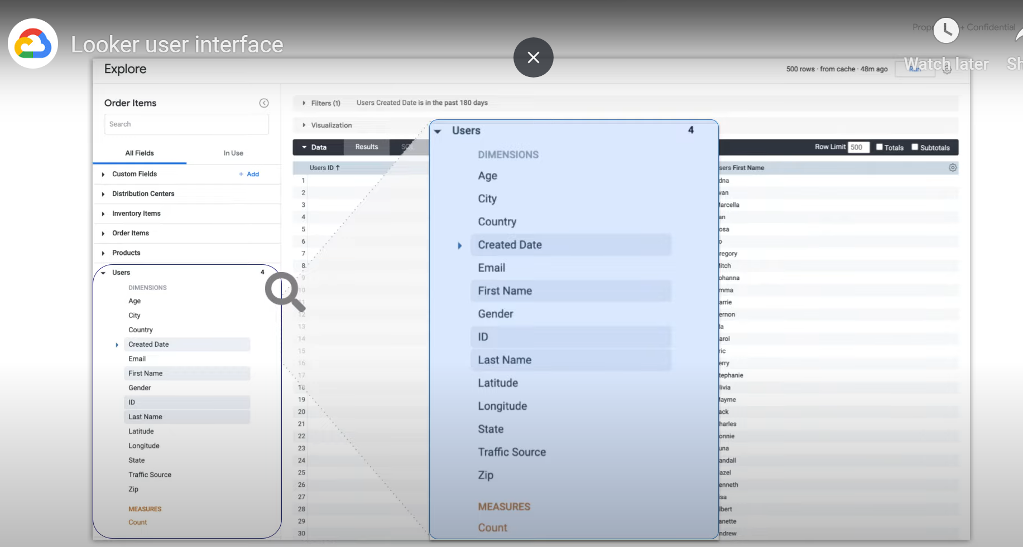

Save a look:
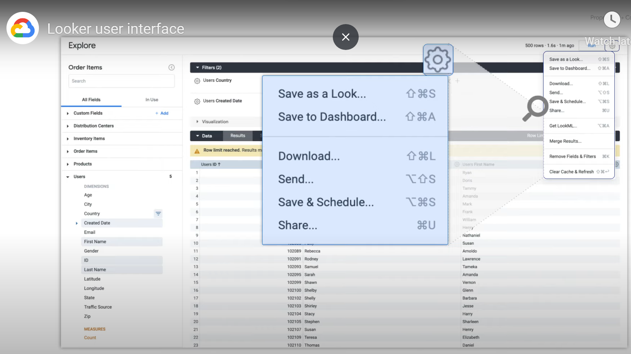

Explore lookMl:
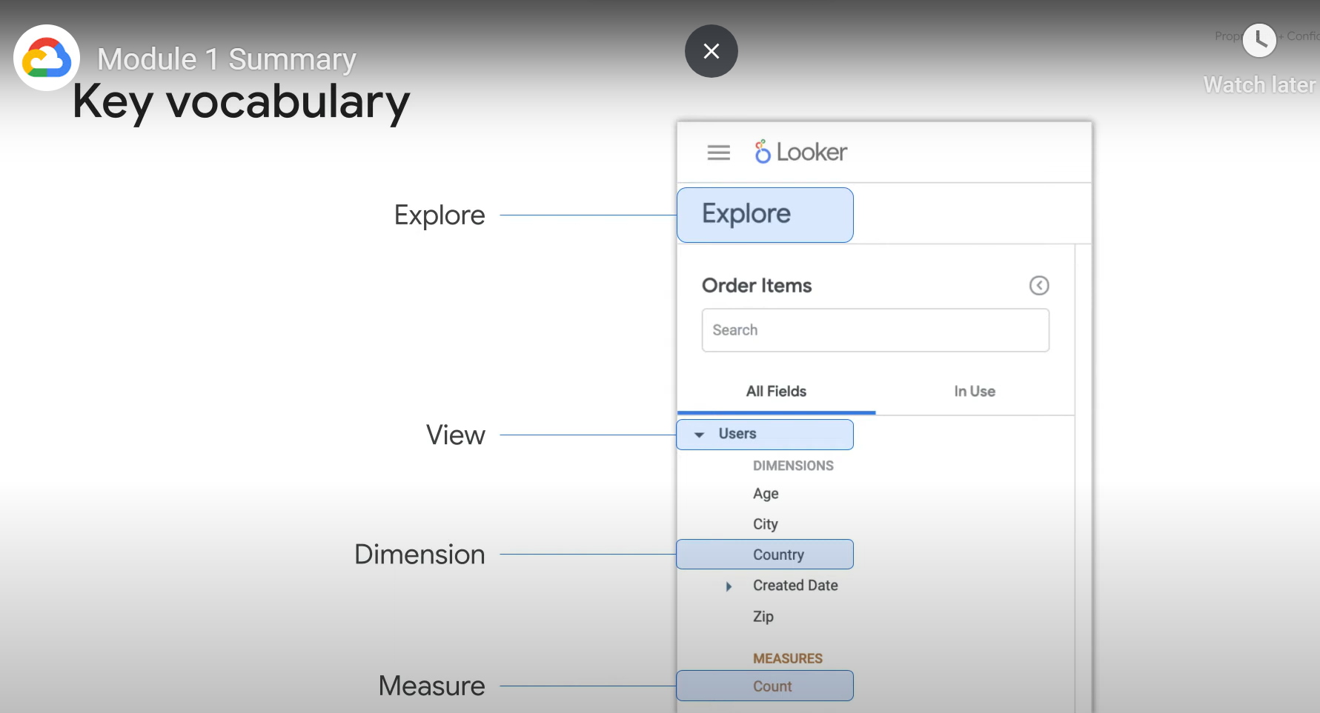

The 4 Key for core analytics concepts:
