

**MICROPROCESSOR AND INTERFACING**

**Date: 12/02/2021**

**Date: 2/12/2021**

**Submitted By,**

**Name - Suraj P**

**Registration Number - 19BCE1044**

Exp:1 Basic arithmetic operations on 8-bit and 16-bit Numbers



**Aim:**

To verify the arithmetic operations for 8 bit and 16-bit numbers using 8086 processor by MASM611 assembler.

**Tool Used:**

Assembler - MASM 611

**Algorithm:**

**8 BIT**

The date and Month of DOB are taken as operands

1. Start

2.The Larger value is moved onto ah register and smaller in bh.

3. For addition and subtraction ,we use the command add ah,bh ( ah = ah+bh) and sub ah,bh ( ah = ah-bh) and the result is stored in ah register. The sum and diff stored in temporary variable in memory.

4. For multiplication instead of ah register , the larger data stored in al register. To generate product, we use mul bh. The result is stored in ax register(16 bits) and mov prod into a temporary variable.

5. For division the dividend (larger) stored in ax register and we use the command div bh .The quotient is stored in al and remainder in ah register. Allocate variable to store this quotient and rem.

6. In the data segment define the size allocated for each variable

7. Halt

**16 BIT**

The date + Month and year of DOB are taken as operands

1. Start

2.The Larger value is moved onto ax register and smaller in bx.

3. For addition and subtraction ,we use the command add ax,bx ( ax = ax+bh) and sub ax,bx ( ax = ax-bx) and the result is stored in ax register. The sum and diff are then stored in temporary variable.

4. For multiplication we use mul bx. The result is stored in ax and dx register as the value can cross 16-bit register capacity of ax and thus overflow stored in dx register. The product is stored in 2 variables each from ax and dx.

5. Before running the division we first clear the dx register using mov dx,0h .

6. For division the dividend (larger) stored in ax register and divisor is chosen to be an 8-bit number stored in bx register. We use the command div bh .The quotient is stored in ax and remainder in dx register.

7.In data segment define the size allocated for each variable

8. Halt

**Program:**

**8 bit**

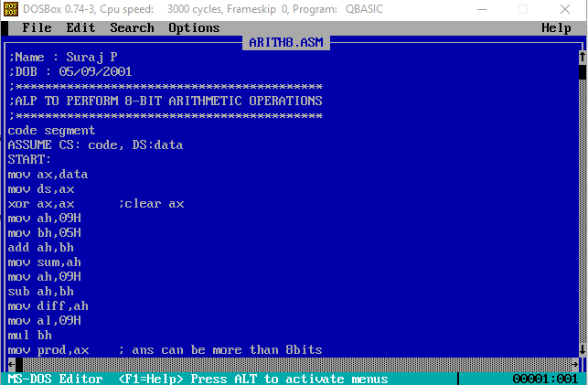

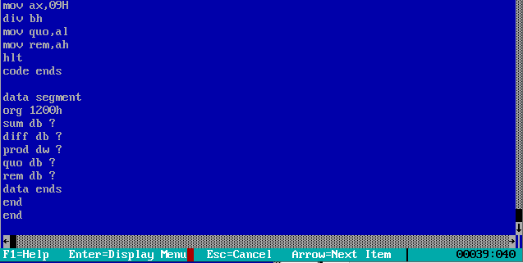

**16 bit**

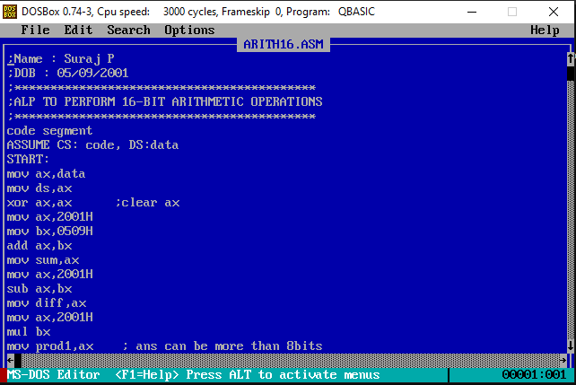

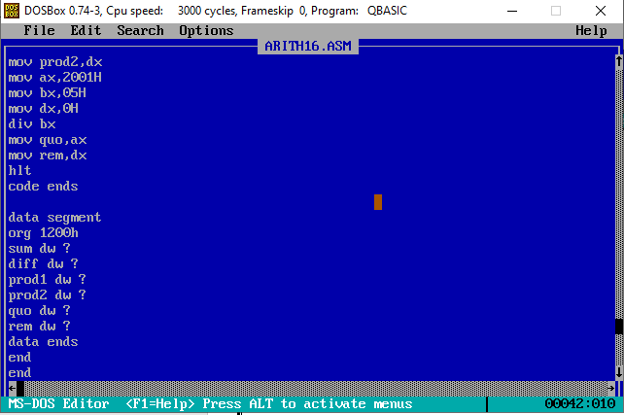

**Sample Input:**

**8 bit**

Num1 : 09H

Num2 : 05H

**16 bit**

**For Addition, Subtraction, Multiplication**

Num1 : 2001H

Num2 : 0509H

**For Division**

Num1 : 2001H

Num2 : 05H

**Sample Output:**

**Addition (8 bit):**  0EH

**Addition (16 bit):** 250AH

**Subtraction (8 bit):** 04H

**Subtraction (16 bit):** 1AF8H

**Multiplication (8 bit):** 002DH

**Multiplication (16 bit):** A12509 H

**Division (8 bit):**

**Quotient :** 01H **Remainder:** 04H

**Division (16 bit):**

**Quotient :** 0666H **Remainder:** 0003H

**Snapshot of the Output:**

**8 bit**

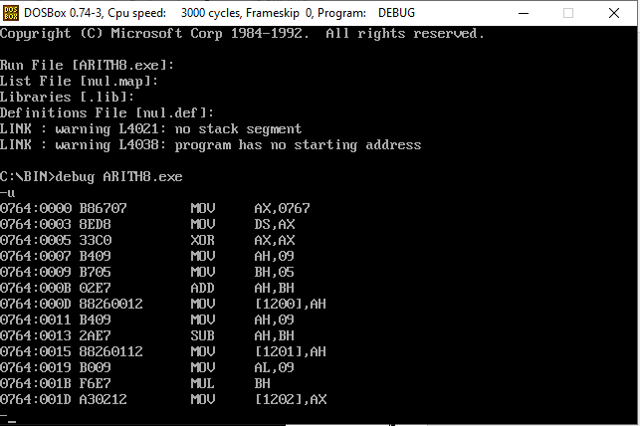

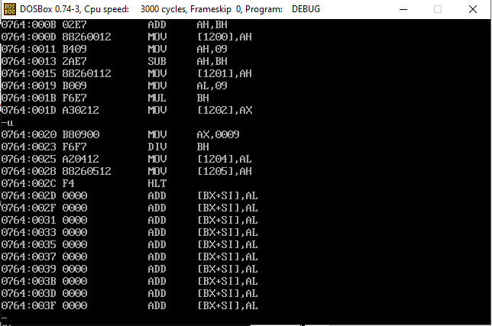

**16 bit**

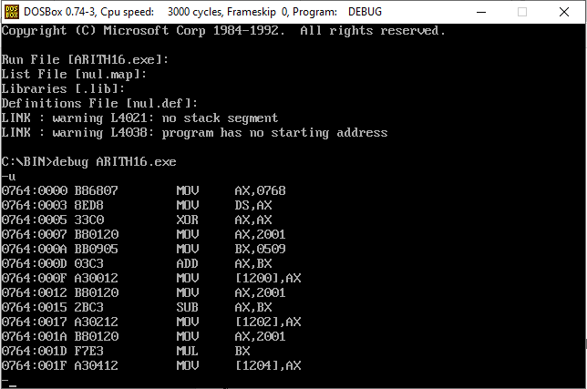

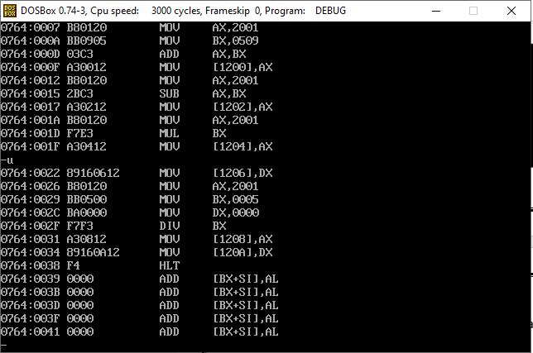

**Register/Memory Contents for I/O**

**8 bit**

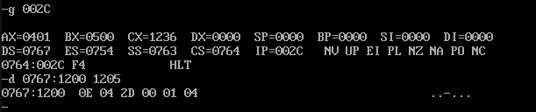

**16 bit**

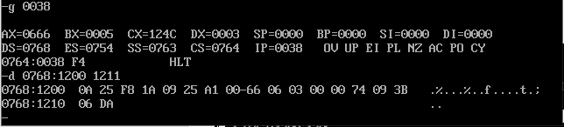

**Manual Verification:**

**8 bit**

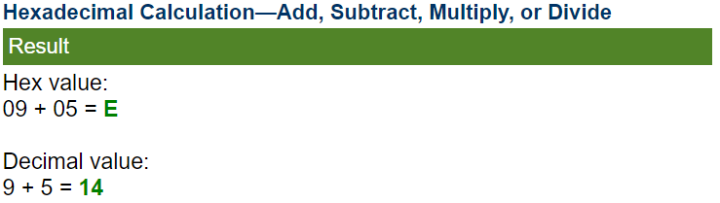

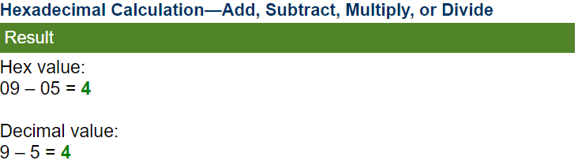

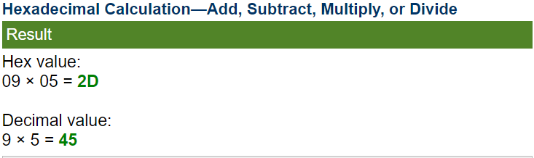

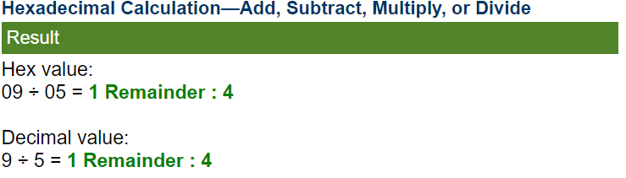

**16 bit**

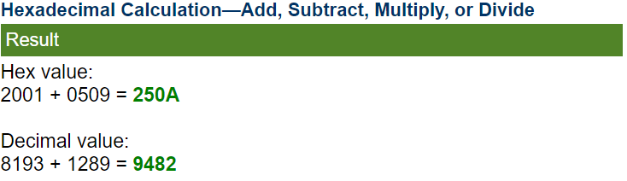

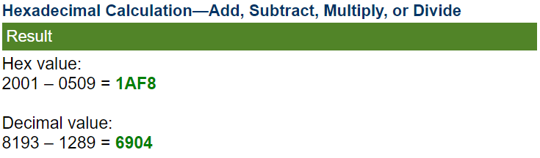

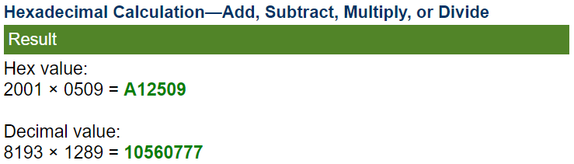

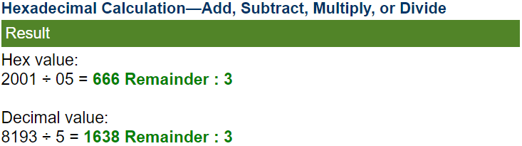

**Result:**

Hence all operations-addition, subtraction, multiplication and division in both 8-bit as well as 16-bit representation have been performed and verified using the MASM611 application in DOSBOX.