1. **INTRODUCTION**
   1. **Introduction**

The "Olympics Data Analysis" system is an extraordinary and versatile tool meticulously designed for an extensive exploration of the expansive realm of Olympic data. With its harnessing of the extraordinary capabilities of acclaimed Python libraries, such as Pandas, NumPy, Matplotlib, Seaborn, and Plotly, it opens the door to a world teeming with data-driven insights. The centerpiece of this system is the "Gold Medal Predictor," a brilliant predictive engine that stands as a testament to the mastery of machine learning. Its fundamental mission is to predict the likelihood of an individual emerging as a gold medalist at the Olympics. This prediction is achieved through the ingenious application of machine learning techniques, with a primary focus on the Random Forest and Logistic Regression algorithms. This introduction offers a glimpse into the limitless potential of the system, setting the stage for an in-depth exploration.

The Gold Medal Predictor operates by first gathering data on athletes, including attributes like age, weight, height, country, and sport. This data is then used to train the Random Forest and Logistic Regression models.

This phase ensures that the models capture complex relationships and can make informed predictions.

* 1. **Purpose and Objectives**

A Primary purpose of the system is to predict the likelihood of an individual winning a gold medal. It achieves this through the Gold Medal Predictor, which considers attributes like age, weight, height, country, and sport. The purpose here is to provide personalized and data-driven predictions for aspiring athletes. The another purpose of this system is to analyze and gain insights from the vast pool of Olympics data. By utilizing Python libraries like Pandas, NumPy, Matplotlib, Seaborn, and Plotly, the system aims to provide valuable information regarding various aspects of the Olympics, including medal distribution and athlete performance.

Objectives:

The "Olympics Data Analysis" system is a comprehensive tool with multiple objectives. It conducts an overall analysis of Olympic data, examining facets like medal distribution, athlete performance, and trends. It also assesses the medal tally, providing insights into how medals are distributed. Furthermore, the system offers country-wise performance evaluation, tracking medal counts and performance evolution. Lastly, it delves into athlete performance, identifying factors contributing to success. Additionally, the system develops a Gold Medal Predictor that uses machine learning to predict an individual's gold medal chances, categorized as high, low, or medium.

* 1. **Problem Statement and their solution**

In the realm of Olympics Data Analysis, several challenges and objectives converge to form a comprehensive system. These challenges span diverse aspects of data analysis, machine learning, and ethical considerations, and the solutions involve a blend of techniques and practices.

**Medal Distribution Understanding:**

Problem: The system faces the intricacy of comprehending how medals are distributed among countries and athletes. This requires discerning trends and patterns.

Solution: Employ data analysis techniques to unveil these patterns, analyze historical medal distribution data, and gain insights into successful countries and sports.

**Athlete Performance Analysis:**

Problem: Analyzing athlete performance demands identifying the factors contributing to success in the Olympics. This includes attributes like age, weight, height, and training regimens.

Solution: Implement machine learning algorithms to extract valuable patterns and insights from historical data, helping understand the ingredients of an outstanding performance.

**Gold Medal Prediction:**

Problem: The core challenge revolves around predicting an individual's chances of winning a gold medal, considering attributes like age, weight, height, country, and sport.

Solution: Leverage machine learning models, particularly Random Forest and Logistic Regression, to make personalized predictions by training them on historical data, thus providing tailored insights.

**Country Performance Evaluation:**

Problem: Evaluating the performance of different countries in the Olympics requires scrutinizing historical medal tallies and recognizing trends, improvements, and underperforming areas.

Solution: Conduct country-wise analysis to enable stakeholders to make informed decisions about resource allocation, training, and support for athletes.

**Athlete Traits Analysis:**

Problem: Athlete-wise analysis necessitates delving into individual performance traits, including training regimens, previous performances, and personal attributes.

Solution: Employ machine learning algorithms trained on historical athlete data to uncover the factors contributing to an athlete's success.

1. **PROPOSED SYSTEM**
   1. **Introduction**

The "Olympics Data Analysis" system represents a sophisticated and multifaceted platform meticulously designed to fulfill its overarching purpose comprehensively. It encompasses a range of essential elements, including comprehensive data analysis, a Gold Medal Predictor utilizing machine learning techniques like Random Forest and Logistic Regression, and a well-defined set of objectives aimed at addressing critical aspects of Olympic data analysis.

Features Added:

1. Overall Analysis: One of the system's primary objectives is to conduct a comprehensive overall analysis of Olympic data. This entails scrutinizing various facets of the Olympics, from medal distribution and athlete performance to identifying relevant trends and patterns. The system harnesses the power of Python libraries such as Pandas, NumPy, Matplotlib, Seaborn, and Plotly to delve deep into the data, extracting valuable insights.
2. Medal Tally Assessment: The system seamlessly navigates through the intricate landscape of the Olympic medal tally. Through meticulous data analysis, it provides valuable insights into how medals are distributed among countries and athletes. This analysis offers a nuanced view of medal distribution across different events and over various Olympic editions.
3. Country-wise Insights: Country-wise analysis is another pivotal element of this system. It aspires to evaluate the performance of different countries in the Olympics, providing stakeholders with valuable information. The system dissects each country's medal count, the types of medals they have won, and how their performance has evolved over various Olympic editions.
4. Athlete Performance Evaluation: The system's multifaceted approach includes athlete-wise analysis. By examining historical data and exploring the factors contributing to Olympic success, it identifies patterns and traits that lead to outstanding performances.
5. Gold Medal Predictor Component: The system's Gold Medal Predictor leverages the power of machine learning, with a primary focus on Random Forest and Logistic Regression. These algorithms serve as the foundation for making predictions regarding an individual's chances of winning a gold medal. The choice of these algorithms reflects their suitability for classification tasks and their effectiveness in predicting gold medal probabilities based on specific attributes.
   1. **Key Components of Proposed System**

Gold Medal Predictor Component:

1. Data Collection: Like the data analysis phase, the Gold Medal Predictor starts by gathering data. It collects not only historical Olympic data but also attributes of athletes, such as age, weight, height, country, and sport, which are essential for making personalized predictions.
2. Data Preprocessing: The collected data undergoes rigorous preprocessing, which includes selecting relevant features and the target variable (gold medal status). This process ensures that the data is well-prepared for training machine learning models.
3. Model Training: The core of the Gold Medal Predictor is the training of machine learning models. In this case, the system employs algorithms like Random Forest and Logistic Regression to build predictive models. These models learn from historical data to understand patterns and relationships between attributes and gold medal wins.
4. Model Evaluation: Once the models are trained, they are evaluated to assess their performance. A range of metrics, such as accuracy, precision, recall, and F1-score, are used to determine the quality of the models.
5. Prediction: The trained models are then ready for prediction. When provided with the attributes of a new individual aspiring to win a gold medal, the models apply their knowledge to estimate the likelihood of this individual's success. The outcome of this prediction is presented in three levels: high, low, or medium, offering a comprehensive assessment of the individual's prospects.

Data Analysis Component:

1. Data Collection: The system initiates its data analysis journey by gathering comprehensive Olympics data from reliable sources. This data could be in the form of CSV files or obtained through APIs, ensuring its credibility and relevance.
2. Data Preprocessing: Once the data is collected, the system meticulously preprocesses it to ensure data quality. This involves handling missing values, eliminating duplicates, and addressing inconsistencies in the data. Categorical variables are converted into numerical representations for further analysis.
3. Data Analysis: The heart of the system lies in its data analysis phase. Leveraging powerful Python libraries such as Pandas, NumPy, Matplotlib, Seaborn, and Plotly, the system loads the Olympics data into a structured format. It then employs a range of analytical techniques, including grouping, filtering, and aggregating, to derive insights from the data. Visualization techniques are applied using Matplotlib, Seaborn, and Plotly to create meaningful and informative visualizations. The system aims to understand medal distribution, athlete performance, and trends within the Olympic data.
4. **SYSTEM REQUIREMENT**
   1. **Hardware Requirements**
   2. **Processor:** Intel®core™ i5-10750H CPU @2.35GHz.
   3. **RAM:** 6.00 GB.
   4. **System:** 64-bit Operating System like Windows 10 or above.
   5. **Software Requirements**
5. VS Code: Visual Studio Code, commonly referred to as VS Code, is a lightweight, open-source code editor developed by Microsoft. VS Code serves as an integrated development environment (IDE) for working on the Olympics Data Analysis system.
6. Jupyter Notebook: Jupyter Notebook is an open-source web application that allows you to create and share documents that contain live code, equations, visualizations, and narrative text. It's an indispensable tool for interactive data analysis, data visualization, and report generation within the Olympics Data Analysis system.
7. Streamlit (version 1.25.0): Streamlit is a Python library for creating interactive web applications for data science and machine learning.
8. Pandas (version 2.0.3): Pandas is used for data handling, cleaning, and analysis, making it an essential requirement.
9. Plotly (version 5.15.0): This version of Plotly is crucial for creating interactive charts and plots to present Olympic data effectively.
10. Seaborn (version 0.12.2): In the Olympics Data Analysis system, Seaborn is used for enhancing the visual appeal of data visualizations.
11. Matplotlib (version 3.7.2): Matplotlib is a widely-used Python plotting library for creating static, animated, or interactive visualizations.
12. NumPy (version 1.23.5): In the context of the system, NumPy is essential for data manipulation and numerical computations.
13. scikit-learn (version 1.2.2): Scikit-learn is a machine learning library for Python that provides simple and efficient tools for data mining and data analysis. This specific version of scikit-learn is necessary for implementing the machine learning components of the Gold Medal Predictor, which uses Random Forest and Logistic Regression algorithms.
14. **RESULT**

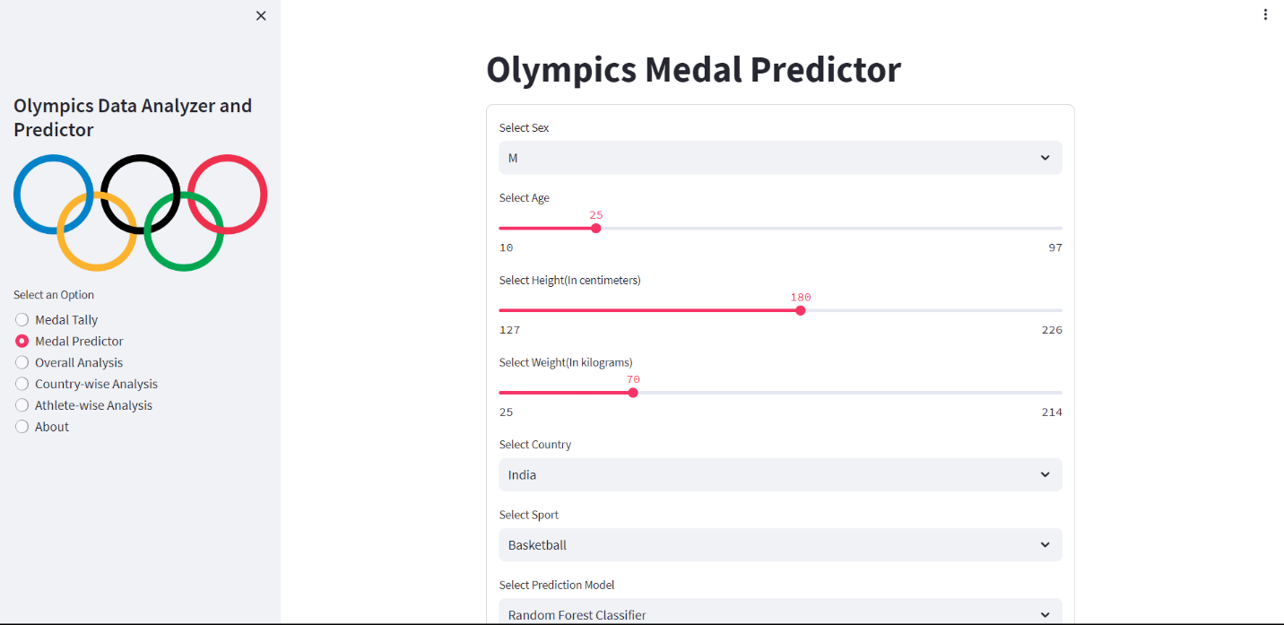

Fig. 4.1. Olympic Medal Predictor

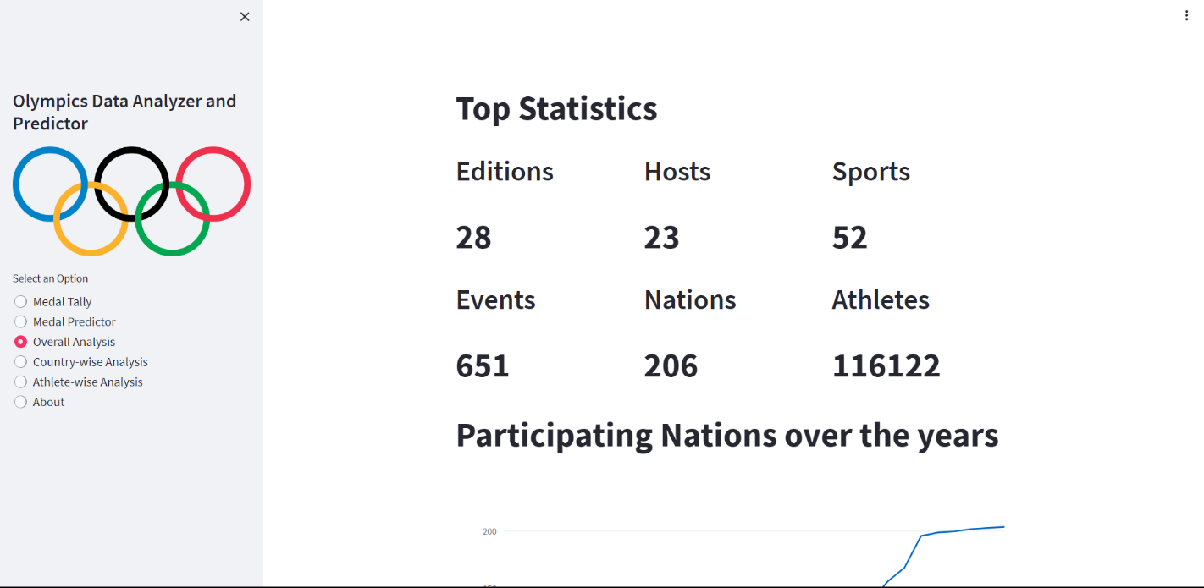

Fig. 4.2. Overall Analysis

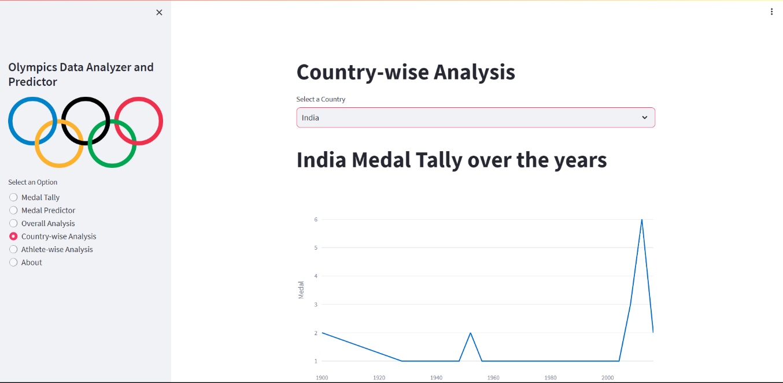

Fig. 4.3. Country-wise Analysis

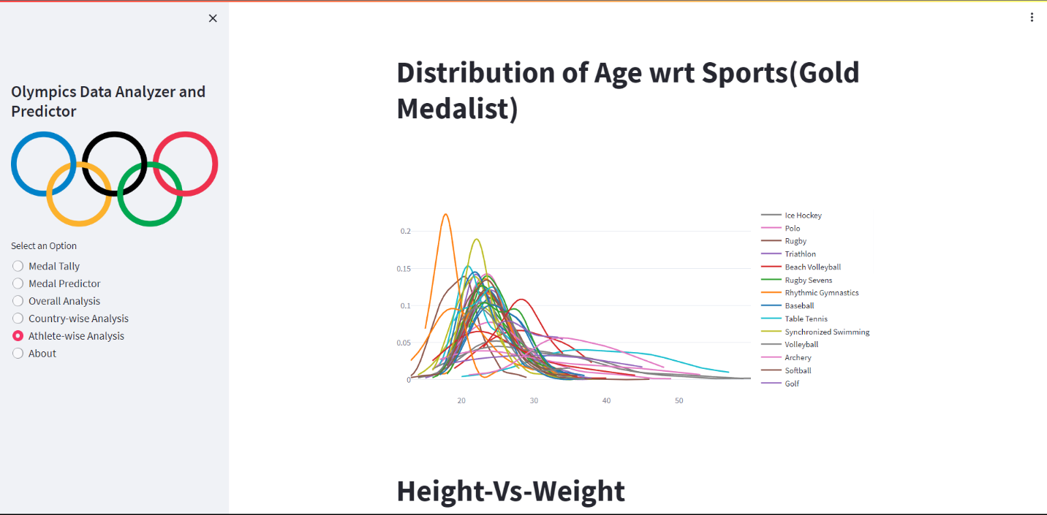

Fig, 4.4. Athlete-wise Analysis

1. **CONCLUSION**

In conclusion, the "Olympics Data Analysis" system represents a powerful and versatile platform meticulously designed to delve into the extensive realm of Olympic data. It harnesses the capabilities of renowned Python libraries, including Pandas, NumPy, Matplotlib, Seaborn, and Plotly, unlocking a world teeming with data-driven insights. The true standout feature of this system is the "Gold Medal Predictor," a sophisticated predictive engine that epitomizes the mastery of machine learning. Its primary mission is to foretell the probability of an individual winning a gold medal at the Olympics, considering attributes such as age, weight, height, country of origin, and chosen sport.

1. **REFERENCES**
2. Sachs, G., 2012. "The olympics and economics 2012". Goldman Sachs Global Economics, Commodities and Strategy Research.
3. Jayantha, K., and Ubayachandra, E., 2015. "Going for gold medals: factors affecting olympic performance". International Journal of Scientific and Research Publi- cations, 5(6), pp. 2250-3153.
4. Shailaja, V., Lohitha, R., Musunuru, S., Reddy, K. D... and Priya, J. P., 2020. "Predictive analytics of perfor mance of india in the olympics using machine learning algorithms". International Journal, 8(5).
5. Schlembach, C., Schmidt. S. L. Schreyer, D., and Wunderlich, L., 2020. Forecasting the olympic medal distribution during a pandemic: a socio-economic ma- chine learning model.
6. Fazlollahi, P., Afarineshkhaki, A., and Nikbakhsh, R. "Predicting the medals of the countries participating in the tokyo olympic games (2020) using the test of net- works of multilayer perceptron (mlp)". Annals of Ap plied Sport Science, pp. 0-0.