Epoch:

Presentation of the set of training (input and/or target) vectors to a network and the calculation of new weights and biases. Note that training vectors can be presented one at a time or all together in a batch.

Baseline correction:

A preprocessing step commonly applied to EEG data to remove or adjust for baseline fluctuations or offsets in the signal. The baseline typically refers to a period of time before the onset of an experimental stimulus or task, during which the brain activity is assumed to be stable and not influenced by the experimental manipulation.

Correlation Coefficients:

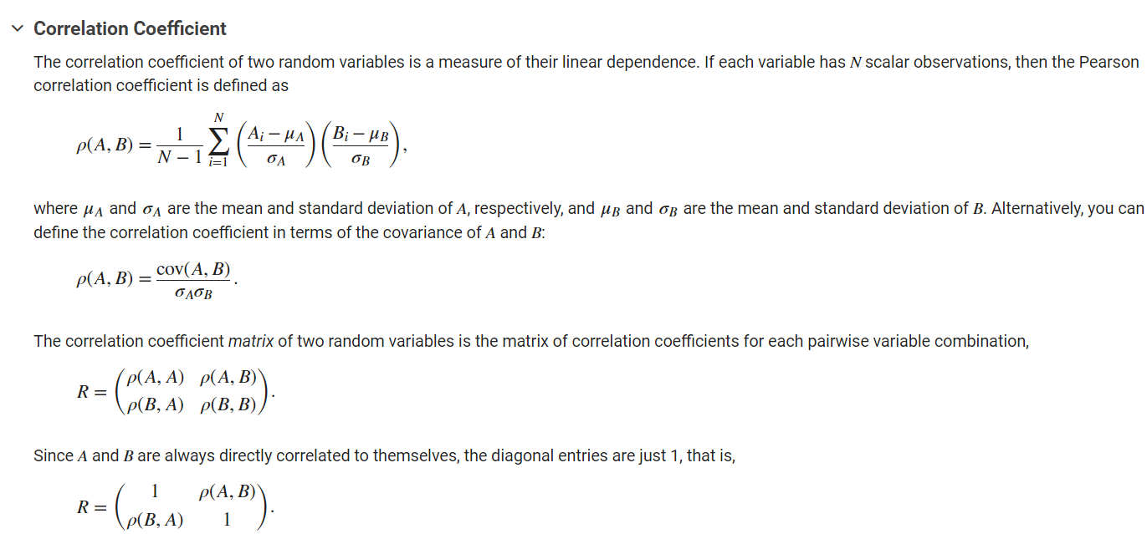

returns the matrix of correlation coefficients for A, where the columns of A represent random variables and the rows represent observations.