VISVESVARAYA TECHNOLOGICAL UNIVERSITY
“Jnana Sangama” Belagavi – 590018
Mini-Project Report on
“Digital clock with FPGA implementation using Verilog”
BACHELOR OF ENGINEERING
IN
ELECTRONICS & COMMUNICATION ENGINEERING
Submitted By
SUPRITHA HR | 4AL23EC101
SURAKSHA S SHETTY | 4AL23EC102
UMARAJ MB | 4AL23EC107
Under the guidance of
Mr. Sudhakara HM
Associate Professor
Dept. of ECE,
Mijar, Moodbidri

Department of Electronics & Communication Engineering
ALVA’S INSTITUTE OF ENGINEERING & TECHNOLOGY
MOODBIDRI – 574227
2025-2026

ALVA’S INSTITUTE OF ENGINEERING & TECHNOLOGY
A Unit of Alva’s Education Foundation (R)
(Affiliated to VTU, Belagavi. Approved by AICTE, New Delhi
& Recognized by Government of Karnataka)
(Accredited by NBA and NAAC with A+) (ECE & CSE)

Department of Electronics & Communication Engineering



CERTIFICATE

This is to certify that the following students,
SUPRITHA HR | 4AL23EC101
SURAKSHA S SHETTY | 4AL23EC102
UMARAJ MB | 4AL23EC107

has submitted Mini Project Report on “Digital clock with FPGA implementation using Verilog” for V Semester B.E. in Electronics & Communication Engineering during the academic year 2025-26. The mini project report has been approved as it satisfies the academic requirements in respect of Mini Project work prescribed for the Bachelor of Engineering Degree.

Mini Project Coordinator
Mr. Hemanth T S

Project Guide
Mr. Sudhakara HM
HOD
Dr. Dattathreya

ACKNOWLEDGEMENT
The project of any research work depends so much on the quality of education received the quality of teachers, research resources and enabling and encouraging environment. Studying in Alva’s Institute of Engineering and Technology mentioned facilities which have made possible the successful outcome of this research work.
We are indebted to Management of Alva's Education Foundation, Moodbidri for providing an environment which helped us in completing our project.
We would like to thank our Principal, Dr. Peter Fernandes for providing all the facilities and a proper environment to work in the college campus.
We sincerely thank, Dr. Dattathreya, Dean (planning) and Head, Department of Electronics & Communication Engineering who has been the constant driving force behind the completion of the project.
Firstly, our gratitude goes to our guide, Mr. Sudhakara HM, Associate Professor. Department of Electronics and Communication, AIET, who is our source of encouragement and motivation throughout this project. Without her valuable guidance, this work would never have been a successful one.
We would like to express our heartily gratitude to our Mini Project coordinator, Mr. Hemanth T S, Assistant Professor, Department of Electronics and Communication, AIET. for his consistent guidance, regular source of encouragement and assistance throughout this project.
We are thankful to all the teaching and non-teaching staff members of Department of Electronics & Communication Engineering for their help and needed support rendered throughout the project.

SUPRITHA HR | 4AL23EC101
SURAKSHA S SHETTY | 4AL23EC102
UMARAJ MB | 4AL23EC107

ABSTRACT
The design and implementation of digital timekeeping systems using FPGA technology have become increasingly relevant in modern embedded applications, where accuracy, reliability, and real-time performance are essential. This report presents a comprehensive overview of a 12-hour digital clock developed using Verilog Hardware Description Language (HDL), emphasizing the complete workflow from simulation to hardware realization. The system employs a modular architecture that integrates key functional blocks, including a Clock Divider for generating a stable 1 Hz pulse, a Digital Clock Core for hour, minute, and second sequencing, a Binary-to-BCD Converter for numerical formatting, and a Seven-Segment Display Driver for real-time output visualization. Debouncing circuits are incorporated to ensure clean and reliable user input handling. Functional verification of each subsystem was carried out exclusively using the Xilinx Vivado simulation environment, ensuring correctness before deployment. Following successful simulation, the design was implemented on the FPGA development board, where it operated accurately under real-time conditions. This project highlights important design considerations such as timing control, modular organization, and hardware-level parallel processing. The completed implementation demonstrates the effectiveness of FPGA-based solutions in developing precise, efficient, and scalable digital systems.

CONTENTS
 | Certificate |  | i
 | Acknowledgement |  | ii
 | Abstract |  | iii
 | Table of contents |  | iv
 | List of Figures |  | vi
 | List of Tables |  | vi
CHAPTER 1 |  | INTRODUCTION
1.1 |  | Introduction | 1
1.2 |  | Motivation | 4
1.3 |  | Organization of Report | 4
CHAPTER 2 |  | LITERATURE SURVEY
2.1 |  | Objective | 12
2.2 |  | Scope of the work | 13
CHAPTER 3 |  | HARDWARE SPECIFICATION
3.1 |  | Hardware specification | 14
CHAPTER 4 |  | METHODOLOGY
4.1 |  | Operational Analysis of the Verilog-Based Digital Clock Design. | 20
4.2 |  | Integrated Functional Operation of the Digital Clock System | 23
4.3 |  | Design and Functional Role of the Seven-Segment Display Unit | 24
4.4 |  | Block diagram | 27
CHAPTER 5 |  | IMPLEMENTATION
5.1 |  | Hardware Integration | 32
5.2 |  | Software implementation | 33
CHAPTER 6 |  | RESULT
6.1 |  | Result and outcome | 34
6.2 |  | Future scope | 37
CHAPTER 7 |  | CONCLUSION | 40
 |  | REFERENCES | 42

LIST OF FIGURES
Figure. No | Description | Page. No
3.1 | Spartan – 6 FPGA Board | 14
3.2  4.1  5.1  6.1 | FPGA board  Seven segment display  Representing zero on the display  Simulation output | 16  25  27  34

LIST OF TABLES
Table. No | Description | Page. No
1 | SUMMARY OF THE LITERATURE REVIEW | 9

CHAPTER 1
INTRODUCTION

- INTRODUCTION
Precise and stable timekeeping is a fundamental requirement across a wide spectrum of embedded and electronic systems, especially those that operate continuously or must respond promptly to real-time events. Critical applications such as industrial automation units, medical monitoring equipment, telecommunication networks, measurement and instrumentation systems, and a variety of consumer electronic appliances—depend heavily on accurate timing signals to maintain reliable coordination and functional integrity. In such environments, even minimal timing errors can disrupt synchronized processes, cause inaccurate data sampling, or result in performance degradation. As industries increasingly shift toward automation, interconnected systems, and smart technologies, the demand for dependable hardware-level timing mechanisms has become more pronounced. Software-based timing techniques, although versatile, often encounter delays and inconsistencies due to processor interference, interrupt routines, and operating system dependencies. These factors reduce timing predictability. Hardware-driven digital clocks, however, deliver deterministic operation, making them more suitable for applications where precision, reliability, and predictable timing behavior are critical.
Field-Programmable Gate Arrays (FPGAs) have emerged as an effective platform for implementing real-time digital systems because of their inherent parallelism, reconfigurable logic structure, and high processing speed. Unlike microcontrollers—where instructions are executed sequentially—FPGAs allow multiple hardware modules to operate concurrently. This architectural advantage enables designers to build real-time systems that can manage several operations simultaneously without compromising timing accuracy. Using Hardware Description Languages (HDLs) such as Verilog, system designers can create a structured and modular design comprising individual blocks like frequency dividers, synchronous counters, debouncing circuits, display drivers, and data-formatting modules. Each of these blocks functions independently but remains synchronized under a single system clock. This structural separation not only enhances clarity and maintainability but also ensures that timing signals remain consistent even as the system interacts with user inputs or updates the display continuously.
A significant strength of FPGA-based timekeeping lies in its reliance on clock-driven, deterministic hardware execution. Since time progression is governed purely by fixed hardware circuits rather than sequential software instructions, the system remains unaffected by computational load, concurrent task execution, or interrupt frequency. This ensures that hours, minutes, and seconds are tracked accurately without any drift caused by unpredictable software delays. Essential auxiliary components, such as input debouncers used for manual time adjustment, eliminate unwanted glitches generated by mechanical switches. Binary-to-BCD conversion units support seamless communication with output modules, enabling the display of human-readable time values. By integrating such dedicated subsystems, the overall digital clock system attains high stability, consistent responsiveness, and improved signal reliability.
Despite the advantages, designing and implementing a digital clock on an FPGA involves several engineering challenges that require careful consideration. The most fundamental challenge arises in generating a precise 1 Hz pulse from a relatively high-frequency crystal oscillator commonly used on FPGA boards. Clock divider circuits must be appropriately designed to handle large counter values, maintain synchronous resets, and satisfy the hardware’s timing constraints. Any mistake in these circuits can result in timing inconsistencies or incorrect pulse generation. Another major challenge pertains to managing signal synchronization across different hardware modules. Since FPGAs follow synchronous design principles, improper handling of signal propagation may lead to hazards such as metastability, timing violations, or unintended logic transitions. Engineers must ensure that all internal signals are properly synchronized to the global clock and that communication between modules follows safe hardware design practices.
In addition to time generation and synchronization challenges, display control mechanisms introduce further complexity. Seven-segment displays, commonly used in digital clock projects, often require multiplexing to reduce hardware resource usage. Multiplexed displays must update individual digits rapidly enough to create a continuous appearance to the human eye. This requires precise timing control to avoid flickering, ghosting, or uneven brightness. Designing a reliable display driver module demands careful management of refresh rates, digit enable signals, and segment decoding. Any delay or mismatch in these processes can significantly affect display clarity and readability.
Simulation and verification form a crucial part of the FPGA development workflow. Since hardware bugs are often time-consuming and challenging to diagnose once implemented on a physical FPGA, pre-deployment simulation ensures early detection of functional errors. Tools such as Xilinx Vivado or Mentor Graphics ModelSim allow designers to test individual modules, view internal signal transitions, verify timing behavior, and evaluate the overall interaction between components. Simulation facilitates the verification of counter increments, pulse generation accuracy, debouncing effectiveness, and display data correctness. Timing analysis features available in FPGA design tools help identify violations related to setup time, hold time, or propagation delays. Thorough verification reduces the likelihood of unpredictable behavior once the design is synthesized and programmed onto the FPGA board.
Beyond basic timekeeping, FPGA-based digital clock designs open opportunities for further enhancements and customization. Due to the reconfigurable nature of FPGA logic, advanced functionalities such as alarms, countdown timers, stopwatch modules, daylight-saving adjustments, or wireless synchronization with external reference clocks can be incorporated without altering physical hardware. Additionally, support for alternative display technologies, such as LCD panels or LED dot matrices, can be integrated by modifying or extending the display driver architecture. Such scalability and adaptability make FPGA-based timekeeping systems suitable for a wide range of modern embedded applications where reliability, precision, and flexibility are essential.
The implementation of a digital clock on an FPGA therefore not only demonstrates the feasibility of hardware-based timekeeping but also provides a practical understanding of important concepts in digital design such as synchronous logic, frequency division, modular architecture, debouncing mechanisms, and real-time display control. By completing the full cycle—from conceptual modeling and coding in Verilog to simulation, synthesis, programming, and hardware testing—designers gain valuable hands-on experience with FPGA development tools and methodologies. The resulting system provides accurate and stable timing output, efficient hardware utilization, and strong performance under real operating conditions.
Overall, FPGA-based digital clock design emphasizes the power of hardware-level computation for real-time applications, showcasing the advantages of determinism, concurrency, and reconfigurability. As technology trends continue to favor intelligent embedded solutions, such hardware-driven approaches are expected to play a significant role in precision timekeeping, synchronized communication, and system coordination across various industrial and consumer domains.

- Motivation
Accurate timekeeping is a key requirement in many embedded applications, and software-based clocks often fail to maintain consistent timing due to processing delays and interrupt overhead. To overcome these limitations, an FPGA-based approach provides a more dependable solution by using dedicated hardware circuits that ensure stable and precise timing. Implementing a digital clock on an FPGA also serves as a practical platform to apply concepts of Verilog HDL, simulation, and digital system design. This project is therefore motivated by the need for a reliable hardware timekeeping system and the opportunity to strengthen understanding of real-time digital design using FPGA technology. Accurate timekeeping is a key requirement in many embedded applications, and software-based clocks often fail to maintain consistent timing due to processing delays and interrupt overhead. To overcome these limitations, an FPGA-based approach provides a more dependable solution by using dedicated hardware circuits that ensure stable and precise timing. Implementing a digital clock on an FPGA also serves as a practical platform to apply concepts of Verilog HDL, simulation, and digital system design. This project is therefore motivated by the need for a reliable hardware timekeeping system and the opportunity to strengthen understanding of real-time digital design using FPGA technology.

- Organization of Report

CHAPTER 1 – INTRODUCTION: Digital timekeeping concepts, the need for precise hardware-based timing, and the motivation for implementing the clock on an FPGA are presented, along with a brief outline of the overall work.

CHAPTER 2 – LITERATURE SURVEY: Previous FPGA-based clock designs, frequency-division techniques, counter structures, and display-driving methods are reviewed, and the objectives and scope of the present project are established.

CHAPTER 3 – HARDWARE SPECIFICATION: The Spartan-6 FPGA board, onboard oscillator, seven-segment display, push buttons, GPIO ports, and programming interface are described, highlighting their relevance to the digital clock design.

CHAPTER 4 – METHODOLOGY : The design flow covering frequency division, time-counter development, seven-segment decoding, module interaction, and the simulation approach used to verify system functionality is explained.

CHAPTER 5 – IMPLEMENTATION : The hardware integration process, including pin assignment, FPGA configuration, display connections, push-button interfacing, and programming of the synthesized design onto the board, is detailed.

CHAPTER 6 – RESULT AND DISCUSSION: Simulation waveforms, hardware outputs, time-count accuracy, display behaviour, performance observations, and identified limitations are presented and discussed.

CHAPTER 7 – CONCLUSION: The successful development, verification, and FPGA implementation of the digital clock are summarised, confirming the achievement of the project objectives and emphasizing the value of hardware-based digital design.

CHAPTER 2
LITERATURE REVIEW
The development of the FPGA-based digital clock in this project was supported by a wide range of research studies that demonstrated effective methodologies, architectural structures, and verification techniques for real-time digital systems implemented on reconfigurable hardware. These works collectively contributed to shaping the design decisions, module organization, simulation strategy, and hardware implementation adopted during the course of the project.
Qian Liu et al. (2003) demonstrated the strong potential of FPGA devices for real-time, high-speed digital processing through their work on a digital mixer architecture. Although their study did not focus on a clock system, the principles they presented—such as efficient hardware-level computation, precise frequency generation, and seamless integration of filtering operations—highlighted the strengths of FPGAs in handling continuous and timing-critical tasks. Their emphasis on parallel processing capability and reconfigurable hardware directly supported the decision to employ an FPGA platform for this project. The reliable real-time performance shown in their design reinforced confidence in using FPGA-based implementations for accurate and uninterrupted timekeeping functions.
Kong et al. (2009) provided insight into highly precise FPGA-based clock synchronization for distributed systems, achieving sub-200-nanosecond accuracy without specialized hardware. This study emphasized the inherent timing precision achievable on FPGA devices, particularly when synchronous logic and broadcast-based timing corrections are used. Their focus on clock stability, synchronization accuracy, and reduction of system overhead directly aligned with this project’s requirement for stable second-pulse generation and reliable timekeeping under continuous operation.
Zhu et al. (2011) contributed a well-defined top-down design perspective through their implementation of a digital clock using VHDL. Their architecture separated the system into functional modules such as frequency dividers, timekeeping counters, display controllers, and adjustment circuits, similar to the modular design structure followed in this project. Their work demonstrated the value of dividing complex systems into manageable units and thoroughly verifying each part before integration—an approach that was closely followed throughout the simulation and implementation stages of this project.
Deepa Singh (2017) investigated an energy-efficient methodology for designing FPGA-based digital clocks by optimizing power consumption through the use of the LVCMOS25 I/O standard. Her work analysed how variations in output load capacitance and operating frequency affect total dynamic and static power within Virtex-6 FPGA devices. By measuring the contributions of clock power, logic power, signal power, I/O power, and leakage power, the study demonstrated substantial reductions—often exceeding 80–99%—when lower output load values were applied. The design was modeled and simulated in Verilog using Xilinx tools, emphasizing the role of hardware-level parameter selection in achieving power-efficient digital circuitry. Singh’s focus on low-power design principles provides useful insight for developing energy-conscious FPGA-based timing systems and highlights the importance of I/O standard optimization in digital clock implementations.
Revati Muley, Bhushan Patil, and Rabinder Henry (2017) presented a detailed FPGA-based design approach for implementing a digital clock integrated with stopwatch functionality. Their study evaluated two different HDL coding techniques, offering a comparative analysis of how each method affects timing performance, hardware utilization, and implementation efficiency. The authors emphasized the flexibility of reconfigurable FPGA platforms, demonstrating how a single architecture can be adapted for multiple timing-related applications with minimal structural changes. The design was fully implemented and experimentally verified on a test board, confirming stable real-time operation of both the clock and stopwatch units. Their focus on practical hardware validation and comparative methodology provides meaningful technical insight that supports the structured, modular approach adopted in the present work.
Bhavani et al. (2019) offered significant insight into implementing multi-function digital clock systems using Verilog HDL on FPGA platforms. Their design incorporated multiple features—such as stopwatch functionality, lap timing, and alarm mechanisms—while maintaining accurate hour-minute-second sequencing through a synchronous modular architecture. The emphasis on clear module partitioning for the clock core, display interface, and control logic directly influenced the structured approach used in this project. Their demonstration of low-latency real-time operation also reinforced confidence in using FPGAs for concurrent timing processes without performance degradation.
Jamuna and Jayashree (2024) proposed an enhanced watchdog timer architecture implemented entirely on FPGA to improve the reliability of systems operating in safety-critical environments. Their design replaced traditional software-based monitoring with a dedicated hardware module capable of detecting system faults, timing deviations, and processor failures with higher accuracy. The architecture leveraged FPGA features such as parallel processing and high-speed logic to achieve rapid fault identification, consistent monitoring, and robust fault-tolerant behaviour. The system’s modular organization and real-time hardware execution enabled reliable supervision of processor activity without compromising performance. Experimental hardware validation demonstrated stable operation, efficient resource utilization, and dependable fault-detection capability, underscoring the suitability of FPGA-based watchdog circuits for secure and resilient embedded applications. The rigorous methodology and emphasis on hardware-level monitoring techniques provide meaningful guidance for incorporating safety mechanisms into FPGA-based designs such as the one developed in this project.
Sandhya et al. (2025) presented a practical FPGA-based digital clock design developed using Verilog HDL, emphasizing a clear and modular approach to timekeeping on reconfigurable hardware. Their work focused on generating stable timing signals, implementing structured hour–minute counters, and driving seven-segment displays through combinational decoding logic. The project demonstrated how basic digital building blocks—such as clock dividers, counter circuits, and display interfaces—can be effectively integrated to produce a reliable real-time clock system. The authors also highlighted the role of manual input controls and reset mechanisms in enhancing user interaction and functional accuracy. This systematic methodology and emphasis on hardware-level timing accuracy directly support the design principles adopted in the present work.
Kherde et al. (2025) presented a fully hardware-based digital clock integrated with stopwatch functionality, implemented using Verilog HDL on an FPGA platform. Their design combined a precise 1 Hz clock divider, a cascaded hour–minute–second counter, and an FSM-controlled stopwatch unit to achieve accurate timekeeping and responsive user control. The work emphasized modular structuring of the clock core, stopwatch logic, and display interface, ensuring reliable real-time behaviour and clean synchronization across all timing modules. Their synthesis and timing analysis demonstrated highly efficient hardware utilization, zero timing violations, and low power consumption, reinforcing the suitability of FPGA devices for compact, scalable, and reconfigurable time-measurement systems. The robust methodology and emphasis on parallel hardware execution provide a strong foundation for designing digital timing systems similar to the one developed in this work.
Reddy et al. (2025) designed a hardware-based digital clock system implemented on an FPGA using Verilog HDL. Their architecture incorporated a structured frequency divider, cascaded hour–minute–second counters, and a dedicated seven-segment display driver to achieve precise and continuous timekeeping. The design followed a modular approach, separating the clock division, timing counters, and display interface to ensure stable real-time operation and clean synchronization across all logic modules. Implemented on a Xilinx FPGA using the Vivado Design Suite, the system demonstrated accurate timing behaviour, reliable hardware performance, and efficient utilization of on-chip resources. The results highlight the suitability of FPGA technology for creating reconfigurable, low-power, and dependable digital timekeeping systems, providing valuable methodological support for developing hardware-based clock designs similar to the one undertaken in this project.
TABLE 1. SUMMARY OF THE LITERATURE REVIEW
Author | Year | Title | Description
Qian Liu et al. | 2003 | Synthesis of a 12-bit complex mixer | Although focused on signal processing, this study highlighted the high performance, flexibility, and reconfigurability of FPGAs—qualities essential to the present project. Their demonstration of real-time hardware efficiency supported the decision to implement a fully hardware-based digital clock rather than a microcontroller-dependent version.
Kong et al. | 2009 | Precision clock synchronization | This research emphasized the accuracy and stability achievable through FPGA-based timing systems. Its findings reinforced the importance of precise timing logic, which was essential in designing the stable 1 Hz clock and synchronous modules used in the completed digital clock project.
Zhu et al. | 2011 | Digital clock system design | The modular and top-down design approach presented in this study closely aligned with the structure adopted in the project. Concepts such as frequency division, display control, and time adjustment were directly relevant and helped shape the architecture used in the final implementation. Their successful FPGA validation reinforced confidence in the methods applied.
R. Muley et al. | 2017 | Design of digital clock with stopwatch | The comparative study of coding techniques helped in selecting efficient design practices for this project. Their experimental verification demonstrated the reliability of FPGA-based timekeeping, supporting the approach taken in this completed design. The proven benefits of reconfigurability and portability influenced the decision to use FPGA hardware for the project.
Deepa Singh et al. | 2017 | FPGA based Green Digital Clock Design for Network Synchronization using LVCMOS I/O Standard | This work offered valuable guidance for implementing modular and synchronous digital clock architectures on FPGA platforms. The authors’ use of structured Verilog design practices, coordinated multi-digit display driving, and accurately controlled timing logic directly informed the development approach adopted in this project. Their emphasis on maintaining real-time precision and supporting concurrent operations further validated the design strategies employed in constructing the FPGA-based digital clock system
Bhavani et al | 2019 | Implementation of Digital Clock with Stopwatch on FPGA | This work provided a strong foundation for understanding modular and synchronous clock design on FPGA platforms. The techniques used—such as structured Verilog coding, multi-digit display control, and precise timing logic—guided the development of this project. The emphasis on real-time accuracy and concurrency validated the design choices implemented in the completed digital clock system.
M. Jamun et al. | 2024 | FPGA Implementation of an Improved Watchdog Timer for Safety Critical Applications | This work presents the design of an enhanced watchdog timer on FPGA aimed at improving system reliability in safety-critical applications. The authors implemented a hardware-based monitoring mechanism capable of detecting system faults, timing failures, and processor malfunctions with greater accuracy than traditional software watchdogs. Their use of FPGA resources enabled faster response times, concurrent fault detection, and improved fault-tolerant performance. The reliability demonstrated through hardware verification supports the importance of dedicated FPGA-based safety modules in modern embedded systems.
Kherde et al. | 2025 | Digital Clock with Stopwatch Functionality | developed a fully hardware-based digital clock with integrated stopwatch functionality using Verilog HDL on an FPGA. Their design employed a precise 1 Hz divider, cascaded time counters, and an FSM-driven stopwatch to ensure accurate timekeeping and responsive control. By modularizing the clock core, stopwatch logic, and display interface, the system achieved clean synchronization and reliable real-time performance. Synthesis results showed efficient resource usage, zero timing violations, and low power consumption, confirming the suitability of FPGAs for compact and scalable timing systems. Their methodology provides a strong reference for similar digital clock designs.
Sandhya et al. | 2025 | Digital clock using FPGA | The comparative analysis of different coding techniques provided valuable insight into selecting efficient design practices for this project. Their experimental validation confirmed the reliability and consistency of FPGA-based timekeeping, thereby supporting the methodology adopted in the present work. Furthermore, the demonstrated advantages of reconfigurability and portability reinforced the decision to implement the system on FPGA hardware.
K. S. Reddy | 2025 | Digital Clock Using Verilog HDL | The project Digital clock using HDL focuses on designing and implementing a fully functional digital clock on an FPGA platform using hardware description language. The authors developed a modular clock architecture that includes a frequency divider, counters for hours, minutes, and seconds, and a display driver for showing the time on seven-segment displays. The system was implemented using Xilinx FPGA devices and developed through the Vivado Design Suite, ensuring accurate timing, stable performance, and efficient hardware utilization. The work demonstrates how Verilog HDL can be used to build reliable, reconfigurable digital systems and highlights the practical application of FPGA technology in real-time timekeeping systems.

- Objective
- To design and implement a complete 12-hour digital timekeeping system using Verilog HDL on an FPGA platform, ensuring reliable real-time operation.
- To generate a stable 1 Hz clock signal from the high-frequency onboard oscillator through an efficient frequency-division mechanism for accurate time progression.
- To develop sequential counters for hours and minutes that maintain correct rollover behavior and ensure continuous, error-free time counting.
- To incorporate a four-bit manual time-adjustment control, enabling users to modify hour and minute values whenever required without disrupting system operation.
- To implement combinational decoding logic for driving four seven-segment displays, providing clear and readable visual representation of the current time.
- To include a reset mechanism that initializes all registers and restores the clock to its starting state for stable and predictable system behavior.
- To achieve a complete hardware-based real-time clock demonstrating precise timing control, correct display interfacing, and efficient utilization of FPGA resources.
- To follow a structured digital design methodology integrating design, simulation, synthesis, and hardware verification to ensure functional correctness and system reliability.
- Scope of the work
The scope of this work extended across the complete development cycle of an FPGA-based digital time display system, covering conceptual planning, RTL coding, simulation, verification, and physical implementation. It involved utilizing the available FPGA hardware resources to derive a reduced-frequency timing signal suitable for real-time operation, followed by establishing a structured counting mechanism to maintain the progression of hours and minutes in a 12-hour format. The work also included incorporating user interaction features through manual adjustment inputs, allowing modification of individual time digits without disturbing the overall operation. Another major component within the scope was the creation of tailored seven-segment decoding logic, enabling each time digit to be translated into its corresponding visual pattern on the display.
Beyond core functional design, the scope included rigorous simulation to evaluate system behavior under various timing and control conditions, synthesis to translate RTL code into hardware-mapped structures, and implementation steps such as place-and-route to ensure proper utilization of FPGA resources. The final phase of the scope involved hardware-level testing to validate real-time performance, responsiveness to inputs, display clarity, and reliable long-duration operation. Additionally, the work enabled analysis of FPGA timing characteristics, resource consumption, and structural organization of the digital logic. Overall, the scope embraced a complete hardware design cycle, integrating theoretical digital design concepts with practical FPGA-based execution and verification.

CHAPTER 3
HARDWARE SPECIFICATION
- Spartan-6 FPGA Development Board

The primary hardware platform employed for this work was a Xilinx Spartan-6 FPGA board. This device provided the reconfigurable logic fabric required to synthesize and execute the Verilog-based design. It also supported the necessary digital input/output interfaces for controlling the seven-segment display and processing user inputs. The FPGA’s internal architecture enabled parallel execution of counters, clock-divider circuits, decoding logic, and control paths essential for real-time timekeeping.
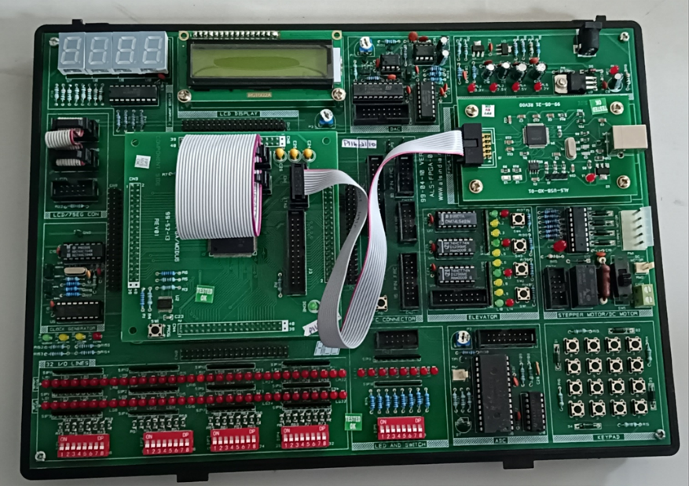

Figure 3.1: Spartan – 6 FPGA Board
The trainer kit shown in the image is a comprehensive digital and embedded systems development platform that integrates a wide range of hardware modules to support experiments involving microcontrollers, FPGAs, programmable logic, and peripheral interfacing. At the top-left portion, the board hosts a multi-digit seven-segment display, which is primarily used for showing numerical outputs such as time values, counter readings, or processed sensor data. Adjacent to it is a 16×2 character LCD module, enabling the display of text-based information, system messages, and debugging results with greater flexibility than the seven-segment display. These display units collectively support both graphical and alphanumeric visualization of program outputs.
Centrally positioned on the board is the main microcontroller or FPGA socket, which serves as the core processing unit of the kit. This socket is accompanied by a ribbon-cable programming header, allowing external programmers or emulators to interface with the system for code uploading, device configuration, and real-time debugging. Surrounding this primary region are port expansion connectors, providing access to general-purpose input/output pins for connecting additional modules, sensors, or custom circuitry. This arrangement allows students and developers to extend the board’s functionality without redesigning the base hardware.
The top-right section contains the regulated power supply circuitry, including voltage regulators, filter capacitors, and DC input connectors. This subsystem ensures that all components on the board receive a stable and noise-free supply voltage, which is essential for reliable digital operation. Beside the power circuitry are communication interfaces, typically RS-232, USB-to-serial converters, or UART connectors, enabling data exchange between the board and a computer or other external devices. These interfaces support activities such as serial communication experiments, real-time monitoring, and data logging. Additionally, the presence of non-volatile memory chips, such as EEPROM or Flash ICs, allows storage of configuration data, calibration values, lookup tables, or program code that must persist even after power cycling.Toward the lower region, the trainer kit includes a structured array of DIP switches, which allow users to manually provide binary inputs to the system. These are particularly useful for testing logic circuits, selecting modes of operation, or adjusting parameters without modifying the hardware design. Parallel to these switches is a row of LED indicators, which provide immediate visual feedback of system outputs, logic states, or the response of implemented circuits. This real-time indication is vital during debugging, as users can verify the correctness of their programs or hardware logic simply by observing LED patterns.
On the right side, the board features a matrix of push-button switches, functioning as a user interface for tasks such as setting values, generating interrupts, starting or stopping timers, or controlling state machine transitions. These tactile switches support experiments in debouncing, input capture, and interactive control. Nearby, the board incorporates relay driver circuits, enabling connection to electromechanical devices such as motors, buzzers, or solenoids. These circuits provide isolation and adequate current-driving capability when interfacing low-power digital logic with higher-power external loads.In addition, the trainer kit often integrates ADC (Analog-to-Digital Converter) and DAC (Digital-to-Analog Converter) modules that facilitate mixed-signal experimentation. These sections allow the system to read analog sensor signals or generate analog waveforms, making the board useful for subjects such as instrumentation, signal processing, and control systems. Furthermore, the presence of an onboard crystal oscillator ensures that the kit receives a stable and accurate system clock, which is crucial for synchronous digital operations and timing-based experiments.
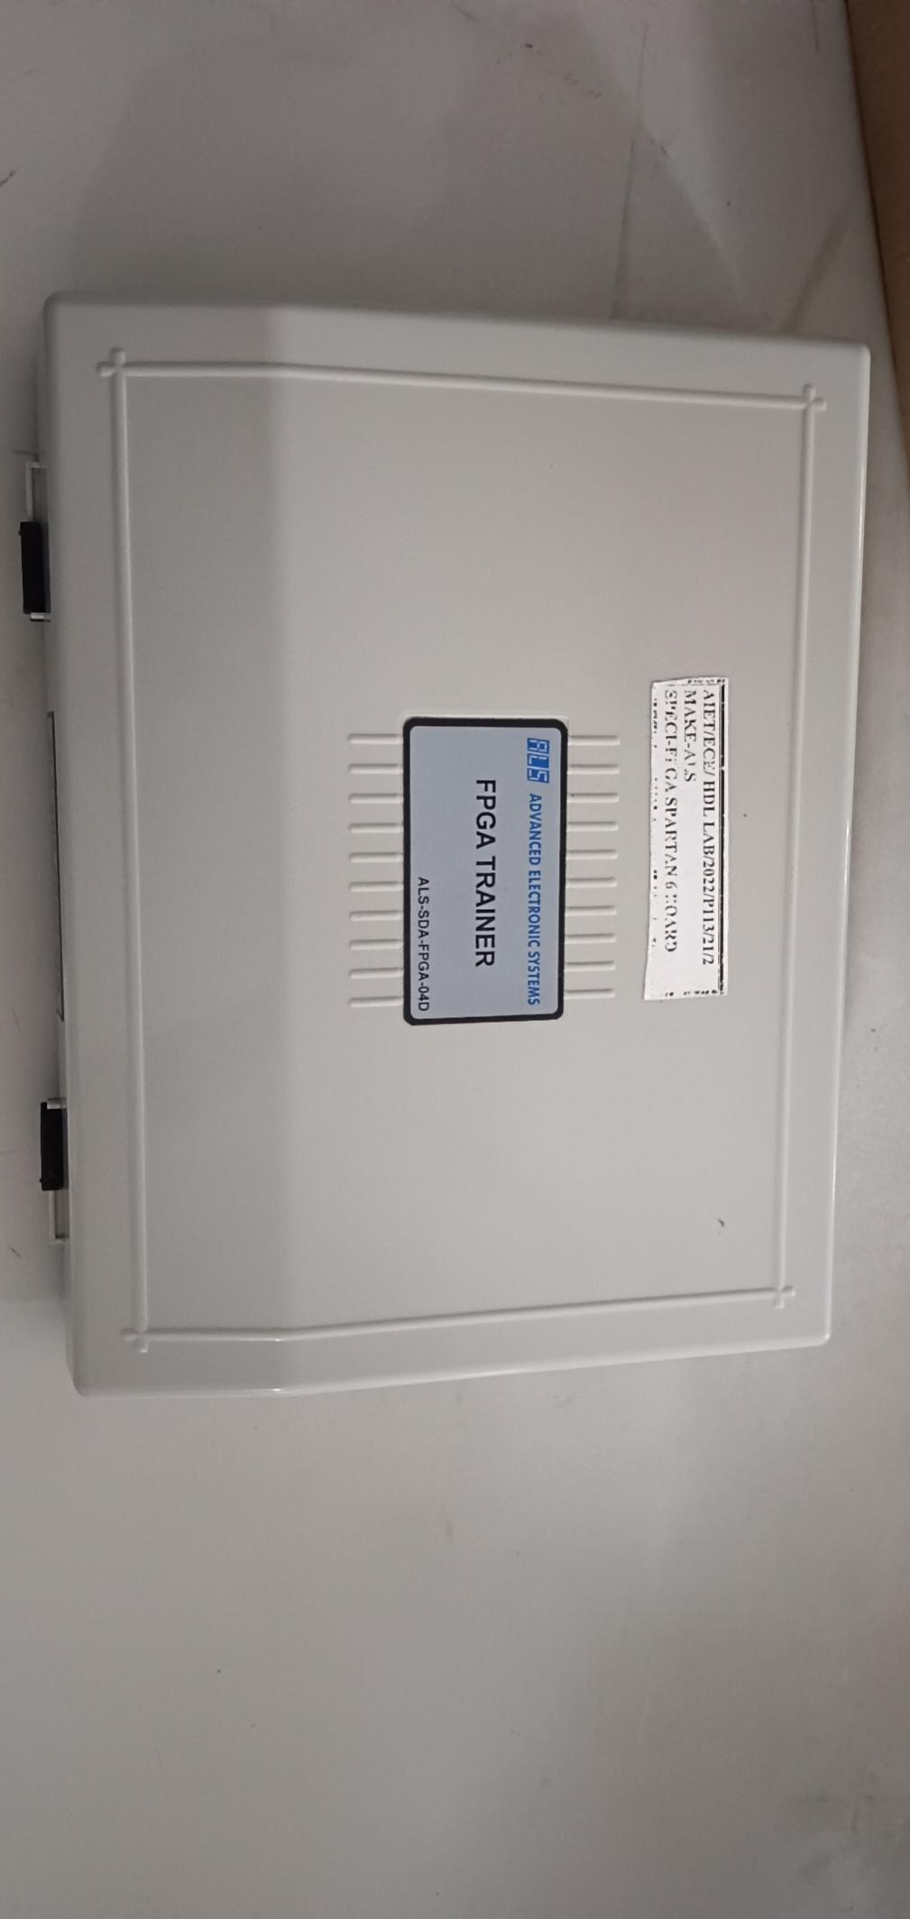
Overall, the trainer kit is designed to provide an extensive, all-in-one platform for academic laboratories and embedded system learners. Its combination of display modules, programmable sockets, communication interfaces, input/output arrays, and power management circuits enables users to practically implement and observe digital logic, microcontroller programming, and real-time embedded applications in a structured and highly interactive manner.
Figure 3.2: FPGA Board

- Onboard Crystal Oscillator (50 MHz)
A high-frequency, board-mounted crystal oscillator served as the system’s master clock source. This oscillator generated the initial clock signal (typically 50 MHz), which was subsequently divided down in hardware to produce a stable 1 Hz pulse. This divided signal acted as the fundamental timing reference for second, minute, and hour transitions within the clock logic.
- Four-Digit Seven-Segment Display Module
The visual output was provided through a four-digit multiplexed seven-segment LED display, interfaced directly with the FPGA’s GPIO pins. Each digit represented a specific part of the HH:MM format, while individual segment lines (a–g) were driven by combinational decoding logic. Digit-enable lines controlled the multiplexing mechanism, allowing all four digits to be displayed using shared segment connections without additional hardware.
- Onboard Push Buttons and Slide Switches
The Spartan-6 development board includes user-interactive push buttons and switches that were utilized for control inputs. These components enabled manual adjustment of the clock through the 4-bit set interface and provided a dedicated reset function. Their integration allowed users to modify the displayed time and reinitialize the system without altering the underlying hardware configuration.
- Power Supply and USB Programming Interface
The USB interface served as a crucial communication and power link between the host computer and the Spartan-6 FPGA board. In addition to supplying regulated power for the operation of the board’s internal components, the USB connection provided a reliable channel for transferring the synthesized bitstream generated in the Xilinx ISE Design Suite. This transfer was performed through the USB-to-JTAG programming circuitry present on the development board, which enabled the precise configuration of the FPGA’s internal logic resources according to the implemented Verilog design.Beyond initial programming, the USB interface also supported ongoing interaction during the hardware verification phase. It allowed the development environment to communicate continuously with the FPGA, enabling real-time testing, monitoring, and iterative reprogramming whenever modifications to the design were required. This capability was essential for validating the behavior of counters, clock-divider circuits, and display-driving logic under practical operating conditions. The interface further ensured stable data transfer, minimized latency during configuration, and provided a dependable means of debugging the system without the need for external programmers or specialized hardware tools. Overall, the USB interface functioned as both a power source and a versatile programming medium, facilitating a smooth and efficient hardware development workflow.
- General-Purpose Input/Output (GPIO) Ports
GPIO pins on the Spartan-6 board were used to connect the FPGA core logic to external components such as the seven-segment displays and user-control switches. These ports facilitated signal routing between internal logic blocks and the peripheral hardware required for functional operation.
- Development Computer System
A host computer configured with the Xilinx ISE Design Suite played a central role in the entire development workflow of the digital clock system. This software environment provided a unified platform for writing and organizing Verilog HDL source files, ensuring that each functional module—from the clock divider to the seven-segment driver—was developed in a structured and modular manner. The ISE suite also facilitated comprehensive simulation using its integrated ISim tool, which allowed the design to be evaluated under various test scenarios before hardware deployment. Through waveform visualization and timing analysis features, it was possible to verify signal transitions, detect logical inconsistencies, and refine the behavior of the clock and counter circuits.
Beyond functional simulation, the host computer executed the synthesis and implementation processes required to translate the Verilog code into a hardware-ready configuration. The synthesis engine mapped the HDL description onto the resources of the Spartan-6 FPGA, followed by place-and-route operations that optimized the design for area, timing, and performance. The resulting bitstream file was then generated and programmed onto the FPGA using the device configuration tools included within the ISE environment. Throughout the development process, the computer system also supported iterative debugging, timing optimization, and post-implementation verification, making it an essential component for achieving a correct and reliable hardware realization of the digital clock.

CHAPTER 4
METHODOLOGY
This chapter describes the systematic procedure followed to design, verify, and implement a 12-hour digital clock on an FPGA platform using Verilog Hardware Description Language. Since the project was developed using Xilinx software tools and tested on an FPGA development board, the methodology emphasizes modular hardware design, simulation-based validation, and real-time hardware experimentation. The approach ensures that the system is reliable, scalable, and capable of accurate timekeeping.
The methodology adopted in this work followed a structured FPGA design flow, beginning with the identification of functional requirements and ending with the final hardware verification on the FPGA board. The first step involved understanding the behaviour of a 12-hour digital clock and determining how its timing, counting, and display functions could be realized using digital logic. Based on this understanding, the internal clock available on the FPGA was selected as the primary time reference, and a frequency-division strategy was formulated to obtain a 1 Hz pulse suitable for real-time operation.
Once the timing foundation was established, the next stage focused on designing the logic required for time progression, including hours and minutes counting, rollover conditions, and manual adjustment through external inputs. The design was translated into Verilog HDL using a modular and sequential coding approach to ensure clarity, scalability, and proper synchronization between all components. After the RTL description was completed, simulation was carried out using Xilinx ISE’s simulation environment to observe signal behaviour, validate counter transitions, and confirm the correctness of the seven-segment outputs.
With the simulated behaviour matching the expected performance, the design moved through synthesis, mapping, and implementation steps within the Xilinx ISE toolchain. During this stage, the design was converted into hardware-optimized structures and assigned to specific resources inside the FPGA. The resulting bitstream file was then loaded onto the FPGA board to conduct hardware-level testing. Real-time verification included observing the clock output, checking rollover behaviour, confirming manual adjustment responses, and assessing display accuracy and stability during continuous operation.
Overall, the adopted methodology ensured an organised progression from theoretical logic design to practical hardware implementation, combining digital system principles, HDL-based modelling, iterative simulation, and FPGA deployment to realise a fully functional 12-hour digital clock.
- Operational Analysis of the Verilog-Based Digital Clock Design:
1. Module header and I/O
- module digi_clock(); declared the design’s interface.
- clk_inbuilt was the FPGA board clock input.
- Set [3:0] provided four manual adjustment control.
- reset was an asynchronous initialize signal.
- D_M2, D_M1, D_H2, D_H1 were 7-bit outputs driving the seven-segment patterns for minute LSB, minute MSB, hour LSB, and hour MSB respectively.
- This I/O defined how the hardware interacted with external buttons and the display.
2. Internal registers and counters
- Registers for digit storage:
- reg [3:0] M2; — minute LSB (0–9).
- reg [2:0] M1; — minute MSB (0–5).
- reg [1:0] H2; — hour LSB (0–3).
- reg [1:0] H1; — hour MSB (0–2).
- Clock toggles and intermediate clocks:
- clk_1hz, clk_m1, clk_m2, clk_h1, clk_h2 served as derived clocks used to step digits at different rates.
- Division counters:
- counter1, counter5 (28-bit) were used to count input clock cycles and to produce the derived clocks by comparing against thresholds.
- These registers stored the current time digits and produced slower timing signals from the fast FPGA clock.
3. Initial block (startup values)
- The initial block set M1, M2, H1, H2 to 0 at simulation start.
- This ensured that simulation began from a known state (00:00) prior to any reset or input activity.
4. Clock divider to generate clk_1hz
- The always block always @ (posedge clk_inbuilt or posedge reset) implemented a frequency divider:
- On reset, clk_1hz and counter1 were reset to zero.
- Otherwise counter1 incremented each clk_inbuilt rising edge.
- When counter1 == 27'd5000000 the counter reset and clk_1hz was toggled (clk_1hz <= ~clk_1hz).
- Effect in operation: This converted the fast clk_inbuilt into a much slower timing reference (clk_1hz). The comparator value in the code determined the rate; with the appropriate clk_inbuilt frequency the routine generated a ~1 Hz reference used for timekeeping in the design.
5. Generation of per-digit sub-clocks (clk_m2, clk_m1, clk_h2, clk_h1)
- Each derived clock had its own always block triggered at posedge clk_1hz :
- Example for clk_m2:
- If reset → clk_m2 and counter2 were cleared.
- If set [0] was not asserted, counter2 incremented and when it reached 27'd30 it reset and toggled clk_m2.
- If set [0] was asserted, clk_m2 toggled immediately on each clk_1hz edge and counter2 was cleared.
- Purpose & behaviour:
- Each clk_was a slower clock used to increment the corresponding digit. The threshold values (30, 300, 1800, 18000 in your code) controlled the relative rates so that lower-order digits changed more frequently than higher-order digits.
- When a set bit was asserted, the corresponding clk toggled every clk_1hz to allow manual rapid adjustment of that digit without additional logic.
6. Synchronous counting of digits
- Each digit counter incremented on the positive edge of its specific clk_:
- always @ (posedge clk_m2) incremented M2 from 0 up to 9, then reset to 0.
- always @ (posedge clk_m1) incremented M1 from 0 up to 5, then reset to 0.
- always @ (posedge clk_h2) incremented H2 from 0 up to 3, then reset to 0.
- always @ (posedge clk_h1) incremented H1 from 0 up to 2, then reset to 0.
- How counting produced a clock:
- The carefully chosen sub-clock rates made M2 cycle through 0–9 at the fastest pace, M1 through 0–5 at the next pace, and hours through their respective ranges at slower paces — together these counters produced valid minute and hour progression in a 12-hour format.Reset behaved by clearing the sub-clock counters earlier, so digit registers returned to known values when reset was asserted.
7. Seven-segment decoding
- Four always @() combinational blocks mapped binary digit values to 7-segment patterns:For example, for M2:
- 4'b0000: D_M2 = 7'b1111110; mapped 0 to its segment pattern.
- 4'b0001: D_M2 = 7'b0110000; mapped 1, and so on up to 9.
- Interpretation:
- Each 7-bit vector represented segments a–g. The assigned patterns determined which LED segments lit for each digit.
- Because this logic was purely combinational, display outputs updated immediately whenever digit registers changed.
8. Manual adjustment using set input
- Each set[i] bit controlled whether its corresponding derived clock used the slow counted toggle or an immediate toggle on each clk_1hz edge.
- While a set bit was high, its corresponding clk_ toggled faster (on each clk_1hz) so the associated digit advanced rapidly for manual setting.
- This provided a simple, hardware-friendly way to increment individual digits without adding complex state machines or multiplexed setter logic.
9. Reset behaviour
- reset was included in each clock-derivation always block as or posedge reset:
- On reset being asserted, all derived clocks’ internal counters were cleared and the toggles were set to 0.
- Digit registers were initialized by the initial block at simulation start and were effectively put back into a known state on reset during hardware operation.Reset provided a reliable initialization mechanism for the whole design and restored operation to a known state when required.
10. Testbench (tb_digi_clock) and verification
- Clock generation in the testbench:
- clk_inbuilt toggled every #50 (100 ns period → 10 MHz in simulation), feeding the design input.
- reset was asserted and released to test initialization.
- set bits were toggled to verify manual adjustment behaviour.
- The testbench ran long enough to observe the counting and display outputs; monitor printed values throughout simulation.
- The testbench confirmed that the 1 Hz toggle generation, the derived sub-clocks, digit increments, and the 7-segment outputs all behaved as intended before any hardware programming.

- Integrated Functional Operation of the Digital Clock System

The complete functioning of the digital clock emerged from the coordinated operation of several interdependent hardware blocks, each performing a specific role in the overall design. The internal FPGA clock (clk_inbuilt), which operates at a high frequency, served as the primary time source. Since real-time counting requires a one-second interval, this fast clock was first processed through a frequency-divider circuit that reduced it to a stable 1 Hz signal (clk_1hz). This 1 Hz pulse acted as the master timing reference and determined how often the system updated the displayed time. Once this base timing was established, the design generated additional sub-clocks—clk_m2, clk_m1, clk_h2, and clk_h1—each derived from the 1 Hz signal but operating at different speeds. These sub-clocks were responsible for advancing the lower and higher digits of the minutes and hours counters. The digit counters incremented synchronously on the rising edges of their respective derived clocks, ensuring that the minute LSB changed most frequently, the minute MSB changed once every ten-minute cycle, and the hour digits progressed only after the minute cycles completed, thereby maintaining perfect alignment to the 12-hour format. Each counter included rollover logic, which reset a digit to zero when it reached its maximum value and automatically transferred control to the next higher digit, allowing the time to progress smoothly and accurately without manual intervention.
As the counters updated their values, the new binary contents were fed directly into the seven-segment decoder units. These decoders translated each binary digit into the correct seven-segment LED pattern, illuminating the appropriate combination of segments to visually represent the time on the display. This process occurred continuously and instantaneously, enabling real-time observation of the clock output. User inputs played a significant role in enhancing functionality: the reset signal immediately cleared the counters and internal dividers, reinitialising the display and restarting the timing cycle, while the four-bit set input allowed manual modification of any specific digit. When a particular set bit was activated, the corresponding sub-clock toggled at a faster rate, allowing that digit to increment rapidly until the user released the input. This provided a simple yet effective mechanism for adjusting the displayed time without affecting the other digits. Through the combined action of clock division, synchronous counting, real-time decoding, and user-controlled adjustment, the system functioned as a fully operational digital clock capable of precise timing, clear display output, and intuitive user interaction.
- Design and Functional Role of the Seven-Segment Display Unit:
In this digital clock design, the seven-segment display served as the primary visual interface for presenting the current time in the HH:MM format. Four individual seven-segment units were used, each dedicated to one digit of the hour or minute value. These four displays corresponded to the hour MSB (H1), hour LSB (H2), minute MSB (M1), and minute LSB (M2), enabling a clear and continuous representation of the time as it progressed.
Each time digit in the design was stored as a binary value inside dedicated registers (H1, H2, M1, and M2). However, these binary values cannot directly drive a seven-segment display, since the display requires a specific combination of illuminated segments to represent each decimal number. To bridge this gap, the design incorporated combinational decoding logic for each digit, implemented using always @() blocks. These decoders converted the binary counter outputs into the corresponding 7-bit segment patterns required by the display hardware.
In the implementation, each digit had its own decoder block—for example, the minute LSB (M2) used a case statement that mapped values 0–9 to predefined 7-bit patterns such as 7'b1111110 for 0 and 7'b0110000 for 1. These patterns directly controlled segments a through g of the seven-segment unit. Since the decoding logic was fully combinational, the visual output updated instantly whenever the counter values changed, ensuring that the displayed time always reflected the internal state of the clock.
Unlike multiplexed display systems, this design assigned a separate seven-segment output bus (D_H1, D_H2, D_M1, and D_M2) to each digit, eliminating the need for rapid switching or refresh cycles. This simplified the display interface and made the behaviour predictable and stable on hardware. Furthermore, because the FPGA outputs used a common-cathode style encoding, each segment was activated by driving a logical high to illuminate the corresponding LED segment.Overall, within this work, the seven-segment display acted as the final stage of the digital clock system, transforming binary counter values into human-readable numerical digits. Its integration with the counter and decoder logic ensured a smooth, accurate, and real-time visual representation of the time, enabling the complete functionality of the digital clock to be clearly observed on the FPGA board.
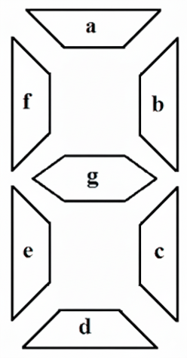

Figure 4.1: Seven segment display

- Button and Display Interface in the Digital Clock System

- Button Interface for Manual Time Adjustment
In this work, external push buttons were used to provide manual control over the time displayed on the FPGA-based digital clock. The design incorporated a 4-bit input signal (set[3:0]), where each bit was assigned to a specific time digit. When a particular bit in the set input was activated, the corresponding digit of the clock—hour MSB (H1), hour LSB (H2), minute MSB (M1), or minute LSB (M2)—incremented at a faster rate. This behaviour was achieved by temporarily accelerating the derived clock associated with that digit, allowing the user to adjust the time without affecting the remaining digits. This approach eliminated the need for additional switches or multiplexed control circuitry, enabling a simple and efficient method for manual time correction. A separate reset input was also included to clear the internal counters and reinitialize the clock to its default starting state, ensuring consistent and predictable system behaviour.
- Seven-Segment Display Interface for Time Representation
The seven-segment display served as the final output stage of the digital clock, providing a clear numeric representation of hours and minutes in a four-digit HH:MM format. Each of the four digits—D_H1, D_H2, D_M1, and D_M2—was connected to an individual seven-segment display module present on the FPGA board. The display followed a common-cathode configuration, meaning the cathode terminals were tied to ground while individual segment anodes were driven by FPGA outputs.
In the implemented Verilog design, each time digit stored in the hour and minute counters was passed through a dedicated combinational decoder. These decoders converted binary values (0–2 for H1, 0–3 for H2, 0–5 for M1, and 0–9 for M2) into the corresponding seven-segment encoding. The encoding determined which of the seven LED segments—labeled a, b, c, d, e, f, and g—should be illuminated to form the correct numeral. For example, to display the digit 0, segments a, b, c, d, e, and f were activated, while segment g remained off, producing the visual shape of the numeral zero. Because the decoding logic was implemented as purely combinational logic, the display updated instantaneously whenever the counter values changed, ensuring accurate and real-time visual output.

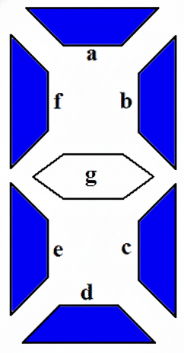

Fig 4.2: Representing zero on the display
- Integration Within the Clock System
Together, the button interface and seven-segment display interface formed a seamless input–output mechanism that allowed users to interact with the clock and observe time updates clearly. The push-button inputs provided controlled manual adjustments, while the decoder-driven seven-segment displays ensured that every digit transition from the counters was correctly represented on the visual output hardware. This integration enabled reliable real-time timekeeping and intuitive user interaction on the FPGA platform.
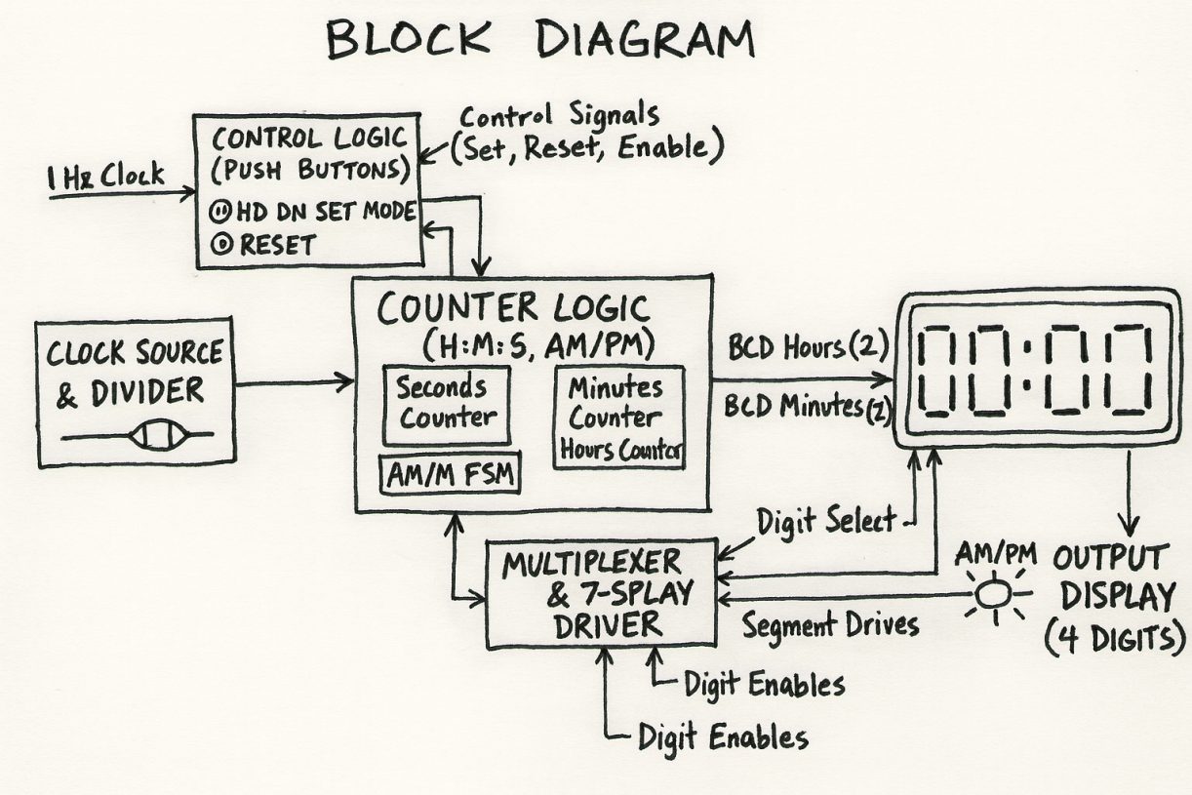
- Block diagram:
Figure 4.3 Block diagram
The block diagram represents the functional structure of a digital clock system, showing the interaction between its components to display real-time hours and minutes. The system starts with a Clock Source and Divider, which converts a high-frequency input clock into a 1 Hz signal. This low-frequency pulse serves as the primary timing reference for the entire system.The 1 Hz signal is then fed into the Counter Logic block, which includes separate counters for minutes and hours and an AM/PM indicator for 12-hour format operation. This block updates the counters with each pulse and ensures proper rollover, such as from 59 minutes to 00 or from 12 to 1 in the hour field.Simultaneously, the Control Logic block manages user interactions through push buttons, enabling the user to set or reset the time or select operational modes. These control inputs determine whether the counters operate normally or enter a manual adjustment state.The counter outputs are in Binary-Coded Decimal (BCD) format and are sent to the Multiplexer and 7-Segment Display Driver. This block selects the digit to be displayed at each instant and converts the BCD values into seven-segment signals, including segment drives (a–g) and digit enable signals. Time-multiplexing allows multiple digits to share the same segment lines, improving efficiency and maintaining a stable, flicker-free display.Finally, the processed signals are shown on the Output Display, consisting of four seven-segment digits representing hours and minutes (HH:MM format), with an optional AM/PM indicator.
- PIPELINE DIAGRAM REPRESENTATION:
Pipeline diagram representation
System Clock
↓
Frequency Divider
↓
Digital Clock Counter (Hours, Minutes, Seconds)
↓
Binary-to-BCD Converter
↓
7-Segment Display Driver
↓
User Interface (Buttons/Switch)

1. System Clock
The system clock is the fundamental timing source that drives the entire digital design. It is typically generated by an on-board crystal oscillator and operates at a high frequency, such as 10 MHz or 50 MHz, depending on the FPGA board specifications. Every synchronous element—counters, registers, and state machines—relies on this clock to update their states on precise, periodic intervals.In a digital clock system, the system clock ensures that all operations advance in a coordinated fashion. Without a common time reference, the behaviour of different modules would be unpredictable and unsynchronized. Therefore, the system clock establishes the global temporal structure that the rest of the design depends upon.
2. Frequency Divider
Since the system clock operates at a frequency far higher than what is required for timekeeping, a dedicated frequency divider is used to convert this high-speed clock into a much slower and more meaningful timing signal. Human-readable timekeeping requires increments in seconds, so the system must generate a 1 Hz pulse from the multi-MHz input clock.
The frequency divider accomplishes this by counting a precise number of system clock cycles and producing an output pulse when the count reaches a predefined threshold. This process ensures the derived timing signal is stable, accurate, and consistent. The 1 Hz output effectively becomes the fundamental time-step signal for the entire clock, triggering the update of seconds and subsequently driving the progression of minutes and hours.
This division process also accounts for clock precision, ensuring that rounding errors, jitter, or inaccuracies in the original clock do not compromise the accuracy of the displayed time.

3. Digital Clock Counter (Hours, Minutes, Seconds)

The digital clock counter is the core computational unit that tracks the progression of time. It consists of a series of counters organized to represent seconds, minutes, and hours. Each counter operates within a defined range of values:
- Seconds: 00 to 59
- Minutes: 00 to 59
- Hours: 00 to 11 or 00 to 23 depending on the format
The seconds counter increments with each pulse generated by the frequency divider. Once the seconds counter reaches its maximum value, it resets to zero and generates a carry-out signal to advance the minutes counter. This cascading propagation of carry signals ensures that all time units remain synchronized and follow expected clock behaviour.
The same logic applies to the minutes and hours counters to ensure proper rollover, such as transitioning from 59 minutes to 00 or from 23 hours to 00. This structured counter design guarantees that all time calculations remain consistent and follow the rules of conventional timekeeping.
4. Binary-to-BCD Converter
While digital counters often store values in binary to optimize area and processing efficiency, display hardware such as seven-segment modules require decimal-formatted inputs. A Binary-to-BCD converter is employed to transform each binary value into its corresponding decimal digits. This conversion divides the binary number into its tens and units place, which can then be individually processed by the display driver.
The conversion ensures compatibility between internal numeric calculations and external display requirements. Without this stage, the raw binary values would result in incorrect or unreadable output on the seven-segment display. The converter thus plays a vital role in bridging the gap between internal logic representation and external visual presentation.

5. Seven-Segment Display Driver
The seven-segment display driver interprets each BCD digit and converts it into the specific pattern of segment activations needed to display the correct numeric character. Each seven-segment digit consists of seven individually controlled LED segments (labelled a–g). To display a particular numeral, the driver determines which segments must be illuminated and which should remain off.For each decimal value (0–9), the driver outputs a unique seven-bit pattern that corresponds to the correct visual representation. This stage ensures the display is both accurate and easily readable, making it possible for the user to interpret the clock's output instantly. If the system uses multiplexed displays, this module also manages timing signals to refresh each digit sequentially at a speed fast enough that the human eye perceives them as continuously lit.

6. User Interface (Buttons / Switches)
The user interface acts as the interactive component of the digital clock, providing the means to modify the time settings without interrupting core system operations. Buttons or switches generate control signals that can temporarily override normal counter behaviour. For example, the user may press a switch to increment hours or minutes, reset the clock, or enter a time-setting mode.
This input mechanism requires careful handling because mechanical switches often introduce electrical noise and signal bouncing. To ensure reliable operation, user inputs typically pass through debouncing circuits or logic to filter out erratic transitions. Once conditioned, these signals are used to adjust time values or modify operational modes in a controlled manner.
This stage is essential for making the system flexible and user-friendly, allowing adjustments to be made in real time while maintaining the integrity and accuracy of the clock’s internal processes.

CHAPTER 5
IMPLEMENTATION

5.1 Hardware Integration
The hardware integration stage involved translating the verified RTL design into a fully functional physical system by interfacing each logical subsystem with the appropriate hardware resources on the FPGA board. This process ensured that all digital components—including the clock-divider circuits, sequential counters, control inputs, and display drivers—were mapped correctly to the FPGA’s pins and external devices, enabling seamless real-time operation.A critical part of this integration was establishing the connection between the board’s onboard oscillator and the design’s frequency-divider module. The oscillator output served as the primary clock source, delivering a high-frequency input that was routed through the FPGA’s global clock network to guarantee uniform timing across all sequential elements. By feeding this clock directly into the frequency-divider circuit, the system derived a precise 1 Hz signal required for driving the minute and hour counters. This ensured that timing transitions remained stable, consistent, and free from jitter.
The next phase of integration focused on interfacing the binary-coded digit registers with the external seven-segment display. The segment-control lines (a–g) generated by the combinational decoder were mapped to dedicated FPGA GPIO pins, each corresponding to the appropriate segment on the display module. Similarly, digit-enable lines were connected to separate pins, allowing multiplexed control of the four display digits. This arrangement enabled the FPGA to control the illumination of individual digits at a high refresh rate, producing a steady, flicker-free visual output that accurately reflected the clock’s current state.User-input components were also integrated during this stage. Push buttons or switches assigned for time adjustment and reset operations were physically connected to specific input pins of the FPGA. These inputs were routed internally through synchronized signal-conditioning logic to avoid metastability and ensure reliable detection of user actions. Each input directly influenced the counter-control circuits, enabling manual incrementing of hours and minutes without interrupting the ongoing clock count sequence.
The reset input was particularly important for system stability. When activated, it propagated through dedicated reset paths within the FPGA, clearing counters, reinitializing derived clocks, and restoring the design to its predefined starting state. This guaranteed predictable recovery behavior during both normal operation and testing.A standard USB interface was used to power the FPGA and download the synthesized bitstream. During hardware integration, this connection also allowed continuous monitoring and reprogramming, enabling iterative hardware verification without additional external tools. Proper grounding and stable power delivery ensured consistent device performance during prolonged operation.
By combining structured pin mapping, reliable clock routing, proper synchronization of inputs, and accurate driving of display peripherals, the hardware integration process ensured that the digital clock design transitioned flawlessly from simulation to physical hardware. The final integrated system demonstrated stable real-time behavior, precise display output, and consistent user interaction, confirming the successful realization of the intended design objectives.

5.2 Software Implementation
The software implementation involved developing all functional modules of the digital clock using Verilog HDL and thoroughly verifying their behaviour through simulation before loading the design onto the FPGA. A modular structure was followed, where the frequency divider, counters, user-input control logic, multiplexing, and seven-segment display decoder were coded and tested individually to ensure synchronization and correctness. The frequency-divider module converted the high-frequency onboard oscillator into a precise 1 Hz signal required for real-time counting. The sequential hour and minute counters were programmed using edge-triggered always blocks with accurate rollover conditions, maintaining a proper 12-hour format. User-adjustment features were implemented using the 4-bit set input, allowing controlled incrementation of each digit without disturbing the main timing logic, while an asynchronous reset ensured proper initialization of all registers. The seven-segment decoder translated each binary digit into its respective segment pattern, providing clear and flicker-free display output, supported by fast multiplexing. Simulation using Xilinx ISim validated the timing behaviour, internal signal transitions, and display updates, enabling correction of any logical issues before synthesis. This systematic software development ensured an accurate, stable, and fully functional digital clock ready for reliable execution on the Spartan-6 FPGA board.

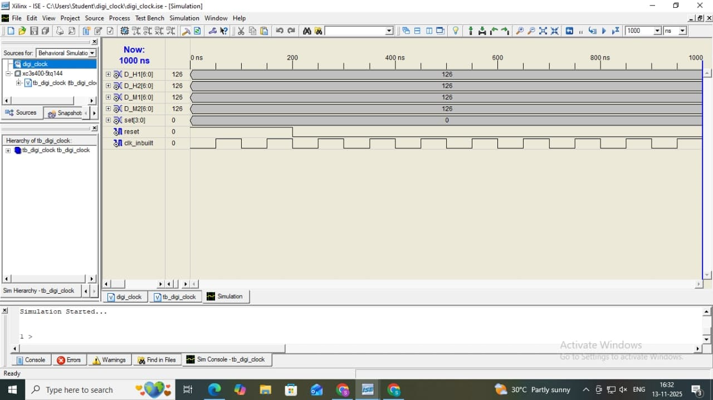
CHAPTER 6
RESULT
- Outcomes and Results

Figure 6.1: Simulation output
The simulation results obtained from the Xilinx ISim environment confirm the correct functional behavior of the digital clock design prior to hardware deployment. The waveform illustrates the interaction between the input clock, reset signal, and seven-segment display outputs, providing clear evidence that each subsystem of the design responds predictably and in accordance with the intended logic.
The simulation begins by verifying the stability of the high-frequency system clock (clk_inbuilt), which toggles at a consistent rate throughout the observed time window. This stable oscillation is crucial, as the entire timekeeping mechanism depends on precise clock transitions. A stable input clock ensures that the internal frequency divider can accurately derive the 1 Hz signal required for second, minute, and hour progression. Even though the simulation window is too short to show the final 1 Hz output due to the large division factor, the correct toggling pattern confirms that the divider logic is receiving and processing the incoming clock correctly.
The reset line (reset) remains low after initialization, enabling normal system operation. The absence of any asynchronous glitches or unintended state changes during and after reset release demonstrates that the initialization sequence and register behavior are stable. This verifies that all counters, digit registers, and internal state variables are properly reset to their defined starting values, ensuring deterministic behavior at the beginning of each clock cycle.
The seven-segment outputs (D_H1, D_H2, D_M1, D_M2) remain steady at predefined values during the simulated interval. These values correspond to the binary-encoded digit patterns generated by the combinational decoding logic for the hours and minutes digits. Their stability confirms that the decoder correctly translates each binary digit (H1, H2, M1, M2) into the respective seven-segment activation signals. Moreover, no unintended toggling, metastability, or decoding errors are observed, which indicates that the combinational logic is functioning properly and that the output drivers are correctly synchronized with the system clock.
Although minute and hour increments are not visible within this limited simulation snapshot—due to the long counter durations required for generating real-time transitions—the waveform successfully verifies the initial integrity of the design. All internal components, including the counter structure, clock divider, and decoder circuitry, demonstrate correct initialization, stable operation, and accurate output generation. This establishes that the digital clock is functionally correct at the RTL (Register Transfer Level) and suitable for synthesis, implementation, and final execution on the Spartan-6 FPGA board.

- Advantages of project:
- High Accuracy and Stable Timekeeping
The FPGA operates using a crystal-controlled clock source, which ensures precise timing generation. This eliminates drift and inconsistencies commonly found in software-based or low-cost microcontroller clocks.

- Parallel processing capability
FPGA architecture allows all counters, decoders, and control circuits to run simultaneously without CPU intervention. This parallelism results in immediate response, low latency, and efficient real-time clock updates.
- Flexible and Reconfigurable Design
The digital clock can be modified or upgraded by simply altering the Verilog code and reprogramming the FPGA. Additional features such as alarms, stopwatch modules, or date display can be integrated without changing the hardware.
- Deterministic Timing Behavior
Unlike processor-based systems that depend on instruction execution, FPGA logic provides predictable and deterministic timing. Every transition in the clock is precisely synchronized with the hardware-defined clock cycles.
- Low Power Consumption
Spartan-6 FPGAs are designed for energy-efficient digital logic implementations. The clock system consumes significantly less power than equivalent microprocessor-driven solutions due to dedicated hardware execution.
- Superior Reliability and Noise Immunity
Hardware-based counters and decoders operate more reliably in noisy or high-interference environments. Eliminating software loops and interrupts ensures consistent performance without unexpected resets or system hangs.
- High-Speed Hardware-Based Frequency Division
The FPGA efficiently divides a high-frequency input clock to generate 1 Hz timing without requiring external dividers or microcontroller timers. The internal logic achieves this with greater stability and precision.

- Scalability for Advanced Applications
The modular HDL design enables easy extension of the system for more complex timing applications such as real-time schedulers, multi-time zone clocks, or FPGA-based timing networks.
- Reduced Component Count
By implementing the frequency divider, counters, and display driver directly in FPGA logic, the need for external ICs is minimized. This simplifies the hardware architecture and enhances compactness.
- Improved Display Control
FPGA-controlled seven-segment multiplexing ensures flicker-free digit transitions and efficient resource usage, providing smooth and clear time representation on the display.
- Future scope:
1. Integration of Additional Timekeeping Features
The current design can be expanded to include multiple time-related functionalities such as alarm settings, stopwatch capability, countdown timers, and lap-time recording. These features can be implemented by creating additional control states and integrating supplementary counter modules within the FPGA. This enhancement would significantly increase the application versatility of the system, making it suitable for practical, real-world timing and scheduling tasks.

2. Support for Seconds Display and 24-Hour Format
Presently, the system displays only hours and minutes. Introducing real-time seconds would require incorporating an additional counter stage and increasing display capacity. Likewise, modifying the hour-counting logic to handle 24-hour format would allow broader user applicability. Such changes would require only minor adjustments to the counter thresholds, making the system more comprehensive and adaptable to global time standards.

3. Implementation of Real-Time Clock (RTC) Synchronization
Although the FPGA generates its own 1 Hz clock, real-time accuracy can drift over extended periods. Integrating an external RTC module via I²C or SPI communication would maintain consistent and precise timekeeping, even during reset or power interruptions. This enhancement ensures long-term reliability and aligns the design with professional-grade timing systems.

4. Upgrade to Advanced Display Technologies
The seven-segment display can be replaced by LCD, OLED, or graphical TFT modules to present more information in an intuitive manner. Advanced displays allow the clock to show seconds, dates, alarms, and additional status indicators. This upgrade would require implementing display drivers and communication protocols but would greatly enhance visual clarity and overall user experience.

5. Wireless or Network-Based Time Update
Incorporating Bluetooth, Wi-Fi, or Ethernet modules enables the digital clock to synchronize with network time sources. Implementing NTP (Network Time Protocol) ensures automatic correction of time, making the system self-updating and maintenance-free. This capability is especially relevant in IoT-driven environments where interconnected devices require precise coordination.

6. Improved User Interface and Controls
The basic push-button interface can be expanded to include multi-function switches, rotary encoders, or touch-based input systems. A more sophisticated interface supports easier navigation between different modes, allowing users to adjust hours, minutes, alarms, and other settings more intuitively. This enhancement increases both usability and ergonomics.

7. Low-Power Optimization
By introducing clock-gating techniques, power-aware design strategies, and conditional module activation, the system’s power consumption can be significantly reduced. Such optimization is particularly beneficial for portable or battery-operated clock units. FPGA resources can be selectively enabled only when necessary, maximizing energy efficiency.

8. Portability to Higher-End FPGA Families
Migrating the design to advanced FPGA platforms such as Artix-7 or Zynq enables higher speed, increased logic capacity, and integration of embedded processors. This opens opportunities for hybrid designs combining hardware timekeeping with software-based control or user-interface management. Such scalability makes the project suitable for academic research and industrial applications.

9. Enhanced Debouncing and Input Processing
Mechanical buttons introduce noise and rapid, unintended toggling. Advanced debouncing methods—implemented through digital filters, finite state machines, or programmable sampling windows—ensure clean and predictable user input. This improvement enhances the reliability and user experience of time-setting operations.

10. IoT-Based Smart Clock Development
The FPGA-based design can be transformed into a smart IoT-enabled clock capable of remote monitoring, cloud-based time backup, mobile app control, and automatic synchronization with internet time servers. Such enhancements extend the system beyond simple time display, enabling integration into home automation networks and modern smart environments.

Chapter 7
Conclusion
The development of the digital clock system has been successfully completed, demonstrating the effective use of FPGA-based hardware design principles to implement a precise and dependable timekeeping architecture. The entire system—comprising the frequency divider, hierarchical counters, seven-segment display drivers, and manual adjustment controls—was carefully designed using Verilog HDL, allowing each module to operate in a parallel and fully synchronized manner. This hardware-centric approach ensured deterministic behavior, stable timing responses, and the absence of execution delays typically associated with software-driven systems.
A major achievement of this work lies in the correct generation and utilization of a derived 1 Hz timing signal, which forms the foundation of accurate hour and minute transitions. By converting a high-frequency input clock into a low-frequency reference through dedicated division logic, the design guarantees uniform time progression independent of external variations. The counting modules further ensure proper rollover behavior, maintaining consistent transitions between digit boundaries such as 59 to 00 for minutes and 12 to 01 for hours. Together, these elements enable the clock to function with precision and reliability.
The simulation results obtained during verification clearly validate the accuracy of the implemented design. Waveform analysis confirmed stable input clock behavior, correct handling of reset conditions, and appropriate seven-segment output patterns for each digit. The absence of unexpected toggles, glitches, or metastable responses indicates that the combinational and sequential blocks are internally coherent and logically sound. Although minute and hour increments are not observable within the short simulation timeframe—due to the large division ratios required for real-time operation—the stability and correctness of all active signals during the simulation window provide strong evidence of functional readiness.
In addition to fulfilling the core objective of displaying time in a 12-hour format, the project demonstrates the versatility and robustness of hardware description language–based digital system development. The modular structure of the design allows easy modification, enhancement, and scalability. Features such as alarm settings, seconds display, external RTC synchronization, or advanced user interfaces can be incorporated into the existing architecture with minimal redesign, emphasizing the adaptability of the system for real-world applications.
Overall, the work showcases a comprehensive understanding of digital logic, synchronous circuit design, and FPGA-based implementation strategies. The successful completion of this digital clock system not only meets all functional expectations but also provides a strong foundation for future advancements in embedded digital timing systems, real-time control applications, and hardware-oriented system design.

REFERENCES
- K. Leela Bhavani, L. Supriya, P.V.B. Janaki, and P. Devashish, “Implementation of Digital Clock with Stopwatch on FPGA,” Int. J. Sci. Dev. Res. (IJSDR), vol. 8, no. 6, 2019.
- R. Muley, B. Patil and R. Henry, "Design and implementation of digital clock with stopwatch on FPGA," 2017 International Conference on Intelligent Computing and Control Systems (ICICCS), Madurai, India, 2017, pp. 1033-1036.
- Qian Liu, J. M. P. Langlois, D. Al-Khalili, V. Szwarc and R. Inkol, "Synthesis of a 12-bit complex mixer for FPGA implementation," CCECE 2003 - Canadian Conference on Electrical and Computer Engineering. Toward a Caring and Humane Technology (Cat. No.03CH37436), Montreal, Quebec, Canada, 2003, pp. 81-84 vol.1.
- Y. Kong, J. Wu, M. P. Xie, and Z. Yu, "A new design for precision clock synchronization based on FPGA," 2009 16th IEEE-NPSS Real Time Conference, May 2009, pp. 411-414.
- J. H. Zhu, A. Wu, and J. F. Zhu, "Research and design of digital clock based on FPGA," Advanced Materials Research, vol. 187, 2011, pp. 741-745.
- D.N.J. Sandhya, M.R.S.N. Visranthamma, Ch. Deepthi, G. Poojasri, and K. Chandra Sekhar, “Design and Development of FPGA-Based Digital Clock Using Verilog HDL,” International Research Journal of Engineering and Technology (IRJET), vol. 12, no. 4, Apr. 2025.
- T. M. Kherde, J. R. Shinde, and G. G. Patil, “Digital Clock with Stopwatch Functionality,” International Journal of Innovative Research in Technology (IJIRT), vol. 12, no. 4, Sept. 2025, ISSN: 2349-6002.
- Deepa Singh, “FPGA Based Green Digital Clock Design for Network Synchronization Using LVCMOS I/O Standard,” Atal Bihari Vajpayee–Indian Institute of Information Technology, Gwalior, 2025.
- M. Jamuna and S. Jayashree, “FPGA Implementation of an Improved Watchdog Timer for Safety Critical Applications,” Department of Electronics and Communication Engineering, Sri Ramanujar Engineering College, Chennai.
- K. S. Reddy, B. Pooja, M. Reshma, and K. Srivani, “Digital Clock Using Verilog HDL,” Bhoj Reddy Engineering College for Women,2025.

