1. Implement Tic –Tac –Toe game.

<https://github.com/SurakshaRV/AI-Lab1BM17CS108/blob/master/lab1tictactoe.py>

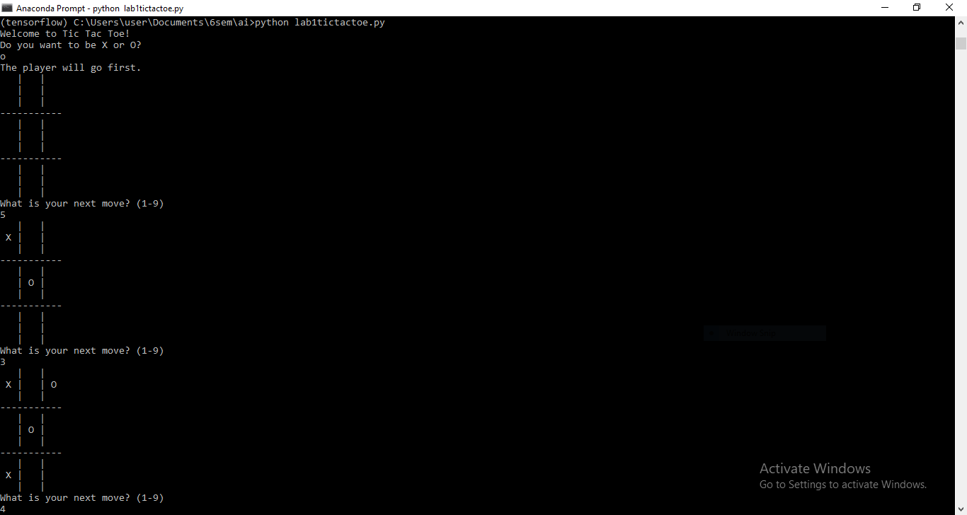

1. Solve 8 puzzle problem.

<https://github.com/SurakshaRV/AI-Lab1BM17CS108/blob/master/8puzzle_BFS.py>

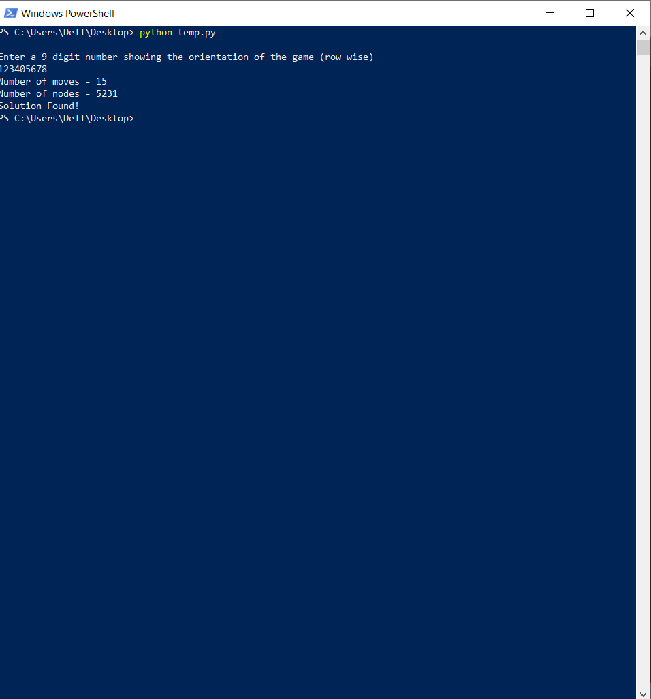

1. Implement Iterative deepening search.

<https://github.com/SurakshaRV/AI-Lab1BM17CS108/blob/master/8puzz_iter_search.py>

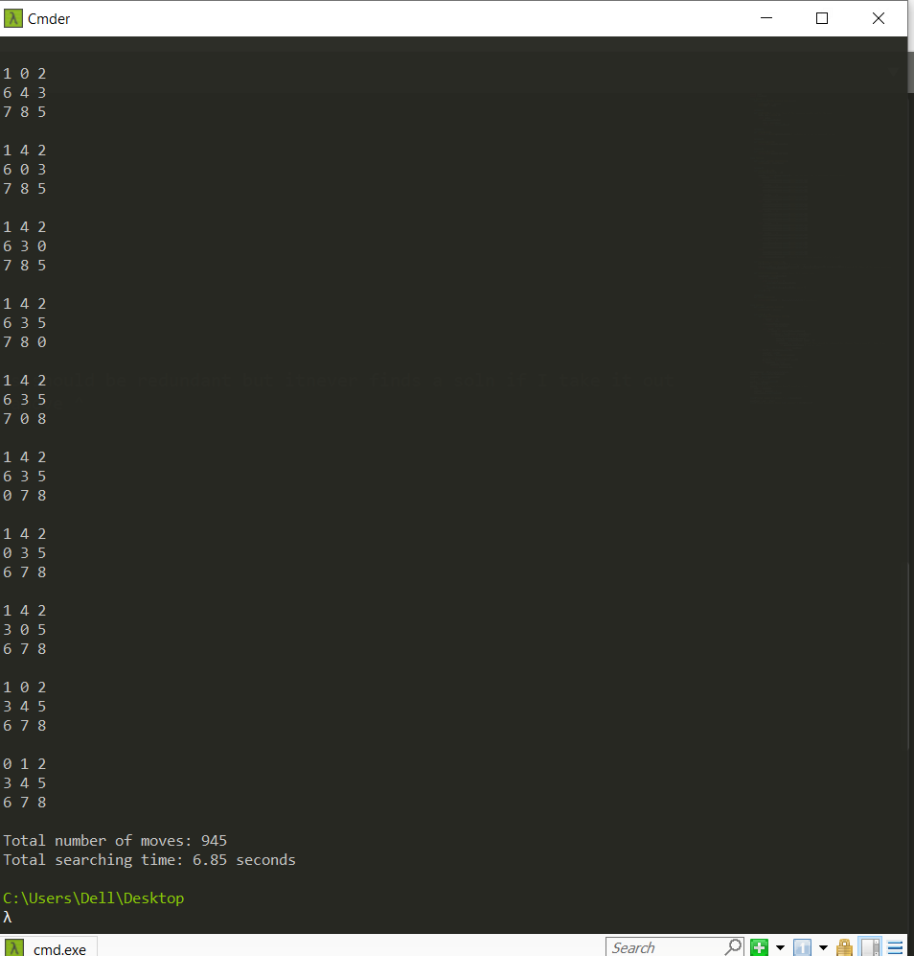

1. Implement A* search.

<https://github.com/SurakshaRV/AI-Lab1BM17CS108/blob/master/astar.py>

Input:

[[0, 0, 0, 0, 1, 0, 0, 0, 0, 0],

|  |
| --- |
| [0, 0, 0, 0, 1, 0, 0, 0, 0, 0], |
| [0, 0, 0, 0, 1, 0, 0, 0, 0, 0], |
| [0, 0, 0, 0, 1, 0, 0, 0, 0, 0], |
| [0, 0, 0, 0, 1, 0, 0, 0, 0, 0], |
| [0, 0, 0, 0, 0, 0, 0, 0, 0, 0], |
| [0, 0, 0, 0, 1, 0, 0, 0, 0, 0], |
| [0, 0, 0, 0, 1, 0, 0, 0, 0, 0], |
| [0, 0, 0, 0, 1, 0, 0, 0, 0, 0], |
| [0, 0, 0, 0, 0, 0, 0, 0, 0, 0]] |



1. Implement vacuum cleaner agent.

<https://github.com/SurakshaRV/AI-Lab1BM17CS108/blob/master/lab2vaccumcleaner.py>

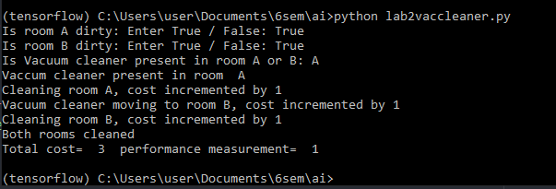

1. Create a knowledge base using prepositional logic and show that the given query entails the knowledge base or not. 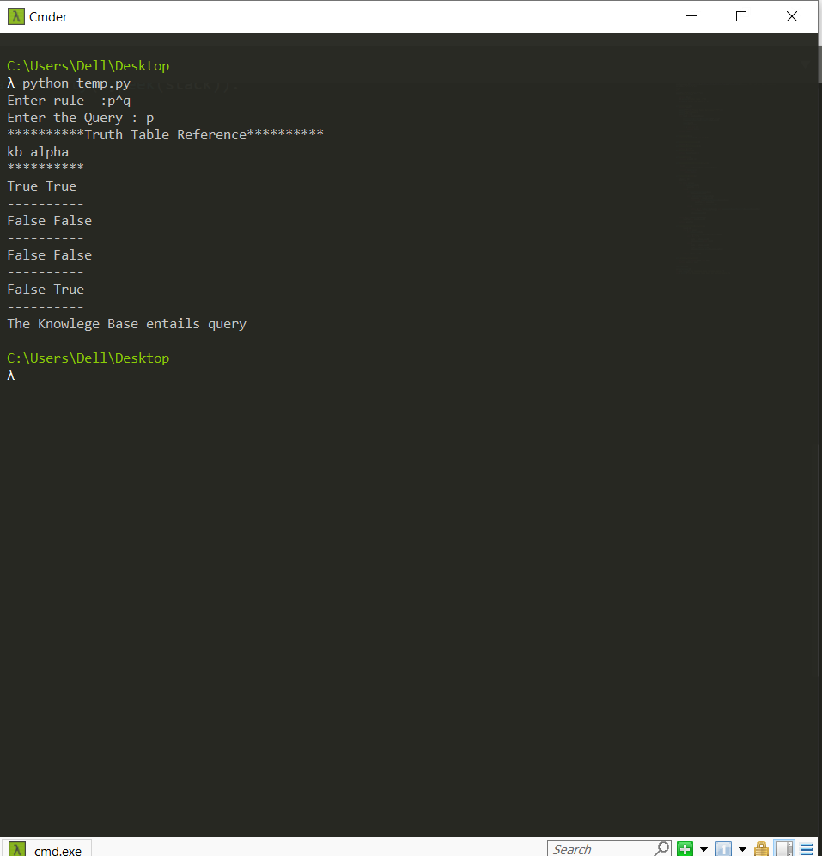

<https://github.com/SurakshaRV/AI-Lab1BM17CS108/blob/master/entailskb.py>

1. Implement unification in first order logic.

<https://github.com/SurakshaRV/AI-Lab1BM17CS108/blob/master/unify.py>

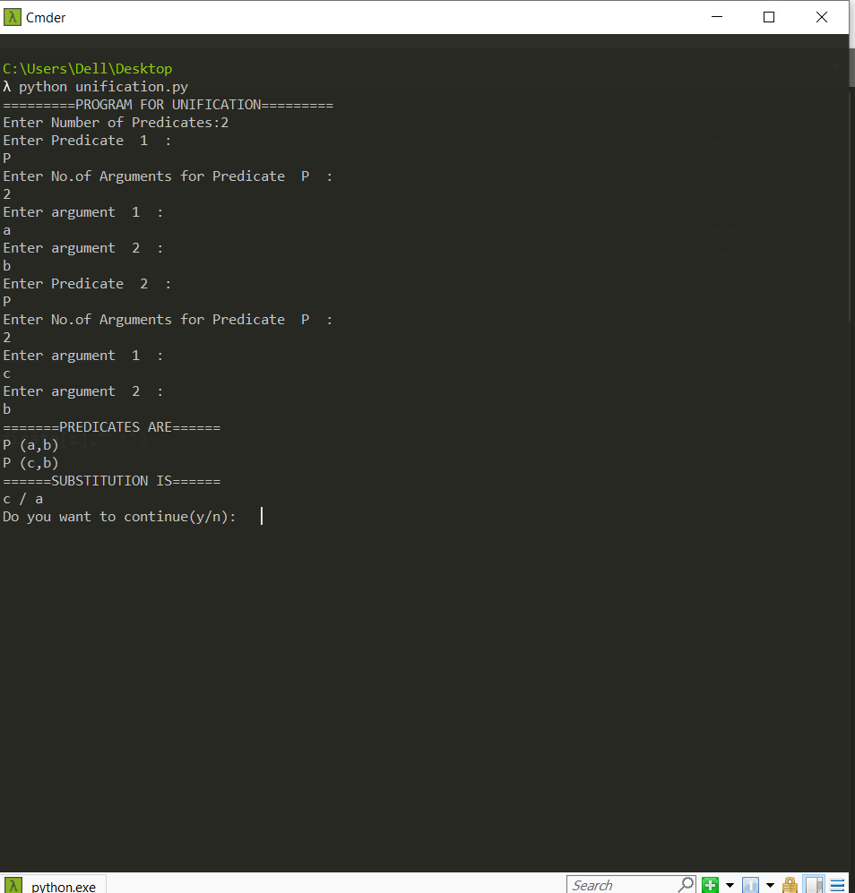

1. Convert given first order logic statement into Conjunctive Normal Form (CNF).

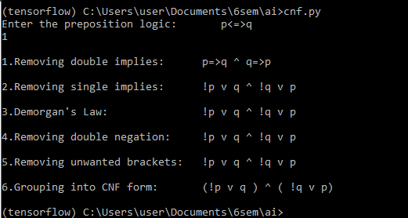

1. Create a knowledgebase consisting of first order logic statements and prove the given query using forward reasoning.

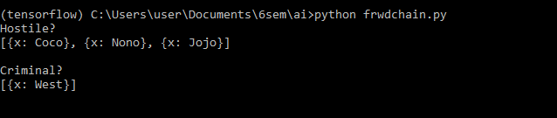

1. Demonstrate decision tree learning for a given set of training examples and test data.

Output exists in the python notebook itself

<https://github.com/SAGAR-RUDAGI/AI-Lab-CS085/blob/master/Decision_Tree.ipynb>