**Creating a new database.**

CREATE DATABASE movies_info;

**Selecting the database to work with.**

USE movies_info;

**Creating a table to store movie details.**

CREATE TABLE movies(

id INT PRIMARY KEY,

movie_name VARCHAR(70),

lead_actor VARCHAR(50),

lead_actress VARCHAR(50),

director VARCHAR(50),

year_of_release year

);

DESCRIBE movies;

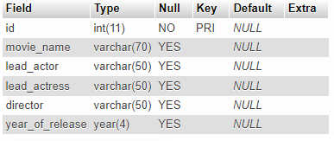

**Inserting data into the movies table.**

INSERT INTO movies(id,movie_name,lead_actor,lead_actress,director,year_of_release)

VALUES

(1,'The Mummy','Brendan Fraser','Rachel Weisz','Stephen Sommers',1999),

(2,'Jurassic Park','Sam Neill','Laura Dern','Steven Spielberg',1993),

(3,'Black Panther','Chadwick Boseman','Letitia Wright','Ryan Coogler',2018),

(4,'The Batman','Robert Pattison','Zoe Kravitz','Matt Reeves',2022),

(5,'Fantastic Beasts','Eddie Redmayne','Ktherine Waterson','David Yates',2016);

**Selecting all rows from movies table.**

SELECT * FROM movies;

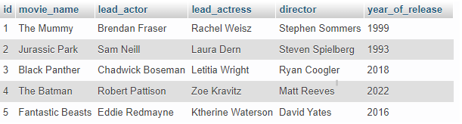

**Selecting a movie based on the actor’s name.**

SELECT * FROM movies WHERE lead_actor='Sam Neill';



SELECT movie_name,director FROM movies WHERE director='Ryan Coogler';

