**Smart Plantation**



**B.S. (SE) 2017 Final Year Project Report**

**Submitted by:**

**Aimun Tahir 2017/COMP/BS (SE)/21587 1720658**

**Hiba binte Tariq 2017/COMP/BS (SE)/21599 1720675**

**Namrah Komal 2018/COMP/BS (SE)/23118 18558**

**Surayya Obaid 2017/COMP/BS (SE)/21635 1720710**

**February, 2021**

**Department of Computer Science and Software Engineering**

**Jinnah University for Women**

5-C NAZIMABAD, KARACHI 74600

**Smart Plantation**



**B.S. (SE) 2017 Final year Project Report**

**Submitted by:**

**Aimun Tahir 2017/COMP/BS (SE)/21587 1720658**

**Hiba binte Tariq 2017/COMP/BS (SE)/21599 1720675**

**Namrah Komal 2018/COMP/BS (SE)/23118 18558**

**Surayya Obaid 2017/COMP/BS (SE)/21635 1720710**

**Project Advisor:**

**Ms. Tehreem Qamar**

**February, 2021**

**Department of Computer Science and Software Engineering**

**Jinnah University for Women**

5-C NAZIMABAD, KARACHI 74600

**Department of Computer Science and Software Engineering**

**Jinnah University for Women**

**Project Approval**

Project Title: Smart Plantation

By:

Aimun Tahir 2017/Comp/BS(SE)21587 1720658

Hiba binte Tariq 2017/Comp/BS(SE)21599 1720675

Namrah Komal 2018/Comp/BS(SE)23118 18558

Surayya Obaid 2017/COMP/BS(SE)21635 1720710

Approval Committee:

___ ____ _____________

Name: Ms. Tehreem Qamar

Designation: Lecturer

(Internal Advisor)

___________________________

(Head of the Department)

# Abstract

Smart plantation is all about purifying the environment. The plantation is a process that doesn't bring noticeable changes in small duration to the environment. On the other hand, it's one of the causes that has marked lethal impacts on the planet. We can take the example of recent incidents like Amazon Rainforest fire, Australia bush fire, and many more. We have seen in Karachi that heatwave was primarily because of the Conocarpus tree which was massively planted without any prior research. The result was decreased humidity, decreased water level and ultimately KMC had to cut the plant from across the city.

**Smart Plantation** is a solution to the problem of inappropriate plantation by recommending what is needed by the environment. Data with the help of sensors is collected from the air and land. The system then makes a prediction and it is also ensured that the suggested plant is in the approach of the user as they are made able to buy seeds from the app.

# Table of Content

Abstract iv

Table of Content v

List Of Figures viii

List Of Tables ix

Acknowledgement x

Chapter 1 ……………………………………………….Introduction 1

1.1 Purpose 1

1.2 Product Scope 2

1.3 Overall Description 2

1.3.1 Product Perspective 2

1.3.2 User Characteristics 3

1.3.3 Operating Environment 3

1.3.4 Design And Implementation Constraints 3

1.3.5 User Documentation 4

1.3.6 Assumption And Dependencies 4

1.4 System Features 4

1.5 Other Non-Functional Requirements 5

1.5.1 Performance Requirement 5

1.5.2 Safety Requirement 5

1.5.3 Security Requirement 5

1.6 Software Quality Attributes 5

1.6.1 Reliability 5

1.6.2 Accuracy And Precision 5

1.6.3 Understandability & Usability 5

1.7 Business Rules 5

Chapter 2 …………………………………..ANALYSIS AND DESIGN 6

2.1 Workflow Diagram 6

2.2 Relational Model 7

2.3 Use Case Diagram 8

2.4 Entity Relationship Diagram 10

2.5 Data Flow Diagram (Level 1) 11

2.6 Data Flow Diagram (Level 2) 11

2.7 Architecture Diagram 12

Chapter 3 ………………………………TOOLS AND TECHNOLOGIES 13

3.1 Designing Tools 13

3.1.1 Adobe Illustrator 13

3.1.2 Adobe XD 13

3.1.3 Adobe Photoshop 13

3.2 Documentation Tools 13

3.2.1 MS Word 13

3.2.2 MS Visio 14

3.3 Development Tools and Technologies 14

3.3.1 Sublime Text 3 14

3.3.2 HTML/CSS 14

3.3.3 Bootstrap 4 14

3.3.4 Javascript 15

3.3.5 Php Myadmin 15

3.3.6 Android Studio 15

3.3.7 Firebase 15

3.3.8 GitHub 15

Chapter 4 ……………………………………..USER INTERFACE DESIGN 16

4.1 Web User Interfaces 16

4.1.1 Home Page 16

4.1.3 Gardener-Services 17

4.1.4 Gardener-Services 18

4.1.5 Buy-Seeds 19

4.3 Mobile User Interface 20

4.3.1 Cart 21

4.3.2 Prediction 21

4.3.3 Plant Description 22

4.3.4 Donation 22

4.3.5 Plant Maintenance 23

4.3.6 Gardener 23

Chapter 5 ………………………………………………..METHODOLOGY 24

5.1 Agile Process Model 24

5.1.1 Requirement Gathering 24

5.1.2 Designing 24

5.1.3 Implementation 24

5.1.4 Testing 25

5.2 Project Plan According to Agile Methodology 25

Chapter 6 …………………………….IMPLEMENTATION DETAILS 29

6.1 Database Design 29

6.1.1 User Table 29

6.1.2 Buyer Table 29

6.1.3 Gardener Table 29

6.1.4 Gardener payment Table 29

6.1.5 Plant Table 30

6.1.7 Plant Table 30

6.1.8 Plant Table 30

6.2 Web Services 31

6.2.1 Admin-Side Services 31

6.2.2 Web-Side Services 31

6.2.3 Mobile-Side Services 31

6.3 Mobile App Development 32

6.4 APIs Development 32

6.5 APIs Used In Prediction Module 32

6.6 Deployment 33

6.6.1 Web Application Deployment 33

6.6.2 Mobile Application Deployment 33

Chapter 7 ………………………………………………….TEST CASES 34

7.1 Test case for login 34

7.2 Test case for signup 35

7.3 Test cases for ordering device 36

7.4 Test case for requesting a gardener 37

7.5 Test case for checkout form 38

Conclusion 40

REFERENCES 41

List Of Figures

Figure 2.1 Workflow Diagram 6

Figure 2.2 Relational Model 7

Figure 2.3 Use-case (Buyer) 8

Figure 2.4 Use-case (Donor) 9

Figure 2.5 Entity Relationship Diagram 10

Figure 2.6 DFD (level 1) 11

Figure 2.7 DFD (Level 2) 11

Figure 2.8 Architecture Diagram 12

Figure 4.1 Homepage 16

Figure 4.2 Buy Device Page 17

Figure 4.3 Donation page 17

Figure 4.4 Gardener page 18

Figure 4.5 Buy Seeds (1) 19

Figure 4.6 Buy Plants (2) 19

Figure 4.7 View Plant 20

Figure 4.8 Checkout 20

Figure 4.9 Hardware Interface 20

Figure 4.10 Cart 21

Figure 4.11 Prediction 21

Figure 4.12 Plant Description 22

Figure 4.13 Donation 22

Figure 4.15 Maintenance (1) 23

Figure 4.14 Maintenance (2) 23

Figure 4.16 Gardener (2) 23

Figure 4.17 Gardener (1) 23

# List Of Tables

Table 1. Sprint Planning 28

Table 2. Log-in Test Cases 34

Table 3. Sign-up Test Cases 35

Table 4. Device Ordering Test Cases 36

Table 5. Gardner Module Test Cases 37

Table 6. Checkout Test Cases 38

# Acknowledgement

The team would like to express sincere gratitude to supervisor Ms. Tehreem Qamar for giving us her invaluable time, guidance, support and suggestions throughout the course of this project. Her leadership has paved the way for us to transform our idea into a reality for which we have received overwhelming appreciation from all who see this project.

We would like to express our gratitude for all of faculty members and especially Chairperson Dr. Narmeen Bawany, for opening the doors of knowledge and opportunities for us. The shape of project we were able to make, wasn’t possible without encouragement and guidance of FYP committee who has always helped us out in defeating odds that caused hindrance in this journey.

# Chapter 1

# Introduction

## 1.1 Purpose

With the evolution in technology and other industries, there comes the need to manage their impact on the environment. All the terms that we hear these days like global warming, depletion of earth's resources (like air, water, soil, etc.), destruction in the ecosystem, are the result of this revolution. And it's noticeable that we can't keep ourselves away from the changes that are brought through technology but we can certainly lower down the worsening effect.

Very few people go for research before planting trees. Most of them feel free to plant whatever they want without taking care of how their decision will make an impact on the environment. This can be overcome by deploying a system that is smart enough to suggest a flora as per the environment.

Few factors are considerable for plantation. We can categorize these into two types i.e. factors that affect plants from the soil and those that affect from Air. Another consideration for plantation is that not every plant is suitable for the environment that may benefit in any other area. For example, Heat wave in 2015 was slight because of Conocarpus Tree that was massively planted in 2008 without any research [1]. The tree itself has no ill effect but its plantation isn't suitable for our environment [2]. Researchers say that the plant's roots extend horizontally which causes two things. First, due to extended roots, it absorbs a huge amount of water from the soil that ultimately results in decreased humidity in the Air. And apart from this issue, its roots are strong enough to penetrate solid objects destroying man-made structures like service lines and other vital facilities. So the plantation of Conocarpus near residential areas isn't appropriate and should be avoided in Karachi too.

Another example is of Paper Mulberry trees that are planted in the country's capital, Islamabad [3]. These trees release pollen twice a year resulting in Air pollution. Although they add beauty to the landscape, on the other hand, they are the cause of an increased number of Asthma patients in the city. Again, Tree itself isn't harmful; rather its specifications aren't compatible with the environment.

## 1.2 Product Scope

The proposed system covers predictions for plants according to the indoor and outdoor environment. For such predictions, the network of sensors is used which takes and delivers the measures of current temperature, humidity, concentration of oxygen, carbon dioxide etc. which is all needed for a plant to be grown properly.

## 1.3 Overall Description

Smart Plantation is a solution for the problem of an inappropriate plantation by recommending what is needed for the betterment of the environment. As the reversal of the process of plantation is so costly, it’s preferable to do it precisely in first attempt. Therefore, this system is making prediction and also it is ensured that the suggested plant is in approach of the user.

Data from the environment is collected with the help of a network of sensors which includes data of temperature, humidity, the concentration of oxygen and carbon dioxide in the air, concentration of salt, nitrogen, water, etc. in the soil. Based on this data, the system suggests a plant enlisted in the database of the system that has the most matched features with the environment.

Apart from the prediction of suitable plants, the system also ensures the availability of seeds of the suggested plant so that the user can buy the seed of a recommended plant from the same place. Some people don't get satisfied with the outcomes and recommendations made by the machines that is why the system side by side provides the consultation services from professional gardeners so that users get deserved satisfaction.

### 1.3.1 [Product Perspective](http://www.cloudbus.org/cdn/reports/SRS_CDN%20Peering.pdf)

The product is an IoT project that is intended to provide a smart solution to environmental pollution. It is accessible through the web as well as an android application. Few sections like E-commerce of plants are overlapped on both the website and mobile application while few like Plant suggestion (through mobile), hardware purchasing (through the website) are restricted to a particular platform.

#### 1.3.1.1 Initiation

The system is initiated by signing up followed by logging in.

#### 1.3.1.2 Device Connection

User has to buy device in order to go further for suggestion of plant. Device is then connected by entering serial number provided on device.

#### 1.3.1.3 Plant suggestion

Data collection begins after the device connection and data obtained, is processed in order to make suggestion for plant in accordance with needs of that particular environment.

The process can be followed by acquiring gardeners’ services and purchasing seeds.

### 1.3.2 [User Characteristics](https://aakashtechsupportdocs.readthedocs.io/en/latest/prodpersp.html)

It is considered that the user does have the basic knowledge of operating the internet & smartphone.

The administrator is expected to be familiar with the interface of the tech support system. Basic knowledge to handle hardware equipment will be required for the user.

### 1.3.3 Operating Environment

This is a web plus app-based system and hence will require the operating environment for a client and server GUI. This software highly depends on the type and version of the browser being installed in the system i.e., browser version should be used which have HTML5 support.

### 1.3.4 Design And Implementation Constraints

* Android Application is usable on the devices with API level 23 or greater.
* Large data storage is required for efficiency of system as database of native plants and their characteristics is massive.

### 1.3.5 User Documentation

Users will be provided with support to handle possible issues of the device along with software queries under the Frequently Asked Questions (FAQs) section.

### 1.3.6 Assumption And Dependencies

#### 1.3.6.1 Assumptions

* The people having lawns or gardens in their homes will prefer using this application.
* Plants will be available in our online nursery when a customer would need it.
* Product delivery will be done without any un-required delays.
* The hardware cost won’t be unreachable for our customers.
* Our gardener’s services will be helpful for our users.

#### 1.3.6.2 Dependencies

* Our services through a mobile application are highly dependent on the purchase of the hardware module by the user.
* The suggestion of plants will be done via application only

## 1.4 System Features

* The system fulfills the requests of the device and proceeds orders.
* The device gathers data from the environment for a certain period of time.
* The system processes data and suggests a plant in accordance with the environment’s characteristics and needs.
* The system lets the user buy suggested plants through an e-commerce module.
* The system facilitates users by enlisting gardeners so that they can utilize the services of a gardener.

## 1.5 Other Non-Functional Requirements

### 1.5.1 Performance Requirement

The system should have excellent response time and execution efficiency.

### 1.5.2 Safety Requirement

The hardware unit of the system should not bring any harmful impact on the lives of plants and environment.

### 1.5.3 Security Requirement

Data of the system must be stored securely.

## 1.6 Software Quality Attributes

### 1.6.1 Reliability

The system works smoothly while there’s a change in atmosphere, every day.

### 1.6.2 Accuracy And Precision

The suggestions and summaries made by the system are free from inaccuracy.

### 1.6.3 Understandability & Usability

There is an understandable interface of a system that is easy to operate for the user.

## 1.7 Business Rules

* Payment is done on delivery.
* No order after 3 days is considered for review.
* Service charges from gardeners is given directly to them.

# Chapter 2

# ANALYSIS AND DESIGN



## 2.1 Workflow Diagram

The diagram includes all possible steps user may have to go through. For retrieving data from device, the first step required is device connection which can be either denied or accepted by the system depending upon the key entered for validating device. Later steps include plant suggestion and monitoring along with gardening and plants e-commerce module.

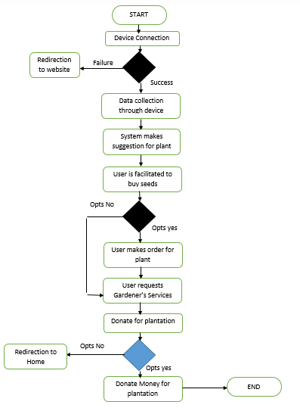

Figure 2.1 Workflow Diagram

## 2.2 Relational Model

Relational model here shows the relation between entities and their attributes. It also shows how data between entities is shared with the help of foreign keys.

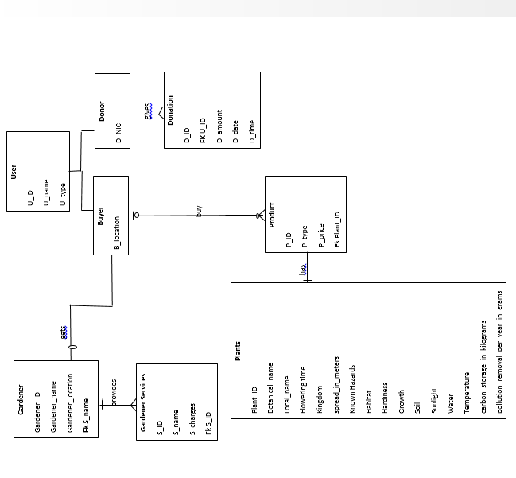

Figure 2.2 Relational Model

## 2.3 Use Case Diagram

There are two cases for use case diagram i.e. buyer and donor. Figure 2.3 is use-case diagram of Buyer which shows all possible use cases of user. Users can **Sign-up, log-in, buy hardware unit** to **get plant suggestion** and to **track plant**. Users can also **request for gardener’s** and is also provided the facility to **buy plants** suggested to them from plant store

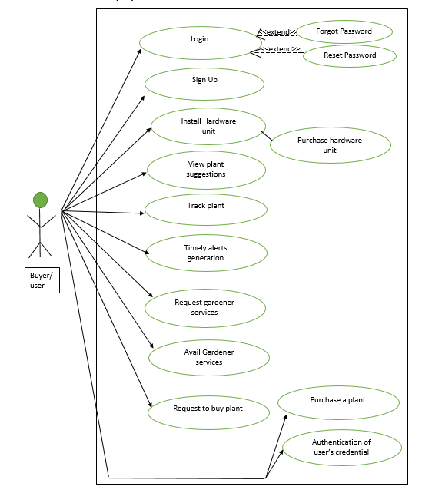Figure 2.4 represents use cases for donor. It isn’t necessary for all users to donate for plantation campaigns but those who do, have to do some extra steps including **request to donate for plant** and **payment of donation amount**.

Figure 2.3 Use-case (Buyer)

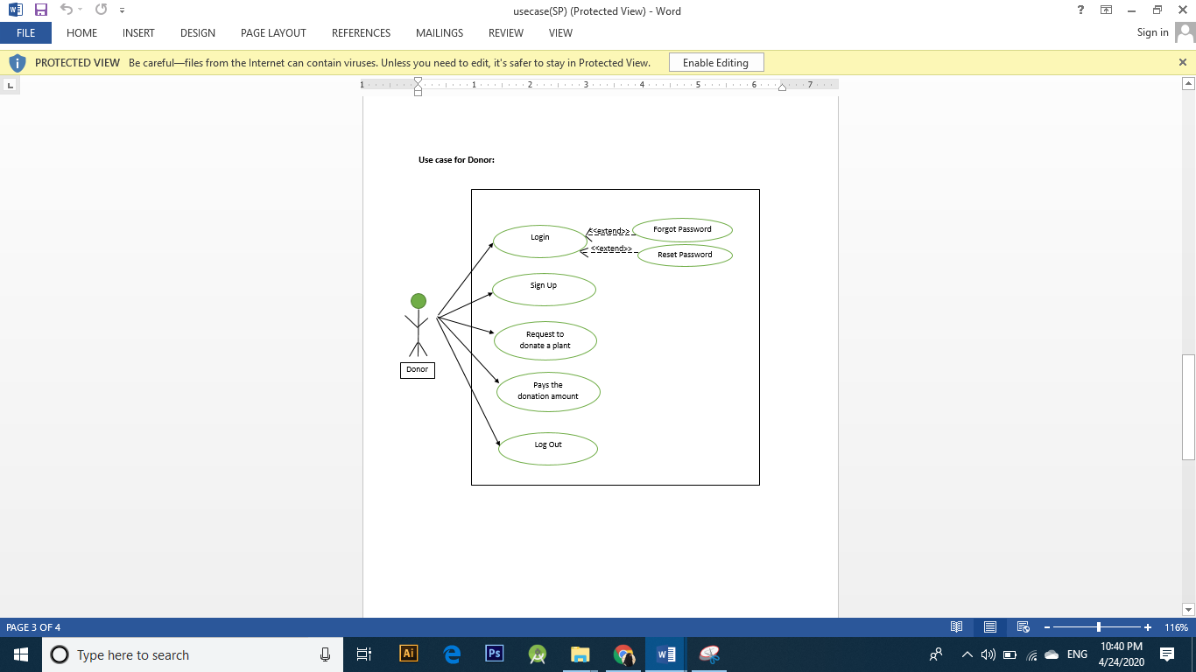

Figure 2.4 Use-case (Donor)

## 2.4 Entity Relationship Diagram

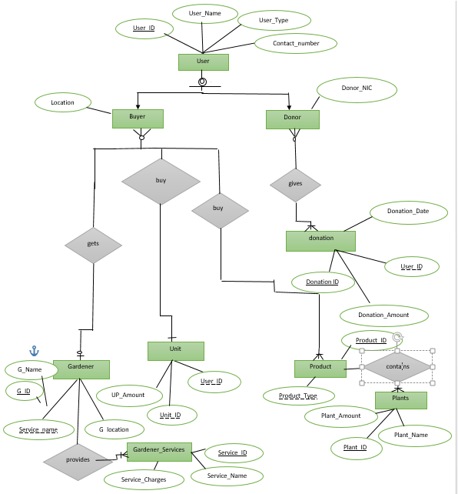ER Diagram represents the logical view of relationship between entities along with the cardinalities defined to show the grouping mechanism. Here, there are 9 entities including user (further divided into buyer and donor), Garden_payment, Product_payment, Unit, Product, Gardener, Gardener_Services, Unit_Payment and Plants. Entities are shown with all potential attributes along with primary key and foreign keys.

Figure 2.5 Entity Relationship Diagram

## Data Flow Diagram (Level 1)

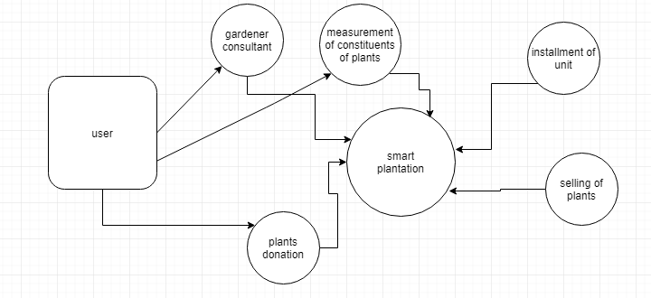Data Flow Diagrams here represent as follows. User can acquire gardener’s services data, which are shared with the user on the basis of location they enter. User can visualize the data collected by the device, with the help of mobile application. User can also buy plants from plants store that are listed on website and mobile application. User can proceed for donating for plantation campaigns being carried out in nearby area.

Figure 2.6 DFD (level 1)

## 2.6 Data Flow Diagram (Level 2)

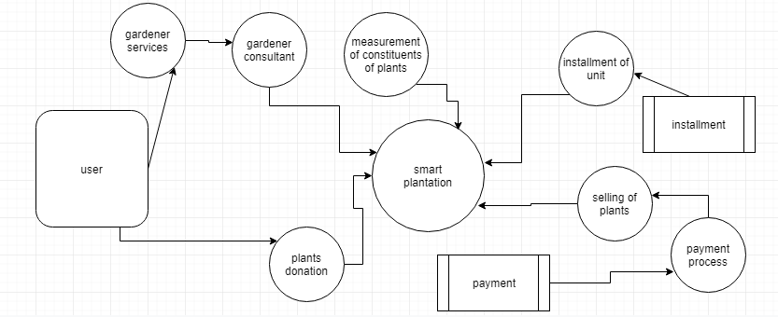

Figure 2.7 DFD (Level 2)

## 2.7 Architecture Diagram

Architecture diagram here discloses the communication between components such as of Web API controller and Android client with presentation layer i.e., front-end of mobile app and website. It also shows the data journey from SQL database till user end.

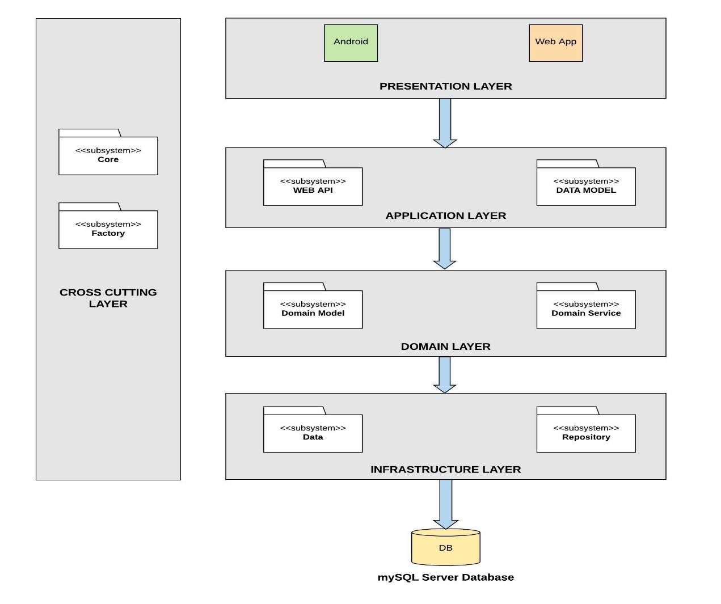

Figure 2.8 Architecture Diagram

# Chapter 3

# TOOLS AND TECHNOLOGIES



## 3.1 Designing Tools

### 3.1.1 Adobe Illustrator

Adobe illustrator is a tool for vector graphics with the most beneficial features. It provides the platform to create high resolution graphics for websites, logos, billboards, etc. Though many other tools have also been developed, but adobe illustrator is still considered the first priority of the graphic designers. We have also used this tool to create our logo for the system.

### 3.1.2 Adobe XD

Adobe XD is prototyping tool that lets the designer visualize look up of both website and android mobile application. There is wide range of widgets in the tool that can be exploited for making interactive prototypes. We have used Adobe XD for prototyping of android app that has micro interactions and partial functioning.

### 3.1.3 Adobe Photoshop

Among the tools of adobe Inc., Adobe Photoshop is most conveniently and widely used tool for raster graphics. It is known only for the raster graphics because this tool fulfils the need of designing based on pixels. We have used this tool to create our creative posters, banners and standees.

## 3.2 Documentation Tools

### 3.2.1 MS Word

As already known, MS Word has made its remarkable place in tools for creating engaging documents. It is extensively used by various groups of people like students, IT professionals, and etc. The tool is not just limited to write a simple text document instead it also possesses some design features which give a captivating impact to the reader. We have also used MS word to document our project.

### 3.2.2 MS Visio

MS Visio is used in our project because this tool of Microsoft provides a template to draw UML diagrams. UML diagrams play a significant role while gathering the requirements for any project because it defines the actual flow of the system which makes it easy for a developer to map it on the development tools. Though these diagrams can be pen paper based but the professionals prefer it to be drawn on the tool. MS Visio therefore brilliantly fulfills this need.

## 3.3 Development Tools and Technologies

### 3.3.1 Sublime Text 3

Sublime is a text editor that is compatible for wide range of programming and markup languages. The tool was first used in the project to develop static website and later on same was used to add dynamic features.

### 3.3.2 HTML/CSS

HTML, the standard markup language along with CSS is used for development of static website including micro animations. This language provides the base for web development which further gets joint with other frameworks to develop dynamic website. We have also used this language as a base for the development of our web application.

### 3.3.3 Bootstrap 4

Using pure CSS for entire designing is tough as it takes much more lines of codes to design something than it takes when using any framework. Bootstrap is a CSS framework that lets the designer use predefined classes for designing. It is used in our website for efficient designing of web pages.

### 3.3.4 Javascript

JavaScript is programming language for web that supports event-driven, functional and imperative-programming styles. For making website even more interactive like events as response of clicking buttons, animations, and forms validation and almost for all dynamic elements that can be included in website, Javascript is used in our project.

### 3.3.5 Php Myadmin

We have used XAMPP local server which provides PhpMyAdmin for database because MySQL database can be handled with the help of this web application i.e. PhpMyAdmin. It provides interface for database creation, tables handling, etc. Also it is provided within the services of domain providers which makes it portable and easy to use for back-end implementation.

### 3.3.6 Android Studio

Android Studio is Google’s Integrated Development Environment (IDE) provided for Android application development. It supports app development for smart phones, Wear OS, TVs, tablets, etc. Current Android Studio i.e. 4.0 is used for development of Android Application of smart plantation with API level 30 and compile SDK version 30. It also lets the user to handle firebase, version control systems and other back-end tools from same interface just by adding few lines of codes and dependencies.

### 3.3.7 Firebase

Firebase is a mobile and web application development platform. It provides services that a web application or mobile application might require including storage, online processing, real-time database, authorization of user etc.

### 3.3.8 GitHub

GIT Hub is used to manage and collaborate in the modifications made in project. We have used it to manage the workload within teams and to prevent any work loss by creating repositories that are accessible through their desktop application as well as from web portal.

# Chapter 4

# USER INTERFACE DESIGN

## 4.1 Web User Interfaces



### 4.1.1 Home Page

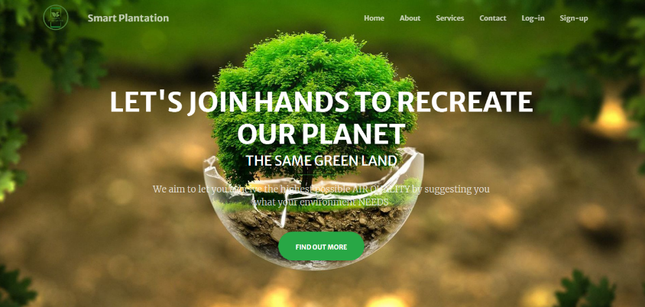The index has brief description of all components provided on website including device, services, plant, seeds.

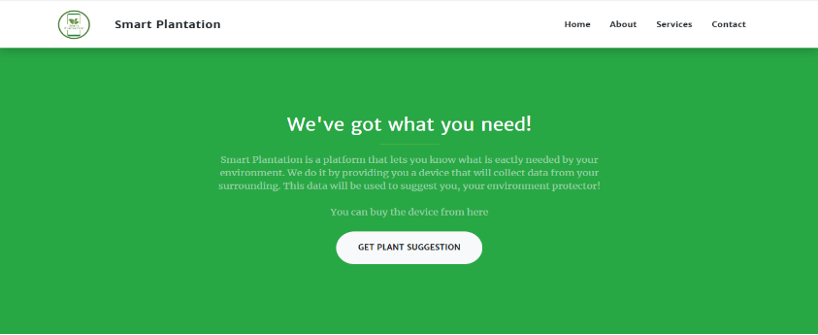

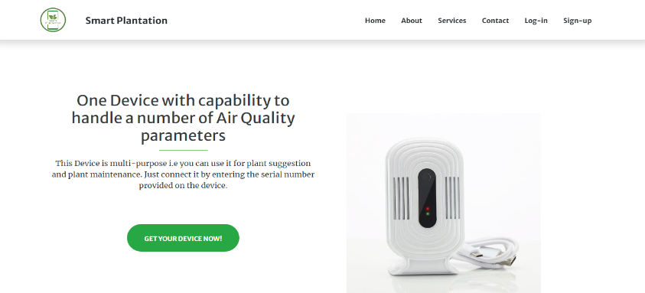

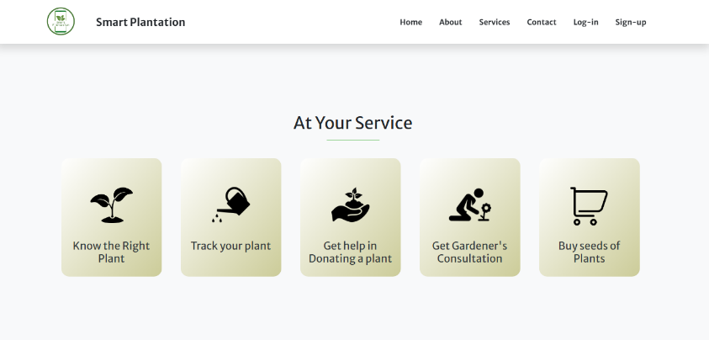

Figure 4.1 Homepage

**4.1.2 Buy-Device Page**

Description of device along with a form through which user can make order for device.

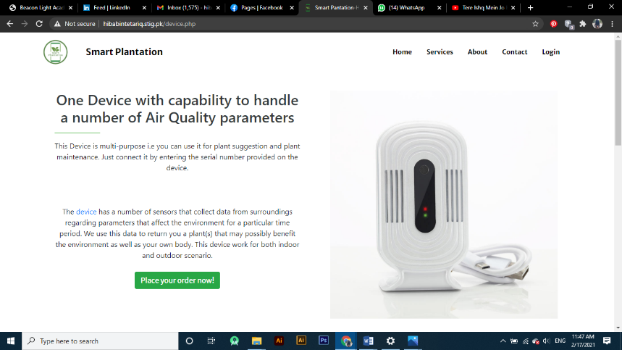

Figure 4.2 Buy Device Page

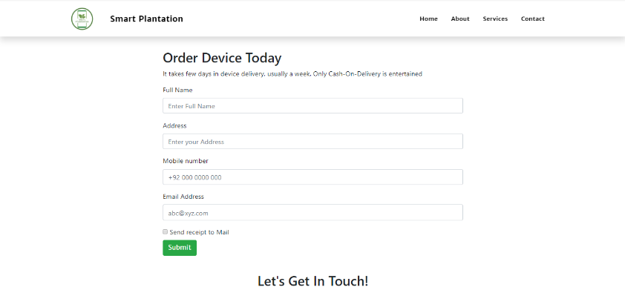

### 4.1.3 Gardener-Services

This page has display of what services our registered gardeners are providing along with a form through which services can be requested.

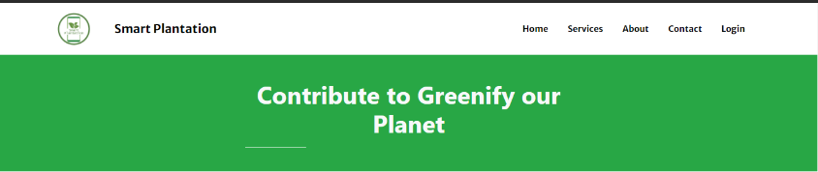

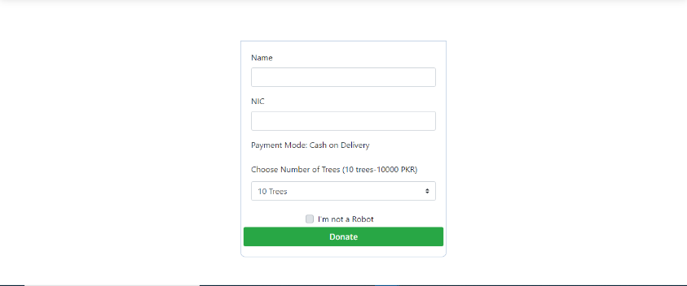

Figure 4.3 Donation page

### 4.1.4 Gardener-Services

This page has display of what services our registered gardeners are providing along with a form through which services can be requested.

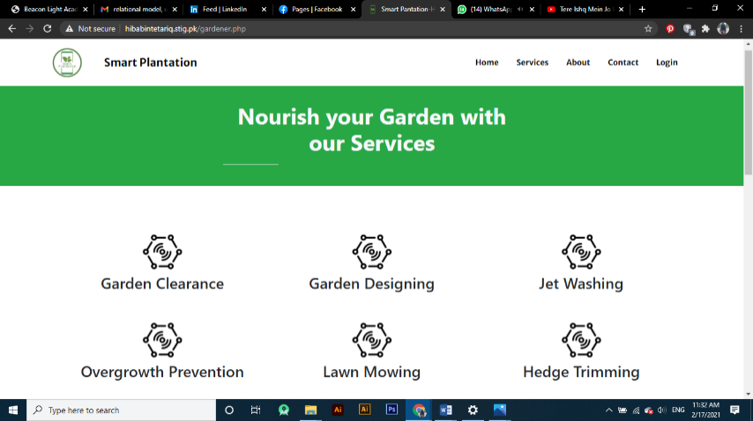

Figure 4.4 Gardener page

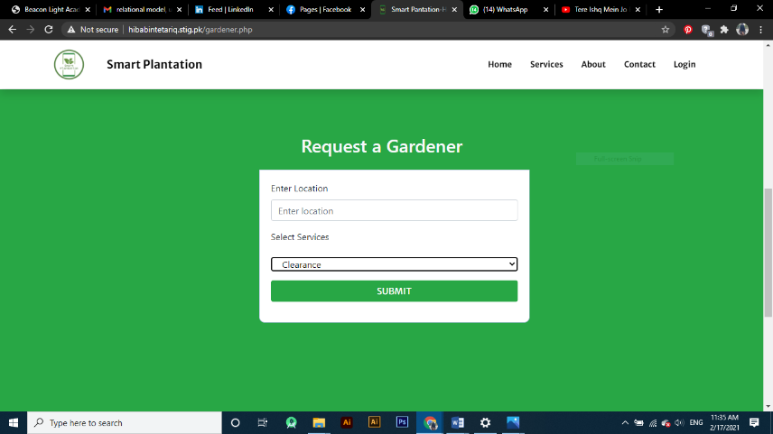

### 4.1.5 Buy-Seeds

It has all of seeds that can be ordered and they are displayed in card view along with price and brief description.

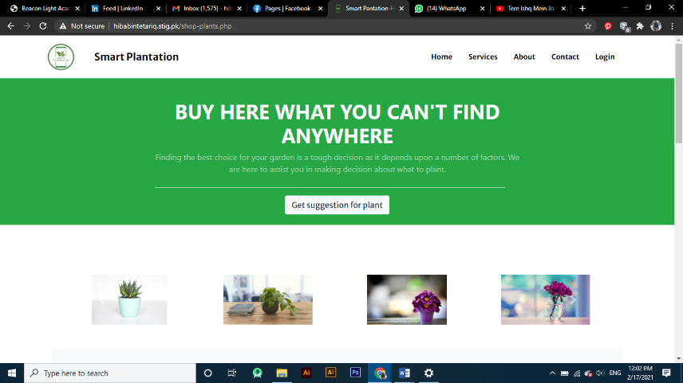

Figure 4.5 Buy Seeds (1)

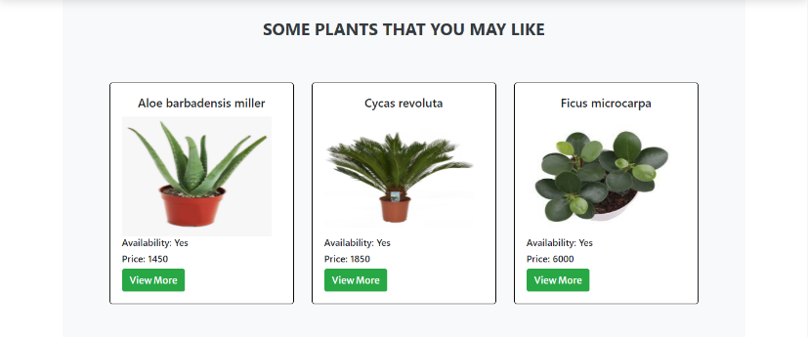

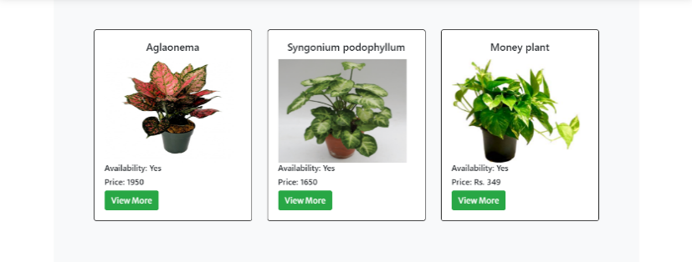

Figure 4.6 Buy Plants (2)

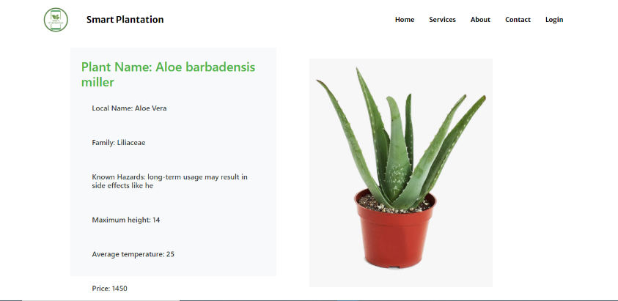



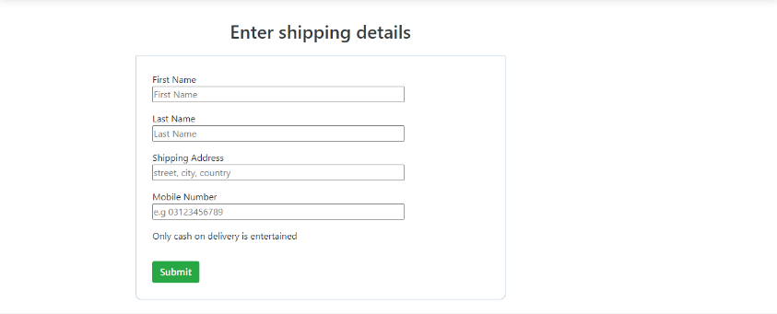

Figure 4.7 View Plant

Figure 4.8 Checkout

**4.2 Hardware Interface**

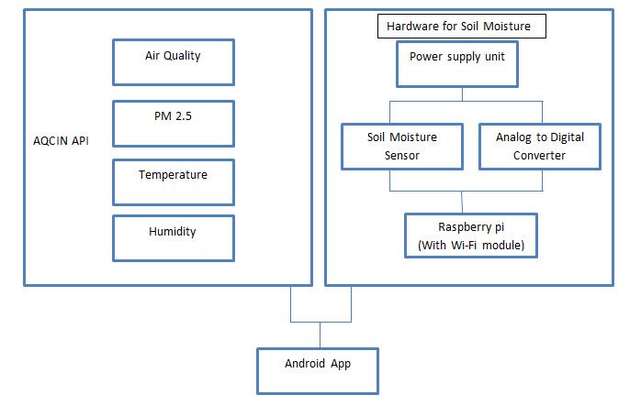

## 4.3 Mobile User Interface

Figure 4.9 Hardware Interface



### 4.3.1 Cart

It has all of seeds that can be ordered and they are displayed along with price and brief description.

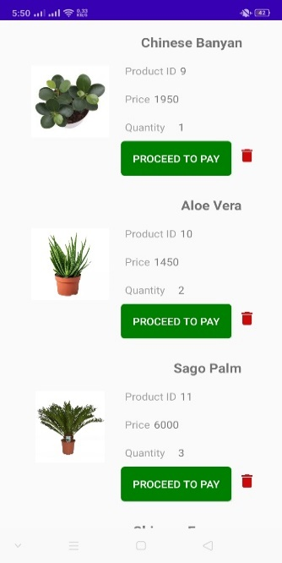

Figure 4.10 Cart

### 4.3.2 Prediction

It suggests plants according to the environment parameters.

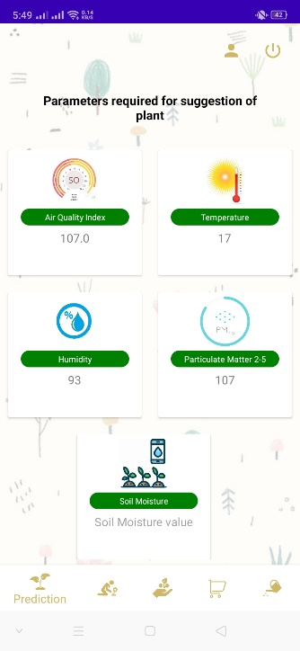

Figure 4.11 Prediction

### 4.3.3 Plant Description

It has the brief description of all of the plants.

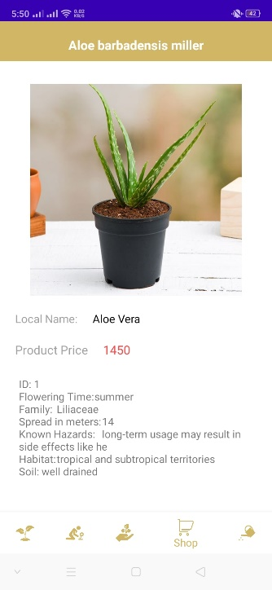

Figure 4.12 Plant Description

### 4.3.4 Donation

It contains donation form for those consumers who want to donate plants.

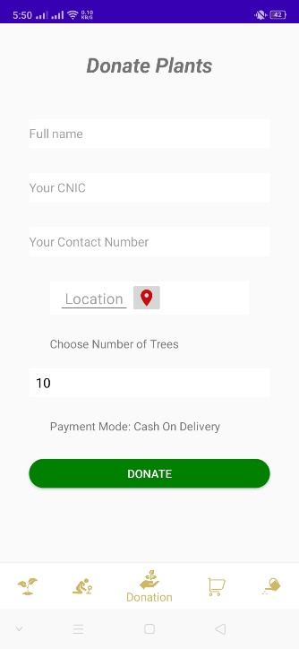

Figure 4.13 Donation

### 4.3.5 Plant Maintenance

It keeps check on all the parameters required for maintaining plant condition.

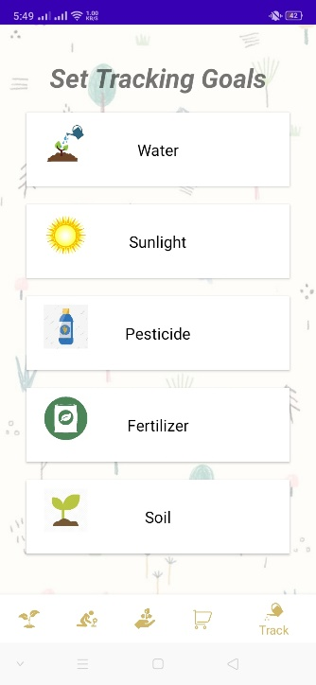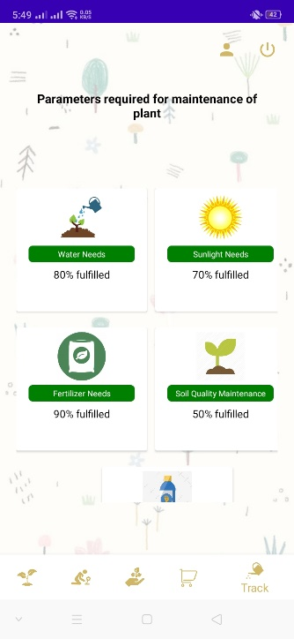

Figure 4.14 Maintenance (1)

Figure 4.15 Maintenance (2)

### 4.3.6 Gardener

It provides gardener’s consultation for consumers.

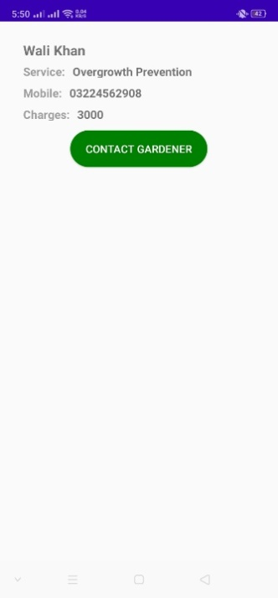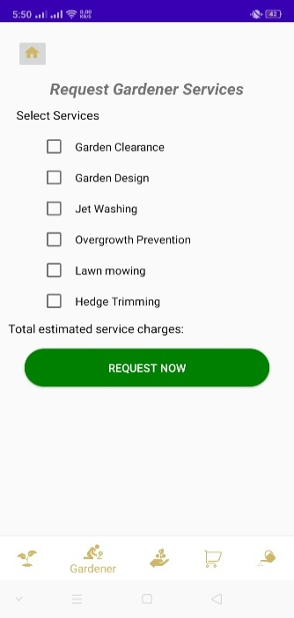

Figure 4.16 Gardener (1)

Figure 4.17 Gardener (2)

# Chapter 5

# METHODOLOGY

## 5.1 Agile Process Model

The process model which is used to develop this system is agile process model. Each phase of agile modelling is implemented with multiple iterations based on the reviews.

We selected this process model because implementation was based on the constant reviews and changes in requirements. Following are the phases, crossed by the system to reach its final milestone.



### 5.1.1 Requirement Gathering

The first step taken was gathering the requirements where we actually defined the scope and the features of the system. Since Smart Plantation is based on a hardware unit too that’s why requirements for hardware like best sensors and microcontroller, were all taken into the consideration.

### 5.1.2 Designing

The next phase of an iteration was designing where we drew UML diagrams in order to understand the flow of the system. In this phase, along with the UML diagrams, we also made web and app prototype using the tools mentioned in chapter 3.

### 5.1.3 Implementation

Implementation of the system was split into 3 major parts. Firstly we made web application where we implemented the features of website like buy hardware, ecommerce and gardeners’ consultations. After spending a time on website, we side by side moved towards the implementation of mobile app’s features which were same as website, but with the addition of prediction and tracking a plant’s module. After completing the implementation of mobile and website, admin panel was made.

### 5.1.4 Testing

The testing procedure was applied on every iteration. Therefore, every error/bug there, was aimed to be resolved at the initial stage.

## 5.2 Project Plan According to Agile Methodology

Table 1. Sprint Planning

|  |  |  |  |  |  |  |  |  |  |
| --- | --- | --- | --- | --- | --- | --- | --- | --- | --- |
| Project Name | Project Manager | | | Start Date | | End Date | | Overall Progress | |
| Smart Plantation | Surayya Obaid | | | 1st January 2020 | | 31st December 2020 | | 100% | |
| Project Deliverables | | Mobile App, Website, Hardware module for prediction. | | | | | | | |
| Scope Statement | | The system is covering a vast area of environmental conditions, to revert the hazardous impacts of climatic changes. For such purpose, predictions is done for plants according to the environment, via a hardware unit. With that, module for alerts for maintenance, gardener’s consultation and e-commerce is developed for further continence of a user. | | | | | | | |
| Task Name | | | Start Date | | End Date | | Responsible | | Status |
| Sprint 1- Requirements Gathering | | | | | | | | | |
| Gather functional and non-functional requirements for the product | | | 1st Jan | | 30th Jan | | Aimun Tahir, Hiba Binte Tariq, Namrah Komal, Surayya Obaid | | Done |
| Gather Plants’ data | | | 20th Jan | | 28th Feb | | Aimun Tahir, Hiba Binte Tariq, Namrah Komal, Surayya Obaid | | Done |
| Gather information for hardware products | | | 28th Feb | | 15th March | | Hiba Binte Tariq, Surayya Obaid | | Done |
| Sprint 2 - Designing | | | | | | | | | |
| Draw UML Diagrams | | | 10st March | | 31st March | | Aimun Tahir, Namrah Komal | | Done |
| Design Mobile app Prototype | | | 20th March | | 15th April | | Hiba Binte Tariq, Surayya Obaid | | Done |
| Sprint 3 - Development | | | | | | | | | |
| Website Development | | | 16st April | | 15h May | | Aimun Tahir, Namrah Komal | | Done |
| App development(Prediction Module and Tracking module) | | | 16th May | | 30th June | | Aimun Tahir, Namrah Komal, Hiba Binte Tariq, Surayya Obaid | | Done |
| App development(E-commerce module, gardener module) | | | 30th June | | 20th August | | Hiba Binte Tariq, Surayya Obaid | | Done |
| Sprint 4 - Hardware Assembling | | | | | | | | | |
| Collect required hardware components | | | 21st August | | 10th Sept | | Aimun Tahir, Namrah Komal | | Done |
| Create hardware module | | | 11th Sept | | 15th Oct | | Hiba Binte Tariq, Surayya Obaid | | Done |
| Sprint 5 - Integration& Testing | | | | | | | | | |
| Integrate Hardware modules with product | | | 16th Oct | | 31st Oct | | Aimun Tahir, Hiba Binte Tariq, Namrah Komal, Surayya Obaid | | Done |
| Test Hardware Unit | | | 1st Nov | | 15th Nov | | Aimun Tahir, Namrah Komal | | Done |
| Test software product | | | 15th Nov | | 30st Nov | | Hiba Binte Tariq, Surayya Obaid | | Done |
| Test complete product on site | | | 1st Dec | | 31st Dec | | Hiba Binte Tariq, Surayya Obaid | | Done |

# Chapter 6

# IMPLEMENTATION DETAILS

We have made database using MySQL. Same is used within APIs to keep data synchronized across both platforms i.e. Website and Android application. Next section includes views of tables we have included in our database.

## 6.1 Database Design

### 6.1.1 User Table

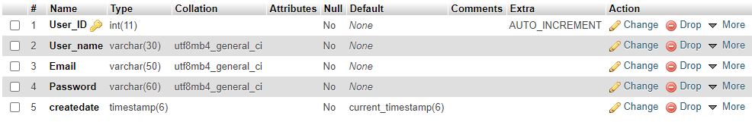

### 6.1.2 Buyer Table



### 6.1.3 Gardener Table

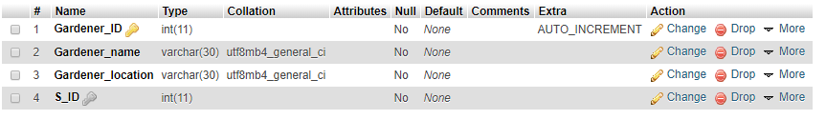

### 6.1.4 Gardener payment Table

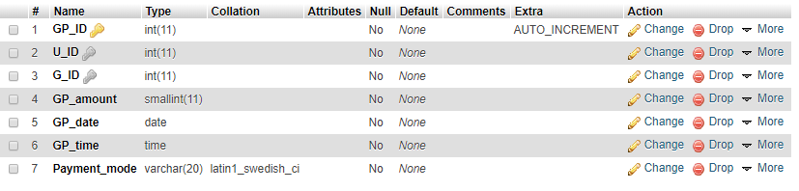

### 6.1.5 Plant Table

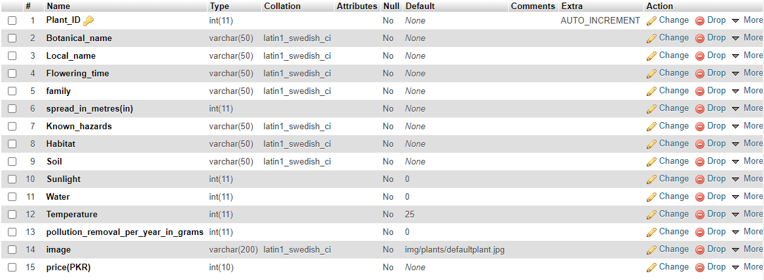



### 6.1.7 Plant Table

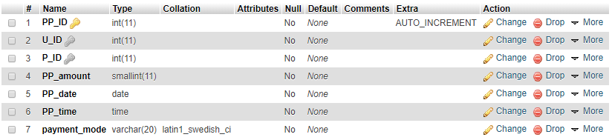

### 6.1.8 Plant Table



## 6.2 Web Services



### 6.2.1 Admin-Side Services

* Admin-Log-In: Admin logs in the system through this.
* Add-Services: It lets the Administrator add any new service through the Admin panel.
* Update-Services: Any change in terms of services is be handled by Admin through Update-Service in Admin-panel.
* Add-Gardener: Any new gardener willing to provide services, is registered in the database, and info about the services is shown on the respective webpage.
* Update-Gardeners: If any update is provided about any gardener, it is handled through the same panel by the administrator.
* Process-Request-for-Device: The whole process of device request doesn’t need Admin to handle it but Admin has to keep an eye over the requests so that if there is any fault or issue (like shortage of devices at the moment of request), admin has to handle it.
* Proceeds-Order-Fulfilment-for Device/Plant: Admin proceeds the order by sending confirmation to the user after ensuring the availability of ordered stuff.

### 6.2.2 Web-Side Services

* User-Registration: User is registered in the database after signing in.
* User-Log-In: This enables the user to use all the services provided on the site.
* Ordering-Device: It lets the user make orders for the device.
* Ordering-Seeds: It lets the user make orders for desired or suggested seeds.
* Request-for-Gardeners Services: Gardeners’ services can be requested on the web as well with the help of a form.

### 6.2.3 Mobile-Side Services

* User_Registration: User is registered in the database after signing in.
* User_Log_In: This enables the user to use all the services provided on the mobile application.
* Get_plant_suggestion: This method triggers the system to display the list of suitable plants on the basis of data collected through the hardware.
* Display_plants: This method will display a digital plant nursery from where the user can buy the seeds of the plants suggested by the system.
* Order_plants: This method enables the user to make an order for seeds of the required plant.
* Request_a_gardener: The method brings a request form to the user to fill the input fields and mark the services to avail.
* Display_gardener: This method brings a list of nearby gardeners on the basis on the requested form.
* Donate_for_plantation: This method is used to donate an amount for plantation campaign via different payment modes.



## 6.3 Mobile App Development

Mobile app has been developed successfully with fulfillment of all the requirements which include the data insertion of plants for plants prediction and e-commerce and data of available registered gardeners.

## 6.4 APIs Development

Data on Android app and website are synced with the help of web services. So far, APIs for registration and other modules have also been developed.

User can register and login both on android app and website with same credentials as the data is synced at backend. We have using MySQL database for the project.

## 6.5 APIs Used In Prediction Module

For prediction of plants, we needed real-time data of Air Quality, Particulate Matter 2.5, temperature, humidity and soil moisture. These requirements were fulfilled with the help of combination of APIs and hardware. We have used API of AQICN which aims to provide real-time data related to Air Quality of about 2000 major cities around the globe. They provide Air Quality Index, PM 2.5, current and 3 day forecast of temperature and humidity. Data was provided in JSON format which we are displaying in the app in prediction module. For soil moisture value, we have used sensor and analog to digital converter along with ESP to get the data.

## 6.6 Deployment

### 6.6.1 Web Application Deployment

Web application is hosted on domain stig.pk and is currently accessible with the URL smartplantation.stig.pk.



### 6.6.2 Mobile Application Deployment

An android app of this system is accessible through Goggle play store.

# Chapter 7

# TEST CASES

## 7.1 Test case for login

Here we have manually tested the response of the system when correct as well incorrect data is entered and system’s behavior when fields are kept blank while logging in.

Table 2. Log-in Test Cases

|  |  |  |  |  |  |
| --- | --- | --- | --- | --- | --- |
| **TU01** | **Test Scenario** | **Test Data** | **Expected Results** | **Actual Results** | **Pass/Fail** |
| TU01 | Check Customer Login with valid Data | Email = obaidmusab  @gmail.com Password =  202cb962ac59075 | User should Login into app | As Expected | Pass |
| TU01 | Check Customer Login with invalid Data | Email = obaidmusab  @gmail.com Password = glass99 | User should not Login into app | As Expected | Pass |
| TU01 | Check customer login with empty fields | Email =  Password = | User should not Login into an application and error message appears of fill out the fields | As expected | Pass |

## 7.2 Test case for signup

The process of signing up has some constraints that user must consider while proceeding for it. In following test case, different combinations of input fields including email, password and user name were checked to analyze system’s response. System seems to be accurate in case of processing and responding accordingly.

Table 3. Sign-up Test Cases

|  |  |  |  |  |  |
| --- | --- | --- | --- | --- | --- |
| **Test Case ID** | **Test Scenario** | **Test Data** | **Expected Results** | **Actual Results** | **Pass/Fail** |
| TU01 | Check new Customer Registration | For eample  Username = Hiba Tariq  Email =  Hibabintetariq  @gmail.com Password =  202cb962ac59075  Confirm Password=  202cb962ac59075 | User successfully registered and become a member | As Expected | Pass |
| TU02 | Check Customer Registration with password less than 8 characters | Username = Hiba Tariq  Email = Hibabintetariq  @gmail.com Password = glass99  Confirm  Password = glass99 | Message should occur “Password should be at least 8 characters | As Expected | Pass |
| TU03 | Check Customer Registration with incorrect/ unmatched confirm password | Username = Hiba Tariq  Email = Hibabintetariq  @gmail.com Password =  202cb962ac59075  Confirm  Password = glass99 | User should not Login into an application and error message appears “Passwords don’t match” | As expected | Pass |
| TU04 | Check customer registration with already registered email | Username = Hiba Tariq  Email = Hibabintetariq  @gmail.com Password =  202cb962ac59075  Confirm  Password = 202cb962ac59075 | Error message appears “mail already exists in our database” | As expected | Pass |
| TU05 | Check customer registration by entering user name less than 5 characters | Username = Hiba  Email = Hibabintetariq  @gmail.com Password =  202cb962ac59075  Confirm  Password = 202cb962ac59075 | Error message appears “ username should be at least 5 characters | As expected | Pass |

## 7.3 Test cases for ordering device

System entertains order placement for device only on website. Here we have checked combination of different input fields.

Table 4. Device Ordering Test Cases

|  |  |  |  |  |  |
| --- | --- | --- | --- | --- | --- |
| **Test Case ID** | **Test Scenario** | **Test Data** | **Expected Results** | **Actual Results** | **Pass/Fail** |
| TU01 | Place an order for device by filling the valid details required in form | For eample  Full name = Hiba Tariq  Address = Shahrah e faisal, Karachi, Pakistan  Mobile number  +92 345 0259090  Email address:  Hibatariq98  @gmail.com | Order successfully  placed | As Expected | Pass |
| TU02 | Place an order without login | Full name = Hiba Tariq  Address = Shahrah e faisal, Karachi, Pakistan  Mobile number = +92 345 0259090  Email address = Hibatariq98  @gmail.com | Message should occur “Order cannot be placed without login” | As Expected | Pass |
| TU03 | Check if user click on submit with empty fields | Full name =  Address =  Mobile number  Email address: | Error Message should occur “fill out the fields” | As expected | Pass |

## 7.4 Test case for requesting a gardener

System provides users facility to gain access to credentials of gardeners relevant to their needs. Different sets of inputs and actions were checked for analyzing response.

Table 5. Gardner Module Test Cases

|  |  |  |  |  |  |
| --- | --- | --- | --- | --- | --- |
| **Test Case ID** | **Test Scenario** | **Test Data** | **Expected Results** | **Actual Results** | **Pass/Fail** |
| TU01 | Requesting a gardener by entering incomplete location | Entering Incomplete location | User should not be directed to the page of gardeners list | As Expected | Pass |
| TU02 | Requesting a gardener by entering complete location and selecting services | Entering complete location  Select services from the drop down list of services | User should directed to the page of gardeners list | As Expected | Pass |

## 7.5 Test case for checkout form

For order completion, user is asked to fill up the form fields necessary to process order. In following test case, we have checked the responses for different inputs.

Table 6. Checkout Test Cases

|  |  |  |  |  |  |
| --- | --- | --- | --- | --- | --- |
| **Test Case ID** | **Test Scenario** | **Test Data** | **Expected Results** | **Actual Results** | **Pass/Fail** |
| TU01 | Check whether Checkout form filled according to the validations | 1. First Name = Namrah 2. Last Name = Komal 3. Shipping Address = Maymar, Karachi, Pakistan 4. Mobile Number = 0333 3497972 | Details shown to the user below and order should be placed | As Expected | Pass |
| TU02 | Check if the user entered incomplete location | 1. First Name = Namrah 2. Last Name = Komal 3. Shipping Address = Karachi 4. Mobile Number = 0333 3497972 | Error message should occur “ Please match the requested format” | As Expected | Pass |
| TU03 | Check if the user enter number in the field of name | 1. First Name = 22 2. Last Name = Komal 3. Shipping Address = Karachi 4. Mobile Number = 0333 3497972 | Error messae should occur “Please match the requested format” | As Expected | Pass |

# Conclusion

Smart Plantation envisions bringing societal contribution in reversing the climate change that is slowly poisoning the atmosphere of the planet. Key concept behind it is making ‘planting what’s needed’ easy for even the ones who don’t have sufficient knowledge of plantation. User can easily access the required information regarding plants with the help of android application where they can see real time values related to the environmental parameters read by the device. Device with sensors is attainable via website only with cash-on-delivery as payment method. While assistance in gardening and plants store can be approached through both application and website. On the other hand, there’s an admin portal for admin to handle admin-side service

As masses are gaining awareness about the need for plantation, there comes the need for a force that may help in channelizing campaigns for plantation. The idea of involving community or neighborhood in restoring forest and urban green habitats turned out to be successful in Philippines as they were able to regrow forest on vast area[4]. Therefore we will be assisting users (via donation module) to donate for the areas that need plantation critically by helping them in initiating plantation campaigns.

# REFERENCES

[1] “Mass plantation of conocarpus: a disaster in the making - Daily Times.” https://dailytimes.com.pk/49462/mass-plantation-of-conocarpus-a-disaster-in-the-making/ (accessed Sep. 27, 2020).

[2] A. Dhabi and S. Al, “The reality of Damas planting in Abu Dhabi city - 2014,” 2014.

[3] “CDA plans to remove paper mulberry trees.” https://www.thenews.com.pk/print/294624-cda-plans-to-remove-paper-mulberry-trees (accessed Sep. 27, 2020).

[4] E. T. Carig, “Benefits and Constraints of Community-Based Forest Management in the Philippines,” no. October, 2018.

**Plagiarism Report**

