HTTP REQUEST MAPPING DIAGRAM

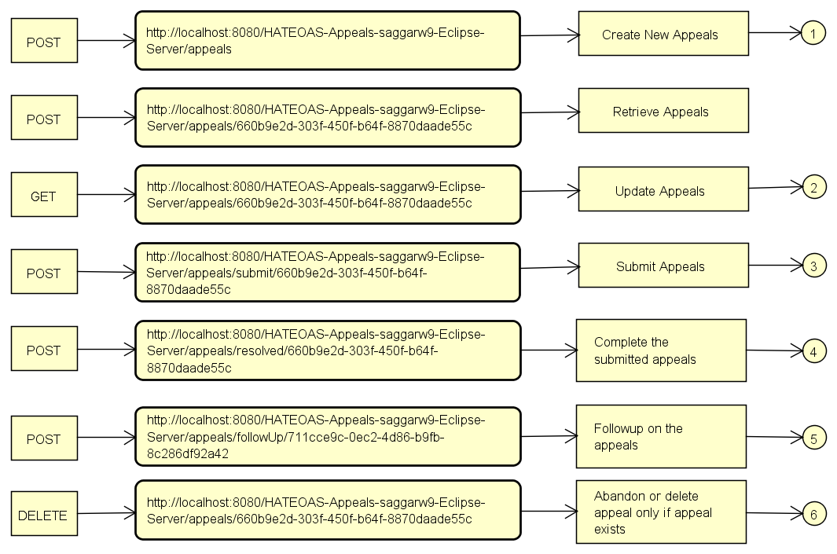

RESOURCE TRANSITION DIAGRAM

