The left view of binary tree corresponds to the nodes of the tree which would be visible to someone seeing the tree from its left side.

In simple words, it can be said that the **leftmost node of each level in the tree is considered in the left view of the binary tree**.

We can use both recursive and iterative approaches to print the left view of binary tree. Broadly we have two approaches -

* Using preorder traversal (Recursive approach).
* Using level order traversal (Iterative approach).

Let us initialize maxLevel with −1 and let the level of root be 0. Now the steps involved in the preorder traversal are mentioned below.

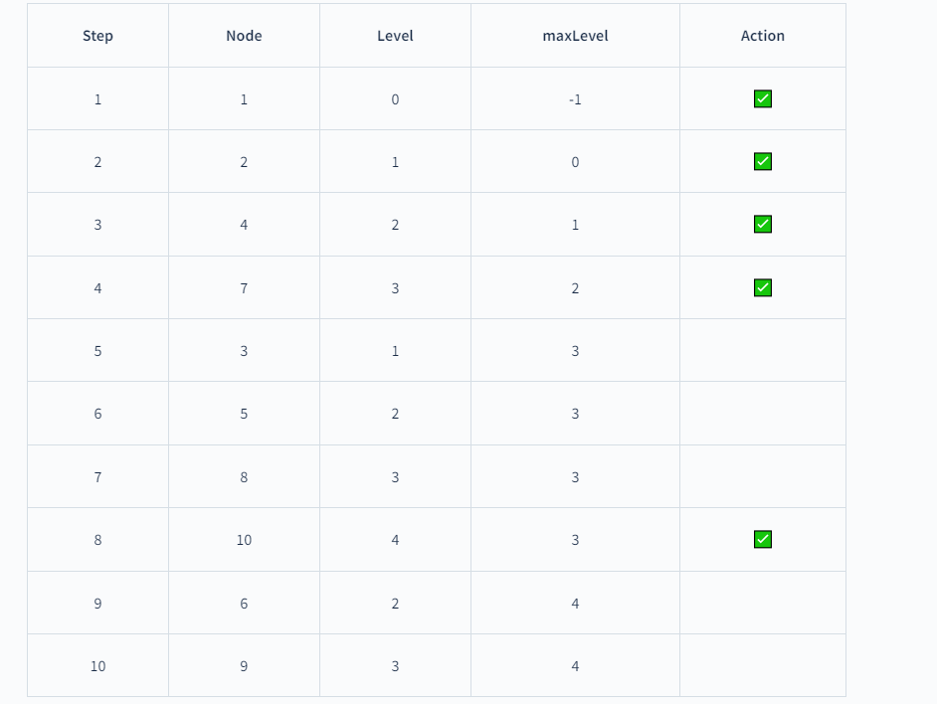

You can see in the above table, whenever **Level>maxLevel** we have included the node in the left view of the tree.