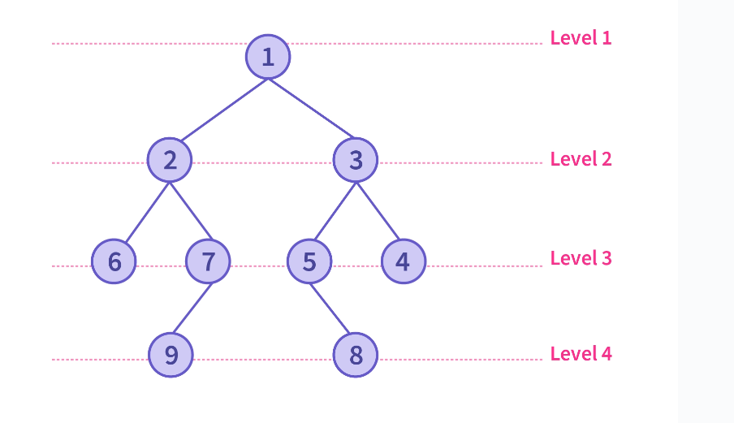

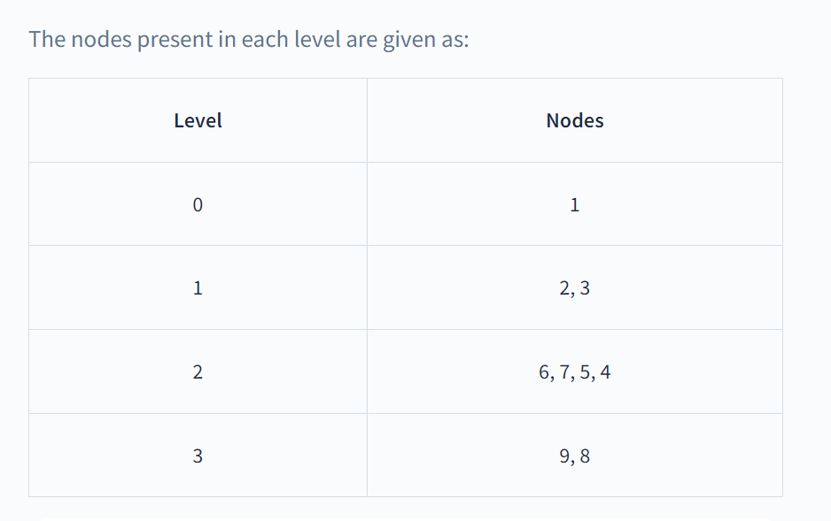

Please note that you can start labelling the levels from either 0 or 1.

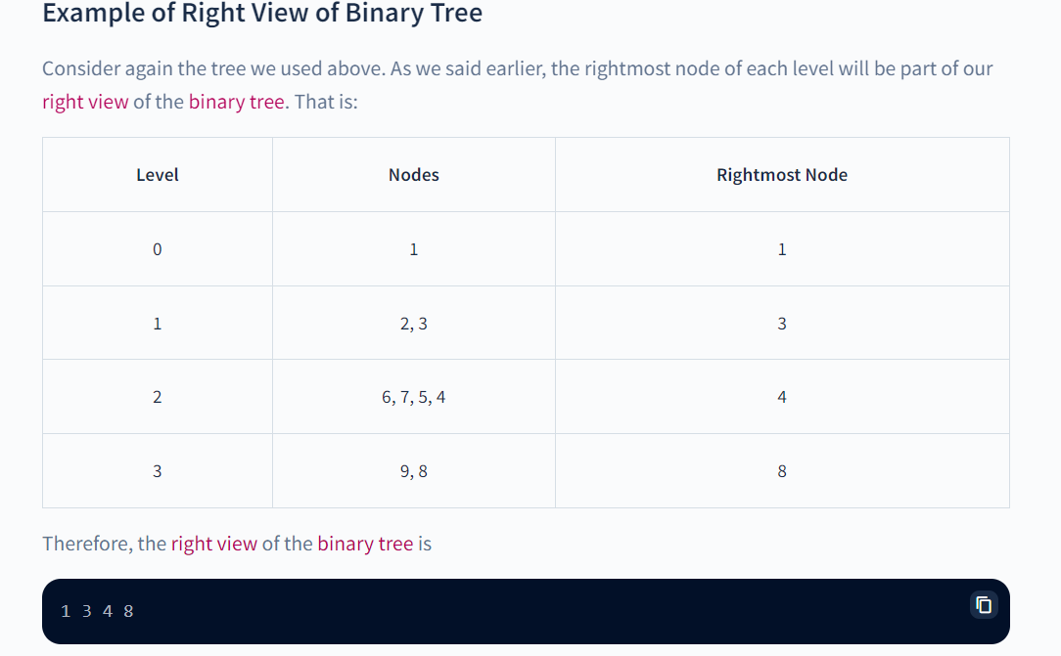

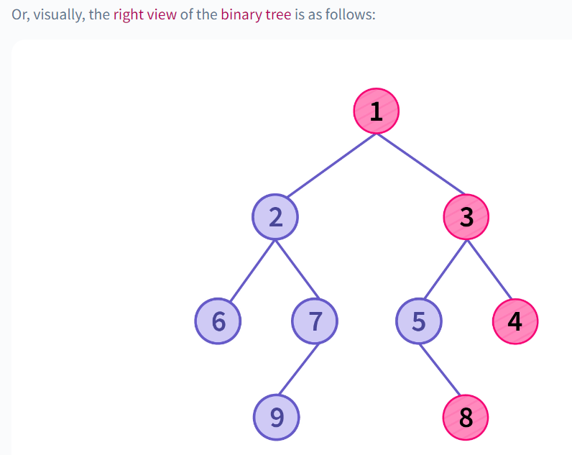

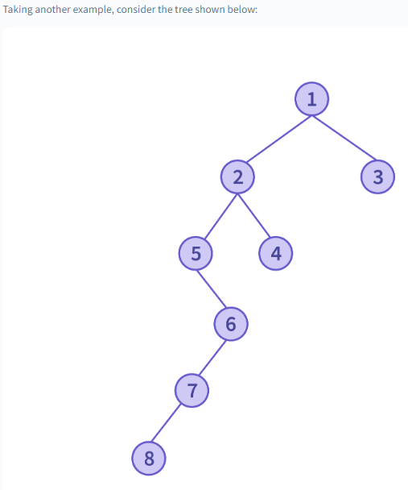

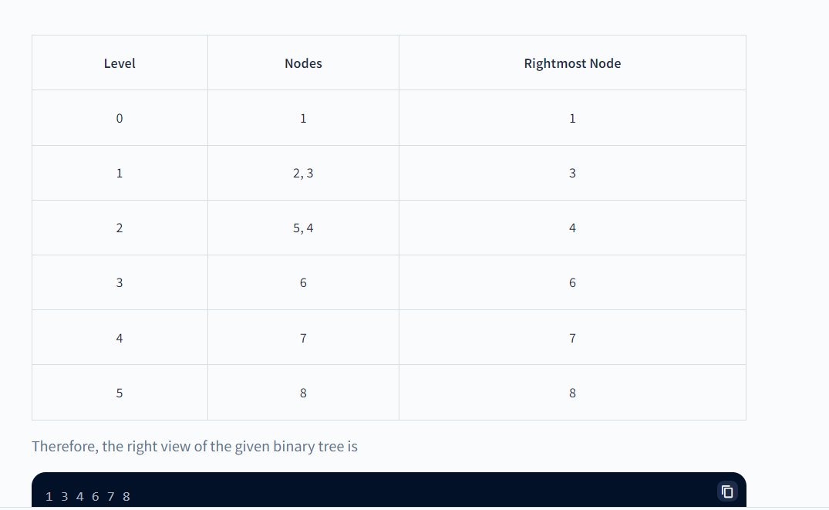

**Algorithm**

There are two approaches to solve this problem, one is recursive ([depth-first-search based](https://www.scaler.com/topics/depth-first-search-dfs-algorithm/)) approach, while the other is iterative ([breadth-first-search based](https://www.scaler.com/topics/breadth-first-search/)) approach.