DOCUMENTATION OF THE PROJECT

Q1a) Is the number of petitions with Data Engineer job title increasing over time?


b) Find top 5 job titles who are having highest avg growth in applications.[ALL]
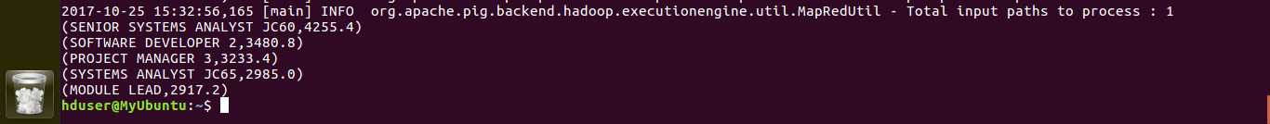
-----------------------------------------------------------------------------------------------------------

2 a) Which part of the US has the most Data Engineer jobs for each year?
Year 2011
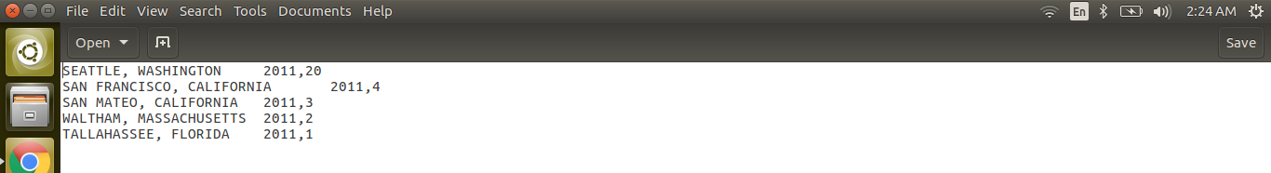

Year 2012
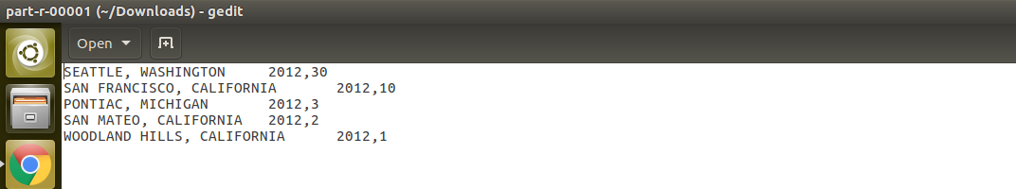

Year 2013
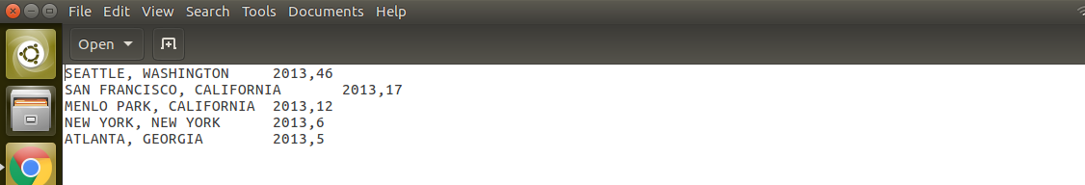

Year 2014

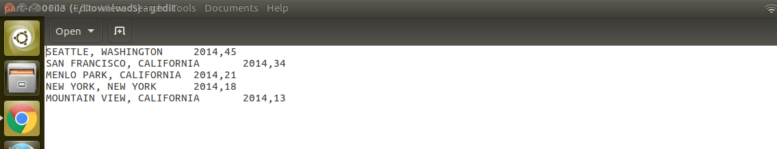

Year 2015

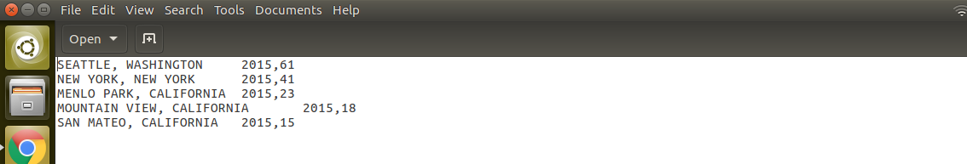

Year 2016
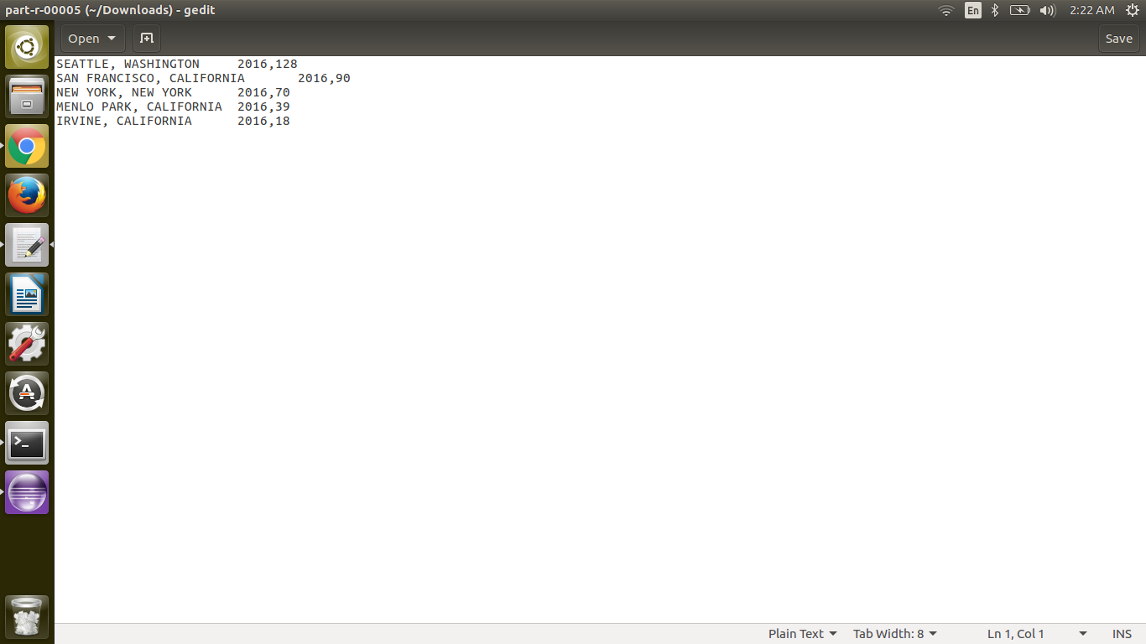

-----------------------------------------------------------------------------------------------------------

b) find top 5 locations in the US who have got certified visa for each year.[certified]
Year 2011
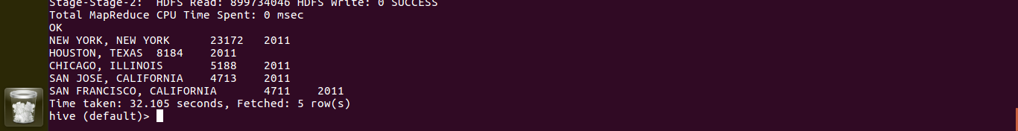
Year 2012
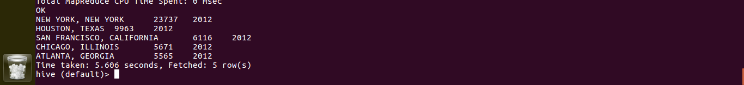
Year 2013
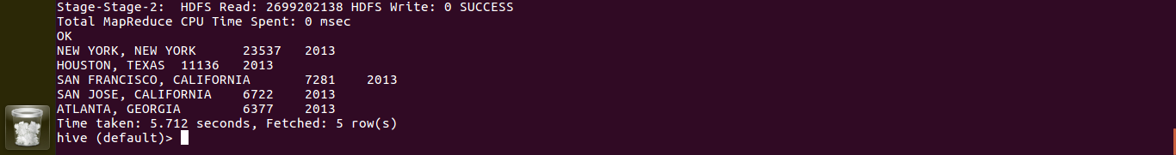
Year 2014
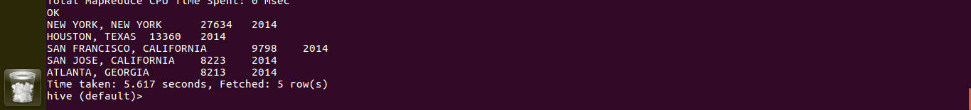
Year 2015

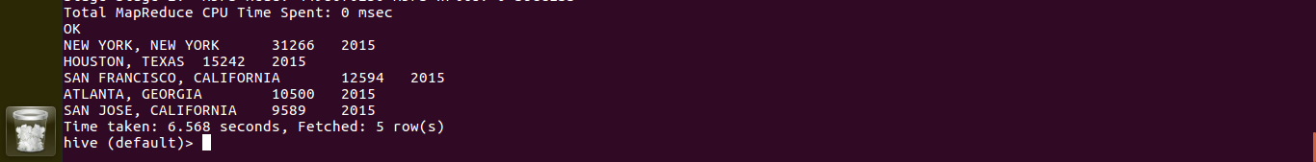

Year 2016

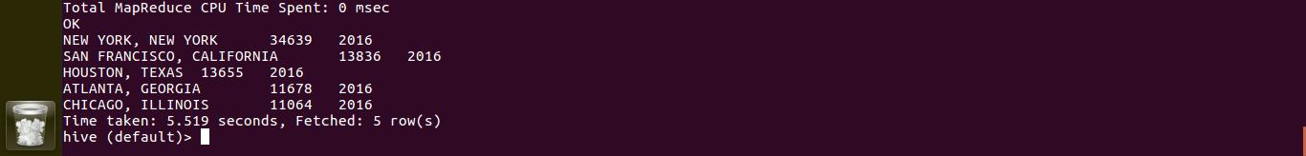
-----------------------------------------------------------------------------------------------------------
3)Which industry(SOC_NAME) has the most number of Data Scientist positions?
[certified]


-----------------------------------------------------------------------------------------------------------
4)Which top 5 employers file the most petitions each year? - Case Status – ALL
Year 2011

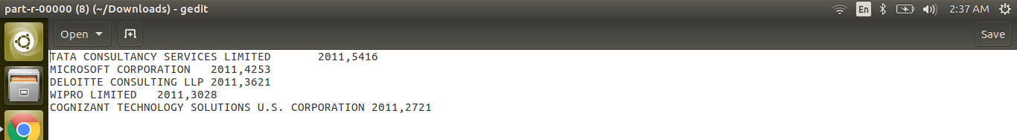
Year 2012

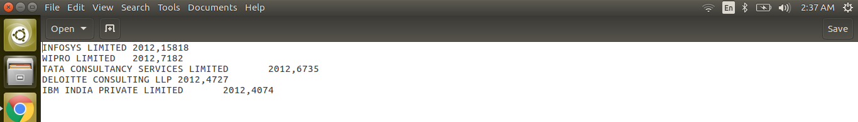
Year 2013

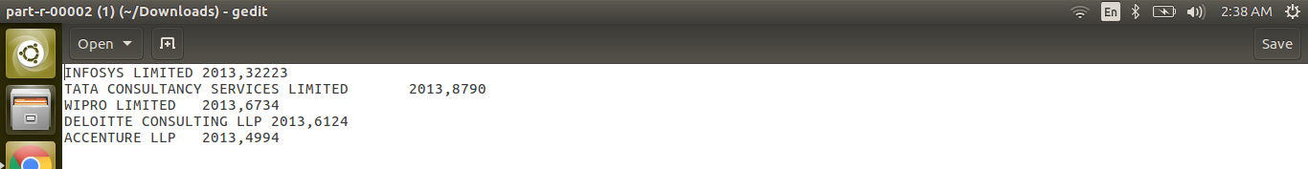
Year 2014

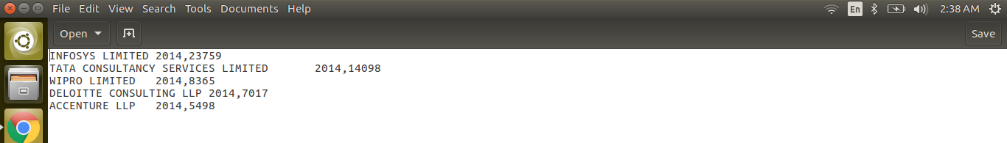

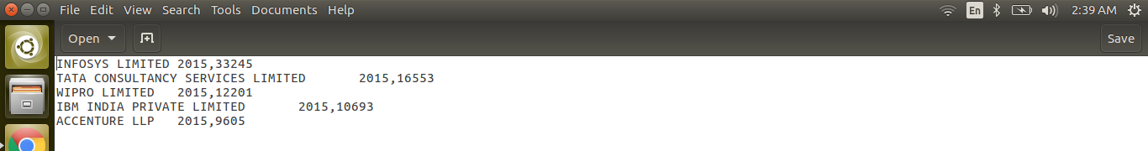

Year 2015

Year 2016
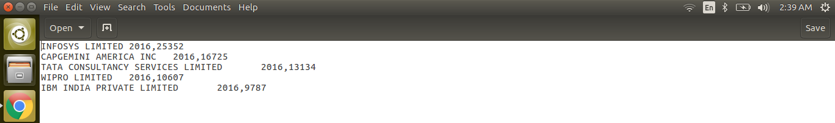
-----------------------------------------------------------------------------------------------------------
5) Find the most popular top 10 job positions for H1B visa applications for each year?
a) for all the applications
Year 2011
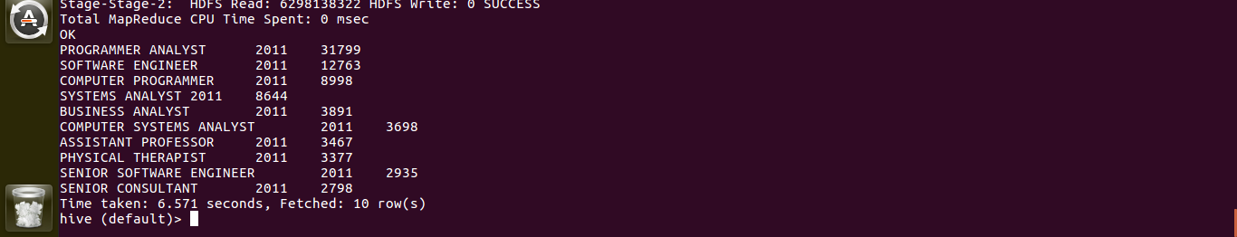

Year 2012
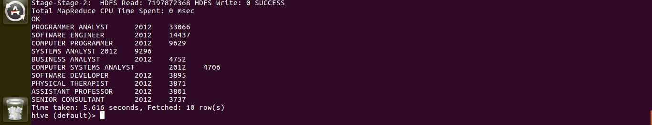

Year 2013

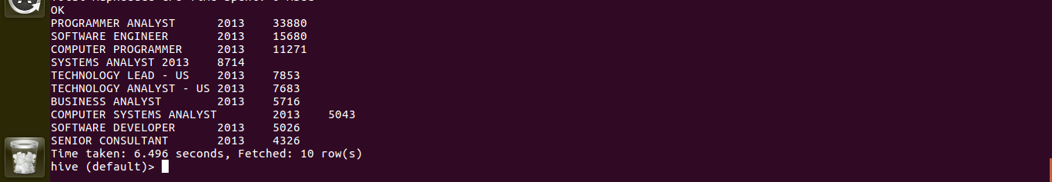
Year 2014

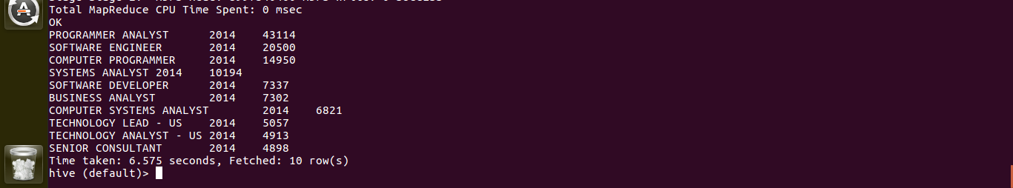
Year 2015
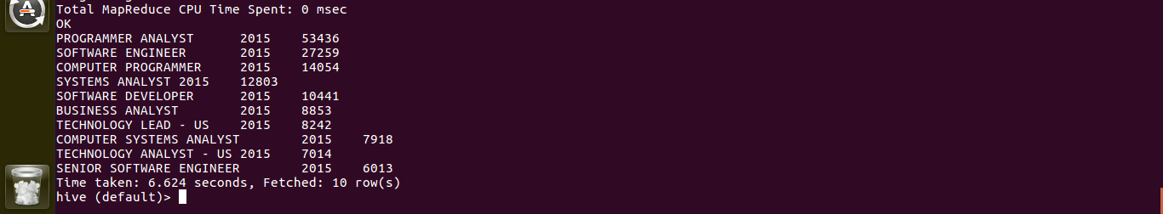

Year 2016

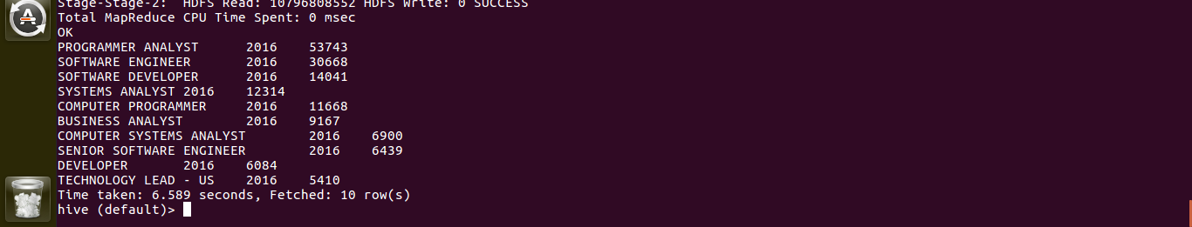
-----------------------------------------------------------------------------------------------------------
b) for only certified applications.

Year 2011
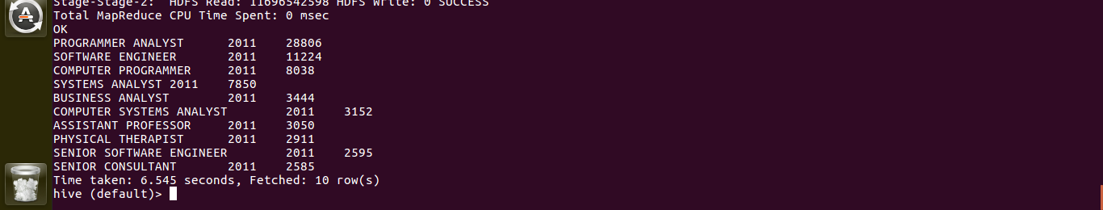

Year 2012
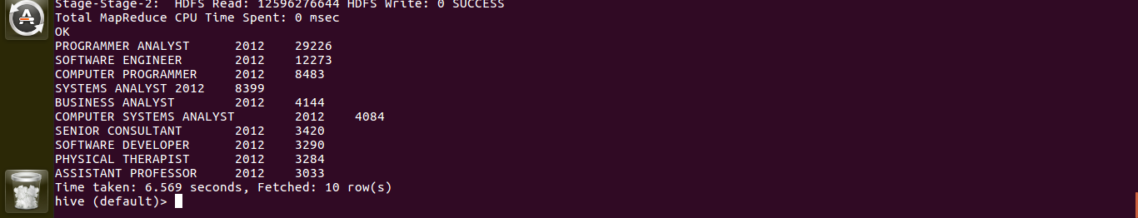

Year 2013
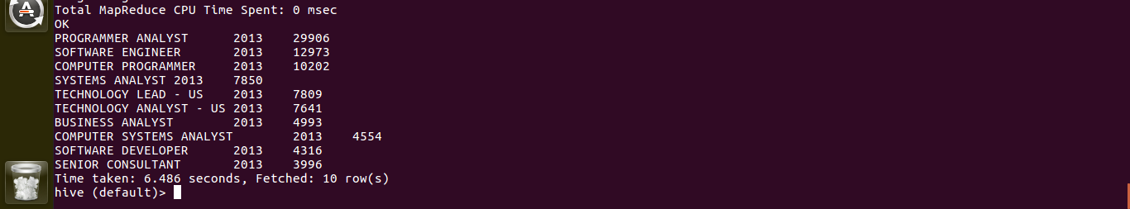

Year 2014
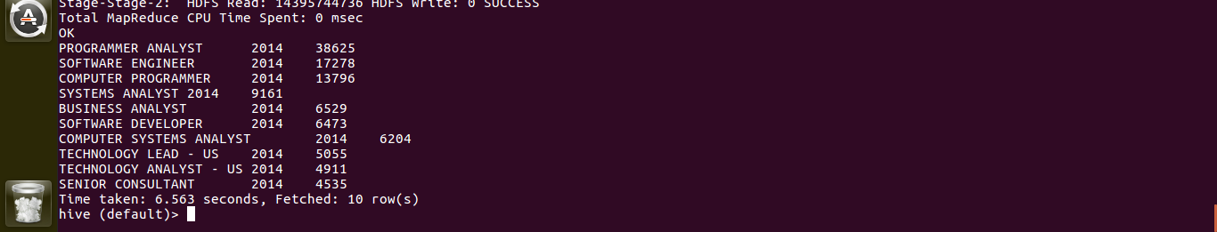

Year 2015
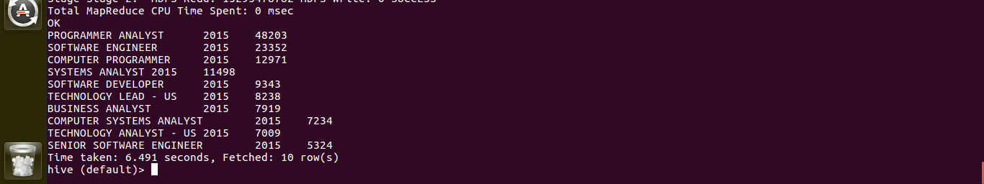

Year 2016
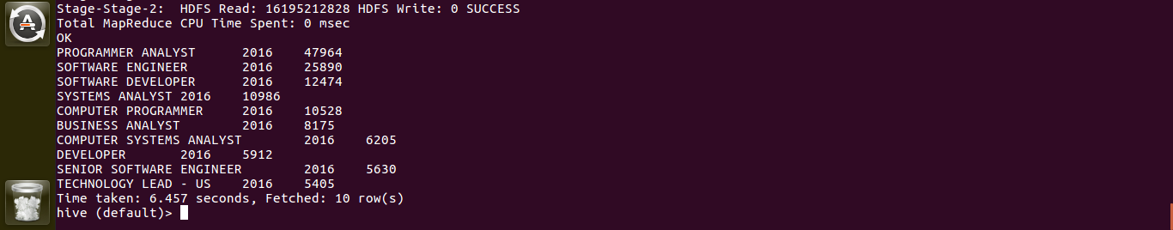

-----------------------------------------------------------------------------------------------------------
6) Find the percentage and the count of each case status on total applications for each year. Create a line graph depicting the pattern of All the cases over the period of time.
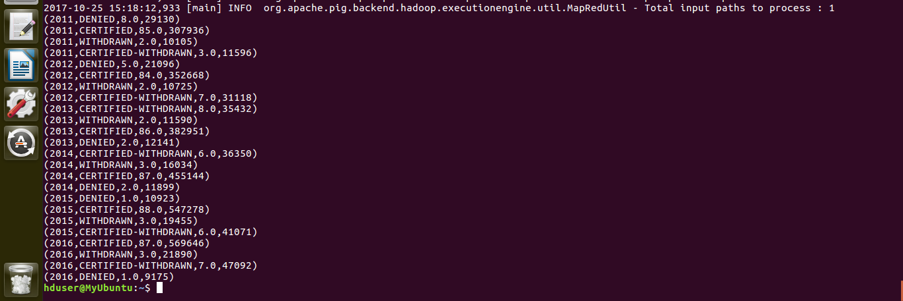
-----------------------------------------------------------------------------------------------------------
7) Create a bar graph to depict the number of applications for each year [All]
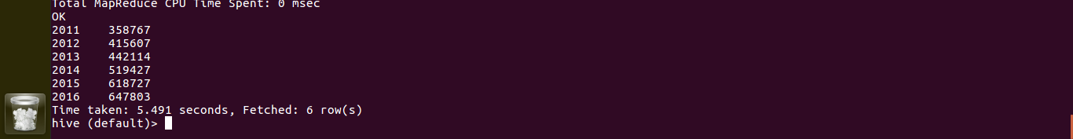

-----------------------------------------------------------------------------------------------------------
8) Find the average Prevailing Wage for each Job for each Year (take part time and full time separate). Arrange the output in descending order - [Certified and Certified Withdrawn.]
If choose Y option:

Year 2011
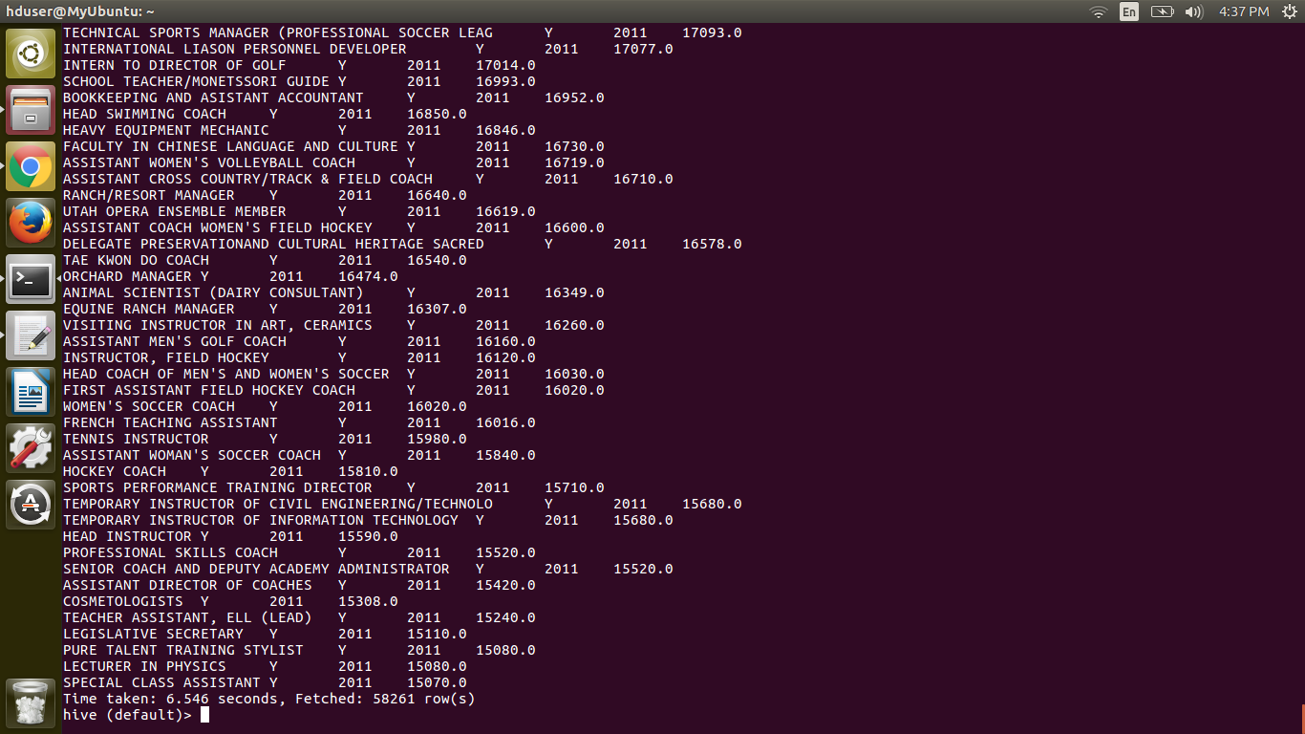
Year 2012
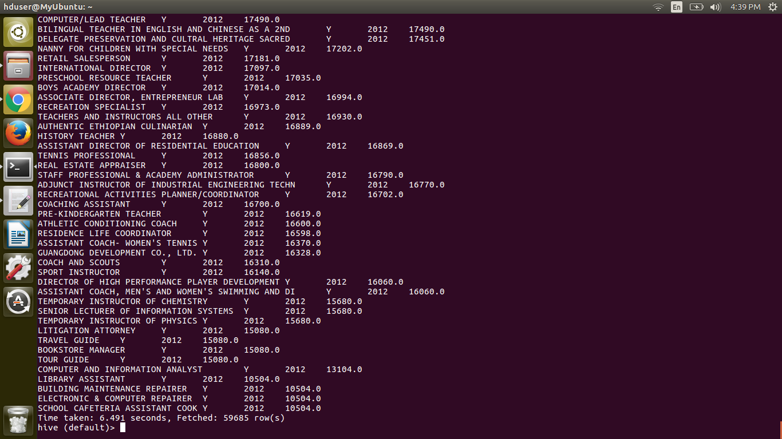
Year 2013
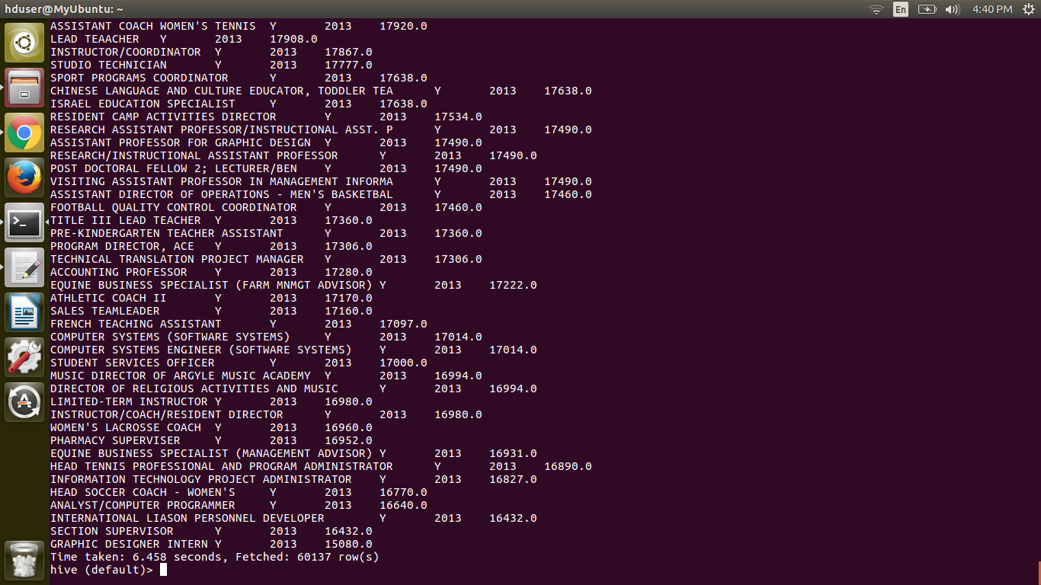

Year 2014
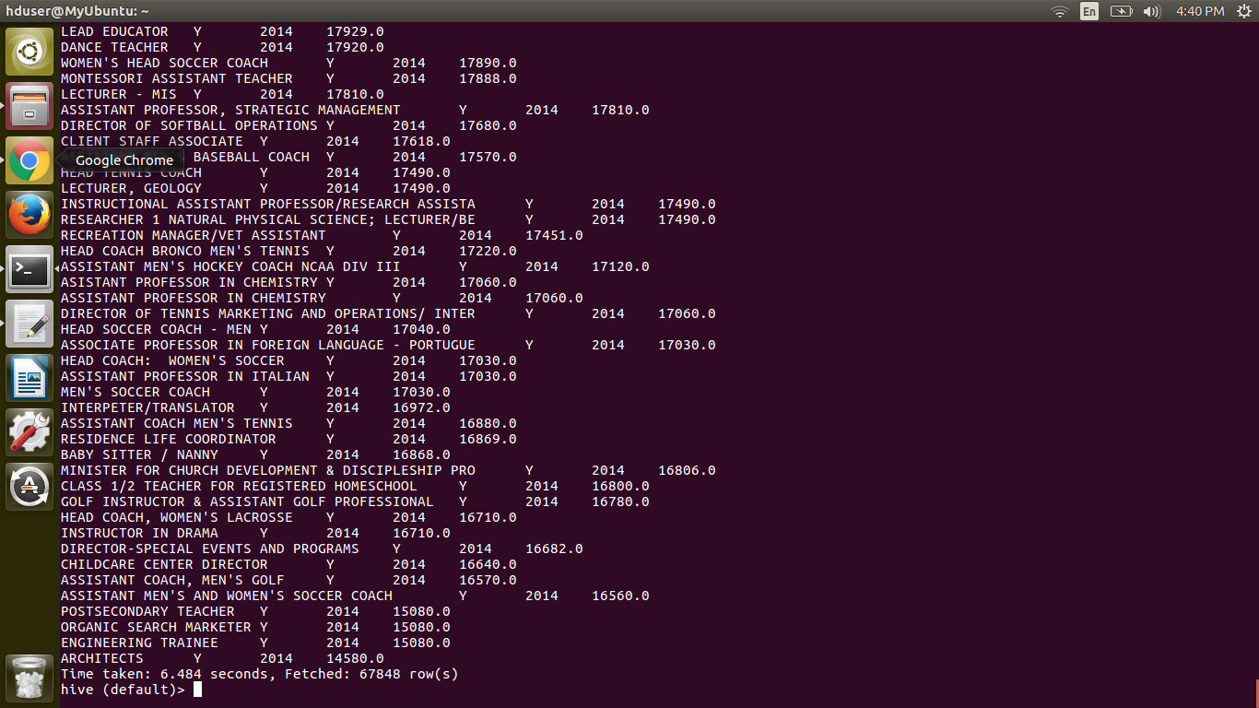

Year 2015
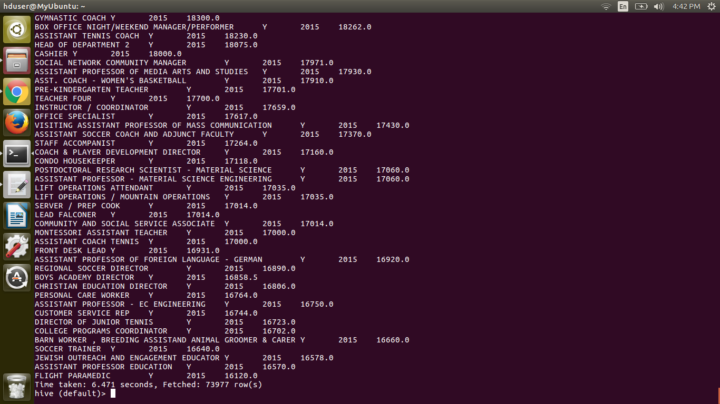

Year 2016
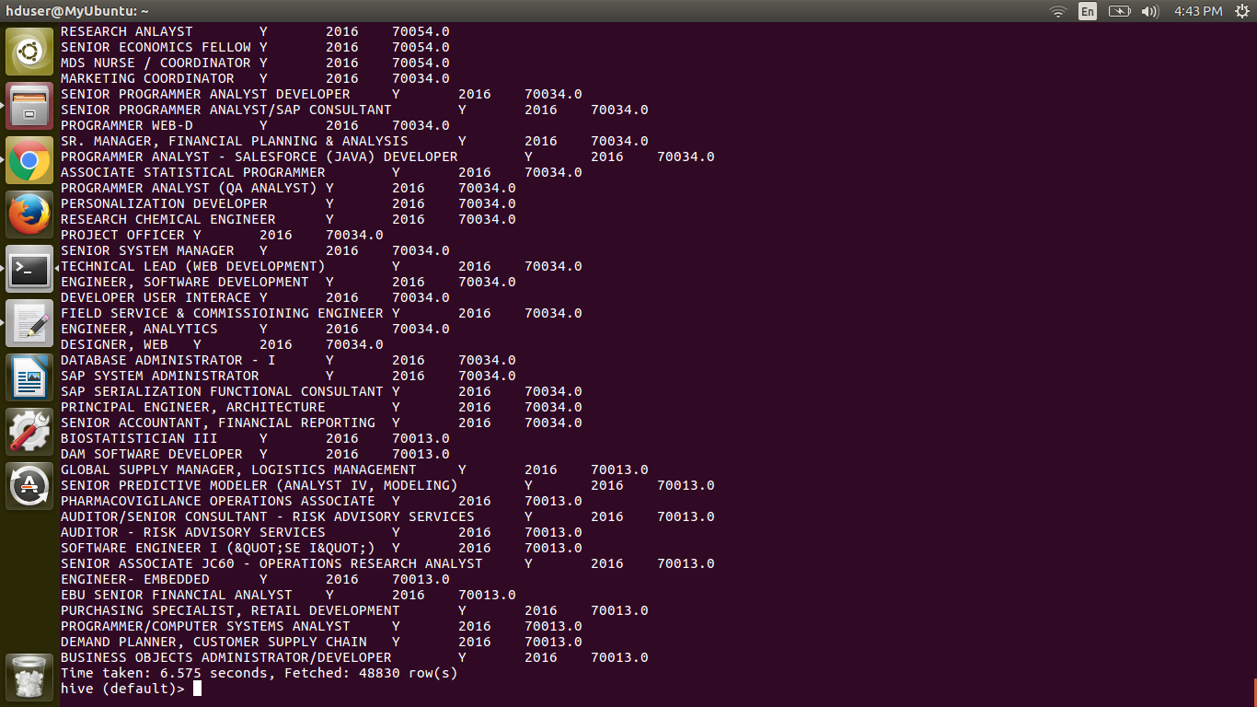

IF chooses N option
Year 2011
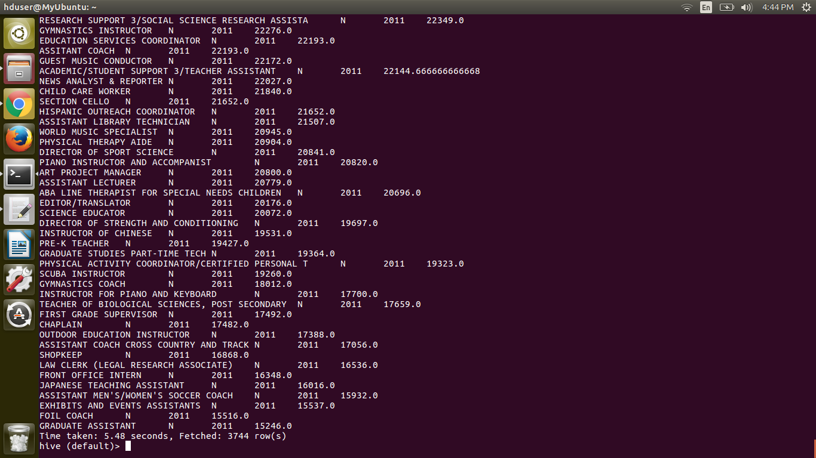
Year 2012
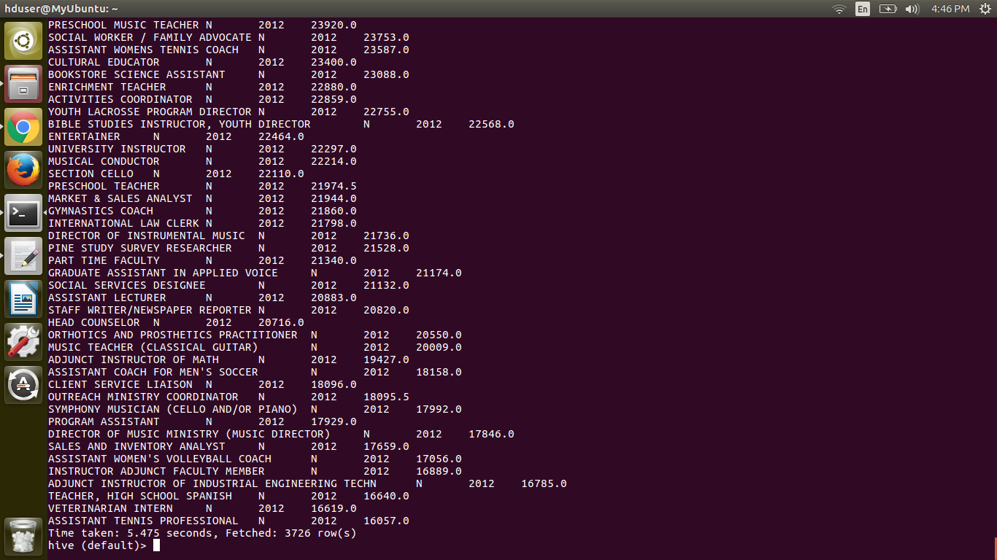
Year 2013
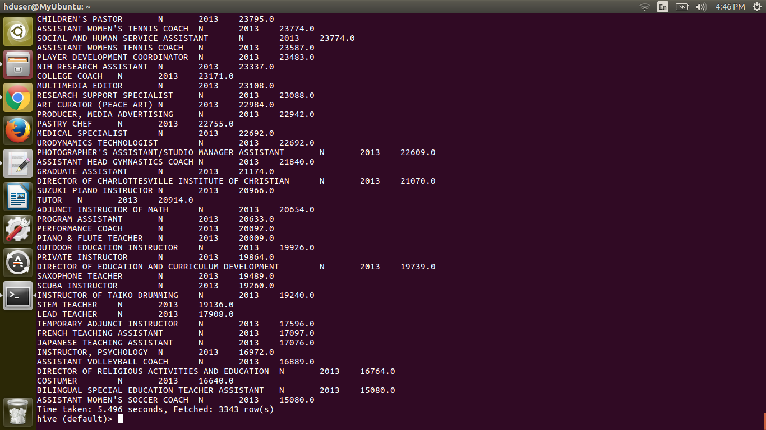

Year 2014
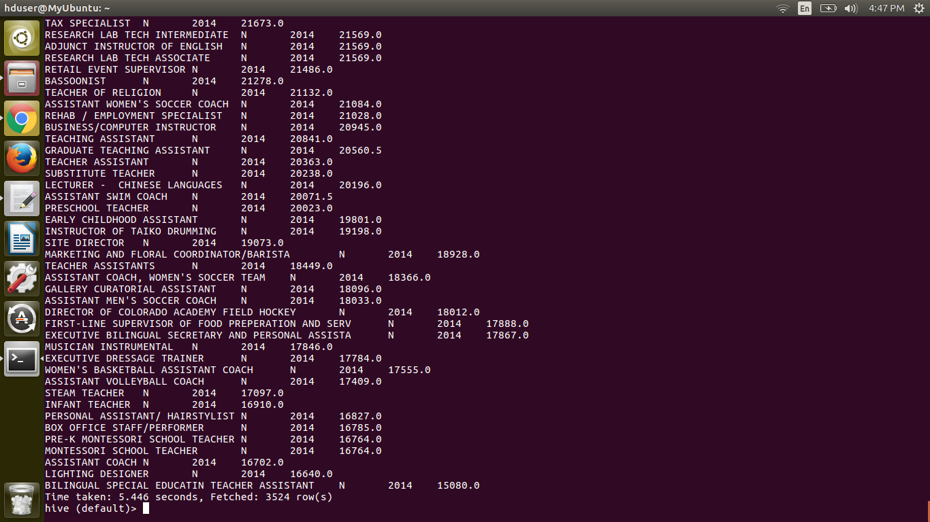
Year 2015
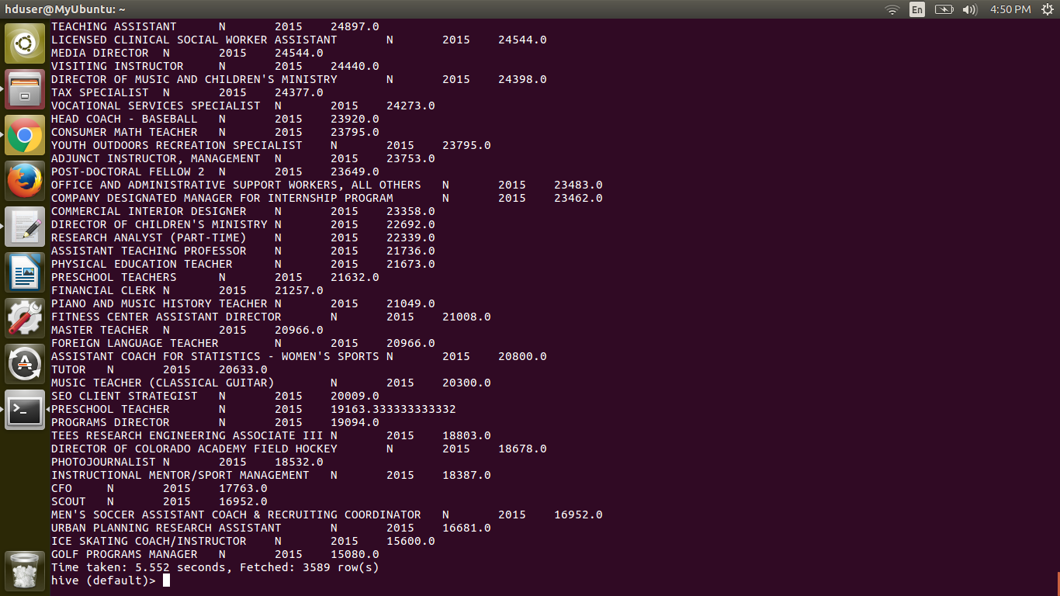

Year 2016
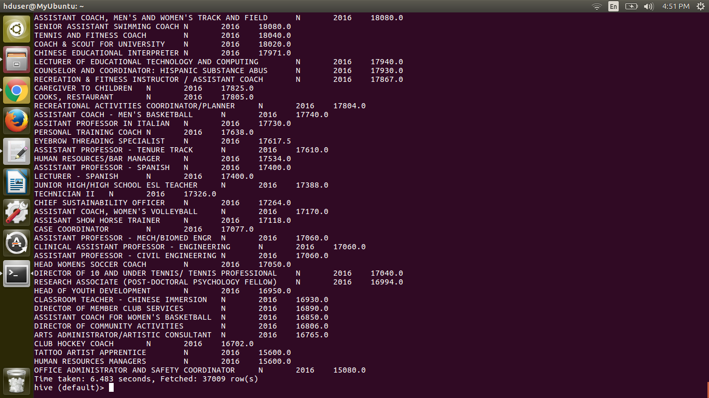

-----------------------------------------------------------------------------------------------------------
9) Which are the employers along with the number of petitions who have the success rate more than 70% in petitions. (total petitions filed 1000 OR more than 1000) ?
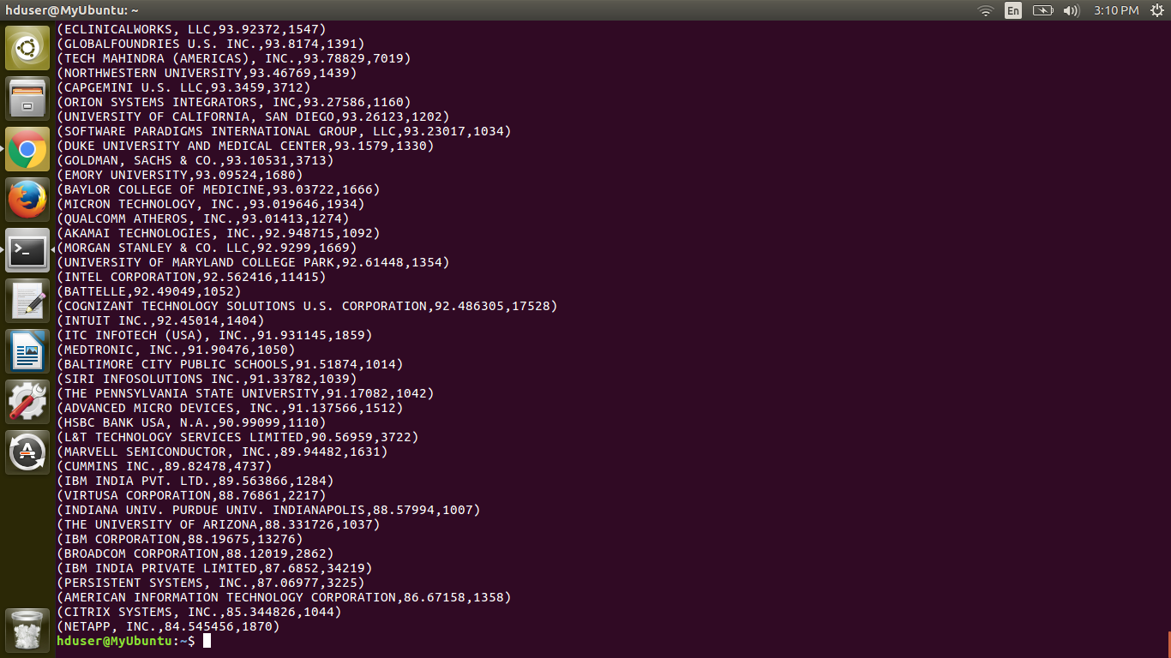

10) Which are the job positions along with the number of petitions which have the success rate more than 70% in petitions (total petitions filed 1000 OR more than 1000)?



11) Export result for question no 10 to MySql database.

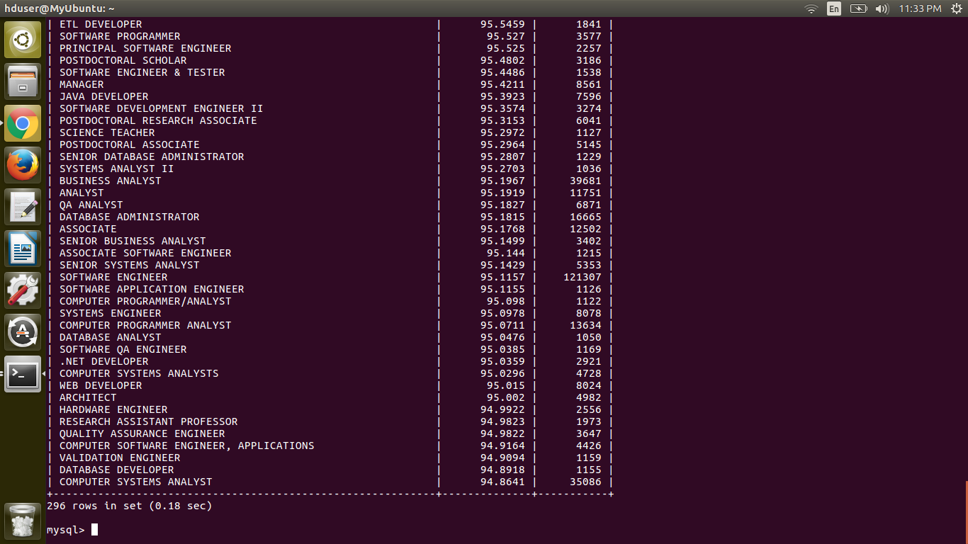

END

