**HIREDO**

MINI – PROJECT – II

SYNOPSIS



Department of Computer Science & Application

## Institute of Engineering & Technology

SUBMITTED BY: -

Ritesh verma

201500573

Tanya Bansal

201500741

Surbhi Bhardwaj

201500722

SUBMITTED TO: -

**Mr. Mayank Saxena** (Training and Placement Department)

(Technical Trainer)

## DECLARATION

We hereby declare that the work which is being presented int the project synopsis “**HIREDO**” in partial fulfilment of the requirement for project is an authentic record of our work carried under the supervision of **Mr.Mayank Saxena, Technical Trainer, GLA University, Mathura** during session **2022-23**.

Sign:

|  |  |  |
| --- | --- | --- |
| **Name of the**  **candidate** | **URN** | **Sign** |
| Ritesh Verma | 201500573 |  |
| Tanya Bansal | 201500741 |  |
| Surbhi Bhardwaj | 201500722 |  |

## ACKNOWLEDGEMENT

It gives us a great sense of pleasure to present the synopsis of the B. Tech. Mini Project undertaken during III Year. This project is going to be an acknowledgement for the inspiration, drive and technical efforts which will be contributed to it by its contributors. We would like to express our gratitude to **Mr.Mayank Saxena, Technical Trainer(T&Pdepartment),** for his unwavering encouragement and support, which allowed us to develop this project to the fullest extent of our skills.

We would also like to thanks all the faculty members of the department of Computer Science & Application for their kind guidance and cooperation.

Ritesh Verma (201500573)

Tanya Bansal (201500741)

Surbhi Bhardwaj (201500722)

## CONTENTS

1. Declaration
2. Acknowledgement
3. Introduction
4. Requirements
   1. Software Requirements
   2. Hardware Requirements
5. Scope of the project
6. Functionalities of the Project
7. Working
   1. First Domain
   2. Second Domain
8. Implementation
9. References

## INTRODUCTION

**HIREDO**, is a web application that provides a platform for hiring workers for various tasks such as homeworker, cook, home cleaner, watchman, baby sitter, laundry man, and more. The application will be built using **HTML, CSS, JavaScript, EJS, Node.js , ExpressJS , MongoDB, Firebase, APIs technologies** and will be fully responsive. To ensure a consistent user experience, the application will utilize the Bootstrap framework.

In terms of data management, **HIREDO** will use two databases: **Firebase and MongoDB**. Firebase will be used to store user data such as login information and preferences, while **MongoDB** will be used to store information about workers, their skills, and availability.



## REQUIREMENTS

* **SOFTWARE REQ:**
  + - **Languages Used**: HTML, CSS, Javascript, NodeJS,ExpressJS.
    - **Framework used:** BootStrap, EJS.
    - **Database:** Google Firebase, MongoDB.
    - **Tools:** VS Code, JetBrains WebStrom, Chrome, Postman.
    - **Version Control:** GIT.
* **HARDWARE REQ:**
  + **Processor:** i5 or above.
  + **Operating System:** Windows
  + **Ram:** 8GB or above.
  + **Hardware Device:** Computer
  + **Hard Disk:** 32GB or above.

## PROJECT DESCRIPTION

The purpose of your project, Hiredo, is to create a platform for hiring workers that provides a streamlined and efficient way for workers to connect with potential clients, and for customers to find workers with the specific skills they need.

By creating this platform, you aim to address the challenges and inefficiencies that can be associated with traditional hiring methods, such as relying on word-of-mouth recommendations or sifting through classified ads. With Hiredo, you aim to make it easy for customers to find workers with the specific skills and availability they need, and for workers to find clients who are looking for the skills they offer.

In addition, your project aims to provide a user-friendly and accessible platform that can be used by people from all walks of life, regardless of their technical expertise. By creating a responsive and intuitive interface, you aim to ensure that your platform is easy to use and accessible to everyone.

# Data Flow Diagram:- (Level-1)

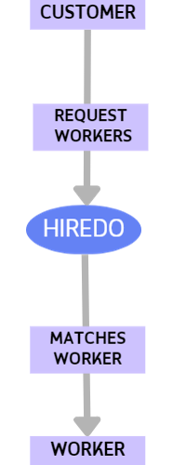

**Data Flow Diagram:- (Level-2)**

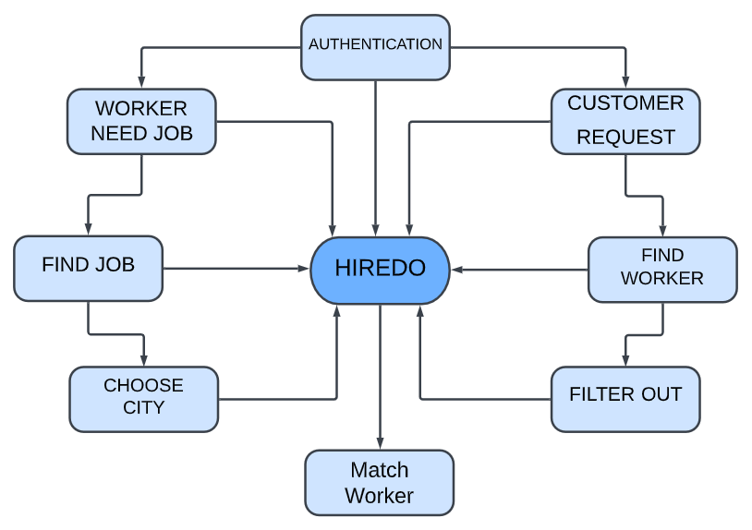

## SCOPE OF HIREDO

The scope of your **Hiredo** project includes developing a hiring platform for various workers such as homeworkers, cooks, home cleaners, watchmen, babysitters, and laundrymen. The platform will be designed to connect clients who need these services with qualified workers who can provide them.

The platform will be built using HTML, CSS, JS, EJS, Node.js, ExpressJS and Bootstrap technologies. The database will use Firebase and MongoDB. The platform will be fully responsive, allowing users to access it from a range of devices, including desktops, laptops, tablets, and smartphones.

The scope of the project also includes developing features such as worker profiles, reviews and ratings, real-time messaging, and a payment system to facilitate transactions between clients and workers. The platform will also need to have an administrative interface for managing worker credentials, client accounts.

## FUNCTIONALITIES OF HIREDO

* Registration and login for both clients and workers
* Profile creation for workers, including their skills, experience, and availability
* Search and filtering of workers by location, availability, and skills
* Posting of job requests by clients
* Real-time messaging between clients and workers to discuss job details
* Review and rating system for workers
* Payment system for transactions between clients and workers
* Administrative interface for managing worker credentials, client accounts, and payments
* Integration with Firebase and MongoDB for database management
* Responsive design for accessibility across a range of devices.

## WORKING

The project works in 2 domains:

**First Domain**: Based on the information you provided earlier, the first domain of your project appears to be the development of the user interface (UI) and user experience (UX) design. This involves creating a visually appealing and user-friendly design for your web application that will be easy for users to navigate and interact with.

To start, you will need to create wireframes and mockups of your design to give you a clear idea of how the final product will look and function. This will involve creating a layout for your website, selecting color schemes and fonts, and designing icons and other visual elements.

**Second Domain**:

The second domain of your project would be the development of the backend functionality and data management. This involves creating the logic and functionality that powers the web application and allows it to interact with the database.

To begin, you will need to set up a server using Node.js, which will handle requests from clients and interact with the database. You will also need to set up the necessary APIs (Application Programming Interfaces) that allow your frontend to interact with the backend.

**IMPLEMENTATION**

# Frontend:

For the frontend we are using HTML and CSS, JavaScript, Embedded JavaScript with some Bootstrap. To make the frontend more reactive and user interactive we will use JavaScript.

# Backend:

In the backend we are using JavaScript, NodeJS, ExpressJS, for the API development & Google firebase and MongoDB for the database and Authentication.

## Tools Description:

**HTML**: Hyper-Text-Markup-Language is used for structuring web pages over the internet. HTML is

the language in which most websites are written. HTML is used to create pages and make them functional.

**CSS**: Cascading-Style-Sheet is a styling language used to style and basically define howthe content will appear on the website.

**JavaScript**: JavaScript is a scripting or programming language which is now used extensively to design modern web applications and website, it allows the developer to write

application which modify themselves according to each user and its data, this made web applications much more accessible and suitable for many purposes.

**NodeJS:** Node.js is a [cross-platform](https://en.wikipedia.org/wiki/Cross-platform), [open-source](https://en.wikipedia.org/wiki/Open-source_software) server environment that can run on [Windows](https://en.wikipedia.org/wiki/Microsoft_Windows), [Linux](https://en.wikipedia.org/wiki/Linux), [Unix](https://en.wikipedia.org/wiki/Unix), [macOS](https://en.wikipedia.org/wiki/MacOS" \o "MacOS), and more. Node.js is a [back-end](https://en.wikipedia.org/wiki/Frontend_and_backend) [JavaScript](https://en.wikipedia.org/wiki/JavaScript) [runtime environment](https://en.wikipedia.org/wiki/Runtime_system), runs on the [V8](https://en.wikipedia.org/wiki/V8_(JavaScript_engine)) [JavaScript Engine](https://en.wikipedia.org/wiki/JavaScript_Engine), and executes JavaScript code outside a [web browser](https://en.wikipedia.org/wiki/Web_browser).

**ExpressJS:** Express.js is a popular web application framework for Node.js. It provides a simple, yet powerful set of features for building web applications and APIs. With Express, developers can easily define routes, handle HTTP requests and responses, and implement middleware to add additional functionality to their applications.

**Bootstrap**: Bootstrapis a free and open-source CSS framework directed at responsive, mobile-first front-end web development. It contains HTML, CSS and

(optionally) JavaScript-based design templates

for typography, forms, buttons, navigation, and other interface components.

**MongoDB:** MongoDB is a popular NoSQL database that uses a document-oriented data model. Unlike traditional relational databases, MongoDB stores data in flexible JSON-like documents, which allows for greater flexibility and scalability.

**Google FireBase**: Firebaseis a set of hosting services for any type of application (Android, iOS, Javascript, Node.js, Java, Unity, PHP, C++ ...). It offers NoSQL and real-time hosting of databases, content, social authentication (Google, Facebook, Twitter and Github), and notifications, or services, such as a real-time communication server.

## REFERENCES

**Books**:

a. Black Book HTML5, CSS, JS, NODEJS, EXPRESSJS, MongoDB

## Websites:

1. MDN Web Docs (link)
2. W3Schools (link)
3. GeeksForGeeks (link)
4. CSSTricks (link)

## Documentations:

1. JavaScript Documentation (link)
2. Google firebase Documentation (link)

## Faculty Guidelines:

Mr.Mayank Saxena (Technical Trainer, GLA University)

**GitHub Repository Link**: https://github.com/codeurritesh/HIREDO