

**NIT6150**

**Assignment 3**

**Final System Delivery and Report**

**Submitted by:**

**Monika Nain (4608744)**

**Supriya Gupta (4608578)**

**Surbhi Dhawan (4608520)**

**Mohamed Mohamed (4597834)**

**Table of Contents**

**1. Abstract 4**

**1.1. Project Description 4**

**1.2. Problem Recognition 4**

**1.3. Project Schedule 5**

**1.4. Project Completion 5**

**2. System Development Plan 6**

**2.1. Corporate Strategic Planning and Mission Statement 6**

**2.2. Current and Future Situations 6**

**2.3. Feasibility Study 6**

**2.3.1. Social Feasibility 6**

**2.3.2. Economic Feasibility 7**

**2.3.3. Technical Feasibility 8**

**2.3.4. Schedule Feasibility 8**

**2.4. Project Scope 8**

**3.0 Methodology. 8**

**4.0 System Requirement Specification 9**

**4.1. Context and Data flow Diagrams 9**

**4.1.1. System Testing and Risk Mitigation Measures. 10**

**4.2. Test Plan 10**

**4.2.1. Unit testing 10**

**4.2.2. Integration Testing 10**

**4.2.3. Acceptance Testing 11**

**5. System Analysis 11**

**5.1. Strengths and Limitations. 11**

**5.2. Computer Ethics application. 12**

**6. Installation plan 12**

**7. Training Plan 13**

**8. Coding Comments 13**

**9. Conclusion 18**

**References 19**

# Abstract

## Project Description

As necessity for education increases all over the world, academic institutions increase also. The urge to excel in studies push students towards employing many methods of revision, including looking for tutors or even peer tutors to help them in studies. This process may be difficult and even sometimes impossible considering a student who may have just moved in, knows nobody around their new area and their only tutors are probably miles away. ABC Online tutoring is a site that addresses this problem. It provides a platform where students can find tutors of their choice and schedule sessions with them. Once a client schedules a session with their tutor, they meet up for these sessions at the stated time and a fair compensation is made to the tutor at the student’s expense. At ABC Online tutoring, students can upload assignment, view dashboard, and teachers can rate the assignments, give feedbacks and upload marks.

## Problem Recognition

Other people and organizations have launched phishing sites purporting to be photographic websites. They obtain credit card numbers, account passwords and other personal information. Therefore, this project intends to provide a free and secure site whereas no unnecessary information will be collected. The site will also not have any ads or redirecting links thus ensuring internet safety. During the hosting process, the site will incorporate SSL security certificates and https connection to ensure that the connection is secure so that hackers may not intercept any data flow. The team also made sure that the forms used on the website use an end to end encryption thus the information submitted through these forms is safe and secure.

## Project Schedule

The development of this system was estimated to take roughly 14 weeks. The following diagram is the detailed schedules for this project. 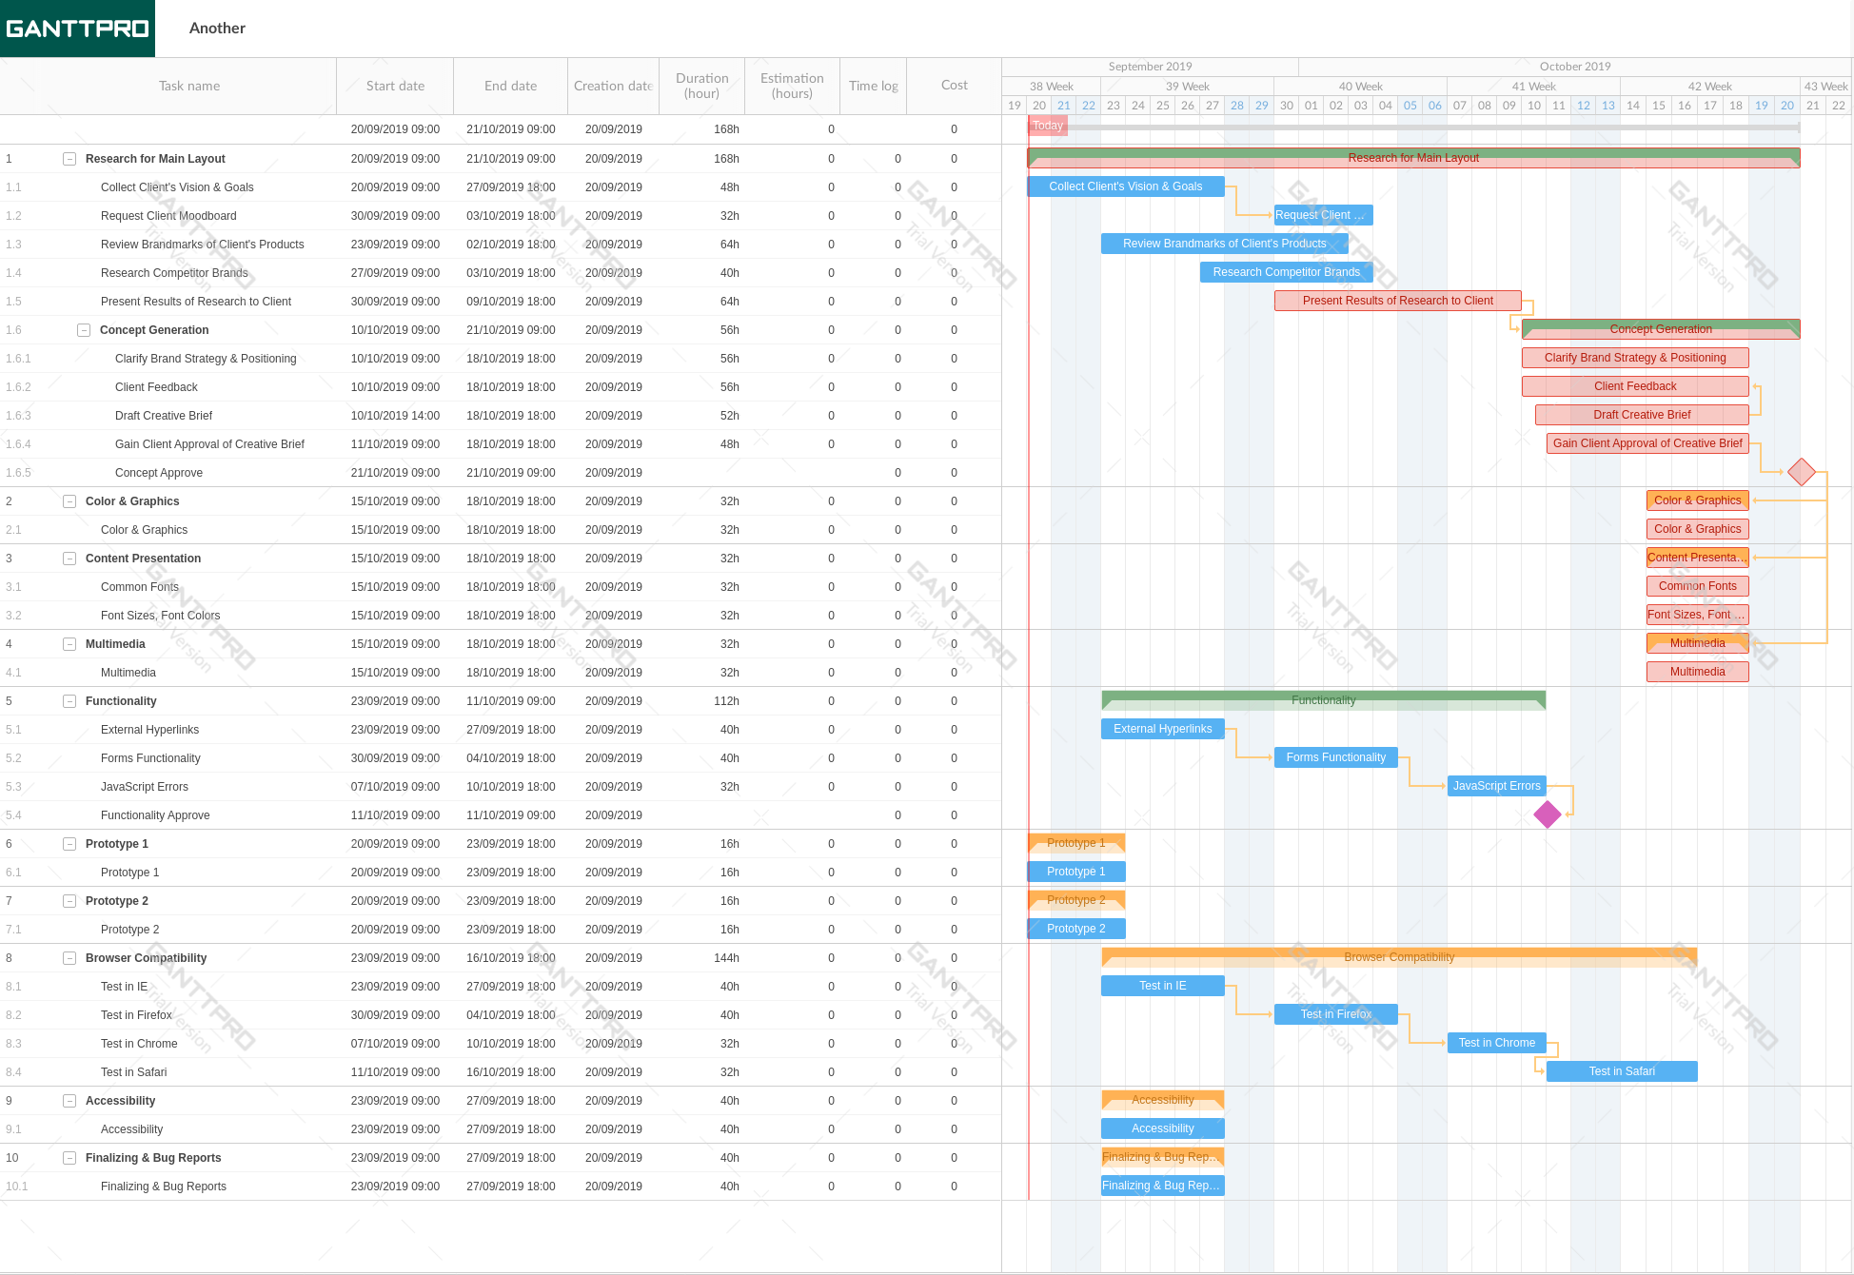

Figure : Gantt Diagram showing the project schedule

## Project Completion

The system, through rapid Application Development, was fully developed as per the requirement specifications stage. So far, the system meets all the requirements. However, the team intends to make further advancements and increase utilities in the system. The team agreed to update the website every two weeks. This is to ensure that the website remains visible on the search engines pages.

# System Development Plan

## Corporate Strategic Planning and Mission Statement

This project aims at coming up with an online platform for booking tutoring appointments. Basically, it will be a website where people can View the services offered by ABC Online tutoring company. In addition to that, the site will ensure that there is accurate contact information for anyone who might be interested in visiting them. The main target group of people in for the system is the youth of age between 13-23.

## Current and Future Situations

The world wide web has been a site for all sorts of products and services. As the internet costs go down, the number of people browsing the web is rising rapidly (Brügger, 2009). The devices accessing the websites are also becoming sophisticated by the hour, which leaves web designers with the tasks of customizing their web sites to be accessible from as most devices as possible. With these advancements, firms, organizations, and most service providers are forced to adapt to this new world of internet of things. The website will also include a shopping cart which will allow members to pay tutors through the PayPal and credit card integrated APIs.

## Feasibility Study

### Social Feasibility

This project is expected to be widely accepted by people of all ages, gender, age groups and social classes. This is because unlike other sites like gambling sites, social sites and pornographic sites, this site aims at improving the academic status of the clients. The former does not only waste resources but also compromises human dignity. Therefore, the site will be widely acceptable to the public, hence the project is socially feasible.

### Economic Feasibility

The following table is a rough estimate of the total and nit cost for the project development.

Table : Showing a summary of the expected cost in system development

|  |  |  |
| --- | --- | --- |
| Task name / Title | Planned start date | Cost |
| Web Design Checklist | 20/09/2019 09:00 | 33940 |
| Research for Main Layout | 20/09/2019 09:00 | 59343 |
| Collect Client's Vision & Goals | 20/09/2019 09:00 | 372800 |
| Request Client Moodboard | 30/09/2019 09:00 | 4400 |
| Review Brandmarks of Client's Products | 23/09/2019 09:00 | 233600 |
| Research Competitor Brands | 27/09/2019 09:00 | 6370 |
| Present Results of Research to Client | 30/09/2019 09:00 | 500 |
| Concept Generation | 10/10/2019 09:00 | 650 |
| Clarify Brand Strategy & Positioning | 10/10/2019 09:00 | 1300 |
| Client Feedback | 10/10/2019 09:00 | 1980 |
| Draft Creative Brief | 10/10/2019 14:00 | 1300 |
| Gain Client Approval of Creative Brief | 11/10/2019 09:00 | 2850 |
| Concept Approve | 21/10/2019 09:00 | 2010 |
| Color & Graphics | 15/10/2019 09:00 | 4300 |
| Color & Graphics | 15/10/2019 09:00 | 6400 |
| Content Presentation | 15/10/2019 09:00 | 450 |
| Common Fonts | 15/10/2019 09:00 | 90 |
| Font Sizes, Font Colors | 15/10/2019 09:00 | 50 |
| Multimedia | 15/10/2019 09:00 | 100 |
| Multimedia | 15/10/2019 09:00 | 100 |
| Functionality | 23/09/2019 09:00 | 12300 |
| External Hyperlinks | 23/09/2019 09:00 | 30 |
| Forms Functionality | 30/09/2019 09:00 | 1200 |
| JavaScript Errors | 07/10/2019 09:00 | 3500 |
| Functionality Approve | 11/10/2019 09:00 | 1920 |
| Prototype 1 | 20/09/2019 09:00 | 32000 |
| Prototype 1 | 20/09/2019 09:00 | 23000 |
| Prototype 2 | 20/09/2019 09:00 | 0 |
| Prototype 2 | 20/09/2019 09:00 | 0 |
| Browser Compatibility | 23/09/2019 09:00 | 2390 |
| Test in IE | 23/09/2019 09:00 | 0 |
| Test in Firefox | 30/09/2019 09:00 | 0 |
| Test in Chrome | 07/10/2019 09:00 | 0 |
| Test in Safari | 11/10/2019 09:00 | 0 |
| Accessibility | 23/09/2019 09:00 | 0 |
| Accessibility | 23/09/2019 09:00 | 0 |
| Finalizing & Bug Reports | 23/09/2019 09:00 | 0 |
| Finalizing & Bug Reports | 23/09/2019 09:00 | 0 |
| Totals |  | 808873 |

We expect that the amount will be recovered in about four months after the system is up and running. Therefore, the project is economically feasible.

### Technical Feasibility

In the development of this project, php, HTML5, CSS and JavaScript will be used. Most of the browsers in the market support the three scripting languages. Therefore, most of the devices will be able to access the system hence it is technically feasible.

### Schedule Feasibility

As stated earlier in section Project Schedule the estimated development time is 14 weeks. There is no time pressure therefor the project is time feasible. However, the system development took 11 days, which is relatively quicker than the estimated development time. The team implemented Rapid Application Development to speed up the development process. The system was divided into several modules where each developer was given a module to work on. As a result, the development time was reduced to 11 days from the original 14 days. The Actual System Design and Coding step took less time than planned, thanks to the dedication of the development team.

## Project Scope

## Methodology.

In the development of this website, Microsoft Expression Web 4 was as the development environment. This is because the software is available freely under the GNU Public License. On the other hand, the equally functional software is Dreamweaver, which requires purchase for you to access full features. In terms of functionality, Web 4 provides a better-debugging utility than Dream weaver thus it is the most suitable in this context. For backend testing, WAMP or Lamp server will be required for testing the PHP execution. The testing will be done on localhost. It will also help in creating the database to store the images. The first and the most important file to come up with is the index.php which is the starting execution starting point for the server. The file contains the credentials to access the database and check the login details. The index.php file has only two links. One for resetting the password and the other for registering. The development environment used is more graphical based other than text-based. Therefore, some features and utilities are carried out using the drag and drop functionality. Since it allows code customization, the code was then edited to ensure perfection of the graphics.

# System Requirement Specification

## Context and Data flow Diagrams

The following is a general representation of the flow of data in the system.

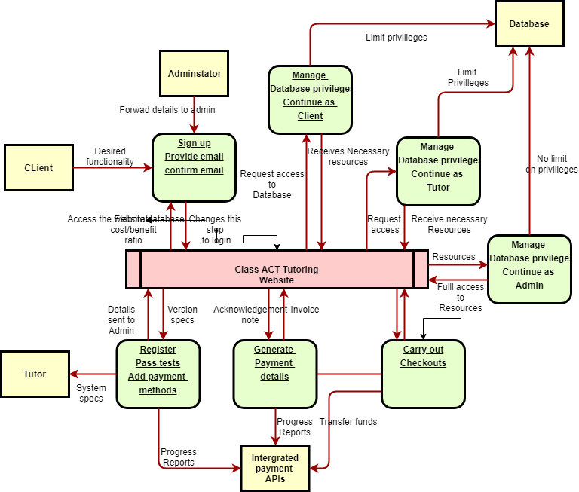

Figure : Data flow Diagram showing the organization and flow of data through the system

1. Phoenix

### System Testing and Risk Mitigation Measures.

## Test Plan

### Unit testing

Here, the team will test the system by inputting all possible invalid input to evaluate the efficiency of the error handling methods. Different tests were conducted for the Client, Admin, and the tutor modules in the site.

### Integration Testing

The system was tested for compatibility with the following browsers.

1. Compatibility with Internet Explorer
2. Compatibility with Mozilla Firefox
3. Compatibility with google chrome
4. Compatibility with safari browser
5. Compatibility with Phoenix

The system proved to be compatible with all the above browsers, the team therefore proceeded to test compatibility with mobile phones. The team discovered that the system is also compatible with mobile phone browsers except Opera mini. The browser takes long to load the styling thus the site appears old and unstilled. Unfortunately, the development team could do nothing to rectify this since it is the duty of Opera Mini’s developers to update their browser. The next test plan was testing the security of the system. The team attempted launch SQL injection attacks and phishing. In the login window, the team inserted syntaxial statements to see if they could unethically execute queries on the database. After the testing, the team discovered that the system was vulnerable to sql injection. Therefore, the team had to make use of prepared statements to prevent this attack.

### Acceptance Testing

Our system passed all the above tests; therefore, the team will then proceed with the web hosting process. Advertisements will be made over social media, gather the views across all these platforms and analyze them. It is expected that the system will be widely accepted by people across all gender and ages.

### System Analysis

### Strengths and Limitations.

The system has limited mobile browsing experience. Study shows that desktop browsing has reduced greatly while mobile browsing has risen by 50%, (Anon,2019). Therefore, limited mobile browsing translates to limited market coverage. The team suggested that with time, the system will be optimized to suit mobile browsing also. The other challenge that the team came across is search Engine Optimization. On average, a website takes 4 months to be successfully ranked by google tags. Therefore, the system might not meet its financial target in good time. The team decided to come up with other methods of service marketing such as you tube advertising.

### Computer Ethics application.

In the development of this system, the team made sure to abide by the ten commandments of computer ethics, (Ermann & Shauf, 2002). The developed system does not override any copyrights. In addition to that, the system uses secure https and therefore prevents phishing. By doing this, the system implements user privacy protection. The system does not disclose personal information to different parties in the website. This means that the tutors details remain capsulated to our technical team, while the client’s detail also remain private. The organization also takes full responsibility of any failure that may occur in the system. In this system, the admin is the only person who retains the privileges to clear the system logs and user details. This ensures that all files are kept safe. In general, the system was developed in accordance to computer ethics and commandments.

## Installation plan

During the development of this system, the team installed it on WAMP server since a virtual host is required to be able to execute php. WAMP server was also helpful in terms of ceating the required databases. The website will be registered with a .com domain and on a server that uses https proxy for security purposes. It will also install SSL certificates.

## Training Plan

The team will come up with video tutorials and upload them to YouTube for easier content delivery. The team will also offer training for a sampled group of people who will in turn be paid to train others on the system usage.

## Coding Comments

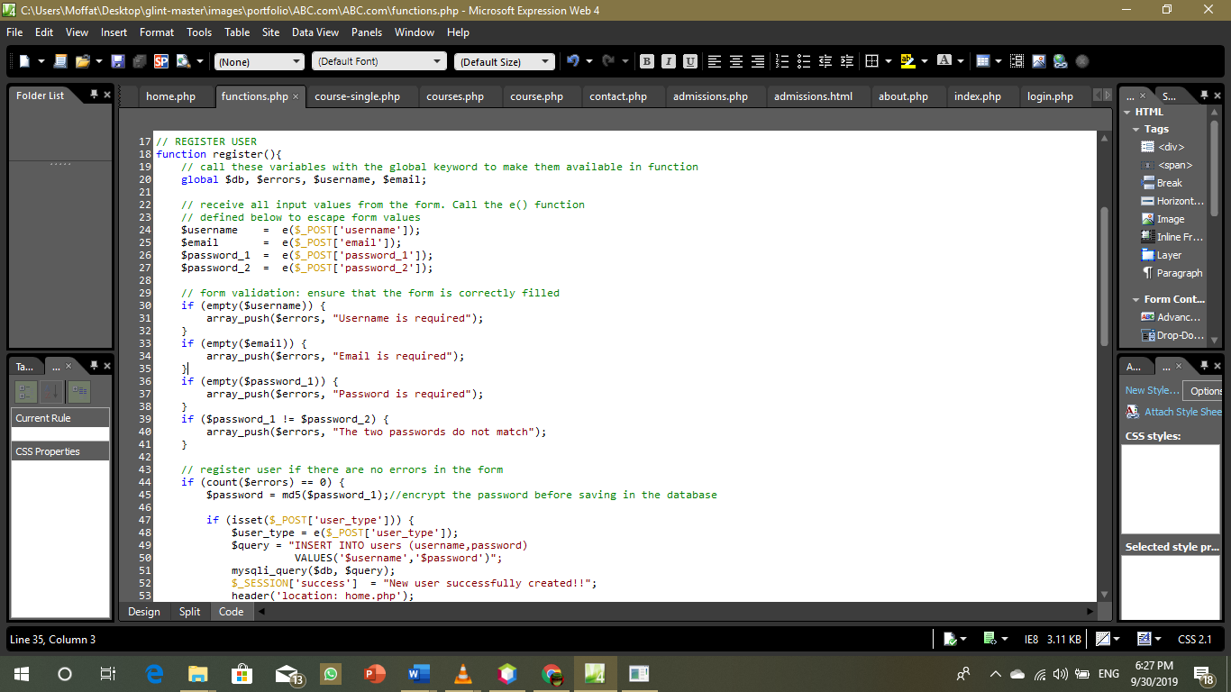

**Figure 1:Showing an example of comments.**

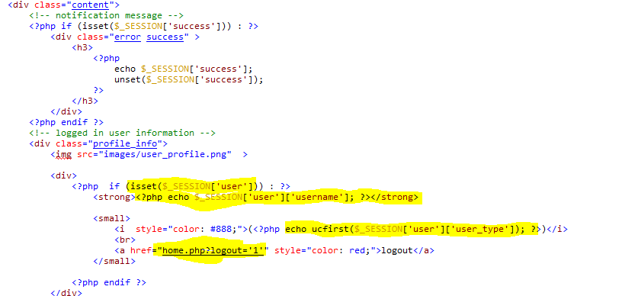**Figure 2: Putting the logged-on user in session.**

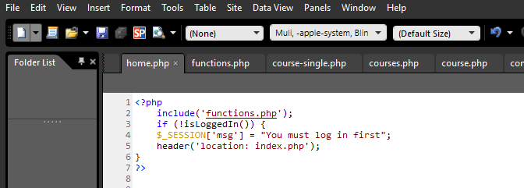

**Figure 3: Ensuring the user is logged in before accessing home.php**

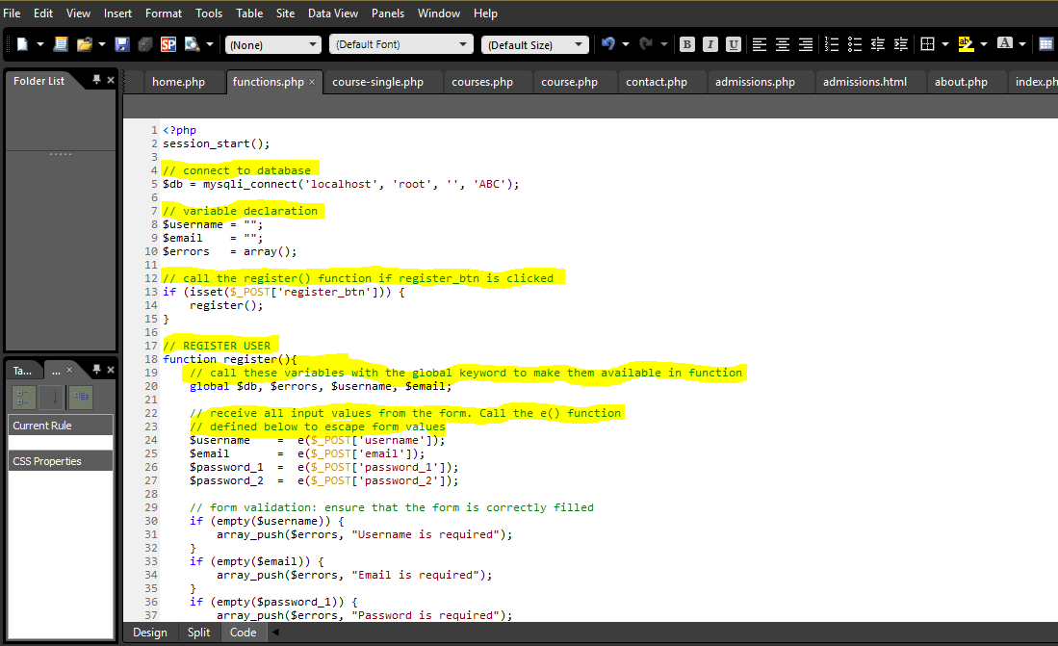

**Figure 4: Example of comments**

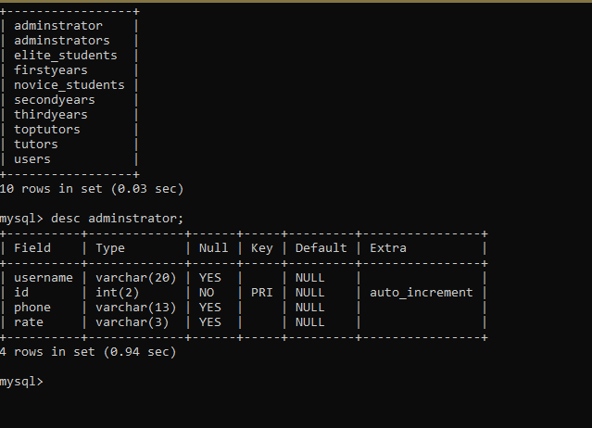

**Figure 5: Database organization**

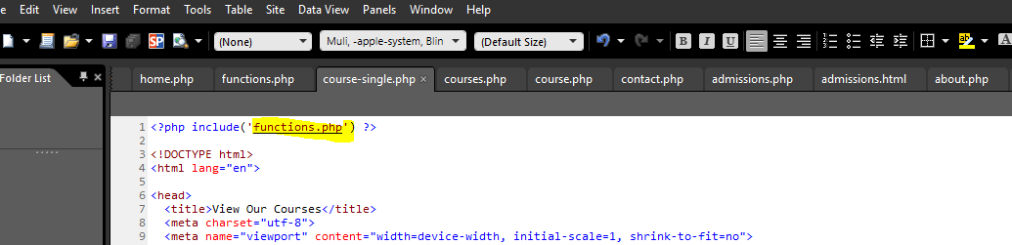

**Figure 6: Intergarting functions in functions.php**

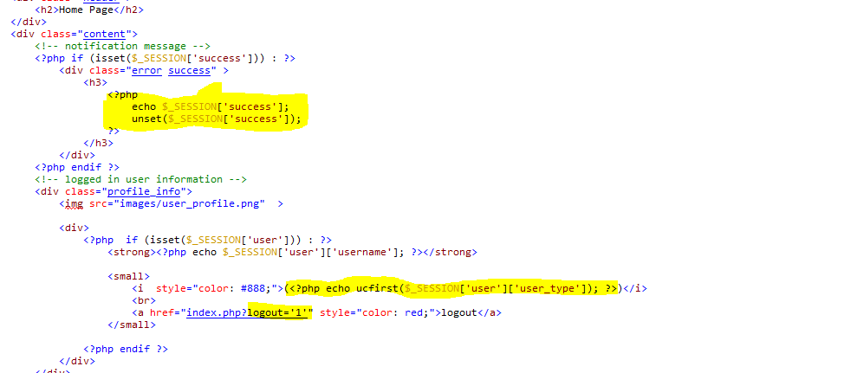

**Figure 7: Intergrating logout functionality**

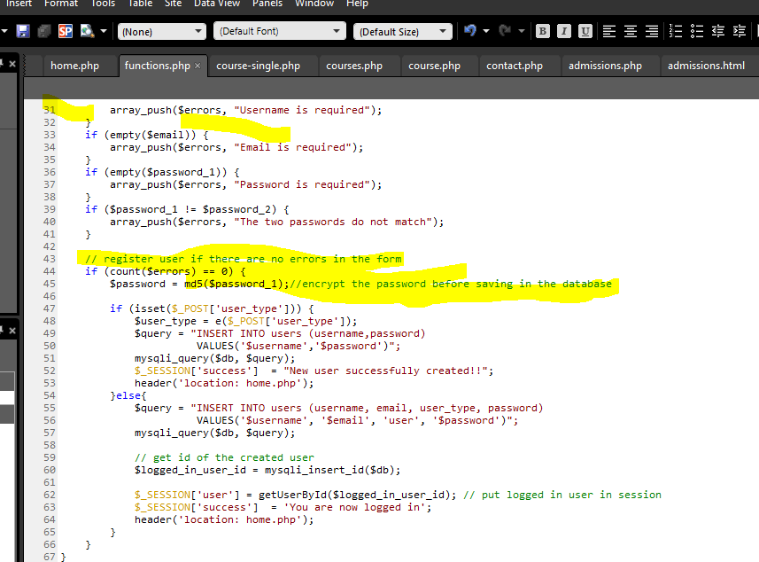

**Figure 8: MySQL execution in php**

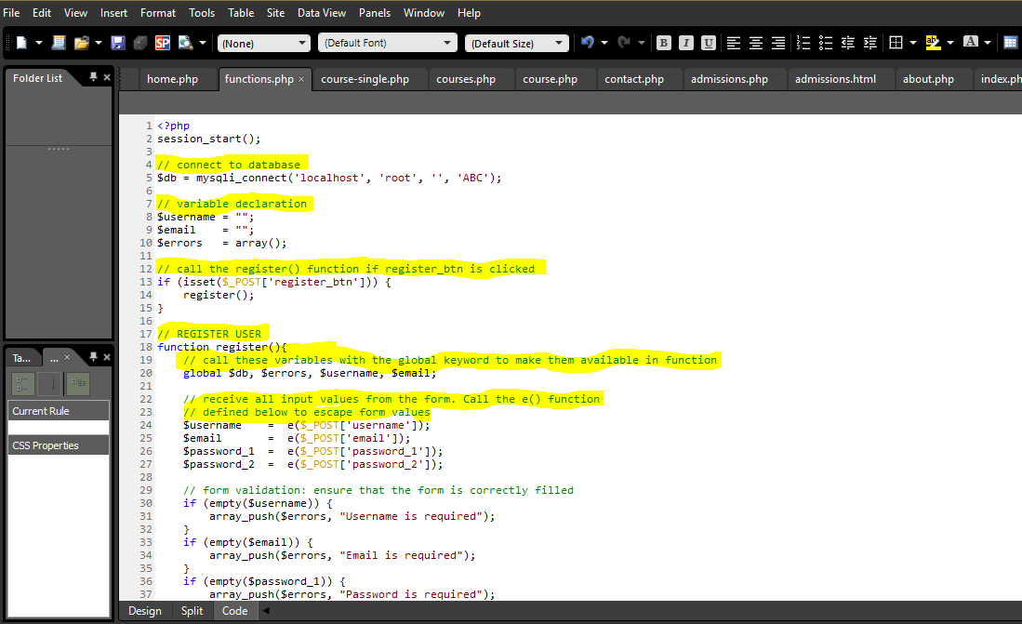

## Conclusion

This report includes all the Project description about creating website, project development plan and schedule and coding comments. This website has features like uploading assignment, viewing dashboard by the student. The teacher can view the assignments, give marks and feedback, delete user and upload syllabus and lecture materials. The screenshots of website working, and coding comments are added in the report. Our team had weekly meetings and followed agile methodology to work on this project.

# References

Anon, What are the Disadvantages and Limitations of Website Builders? *Igniting Business*. Available at: https://www.ignitingbusiness.com/blog/web-development/what-are-the-disadvantages-and-limitations-of-website-builders [Accessed September 26, 2019].

Berry, D. M.,2012. *Understanding Digital Humanities*. New York: Palgrave

Boyd, S.W. and Keromytis, A.D., 2004, June. SQLrand: Preventing SQL injection attacks. In *International Conference on Applied Cryptography and Network Security* (pp. 292-302). Springer, Berlin, Heidelberg.

Brügger, N., 2009. Website History and the Website as an Object of Study. *New*

Macmillan *Magazine (PCMag.com).* Ziff Davis. Retrieved on 11 th September, 2019.

*Media &amp; Society* 11 (1-2): 115-32.

Ermann, M.D. and Shauf, M.S., 2002. *Computers, ethics, and society*. Oxford University Press, Inc..

Mendelson, E., 2012. &quot;Microsoft Expression Web 4 Review &amp; Rating&quot;. *PC*

Welling, L. and Thomson, L., 2003. *PHP and MySQL Web development*. Sams Publishing.