|  |  |
| --- | --- |
| logo png.png | **AAA COLLEGE OF ENGINEERING & TECHNOLOGY**  **Accredited by NAAC with Grade ‘A’,**  **Accredited by NBA (CSE, EEE, ECE& MECH)**  **Approved by AICTE, New Delhi & Affiliated to Anna University, Chennai**  **Amathur, Sivakasi - 626 005.**  **Department of Electronics and Communication Engineering** |

**REPORT ON**

**WORKSHOP REPORT ON LT SPICE & HACKATHONS: TIPS AND TRICKS**

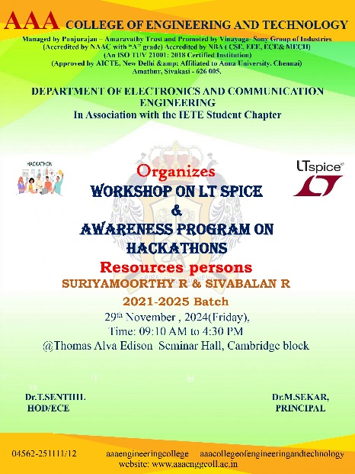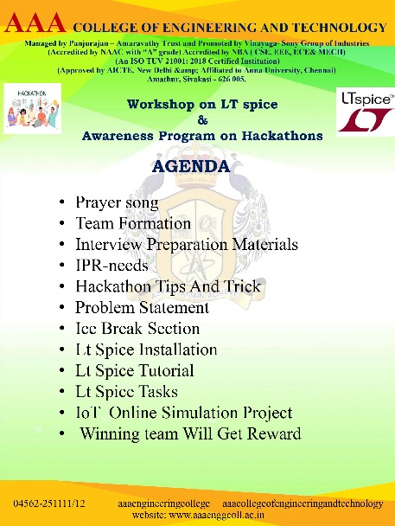

**Fig-1.1: poster Fig-1.2:Adenda**

**Organized by:**

**Priceless Brain Team**  
**Date:** November 27, Friday,2024  
**Venue:** AAA College of Engineering and Technology-Sivakasi  
**Target Audience:** 2nd-Year Electronics and Communication Engineering (ECE) Students  
  
**Workshop Coordinators:**

* **HOD (ECE):** Dr. T. Senthil
* **Faculty In-Charge:** Dr. Jayahari Prabhu

**Objective of the Workshop:**

The workshop on **LT SPICE & Hackathons: Tips and Tricks** was designed to provide hands-on training in Analog Integrated Circuit (IC) Design using LT SPICE software, combined with valuable strategies for excelling in hackathons. The event aimed to foster technical proficiency and help students understand the importance of competitive tech events in academic and professional growth.

**Resource Persons:**

* **R. Suriyamoorthy**, Priceless Brain Team, BE ECE (2021-2025)
* **R. Sivabalan**, Priceless Brain Team, BE ECE (2021-2025)

**Co-Hosts:**

* **Mr. Kesavan**
* **Miss Poorana Selvi**
* **Miss Kartheeswari**

**Workshop Structure:**

1. **PrayerSong**  
   The session started with a prayer song to create a focused and positive environment.
2. **TeamFormation**  
   Participants were grouped into teams to foster collaboration and teamwork during the workshop.
3. **Interview Preparation Materials**  
   Resource persons provided participants with key materials and tips for interview preparation, emphasizing technical and behavioral readiness.
4. **IPR** (**Intellectual Property Rights) Needs**  
   An overview of the importance of IPR in protecting innovations and how it applies to student projects and hackathon ideas.
5. **Hackathon Tips and Tricks**
   * Guidance on excelling in hackathons, covering team collaboration, time management, and prototype development.
   * Real-world examples and success stories were shared for inspiration.
6. **Problem Statement**  
   Participants were introduced to a sample problem statement to brainstorm ideas and develop solutions collaboratively.
7. **Ice Break Section**  
   Fun and interactive activities were conducted to energize participants and encourage networking.
8. **LT SPICE Installation**
   * Step-by-step guidance on installing LT SPICE software.
   * Ensured every participant could access and operate the tool.
9. **LT SPICE Tutorial**
   * A detailed walkthrough of LT SPICE, explaining its interface, features, and practical applications.
   * Demonstrations included basic and advanced circuit designs.
10. **LT SPICE Tasks**
    * Hands-on tasks were assigned to participants to design and simulate circuits using LT SPICE.
    * Resource persons provided guidance throughout the session.
11. **IoT Online Simulation Project**
    * Participants engaged in an IoT simulation project to combine theoretical knowledge with practical application.
    * Projects included designing simple IoT-based solutions.
12. **Winning Team Rewards**
    * The top-performing team was recognized and rewarded with IoT Mini Kits to encourage future learning and innovation.

**Workshop Outcomes:**

* **Skill Development:** Participants gained hands-on experience with LT SPICE and could simulate their circuit designs independently.
* **Hackathon Readiness:** Students learned essential skills for preparing and excelling in hackathons, such as ideation, teamwork, and quick prototyping.
* **Participation Certificates:** All students who attended the workshop received **E-certificates**.
* **Incentives for Top Performers:** The resource persons sponsored the top-performing students, who were awarded IoT Mini Kits to motivate further learning and participation in technical competitions.

**Glimpse of event:**

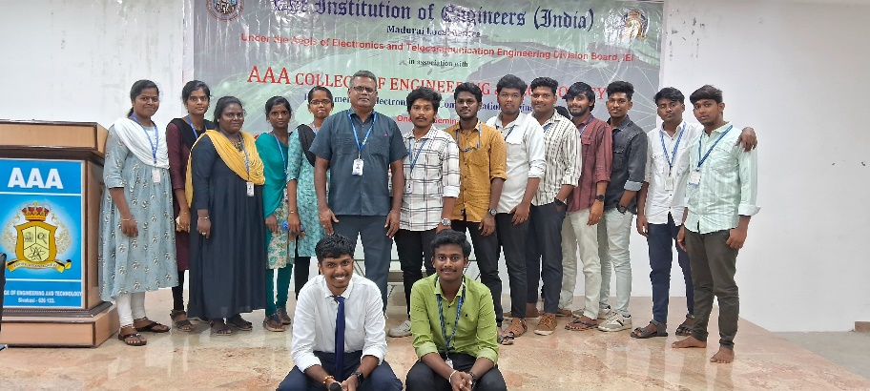

Fig:2.1-Organizing committee

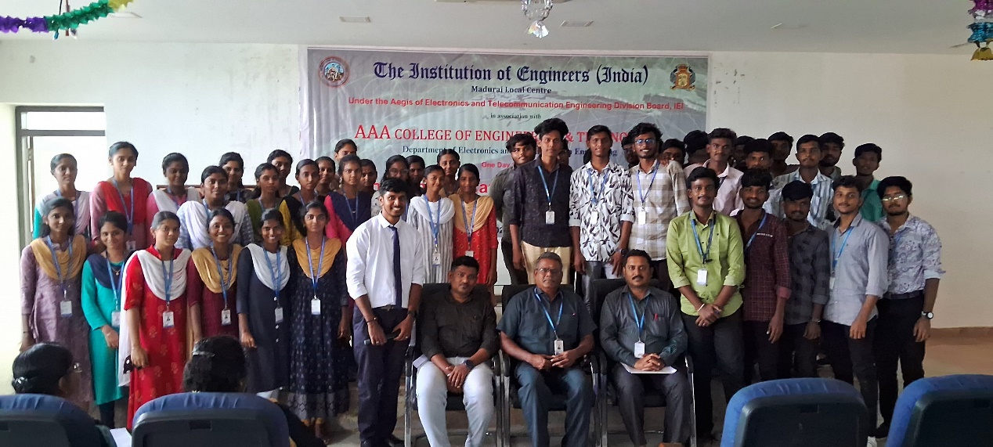

Fig:2.2-Group photo

Prize winners for Mini hacthon

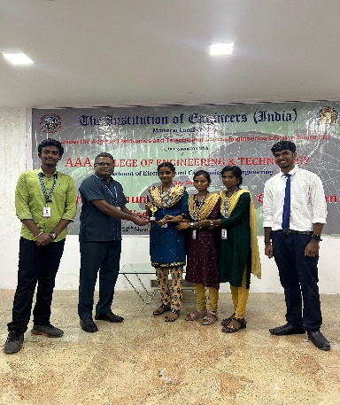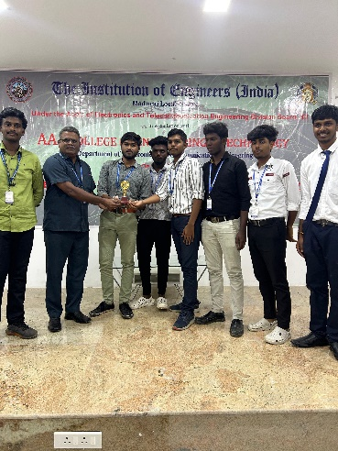

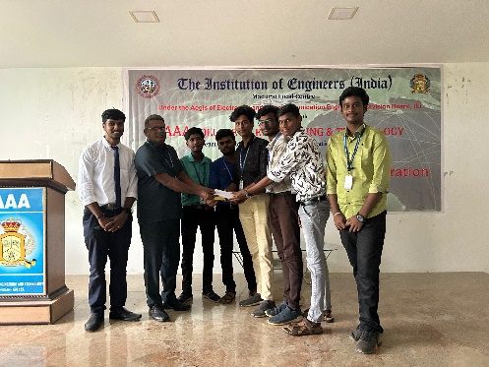

1st prize Team :Anniyan 2nd Prize : Team Bluppers 3rd prize :Team daisy girls

**Feedback:**

The students provided positive feedback about the workshop, expressing that it helped them gain practical circuit design and hackathon participation skills. Many appreciated the hands-on approach and the real-world tips shared by the resource persons.

**Acknowledgments:**

The Priceless Brain Team extends heartfelt thanks to the following individuals for their support and guidance in organizing this workshop:

* **Dr. T. Senthil** (HOD, ECE Department)
* **Dr. Jayahari Prabhu** (Faculty In-Charge)
* The co-hosts, Mr. Kesavan, Mr. Sanjeev Raj, Miss Poorna Selvi, Miss Kartheswari, for their invaluable assistance.