Experiment 1.1:Demonstrating html tags

Program:

<!DOCTYPE html>

<head>

<title>Hello world page</title>

</head>

<body>

<h1>hello world</h1>

<h2>hello world</h2>

<h3>hello world</h3>

<h4>hello world</h4>

<h5>hello world</h5>

<h6>hello world</h6>

<p> This is a Hello world page displaying hello world with different heading tags</p>

</body>

</html>

Output:

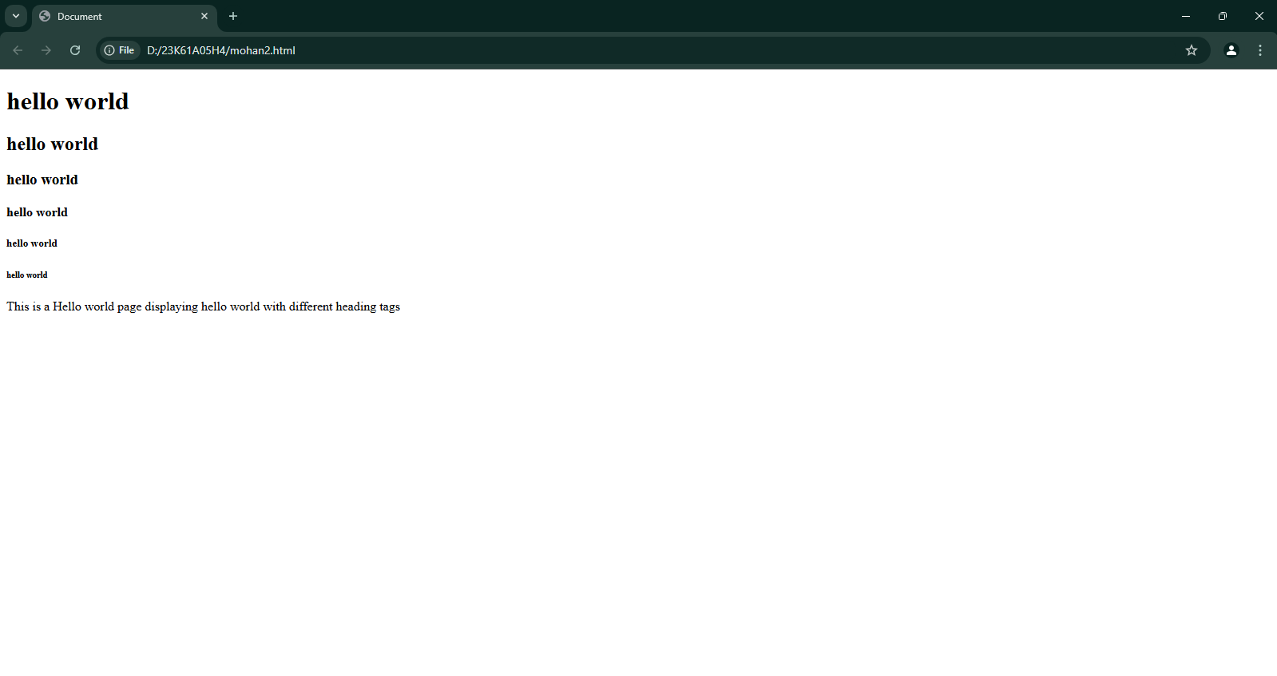

Experiment 1.2:Demonstrating hr tag in html

Program:

<!DOCTYPE html>

<head>

<title>Hello World page</title>

</head>

<body>

<p> <h1>hello world</h1><hr>

<h2>hello world</h2><hr>

<h3>hello world</h3><hr>

<h4>hello world</h4><hr>

<h5>hello world</h5><hr>

<h6>hello world</h6><hr>

</p>

</body>

</html>

Output:

Experiment 1.3:Demonistarting align tag in html

Program:

<!DOCTYPE html>

<head>

<title>Hello World page</title>

</head>

<body>

<h1 style="text-align: center;">Hello World</h1>

<h2 style="text-align: right;">Hello World</h2>

<h3style="text-align: left;">Hello World</h3>

</body>

</html>

Output: 