# **Connect your Magento website with Facebook Messenger**

You would need a **Facebook Page**. Please navigate here to create a Facebook Page [**https://www.facebook.com/pages/create**](https://www.facebook.com/pages/create)

Then follow these steps to generate a Facebook Token for the connection:

1. Redirect here <https://developers.facebook.com/> to login to your **Facebook Developers** (Using your Facebook account)

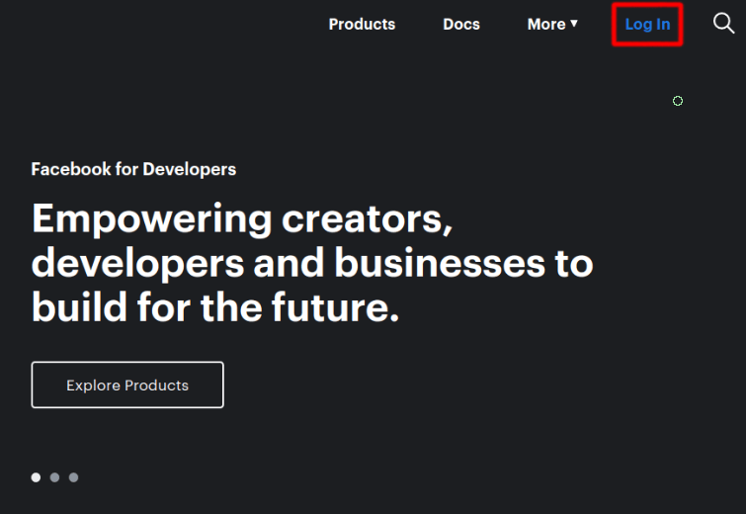

2. Click on the Create App option

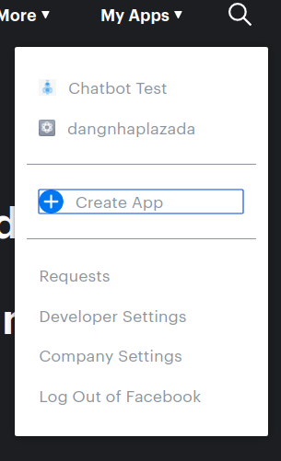

3. Then enter the App Display Name and add contact email to create New App ID

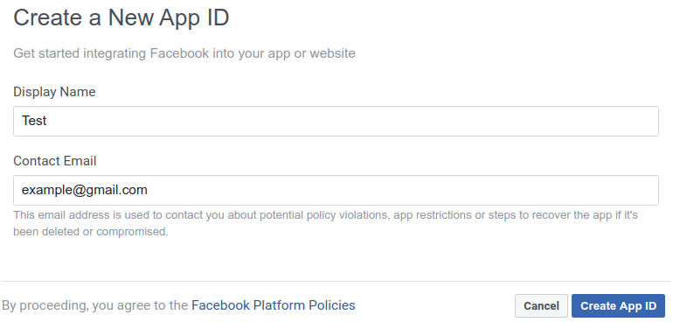

4. On the left menu navigation bar: Click **Add Products**

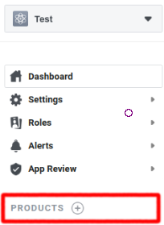

5. Choose Messenger: Click **Set up**

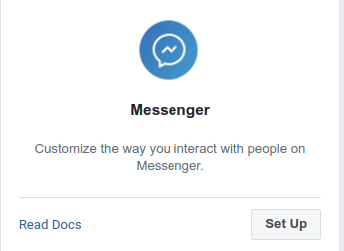

6. Scroll down to see the **Access Tokens** section to add the newly created page

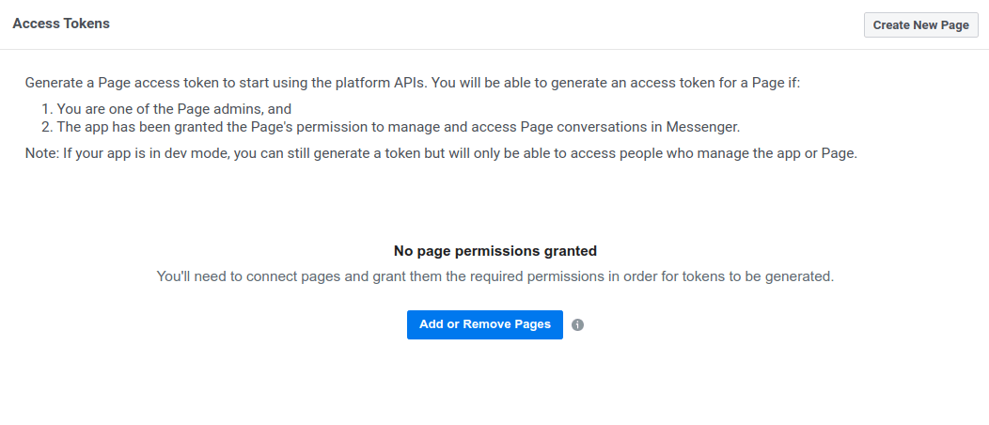

### **Generate Token**

1. After adding your page, continue to generate a **Token** to start using the API



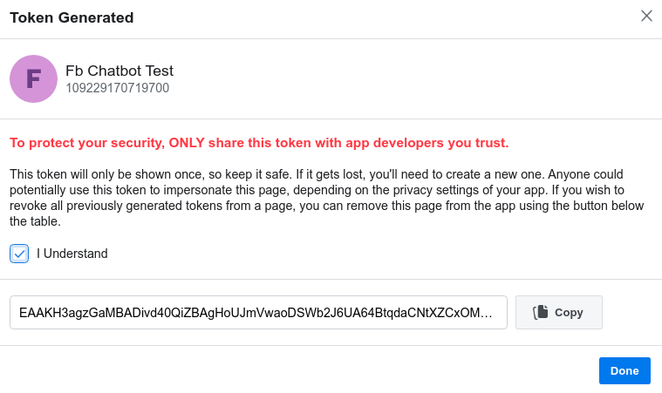

After generating the Facebook Token as instructed, click on **Copy** to get the Token for your Magento store connection.

2. On your Magento **Admin sidebar**, go to **Facebook chatbot menu > Configuration.**

3. On the **Facebook Connection** section.

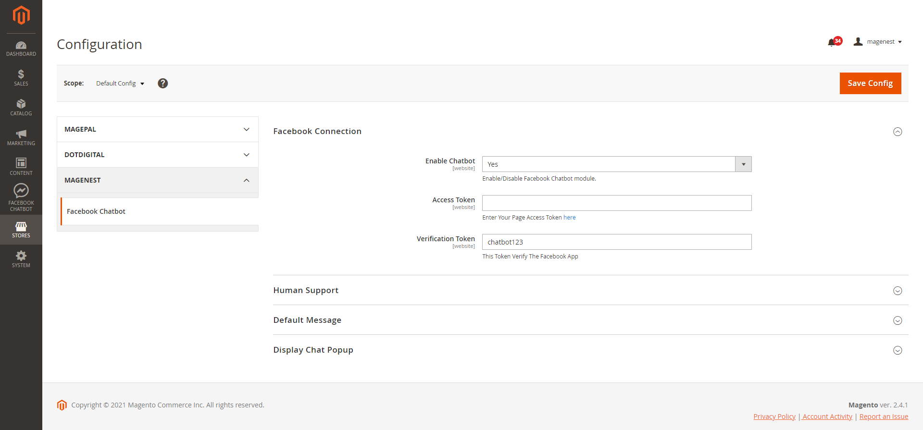

* **Enable Chatbot:** Select **Yes** to enable the Facebook Chatbot extension.
* **Access Token:** Fill in this field with the Access Token that you’ve copied in the previous step.
* **Verification Token:** Define your own Verification Token

4. After finishing the above steps, click on the **Save Config** button. Then open your Facebook App again, in the **Webhook** section, click **Add Callback URL.**

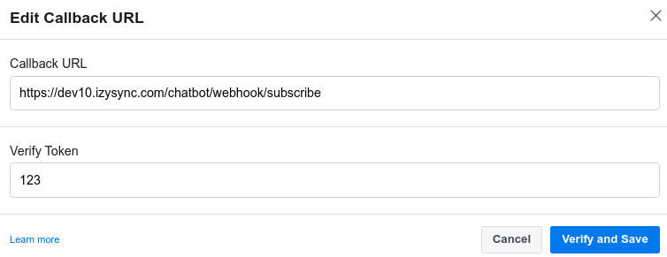

* **Callback URL:** your_url/chatbot/webhook/subscribe
* **Verify Token:** Enter the verification token that you’ve defined previously.
* Click on **Verify** and **Save**

After the verification step, you’ll be able to see this page. Click on the Add Subscription button

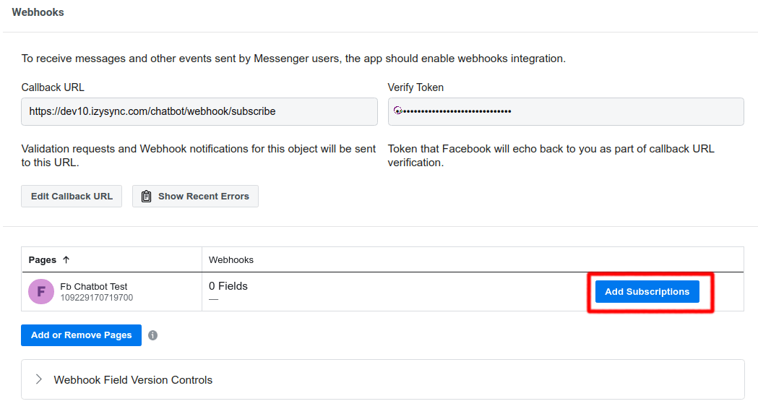

* Then, choose at least 2 options: **messages and messaging_postbacks**

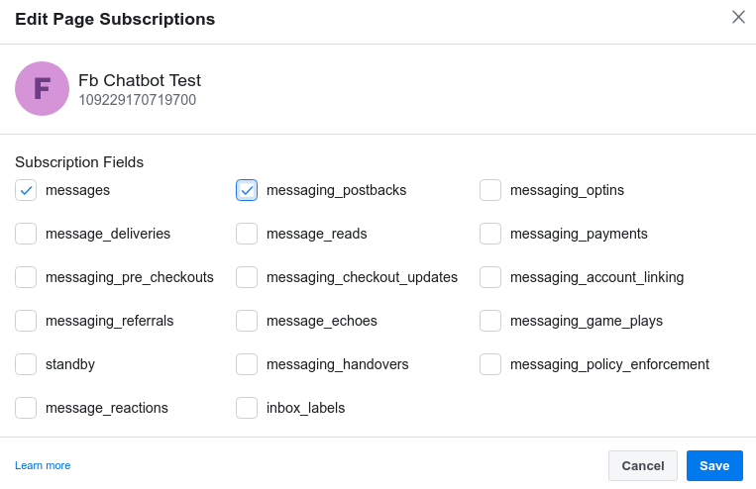

### **Human Support Configuration**

In the development mode, redirect to this link to Add Permissions for Human Support [**https://developers.facebook.com/tools/explorer/v2/**](https://developers.facebook.com/tools/explorer/v2/)

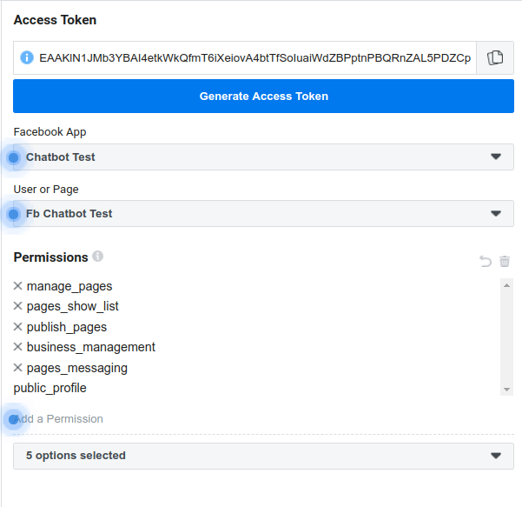

**After that, please follow the confirmation steps here** [**https://developers.facebook.com/tools/debug/accesstoken/**](https://developers.facebook.com/tools/debug/accesstoken/)

# **Configuration**

**On the Admin sidebar, go to Store > Configuration > Magenest > Facebook Chatbot**

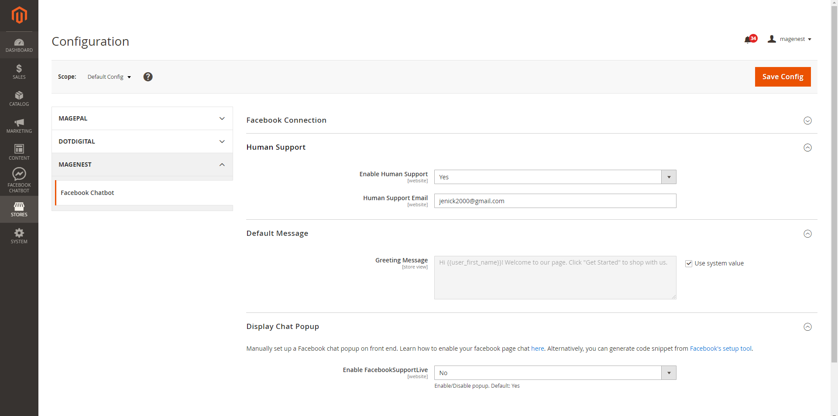

* **Human Support:** Select Yes to enable the human support feature
* **Human Support Email:** Fill in the email of your human support. This provided email will receive a notification when the user submits a request.
* **Greeting Message:** Specify the greeting message that customers will see when they first open the chat.
* **Enable Facebook Support Live:** choose Yes to enable Facebook Support Live

Manually set up a Facebook chat popup on front end. Learn how to enable your Facebook page chat [here](https://medium.com/@jamesfuthey/how-to-add-facebook-live-chat-to-your-website-dd48fc8bb066). Alternatively, you can generate code snippet from [Facebook's setup tool](https://developers.facebook.com/docs/messenger-platform/discovery/facebook-chat-plugin/).

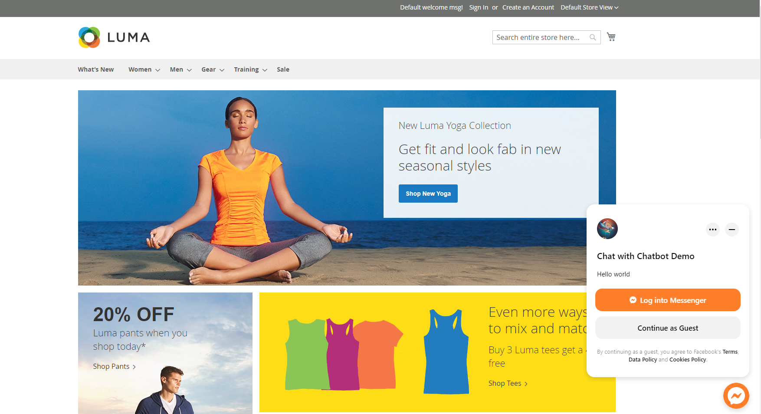

## **Create Persistent Menu**

On the Admin Sidebar, go to **Facebook Chatbot > Persistent Menu**

On the Persistent Menu page, you will see some default menu such as **Request Human Support, My order and My Wishlist.**

Please note that you won’t be able to change the name of **Request Human Support** menu, or delete it.

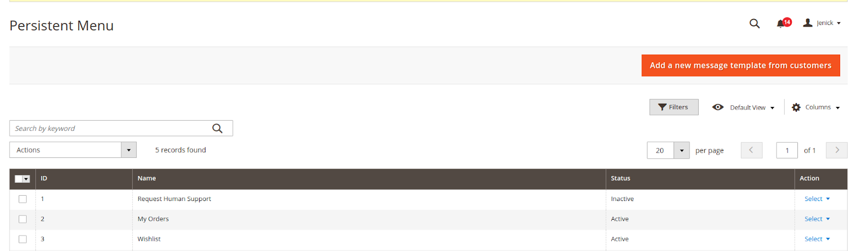

Click on **Add a new message template from customers**

On the **Edit Menu** page**:**

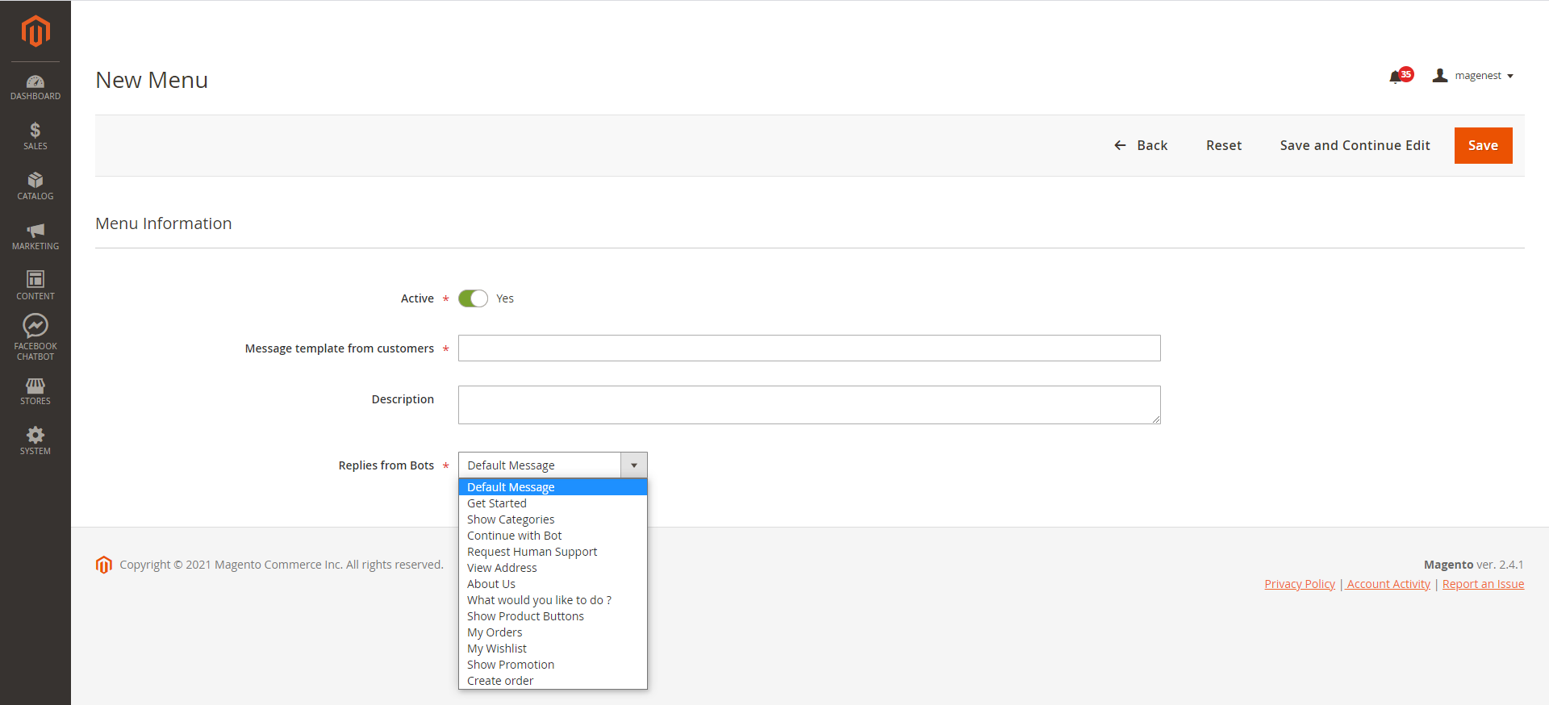

* **Active:** Switch to Yes to activate the menu
* **Name:** Fill in the label for the persistent menu messenger
* **Description:** This field is non-mandatory. You could fill in the menu description.
* **Replies from Bots:** Fill in this field with the message (get from message grid) that the bot will reply when the user selects the menu.

Display on the front end

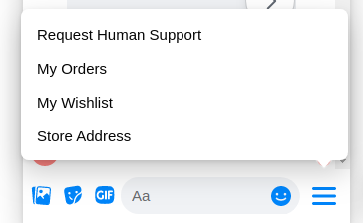

## **Create Message**

## On the Admin Sidebar, go to **Facebook Chatbot > Automated messages from Bots**

On the **Messages** page:

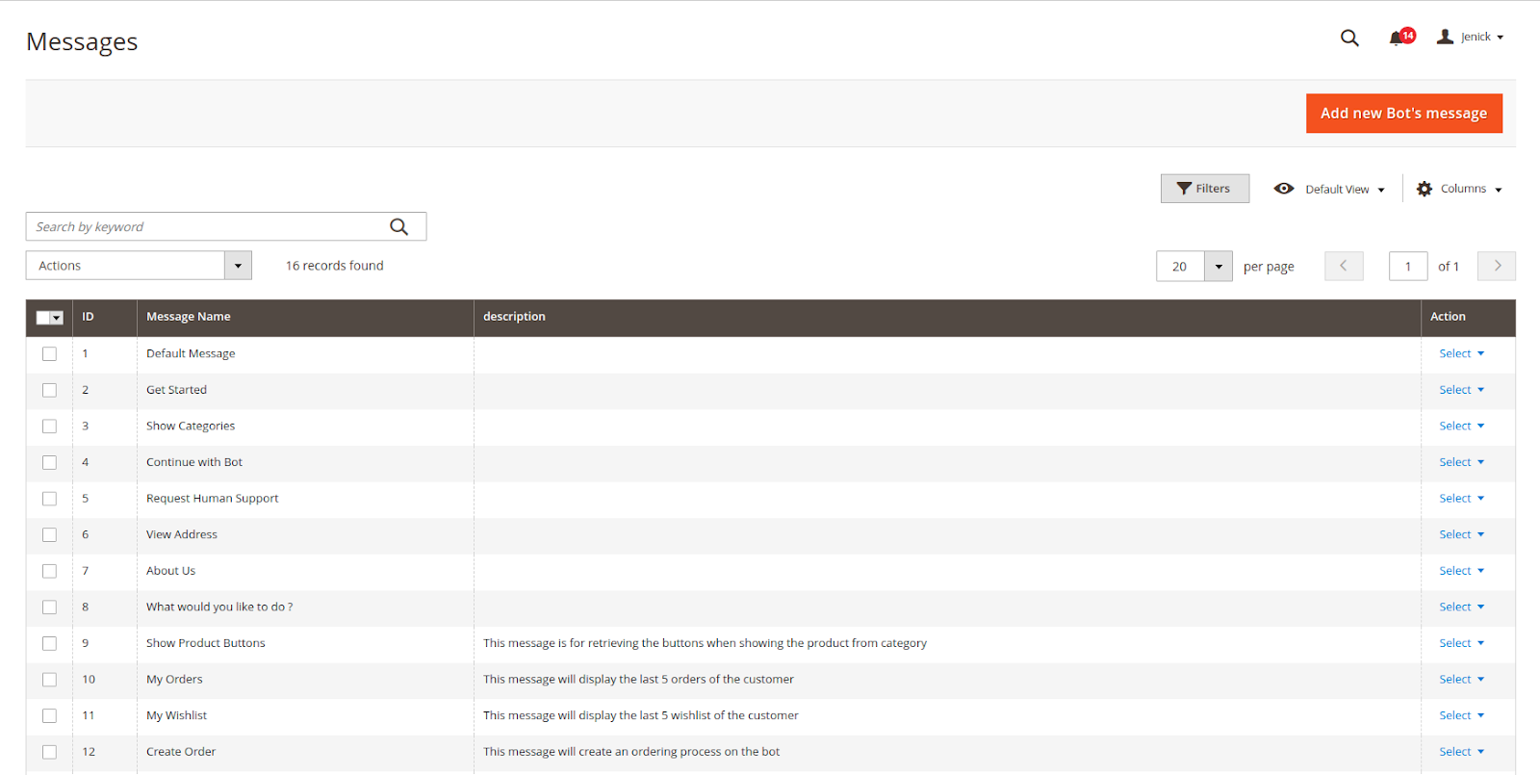

* There are **12** default messages when you first install the module. Please note that you cannot delete and change the message name for the Message ID: 1, 2, 4, 5.
* Click on **Add new Bot's message** on the New Message page:

**Message Information**

* **Name**: Fill in a title for the message to better management on the backend
* **Description**: Describe the content of the message

**Sender Actions**

* **Show typing time:** Switch to Yes to allow the bot to delay the message
* **Bot's typing time(s):** Enter the time (measured in seconds) you want to let the customer aware that his message is received and an answer is being processed

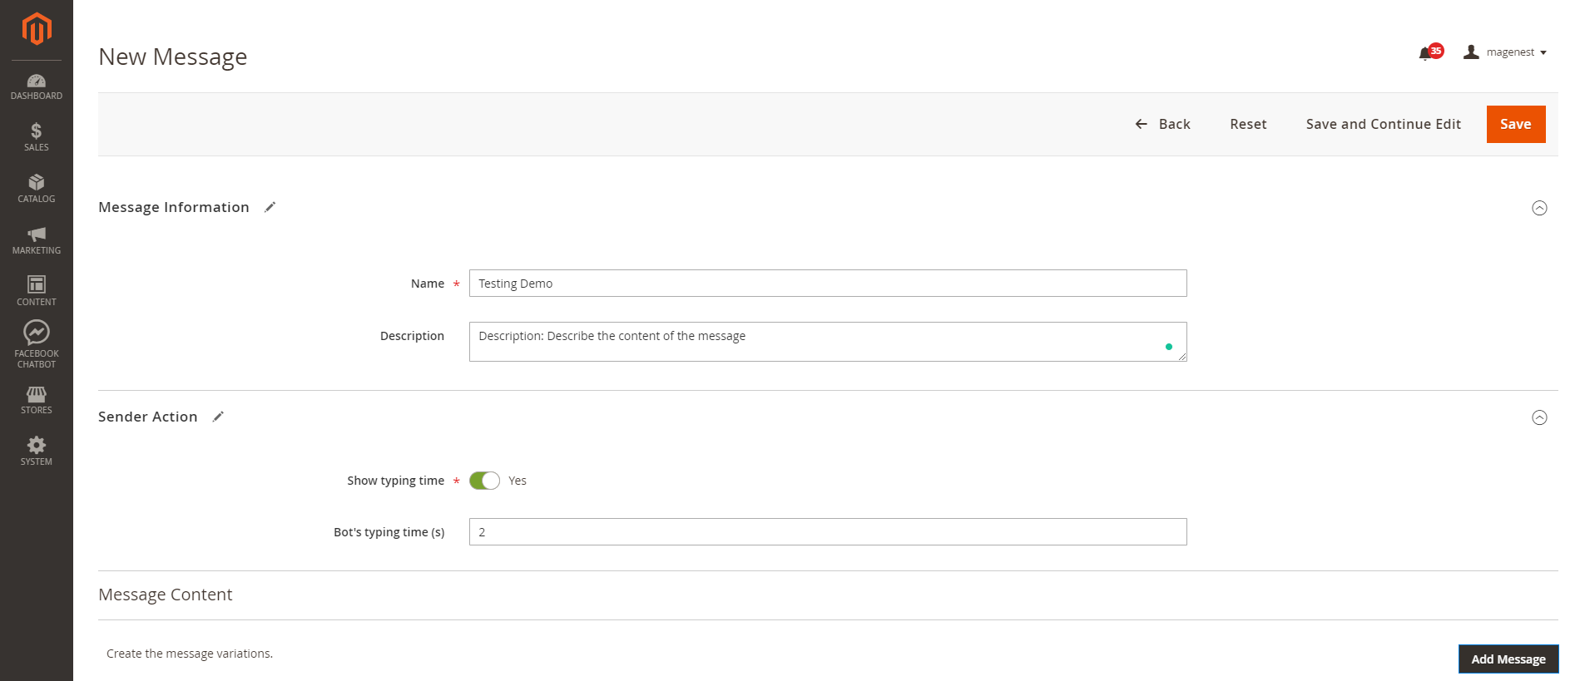

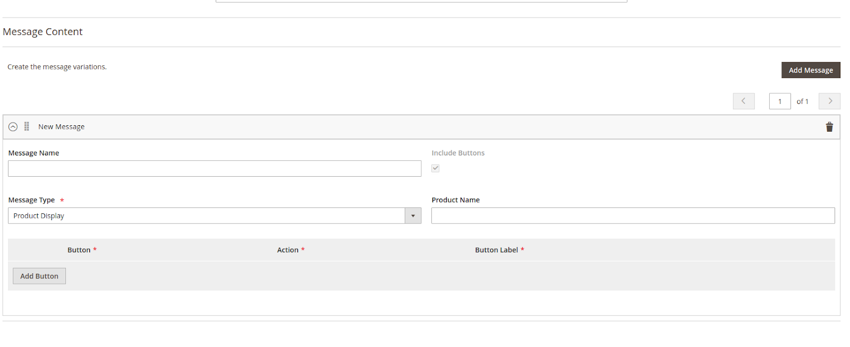

**Message Content**

Message Name: Only used to describe the message content item.

Message Type: You will be able to see 1 of 8 message types.

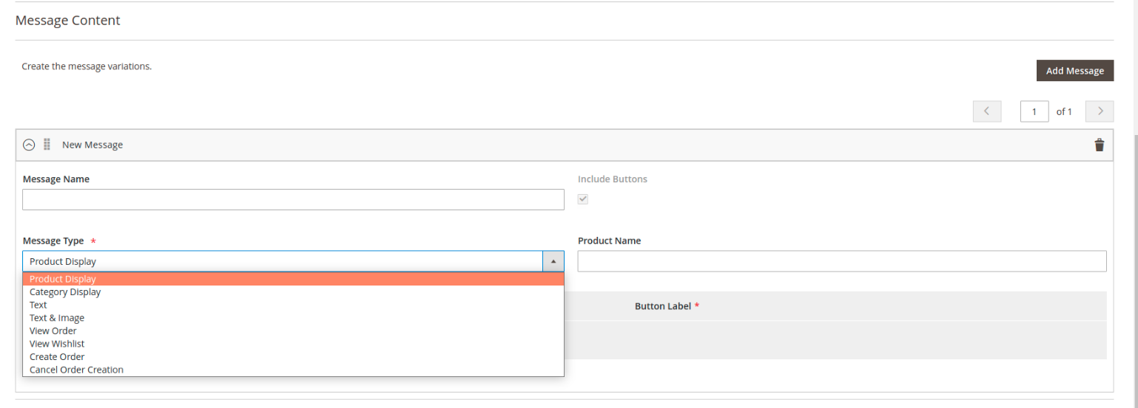

* **Product display:** show product list.

**Product Name:** will display products whose names like the value in this field. If not entered, product random will be displayed.

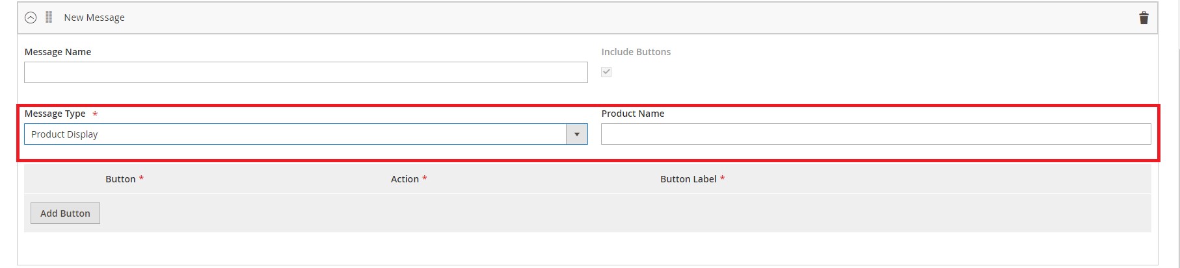

**Categories:** display categories by level

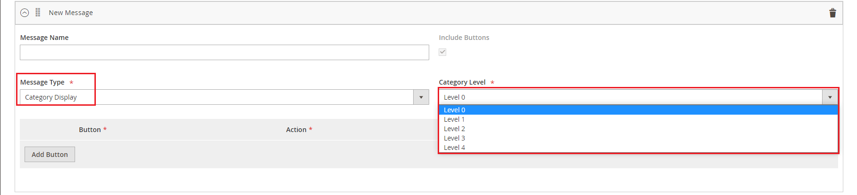

**Text:** display message as text

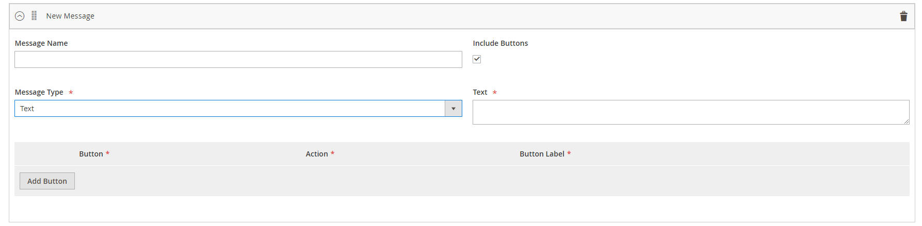

**Text & Image:** Display image and text

**Image:** upload image from local or gallery

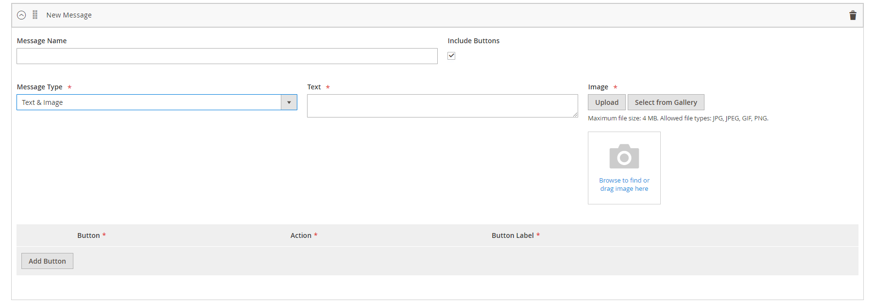

* **View Order:** display 5 previous orders generated by bot
* **View Wishlist:** display 5 item of customer's wishlist
* **Create Order:** start the order creation process [NEW]
* **Cancel Order Creation:** cancel order creation [NEW]

**Note:** The default message script in the bot can be changed by updating the csv file available in the module

Fbchatbot/i18n/en_US.csv

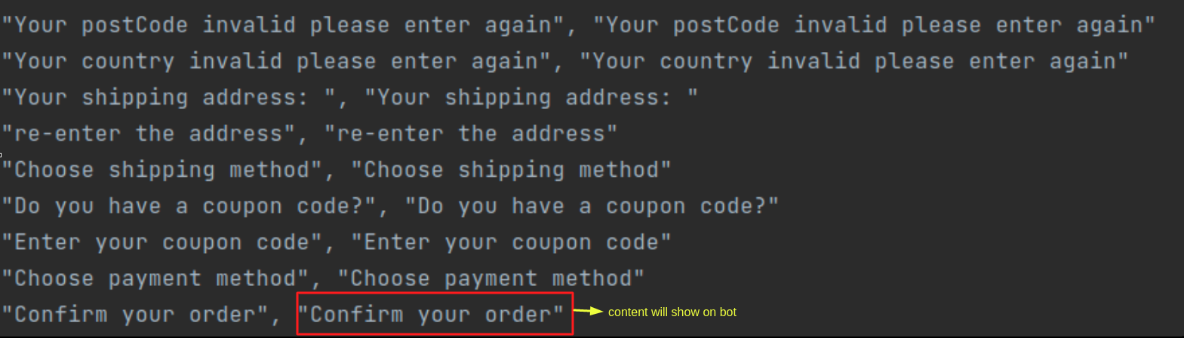

**Include Button**

To include buttons in the message (In addition to **Text** and **Text & Image** message type, all must include buttons), click **Add Button**.

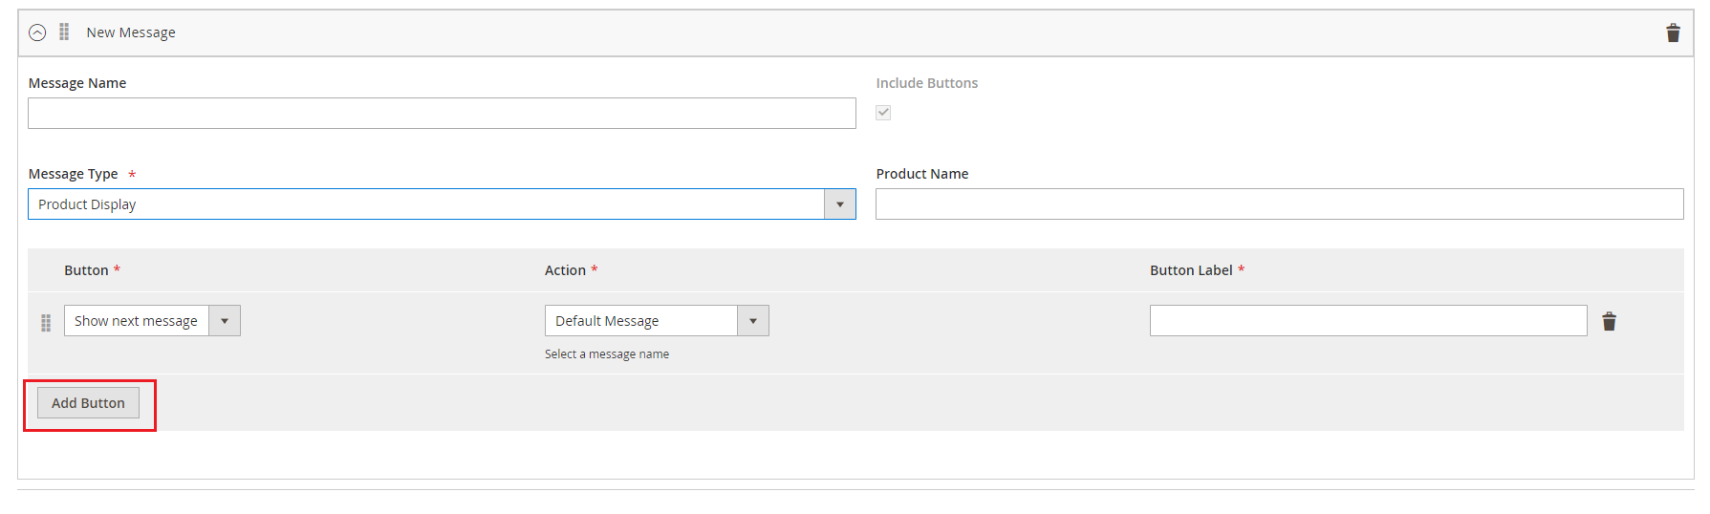

* **Button:** Select a button type enclosed in the message. There are 4 Button Types:

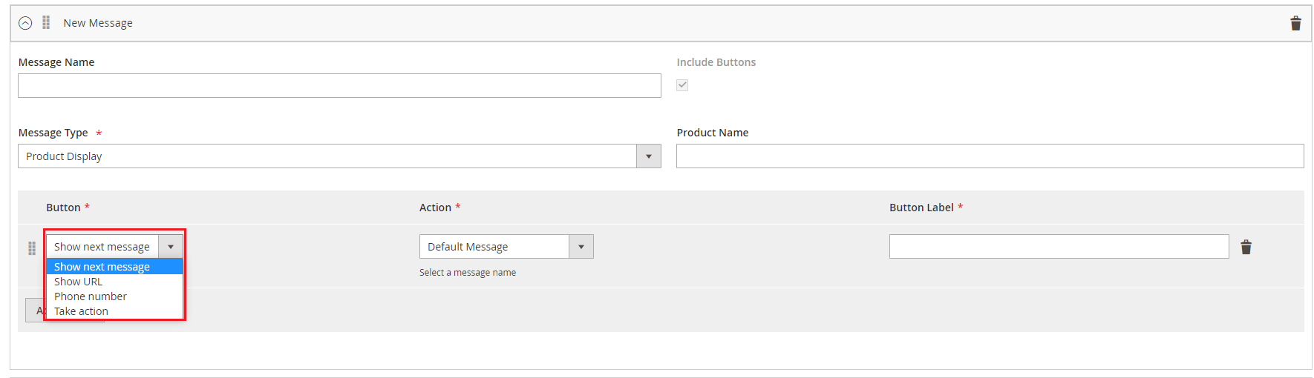

* **Action:** this field depends on the field Button

Select **Show next message** to select one of the corresponding options.

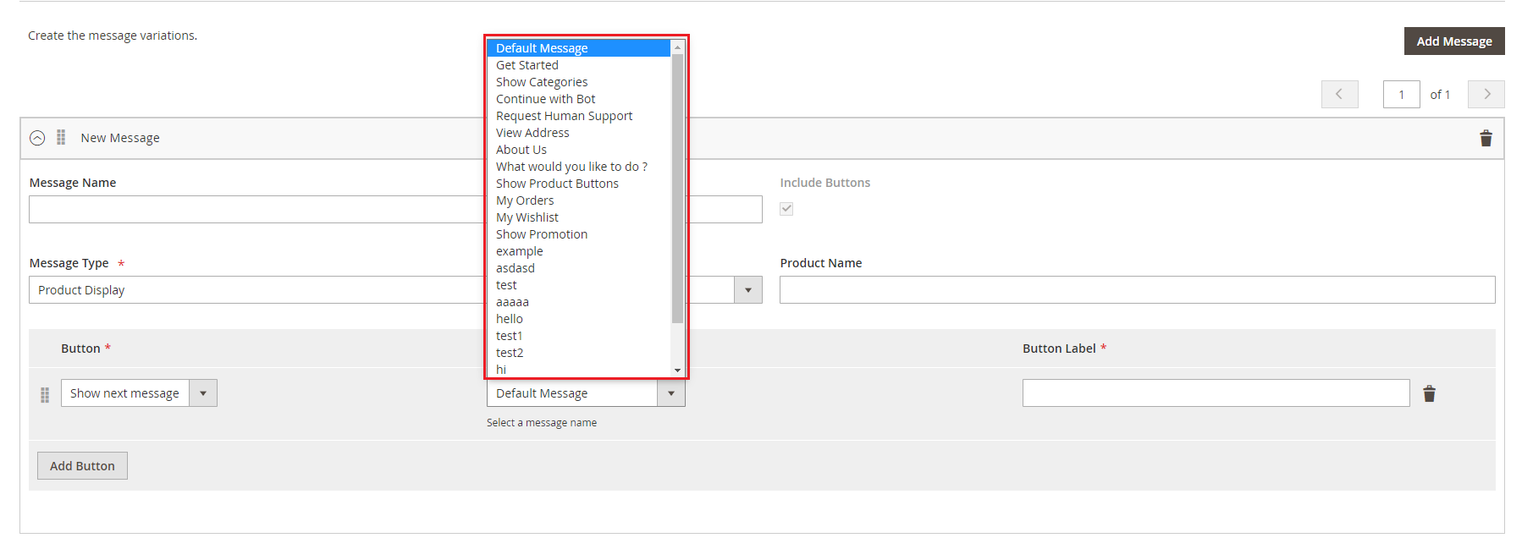

Select **URL** to enter a redirect link.

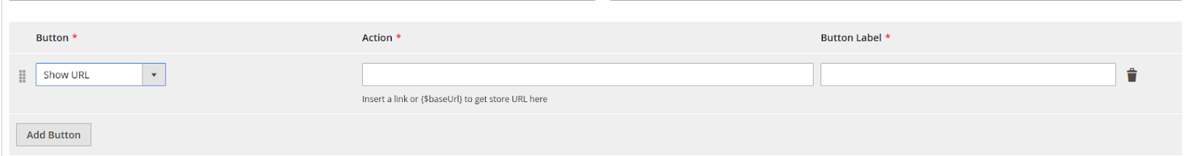

Select **Telephone** to enter a hotline.

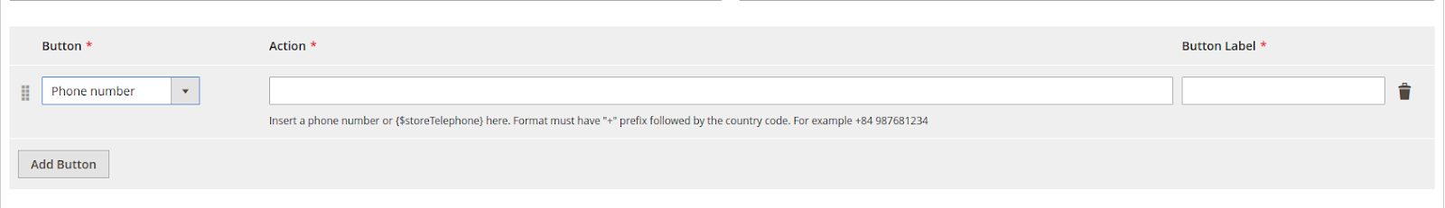

Select **Take Action** to choose one of the corresponding actions.

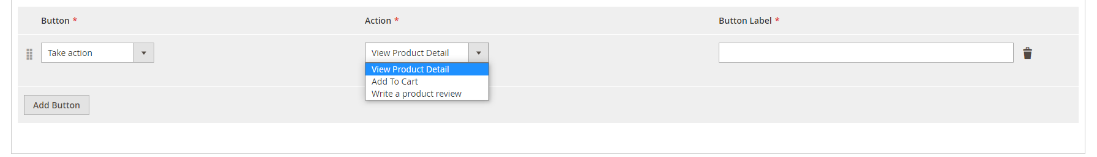

* **Button Label:** display label for button

# **Configure Your Facebook App**

You are required to provide the following basic information in the app console under **Settings > Basic:**

* **App Icon**
* **Privacy Policy URL**
* **Category**
* **Business Use**

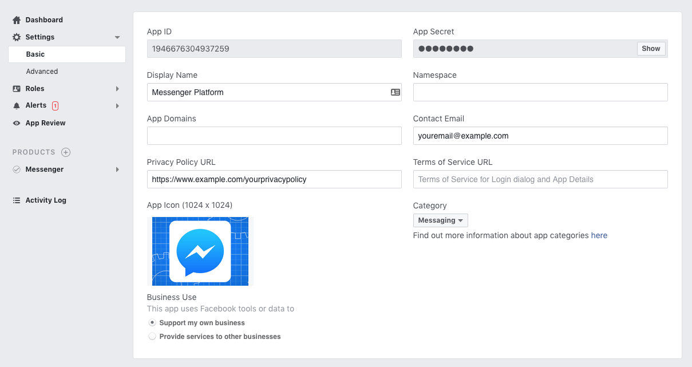

In order to allow Users to Message Your Page, you must enable messaging on your Page. Go to Page Settings > General.

* In the '**Messages**' section, click the '**Edit**' button.
* Select the 'Allow people to contact my Page privately by showing the Message button' checkbox.
* Click 'Save Changes'

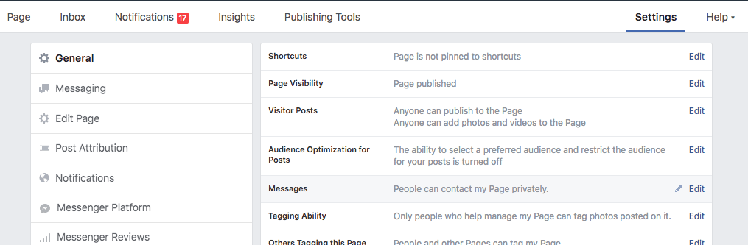

Then, please **Activate** Your app in Live Mode

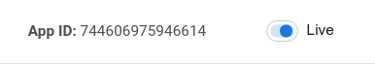

In order to add more permissions, please sign in to your **App Dashboard** and click on your app. Under Products, click **Messenger > Settings.** (If Messenger does not appear under Products, click the + icon and add it.)

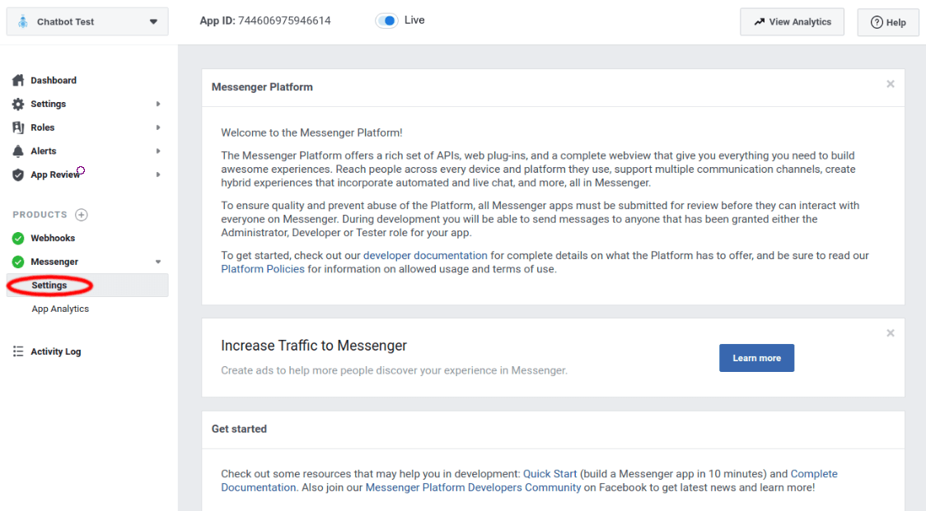

Scroll down to the **App Review** for Messenger section, then click the **Add to Submission** button for the pages_messaging permission.

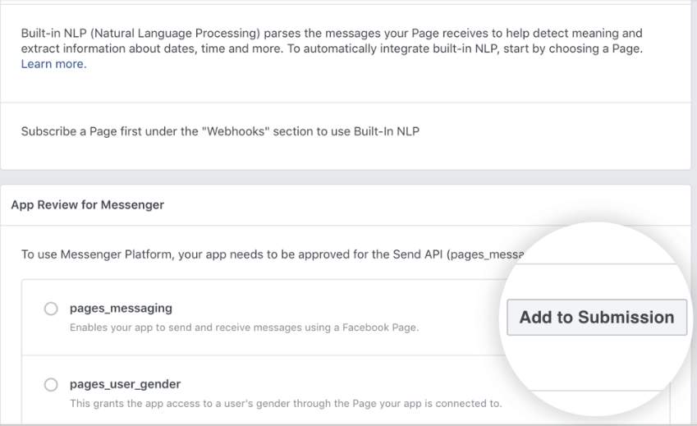

Then, to **Describe Data Usage**, you could follow the steps below

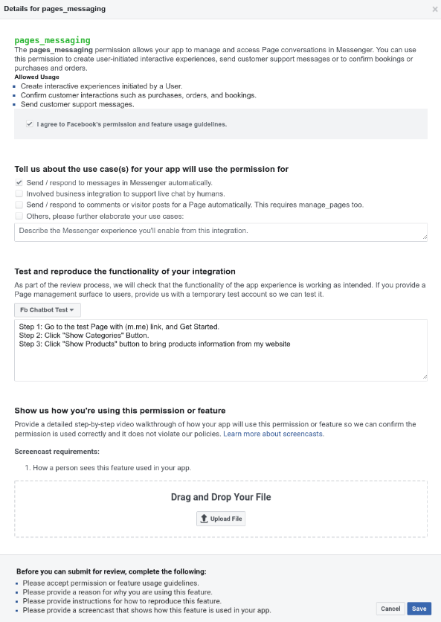

Download file and drag into screencast requirements: [File](https://drive.google.com/file/d/1aQ_eR6R0WXoRlbSmal06x5KPIgLGYylP/view?usp=sharing)

After providing all the necessary information, you will need to have a reviewer to verify that your app uses the pages_messaging permission correctly, click Submit For Review.

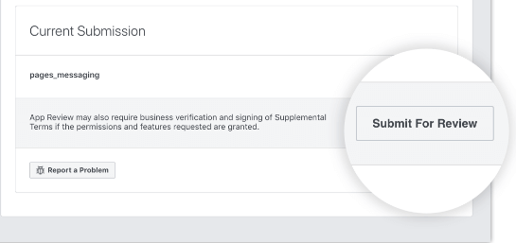

When approved, a green checkmark will also appear next to the pages_messaging permission under '**App Review for Messenger**'.

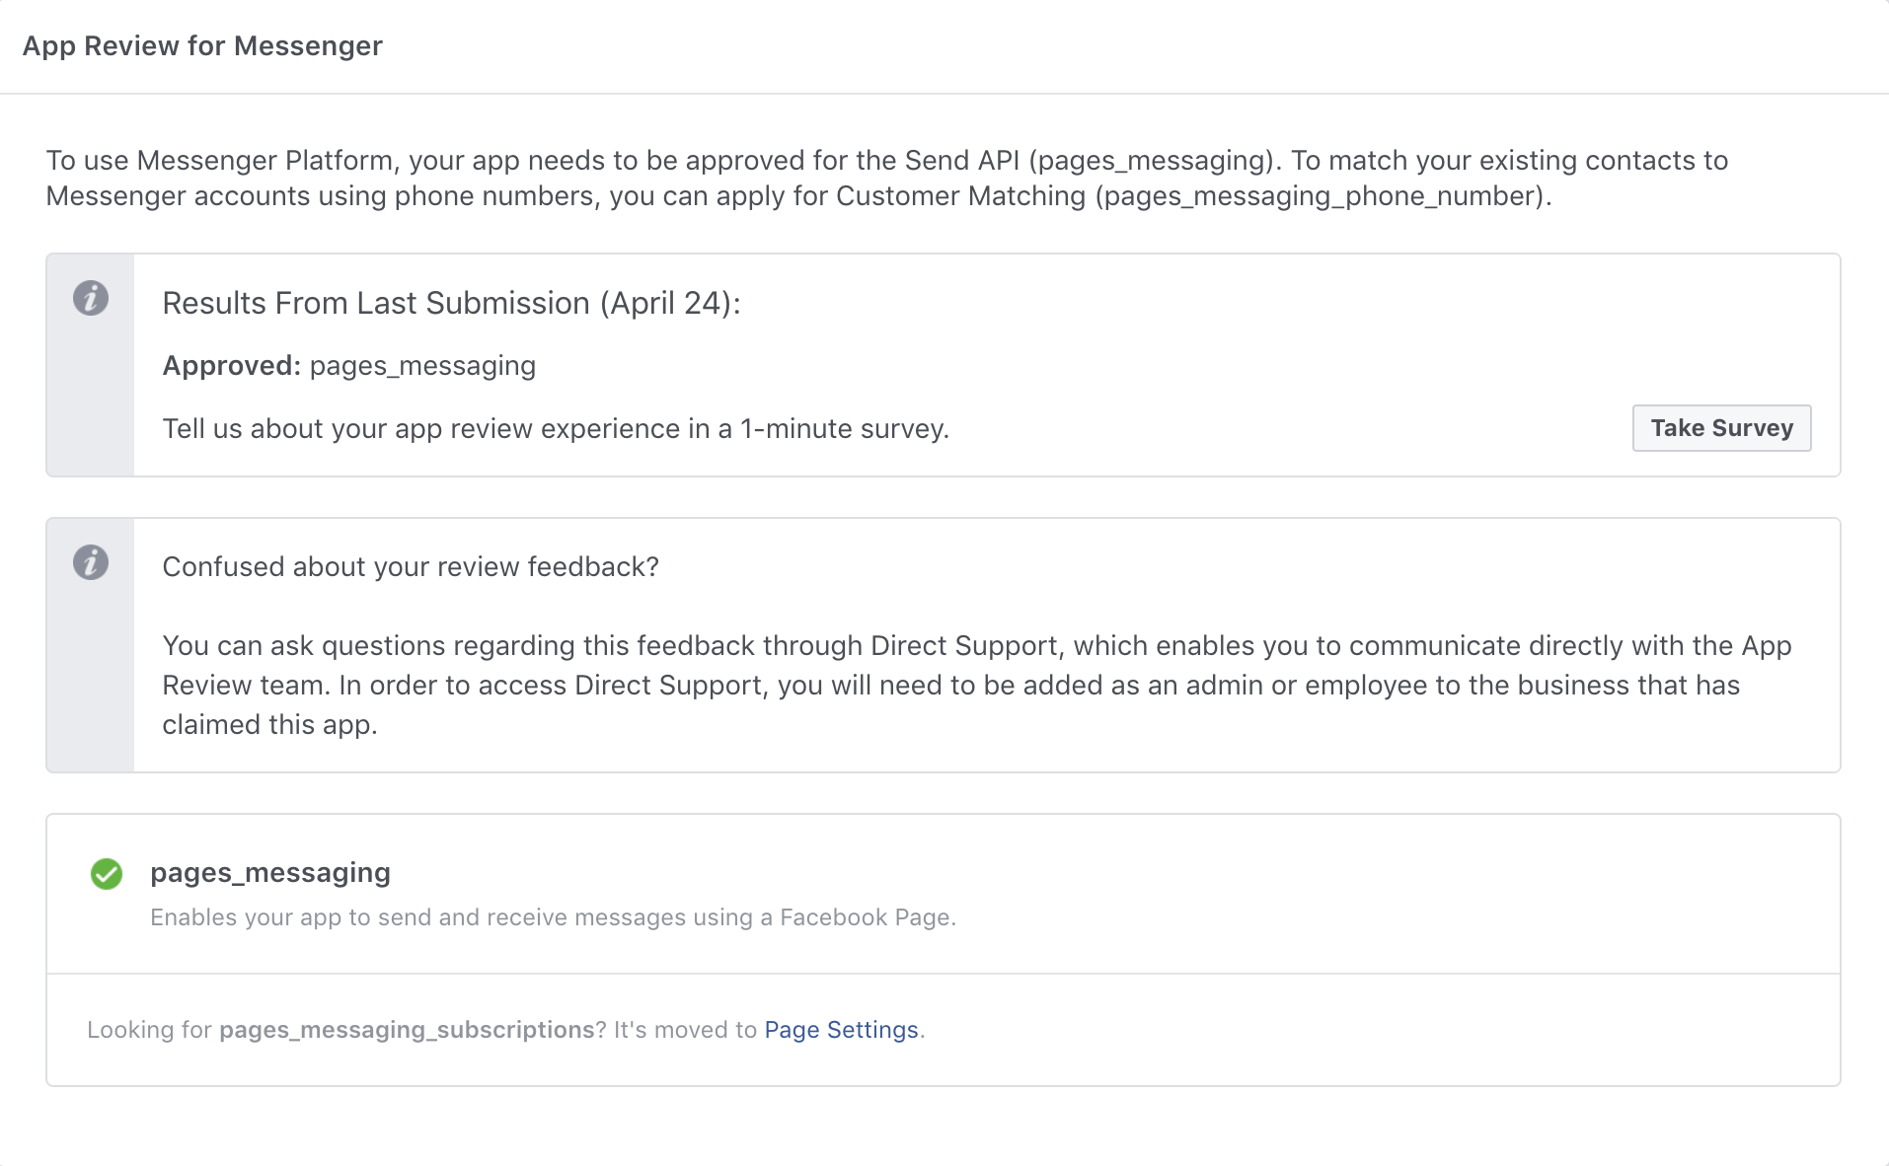

In rare cases that your app is not approved, click the 'Add to Submission' button next to 'pages_messaging' to see the feedback from Facebook review team.

If you have any questions, you can communicate directly with the review team to clarify how you can update your app by using the 'Ask a Question' button below the rejection notice

# **Live Facebook Chatbot**

After finishing all the required configurations, you could see your Bot ready to serve the customer and boost your business.

