CampusBite: Campus Food Ordering and Management System

Boholst, Darwin Uraddylle
Domiquel, Jermaine Vladimir Y.
Embalzado, Mary Rose B.
Gil, Kean Adrian R.
Hermia, Niño Kean Dayne
Isabelo, Cj M.
Medina, Nicole Mekhael
Regidor, Shokri Iam

Sibonga Community College
BSIT
Mrs. Maria Sarah Jean Cui
October 27, 2026
CampusBite: Campus Food Ordering and Management System
CampusBite brings students, campus food vendors, and administrators into one web-based ordering and management workflow. Students browse and place pickup orders; vendors manage menus, stock, order progress, and cash sales; administrators manage access and oversight.
Core operating rules. Public browsing is available without signing in. Student pickup orders contain food from one vendor only. Payment is CASH ONLY and is confirmed at pickup; no online payment gateway or delivery workflow is included. Reviews are available after a student order is completed.

Project Context
CampusBite is designed for a campus environment where students need to find food options and pickup details, while vendors need to coordinate menu availability, incoming orders, stock, and payment collection. Administrators also need a central way to oversee vendor accounts, users, food categories, reviews, and operational records.
When menus, stock counts, and order updates are handled through separate conversations or manual notes, students may not know whether an item is available or when to collect it, and vendors may have to reconcile orders and inventory by hand. CampusBite addresses this operational context by providing a shared, role-based application with a consistent order and pickup process.

Stakeholders
Table 1
Stakeholders and Needs
Stakeholder | Need addressed
Visitors | Browse public food listings, categories, and active campus vendors before signing in.
Students | Create an account, build a cart, place and track pickup orders, and review eligible completed purchases.
Vendors | Manage their own foods and inventory, fulfill student orders, record cash received, and process in-person POS sales.
Administrators | Create vendor accounts, control access and storefront status, manage shared content, and review system records.

Purpose and Description
The purpose of CampusBite is to organize campus food ordering and vendor operations through a single application. It provides students with a public catalog and a pickup-order workflow, gives vendors tools to manage fulfillment and inventory, and gives administrators role-based oversight.

System Description and Scope
CampusBite is a browser-based application built with PHP, MySQL/MariaDB, HTML, CSS, and vanilla JavaScript. It is structured for local XAMPP use, with a root-level index.php front controller and schema.sql database setup. MySQL/MariaDB stores application records; uploaded and seeded images are stored in the media.data LONGBLOB table rather than in a permanent uploads folder.
- Students can register and sign in. Visitors can browse without an account. Vendor accounts are created by an administrator; there is no public vendor-application workflow.
- Student checkout is for campus pickup and is limited to one vendor per cart. Availability and stock are checked again when an order is placed; stock is reserved as part of the order transaction.
- Payment is cash only. For a student pickup order, cash received is entered when the vendor marks the order Completed. The system requires the amount to cover the total and records any change due.
- The vendor POS records a cash sale and inventory movement. Online payments, delivery dispatch, external email/SMS messaging, and native push notifications are outside the project scope.

Objectives of the Study

General Objective
To develop and document CampusBite, a role-based campus food ordering and management application that supports food discovery, student pickup orders, vendor operations, cash-only sales, and administrative oversight.

Specific Objectives
- Provide public access to searchable food listings, categories, and active vendor storefronts.
- Provide role-appropriate accounts and permissions for students, vendors, and administrators.
- Enable students to manage a single-vendor cart, place pickup orders, and follow order-status updates.
- Validate food availability and inventory during ordering and keep stock and order records consistent through transaction-safe operations.
- Enable vendors to maintain food listings and inventory, process order statuses, record cash at pickup, and complete POS sales.
- Allow students to submit or edit reviews only for eligible completed purchases, while supporting vendor responses and administrator moderation.
- Provide administrators with tools for vendor-account management, user and category administration, reports, content settings, and audit review.

Functional Modules or Processes
The following modules represent distinct user-facing processes in the application. Together they cover the minimum requirement of three functional modules and define the project’s primary inputs, checks, and outputs.
Table 2
Functional Modules and Processes
Module | Primary users | Main functions and outputs
1. Accounts and role access | Visitor, Student, Vendor, Admin | Public browsing; student registration and sign-in; role-based navigation and server-side permission checks; profile management. Output: an authenticated session and access limited to the user’s role.
2. Food discovery and catalog | Visitor, Student, Vendor, Admin | Search foods, categories, and vendors; vendors maintain food details, prices, and availability; administrators manage shared categories and featured foods. Output: a browsable catalog that reflects current listing status.
3. Student cart, checkout, and order tracking | Student, Vendor | Add, update, or remove cart items; enforce one vendor per cart; verify active vendor, availability, and stock; create pickup order and track its status. Output: an order record, reserved inventory, and cash-payment record.
4. Vendor fulfillment, inventory, and POS | Vendor | Record inventory movements; confirm and prepare orders; mark food Ready and later Completed; enter cash received; create completed in-person POS sales. Output: order/status history, stock updates, payment/change records, and sales data.
5. Reviews, notifications, and administration | Student, Vendor, Admin | Students review completed purchases; vendors respond; administrators moderate reviews and reports. In-app notifications provide updates. Administrators manage vendor accounts, users, settings, content, and audit/report views. Output: feedback, alerts, and managed system records.

Procedural Flow
The flow below describes the normal student purchase and the related vendor and administrator processes. Actual access is controlled by the signed-in account’s role and permissions.
Student order at a glance. Browse → Select one vendor → Add foods to cart → Recheck availability and stock → Place pickup order (PENDING / CASH UNPAID) → Vendor prepares → Student picks up and pays cash → Vendor records cash and completes order → Student may submit a review.
Figure 1
Student Pickup-Order Workflow, Including Stock and Cash Checks
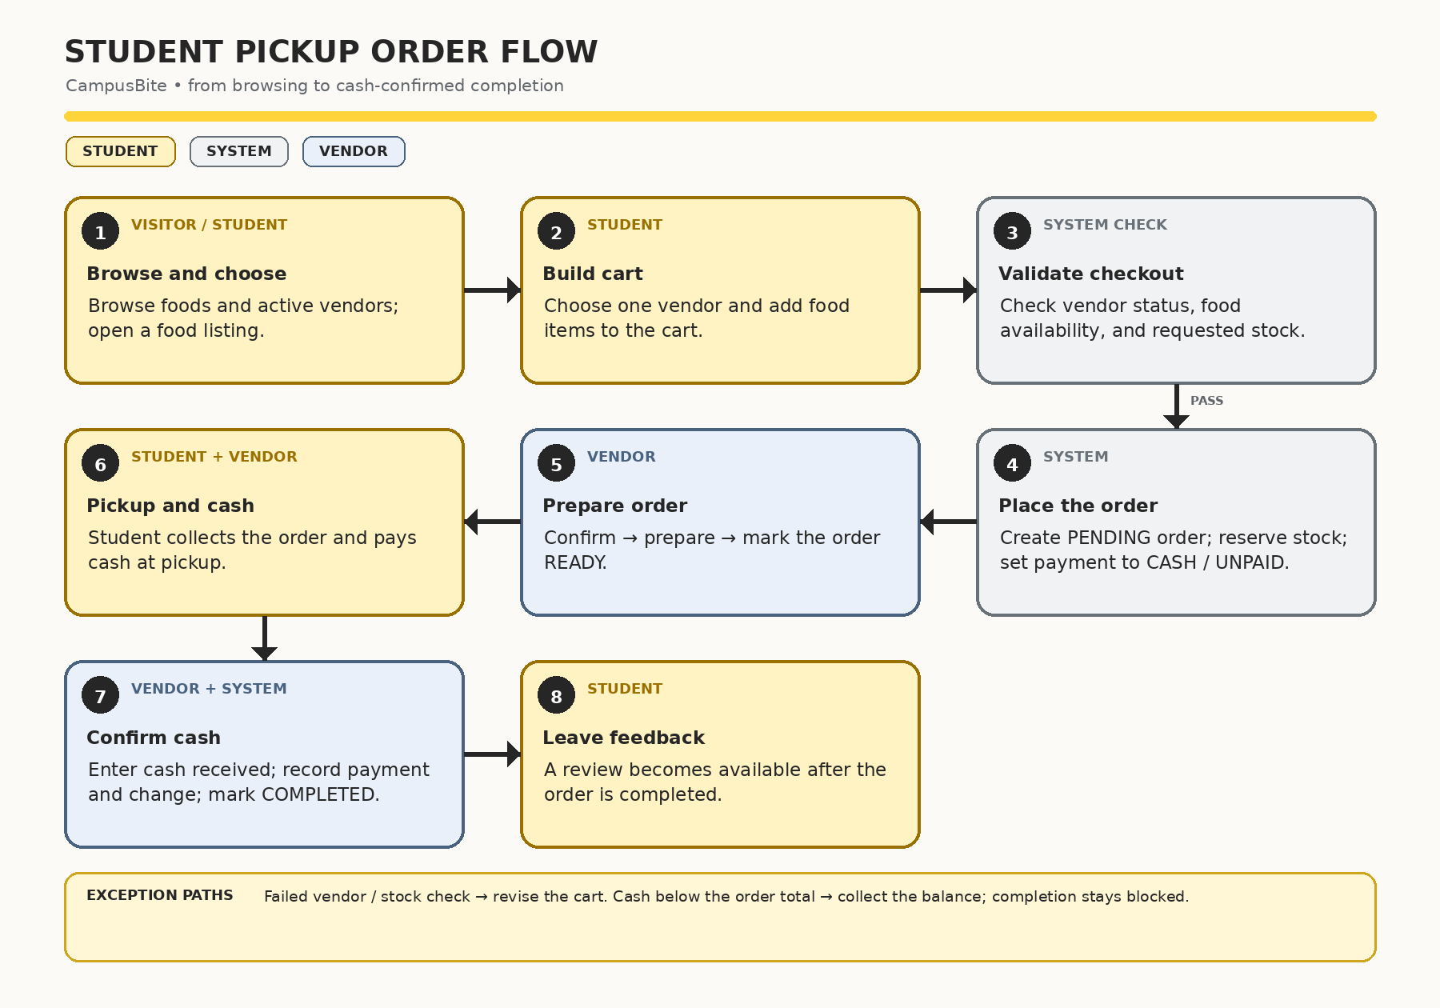
Note. Checkout checks vendor acceptance, food availability, and stock; cash below the order total blocks completion.

Student Ordering and Pickup
Table 3
Student Order and Pickup Procedure
Step | Actor | Action / system response
1 | Student | Browse foods and active vendors. Search or filter the catalog, then open a food listing.
2 | Student | Choose food and quantity, then add it to the cart. The cart is limited to foods from one vendor.
3 | System | At checkout, verify that the vendor is active and accepting orders, each food is available, and requested quantities are in stock. Show pickup location and order total.
4 | Student | Review the order, optionally add a pickup note, and submit. No online payment is taken.
5 | System | Within a database transaction, create a PENDING student order, save item/price details, reserve the quantities from inventory, create an UNPAID CASH payment record, and clear the cart.
6 | Vendor | Review the incoming order and move it through the allowed fulfillment sequence: PENDING → CONFIRMED → PREPARING → READY.
7 | Student + Vendor | The student collects the order at the stated pickup location and pays in cash. When marking the order Completed, the vendor enters cash received; the system requires at least the order total and records the payment and change due.
8 | System + Student | Save the completed status and notify the student in-app. The student may then submit or edit a review for the completed order item.

Vendor Order and Inventory Process
- The vendor signs in and opens the vendor workspace. The account must have an active storefront for order-management features.
- The vendor maintains food listings, categories, availability, prices, preparation estimates, and inventory quantities. Stock movements are recorded for auditability.
- A new student order appears in the vendor order list. The vendor confirms it, prepares the food, and marks it Ready when it can be collected.
- At handoff, the vendor enters the cash received and marks the order Completed. The amount must be at least the order total; change due is calculated and payment status is updated.
- If an order is cancelled or rejected where allowed, the system returns its reserved quantity to inventory and records the return movement.

Vendor Point-of-Sale Process
- The vendor selects available foods and quantities for an in-person sale.
- The system checks vendor ownership, food availability, stock, and the calculated total.
- The vendor enters cash received. The sale is rejected if cash is less than the total or inventory is insufficient.
- On success, a transaction records a completed POS order, cash payment, change due, and stock movements together.

Administrator Process
- The administrator signs in and opens the administration workspace.
- The administrator creates vendor accounts and chooses whether a storefront begins Pending or Active. Vendor access is not opened through public applications.
- The administrator manages user/vendor status, food categories, site content and settings; reviews reports; moderates reviews; and inspects audit records as needed.

System Setup for a Local Demonstration
- Place the project folder under the XAMPP htdocs directory and start Apache and MySQL.
- Import the project root schema.sql file through phpMyAdmin to create the campusbite database and its tables and demo data.
- Open the local project URL, browse publicly, or sign in using a role-specific demonstration account. Change temporary passwords before any non-demo use.

Security, Data Handling, and Limitations

Security and Data Handling
- Passwords are stored using password hashing. State-changing forms use CSRF protection; sessions are regenerated at sign-in and password changes.
- Database access uses prepared mysqli statements; user input is validated and rendered output is escaped. Server-side role and permission checks protect restricted processes.
- Order and inventory changes are performed transactionally where applicable. Administrative actions are audit-logged.
- Profile and food images are validated and stored in the database media.data LONGBLOB table. Profile photos and phone numbers are private to the user and campus administrators; email changes are administrator-managed.

Scope Limitations
- The project is intended for local demonstration and academic evaluation; default XAMPP database settings and demo accounts are not suitable for a public production server.
- The application supports pickup and cash payment only. It has no online payment gateway, delivery dispatch, external email/SMS service, or native push notification integration.
- Before real deployment, configure HTTPS, a least-privilege database account, strong credentials, backups, log management, privacy controls, and additional security testing.

Conclusion
CampusBite organizes food discovery, student pickup ordering, vendor fulfillment, inventory and cash-sale recording, and administrator oversight in a single role-based system. Its core workflow connects an order to stock reservation, vendor preparation, cash payment at pickup, and post-completion feedback while keeping online payments and delivery outside the stated scope.

