Assignment-1
Create a strong code for password authentication using python
- Loop method
Secret_pin = “7890”
Access_granted = False
while not Access_granted:
Guess=input(“Enter your 4-digit pin: “)
if Guess == Secret_pin:
print(“Opening…”)
Access_granted =True
else:
print(“Access denied. Try again.”)
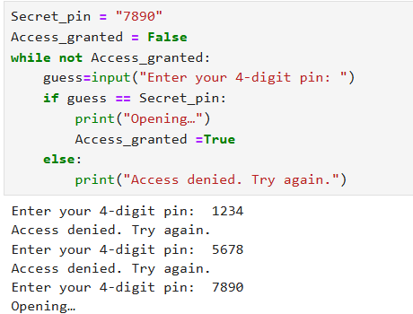
- Using RSA Algorithm
import rsa
public_key , private_key = rsa.newkeys(512)
password = “My SrongSecretPassword”.encode()
encrypted_msg = rsa.encrypt(password, public_key)
print(f”Encrpyted (What hackers see) : {encrypted_msg} \n”)
decrypted_msg = rsa.decrypt(encrypted_msg, private_key)
print(f”Decrpyted : {decrypted_msg.decode()} ”)
