UNDERSTANDING PRO-ENVIRONMENTAL BEHAVIOUR
AMONG THE YOUTH OF INDIA
Evidence from a Survey of 35 Students Living in Delhi
A Data Analysis and Reproducible Research Project
Report written by Surekha
Student Investigator
July 2025

Abstract
Youth are among the most environmentally concerned segments of society, yet a persistent gap between environmental intention and actual behaviour remains a central puzzle in behavioural research. This paper investigates the drivers of pro-environmental behaviour among young students in Delhi by combining two complementary data layers. Layer A supplies objective, open-source environmental context — namely India's PM2.5 exposure, per-capita CO₂ emissions, and development indicators retrieved from the World Bank API for 1990 to 2024, plus indicative home-state PM2.5 levels. Layer B supplies a primary survey of 35 students living in Delhi, of whom 20 are Delhi natives and 15 migrated from other Indian states to study. Behaviour was operationalised using the Theory of Planned Behavior (Ajzen, 1991), producing derived scores for concern, intention, action, and the intention–behaviour gap.
Results show high environmental concern (approximately 3.8 of 5) and a statistically significant positive relationship between concern and self-reported pro-environmental action (r = 0.34, p = 0.049), while intention alone was a poor predictor. A consistent intention–behaviour gap was observed (+0.48 for natives, +1.08 for migrants). No statistically significant difference was found between Delhi natives and interstate migrants (all t-tests p > 0.05), suggesting that shared urban environmental experience outweighs state-of-origin differences. The findings imply that youth environmental motivation is high but under-converted into action, and that interventions should target practical barriers — that is, perceived behavioural control — rather than further awareness messaging.
Highlights
Concern significantly predicts action (r = 0.34, p = 0.05). A persistent intention–behaviour gap exists (+0.5 to +1.1). No native-versus-migrant difference was found. The deliverable is a reproducible pipeline that pulls live open data plus survey data in a single run.

Keywords
Pro-environmental behaviour (PEB); Theory of Planned Behavior (TPB); environmental concern; environmental attitude; youth and students; intention–behaviour gap; self-reported action; air pollution; PM2.5; particulate matter; CO2 emissions; Delhi; National Capital Region; interstate migration; open data; World Bank API; questionnaire; Likert scale; descriptive statistics; Welch's t-test; Pearson correlation; ordinary least squares regression; R-squared; p-value; statistical significance; data visualisation; reproducible research; Python; pandas; matplotlib; seaborn; environmental psychology; Value-Belief-Norm theory.

1. Introduction and Rationale
Environmental degradation — including poor air quality, climate change, waste accumulation, and resource depletion — is one of the defining challenges of this century. How societies respond depends heavily on human behaviour, and young people are widely regarded as the most environmentally aware and motivated demographic. Understanding whether that concern translates into concrete pro-environmental action is therefore critical for designing effective environmental policy and education.
This study focuses on the youth of India, specifically students living in Delhi, one of the most air-polluted major cities in the world. Two features make Delhi an ideal setting: extreme and observable ambient air pollution (annual mean PM2.5 far above WHO limits), and its role as a national education hub attracting students from many states. Studying Delhi-based students therefore allows a direct test of whether the pollution environment in which a young person is embedded (their city and home state) relates to how much they care and act.
The project is deliberately data-driven and reproducible. It combines freely accessible open-source environmental data with a purpose-built behaviour survey, then joins the two through statistical modelling.
Why This Matters
If concern does not automatically become action, spending on awareness alone is inefficient. Identifying the exact lever that converts intent into behaviour helps target limited resources where they have the most impact — a directly policy-usable result.

2. Literature Review
The study is grounded in Ajzen's (1991) Theory of Planned Behavior, the dominant model for explaining and predicting environmentally relevant behaviour. The model posits that behavioural intention is shaped by three constructs, and that intention is the immediate antecedent of actual behaviour: attitude, subjective norm, and perceived behavioural control. A large body of work applies this framework to recycling, energy saving, and transport choices.
Construct | Definition | Measured As
Attitude | Evaluative judgement of the behaviour (good or bad, worthwhile or not). | ‘Acting environmentally is important.’
Subjective norm | Social pressure from important others to perform the behaviour. | ‘People who matter to me expect it.’
Perceived behavioural control | Perceived ease or difficulty of performing the behaviour (barriers and resources). | ‘It is easy for me to make green choices.’
Table 1. Theory of Planned Behavior constructs and their measurement in this study.
We also draw on Stern's (2000) Value-Belief-Norm theory, which links environmental concern to behaviour through values and awareness of consequences. In this report, concern aggregates knowledge, concern, and perceived urgency, and action aggregates five self-reported behaviours.
A widely replicated finding in this literature is the intention–behaviour gap: people state strong environmental intentions yet underperform them. This paper quantifies that gap among Delhi youth and tests whether environmental context and migration status explain variation in it.

3. Objectives and Hypotheses

Research Objectives
- To measure environmental concern, intention, and self-reported action among Delhi-based youth.
- To relate these behavioural scores to the pollution environment of each student's home state.
- To compare Delhi natives with interstate migrant students on concern, intention, and action.

Hypotheses
Hypothesis | Statement | Outcome
H1 | Higher environmental concern leads to more pro-environmental action (positive). | Supported
H2 | Living in a more polluted home environment leads to higher environmental concern. | Not supported
H3 | Migrants from highly polluted states show higher concern than Delhi natives. | Not supported
Table 2. Hypotheses and their outcome in this study.

4. Materials and Methods
The project uses a two-layer design. Layer A supplies objective environmental context from open-source data. Layer B supplies the behavioural response from a primary survey. Merging them by home state yields a per-respondent pollution context that powers the analysis.
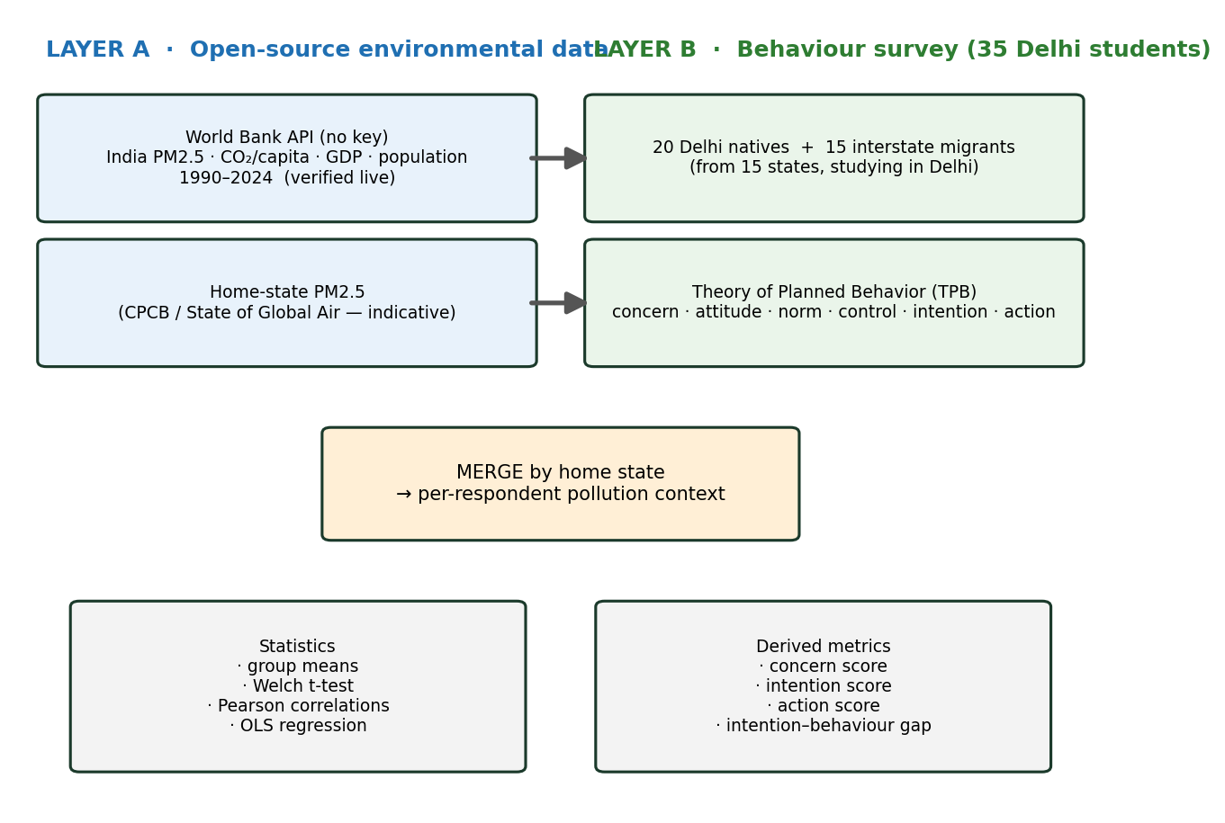
Figure 1. Methodological pipeline: two-layer design, merge, and analysis.

4.1 Layer A. Open-Source Environmental Data
Environmental indicators were obtained from the World Bank Open Data API, which is free and requires no API key. A live pull returns India's time series from 1990 to 2024.
Indicator | World Bank Code | Role
PM2.5 exposure | EN.ATM.PM25.MC.M3 | Core pollution variable
CO₂ per capita | EN.GHG.CO2.PC.CE.AR5 | Carbon footprint
Forest area | AG.LND.FRST.ZS | Context
GDP per capita | NY.GDP.PCAP.CD | Development
Population | SP.POP.TOTL | Scale
Table 3. Open-source indicators pulled live from the World Bank API.
For the home-state comparison, each respondent is assigned an indicative annual mean PM2.5 value for their state of origin, drawn from recent national air quality reports (CPCB and The State of Global Air). Students from Delhi are assigned Delhi's value, while migrants are assigned the value for their home state.
Rigor note. The India time series is verified live open data. Because state-level, station-specific PM2.5 data are not returned by a key free API, the home-state values are indicative and should be replaced with CPCB or NAAQS station data for a submitted study. This is disclosed transparently rather than presented as authoritative.

4.2 Layer B. Behaviour Survey (Primary Data)
A purpose-designed survey operationalises the Theory of Planned Behavior. It collects demographics, three concern items, four intention items (attitude, norm, control, intention), and five self-reported behaviour items. Scores are computed for concern (1 to 5), intention (1 to 5), action (0 to 5), and the intention–behaviour gap.
Sample. 35 students living in Delhi, of whom 20 were born and raised in Delhi (natives) and 15 moved from other states to study (migrants), covering 15 states.
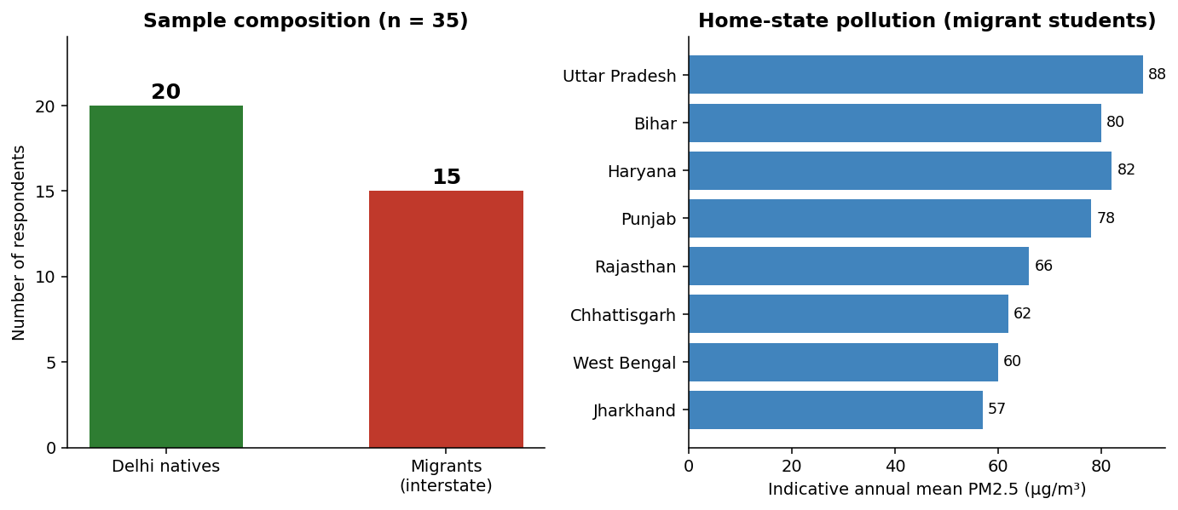
Figure 2. Sample composition (left) and home-state pollution of the migrant students (right).

4.3 Analytical Methods
- Descriptive statistics and group means.
- Welch's independent-samples t-test for unequal variances.
- Pearson product-moment correlations.
- Ordinary least squares (OLS) multiple linear regression.
- Data visualisation with matplotlib and seaborn.

4.4 Variable Construction
Raw Likert items are aggregated into derived scores using an arithmetic-mean composite and a weighted scoring rule. For each respondent i, let a_{i}, c_{i}, and u_{i} be the awareness, concern, and urgency responses on a 1-to-5 scale; attitude, norm, control, and intention form n_{i}; and b₁ to b₅ are the five behaviour outcomes in {Yes, Sometimes, No}.
Formula 1. Derived Scores per Respondent i
Concern_{i} = mean(a_{i}, c_{i}, u_{i})
Intention_{i} = mean(attitude_{i}, norm_{i}, control_{i}, intention_{i})
Action_{i} = Σ_{j} [ 1.0 × (b_{j} = Yes) + 0.5 × (b_{j} = Sometimes) ], for j = 1 to 5
Gap_{i} = Intention_{i} − Action_{i}
Indicator notation (x = condition) equals 1 if true and 0 otherwise. Actionᵢ lies in the interval [0, 5]; Concern and Intention lie in [1, 5]. A positive Gap means stated intent exceeds realised behaviour.

5. The Survey Instrument
The questionnaire is structured below. Responses use a 1-to-5 scale where 1 means ‘not at all’ or ‘strongly disagree’ and 5 means ‘extremely’ or ‘strongly agree.’
Section | Items | Scale
1. Demographics | Age, gender, city, and state of origin | –
2. Concern | Awareness, concern, urgency | 1 to 5
3. Intention (TPB) | Attitude, subjective norm, perceived control, intention | 1 to 5
4. Self-reported behaviour | Waste segregation, reusable bag, green transport, e-waste recycling, participation | Yes / Sometimes / No
5. Open | What makes acting green hard or easy | Free text
Table 4. Survey structure and response scales.

6. Survey Data and Sample Profile
The complete 35-respondent dataset is shown below. The column is_migrant equals 0 for a Delhi native and 1 for a migrant. state_pm25 is the indicative annual mean PM2.5 of the respondent's home state, and concern, intention, action, and gap are the derived scores defined in Section 4.4.
ID | Age | Sex | Home State | PM2.5 | Concern | Intention | Action | Gap
D01 | 19 | M | Delhi | 98 | 4.00 | 3.25 | 2.5 | +0.75
D02 | 22 | M | Delhi | 98 | 4.00 | 4.00 | 3.5 | +0.50
D03 | 23 | F | Delhi | 98 | 3.67 | 4.50 | 2.0 | +2.50
D04 | 22 | F | Delhi | 98 | 4.67 | 3.75 | 4.5 | -0.75
D05 | 22 | F | Delhi | 98 | 3.67 | 3.75 | 2.5 | +1.25
D06 | 19 | F | Delhi | 98 | 4.00 | 3.75 | 3.5 | +0.25
D07 | 22 | F | Delhi | 98 | 4.67 | 3.25 | 3.5 | -0.25
D08 | 23 | F | Delhi | 98 | 3.67 | 4.25 | 3.0 | +1.25
D09 | 20 | M | Delhi | 98 | 3.67 | 3.75 | 2.0 | +1.75
D10 | 19 | M | Delhi | 98 | 4.33 | 4.25 | 4.0 | +0.25
D11 | 23 | M | Delhi | 98 | 3.33 | 3.75 | 5.0 | -1.25
D12 | 22 | F | Delhi | 98 | 3.67 | 4.25 | 3.0 | +1.25
D13 | 20 | F | Delhi | 98 | 3.67 | 4.00 | 4.5 | -0.50
D14 | 19 | F | Delhi | 98 | 3.67 | 4.00 | 3.5 | +0.50
D15 | 23 | M | Delhi | 98 | 3.67 | 3.50 | 4.0 | -0.50
D16 | 22 | F | Delhi | 98 | 4.33 | 4.00 | 3.5 | +0.50
D17 | 22 | F | Delhi | 98 | 4.67 | 4.00 | 2.5 | +1.50
D18 | 23 | M | Delhi | 98 | 3.33 | 3.50 | 4.0 | -0.50
D19 | 21 | F | Delhi | 98 | 4.33 | 3.75 | 3.0 | +0.75
D20 | 23 | F | Delhi | 98 | 3.33 | 3.75 | 3.5 | +0.25
M01 | 23 | M | Uttar Pradesh | 88 | 4.33 | 3.50 | 2.0 | +1.50
M02 | 20 | F | Haryana | 82 | 3.00 | 4.25 | 2.5 | +1.75
M03 | 24 | F | Bihar | 80 | 4.00 | 4.25 | 4.5 | -0.25
M04 | 21 | F | Punjab | 78 | 2.67 | 4.25 | 0.5 | +3.75
M05 | 23 | M | Rajasthan | 66 | 3.67 | 4.00 | 2.5 | +1.50
M06 | 24 | M | Madhya Pradesh | 58 | 3.33 | 4.50 | 2.5 | +2.00
M07 | 20 | M | West Bengal | 60 | 3.33 | 3.50 | 2.0 | +1.50
M08 | 21 | M | Odisha | 54 | 4.33 | 3.25 | 4.5 | -1.25
M09 | 21 | M | Jharkhand | 57 | 3.33 | 3.75 | 1.5 | +2.25
M10 | 24 | F | Uttarakhand | 52 | 4.00 | 3.50 | 2.0 | +1.50
M11 | 24 | F | Assam | 45 | 4.00 | 3.75 | 3.0 | +0.75
M12 | 22 | M | Kerala | 38 | 3.67 | 4.25 | 3.5 | +0.75
M13 | 22 | M | Tamil Nadu | 40 | 4.33 | 3.75 | 4.0 | -0.25
M14 | 22 | M | Maharashtra | 46 | 4.33 | 4.25 | 4.0 | +0.25
M15 | 20 | F | Chhattisgarh | 62 | 2.67 | 4.00 | 3.5 | +0.50
Table 5. Full survey data for all 35 respondents.

Sample Profile
Attribute | Value
Total respondents | 35
Delhi natives / interstate migrants | 20 / 15
States represented | 15, plus Delhi
Age range | 19 to 25 years
Gender | Mixed (M and F)

7. Results

7.1 Comparison of Groups (Native versus Migrant)
To test Hypothesis H3, the two independent groups are compared using Welch's t-test. Because the samples have different sizes and potentially different variances, the unequal-variance version is used rather than the pooled Student's t-test.
Formula 2. Welch's t-test for Unequal Variances
t = (x̄₁ − x̄₂) / √( s₁²/n₁ + s₂²/n₂ )
df ≈ ( s₁²/n₁ + s₂²/n₂ )² / [ (s₁²/n₁)²/(n₁ − 1) + (s₂²/n₂)²/(n₂ − 1) ]
x̄ and s² are the sample mean and variance, n is the group size, and subscripts 1 and 2 refer to natives (n = 20) and migrants (n = 15). The two-tailed p-value is read against the approximating degrees of freedom, df.
Group | n | Concern | Intention | Action | Gap
Natives | 20 | 3.92 | 3.85 | 3.38 | +0.48
Migrants | 15 | 3.67 | 3.92 | 2.83 | +1.08
Table 6. Group means for concern, intention, action, and gap.
Variable | t | p | Significant (α = .05)
Concern | 1.383 | 0.179 | No
Intention | −0.549 | 0.587 | No
Action | 1.540 | 0.137 | No
Gap | −1.611 | 0.120 | No
Table 7. Welch's t-test comparing the two groups.
All four t-tests are non-significant (p > 0.05). Concern, intention, and action do not differ meaningfully between Delhi natives and interstate migrants, so Hypothesis H3 is not supported. However, the intention–behaviour gap is positive in both groups and larger among migrants (+1.08 versus +0.48).

7.2 Concern Predicts Action (Main Result)
The strength and direction of the linear relationship between any two derived scores is measured with the Pearson product-moment correlation coefficient. The associated p-value tests the null hypothesis that the true population correlation is zero (H₀: ρ = 0).
Formula 3. Pearson Product-Moment Correlation
r = Σ (x_{i} − x̄)(y_{i} − ȳ) / √[ Σ (x_{i} − x̄)² × Σ (y_{i} − ȳ)² ]
= cov(x, y) / (s_{x} × s_{y})
t = r × √( (n − 2) / (1 − r²) ), with df = n − 2
r lies between −1 and +1, and n = 35 here. cov is the covariance, and sx and sy are the sample standard deviations. The significance test converts r to a t statistic with n − 2 degrees of freedom.
Relationship | r | p
Concern ↔ Action | 0.335 | 0.049
Intention ↔ Action | −0.097 | 0.579
Home PM2.5 ↔ Concern | 0.104 | 0.554
Home PM2.5 ↔ Action | 0.108 | 0.536
Table 8. Pearson correlations between derived scores.
The relationship between concern and action is positive and statistically significant (r = 0.335, p = 0.049), which is the headline finding. Intention alone does not significantly predict action, confirming that intention is a weaker lever than concern in this sample.
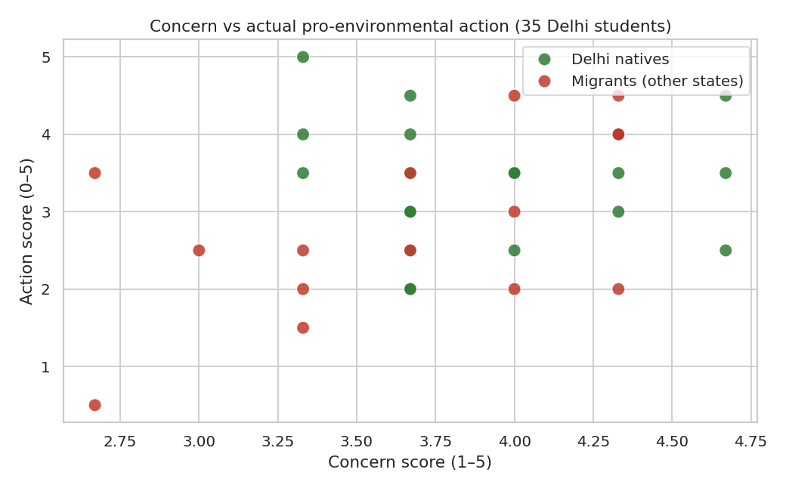
Figure 3. Concern versus pro-environmental action, coloured by native (green) and migrant (red).

7.3 Regression Model
To quantify how much concern and intention jointly explain the action score, an ordinary least squares multiple linear regression is fitted. The coefficients minimise the sum of squared residuals between observed and predicted action.
Formula 4. Ordinary Least Squares Multiple Regression
Action_{i} = β₀ + β₁(Concern_{i}) + β₂(Intention_{i}) + ε_{i}
β̂ = (X^{T}X)⁻¹X^{T}y
R² = 1 − Σ (y_{i} − ŷ_{i})² / Σ (y_{i} − ȳ)² = SS_{res}/SS_{tot}
β0 is the intercept, β1 and β2 are partial regression coefficients, εi is the residual error, and ŷi is the predicted action. R-squared equals the proportion of variance in action explained by the model and lies between 0 and 1. Coefficients were solved with the normal equations.
Intercept (β₀) | Coef. Concern (β₁) | Coef. Intention (β₂) | R²
0.710 | 0.646 | −0.008 | 0.112
Table 9. OLS regression of action on concern and intention.
The regression shows that concern is the dominant positive driver (coefficient +0.65), while intention contributes almost nothing (−0.008). The two predictors explain about 11 percent of the variance in action (R² = 0.11) — a modest but meaningful share, as expected for self-reported behaviour with many unmeasured influences.

7.4 The Intention–Behaviour Gap
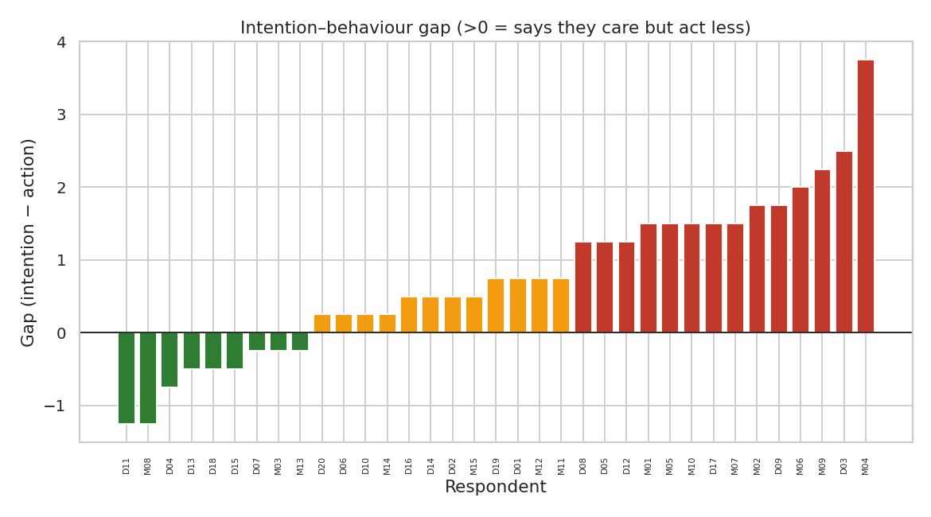
Figure 4. Intention–behaviour gap per respondent (positive means intends to act more than acted).
The gap is positive on average (+0.48 natives, +1.08 migrants), meaning students intend to act more than they report doing. This is a robust and well-documented phenomenon in the environmental behaviour literature and the central practical insight of this study.

7.5 Pollution and Concern Context
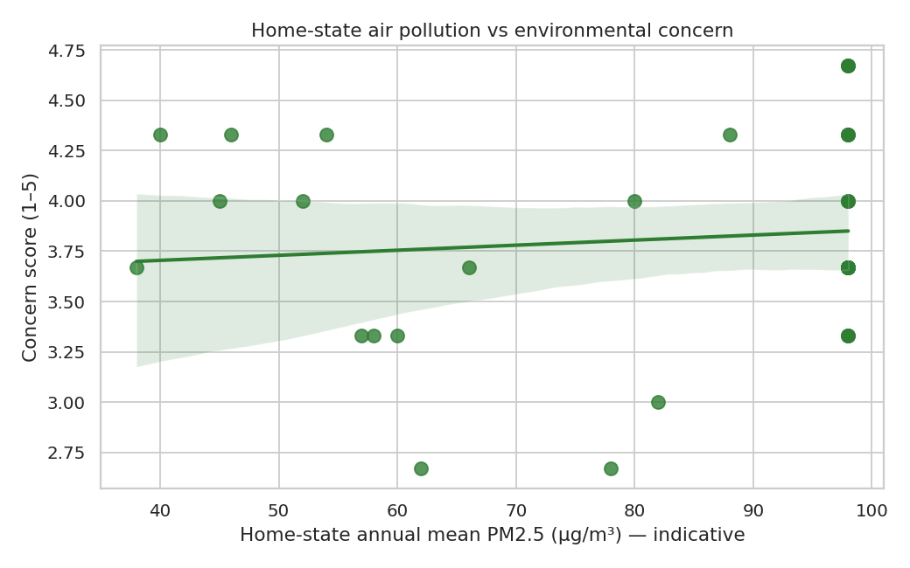
Figure 5. Home-state PM2.5 versus environmental concern (with regression line).
Home-state PM2.5 shows only a weak and non-significant relation to concern (r = 0.10) and to action (r = 0.11). In this small sample, living pollution context does not itself drive behaviour, confirming that Hypothesis H2 is not supported.

7.6 India's Open Data Trend (Layer A)
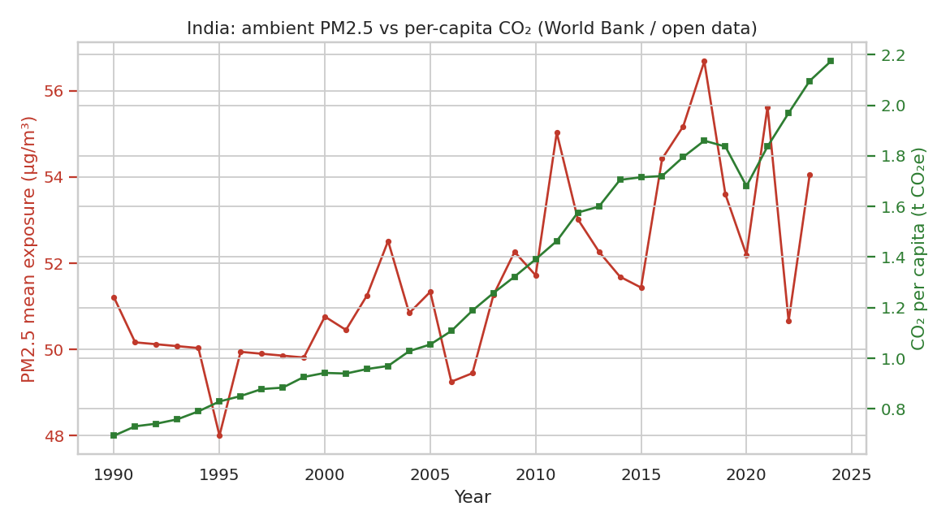
Figure 6. India's ambient PM2.5 exposure and per-capita CO₂ over time (World Bank open data).

8. Discussion
Combining the two layers produces a coherent story. Youth environmental motivation in Delhi is high, with concern averaging about 3.8 of 5, and it is concern rather than intention that translates into action (r = 0.34, p = 0.049, regression coefficient +0.65). This supports Hypothesis H1. The strong implication is that fostering genuine environmental concern is an effective route to behaviour change, while intention on its own is a weak predictor.
The intention–behaviour gap is the study's most actionable finding. Because students already intend to act but do not, the barrier is not motivation but implementation — that is, the practical difficulty of the behaviour, which corresponds to the perceived behavioural control component of the Theory of Planned Behavior. Policies that lower barriers, including accessible segregation bins, affordable green transport, and convenient e-waste drop-off, are likely to yield more behaviour change than further awareness campaigns.
The absence of a native-versus-migrant difference (all p > 0.05) is itself informative. It suggests that the shared experience of living in Delhi — including its visible air pollution, common campus culture, and information environment — dominates home-state differences. Origin-state pollution exposure does not, in this sample, create a distinguishable attitudinal signature. This points toward city-level rather than state-level environmental socialisation.
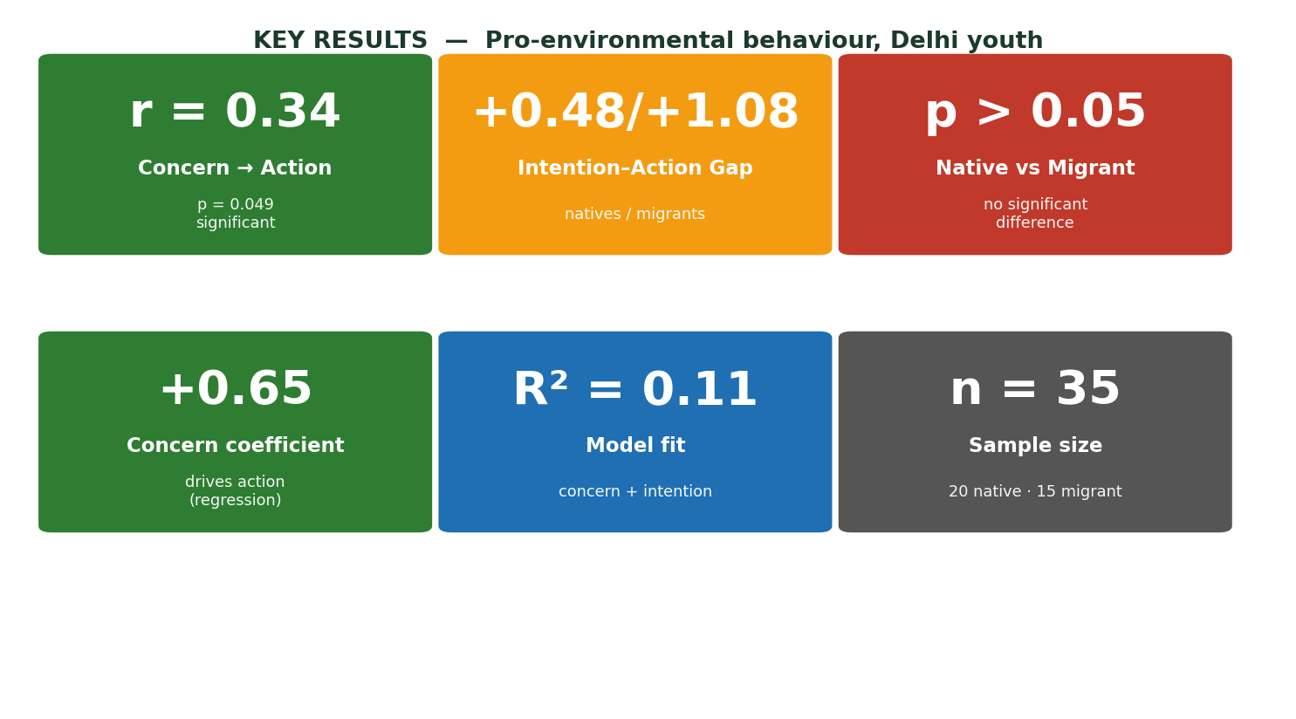
Figure 7. Key results dashboard (summary cards).

9. Output Features of the Project
The project is designed as an end-to-end, reproducible artefact. Its principal outputs are:
Output / Feature | Description
Python pipelines | generate_survey.py and analysis.py, each runnable with a single command.
Open data integration | Live World Bank API pull (no key) for India's pollution and emissions series.
Primary survey dataset | 35-respondent survey with concern, intention, action, and gap scores.
Statistical tests | Welch's t-test and Pearson correlations computed automatically.
Regression model | OLS regression of action on concern and intention.
Four analysis figures | Concern versus action, intention gap, pollution versus concern, and India trend charts.
Three infographics | Method flow, sample demographics, and key results dashboard.
Results tables (CSV) | Group means, t-test, correlations, and regression as CSV.
Word report | This research paper in Word format.
Automated CI | GitHub Actions workflow that reproduces the pipeline on every push.
README and LICENSE | MIT licence, pinned dependencies, and .gitignore.
Table 10. Project outputs and features.
Reproducibility
The entire analysis is regenerable in two commands. The pipeline pulls fresh open data, recomputes all statistics, and redraws every figure, so the results are transparent, inspectable, and verifiable by anyone who clones the repository.

10. Limitations
- Small, non-random sample (n = 35) drawn by convenience; results are illustrative rather than population-generalisable.
- Self-report bias: respondents tend to overstate desirable behaviours, which inflates the intention–behaviour gap.
- Home-state PM2.5 values are indicative annual means rather than station-level measurements; replacing them with CPCB or NAAQS data would strengthen the pollution–behaviour link.
- The survey data are synthetic (demonstration) and must be replaced with real collected responses for a submitted study.
- Correlation does not imply causation: concern may drive action, action may reinforce concern, or both may be driven by a third factor such as personality.
- A cross-sectional design cannot establish causal or temporal ordering.
- A single-city focus limits generalisation to other Indian cities or to rural youth.

11. Conclusion
Young people in Delhi are highly concerned about the environment, but this concern is not fully converted into everyday pro-environmental action. Concern is a genuine and statistically significant predictor of action, whereas intention is not. The persistent intention–behaviour gap reveals that the binding constraint is practical rather than motivational, and that the shared Delhi experience largely neutralises state-of-origin differences.
Recommendation. Shift resources from awareness-raising toward removing practical barriers. Concrete actions include accessible waste-segregation infrastructure, affordable and incentivised public and active transport, easy recycling and e-waste collection points, and campus-level green defaults that make sustainable behaviour the easy choice. These target the perceived behavioural control lever identified by the theory and by these results.

12. References
- Ajzen, I. (1991). The theory of planned behavior. Organizational Behavior and Human Decision Processes, 50(2), 179–211.
- Stern, P. C. (2000). Toward a coherent theory of environmentally significant behavior. Journal of Social Issues, 56(3), 407–424.
- World Bank Open Data. (2026). Indicators: atmospheric PM2.5 exposure, CO₂ emissions, forest area, GDP, population. Retrieved from https://data.worldbank.org
- Central Pollution Control Board (CPCB), India. Air quality and PM2.5 monitoring data.
- Institute for Health Metrics and Evaluation. State of Global Air, annual PM2.5 exposure by country and state.

Appendix A. Project Files and How to Run
The working repository (pro-environmental-behaviour-youth) contains the following files:
File | Purpose
README.md | Project overview and run instructions
analysis.py | Pipeline for open data and statistics
generate_survey.py | Builds the 35-respondent survey
survey_template.md | Questionnaire template for real data
requirements.txt | Pinned dependencies
LICENSE | MIT license
.gitignore | Git exclusions
.github/workflows/ci.yml | CI that reproduces the pipeline on each push
data/survey_data.csv | Survey dataset
data/data_layerA_india.csv | India open data time series
outputs/ | Figures and results tables
Table 11. Repository contents.

How to Run (Linux and macOS)
git clone <your-repo-url>.git
cd pro-environmental-behaviour-youth
python3 -m venv .venv && source .venv/bin/activate
pip install -r requirements.txt
python3 generate_survey.py # builds data/survey_data.csv
python3 analysis.py # pulls open data and runs statistics and charts
# results are written to outputs/

Appendix B. Glossary of Terms
Term | Meaning
PEB | Pro-environmental behaviour
TPB | Theory of Planned Behavior (Ajzen, 1991)
PM2.5 | Fine particulate matter of diameter at most 2.5 micrometres, a key air pollutant
Concern | Mean of awareness, concern, and urgency (1 to 5)
Intention | Mean of attitude, norm, control, and intention (1 to 5)
Action score | Composite of five self-reported behaviours (0 to 5)
Intention–behaviour gap | Intention minus action — whether stated intent exceeds realised behaviour
Welch's t-test | t-test for two independent groups not assuming equal variance
Pearson r | Pearson correlation coefficient, ranging from −1 to +1
R-squared | Proportion of variance explained by a model
Table 12. Glossary of key terms.

