

**RAMNIRANJAN JHUNJHUNWALA COLLEGE**

**GHATKOPAR (W), MUMBAI - 400 086**

**DEPARTMENT OF INFORMATION TECHNOLOGY**

**2021 - 2022**

**M.Sc.( I.T.) SEM IV**

**Natural Language Processing**

**Name: Surekha Omprakash Rajbhar**

**Roll No.: 13**



**CERTIFICATE**

This is to certify that Ms. **Surekha Omprakash Rajbhar** with Roll No. **13** has successfully completed the necessary course of experiments in the subject of **Natural Language Processing** during the academic year **2021 – 2022** complying with the requirements of **RAMNIRANJAN JHUNJHUNWALA COLLEGE OF ARTS, SCIENCE AND COMMERCE**, for the course of **M.Sc. (IT)** semester -IV.

_________________ ________________

Internal Examiner External Examiner

___________________ _____________

Head of Department College Seal

**INDEX**

|  |  |  |
| --- | --- | --- |
| **Practical No.** | **Aim** | **Date** |
| 1.  A.  B. | Convert the given text to speech  Convert audio file speech to text |  |
| 2.  A.  B.  C.  D.  E.  F.  G.  H. | Study of various Corpus – Brown, Inaugural, Reuters, udhr with various methods like fields, raw, words, sents, categories,  Create and use your own corpora (plaintext categorical)  Study Conditional Frequency Distribution  Study of Tagged Corpora with methods like tagged_sents, tagged_words  Write a program to find the most frequent noun tags  Map words to properties using Python Dictionaries  Study i) Default tagger ii). Regular expression tagger iii) Unigram tagger  Find different words from a given text without any space by comparing this text with a given corpus of words. Also find the score of words |  |
| 3  A.  B.  C.  D. | Study of WordNet dictionary with methods as syssets, definitions examples antonyms  Study of lemmas hyponyms hypernyms  Write a program using python to find synonyms and antonyms of word “active ” using WordNet  Compare two nouns  Handling stopwords  i). Using nltk Adding or Removing Stop Words in NLTK's Default Stop Word List  ii) Using Gensim Adding and Removing Stop Words in Default Gensim Stop Words List  iii) Using Spacy Adding and Removing Stop Words in Default Spacy Stop Words List |  |
| 4  A.  B.  C.  D.  E.  F. | Text Tokenization  Tokenization using python split() function  Tokenization using Regular Expressions  Tokenization using nltk  Tokenization using spaCy library  Tokenization using keras  Tokenization using Gensim |  |
| 5.  A.  B.  C. | Import NLP Libraries for indian language and perform  Word tokenization in hindi  Generate similar sentences from a given hindi text input  Identify the indian language of a text |  |
| 6.  A.  B. | Illustrate parts of speech tagging  Part of speech Tagging and chunking of user defined text.  Named Entity recognition of user defined text. |  |
| 7.  A.  B.  C.  D. | Finite State Automata Define grammar using nltk. Analyze a sentence using the same. Accept the input string with regular expression of finite automation: 101+  Accept the input string with regular expression of FA: (a+b)*bba  Implementation of Deductive Chart Parsing using context free grammar and a given sentence. |  |
| 8. | Study PorterStemmer, LancasterStemmer, RegexpStemmer, SnowballStemmer Study WordNetLemmatizer |  |
| 9. | Implement Naïve Bayes Classifier |  |
| 10.  A.  B.  C. | Speech Tagging   1. Using spacy 2. Using nltk   Statistical Parsing   1. Using give and Gave in the Penn treebak sample 2. Probabilistic parser   Malt Parsing:  Parse a sentene and draw a tree using malt parsing |  |
| 11.  A.  B.  C. | Multiword expression in NLP  Normalized Web Distance and word similarity  Word Sense Disambiguation |  |
|  |  |  |

**Practical No.1**

1. **Convert the given text to speech**

Code

!pip install playsound

!pip install gtts

from playsound import playsound

from gtts import gTTS

mytext = "hello, this is Shreyans Upadhyay. Welcome to Natural Language programming"

language = "en"

myobj = gTTS(text=mytext, lang=language, slow=False)

myobj.save("myfile.mp3")

playsound("myfile.mp3")

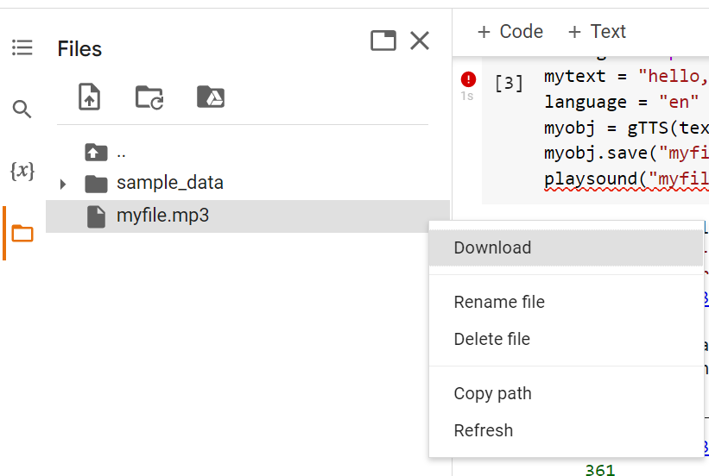

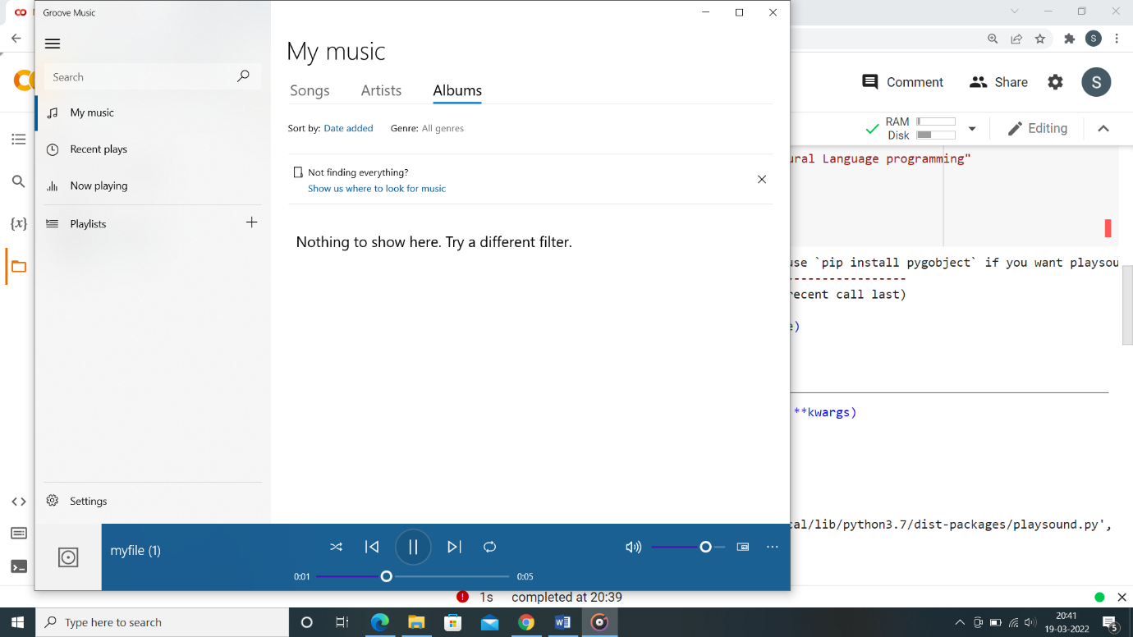

1. Convert audio file speech to text

Code

!pip3 install SpeechRecognition pydub

import speech_recognition as sr

filename = "male.wav"

# initialize the recognizer

r = sr.Recognizer()

# open the file

with sr.AudioFile(filename) as source:

 # listen for the data (load audio to memory)

 audio_data = r.record(source)

 # recognize (convert from speech to text)

 text = r.recognize_google(audio_data)

 print(text)

**Practical no. 2**

1. **Study of various corpus- brown, inaugural, reuters, udhr with various methods like fields, raw words, sents, categories**

Code

import nltk

nltk.download('brown')

from nltk.corpus import brown

print('File ids of brown corpus\n', brown.fileids())

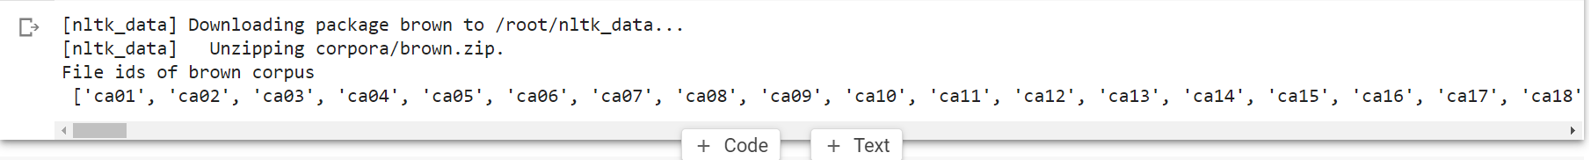

ca01 = brown.words('ca01')

#display the first few words

print('\nca01 has following words:\n', ca01)

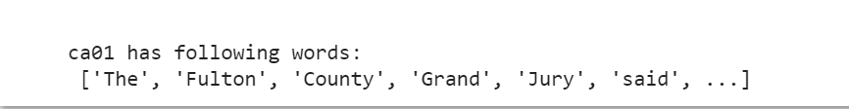

#total number of words in ca01

print('\nca01 has',len(ca01),'words')

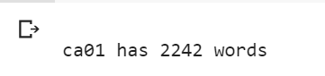

#categories or files

print ('\n\nCategories or file in brown corpus:\n')

print (brown.categories())

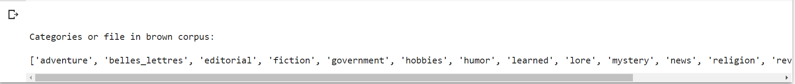

print ('\n\nStatistics for each text:\n')

print('AvgWordLen\tAvgSentenceLen\tno.ofTimesEachWordAppearsOnAvg\t\tFileName')

for fileid in brown.fileids():

  num_chars = len(brown.raw(fileid))

  num_words = len(brown.words(fileid))

  num_sents = len(brown.sents(fileid))

  num_vocab = len(set([w.lower() for w in brown.words(fileid)]))

  print (int(num_chars/num_words),'\t\t\t', int(num_words/num_sents),'\t\t\t', int(num_words/num_vocab),'\t\t\t', fileid)

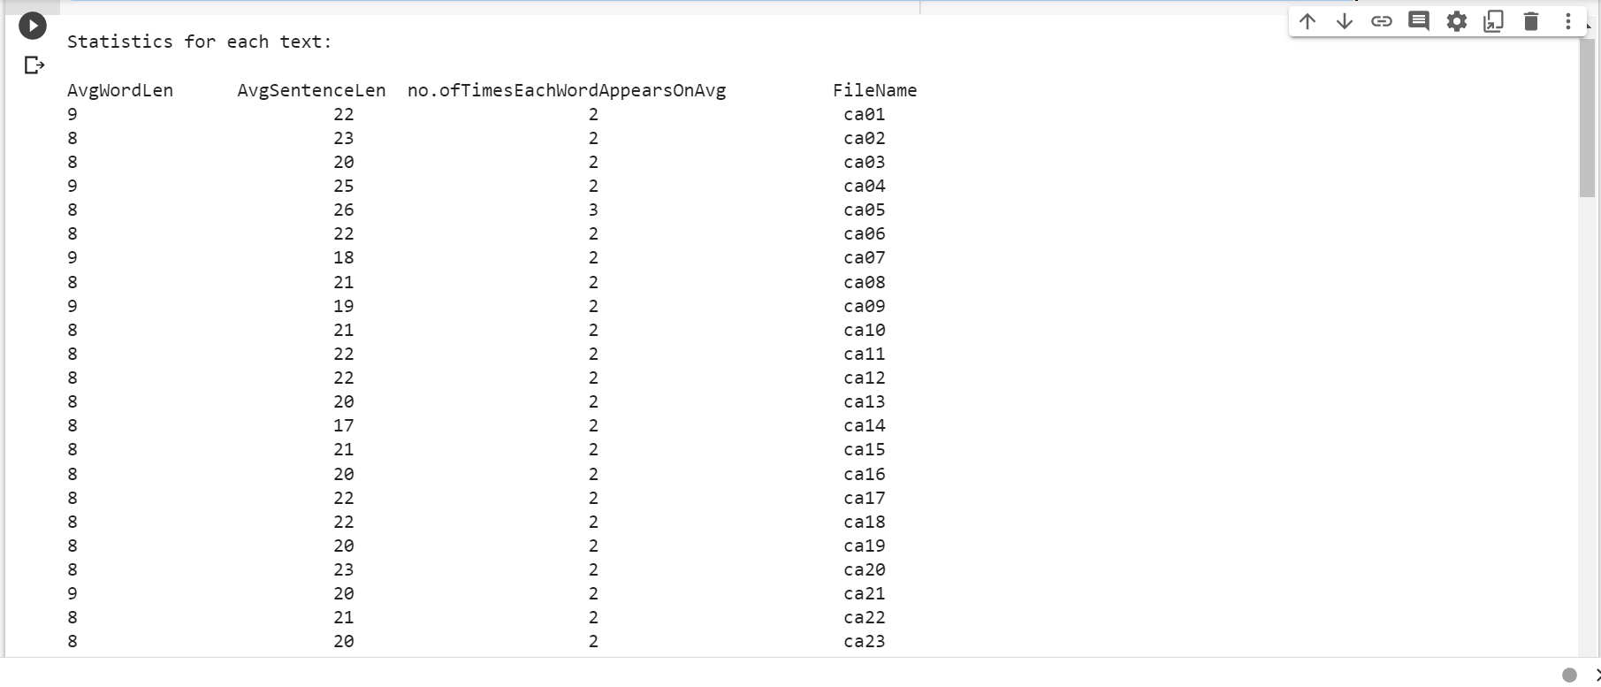

1. **Create and use your own corpora (plaintext, categorical)**

Code

import nltk

from nltk.corpus import PlaintextCorpusReader

corpus_root = '/content/mytext.txt'

filelist = PlaintextCorpusReader(corpus_root,'.*')

print ('\n File list: \n')

print (filelist.fileids())

print (filelist.root)

print ('\n\nStatistics for each text:\n')

print('AvgWordLen\tAvgSentenceLen\tno.ofTimesEachWordAppearsOnAvg\tFileName')

for fileid in filelist.fileids():

  num_chars = len(filelist.raw(fileid))

  num_words= len(filelist.words(fileid))

  num_sents = len(filelist.sents(fileid))

  num_vocab = len(set([w.lower() for w in filelist.words(fileid)]))

  print (int(num_chars/num_words),'\t\t\t', int(num_words/num_sents),'\t\t\t', int(num_words/num_vocab),'\t\t', fileid)

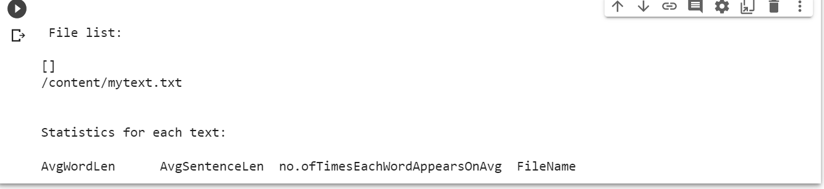

1. **Study Conditional Frequency Distribution**

Code

#processing a sequence of pairs

text = ['The', 'Fulton', 'County', 'Grand', 'Jury', 'said', ...]

pairs = [('news', 'The'), ('news', 'Fulton'), ('news', 'County'), ...]

import nltk

nltk.download('brown')

from nltk.corpus import brown

fd = nltk.ConditionalFreqDist(

 (genre, word)

 for genre in brown.categories()

 for word in brown.words(categories=genre))

genre_word = [(genre, word)

 for genre in ['news', 'romance']

 for word in brown.words(categories=genre)]

print(len(genre_word))

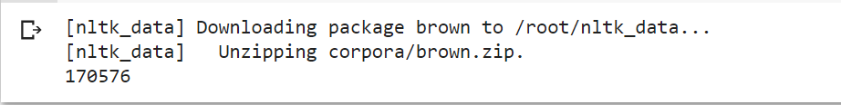

print(genre_word[:4])



print(genre_word[-4:])



cfd = nltk.ConditionalFreqDist(genre_word)

print(cfd)

print(cfd.conditions())

print(cfd['news'])

print(cfd['romance'])

print(list(cfd['romance']))

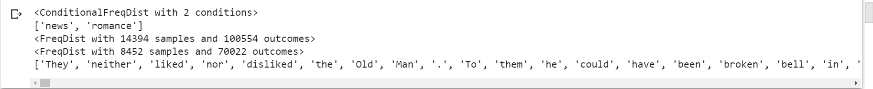

nltk.download('inaugural')

nltk.download('udhr')

from nltk.corpus import inaugural

cfd = nltk.ConditionalFreqDist(

 (target, fileid[:4])

 for fileid in inaugural.fileids()

 for w in inaugural.words(fileid)

 for target in ['america', 'citizen']

 if w.lower().startswith(target))

from nltk.corpus import udhr

languages = ['Chickasaw', 'English', 'German_Deutsch',

 'Greenlandic_Inuktikut', 'Hungarian_Magyar', 'Ibibio_Efik']

cfd = nltk.ConditionalFreqDist(

 (lang, len(word))

 for lang in languages

 for word in udhr.words(lang + '-Latin1'))

cfd.tabulate(conditions=['English', 'German_Deutsch'],

 samples=range(10), cumulative=True)

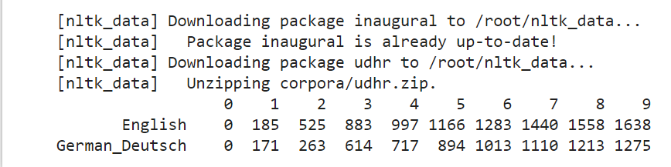

1. **Study of Tagged Corpora with methods like tagged_sents, tagged_words**

Code

import nltk

from nltk import tokenize

nltk.download('punkt')

nltk.download('words')

para = "Hello! My name is Shreyans Upadhyay. Today we'll be learning NLTK. It is one of the powerful library of NLP"

sents = tokenize.sent_tokenize(para)

print("\nsentence tokenization\n===================\n",sents)

# word tokenization

print("\nword tokenization\n===================\n")

for index in range(len(sents)):

 words = tokenize.word_tokenize(sents[index])

 print(words)

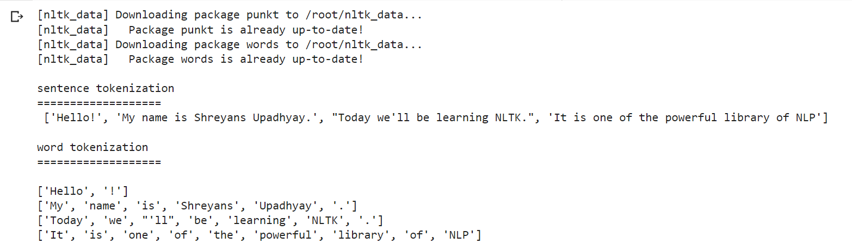

1. **Write a program to find the most frequent noun tags**

Code

import nltk

nltk.download('averaged_perceptron_tagger')

from collections import defaultdict

text = nltk.word_tokenize("Kane Williamson is a kiwi cricketer whereas MS Dhoni is an Indian cricketer..")

tagged = nltk.pos_tag(text)

print(tagged)

# checking if it is a noun or not

addNounWords = []

count=0

for words in tagged:

 val = tagged[count][1]

 if(val == 'NN' or val == 'NNS' or val == 'NNPS' or val == 'NNP'):

  addNounWords.append(tagged[count][0])

count+=1

print (addNounWords)

temp = defaultdict(int)

# memoizing count

for sub in addNounWords:

 for wrd in sub.split():

  temp[wrd] += 1

# getting max frequency

res = max(temp, key=temp.get)

# printing result

print("Word with maximum frequency : " + str(res))

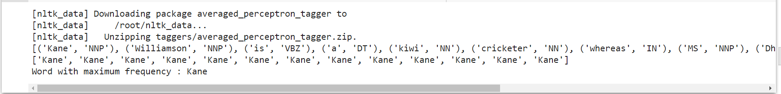

1. **Map Words to Properties using Python Dictionaries**

Code

#creating and printing a dictionay by mapping word with its properties

thisdict = {

 "brand": "Ford",

 "model": "Mustang",

 "year": 1964

}

print(thisdict)

print(thisdict["brand"])

print(len(thisdict))

print(type(thisdict))

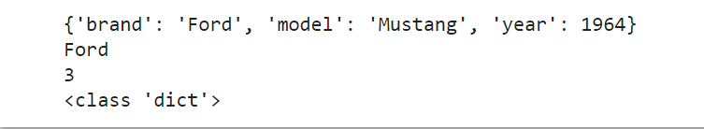

1. **Study i) default Tagger ii) Regular expression tagger iii) Unigram tagger**
2. **Default Tagger**

Code

import nltk

nltk.download('treebank')

from nltk.tag import DefaultTagger

exptagger = DefaultTagger('NN')

from nltk.corpus import treebank

testsentences = treebank.tagged_sents() [1000:]

print(exptagger.evaluate (testsentences))

#Tagging a list of sentences

import nltk

from nltk.tag import DefaultTagger

exptagger = DefaultTagger('NN')

print(exptagger.tag_sents([['Hi', ','], ['How', 'are', 'you', '?']]))

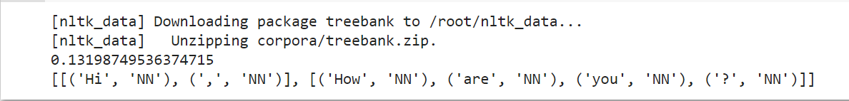

1. **Regular expression tagger**

Code

from nltk.corpus import brown

from nltk.tag import RegexpTagger

test_sent = brown.sents(categories='news')[0]

regexp_tagger = RegexpTagger(

 [(r'^-?[0-9]+(.[0-9]+)?$', 'CD'), # cardinal numbers

 (r'(The|the|A|a|An|an)$', 'AT'), # articles

 (r'.*able$', 'JJ'), # adjectives

 (r'.*ness$', 'NN'), # nouns formed from adjectives

 (r'.*ly$', 'RB'), # adverbs

 (r'.*s$', 'NNS'), # plural nouns

 (r'.*ing$', 'VBG'), # gerunds

 (r'.*ed$', 'VBD'), # past tense verbs

 (r'.*', 'NN') # nouns (default)

])

print(regexp_tagger)

print(regexp_tagger.tag(test_sent))



1. **Unigram Tagger**

Code

# Loading Libraries

from nltk.tag import UnigramTagger

from nltk.corpus import treebank

# Training using first 10 tagged sentences of the treebank corpus as data.

# Using data

train_sents = treebank.tagged_sents()[:10]

# Initializing

tagger = UnigramTagger(train_sents)

# Lets see the first sentence

# (of the treebank corpus) as list

print(treebank.sents()[0])

print('\n',tagger.tag(treebank.sents()[0]))

#Finding the tagged results after training.

tagger.tag(treebank.sents()[0])

#Overriding the context model

tagger = UnigramTagger(model ={'Pierre': 'NN'})

print('\n',tagger.tag(treebank.sents()[0]))

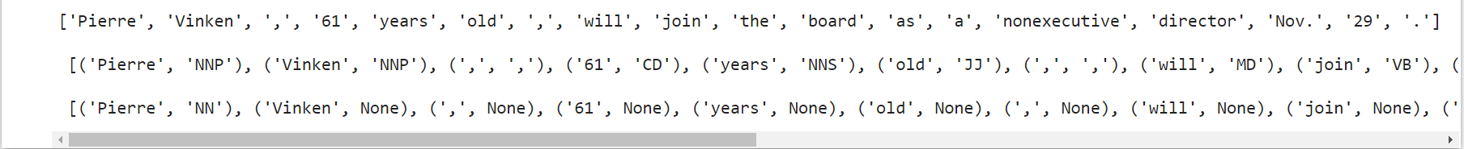

1. **Find different words from a given plain text without any space by comparing this text with a given corpus of words. Also find score of words.**

Code

from __future__ import with_statement #with statement for reading file

import re # Regular expression

words = [] # corpus file words

testword = [] # test words

ans = [] # words matches with corpus

print("MENU")

print("-----------")

print(" 1 . Hash tag segmentation ")

print(" 2 . URL segmentation ")

print("enter the input choice for performing word segmentation")

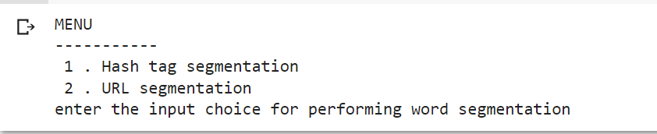

choice = int(input())

if choice == 1:

 text = "#whatismyname" # hash tag test data to segment

 print("input with HashTag",text)

 pattern=re.compile("[^\w']")

 a = pattern.sub('', text)

elif choice == 2:

 text = "www.whatismyname.com" # url test data to segment

 print("input with URL",text)

 a=re.split('\s|(?<!\d)[,.](?!\d)', text)

 splitwords = ["www","com","in"] # remove the words which is containg in the list

 a ="".join([each for each in a if each not in splitwords])

else:

 print("wrong choice...try again")

print(a)

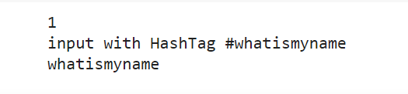

if choice == 1:

 text = "#whatismyname" # hash tag test data to segment

 print("input with HashTag",text)

 pattern=re.compile("[^\w']")

 a = pattern.sub('', text)

elif choice == 2:

 text = "www.whatismyname.com" # url test data to segment

 print("input with URL",text)

 a=re.split('\s|(?<!\d)[,.](?!\d)', text)

 splitwords = ["www","com","in"] # remove the words which is containg in the list

 a ="".join([each for each in a if each not in splitwords])

else:

 print("wrong choice...try again")

print(a)

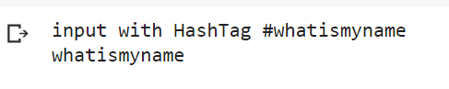

for each in a:

 testword.append(each) #test word

test_lenth = len(testword) # lenth of the test data

# Reading the corpus

with open('mytext.txt', 'r') as f:

 lines = f.readlines()

 words =[(e.strip()) for e in lines]

def Seg(a,lenth):

 ans =[]

 for k in range(0,lenth+1): # this loop checks char by char in the corpus

    if a[0:k] in words:

      print(a[0:k],"-appears in the corpus")

      ans.append(a[0:k])

      break

 if ans != []:

  g = max(ans,key=len)

  return g

test_tot_itr = 0 #each iteration value

answer = [] # Store the each word contains the corpus

Score = 0

N = 37 # total no of corpus

M = 0

C = 0

while test_tot_itr < test_lenth:

 ans_words = Seg(a,test_lenth)

 if ans_words != 0:

  test_itr = len(ans_words)

  answer.append(ans_words)

  a = a[test_itr:test_lenth]

  test_tot_itr += test_itr

Aft_Seg = " ".join([each for each in answer])

# print segmented words in the list

print("output")

print("---------")

print(Aft_Seg) # print After segmentation the input

# Calculating Score

C = len(answer)

score = C * N / N # Calculate the score

print("Score",score)

**Practical No. 3**

1. **Study of WordNet dictionary with methods as synsets, definitions, examples and antonyms**

Code

import nltk

nltk.download('wordnet')

from nltk.corpus import wordnet

print(wordnet.synsets("computer"))

# definition and example of the word ‘computer’

print(wordnet.synset("computer.n.01").definition())

#examples

print("Examples:", wordnet.synset("computer.n.01").examples())

#get Antonyms

print(wordnet.lemma('buy.v.01.buy').antonyms())

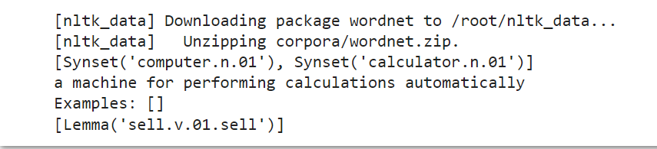

1. **Study lemmas, hyponyms and hypernyms**

Code

import nltk

nltk.download('wordnet')

from nltk.corpus import wordnet

print(wordnet.synsets("computer"))

print(wordnet.synset("computer.n.01").lemma_names())

#all lemmas for each synset.

for e in wordnet.synsets("computer"):

  print(f'{e} --> {e.lemma_names()}')

#print all lemmas for a given synset

print(wordnet.synset('computer.n.01').lemmas())

#get the synset corresponding to lemma

print(wordnet.lemma('computer.n.01.computing_device').synset())

#Get the name of the lemma

print(wordnet.lemma('computer.n.01.computing_device').name())

#Hyponyms give abstract concepts of the word that are much more specific

#the list of hyponyms words of the computer

syn = wordnet.synset('computer.n.01')

print(syn.hyponyms)

print([lemma.name() for synset in syn.hyponyms() for lemma in synset.lemmas()])

#the semantic similarity in WordNet

vehicle = wordnet.synset('vehicle.n.01')

car = wordnet.synset('car.n.01')

print(car.lowest_common_hypernyms(vehicle))

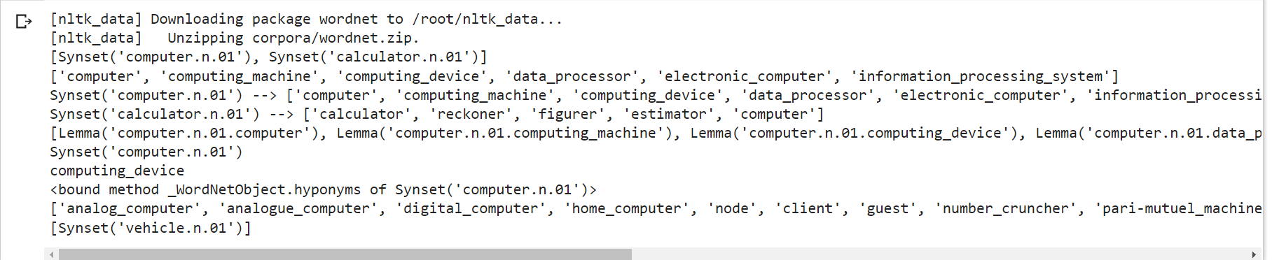

1. **Write a program using Python to find synonyms, and antonyms of word “active” using wordnet**

Code

from nltk.corpus import wordnet

print( wordnet.synsets("active"))

print(wordnet.lemma('active.a.01.active').antonyms())



1. **Compare two nouns**

Code

Using NLTK adding or removing stopwords

from nltk.corpus import wordnet

syn1 = wordnet.synsets('football')

syn2 = wordnet.synsets('soccer')

# A word may have multiple synsets, so need to compare each synset of word1 with synset of word2

for s1 in syn1:

 for s2 in syn2:

   print("Path similarity of: ")

   print(s1, '(', s1.pos(), ')', '[', s1.definition(), ']')

   print(s2, '(', s2.pos(), ')', '[', s2.definition(), ']')

   print(" is", s1.path_similarity(s2))

   print()

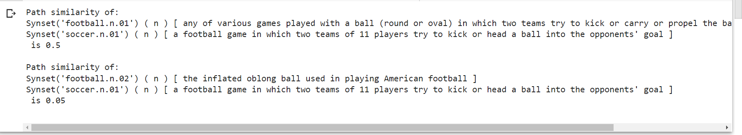

1. **Handling Stopwords**
2. **Using nltk adding or removing stopwords in nltk stop wod list**

Code

import nltk

nltk.download('punkt')

from nltk.corpus import stopwords

nltk.download('stopwords')

from nltk.tokenize import word_tokenize

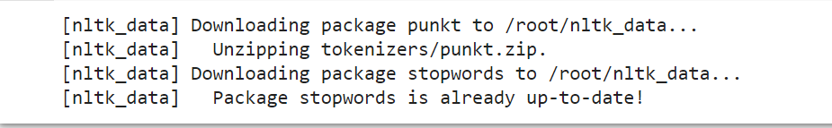

text = "Yashesh likes to play football, however he is not too fond of tennis."

text_tokens = word_tokenize(text)

tokens_without_sw = [word for word in text_tokens if not word in stopwords.words()]

print(tokens_without_sw)



#add the word play to the NLTK stop word collection

all_stopwords = stopwords.words('english')

all_stopwords.append('play')

text_tokens = word_tokenize(text)

tokens_without_sw = [word for word in text_tokens if not word in all_stopwords]

print(tokens_without_sw)



#remove ‘not’ from stop word collection

all_stopwords.remove('not')

text_tokens = word_tokenize(text)

tokens_without_sw = [word for word in text_tokens if not word in all_stopwords]

print(tokens_without_sw)



1. **Using Gensim adding and removing stop words in default Gensim stop words lists**

Code

#pip install gensim

import gensim

from gensim.parsing.preprocessing import remove_stopwords

text = "Yashesh likes to play football, however he is not too fond of tennis."

filtered_sentence = remove_stopwords(text)

print(filtered_sentence)

all_stopwords = gensim.parsing.preprocessing.STOPWORDS

print(all_stopwords)



from gensim.parsing.preprocessing import STOPWORDS

all_stopwords_gensim = STOPWORDS.union(set(['likes', 'play']))

text = "Yashesh likes to play football, however he is not too fond of tennis."

text_tokens = word_tokenize(text)

tokens_without_sw = [word for word in text_tokens if not word in

all_stopwords_gensim]

print(tokens_without_sw)



from gensim.parsing.preprocessing import STOPWORDS

all_stopwords_gensim = STOPWORDS

sw_list = {"not"}

all_stopwords_gensim = STOPWORDS.difference(sw_list)

text = "Yashesh likes to play football, however he is not too fond of tennis."

text_tokens = word_tokenize(text)

tokens_without_sw = [word for word in text_tokens if not word in

all_stopwords_gensim]

print(tokens_without_sw)



1. **Using Spacy adding and removing stop words in Default spacy stop word list**

Code

!pip install spacy

!python -m spacy download en_core_web_sm

!python -m spacy download en

import spacy

import nltk

from nltk.tokenize import word_tokenize

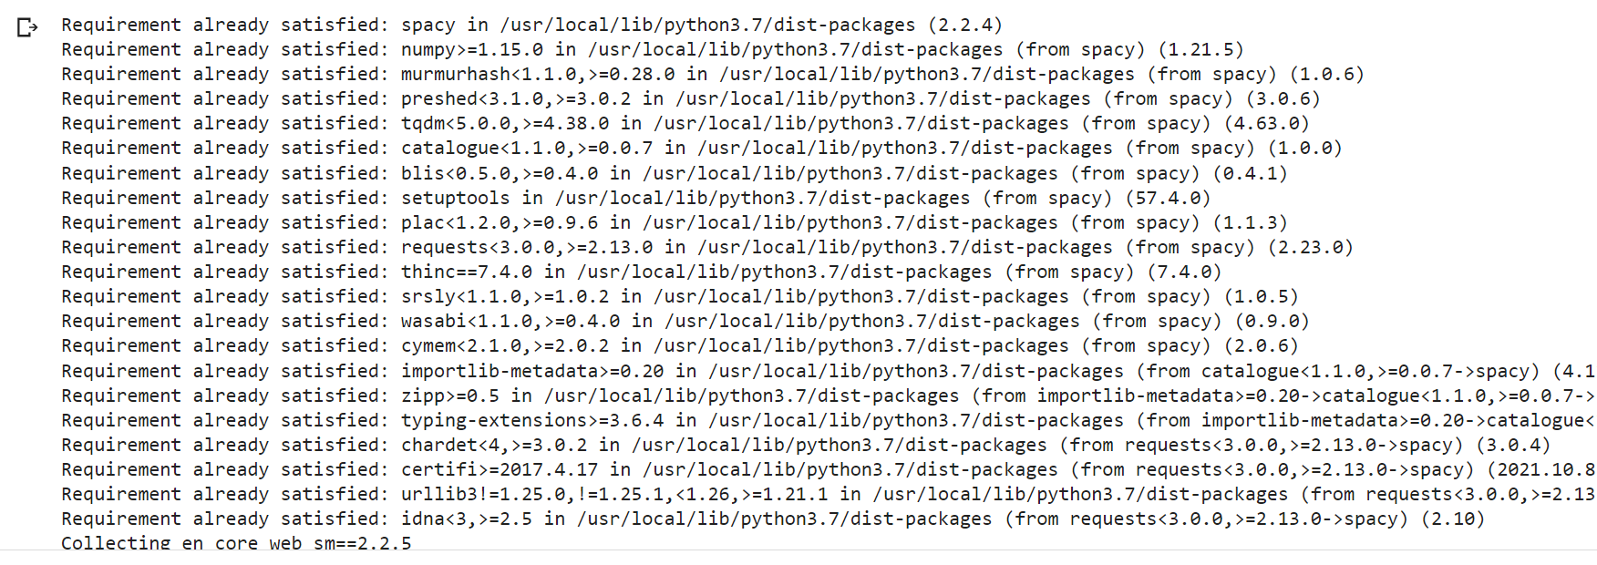

sp = spacy.load('en_core_web_sm')

#add the word play to the NLTK stop word collection

all_stopwords = sp.Defaults.stop_words

all_stopwords.add("play")

text = "Yashesh likes to play football, however he is not too fond of tennis."

text_tokens = word_tokenize(text)

tokens_without_sw = [word for word in text_tokens if not word in all_stopwords]

print(tokens_without_sw)

#remove 'not' from stop word collection

all_stopwords.remove('not')

tokens_without_sw = [word for word in text_tokens if not word in all_stopwords]

print(tokens_without_sw)





**Practical no. 4**

**Text Tokenization**

1. **Tokenization using Python split() function**

Code

text = """ This tool is an a beta stage. Alexa developers can use Get Metrics API to

seamlessly analyse metric. It also supports custom skill model, prebuilt Flash Briefing

model, and the Smart Home Skill API. You can use this tool for creation of monitors,

alarms, and dashboards that spotlight changes. The release of these three tools will

enable developers to create visual rich skills for Alexa devices with screens. Amazon

describes these tools as the collection of tech and tools for creating visually rich and

interactive voice experiences. """

data = text.split('.')

for i in data:

 print (i)

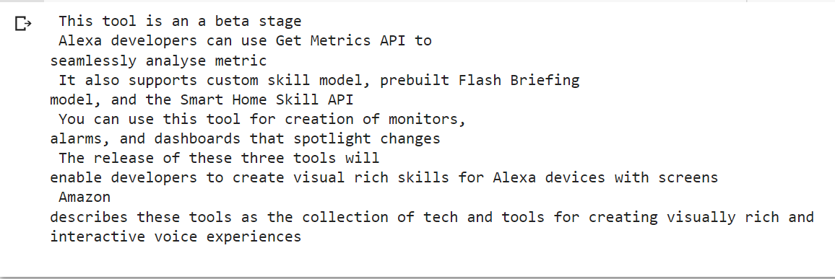

1. **Tokenization using RegEx function**

Code

import nltk

# import RegexpTokenizer() method from nltk

from nltk.tokenize import RegexpTokenizer

# Create a reference variable for Class RegexpTokenizer

tk = RegexpTokenizer('\s+', gaps = True)

# Create a string input

str = "I love to study Natural Language Processing in Python"

# Use tokenize method

tokens = tk.tokenize(str)

print(tokens)



1. **Tokenization using NLTK**

Code

import nltk

nltk.download('punkt')

from nltk.tokenize import word_tokenize

# Create a string input

str = "I love to study Natural Language Processing in Python"

# Use tokenize method

print(word_tokenize(str))

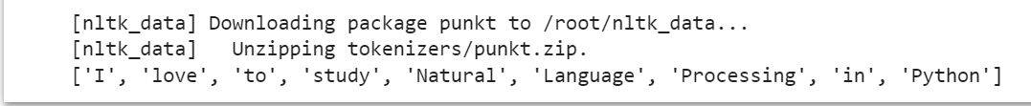

1. **Tokenization using spaCy library**

Code

import spacy

nlp = spacy.blank("en")

# Create a string input

str = "I love to study Natural Language Processing in Python"

# Create an instance of document;

# doc object is a container for a sequence of Token objects.

doc = nlp(str)

# Read the words; Print the words

#

words = [word.text for word in doc]

print(words)



1. **Tokenization using Keras**

Code

!pip install keras

!pip install tensorflow

import keras

from keras.preprocessing.text import text_to_word_sequence

#creating a string input

str = "I love to study Natural Language Processing in Python"

# tokenizing the text

tokens = text_to_word_sequence(str)

print(tokens)



1. **Tokenization using Gensim**

Code

!pip install gensim

from gensim.utils import tokenize

# Create a string input

str = "I love to study Natural Language Processing in Python"

# tokenizing the text

list(tokenize(str))

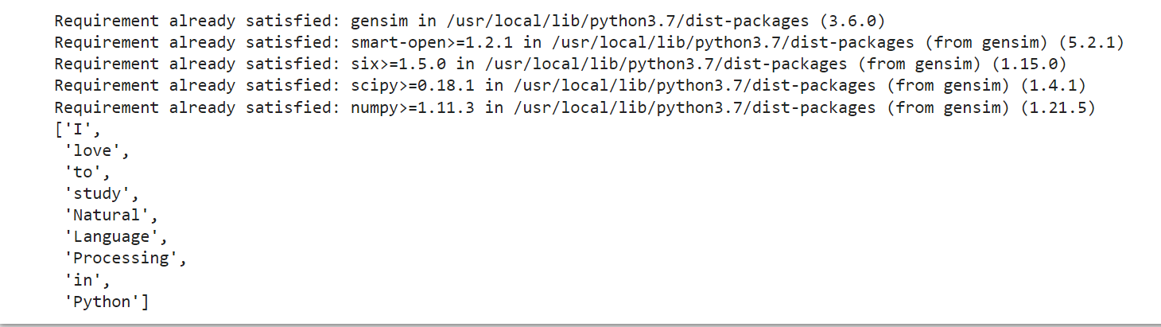

**Practical No. 5**

**Import NLP Libraries for Indian Languages and perform**

1. **Word Tokenization in Hindi**

Code

!pip install torch==1.3.1+cpu -f

!pip install inltk

!pip install tornado==4.5.3

from inltk.inltk import setup

setup('hi')

from inltk.inltk import tokenize

hindi_text = """प्राकितिक भाषा सीखना बहुत दिलचस्प है। """

# tokenize(input text, language code)

tokenize(hindi_text, "hi")

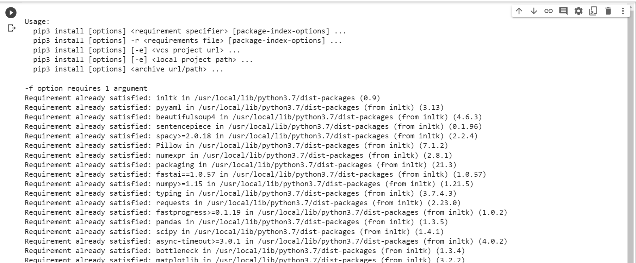

1. **Generate similar sentences from a given Hindi text input**

Code

!pip install torch==1.3.1+cpu -f

!pip install inltk

!pip install tornado==4.5.3

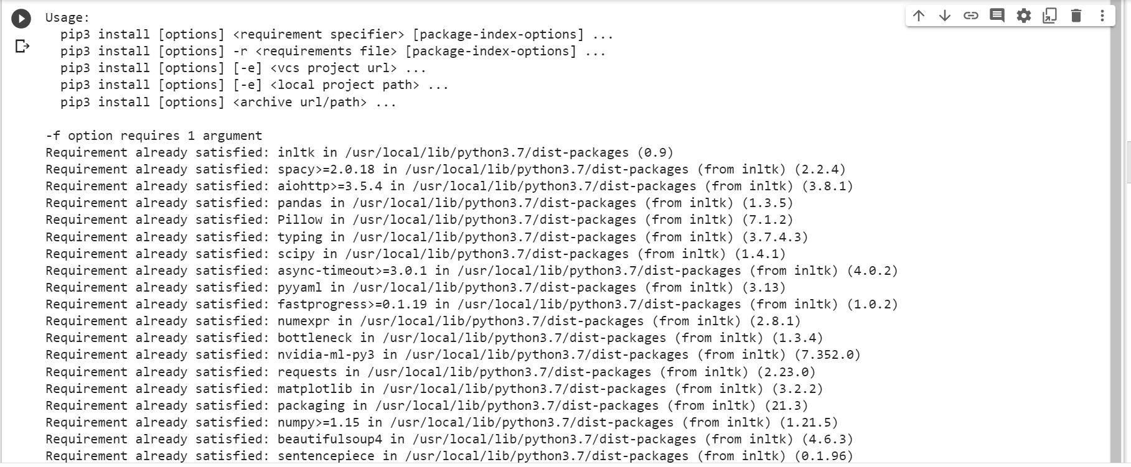

from inltk.inltk import setup

setup('hi')



from inltk.inltk import get_similar_sentences

# get similar sentences to the one given in hindi

output = get_similar_sentences('Mai aaj bahut khush hu.', 5, 'hi')

print(output)

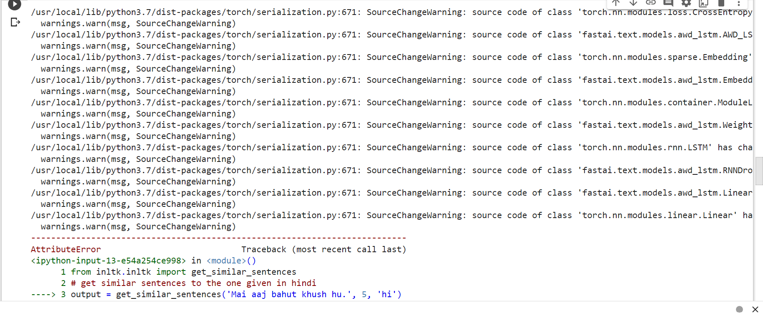

1. **Identify the Indian language from a text**

Code

from inltk.inltk import setup

setup('gu')

from inltk.inltk import identify_language

#Identify the Lnaguage of given text

identify_language('બીના કાપડિયા')

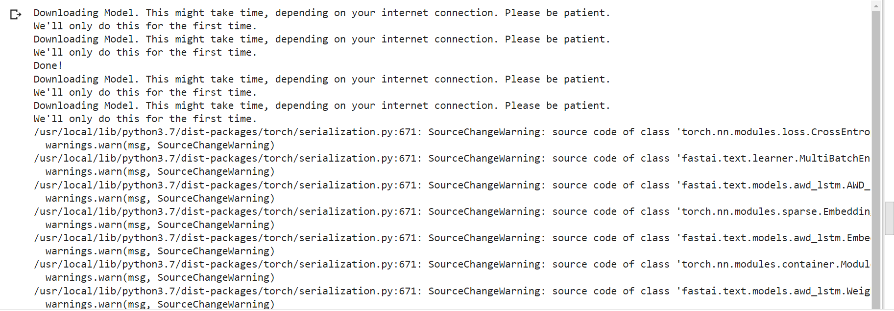

**Practical No. 6**

**Illustrate Parts of Speech Tagging**

1. **Sentence Tokenization, Word Tokenization, Parts of Speech Tagging and chunking of User defined text**

Code

import nltk

from nltk import tag

from nltk import tokenize

nltk.download('punkt')

from nltk import tokenize

from nltk import chunk

nltk.download('averaged_perceptron_tagger')

nltk.download('maxent_ne_chunker')

nltk.download('words')

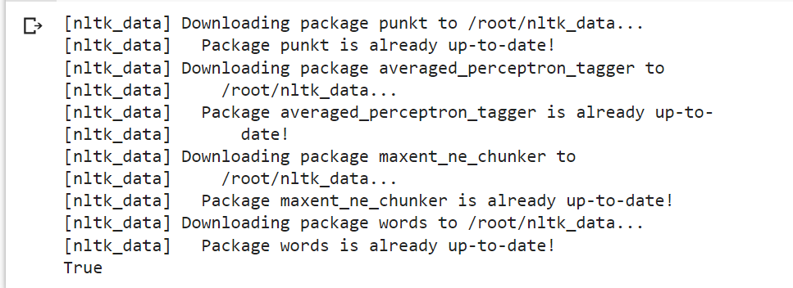

para = "Hello! this is Shreyans. Today we will be learning NLP"

sents = tokenize.sent_tokenize(para)

print("\nsentence tokenization\n===================\n",sents)

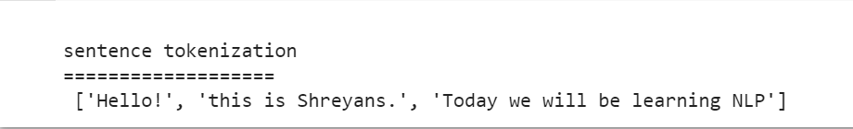

#word tokenization

print("\nword tokenization\n======\n")

for index in range(len(sents)):

  words = tokenize.word_tokenize(sents[index])

  print(words)

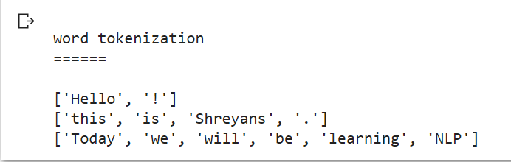

#POS TAGGING

tagged_words=[]

for index in range(len(sents)):

  tagged_words.append(tag.pos_tag(words))

  print("\nPOS Tagging\n===========\n",tagged_words)

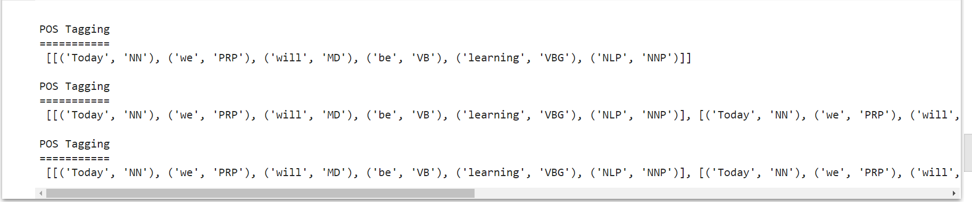

#chunki8ng

tree = []

for index in range(len(sents)):

  tree.append(chunk.ne_chunk(tagged_words[index]))

print("\nchunking\n===========")

print(tree)



1. **Named Entity recognition of user defined text**

Code

import spacy

# Load English tokenizer, tagger, parser and NER

nlp = spacy.load("en_core_web_sm")

#Process whole documnet

text = ("When Sebastian Thrun started working on self-driving cars at "

"Google in 2007, few people outside of the company took him "

"seriously. “I can tell you very senior CEOs of major American "

"car companies would shake my hand and turn away because I wasn’t "

"worth talking to,” said Thrun, in an interview with Recode earlier "

"this week.")

doc = nlp(text)

#Analyze syntax

print("Noun phrase: ", [chunk.text for chunk in doc.noun_chunks])

print("Verb", [token.lemma_ for token in doc if token.pos_ == "VERB"])



**Practical No. 7**

**Finite State Automata**

1. **Define grammar using nltk. Analyze a sentence using the same.**

Code

import nltk

from nltk import tokenize

grammar1 = nltk.CFG.fromstring("""

S -> VP

VP -> VP NP

NP -> Det NP

Det -> 'that'

NP -> singular Noun

NP -> 'flight'

VP -> 'Book'

""")

sentence = "Book that flight"

for index in range(len(sentence)):

all_tokens = tokenize.word_tokenize(sentence)

print(all_tokens)

parser = nltk.ChartParser(grammar1)

for tree in parser.parse(all_tokens):

print(tree)

tree.draw()

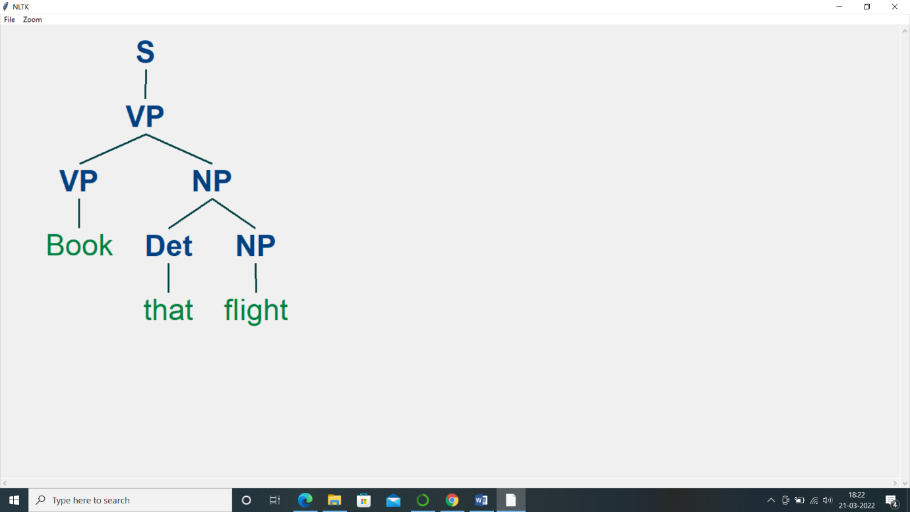

1. **Accept the input string with regular expression of finite automation: 101+**

Code

def FA(s):

#if the length is less than 3 then it can't be accepted, Therefore end the process.

if len(s)<3:

return "Rejected"

#first three characters are fixed. Therefore, checking them using index

if s[0]=='1':

if s[1]=='0':

if s[2]=='1':

# After index 2 only "1" can appear. Therefore break the process if any othercharacter is detected

for i in range(3, len(s)):

if s[i]!='1':

return "Rejected"

return "Accepted"

return "Rejected"

return "Rejected"

return "Rejected"

inputs=['1','10101','101','10111','01010','100','','10111101','1011111']

for i in inputs:

print(FA(i))

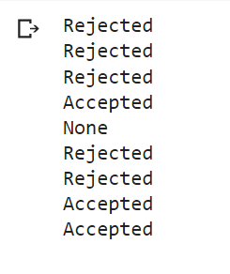

1. **Accept the input string with Regular expression of FA: (a+b)*bba.**

Code

def FA(s):

size=0

#scan complete string and make sure that it contains only 'a' & 'b'

for i in s:

if i=='a' or i=='b':

size+=1

else:

return "Rejected"

#After checking that it contains only 'a' & 'b'

#check it's length it should be 3 atleast

if size>=3:

#check the last 3 elements

if s[size-3]=='b':

if s[size-2]=='b':

if s[size-1]=='a':

return "Accepted"

return "Rejected"

return "Rejected"

return "Rejected"

return "Rejected"

inputs=['bba', 'ababbba', 'abba','abb', 'baba','bbb','']

for i in inputs:

print(FA(i))

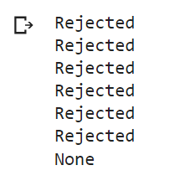

1. **Implementation of Deductive Chart Parsing using context free grammar and a given sentence.**

Code

import nltk

from nltk import tokenize

grammar1 = nltk.CFG.fromstring("""

S -> NP VP

PP -> P NP

NP -> Det N | Det N PP | 'I'

VP -> V NP | VP PP

Det -> 'a' | 'my'

N -> 'bird' | 'balcony'

V -> 'saw'

P -> 'in'

""")

sentence = "I saw a bird in my balcony"

for index in range(len(sentence)):

all_tokens = tokenize.word_tokenize(sentence)

print(all_tokens)

# all_tokens = ['I', 'saw', 'a', 'bird', 'in', 'my', 'balcony']

parser = nltk.ChartParser(grammar1)

for tree in parser.parse(all_tokens):

print(tree)

tree.draw()

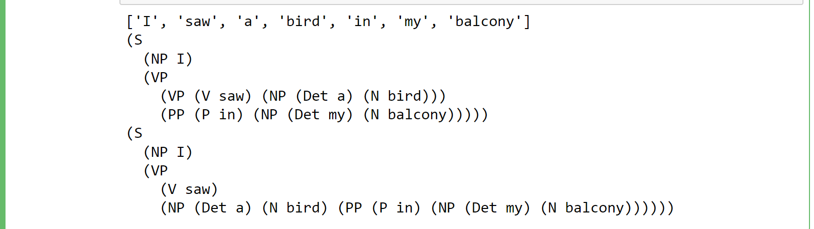

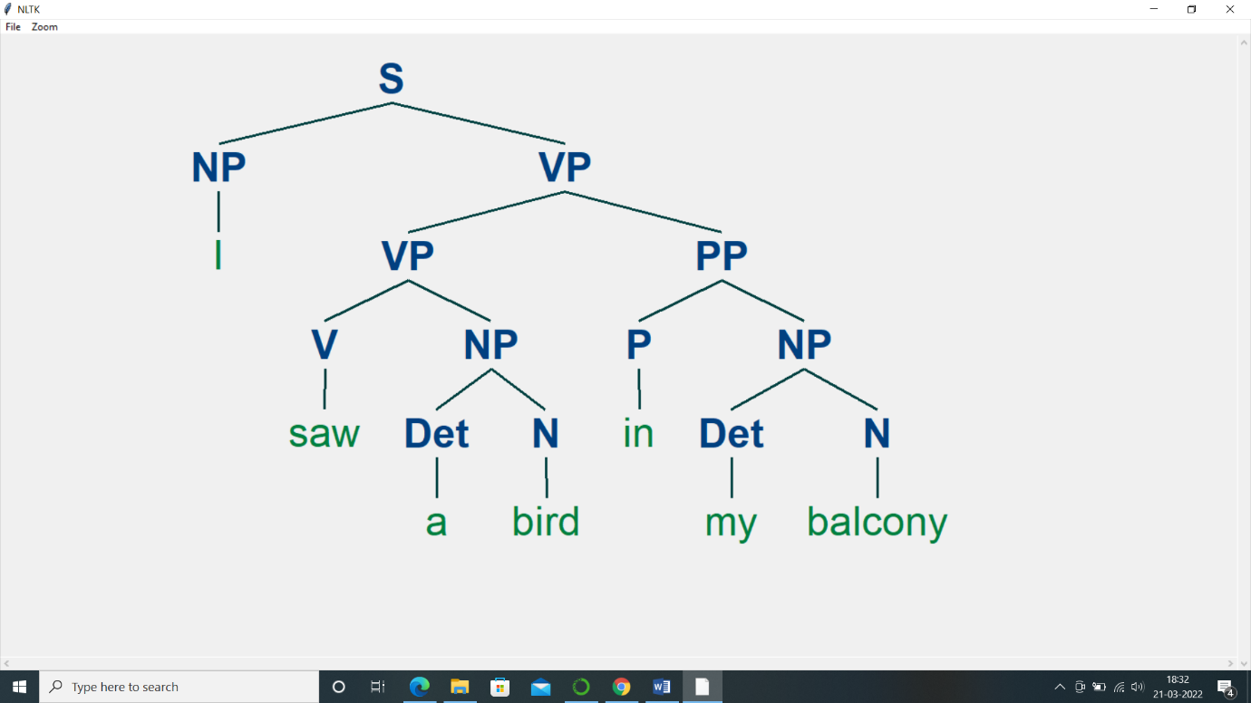

**Practical no. 8**

**Study PorterStemmer, LancasterStemmer, RegexpStemmer, SnowballStemmer Study WordNetLemmatizer**

Code

#PorterStemmer

import nltk

from nltk.stem import PorterStemmer

word_stemmer = PorterStemmer()

print(word_stemmer.stem('writing'))

import nltk

from nltk.stem import LancasterStemmer

Lanc_stemmer = LancasterStemmer()

print(Lanc_stemmer.stem('writing'))

import nltk

from nltk.stem import RegexpStemmer

Reg_stemmer = RegexpStemmer('ing$|s$|e$|able$', min=4)

print(Reg_stemmer.stem('writing'))

import nltk

from nltk.stem import SnowballStemmer

english_stemmer = SnowballStemmer('english')

print(english_stemmer.stem ('writing'))

nltk.download('wordnet')

from nltk.stem import WordNetLemmatizer

lemmatizer = WordNetLemmatizer()

print("word :\tlemma")

print("rocks :", lemmatizer.lemmatize("rocks"))

print("corpora :", lemmatizer.lemmatize("corpora"))

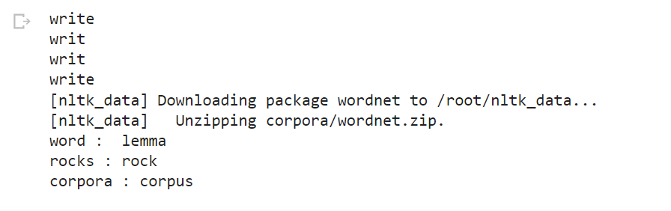

**Practical no. 9**

**Implement Naïve Bayes Classifier**

Code

import pandas as pd

import numpy as np

sms_data = pd.read_csv("/content/spam.csv", encoding='latin-1')

import re

import nltk

from nltk.corpus import stopwords

from nltk.stem.porter import PorterStemmer

nltk.download('stopwords')

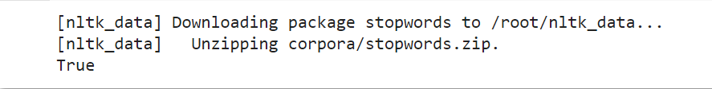

stemming = PorterStemmer()

corpus = []

for i in range (0,len(sms_data)):

  s1 = re.sub('[^a-zA-Z]',repl = ' ',string = sms_data['v2'][i])

  s1.lower()

  s1 = s1.split()

  s1 = [stemming.stem(word) for word in s1 if word not in set(stopwords.words('english'))]

  s1 = ' '.join(s1)

  corpus.append(s1)

from sklearn.feature_extraction.text import CountVectorizer

countvectorizer =CountVectorizer()

x = countvectorizer.fit_transform(corpus).toarray()

print(x)

y = sms_data['v1'].values

print(y)

from sklearn.model_selection import train_test_split

x_train,x_test,y_train,y_test = train_test_split(x,y,test_size = 0.3,

stratify=y,random_state=2)

#Multinomial Naïve Bayes.

from sklearn.naive_bayes import MultinomialNB

multinomialnb = MultinomialNB()

multinomialnb.fit(x_train,y_train)

# Predicting on test data:

y_pred = multinomialnb.predict(x_test)

print(y_pred)

#Results of our Models

from sklearn.metrics import classification_report, confusion_matrix

from sklearn.metrics import accuracy_score

print(classification_report(y_test,y_pred))

print("accuracy_score: ",accuracy_score(y_test,y_pred))

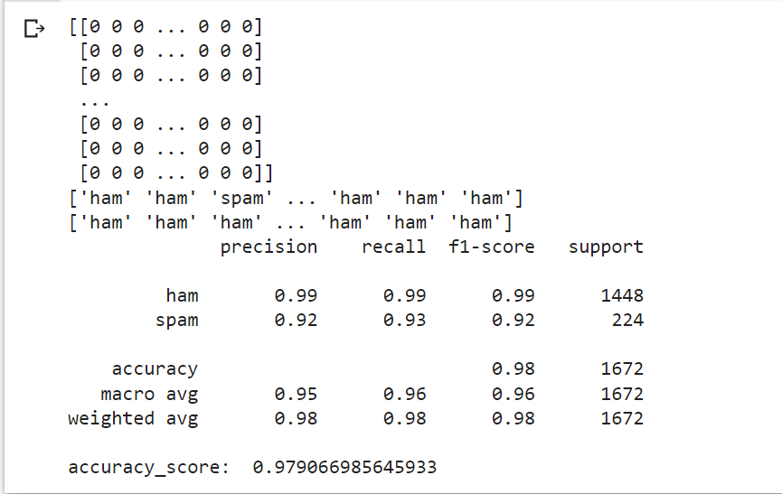

**Practical no 10**

1. **Speech Tagging**
2. **Speech Tagging using spaCy**

Code

import spacy

sp = spacy.load('en_core_web_sm')

sen = sp(u"I like to play football. I hated it in my childhood though")

print(sen.text)

print(sen[7].pos_)

print(sen[7].tag_)

print(spacy.explain(sen[7].tag_))

for word in sen:

 print(f'{word.text:{12}} {word.pos_:{10}} {word.tag_:{8}} {spacy.explain(word.tag_)}')

sen = sp(u'Can you google it?')

word = sen[2]

print(f'{word.text:{12}} {word.pos_:{10}} {word.tag_:{8}} {spacy.explain(word.tag_)}')

sen = sp(u'Can you search it on google?')

word = sen[5]

print(f'{word.text:{12}} {word.pos_:{10}} {word.tag_:{8}} {spacy.explain(word.tag_)}')

#Finding the Number of POS Tags

sen = sp(u"I like to play football. I hated it in my childhood though")

num_pos = sen.count_by(spacy.attrs.POS)

num_pos

for k,v in sorted(num_pos.items()):

 print(f'{k}. {sen.vocab[k].text:{8}}: {v}')

#Visualizing Parts of Speech Tags

from spacy import displacy

sen = sp(u"I like to play football. I hated it in my childhood though")

displacy.serve(sen, style='dep', options={'distance': 120})

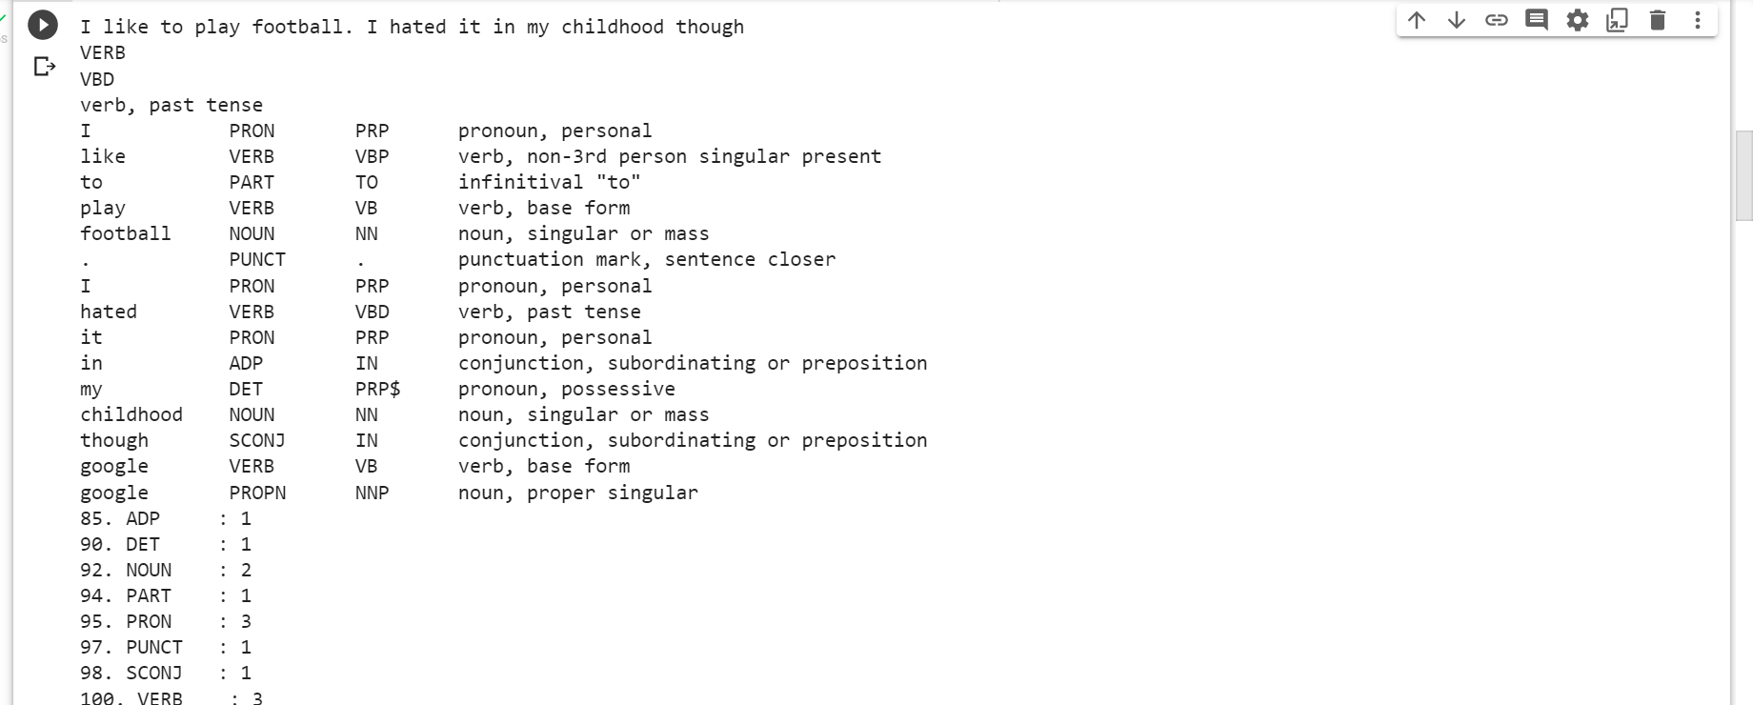

1. **Speech Tagging using nltk**

Code

nltk.download('punkt')

nltk.download('averaged_perceptron_tagger')

import nltk

from nltk.corpus import state_union

from nltk.tokenize import PunktSentenceTokenizer

import nltk

nltk.download('state_union')

#create our training and testing data:

train_text = state_union.raw("2005-GWBush.txt")

sample_text = state_union.raw("2006-GWBush.txt")

#train the Punkt tokenizer like:

custom_sent_tokenizer = PunktSentenceTokenizer(train_text)

# tokenize:

tokenized = custom_sent_tokenizer.tokenize(sample_text)

def process_content():

  try:

    for i in tokenized[:2]:

      words = nltk.word_tokenize(i)

      tagged = nltk.pos_tag(words)

      print(tagged)

  except Exception as e:

    print(str(e))

process_content()

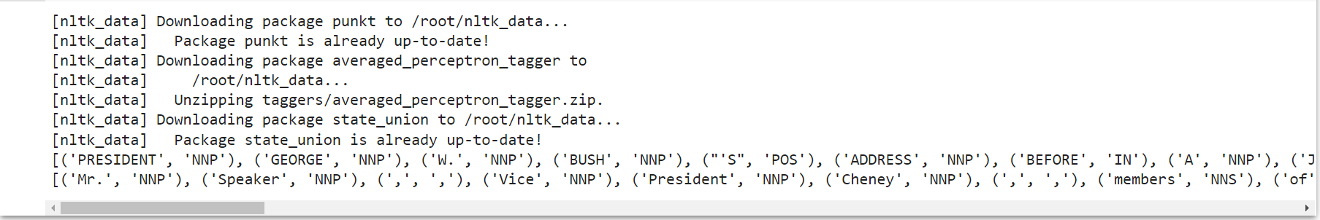

1. **Statistical Parsing**
2. **Usage of Give and Gave in the Penn treebank sample**

Code

import nltk

import nltk.parse.viterbi

import nltk.parse.pchart

def give(t):

  return t.label() == 'VP' and len(t) > 2 and t[1].label() == 'NP'\

    and (t[2].label() == 'PP-DTV' or t[2].label() == 'NP')\

    and ('give' in t[0].leaves() or 'gave' in t[0].leaves())

def sent(t):

  return ' '.join(token for token in t.leaves() if token[0] not in '*-0')

def print_node(t, width):

  output = "%s %s: %s / %s: %s" %\ (sent(t[0]), t[1].label(), sent(t[1]), t[2].label(), sent(t[2]))

  if len(output) > width:

     output = output[:width] + "..."

  print (output)

for tree in nltk.corpus.treebank.parsed_sents():

 for t in tree.subtrees(give):

  print_node(t, 72)

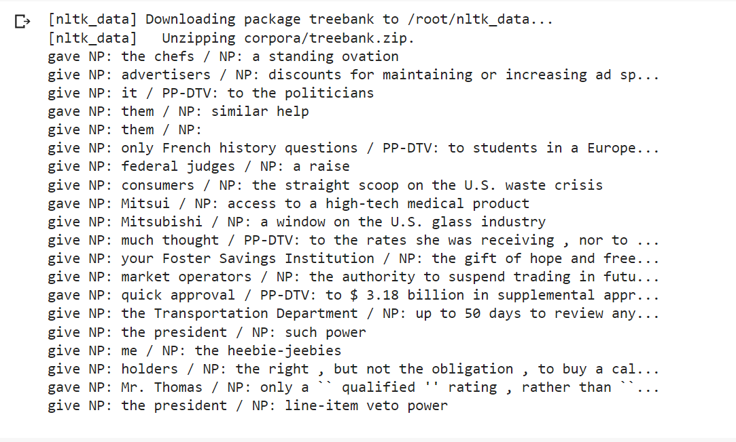

1. **Probabilistic parser**

Code

import nltk

from nltk import PCFG

grammar = PCFG.fromstring('''

NP -> NNS [0.5] | JJ NNS [0.3] | NP CC NP [0.2]

NNS -> "men" [0.1] | "women" [0.2] | "children" [0.3] | NNS CC NNS [0.4]

JJ -> "old" [0.4] | "young" [0.6]

CC -> "and" [0.9] | "or" [0.1]

''')

print(grammar)

viterbi_parser = nltk.ViterbiParser(grammar)

token = "old men and women".split()

obj = viterbi_parser.parse(token)

print("Output: ")

for x in obj:

 print(x)

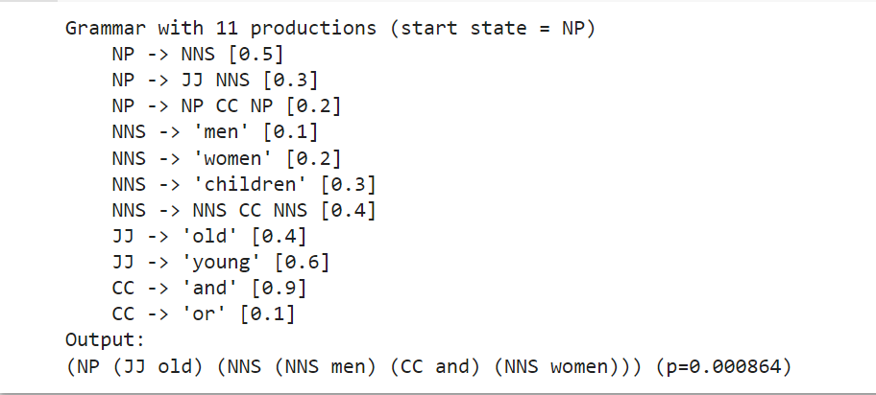

1. **Malt Parsing**

**Parse a sentence and draw a tree using malt parsing**

Code

from nltk.parse import malt

mp = malt.MaltParser('maltparser-1.7.2', 'engmalt.linear-1.7.mco')#file

t = mp.parse_one('I saw a bird from my window.'.split()).tree()

print(t)

t.draw()

**Practical no. 11**

1. **Multiword expression in NLP**

Code

import nltk

nltk.download('punkt')

from nltk.tokenize import MWETokenizer

from nltk import sent_tokenize, word_tokenize

s = '''Good cake cost Rs.1500\kg in Mumbai. Please buy me one of them.\n\nThanks.'''

mwe = MWETokenizer([('New', 'York'), ('Hong', 'Kong')], separator='_')

for sent in sent_tokenize(s):

 print(mwe.tokenize(word_tokenize(sent)))

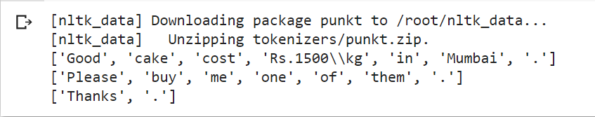

1. **Normalized Web Distance and word similarity**

Code

import numpy as np

import re

!pip install textdistance

import textdistance

# we will need scikit-learn>=0.21

import sklearn #pip install sklearn

from sklearn.cluster import AgglomerativeClustering

texts = ['Reliance supermarket', 'Reliance hypermarket', 'Reliance', 'Reliance', 'Reliance downtown', 'Relianc market','Mumbai', 'Mumbai Hyper', 'Mumbai dxb', 'mumbai airport', 'k.m trading', 'KM Trading', 'KM trade', 'K.M. Trading', 'KM.Trading']

def normalize(text):

 """ Keep only lower-cased text and numbers"""

 return re.sub('[^a-z0-9]+', ' ', text.lower())

def group_texts(texts, threshold=0.4):

 """ Replace each text with the representative of its cluster"""

 normalized_texts = np.array([normalize(text) for text in texts])

 distances = 1 - np.array([

 [textdistance.jaro_winkler(one, another) for one in normalized_texts]

 for another in normalized_texts

 ])

 clustering = AgglomerativeClustering(

 distance_threshold=threshold, # this parameter needs to be tuned carefully

 affinity="precomputed", linkage="complete", n_clusters=None

 ).fit(distances)

 centers = dict()

 for cluster_id in set(clustering.labels_):

  index = clustering.labels_ == cluster_id

  centrality = distances[:, index][index].sum(axis=1)

  centers[cluster_id] = normalized_texts[index][centrality.argmin()]

 return [centers[i] for i in clustering.labels_]

print(group_texts(texts))

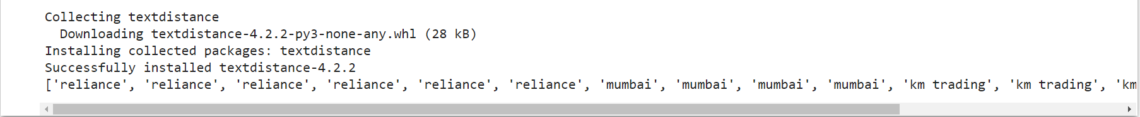

1. **Word Sense Disambiguation**

Code

#Word Sense Disambiguation

nltk.download('wordnet')

from nltk.corpus import wordnet as wn

def get_first_sense(word, pos=None):

 if pos:

  synsets = wn.synsets(word,pos)

 else:

  synsets = wn.synsets(word)

 return synsets[0]

best_synset = get_first_sense('bank')

print ('%s: %s' % (best_synset.name, best_synset.definition))

best_synset = get_first_sense('set','n')

print ('%s: %s' % (best_synset.name, best_synset.definition))

best_synset = get_first_sense('set','v')

print ('%s: %s' % (best_synset.name, best_synset.definition))

