sample

Table of Contents

## R Markdown

This is an R Markdown document. Markdown is a simple formatting syntax for authoring HTML, PDF, and MS Word documents. For more details on using R Markdown see <http://rmarkdown.rstudio.com>.

When you click the **Knit** button a document will be generated that includes both content as well as the output of any embedded R code chunks within the document. You can embed an R code chunk like this:

library(ggplot2)  
library(readr)  
library(dplyr)

##   
## Attaching package: 'dplyr'

## The following objects are masked from 'package:stats':  
##   
## filter, lag

## The following objects are masked from 'package:base':  
##   
## intersect, setdiff, setequal, union

bechdel <- read_csv("./data/bechdel.csv")

## Parsed with column specification:  
## cols(  
## year = col_double(),  
## imdb = col_character(),  
## title = col_character(),  
## test = col_character(),  
## clean_test = col_character(),  
## binary = col_character(),  
## budget = col_double(),  
## domgross = col_double(),  
## intgross = col_double(),  
## code = col_character(),  
## budget_2013 = col_double(),  
## domgross_2013 = col_double(),  
## intgross_2013 = col_double(),  
## period_code = col_double(),  
## decade_code = col_double()  
## )

ggplot(data = bechdel) +  
 geom_point(mapping = aes(x = budget,  
 y = intgross),  
 color ="red")

## Warning: Removed 11 rows containing missing values (geom_point).

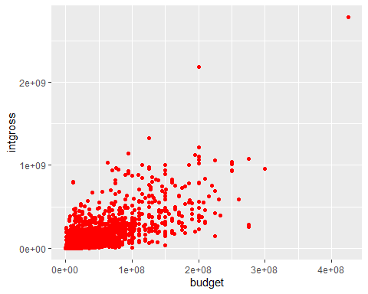

ggplot(data = bechdel) +  
 geom_bar(aes(x = clean_test))

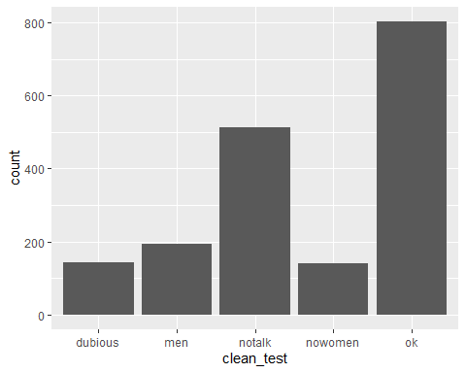

ggplot(data = bechdel,aes(x = test))+  
 geom_bar(aes(fill = test)) +  
 theme(axis.text.x = element_text(angle = ))

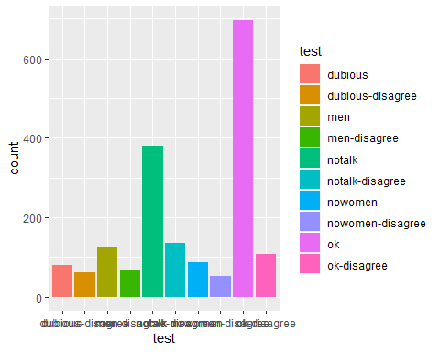

ggplot(data = bechdel, aes(x = clean_test)) +  
 geom_bar(aes(fill = clean_test)) +  
 scale_fill_brewer(palette = "red" )

## Warning in pal_name(palette, type): Unknown palette red

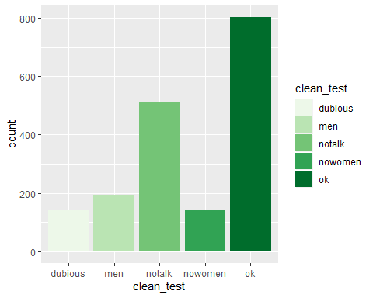

summary(cars)

## speed dist   
## Min. : 4.0 Min. : 2.00   
## 1st Qu.:12.0 1st Qu.: 26.00   
## Median :15.0 Median : 36.00   
## Mean :15.4 Mean : 42.98   
## 3rd Qu.:19.0 3rd Qu.: 56.00   
## Max. :25.0 Max. :120.00

## Including Plots

You can also embed plots, for example:



Note that the echo = FALSE parameter was added to the code chunk to prevent printing of the R code that generated the plot.