Surendar Deenadayalan

Email: [suren.net87@gmail.com](mailto:suren.net87@gmail.com)

Mobile: 07445221928

Visa Type : ILR (Indefinite leave to remain)

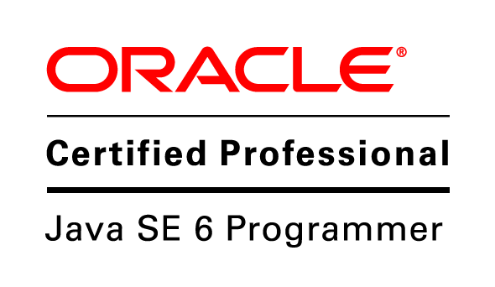

**Profile**

I am an Oracle Certified Professional Programmer with extensive experience in fast-paced, dynamic problem-solving and a proven entrepreneurial track record .

**Experience Summary**

* About six years of professional IT experience as a Programmer Analyst and Software Engineer with complete project life cycle in Java/J2EE technologies. Experience in analysis, design,development, testing and deployment.
* Extensive commercial experience in developing applications using Java, J2EE, JDBC, JSP and database management systems including MySQL, SYBASE.
* Good understanding of overall delivery lifecycle methodologies and processes (Agile ,RUP,Waterfall)
* Good working Experience with Front End Technologies: Apache Wicket ,AJAX, Java FX, JSP, HTML, DHTML, JavaScript and CSS
* Experience in designing solutions with industry leading technologies such as Spring, REST Web Services,JX-WS, Apache CXF Apache Camel, Active MQ, Wicket, Velocity and Quartz scheduler.
* Good Exposure in Spring boot, Cloud foundry, AWS and Microservice Architectures
* Experience with the ORM tool Hibernate involving Connection pooling, Mappings, Transaction

Management, HQL(Hibernate Query Lauguage).

* Experience in XML schema, Style sheets using XPath & XQuery, JAXB.
* Experience using software development tools such as Intellij , Eclipse and Netbeans.
* Strong experience in build tools such as Ant and Maven and also version tool GIT,subversion and

Bitbucket

* Experience of multi-threading, messaging systems, garbage collection and performance tuning
* Experiences in other aspects like testing plan & execution, configuration management,

deployment plan, continuous build & coding integrity management.

* Experienced in using design patterns, both Gang of Four patterns and J2EE design patterns like Model View Controller, Business Delegate and Data Access Object
* Hands-on experience with Unix command line features

**Certifications**

Java Standard Edition 6 certified Professional Exam (1Z0-851) with 90%

**Awarded**: 02 Dec 2011

**Education Qualification**

|  |  |  |
| --- | --- | --- |
| **Title of the Degree with Branch** | **College/University** | **Year of Passing** |
| Bachelor of Engineering in Computer Science.  Masters of Science in Computer Networking  **Commercial Project Experience (Feb 2012 – Present)** | Anna University.  University of Bedfordshire | 2009  2010 |

**Java Developer**

**Organization:** JP Morgan

**Title:** Associate

**Technology:** JAVA**,**Spring, Junit, JBoss, Ibatis, Hibernate, Web Services, XML schema,Sybase ,

CBB,Jenkins ,Jira,Control-m

**Date: 12-09-2017 to Present**

**Project Description**

* Worked as part of a critical Pyramid Qlib Service (QLS) team in delivering real-time risk systems in the Investment banking world and QLS is a major global application within JPMorgan's Equity Derivatives Pricing and Risk management platform. The risk result has to be delivered every day, all day, without fail to enable the traders to trade and manage risk, for effective financial management and to meet critical regulatory requirements

**Role and Responsibilities**

* Analyse, design, and implement solutions in a complex global environment against tight deadlines
* Responsible for design, implementation, support, and documentation of the QLS suite of applications with ownership
* Develop specific enhancements and/or build new solutions to fulfil business objectives related to new business requirements
* Support system testing, user testing and production implementation
* Provide 3rd level support to the business
* Investigate, debug and resolve issues with the team’s applications
* Liaise and work with those responsible for the operation of the application to resolve production issues

**Organization:** CPG Logistics

**Title:** ISIS Interface

**Technology:** Spring, Hibernate, Apache Wicket, Web Services ,CXF , and Apache Camel ,XML

schema ,JAXB ,

Apache Tomcat 6.0 and Maven

**Date: 05-03-2013 to 30-08-2017**

**Project Description**

* Worked as part of a team developing the ISIS Interface- a java-based application for customized order-processing strategy for the new customer. It validates XML using XML schema and uses JAXB to parse the XML .It has separate data access layer implementation using Spring , Hibernate POJO's and configuring Hibernate persistence layer.

**Role and Responsibilities**

* Defines site objectives by analysing user requirements; envisioning system features and functionality.
* Designing and developing user interfaces by setting expectations and features priorities throughout development life cycle; determining design methodologies and tool sets; completing programming using languages and software products; designing and conducting tests.
* Take ownership of a particular solution offering. Provides expertise to identify and translate system requirements into software design documentation

**Web Development**

**Organization:** CPG Logisitics

**Title:** Web Development

**Technology:** Java, J2EE, Web service, Apache Wicket,AJAX, MySQL, Spring ,Hibernate , Struts,HTML,CSS,JSP and Maven

**Date**: 28-12- 2012 to 19-02-2013

**Webapplication:** [**www.mypharmisa.com**](http://www.mypharmisa.com)

[**www.medisa.com**](http://www.medisa.com)

**Project Description**

**C**PG’s IT solutions focus on inventory management and provide customised ordering channels. Linking the clients, suppliers and other fulfilment partners, we integrate with existing processes and systems.

This website has standard shopping basket formats, Order status and tracking Monitoring usage and stock levels to control demand, Real-time reporting Alerting and e-reminders.

**References available on request**