**Advance Software Engineering**

Assignment – 3

WCF Restful Service & Mash Up.

Surendra Koripella

16143350

Installation Results of IIS Server

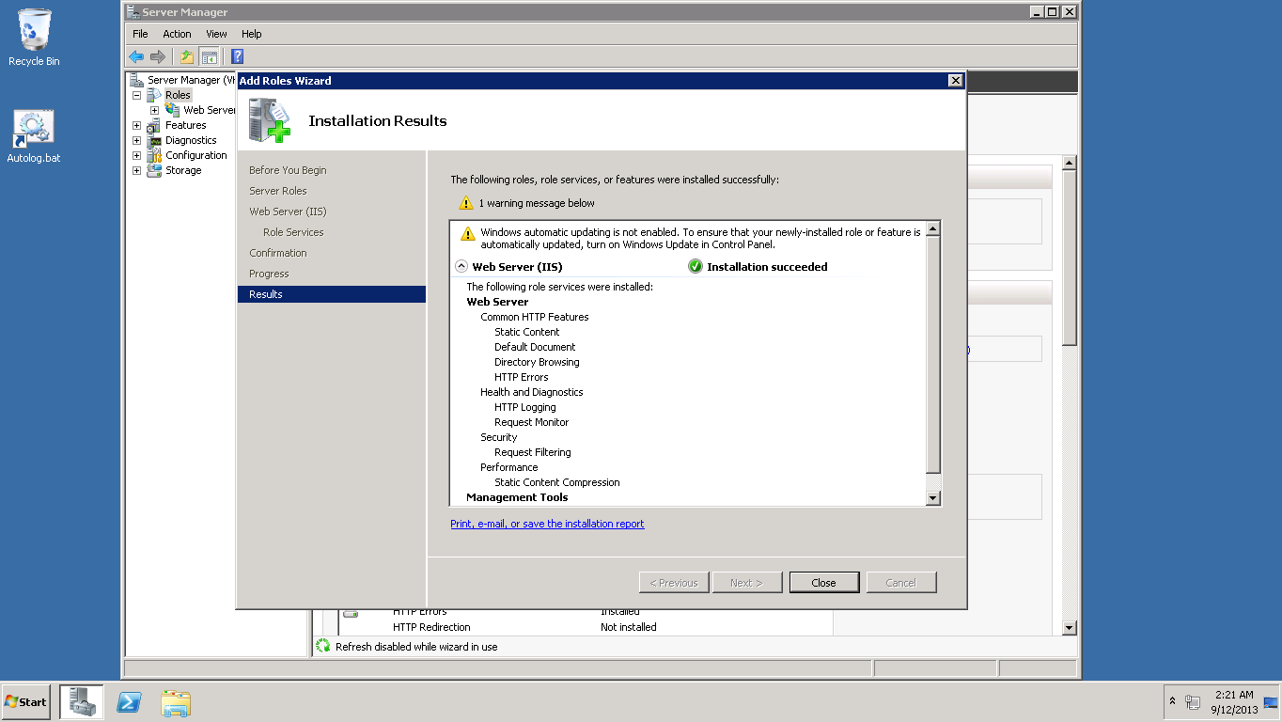

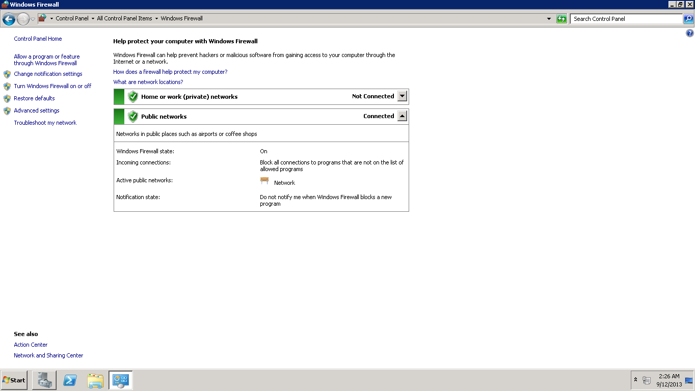

Results of Setting up firewall correctly

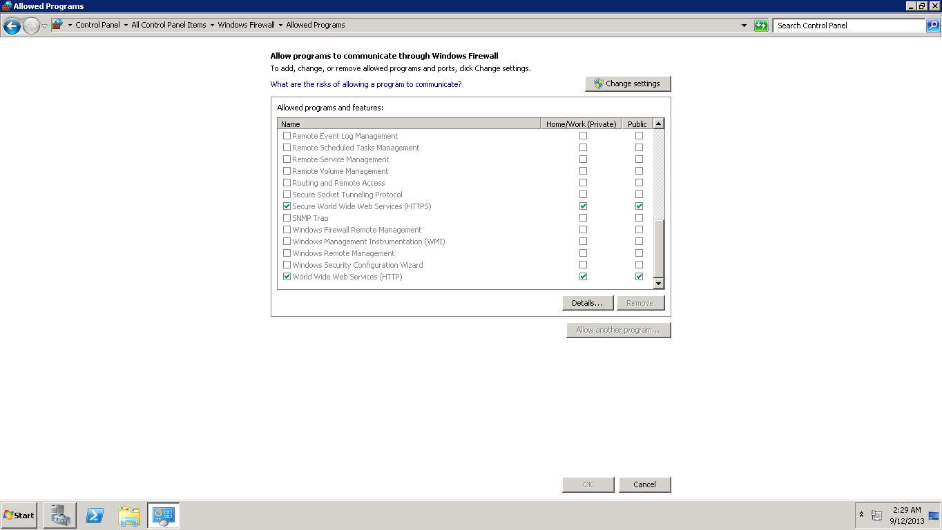

ApplicationHost in Notepad.

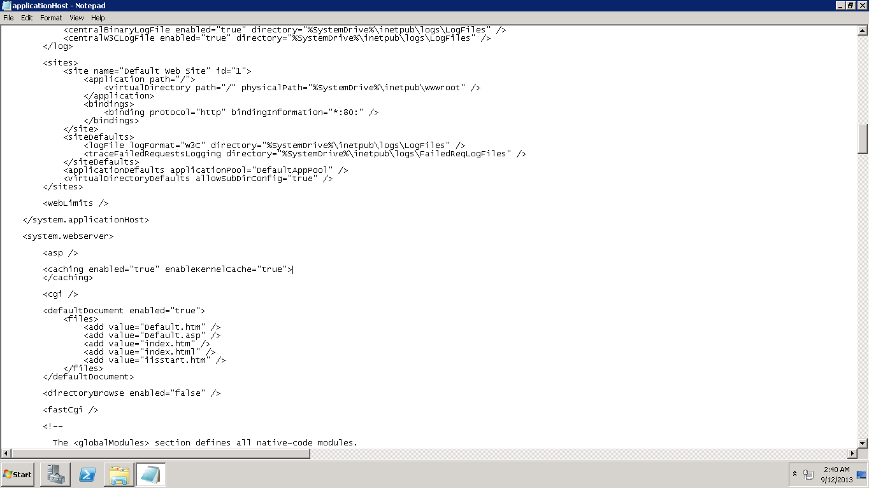

Add 3.5.1 framework Feature

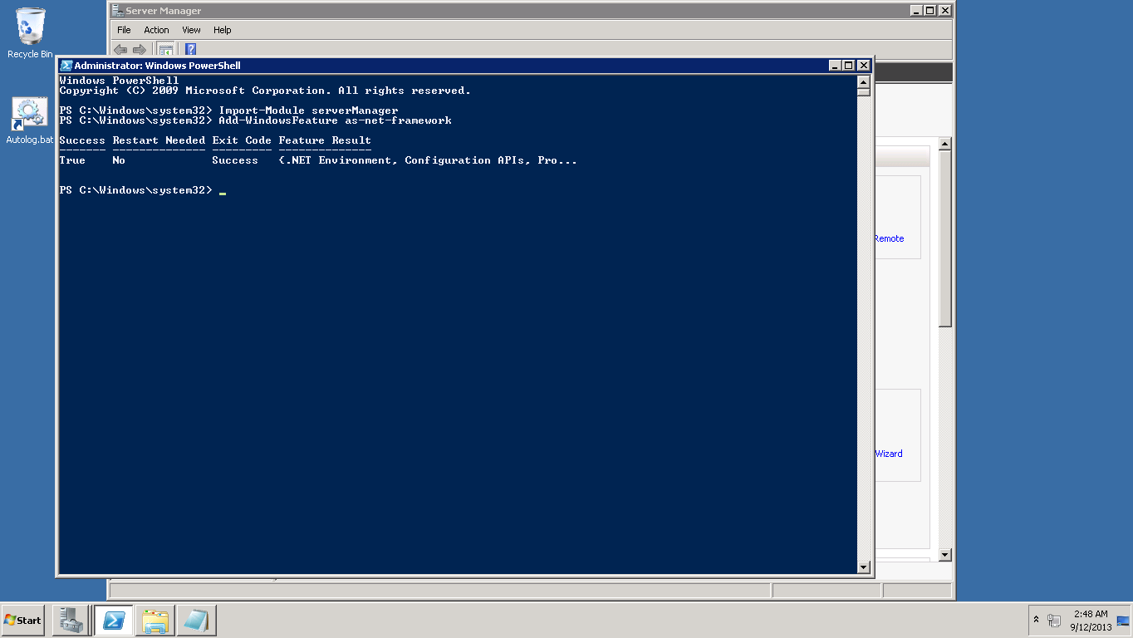

Deploying my Web Service

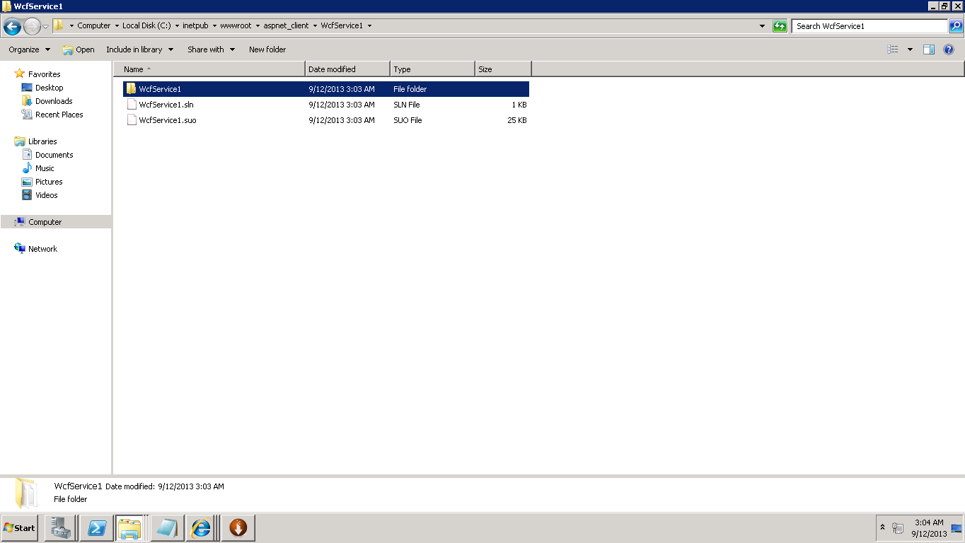

Conversion of web service to application process

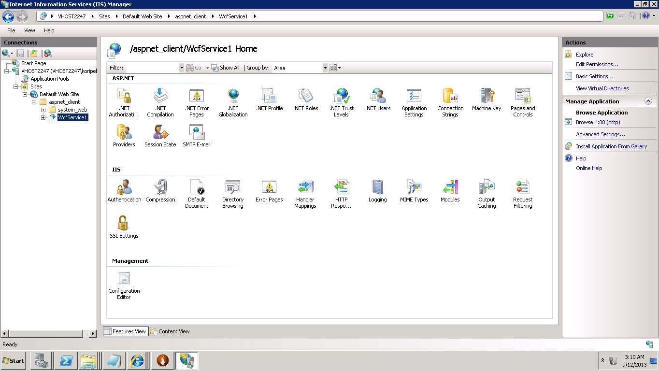

Result of deploying IIS Server

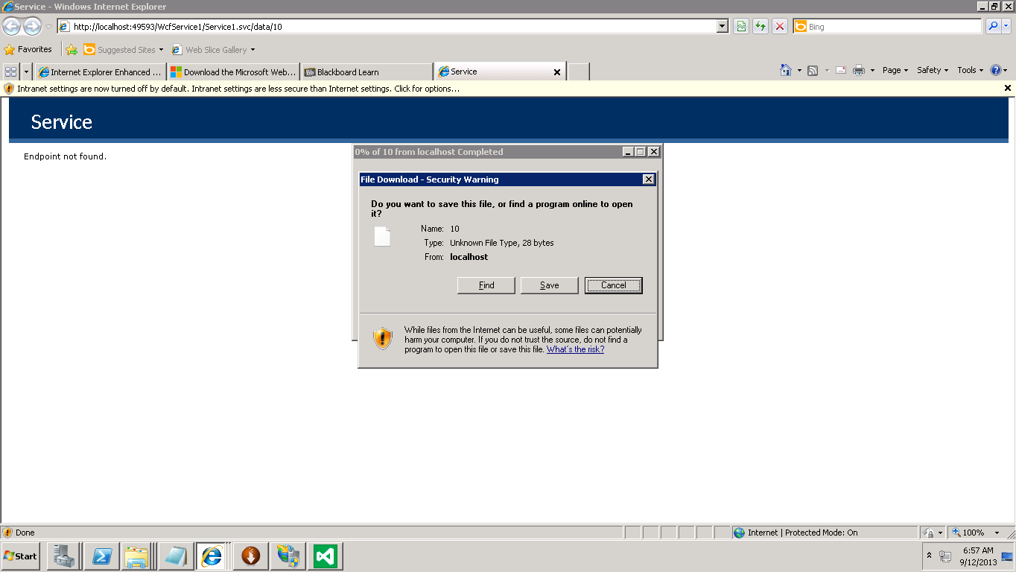

Output of deploying IIS Server.

