**HACKTHON**

**Design:**

**Architecture Diagram:**

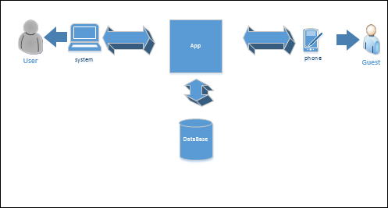

**Class Diagram:**

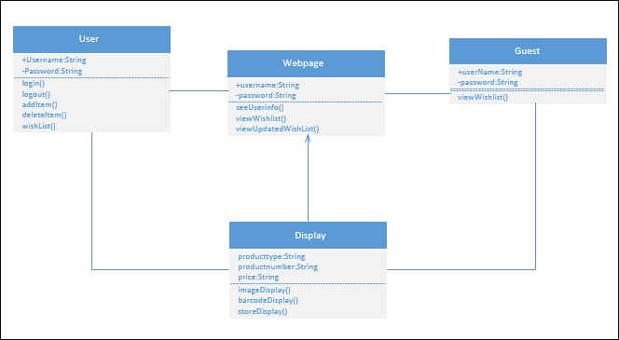

**Features Implemented:**

Data Base: Tomcat application server, oracle.

I have tried using JDBC concept in java. I tried my best.

**Screenshots:**

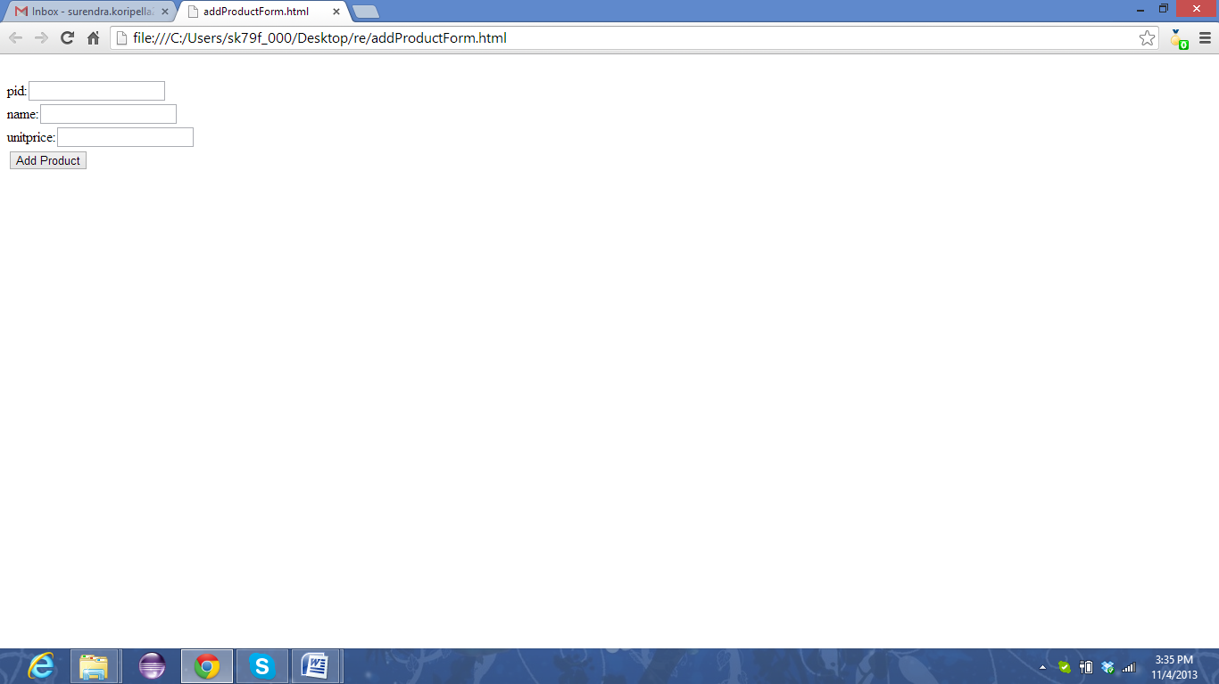

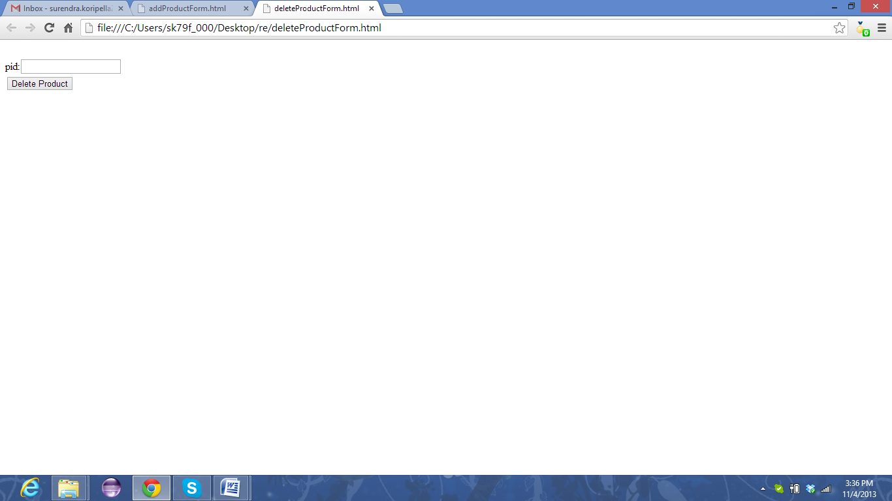

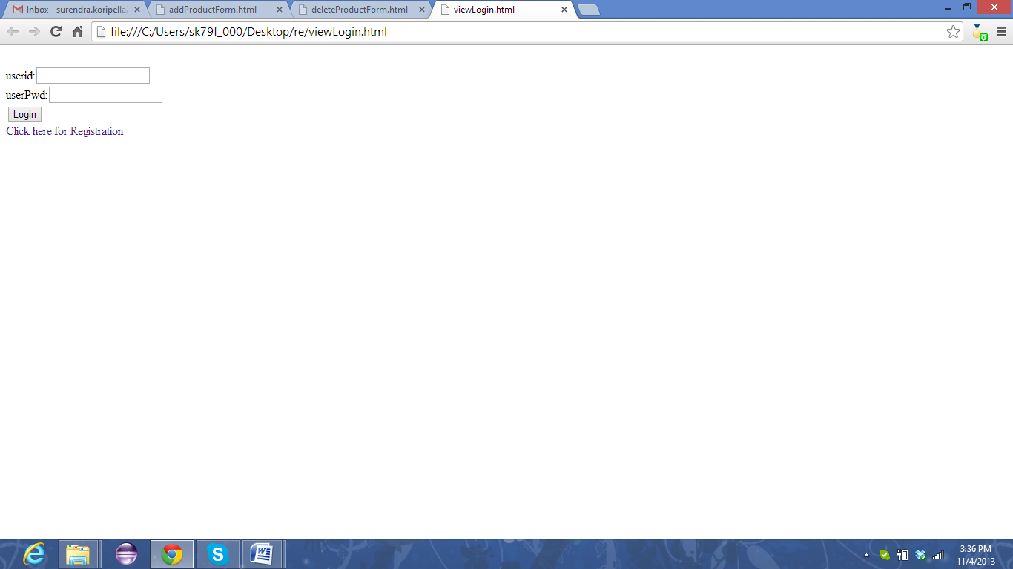

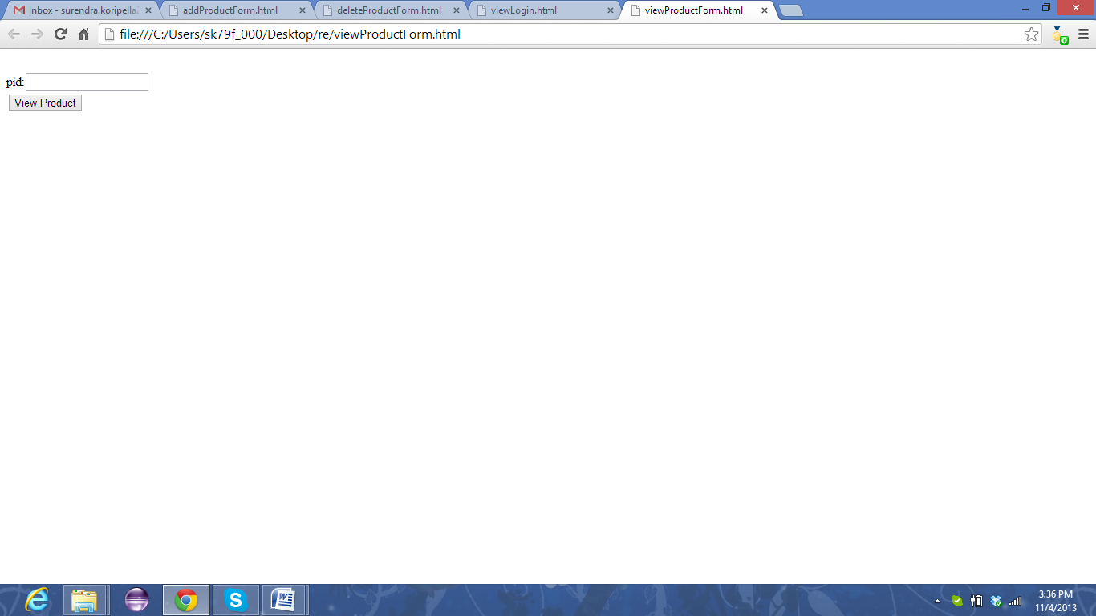

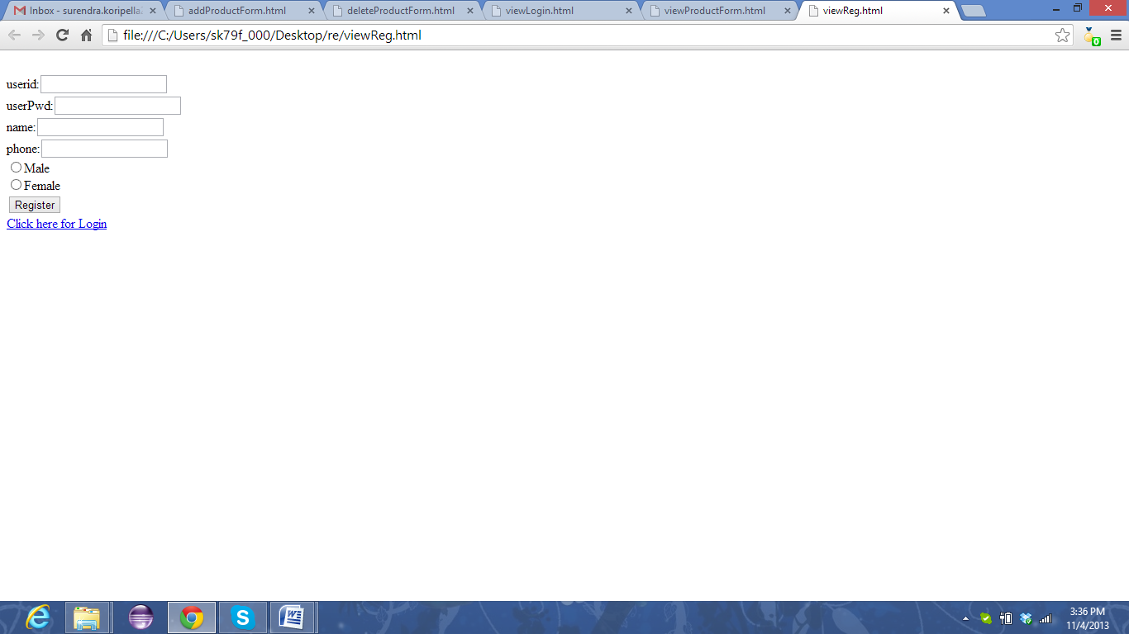

**Limitations:**

Database did not install properly, inviting friends did not work.

**References:**

I have seen used YouTube, stack overflow sites to learn.