**Advance Software Engineering**

**Lab Assignment – 2**

Surendra Koripella,

16143350 .

The following is the link

<http://jsfiddle.net/Suren91/X4tNd/1/>

This shows the my jsfiddle page which contains html, javascript and css parts in which their code is written.

My page contains the Directions from one location to another location using google maps web service.

I have given from and to options to enter source and destination slots and Go button to search the route between two points.

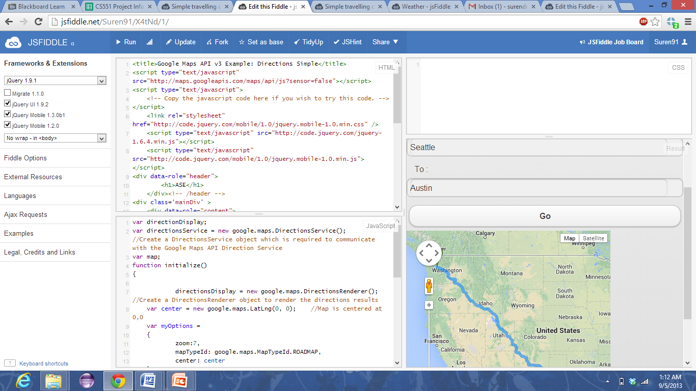

My web app layout

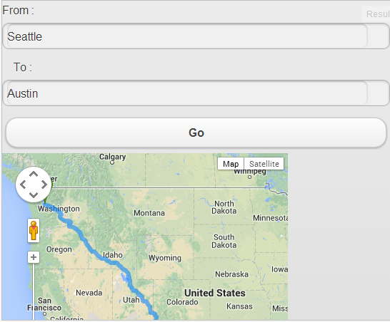

Here we enter source in from button option space and destination in to button option. At last we enter the go button to get the directions between them.

Map showing the source place

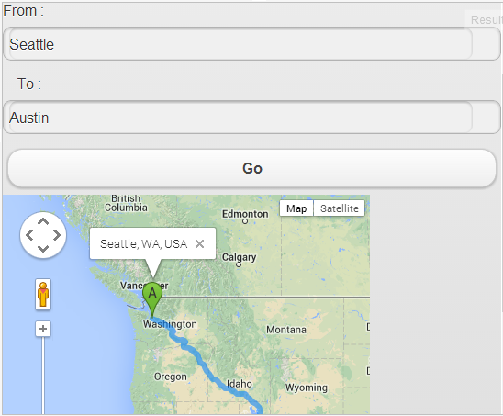

Map showing the destination place

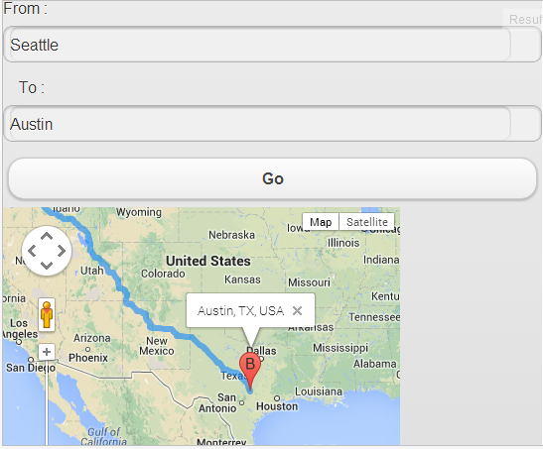

Here is the another source and destination map

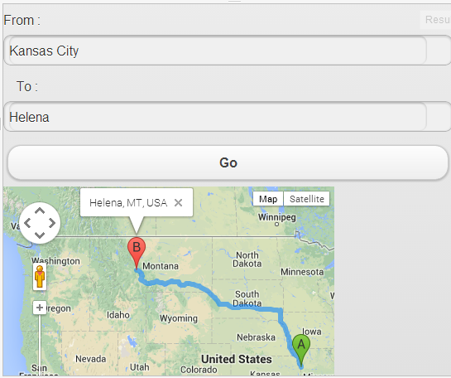

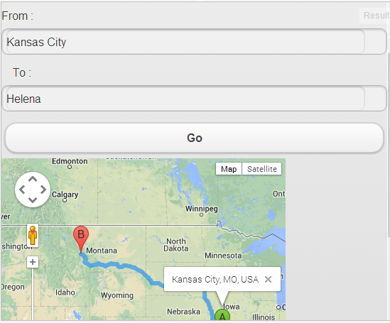

The following are the files I used



