Screenshot showing the service.svc.cs file code

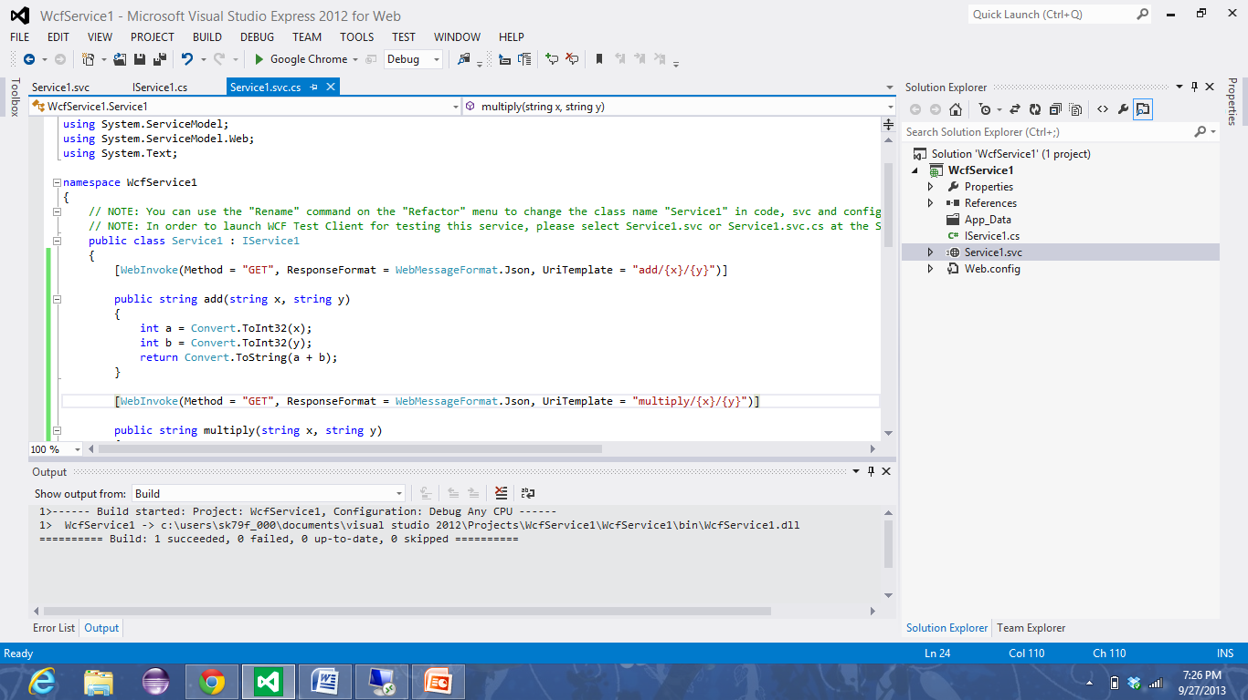

Here the following shows IService1.cs file code

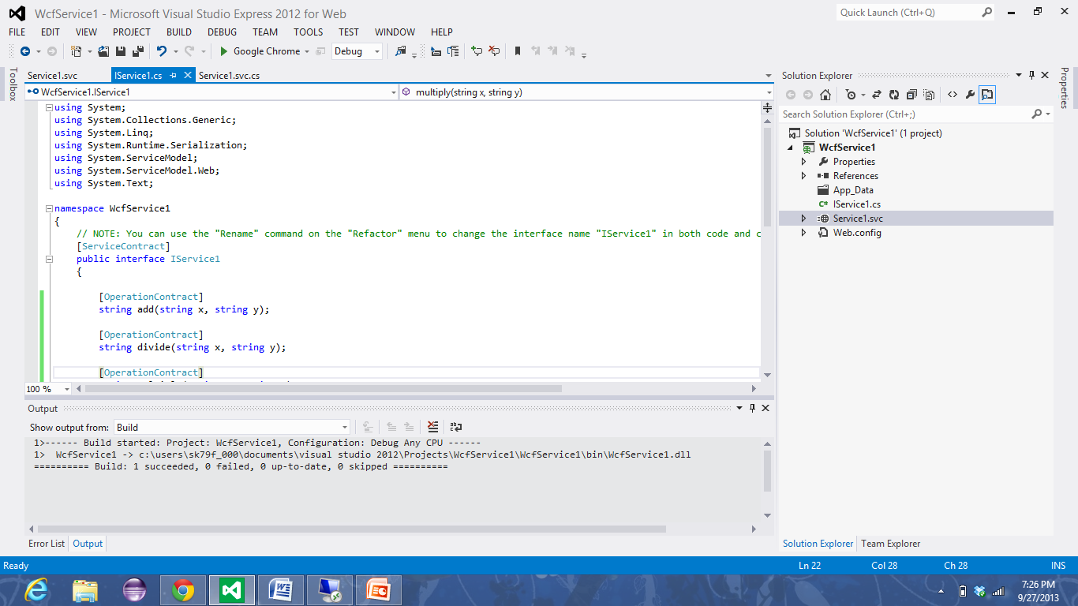

Here the shot shows Service1.svc

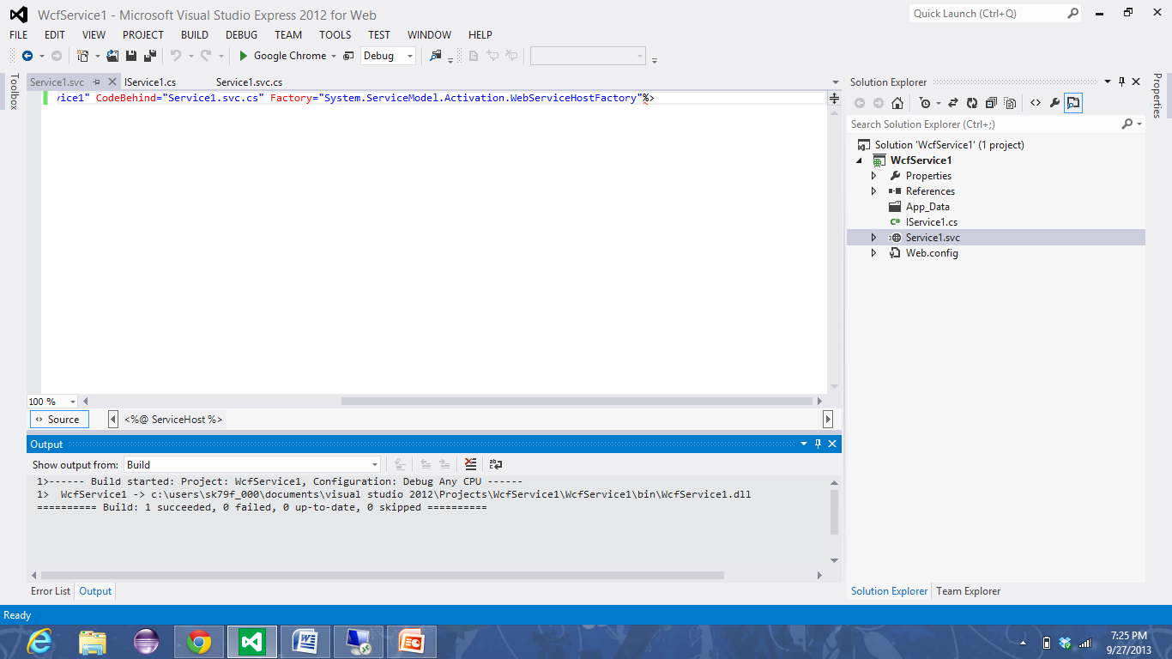

Webpage showing the service1.svc file when clicked on browse option

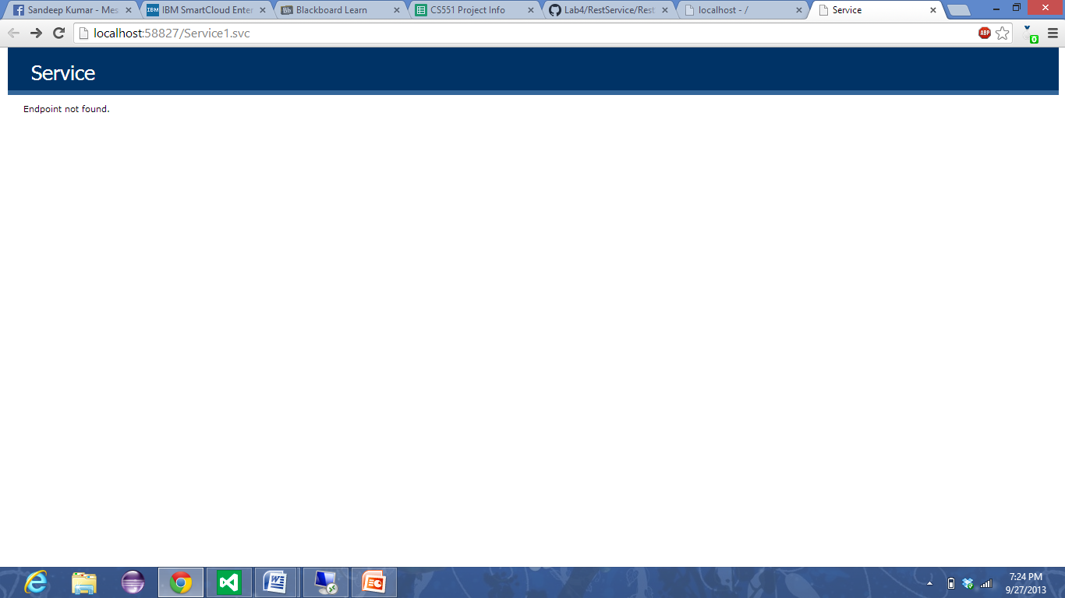

Here the page shows the addition result of 10 and 20

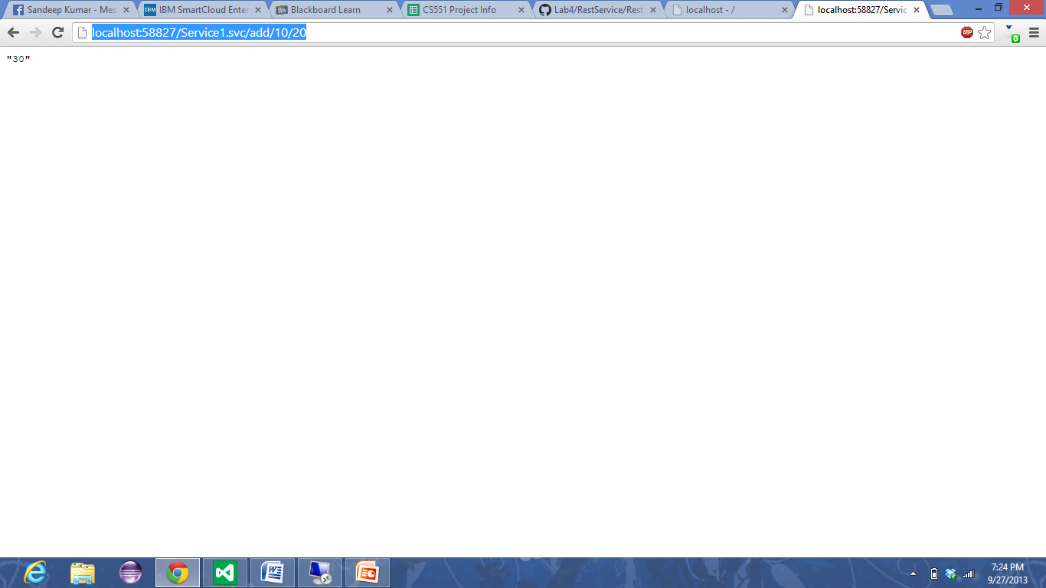

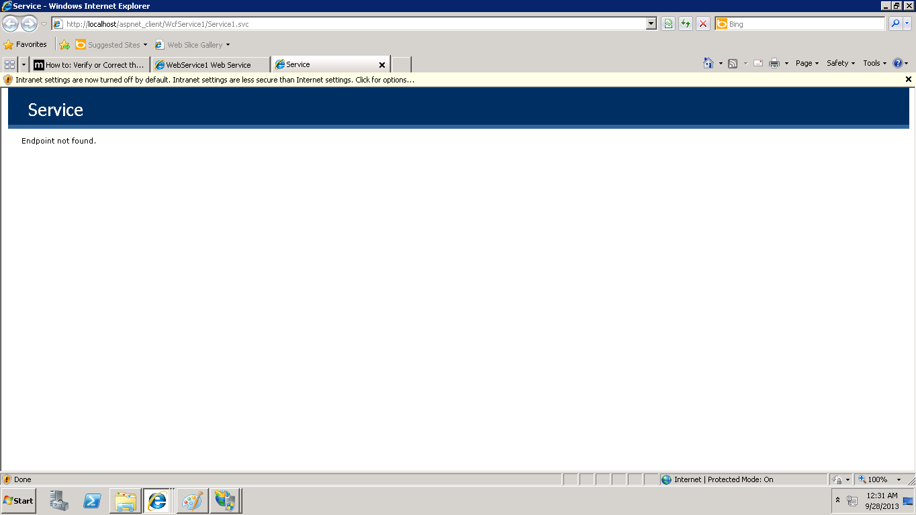

Here the page shows the addition result of 10 and 20 in instance

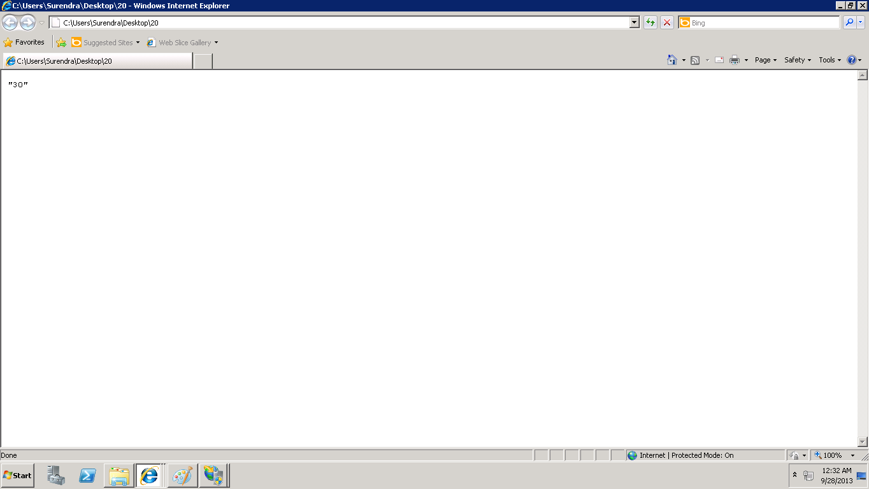

Showing the result of the rest service from locally

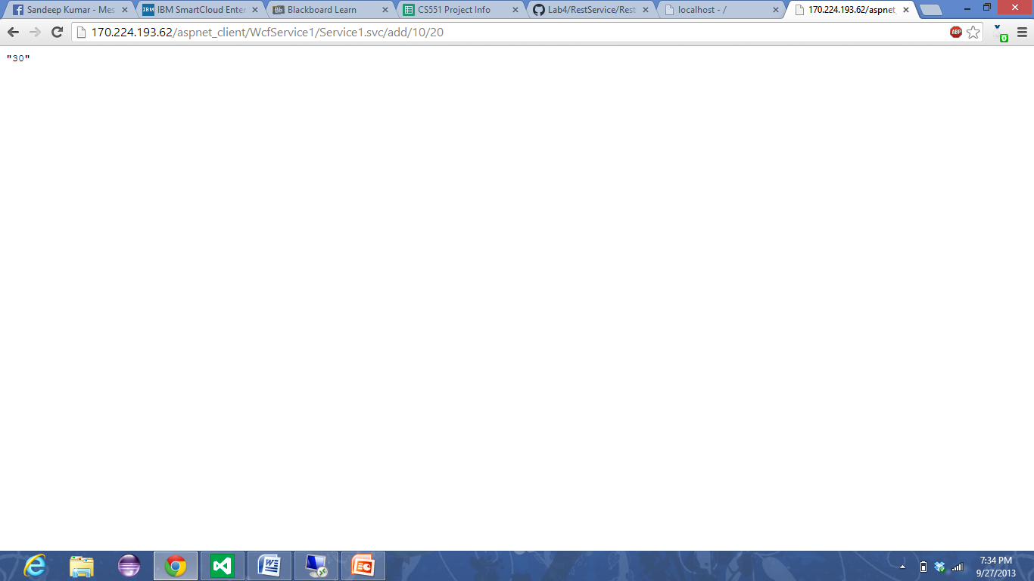

Access Link

<http://170.224.193.62/aspnet_client/WcfService1/Service1.svc/add/10/20>