Screenshot showing created soap web application

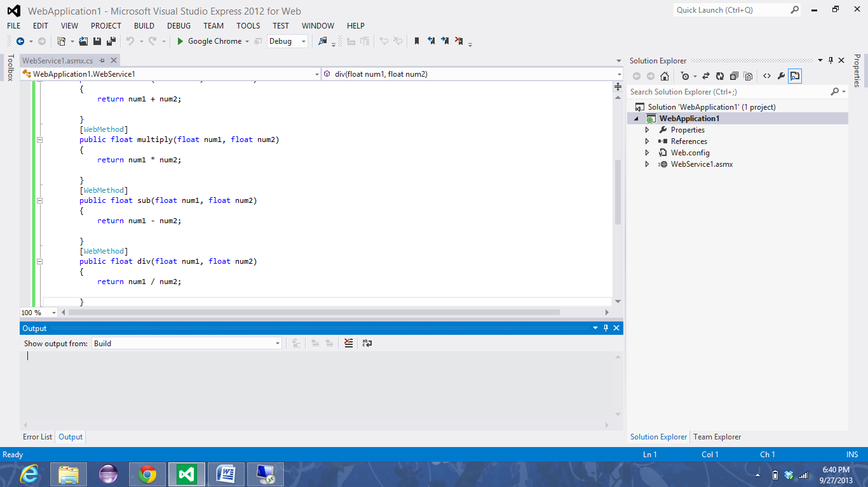

Converting to application in the instance

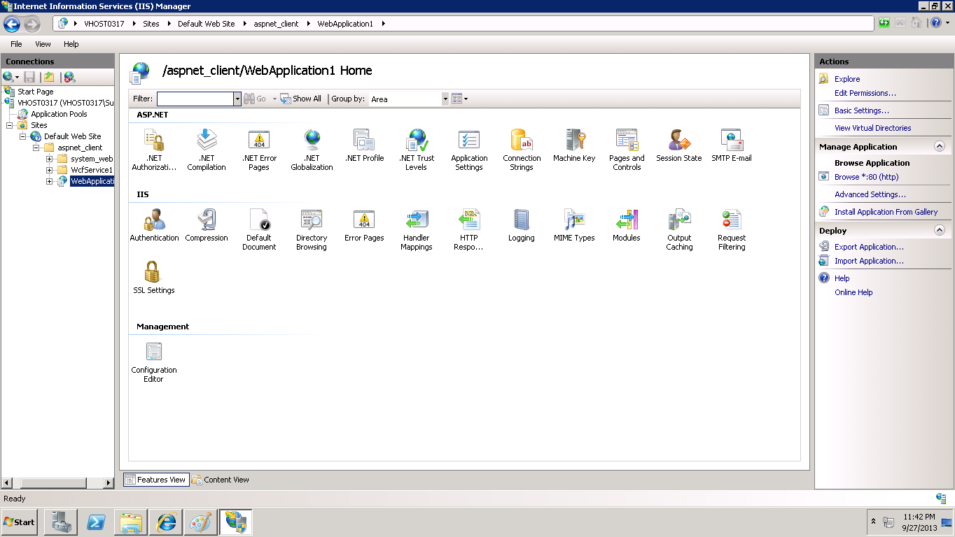

Output screenshot showing the webservice in the instance

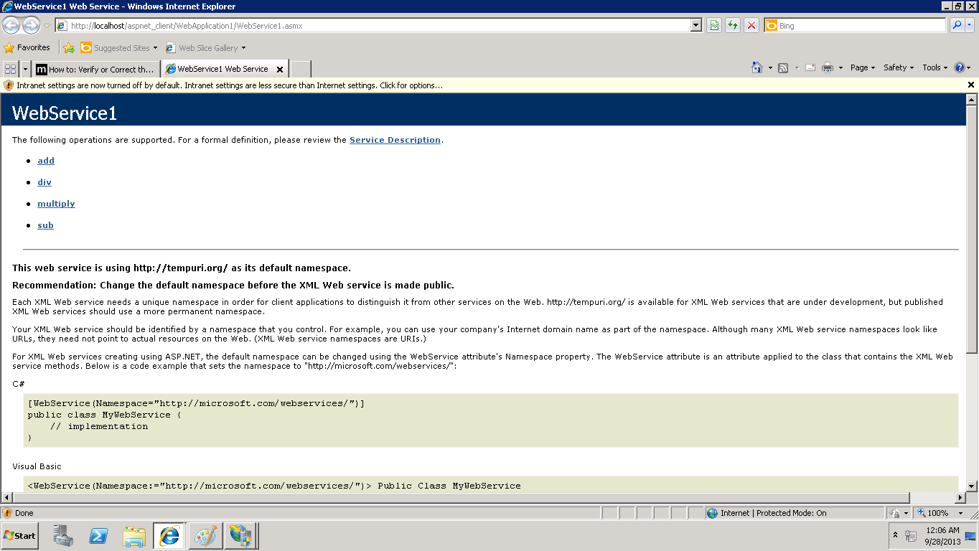

Accessing the web service locally

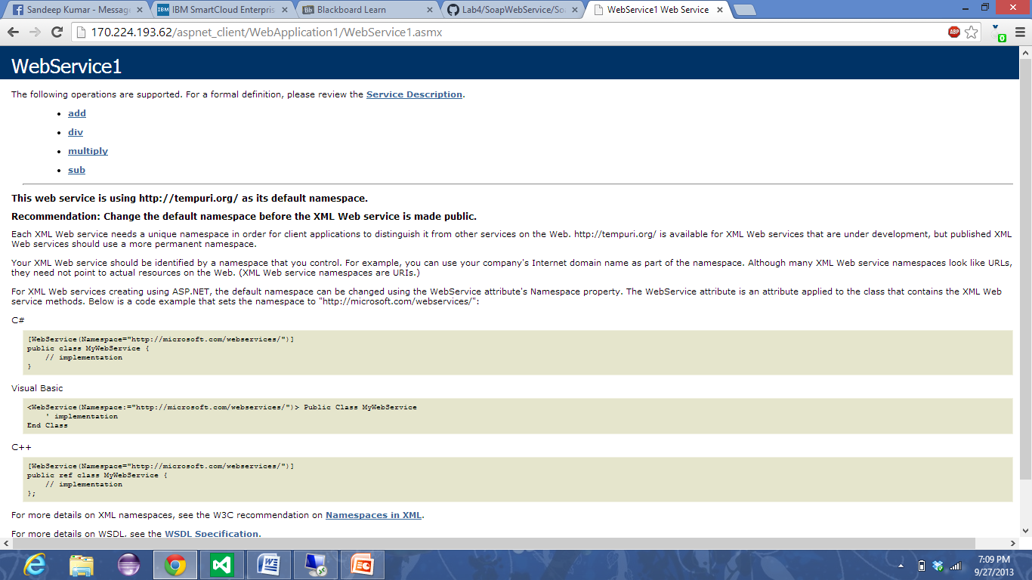

The following is the link for accessing my web service

<http://170.224.193.62/aspnet_client/WebApplication1/WebService1.asmx>