**Manual to Master_fitting VB10 application**

S.G. Arutunian, V.A. Margaryan

Affiliation: AANL (Yerevan physics institute), Accelerator diagnostics group

Program Master_Fitting is plased in: VB10_soft\Master_Fitting\Master_Fitting.exe (folder containing the program Master_Fitting.exe must contain a subfolder Date)․ Main view of program is presented in Fig. 1.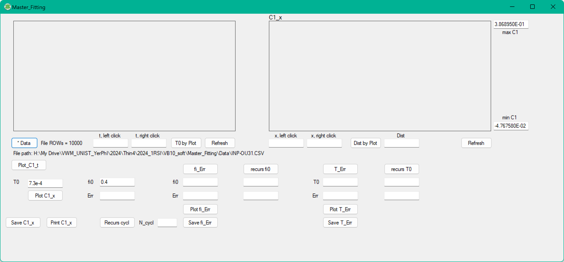

Fig. 1. Main view of window of VB10 Master_Fitting.exe

The files with experimental data in the CSV format are to be processed. The file should contain three columns, the first - time stamps of the process, the second - channel data from the photodiode, the third - data of the electrical signal from the string (in the developed programme this column is not actually used, but formally it should be present). Experimental data should be placed in the Master_Fitting\Data directory. The INP-OU31.CSV file obtained with the RTB2004 oscilloscope is placed in this directory as a sample.

You will see name and location of your chosen file in row of file path (Fig. 1).

By clicking on button **Plot_C1_t** you will see the plot of your data in **C1_t** PictureBox (see Fig. 2).

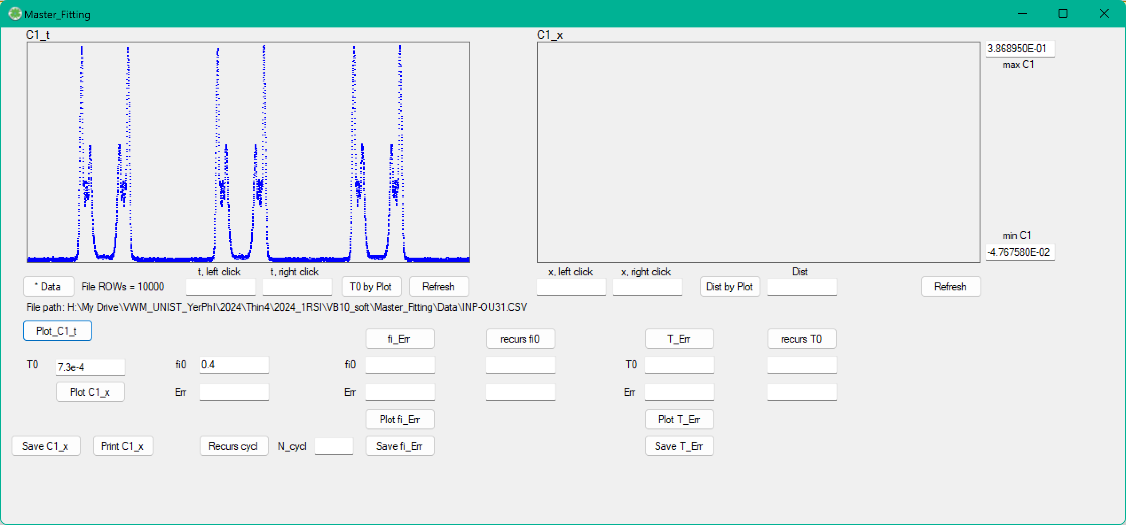

Fig. 2. Plot of raw data in **C1_t** PictureBox.

In order to estimate roughly period of wire oscillations click on **C1_t** PictureBox; left click show left marking line of period, right click show right marking line close the period (corresponding values are shown in TextBoxes: **t, left click** and **t, right click**. By clicking button **T0 by plot** it will calculate value of T0 (see Fig. 3).

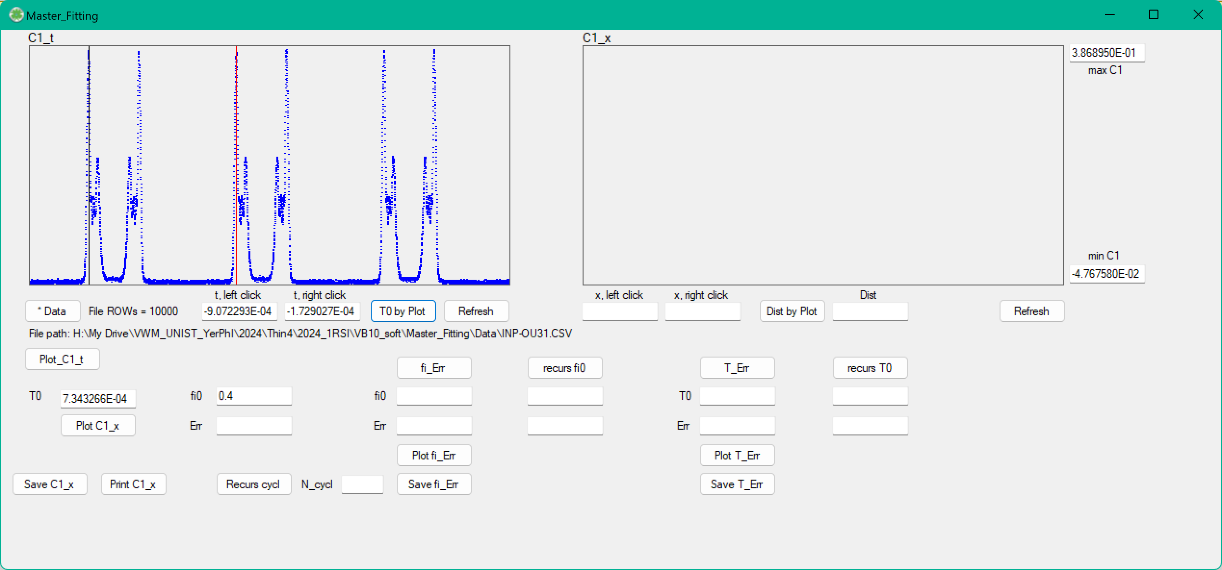

Fig. 3. Roughly estimation of period of wire oscillations.

If you made a mistake by choosing points of time marks you can refresh the process by clicking button **Refresh**.

By clicking **Plot_C1_x** you will see function C1 depending on x is plotted in PictureBox **C1_x** (see Fig. 4). Parameter fi0 here is set to 0.4.

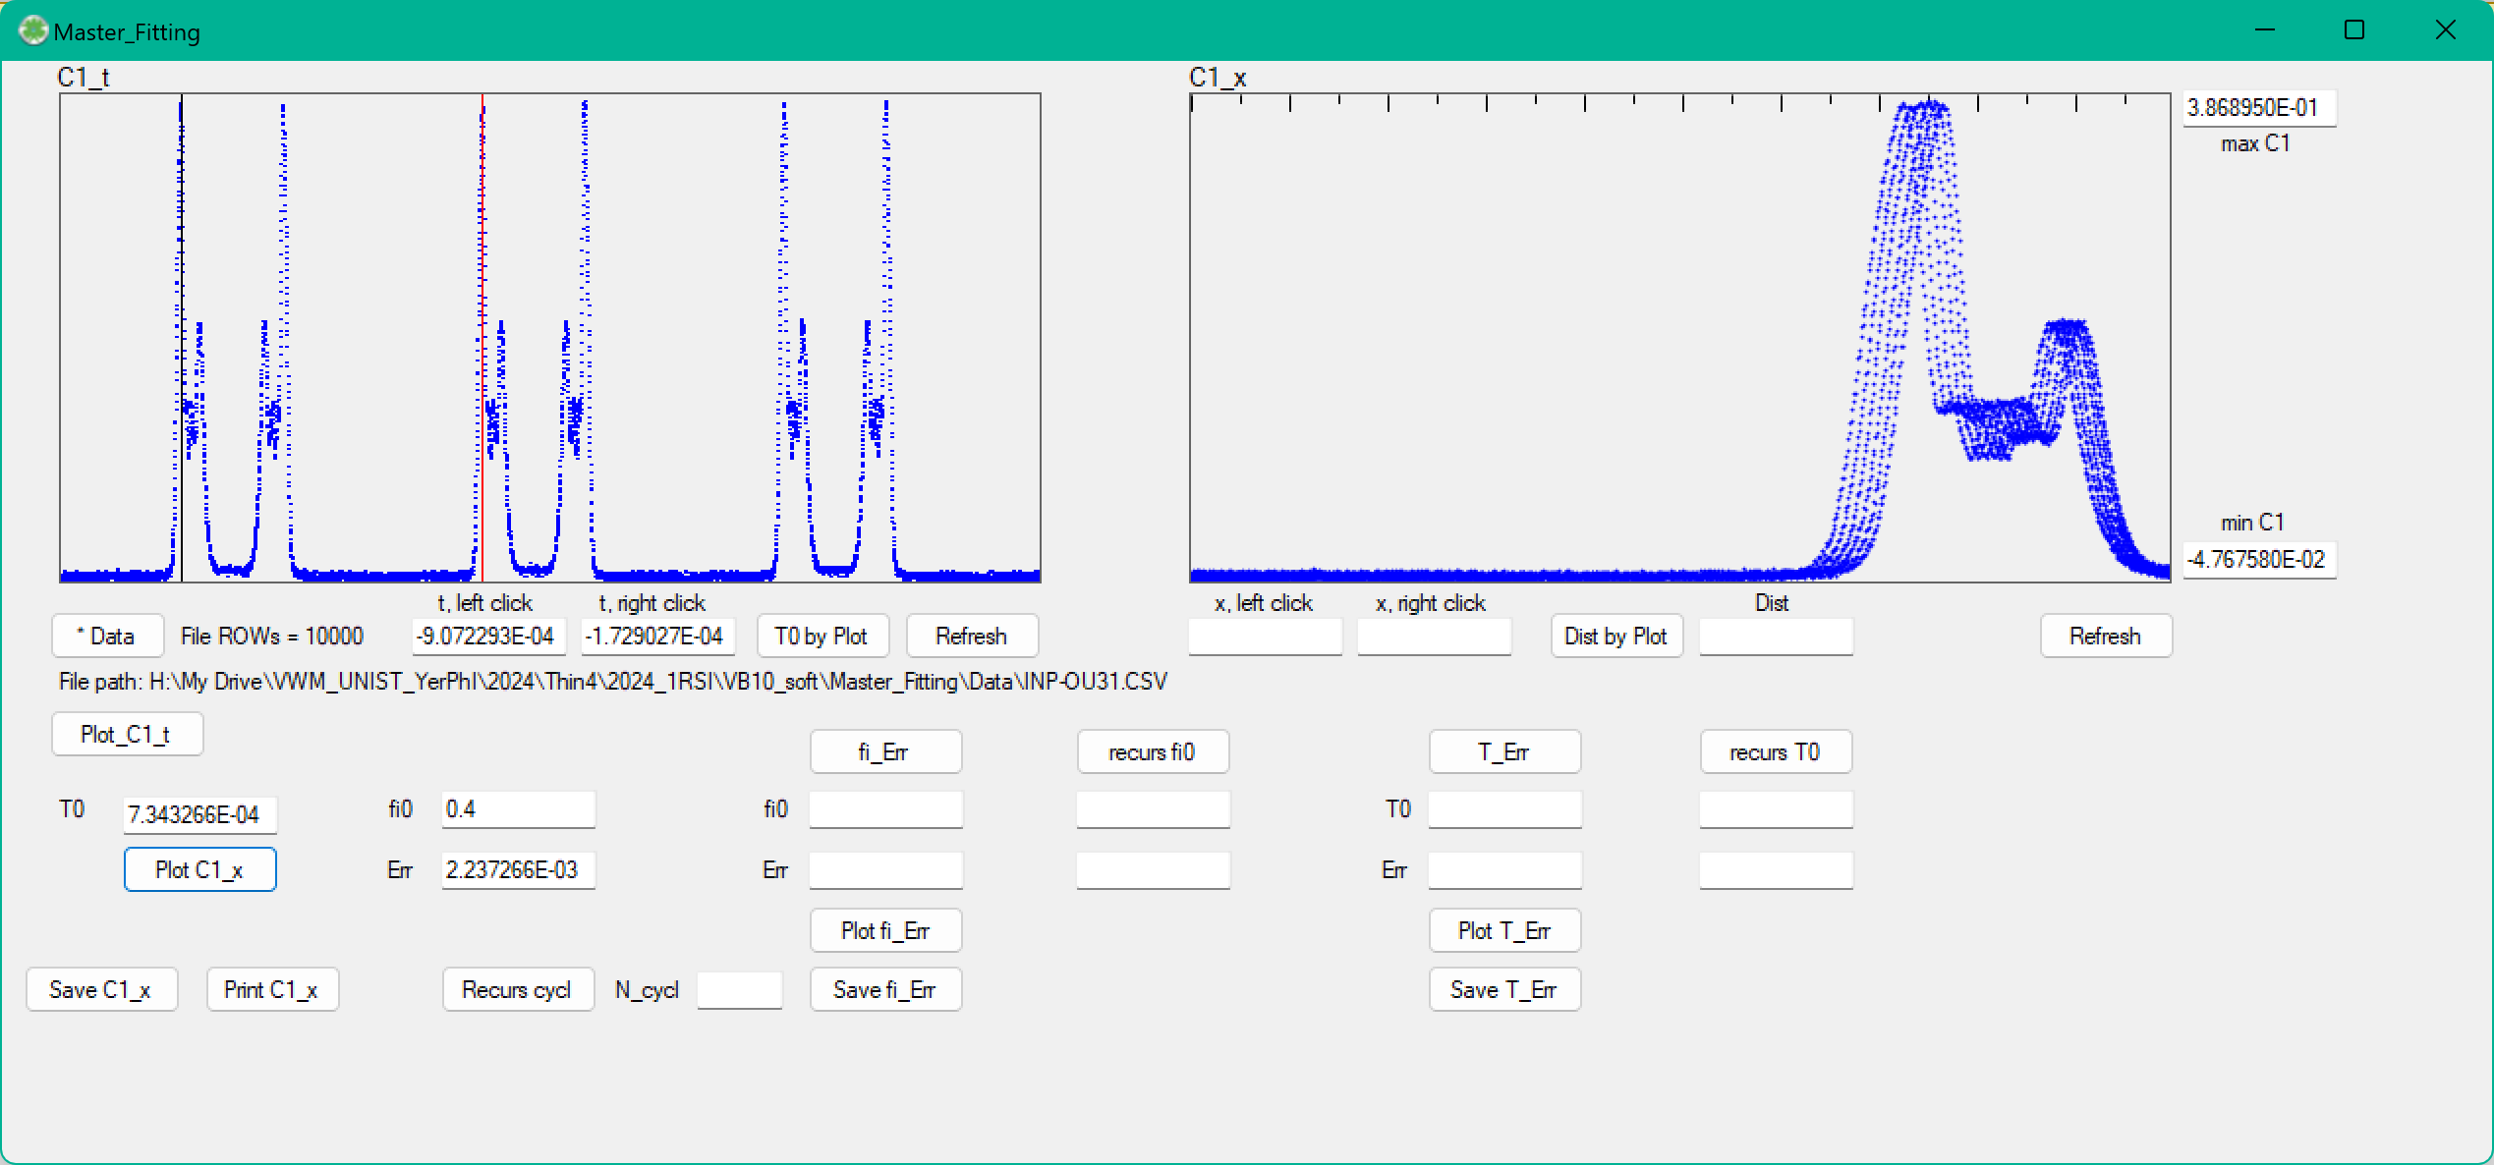

Fig. 4. Function C1 depending on x is plotted in PixtureBox **C1_x**.

In order to see error function depending on phase fi0 click button **fi_Err** and **Plot fi_Err** to see result in left PictureBox **Err_fi** (see Fig. 5). Corresponding value of fi0 minimizing the error function and value of error appear.

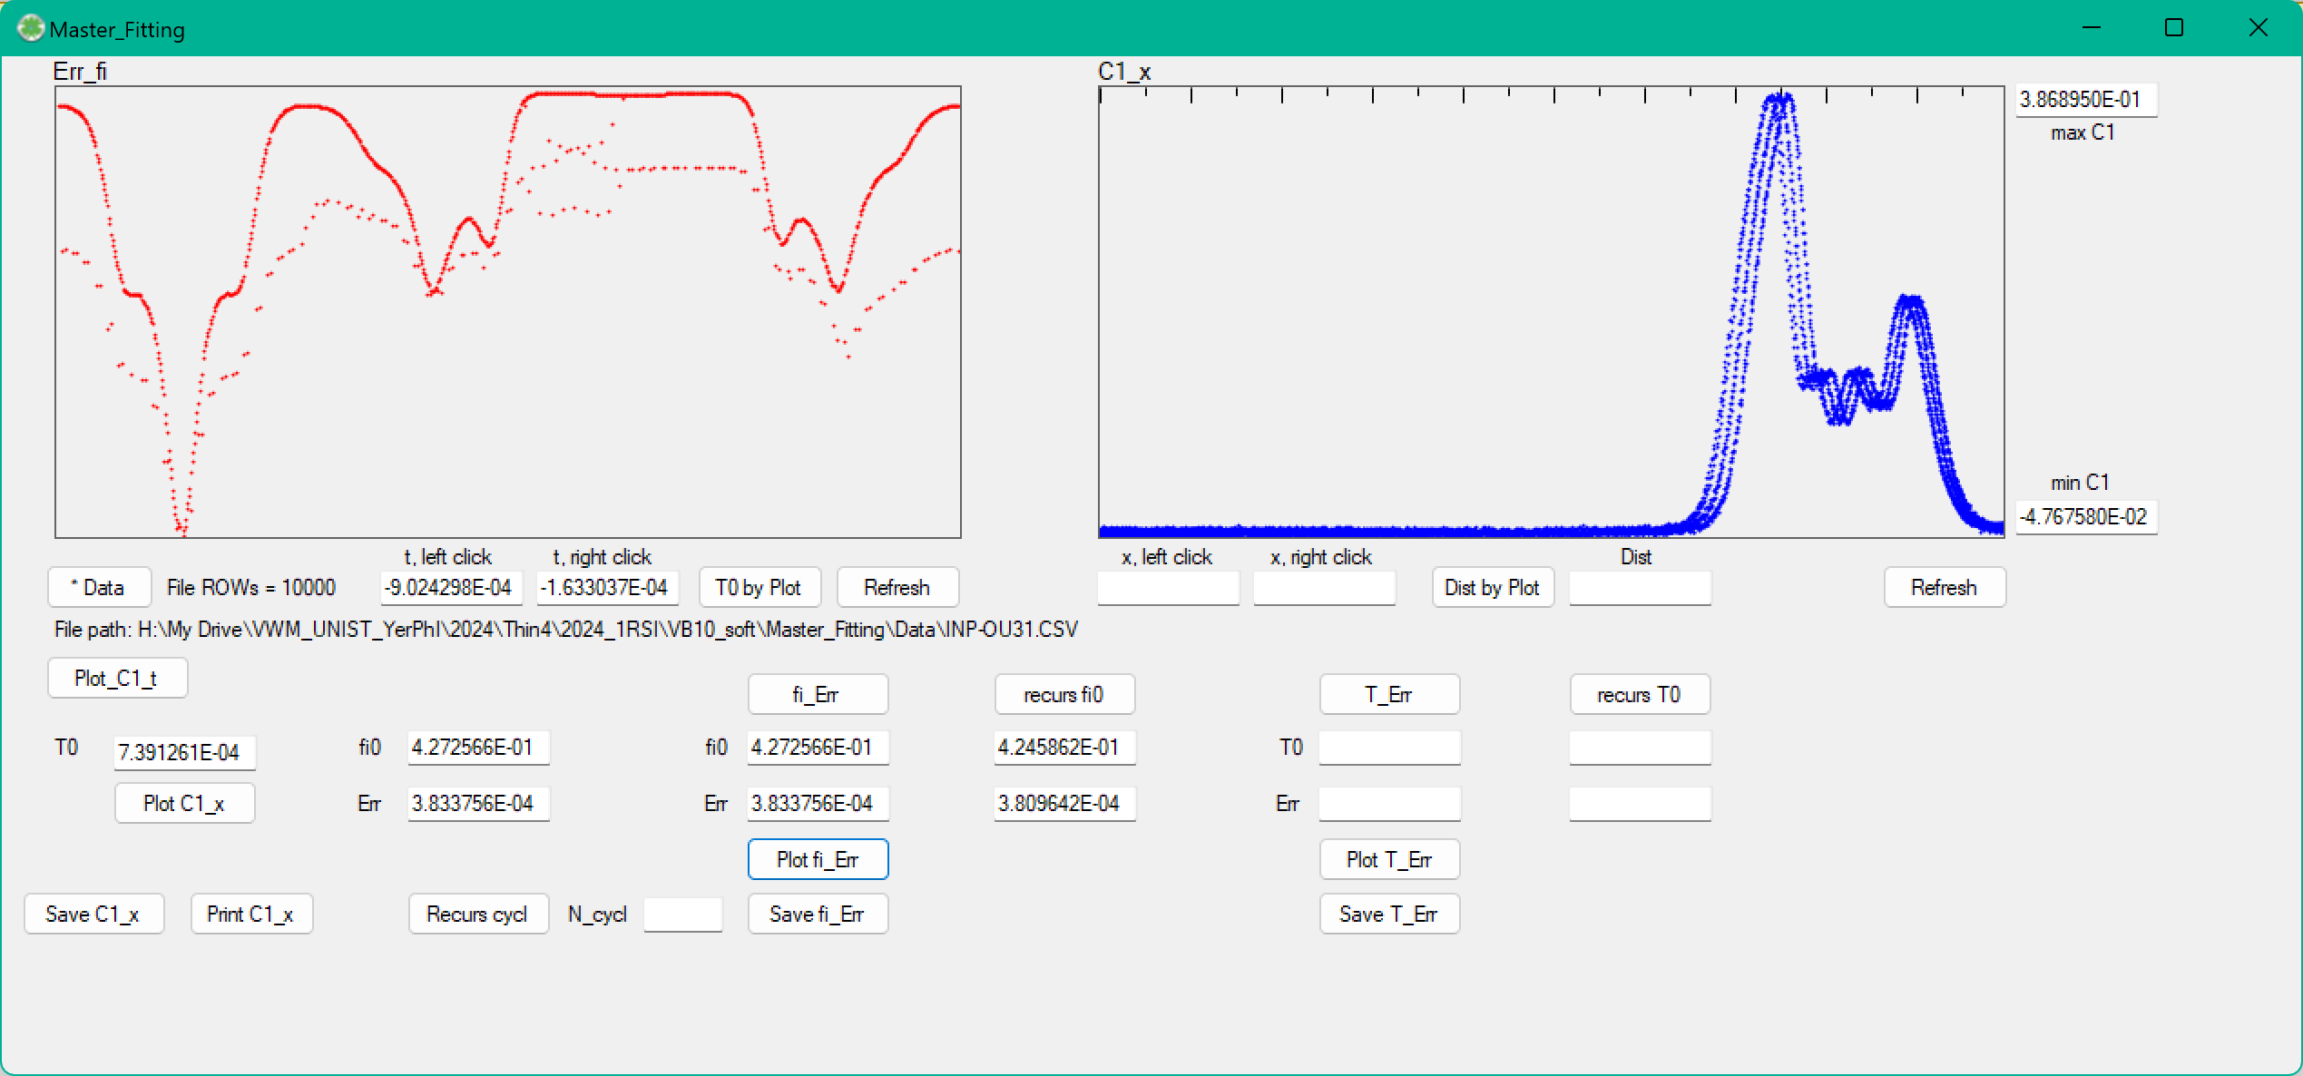

Fig. 5. Error depending on phase fi0

The similar procedure can be done for error dependence on T0 in PictureBox **Err_T0** (see Fig. 6).

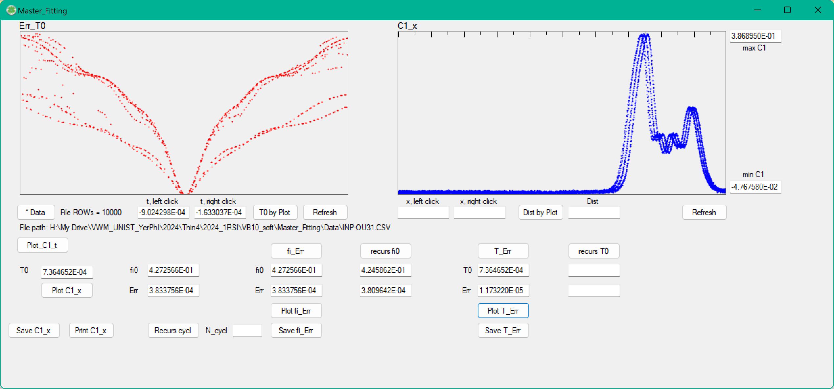

Fig. 6. Error depending on parameter T0.

Using the buttons **recurs fi0** and **recurs T0** we achieve error minimization for INP-OU31.CSV (see Fig. 7).

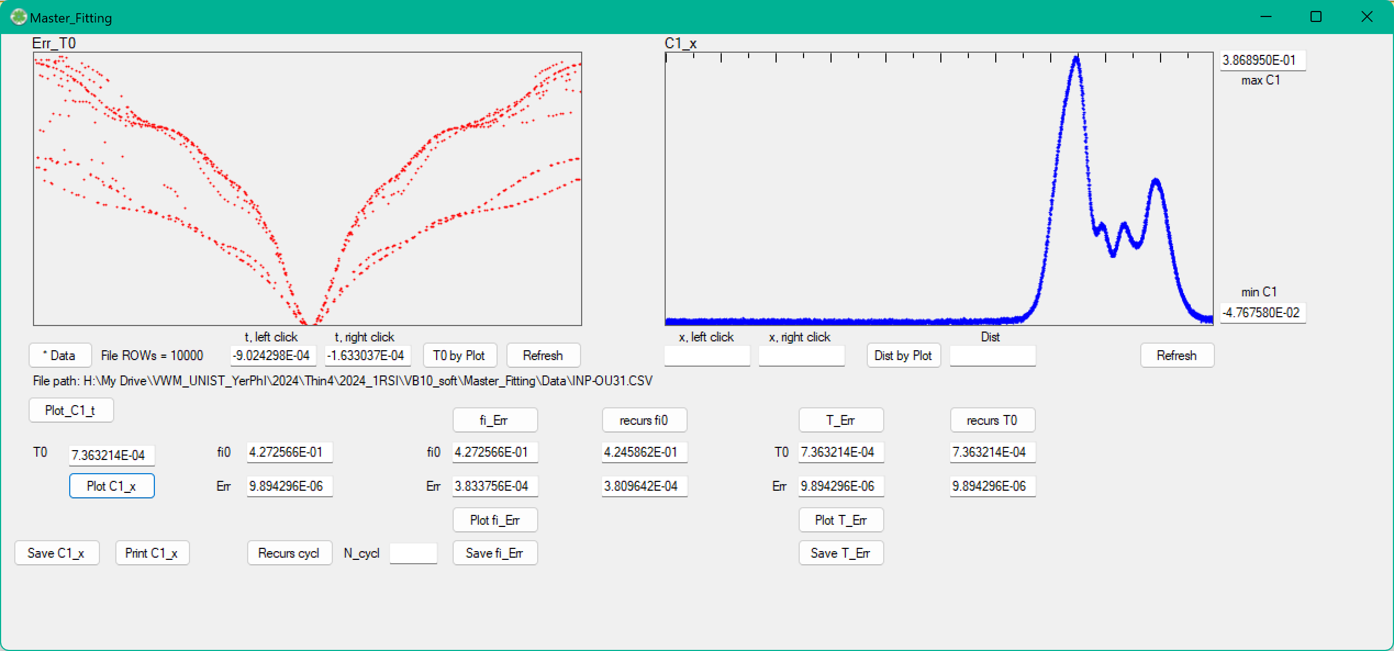

Fig. 7. Final result of profile reconstruction for INP-OU31.CSV.

The program provides graphical tools that estimate the values of characteristic peaks on the resulting profile (Fig. 8).

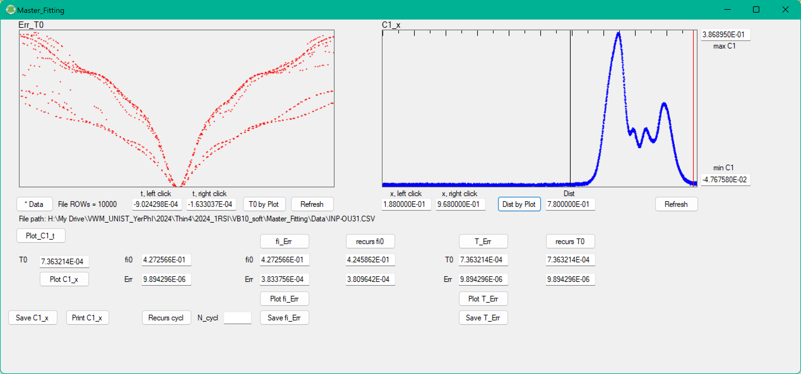

Fig. 8. Rough estimation of characteristic peaks in profile plot (PictureBox C1_x).

The resulting profile should be saved by **Save C1_x** button (as two column text file in CSV format, first column - x coordinate in oscillations amplitude units, second column - C1 in corresponding point). This file will be used by Master_Stitching program where absolute scale x coordinates are obtained.