S01 - DOM to Selenium Code-HW:
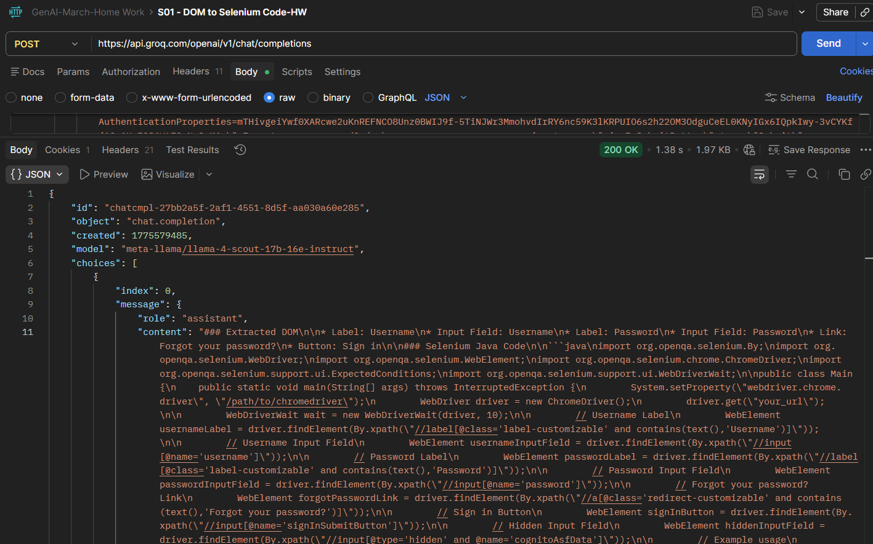

* Label: Username
* Input Field: Username
* Label: Password
* Input Field: Password
* Link: Forgot your password?
* Button: Sign in

### Selenium Java Code

```java
import org.openqa.selenium.By;
import org.openqa.selenium.WebDriver;
import org.openqa.selenium.WebElement;
import org.openqa.selenium.chrome.ChromeDriver;
import org.openqa.selenium.support.ui.ExpectedConditions;
import org.openqa.selenium.support.ui.WebDriverWait;

public class Main {
public static void main(String[] args) throws InterruptedException {
System.setProperty("webdriver.chrome.driver", "/path/to/chromedriver");
WebDriver driver = new ChromeDriver();
driver.get("your_url");

WebDriverWait wait = new WebDriverWait(driver, 10);

// Username Label
WebElement usernameLabel = driver.findElement(By.xpath("//label[@class='label-customizable' and contains(text(),'Username')]"));

// Username Input Field
WebElement usernameInputField = driver.findElement(By.xpath("//input[@name='username']"));

// Password Label
WebElement passwordLabel = driver.findElement(By.xpath("//label[@class='label-customizable' and contains(text(),'Password')]"));

// Password Input Field
WebElement passwordInputField = driver.findElement(By.xpath("//input[@name='password']"));

// Forgot your password? Link
WebElement forgotPasswordLink = driver.findElement(By.xpath("//a[@class='redirect-customizable' and contains(text(),'Forgot your password?')]"));

// Sign in Button
WebElement signInButton = driver.findElement(By.xpath("//input[@name='signInSubmitButton']"));

// Hidden Input Field
WebElement hiddenInputField = driver.findElement(By.xpath("//input[@type='hidden' and @name='cognitoAsfData']"));

// Example usage
usernameInputField.sendKeys("your_username");
passwordInputField.sendKeys("your_password");
signInButton.click();

driver.quit();
}
}

S02 - TextFromImage-Url-HW:

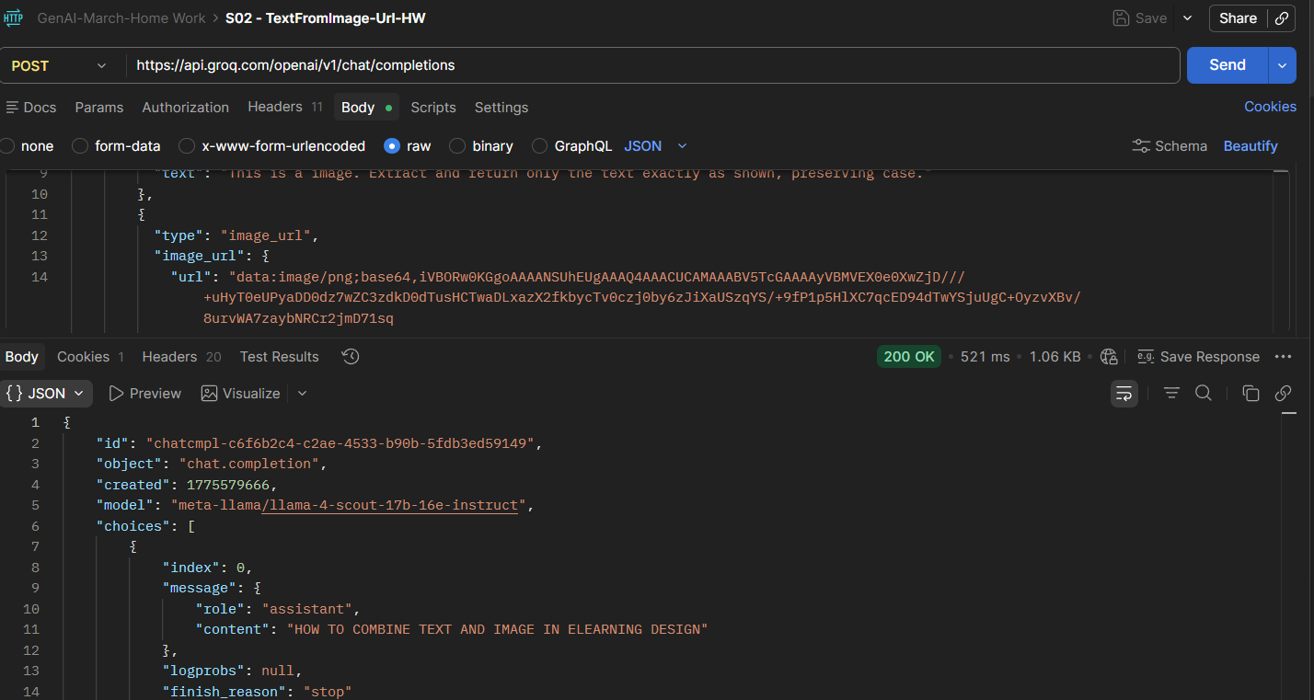

S03-WebSearch-HW:
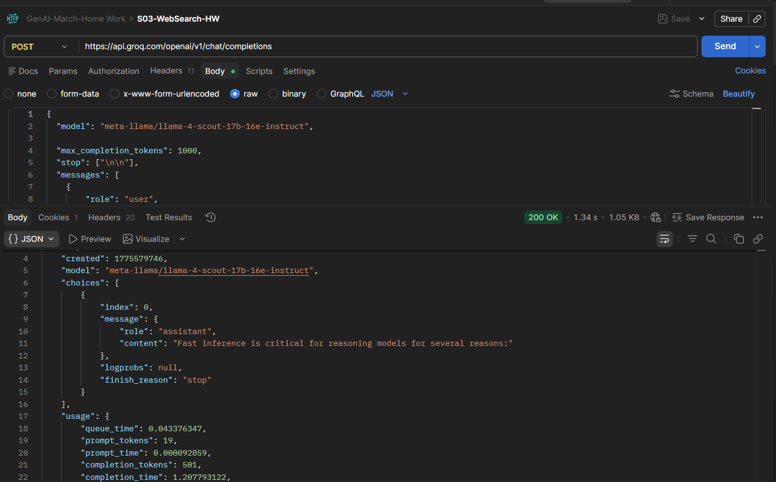

S05- MultiLingual-HW
