**PL/SQL Exercises**

**-- Exercise 1: Control Structures**

**-- Scenario 1: Discount for senior citizens**

Scenario 1: The bank wants to apply a discount to loan interest rates for customers above 60 years old.

* + Question: Write a PL/SQL block that loops through all customers, checks their age, and if they are above 60, apply a 1% discount to their current loan interest rates.

**--Setp1: Database created and listed**

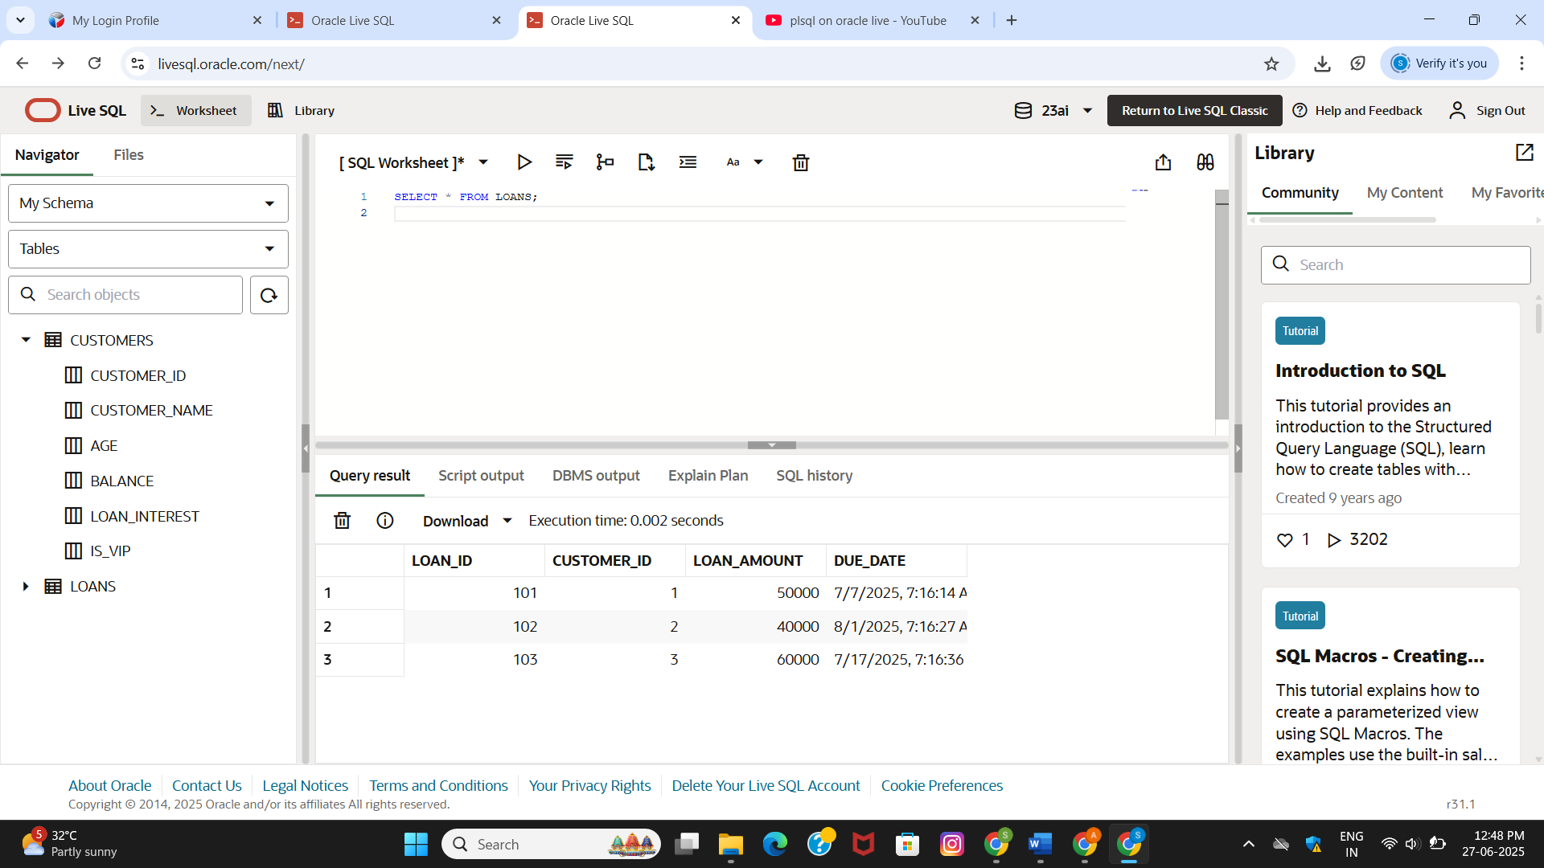 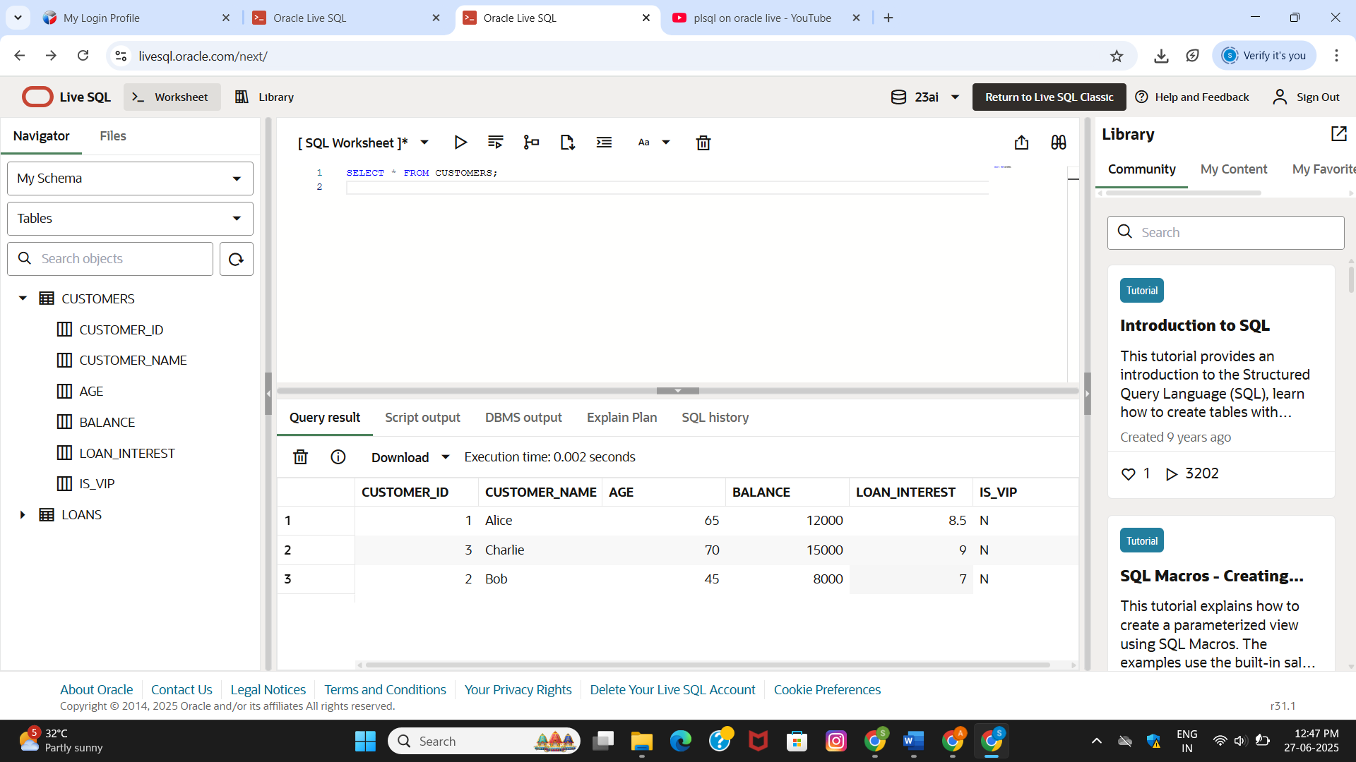

**--Step2:Code**

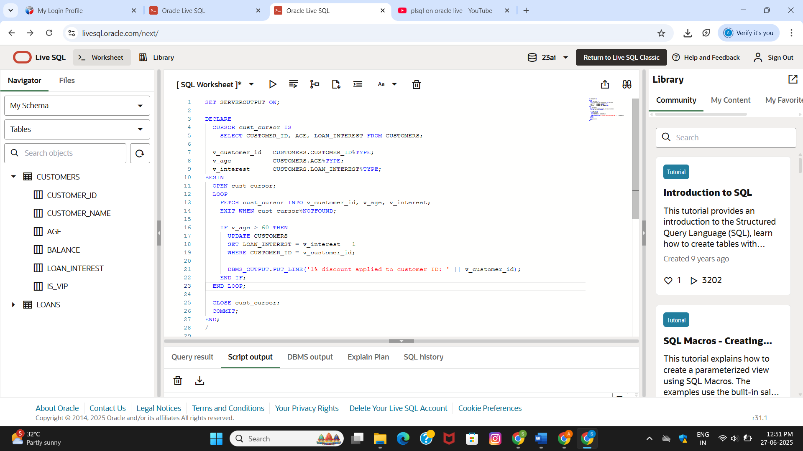

**OUTPUT:**

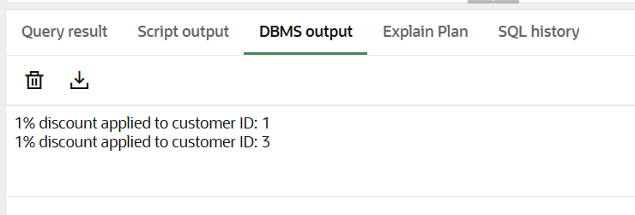

**-- Scenario 2: Promote to VIP**

Scenario 2: A customer can be promoted to VIP status based on their balance.

* + Question: Write a PL/SQL block that iterates through all customers and sets a flag IsVIP to TRUE for those with a balance over $10,000.

**CODE:**

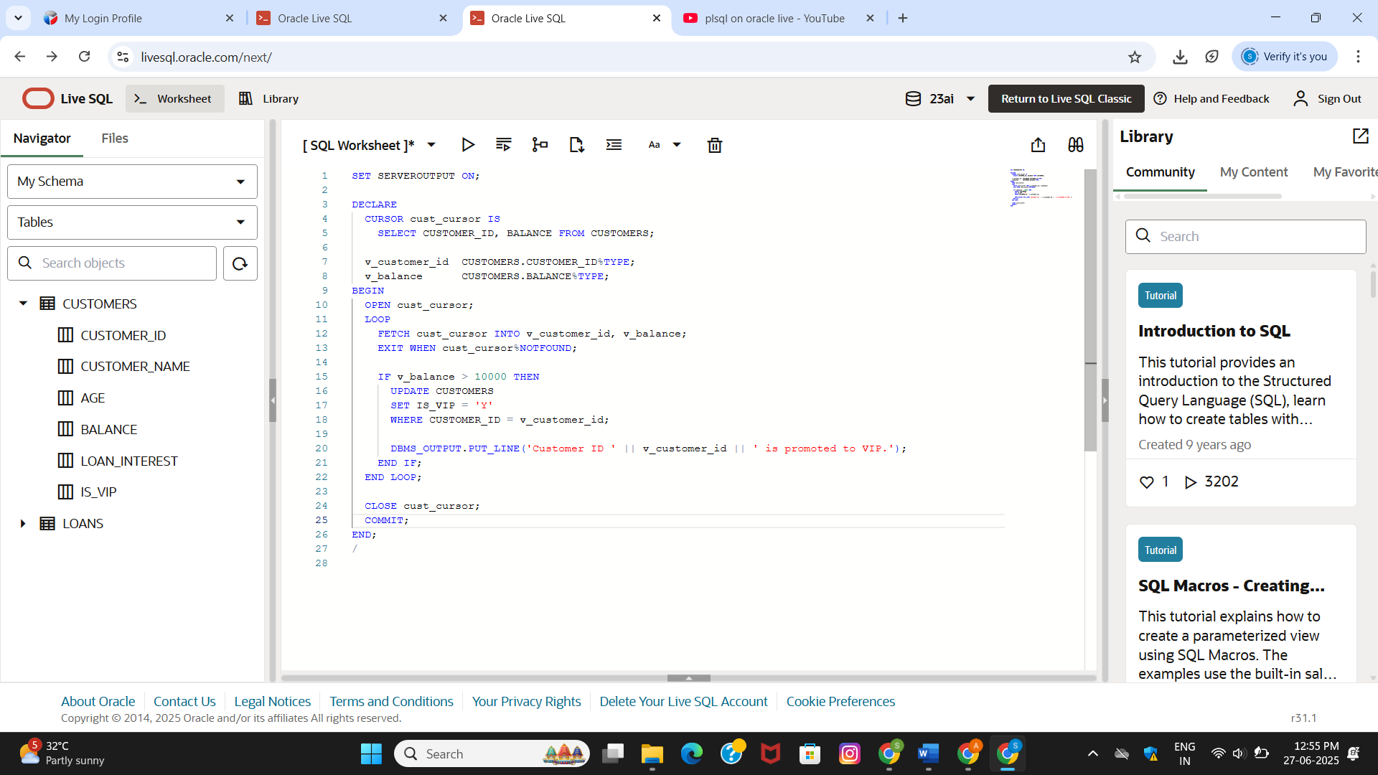

**OUTPUT:**

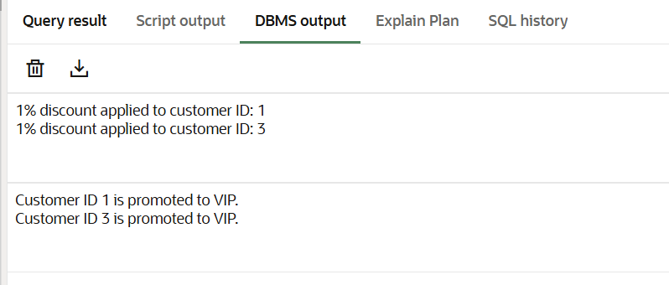

**-- Scenario 3: Loan due reminder**

Scenario 3: The bank wants to send reminders to customers whose loans are due within the next 30 days.

* + Question: Write a PL/SQL block that fetches all loans due in the next 30 days and prints a reminder message for each customer.

**CODE:**

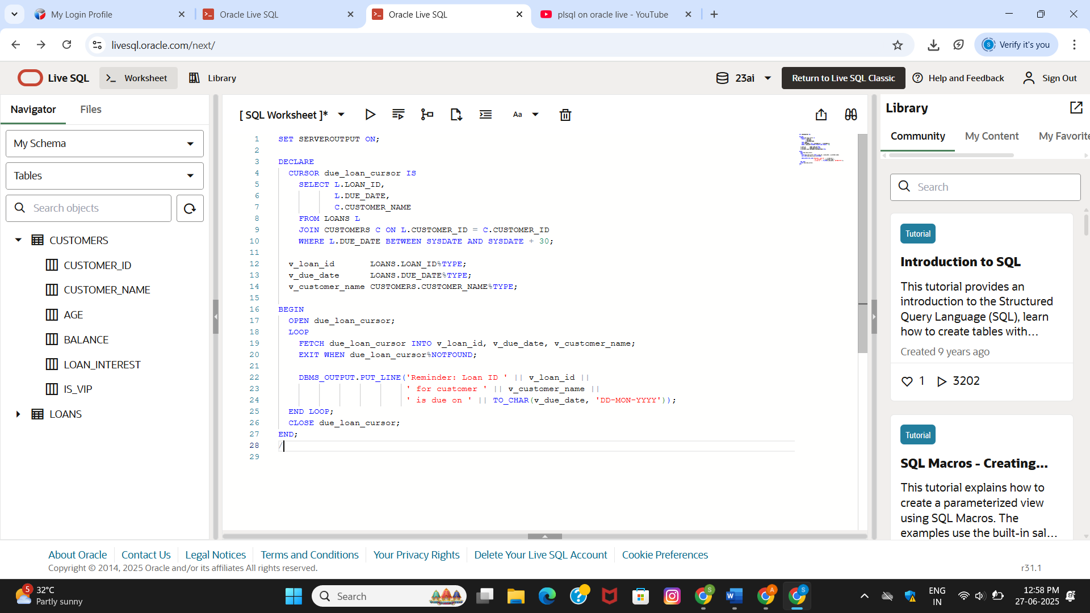

**OUTPUT**:

