**-- Exercise 2: Error Handling**

Scenario 1: Handle exceptions during fund transfers between accounts.

* + Question: Write a stored procedure SafeTransferFunds that transfers funds between two accounts. Ensure that if any error occurs (e.g., insufficient funds), an appropriate error message is logged and the transaction is rolled back.

**--Setp1: Database created and listed**

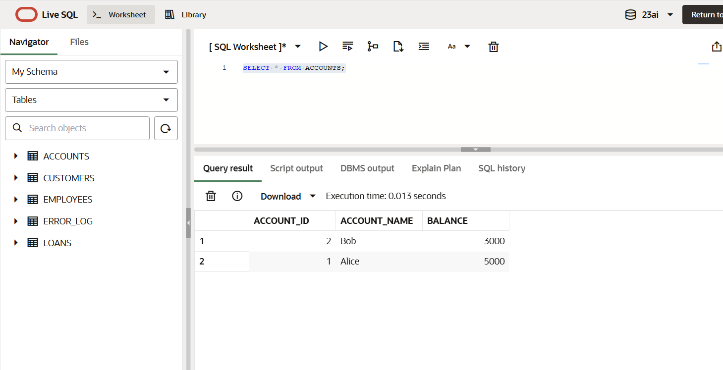 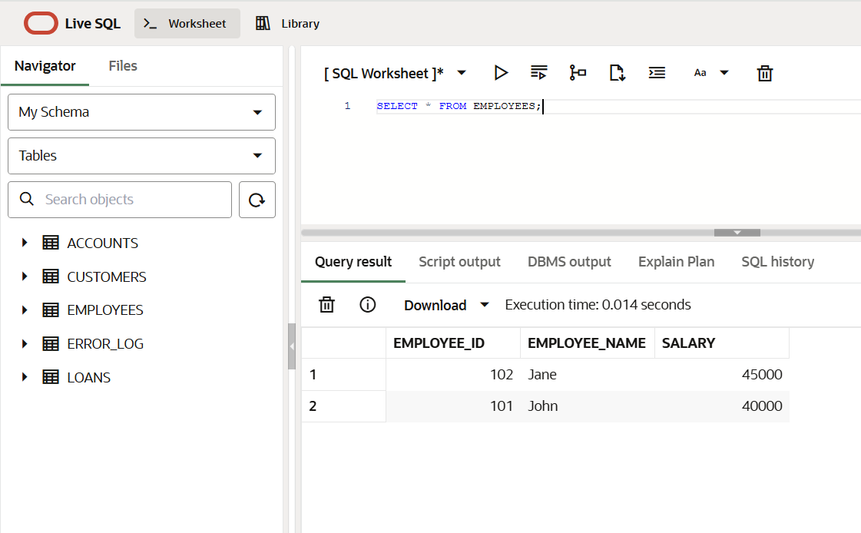

**--Step2:Code**

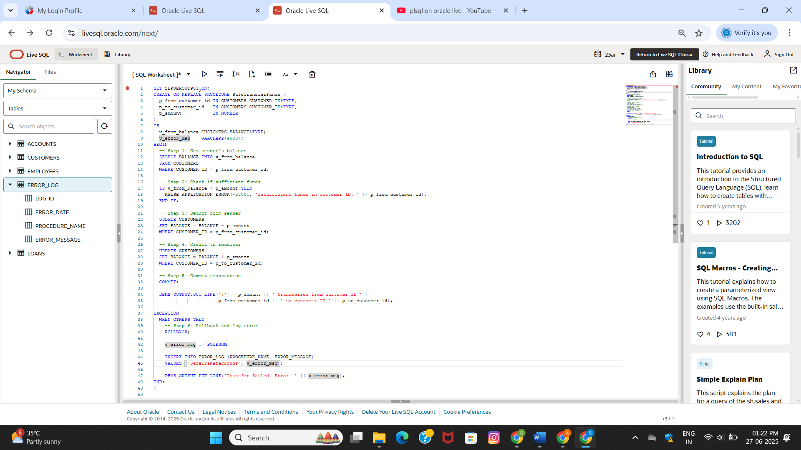

**OUTPUT:**

