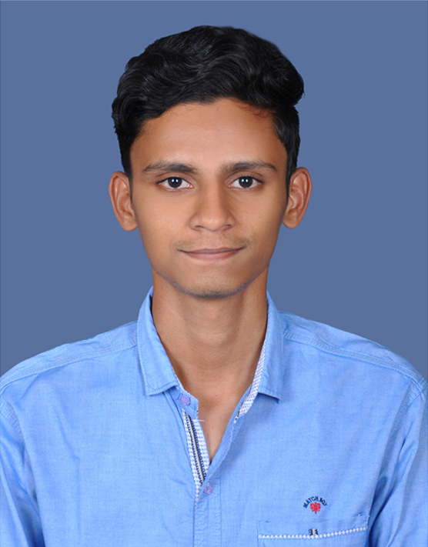Surendrakumar B

Email - [surendrakumar271001@gmail.com](mailto:surendrakumar271001@gmail.com)

LinkedIn - [www.linkedin.com/in/surendrakumar-b-ab9b07222/](http://www.linkedin.com/in/surendrakumar-b-ab9b07222/)

**OBJECTIVE**

Seeking a better platform and opportunity to work in a highly challenging competitive environment for the enhancement of my creative abilities and optimum profitability of the organization.

**SKILLS**

* Python (Beginner)
* C**++** programming (Beginner)
* C programming (Intermediate)
* HTML5 (Intermediate)
* CSS (Intermediate)

**PROJECTS**

* Machine learning model based on **Iris dataset,** For separation of Flower Species. Done using Python and Data science.
* **Counter Drone system** for No-Fly zone using DSSS Technique to Jam the communication signals. Done using MATLAB.
* Hosted a **Personal profile website** on Github, using languages like HTML, CSS & Flexbox.
* **Crude Oil Prediction** ML model, For analysis and prediction of price of oil in upcoming years, Done using Python and Data science.
* **Drowning Prediction** ML model, For prevention of drowning in swimming pools, Done using Image processing in python.

**AREAS OF INTEREST**

1. Web development
2. Python
3. Networking
4. Digital electronics

**INTERNSHIP’s DONE**

1) Organization : EDGATE technologies

Duration : 24/04/21 - 06/05/21

Learnings : Embedded systems and IOT

2) Organization : TESSOLVE technologies

Duration : 01/09/21 - 11/09/21

Learnings : Verilog system design and verification

3) Organization: ACCENT TECHNOSOFT

Duration : 22/01/23 – 15/04/23

Learnings : Web Development

**ACHIEVEMENTS**

1. Won 1st place in AR/VR Workshop conducted at Dr.Mcet during 1st year.
2. Served as Executive Member For 2 years in Department Association Club and hosted various Technical events and Hackathons.
3. Participated at intercollege level Prototype Build expo in 12th grade.

**ACADEMIC QUALIFICATIONS**

B.E in Electronics and communication engineering with 8.8 CGPA in DR.MCET

SSLC : Nirmala Matha convent matric Higher secondary school (2017-92%)

HSLC : Nirmala Matha convent matric Higher secondary school (2019-71%)

**PERSONAL DETAILS**

Address : 2/9 Mariamman Kovil street,Machampalayam,Sundarapuram(po),CBE-24

Date of birth : 27/10/2001

Languages known : Tamil , English