**Deploying Ceph cluster using ansible on VM(All in one) machine**

1. CentOS image
   1. Memory: 8GB
   2. HardDisk: 20Gb
   3. 3 virtual disk:
      1. Ceph-1: 8gb
      2. Ceph-2: 8gb
      3. Ceph-3: 8gb

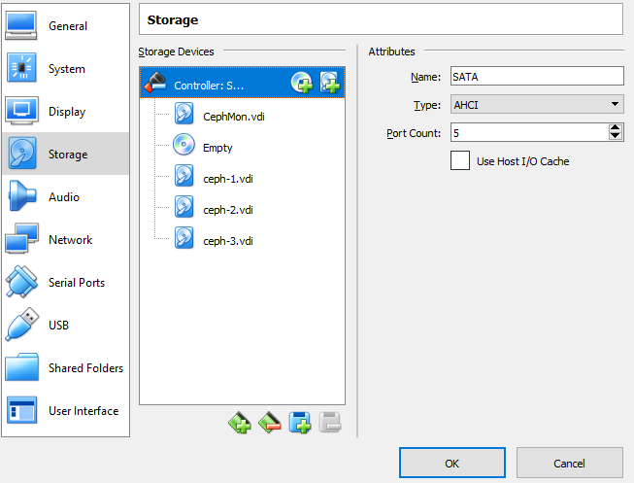

1. Make a local user(Ex: poswal) and give sudo access.
2. Create a new id_rsa key and copy to local host

ssh-keygen

ssh-copy-id poswal@localhost

1. Create a local repo:

[poswal@Ceph yum.repos.d]$ cat myrepo.repo

[myrepo]

name=myrepo

baseurl=http://mirror.centos.org/centos/7/storage/x86_64/ceph-luminous/

enabled=1

gpgcheck=0

1. Packages to be installed:

**ansible-2.6.11-1.el7.ans.noarch.rpm**

**ceph-ansible-3.2.30.1-1.el7cp.noarch.rpm**

**ceph-common**

**ceph-mon**

**ceph-mgr**

**ceph-osd**

**python-pycurl**

**epel-release**

**python-setuptools**

**libselinux-python**

1. Make this entry in /etc/ansible/hosts and verify:

[mons]

localhost

[mgrs]

localhost

[osds]

localhost

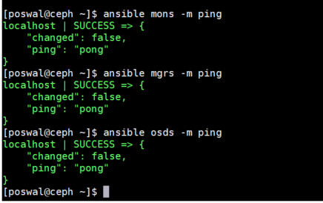

1. Copy the template playbook located at

**/usr/share/ceph-ansible/site.yml.sample** to **/usr/share/ceph-ansible/site.yml**

**/usr/share/ceph-ansible/group_vars/all.yml.sample to /usr/share/ceph-ansible/group_vars/all.yml**

**/usr/share/ceph-ansible/group_vars/osds.yml.sample to /usr/share/ceph-ansible/group_vars/osds.yml**

1. Edit the all.yml and edit these parameters:

ceph_rhcs_cdn_install: True

fetch_directory: ~/ceph-ansible-keys

ntp_service_enabled: false

ceph_repository_type: iso

ceph_origin: repository

ceph_repository: rhcs

ceph_rhcs_version: "3"

ceph_rhcs_iso_path: "/var/tmp/rpm/CentOS-7-x86_64-DVD-1908.iso"

rbd_cache: "true"

rbd_cache_writethrough_until_flush: "false"

monitor_interface: enp0s3

public_network: 10.0.2.15/24

cluster_network: "{{ public_network }}"

common_single_host_mode: true

ceph_conf_overrides:

global:

mon_osd_allow_primary_affinity: 1

mon_clock_drift_allowed: 0.5

osd_pool_default_size: 2

osd_pool_default_min_size: 1

mon_pg_warn_min_per_osd: 0

mon_pg_warn_max_per_osd: 0

mon_pg_warn_max_object_skew: 0

client:

rbd_default_features: 1

ceph_docker_image: "rhceph/rhceph-3-rhel7"

ceph_docker_image_tag: "latest"

ceph_docker_registry: "registry.access.redhat.com"

1. Edit osds.yml:

**devices:**

**- /dev/vdb**

osd_scenario: **"collocated"**





1. Mount the .iso image:
   1. Copy “CentOS-” iso to /var/tmp/rmp/
   2. cd /var/tmp/rpm
   3. sudo mount -o loop ceph-3.3-rhel-7-x86_64-debug.iso /mnt
2. Update the repo:

cat /etc/yum.repos.d/centosdvdiso.repo

[centosdvdiso]

name=CentOS DVD ISO

baseurl=file:///mnt

enabled=1

gpgcheck=1

gpgkey=file:///mnt/RPM-GPG-KEY-CentOS-7

1. Go to /usr/share/ceph-ansible

**ansible-playbook site.yml**

