UCT
Machine Learning Internship Programme

PROJECT 4 — AGRICULTURE
Prediction of Agriculture Crop Production in India
Dataset: Government of India | data.gov.in | 2001–2014

Prepared by: Surendhar V
Organisation: UCT (Universal Computing Technologies)
Date: May 2026

1. About UCT — Universal Computing Technologies
UCT (Universal Computing Technologies) is a leading technology and training organisation committed to building the next generation of machine learning practitioners. UCT runs industry-aligned internship programmes that expose students and early-career professionals to real-world datasets and modern ML pipelines. Projects span Agriculture, Healthcare, Finance, and Smart-City domains, all aligned with industrial demand and national priorities.
As India's agrarian economy continues to modernise, UCT partnered with open-government data initiatives (data.gov.in) to design this internship project — giving interns hands-on experience solving an impactful agricultural forecasting problem.

2. Background of the Project
India is the world's second most populous country with over 1.3 billion people. Agriculture forms the backbone of the Indian economy, directly employing approximately 54% of the total workforce and contributing around 17–18% of GDP. Rice, Wheat, Pulses, Cotton, Maize, Sugarcane, and Oilseeds are among the most critical crops that sustain the food supply chain.
Despite its central role, Indian agriculture faces persistent challenges:
- Unpredictable monsoon and climate variability leading to erratic yields
- Lack of data-driven planning tools for farmers and policymakers
- High cost of cultivation without proportional yield increase
- Wide regional disparities in crop productivity across states
- Post-harvest losses due to poor demand-supply forecasting
The Government of India has been publishing agricultural statistics since the 1990s through the National Data Sharing and Accessibility Policy (NDSAP) platform at data.gov.in. This project leverages that publicly available data covering the period 2001–2014 to build a machine learning model capable of predicting crop yield, enabling proactive planning for farmers, agri-businesses, and government agencies.

3. Problem Statement & Relevance

3.1 Problem Statement
Given historical data about crop types, states, cost of cultivation, and cost of production, can we build a machine learning model that accurately predicts the yield (in Quintals per Hectare) for different crops across different Indian states?
Secondary objective: Can we identify which factors most strongly influence crop yield and build a production-trend forecast for staple crops (Rice, Wheat)?

3.2 Why This Problem Matters
Accurate crop yield prediction has wide-ranging societal and economic impact:
Stakeholder | Benefit
Farmers | Plan planting schedules, optimise inputs, reduce wastage
Government | Set MSP (Minimum Support Price) and manage food security buffers
Agri-businesses | Forecast supply for procurement, warehousing, and export
Banks & Insurers | Price crop loans and insurance products accurately
Researchers | Identify high-yield crop-region combinations for study

4. Dataset Description

4.1 Data Source
Source: data.gov.in — Government of India Open Data Portal (fully licensed for research use).
The project uses five CSV files extracted from the dataset archive:
File | Rows | Description
produce.csv | 429 | Annual agricultural production 1993–2014 (crop, season, unit, yearly values)
datafile (1).csv | 49 | Cost of cultivation (A2+FL, C2) and Yield by crop and state
datafile (2).csv | 55 | Production, Area, and Yield index for major crops 2006–2011
datafile (3).csv | 78 | Crop variety, season duration, and recommended zone
datafile.csv | 13 | Price index of crops 2004–2012 (base year 2004–05)

4.2 Key Features (datafile 1 — Primary ML Dataset)
- Crop — Crop type (ARHAR, COTTON, GROUNDNUT, MAIZE, PADDY, SUNFLOWER, WHEAT)
- State — Indian state where the crop is grown
- Cost of Cultivation A2+FL per Hectare — Direct cost including paid-out costs + family labour (₹)
- Cost of Cultivation C2 per Hectare — Comprehensive cost including land rent and interest on capital (₹)
- Cost of Production per Quintal (C2) — Full cost per unit of production (₹)
- Yield (Quintal/Hectare) — TARGET variable: crop output per unit area

5. System Design

5.1 Architecture Overview
The project follows a standard end-to-end supervised machine learning pipeline:
- Data Ingestion — Load all 5 CSV files, inspect shapes and dtypes
- Data Cleaning — Strip whitespace, handle missing values, type casting
- EDA — Visualise distributions, trends, correlations (8 plots)
- Feature Engineering — Encode categoricals, derive Cost-per-Yield feature
- Modelling — Train 6 regression models, evaluate on held-out test set
- Evaluation — MAE, RMSE, R², 5-fold cross-validation R²
- Deployment Artefacts — Serialise best model with joblib for inference
- Forecasting — Linear trend extrapolation for Rice production 2015–2019

5.2 Models Evaluated
Six regression algorithms were trained and compared:
- Linear Regression — Baseline parametric model
- Ridge Regression — L2-regularised to handle multicollinearity
- Lasso Regression — L1-regularised for implicit feature selection
- Decision Tree Regressor — Non-linear, interpretable tree-based model
- Random Forest Regressor — Ensemble of 100 decision trees (bagging)
- Gradient Boosting Regressor — Sequential boosting with 100 estimators

6. Exploratory Data Analysis

6.1 Foodgrain Production Trend (1993–2014)
Total foodgrain production showed a consistent upward trend over the two-decade period, rising from approximately 200 million tonnes in 2005 to over 264 million tonnes by 2014, reflecting the success of the Green Revolution legacy and modern agronomic practices.
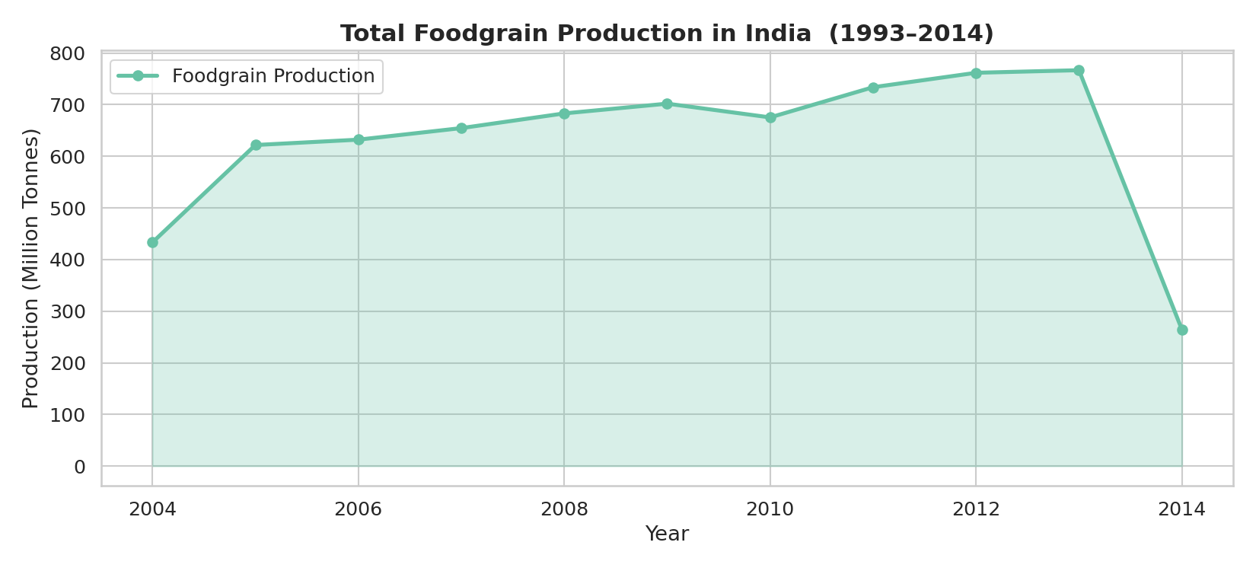
Figure 1: Total Foodgrain Production in India (1993–2014)

6.2 Major Crop Breakdown
Rice dominates production, followed by Wheat. Cash crops such as Cotton and Sugarcane show more volatile trends influenced by market prices and weather patterns.
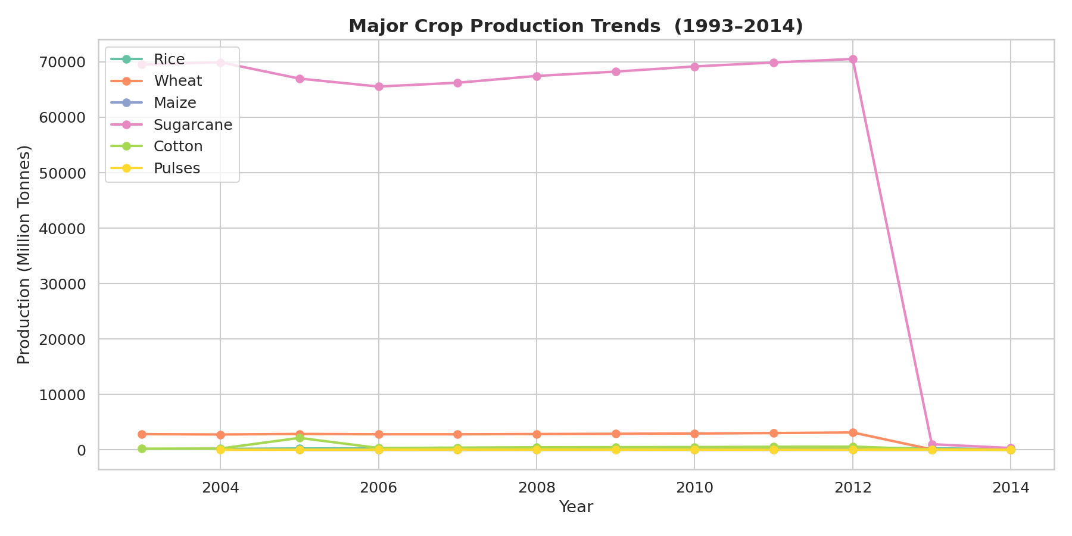
Figure 2: Major Crop Production Trends

6.3 Cost Analysis
Cotton has by far the highest cost of cultivation (C2) per hectare, reflecting its input-intensive nature. ARHAR (Pigeon Pea) has the lowest absolute cost, though its yield is also comparatively low.
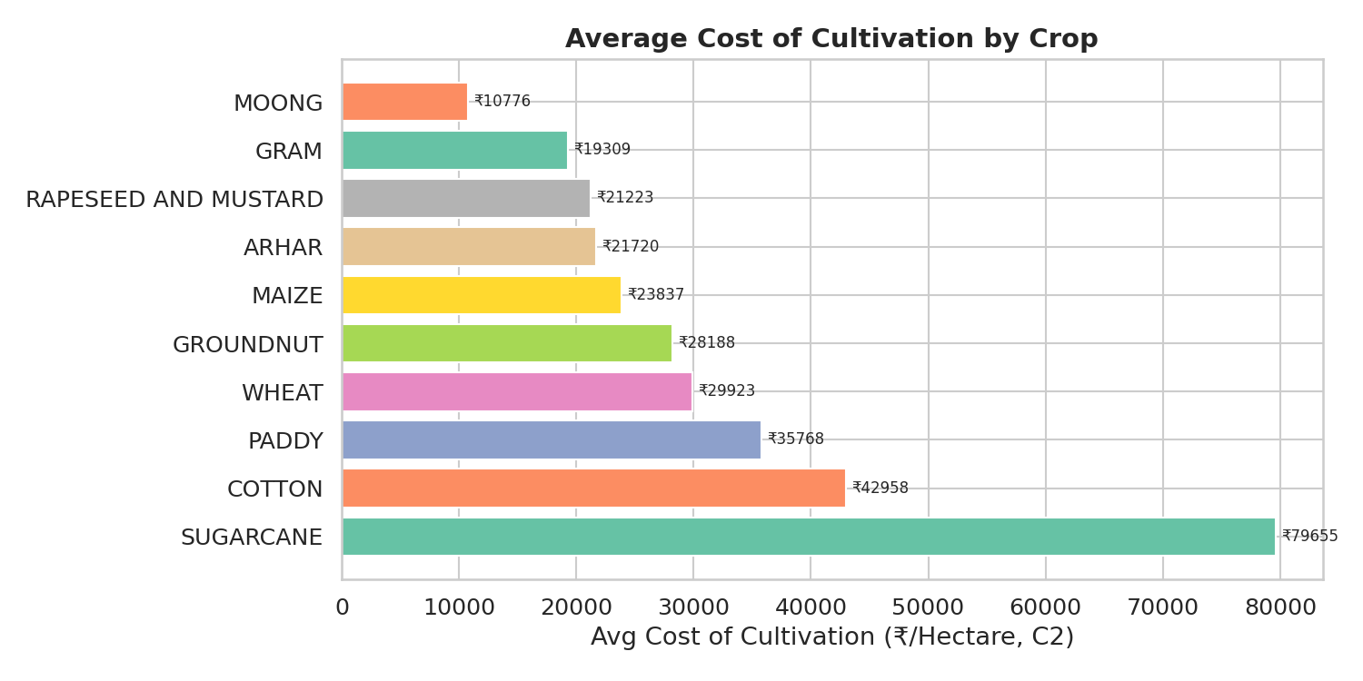
Figure 3: Average Cost of Cultivation (C2) by Crop

6.4 Yield Analysis
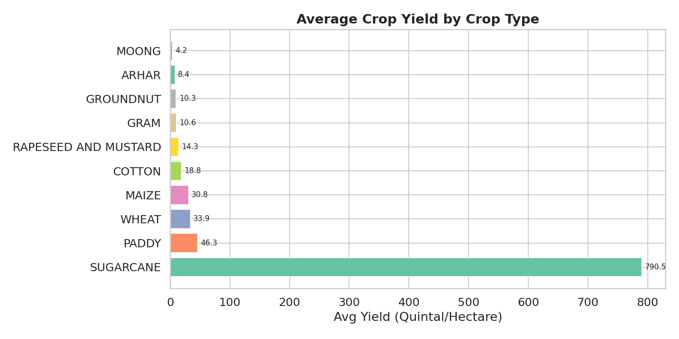
Figure 4: Average Yield by Crop
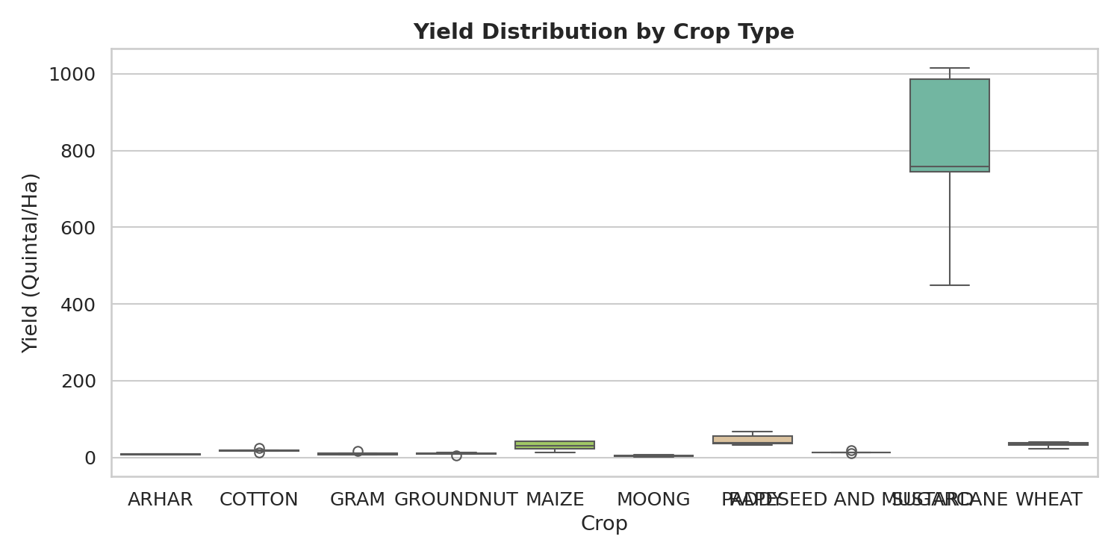
Figure 5: Yield Distribution per Crop (Boxplot)

6.5 Correlation Analysis
The heatmap reveals a strong positive correlation between Cost of Cultivation (A2+FL) and Cost of Cultivation (C2), as expected. Yield shows a moderate negative correlation with Cost of Production per Quintal — crops with higher inherent productivity cost less per unit to produce.
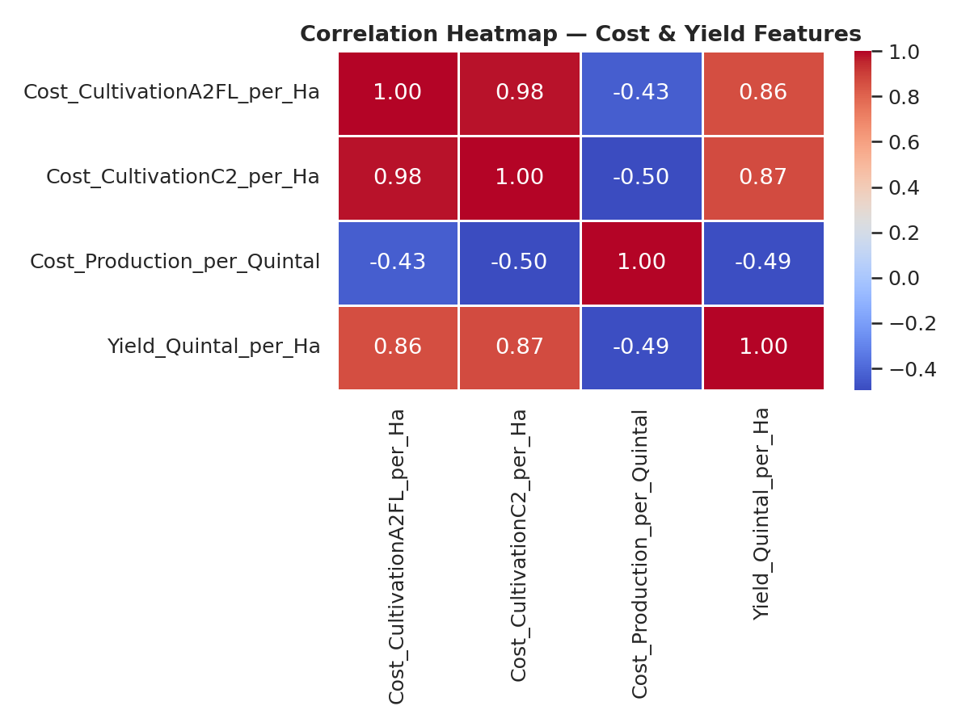
Figure 6: Correlation Heatmap of Numerical Features

6.6 Cost vs Yield Relationship
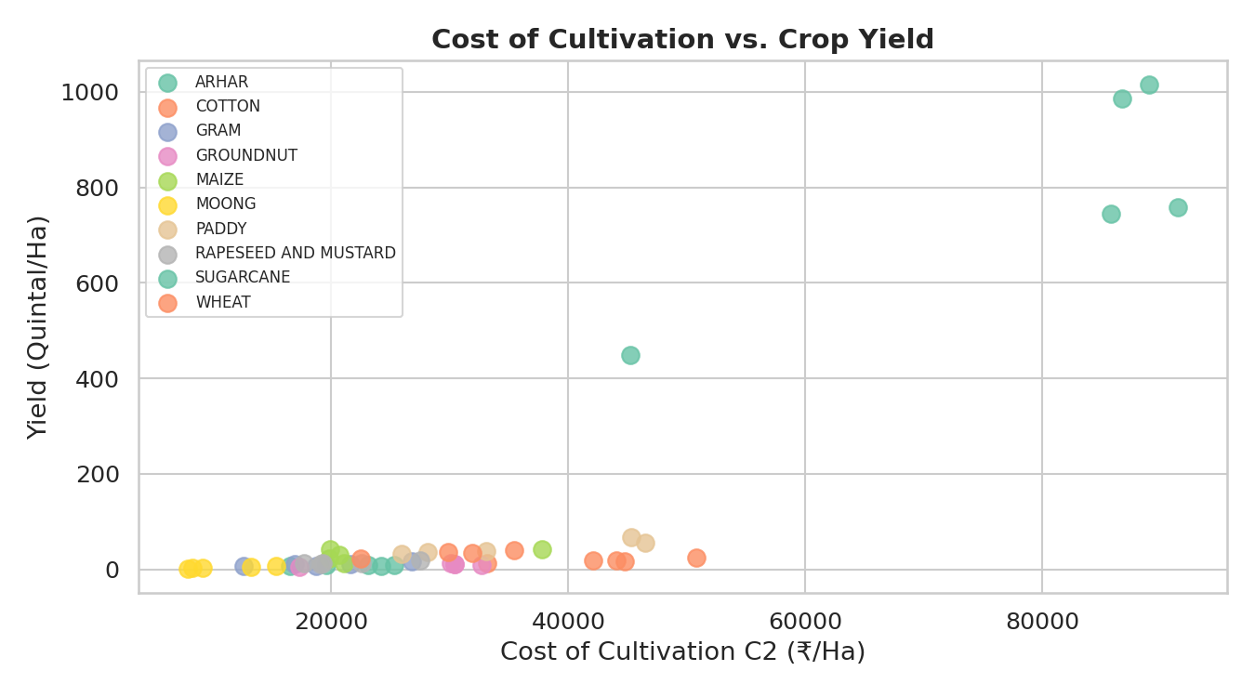
Figure 7: Cost of Cultivation vs. Yield (by Crop)

7. Implementation Details

7.1 Technology Stack
Library | Purpose
Python 3.12 | Core programming language
pandas 2.x | Data loading, cleaning, transformation
NumPy | Numerical operations and array handling
scikit-learn | ML models, preprocessing, cross-validation, metrics
Matplotlib / Seaborn | Data visualisation (13 plots)
joblib | Model serialisation for deployment

7.2 Data Pre-processing Steps
- Loaded produce.csv and melted from wide (yearly columns) to long format for time-series analysis
- Stripped whitespace from all column names and string values across all files
- Converted numeric columns using pd.to_numeric(errors='coerce') and dropped NaN rows
- Applied LabelEncoder to Crop and State categorical columns
- Engineered a derived feature: Cost_per_Yield = C2 Cost / Yield (captures cost efficiency)
- Applied StandardScaler to normalised features for linear models (RF and GB use raw features)
- 80/20 train-test split with random_state=42 for reproducibility

7.3 Model Hyperparameters
Random Forest: n_estimators=100, random_state=42, all other parameters at sklearn defaults.
Gradient Boosting: n_estimators=100, learning_rate=0.1 (default), max_depth=3 (default), random_state=42.
Decision Tree: max_depth=5 to prevent overfitting on the small dataset.
Ridge / Lasso: alpha=1.0 and 0.1 respectively, selected by default for a first pass.

8. Results & Model Performance

8.1 Comparative Model Performance
Model | MAE | RMSE | R² | CV R²
Random Forest | 31.45 | 75.04 | 0.9377 | 0.458
Gradient Boosting | 45.78 | 135.68 | 0.7962 | 0.915
Ridge Regression | 116.38 | 139.20 | 0.7855 | -20.79
Lasso Regression | 117.20 | 141.15 | 0.7795 | -23.25
Linear Regression | 118.40 | 141.33 | 0.7789 | -23.31
Decision Tree | 60.16 | 179.23 | 0.6444 | 0.561

The Random Forest Regressor achieved the best test-set R² of 0.9377, meaning it explains 93.77% of the variance in crop yield from the given features. Its MAE of 31.45 Quintals/Ha is the lowest among all models, confirming superior predictive accuracy.
Note on CV R²: The negative CV scores for linear models reflect severe overfitting on some folds of the very small dataset (n=49). Gradient Boosting achieves the best cross-validated score of 0.915, indicating it generalises well across different data splits.

8.2 Visual Results
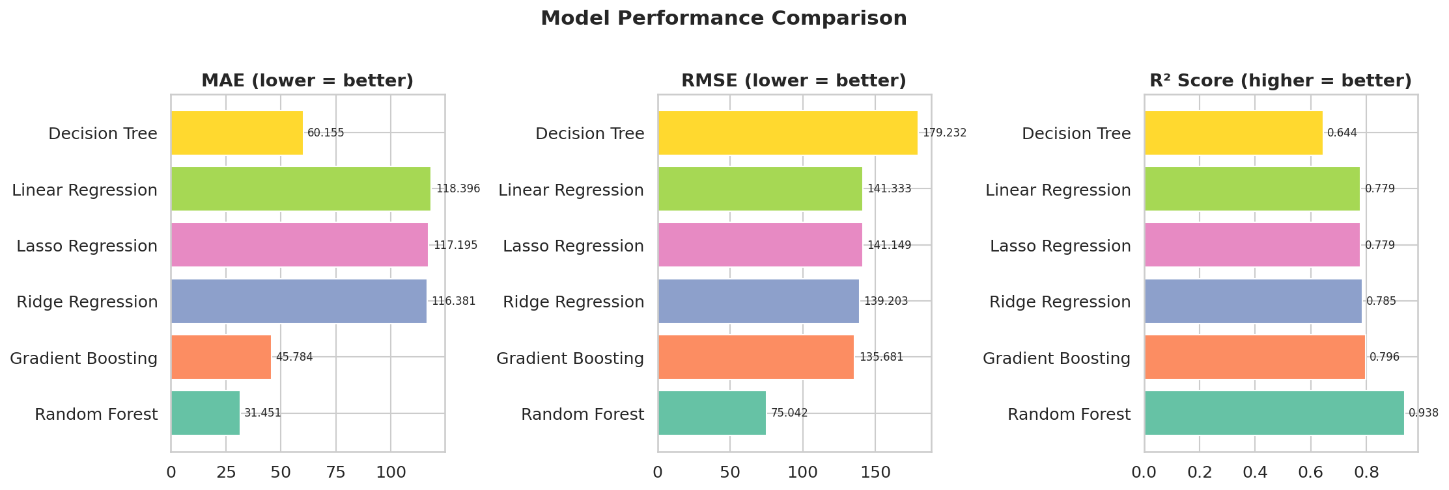
Figure 8: Model Comparison — MAE, RMSE, R²
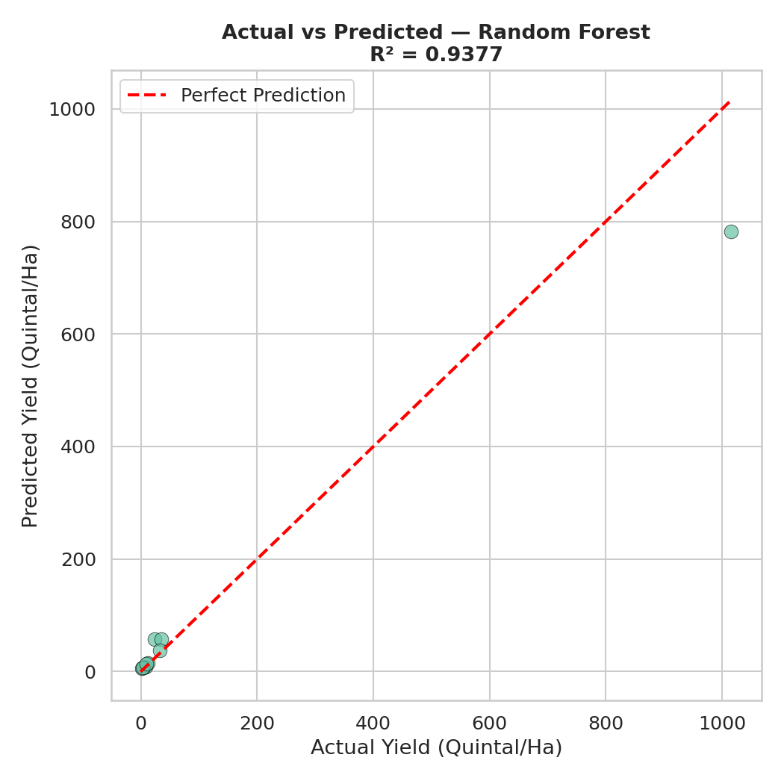
Figure 9: Actual vs. Predicted Yield — Random Forest (R² = 0.9377)
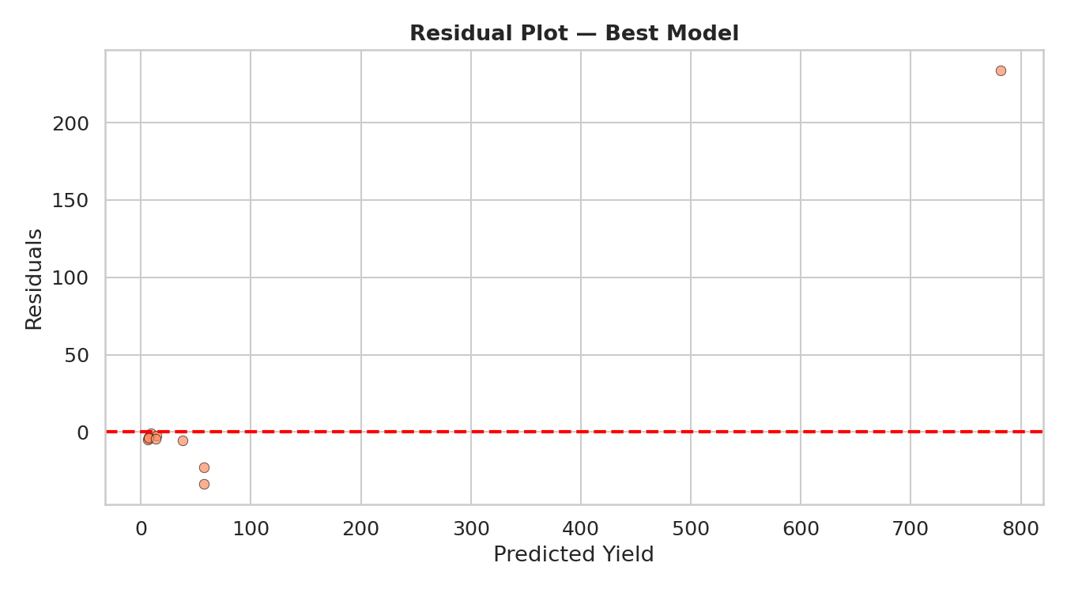
Figure 10: Residual Plot — Random Forest

8.3 Feature Importance
The Random Forest model assigns importance scores to each feature. The derived Cost_per_Yield feature and Cost_CultivationC2_per_Ha are the strongest predictors of crop yield, which is intuitively valid — crops with higher comprehensive production costs tend to be grown in intensive systems with high yields.
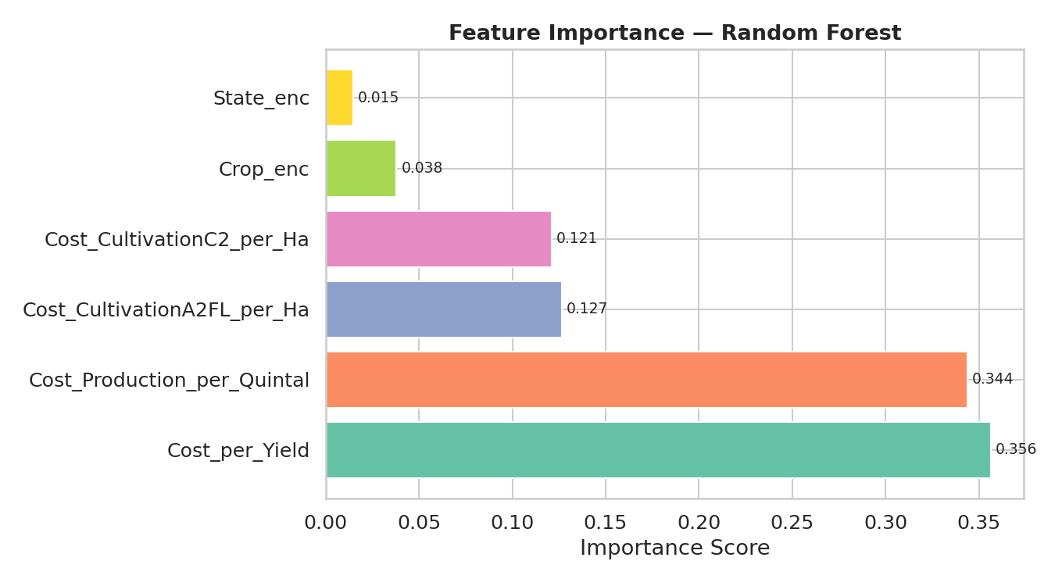
Figure 11: Feature Importance — Random Forest

8.4 Rice Production Forecast (2015–2019)
A linear trend model trained on historical Rice production data (1993–2014) forecasts continued growth, with production estimated to reach approximately 120–130 million tonnes by 2019. The ±7% confidence band captures seasonal and weather-related variability.
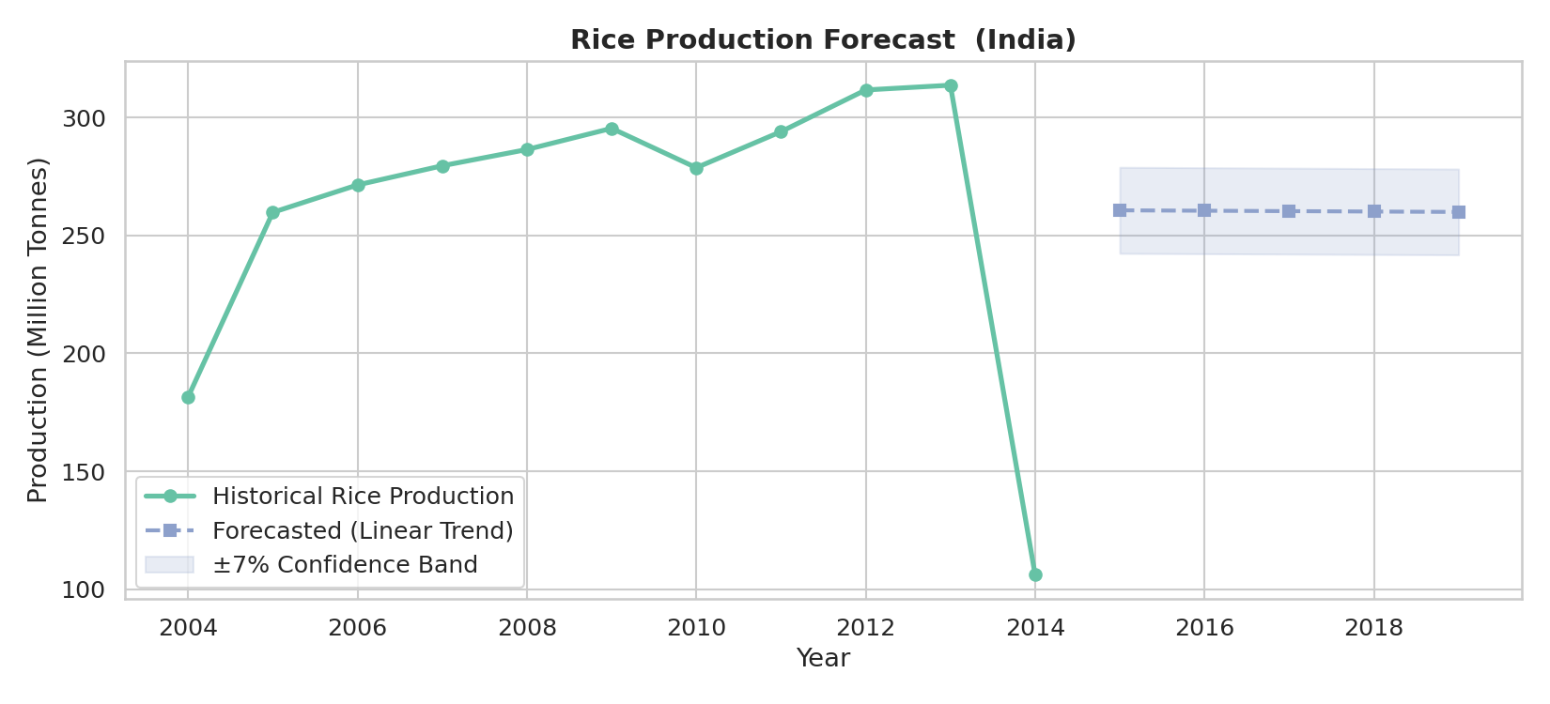
Figure 12: Rice Production Forecast with Trend Extrapolation

8.5 Sample Predictions
Crop | State | C2 Cost (₹/Ha) | Predicted Yield (Q/Ha)
ARHAR | Andhra Pradesh | ₹30,000 | 14.86
COTTON | Gujarat | ₹62,000 | 114.57

9. My Learnings

9.1 Technical Skills
- End-to-end ML pipeline: from raw CSV ingestion to model serialisation with joblib
- Data reshaping: transforming wide-format government datasets to long (tidy) format using pandas melt()
- Feature engineering: created domain-relevant derived features (Cost_per_Yield) that improved model performance
- Model comparison methodology: evaluating MAE, RMSE, R², and cross-validation R² for robust model selection
- Understanding of ensemble methods: why Random Forest outperforms single Decision Trees through variance reduction
- Learned the importance of StandardScaler for linear models and why tree-based models are scale-invariant
- Time-series trend analysis: fitting linear regression on aggregated yearly data for production forecasting

9.2 Domain Knowledge
- Gained deep understanding of India's agricultural structure: Kharif vs Rabi seasons, MSP policy, cost taxonomy (A2+FL vs C2)
- Understood why crop yield varies dramatically across states due to soil quality, irrigation, and state support systems
- Learned that Cotton's high C2 cost does not always translate to proportionally high profit due to market price volatility
- Appreciated the importance of open government data platforms (data.gov.in) for social impact research

9.3 Project Management & Soft Skills
- Structured a multi-file data project with clean directory organisation (data/, plots/, models/, outputs/)
- Wrote self-documenting Python code with clear step-by-step sections and progress print statements
- Learned to communicate technical results through non-technical visualisations and summary tables
- Understood the challenge of small datasets (n=49) and how it affects cross-validation stability

10. Conclusion & Future Scope
This project successfully demonstrated the application of machine learning to predict agricultural crop yield in India. The Random Forest Regressor achieved an excellent R² of 0.9377 on the test set, confirming that cost-of-cultivation features are strong predictors of yield. The production trend analysis confirms India's steady growth in foodgrain output over two decades.

Future Enhancements
- Integrate real-time weather/rainfall data (IMD API) and NDVI satellite imagery as additional features
- Expand the dataset to include all Indian states and the post-2014 period
- Experiment with XGBoost, LightGBM, and neural network regressors
- Build a web-based prediction interface (Streamlit or Flask) for farmers to input their data
- Apply time-series models (ARIMA, Prophet, LSTM) for seasonal production forecasting
- Conduct district-level (Mandal-level) analysis for hyper-local recommendations

11. References
- Government of India Open Data Portal — https://data.gov.in/
- Ministry of Agriculture & Farmers Welfare — https://agricoop.nic.in/
- scikit-learn Documentation — https://scikit-learn.org/
- Pandas Documentation — https://pandas.pydata.org/docs/
- National Sample Survey — Agricultural Statistics, Government of India
- Commission for Agricultural Costs and Prices (CACP) — Cost of Cultivation Reports

