**InsightStream: Navigate the News Landscape**

**Ideation Phase**

**Define the Problem Statements**

|  |  |
| --- | --- |
| Date | 5 March 2025 |
| Team ID | SWTID1741161984154458 |
| Project Name | InsightStream |
| Maximum Marks | 2 Marks |

**Customer Problem Statement Template:**

Create a problem statement to understand your customer's point of view. The Customer Problem Statement template helps you focus on what matters to create experiences people will love.

A well-articulated customer problem statement allows you and your team to find the ideal solution for the challenges your customers face. Throughout the process, you’ll also be able to empathize with your customers, which helps you better understand how they perceive your product or service.

Reference: <https://miro.com/templates/customer-problem-statement/>

**Example:**

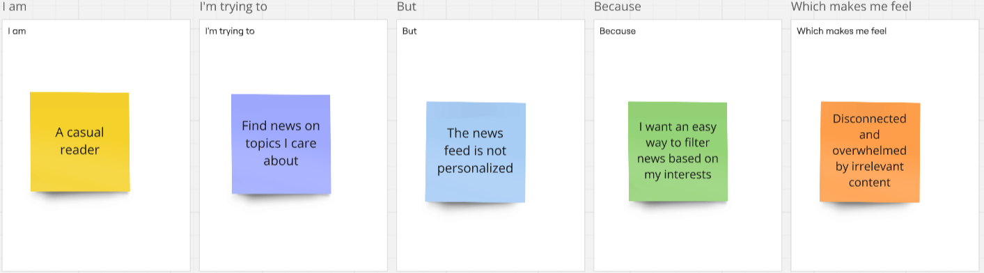

|  |  |  |  |  |  |
| --- | --- | --- | --- | --- | --- |
| **Problem Statement (PS)** | **I am (Customer)** | **I’m trying to** | **But** | **Because** | **Which makes me feel** |
| **PS-1** | A busy professional | Stay updated with the latest news quickly | Most news websites are cluttered with ads and unnecessary content | I need a clean, distraction-free interface with only relevant news | Frustrated and unwilling to browse for long |
| **PS-2** | A casual reader | Find news on topics I care about | The news feed is not personalized | I want an easy way to filter news based on my interests | Disconnected and overwhelmed by irrelevant content |
| **PS-3** | A mobile user | Read news on the go | Many platforms are not mobile-friendly or take too long to load | I need a smooth, fast-loading, and responsive experience | Annoyed and likely to leave the platform |
| **PS-4** | A user concerned about credibility | Get reliable news from trusted sources | A lot of platforms spread misinformation or lack source transparency | I need verified news from reputable sources | Skeptical and unsure which news to trust |