IPR MANAGEMENT
IP Commercialization
Class notes, in the order the topic was taught

How this document is built
The spine is the class material — the seminar deck: first principles of the patent system, the guest session by Dr Osman Ahmed on IP commercialization in the corporate world, Bayh–Dole, AUTM, patent strategy, valuation heuristics, and the public research sector. Every slide is covered, in slide order.
The book chapter is used only as explanation. Where a slide states a conclusion, survey evidence from “Technology and Commercialization Strategies” (BIP, Chapter 6) is brought in to show why it holds. These passages are marked
Evidence from the book so you can see at a glance what is class content and what is supporting material. Chapter 6 material that belongs to its own argument — Japanese technology policy, early/late movers, diversification history, standardization — is not treated as a topic here.
Short research notes fill gaps the slides leave open, and are marked as such.

Contents

If the list above appears blank, click in it and press F9 (Windows) or right-click → Update Field.

1 First Principles
One idea governs the whole topic. Intellectual property is not valuable because it exists; it is valuable because of what somebody can do with it. A patent left in a drawer costs a maintenance fee every year and earns nothing. IP commercialization is the set of activities — technical, commercial, legal and organizational — that converts a protected piece of knowledge into revenue, market position, freedom to operate or bargaining power. Protection is the means; commercialization is the point.

1.1 What IP is, and what the instruments do
An IP right is a legal right over the output of the mind: an invention, a brand, a design, a text, a body of know-how. The right is negative in character — it lets the owner stop others from doing something, rather than guaranteeing the owner the ability to do it. That single feature explains everything downstream. Because the right is a right to exclude, value comes either from using exclusivity yourself (selling something nobody else may copy) or from selling permission to others (licensing, cross-licensing, assignment).
Right | What it protects | Typical term | Commercialization role
Patent | A new, non-obvious, industrially applicable invention, in exchange for full public disclosure | 20 years from filing | The core exclusivity asset: blocks imitation, earns royalties, and is the currency of cross-licensing
Utility model | Smaller technical improvements; little or no examination in some countries | 6–10 years | Fast, cheap fencing around a core patent
Trademark | A sign distinguishing one undertaking's goods or services | 10 years, renewable indefinitely | Carries value into new product areas and outlives the patent
Industrial design | The appearance of a product | Up to 25 years in many systems | Protects the embodiment when the function is unpatentable
Copyright | Original expression — code, text, drawings, data compilations | Life of author + 50–70 years | Dominant in software and content licensing; arises automatically
Trade secret | Commercially valuable information kept confidential | As long as secrecy holds | The alternative to patenting: no disclosure, but no right against reverse engineering or independent discovery
Table 1.1 The instrument set (deck: “Definition of IP”, WIPO and USPTO references). A real product usually carries several of these at once.
A patent in particular is a bargain: the inventor discloses the invention completely enough that a skilled person could reproduce it, and in return the state grants a time-limited right to exclude. Hence the practical consequences that shape every later decision — the disclosure must be drafted with future claims in mind, the right expires and so has a shrinking commercial window, and territory must be chosen and paid for country by country.

1.2 Origins of the U.S. patent system: four dates
The American patent system is very nearly as old as the republic itself, and four dates establish its architecture.
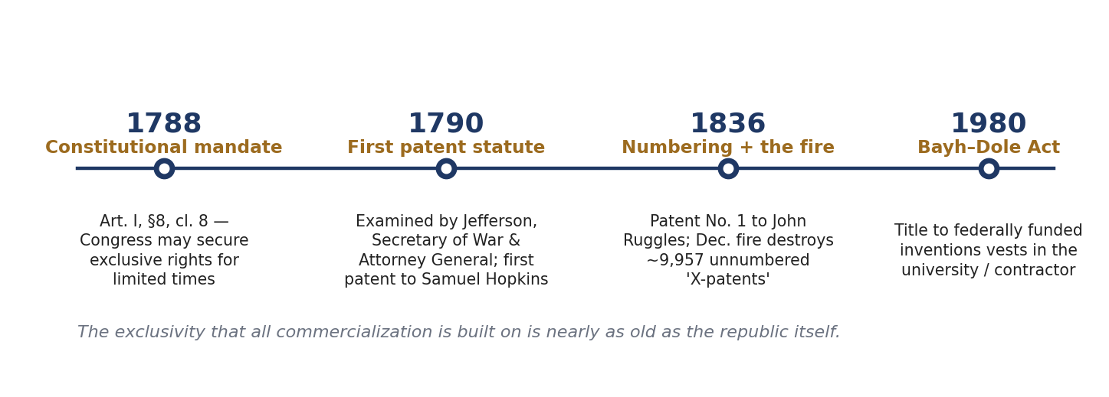
Figure 1.1 The four dates. Bayh–Dole is taken up in Part 3.
1788 — a constitutional mandate. The Constitution was ratified on 21 June. Article I, Section 8, Clause 8 empowers Congress to promote the progress of science and useful arts by securing, for limited times, exclusive rights to authors and inventors in their writings and discoveries. IP is written into the founding document itself. Note the two limits inside the clause: the right is for a limited time, and it exists to promote progress, not to reward ingenuity for its own sake.
1790 — the first patent statute. The Patent Act of 1790 was enacted on 10 April, the first federal patent law. Applications were examined by a board comprising the Secretary of State (Thomas Jefferson), the Secretary of War and the Attorney General. On 31 July, President Washington signed the first U.S. patent, to Samuel Hopkins of Vermont, for a process of making potash. For forty-six years, patents were signed personally by the President. The point that matters commercially: examination was a substantive quality filter from the very beginning, and that filter is what makes a patent a tradeable asset.
1836 — numbering, and a fire. The Patent Act of 4 July 1836 established the numbering system still in use. Patent No. 1 issued on 13 July to John Ruggles for traction wheels. That December, a fire destroyed the records of roughly 9,957 unnumbered patents granted since 1790 — the X-patents, reconstructed only from inventors’ own copies. The lesson survives in modern practice: a right is only as good as the record that proves it, which is why invention-disclosure forms, dated notebooks and recorded assignments decide who actually owns what when a licence or a dispute arrives.

1.3 The accelerating pace of patenting
The system has compressed dramatically. The first million U.S. utility patents took 121 years to accumulate; the eleventh million took three.
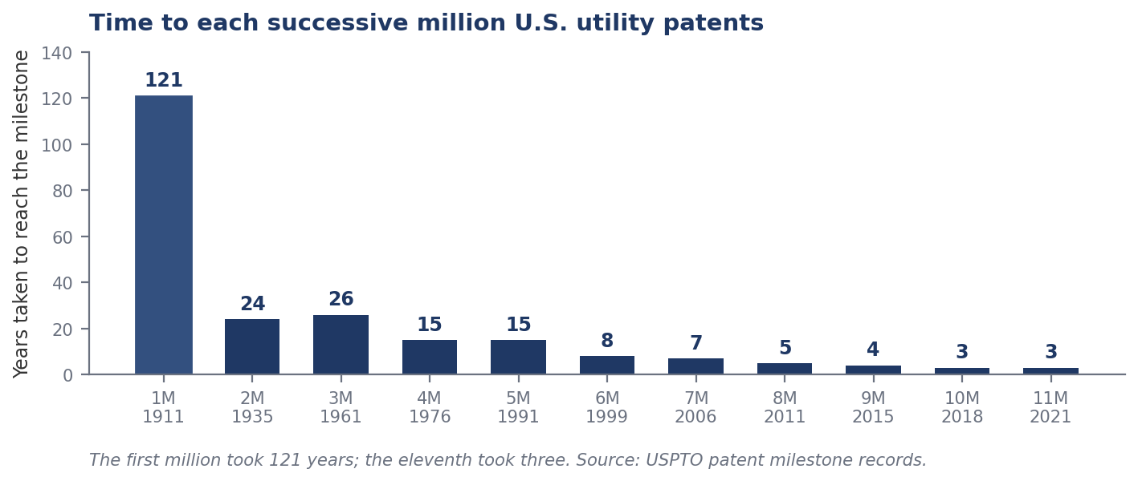
Figure 1.2 Years taken to reach each successive million U.S. utility patents. Source: USPTO patent milestone records.
- Patent 10,000,000 issued on 19 June 2018 to Raytheon, for a coherent laser radar system; patent 11,000,000 followed on 11 May 2021, for a prosthetic heart valve device.
- Annual U.S. grants rose from roughly 70,000 in 1976 to about 374,000 in 2024.
- Worldwide filings passed 3.5 million for the first time in 2023, led by China at 1.64 million and the United States at 518,364.
Research note — the current figures
WIPO’s World Intellectual Property Indicators 2025 puts global patent filings in 2024 at a record 3.7 million, up 4.9% on 2023 and the fastest growth since 2018 — a fifth consecutive year of increase. China’s office received about 1.8 million applications (roughly 49% of the world total); by origin, China led, followed by the United States (501,831) and Japan (419,132). Patents in force worldwide stood at approximately 18.6 million.
Read the trend commercially rather than statistically. Rising volume means more prior art, so the room for a broad core claim narrows every year; more overlapping rights on any complex product, which makes freedom-to-operate analysis and cross-licensing unavoidable; and more competition for the same licensees, which lowers the price of an average patent while raising the price of a genuinely blocking one.

1.4 Do patents show up in the share price?
If IP were commercially irrelevant, capital markets would not pay for it. They do — but the evidence says they price patent quality, not patent count.
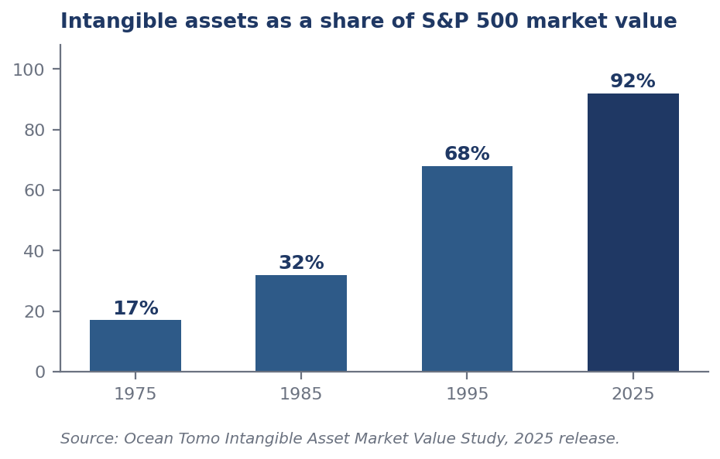
Figure 1.3 Intangible assets as a percentage of S&P 500 market value. Source: Ocean Tomo Intangible Asset Market Value Study, 2025 release.
The share of S&P 500 market value attributable to intangible assets rose from 17% in 1975 to 32% in 1985, 68% in 1995 and 92% in the 2025 release. The great majority of the value of large listed American companies now sits in assets that barely appear on a balance sheet: patents, brands, data, software and know-how. That is the macro reason IPR management became a board-level function.

The canonical finding: Hall, Jaffe and Trajtenberg
Hall, Jaffe and Trajtenberg estimate Tobin’s q equations for U.S. firms over 1963–1995 using three ratios: R&D to assets, patents to R&D, and citations to patents.
- Each of the three ratios significantly affects market value — the market prices research input, patent output and patent quality separately.
- An extra citation per patent adds roughly 3% to market value; firms averaging twenty or more citations per patent command something like a 54% premium.
- The effect is strongest in drugs and weakest in computers and communications: industry-specific, not universal.
- Unpredictable citations matter more than the predictable component — the market has already priced what it could forecast, so only genuine surprise moves valuation.
The caveat that governs everything downstream
Patent value is extremely skewed, approximately log-normal, with a small share of patents carrying most of the value. A raw count of active patents is a poor proxy for portfolio worth: the market rewards the tail, not the total.
Three consequences follow. Portfolio pruning creates value rather than merely saving cost, because dropping the long tail of unused families releases maintenance fees without losing much worth. Measuring an IP department by filings per year rewards the wrong behaviour. And when you value a portfolio you are valuing a handful of assets plus an option on the rest — which is why average royalty rates are a weak guide to any particular deal.

What the exclusivity actually buys
It is worth being precise about the commercial mechanism the market is pricing. A patent does not create demand; it creates a temporary monopoly. There are four ways to do that, and only one of them is what a patent does.
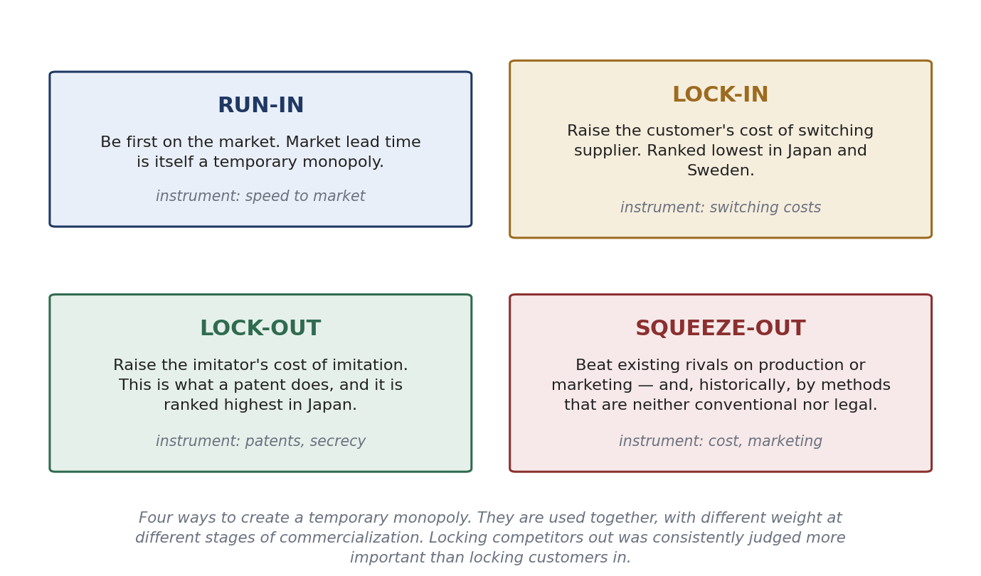
Figure 1.4 Four routes to a temporary monopoly. Book explanation, used here to show what a patent contributes and what it does not.
Evidence from the book — patents versus marketing and production
Chapter 6 surveyed 24 large Japanese corporations on how important each means is for commercializing new product technologies, and compared the answers with Swedish and U.S. data (0 = no importance, 4 = major importance).
Taking out patents to deter imitators: Japan 3.3, Sweden 1.9, USA 2.0. · Creating superior marketing: Japan 2.7, Sweden 3.0, USA 3.1. · Exercising secrecy: Japan 2.4, Sweden 2.0, USA 1.7. · Creating switching costs at the user end: Japan 1.9, Sweden 1.7.
Three readings matter. Patents ranked highest in Japan but close to the bottom in Sweden and the USA — it is the means on which the three countries differ most, so the claim “patents are how you capture returns” is a strategic choice and not a law of nature. Marketing ranked highest in the West. And locking customers in ranked lowest everywhere, so locking competitors out through patents was consistently judged the more important lever. Within Japan, patenting ranked highest in chemicals (3.89) and electricals (3.40) but only third in mechanicals (2.60), where production cost reduction and process secrecy led instead — a reminder that the right instrument depends on whether your invention is visible in the product.

2 IP Commercialization in the Corporate World
The guest session by Dr Osman Ahmed, taken slide by slide. It answers the practical question: inside a company, what has to be true for IP to generate money, and what are the actual mechanisms by which it does so.

2.1 The innovation ecosystem: where IP sits in the corporate loop
Corporate IP commercialization is not a standalone activity. It is one loop inside a closed circulation of capital and knowledge whose declared goal is to create corporate wealth of two kinds at once — intellectual wealth and financial capital — with IP as the mechanism of conversion between them.
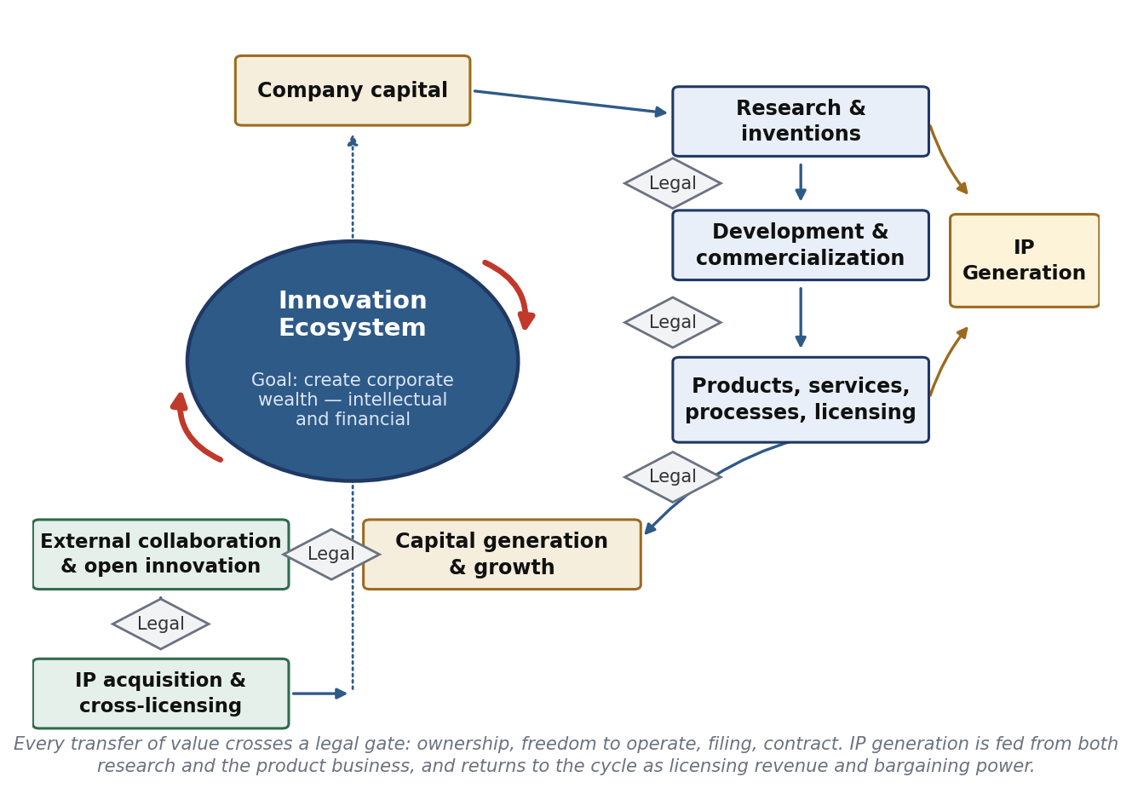
Figure 2.1 The corporate innovation ecosystem and its legal gates.
Trace the loop. Company capital funds research and inventions. Research feeds development and commercialization, which produces products, services, processes and licensing opportunities. These generate capital and growth, which flows back into company capital, and also outward into external collaboration and open innovation, and into IP acquisition and cross-licensing, which re-enter the firm as inputs to the next cycle. Down the right-hand side runs IP generation, fed both by research (inventions not yet in a product) and by the product business itself (improvements, process and application inventions). IP generation is not a terminus: it returns to the cycle as licensing revenue, as defensive strength and as bargaining currency.
The diamonds marked “Legal” are the instructive part. Every transfer of value in the loop passes through a legal gate: who owns the invention, is the company free to operate, what is filed and when, and what the contract with the partner or licensee actually says. Where those gates are missing or late, value leaks — through inventions that can no longer be claimed because they were published first, through collaborations whose background and foreground IP were never separated, and through products found to infringe after the launch budget is spent.

2.2 The seven requirements for robust corporate IP commercialization
The session sets out a process, not a formula. Each requirement is a failure mode when absent.
- Management’s commitment to innovation and IP creation. IP spend is discretionary, long-dated and easy to cut. Without a standing commitment at the top, filing budgets and inventor awards are the first casualties of a bad quarter, and the damage appears years later when there is nothing to license and nothing to trade.
- Strategy implementation — efficient and timely execution. In IP, timing is substantive: a filing made after a conference presentation may be void, and one made before the invention is properly described may be worthless. Execution speed is part of the asset’s quality.
- Sound identification and assessment of the right opportunity, at the right time, for the right reason. Three separate tests. The right opportunity means the invention is protectable and commercially relevant. The right time means market and technology are both ready. The right reason means you can say what the patent is for — exclusion, revenue, trading stock or reputation — because the reason determines how the claims are drafted and where the family is filed.
- Select and create the right value propositions for the right market. One technology supports different propositions in different markets, and each proposition implies different claims and a different licensee. Value propositions are created, not discovered.
- Talented and motivated resources. The session invokes Steve Jobs’s pirates-and-navy line: it is better to be a pirate than to join the navy. New technology needs people willing to work outside the established process, protected by management from the process they are circumventing — but eventually the pirates must work with the navy, because the navy owns manufacturing, distribution and quality.
- Open collaboration. No single firm owns all the complementary assets a new technology needs, so collaboration is an economic necessity. IP is what makes it safe: background and foreground IP defined in advance, field-of-use boundaries, and publication and confidentiality rules.
- A symbiotic and synergistic relationship between IP legal and R&I / R&D. The requirement the session draws as a diagram, and the one most often missing.
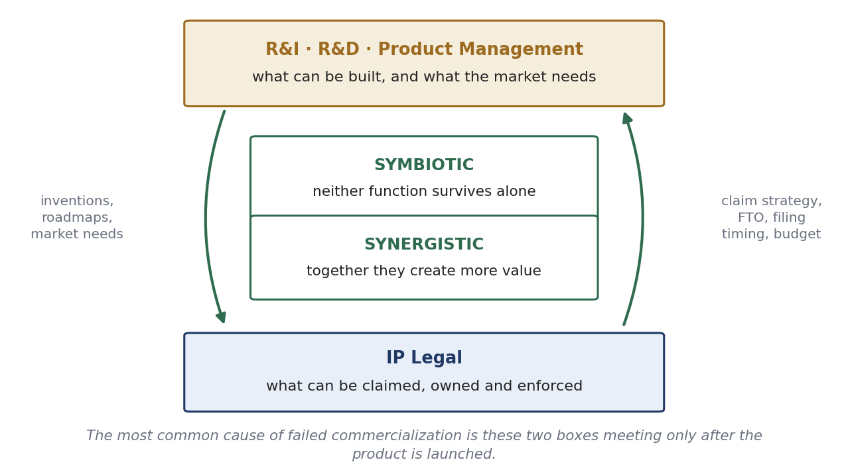
Figure 2.2 Symbiotic and synergistic: the technical functions on one side, IP legal on the other.
Symbiotic means neither function can achieve its purpose alone: engineers cannot create a defensible asset without claim strategy, and lawyers cannot draft a valuable claim without knowing what the technology does and where the market is going. Synergistic means that together they produce more than the sum. The engineer who understands claim structure invents around competitors deliberately and designs inventions whose infringement can be detected; the attorney who understands the product roadmap files a core claim broad enough to cover products that do not exist yet. In practice the relationship is built with routine mechanisms — invention-review boards with both functions present, IP training for engineers, patent-landscape briefings into R&D planning, and attorneys embedded in product teams rather than summoned at the end.
Evidence from the book — why requirements 4, 6 and 7 matter more than they look
Chapter 6 asked the same 24 corporations what actually limits their ability to profit from innovation (0–4 scale, total across all firms):
High cost or limited access to the technology needed 2.62 · High costs or difficulties in marketing 2.57 · Problems getting a product into production in a timely way 2.48 · Inability to prevent other firms copying the technology 2.48 · High cost or limited access to capital 2.20 · Lack of competent suppliers 1.80.
Copying is not the biggest obstacle. Access to technology, timely production and marketing cost all rank at or above it. A patent therefore addresses one limitation out of six — and not the largest. This is the empirical case for requirements 4, 6 and 7: an IP strategy detached from manufacturing ramp-up, market access and technology sourcing solves a second-order problem at first-order cost. It also points to the patent’s second job, which addresses the top-ranked limitation directly: patents can be used to obtain access to technology you need, through cross-licensing (Section 2.6).

Evidence from the book — how firms actually exploit technology
Asked how they commercialize their technological capabilities, the same firms ranked the options as follows (0–4, total across firms), arranged from full organizational integration down to arm's-length dealing:

Route | Score | What the number tells you
Internal exploitation | 3.75 | Making and selling it yourself dominates everywhere, and did not grow between 1987 and 1992. The default route is still to use the technology, not to trade it
Joint ventures | 2.50 | Quasi-integrated forms grew fastest in importance — the practical expression of “open collaboration”
Technology selling (licensing out, contract R&D, engineering services) | 2.25 | Growing, and fastest in mechanical firms (growth ratio 1.90) where patents matter least
Creation of innovative firms | 2.09 | Used for technologies falling outside existing business areas, or radical ones that an entrenched division would smother
Divestment | 0.59 | Dismissed across industries. Firms very rarely sell the asset outright
Uncommercialized technology (a problem, not a route) | 2.14 | Significant and growing — technology paid for and never used
Loss and leakage of proprietary technology (likewise) | 2.42 | Roughly the same magnitude as deliberate technology selling: firms were losing about as much technology as they were selling
Table 2.1 Routes for exploiting technology, with the two silent losses. Book evidence, used here to show what “commercialization” looks like in aggregate before any single deal is negotiated.
The last two rows deserve a moment. Uncommercialized technology arises from lags, serendipity, exploratory R&D or simply unsuccessful R&D; leakage arises from weak confidentiality, leaky suppliers and departing staff. The chapter also cites evidence that 43% of R&D projects are not technically successful, 35% of the technically successful ones are never commercialized, and 26% of those commercialized are not economically successful — so roughly a quarter of projects end in economic success. That is the arithmetic behind requirement 1: tolerance of failure is a technical requirement of the system, and reducing leakage or shortening the lag to commercialization is as valuable as inventing more, because it acts on inventions already paid for.

2.3 What really drives invention? Inventor motivation and the ownership rule
Commercialization begins with an invention, and inventions come from people who must be motivated to make them and to report them. Two legal traditions produce two very different management problems.

The United States
- IP belongs to the company and not to the inventors — usually as a term of the employment contract.
- The employee should disclose the invention and assign it to the company.
- Inventors typically receive a small honorarium plus awards, recognition and other goodies — symbolic rather than economic compensation.
- The company creates and cultivates an open environment that accepts failures as a learning experience.
- That environment motivates employees to be passionate about invention — and the passion, not the payment, is what drives invention.

Germany and other EU countries
- IP belongs to the inventor and not to the company — again as part of the employment framework.
- Inventors assign the IP to the company, but only after negotiating terms and conditions under government rules and guidelines.
- There is usually a term limit on the assignment. After it, the inventor may assign the invention to an external entity under government rules designed to reward the inventor while compensating the company and safeguarding its interests.
- The open environment, the culture and the passion are all big challenges in this system.
Research note — how the German rule actually works
Under the German Employee Inventions Act (Arbeitnehmererfindungsgesetz, in force since 1957), rights in a service invention initially vest in the employee inventor. The employee must report the invention without delay and in text form. The employer may claim it — and critically, if the employer does not release it within four months of a proper notification, it is deemed to have been claimed and all rights pass to the employer automatically. Once claimed, the employee has a non-waivable right to reasonable remuneration, calculated under Federal Ministry guidelines as the invention value multiplied by a share factor reflecting the company’s contribution. Disputes go first to the Arbitration Board at the German Patent and Trade Mark Office. German universities claim employee inventions too, with the inventor entitled to 30% of gross licensing income.
So the practical difference is not that European companies cannot own inventions — they almost always end up owning them. Ownership is conditional, procedural and priced: notification duties, hard deadlines, a mandatory payment that scales with commercial success, and an arbitration route. That is why European IP departments run formal invention-disclosure systems as a legal necessity rather than good practice.

Dimension | United States model | Germany / EU model
Default ownership | Company, by contract | Inventor, by statute; transferred by claim
What the company must do | Take the assignment and document it | Observe notification, claiming and release deadlines; pay statutory remuneration
Inventor upside | Honorarium, awards, recognition, career | Legally enforceable share of commercial success
Main managerial lever | Culture: tolerance of failure, passion, prestige | Process compliance plus negotiated terms
Commercialization consequence | Low transaction friction; motivation must be engineered culturally | Higher administrative cost and a real royalty-cost line; but a built-in financial incentive to invent and to disclose
Risk if mishandled | Inventors disengage; inventions go unreported or leave with the employee | Deemed claims, back-pay exposure, and ownership defects that surface in due diligence
Table 2.2 Two ownership regimes, two different management problems. In multinational R&D both must be run in parallel.

2.4 Use case: corporate IP commercialization in practice (Micro-IoT, 2004)
In 2004 a new technology was born: Micro-IoT — microsystems on a chip. Its technical content was the convergence of four capabilities within a single silicon layer: sensing, micro-processing, wireless communication and efficient power management. Its commercial content was different and more important: super affordability, ease of installation, commissioning and operation; the data it generated, driving digitalization and the fourth industrial revolution; and global partnership and collaboration as the means of reaching market.
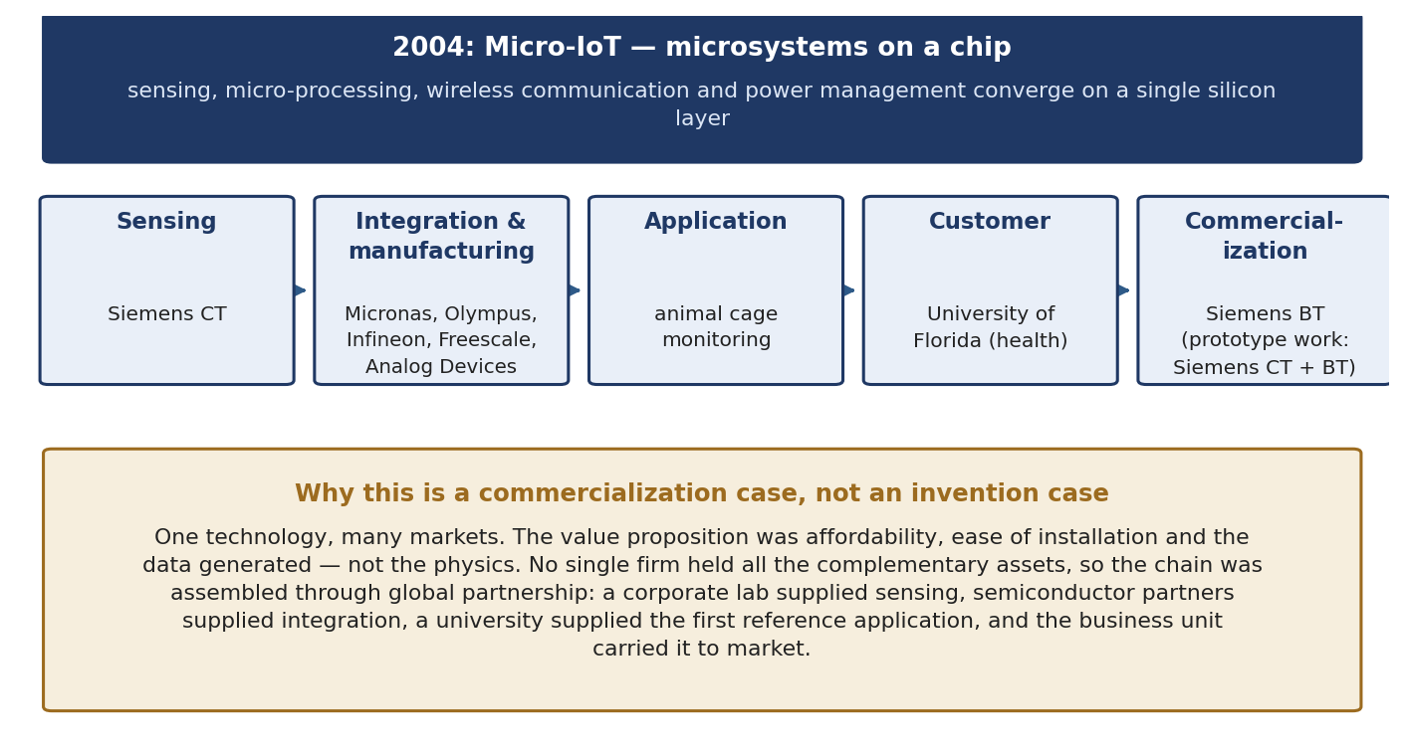
Figure 2.3 The Micro-IoT value chain — a technology assembled across firms and a university.
Read the chain as an assembly of complementary assets. Sensing came from Siemens Corporate Technology. Integration and manufacturing came from semiconductor partners — Micronas, with Olympus, Infineon, Freescale and Analog Devices. The first application was animal cage monitoring; the customer was the University of Florida’s health system. Research, prototyping and development sat with Siemens CT together with Siemens Building Technologies, and commercialization sat with Siemens BT.
Three lessons carry forward. The technology is generic — the same convergence serves buildings, health, industry and mobility — which is exactly the condition under which portfolio thinking pays off, and the subject of the next section. No single participant held all the complementary assets, so the collaboration was architecture rather than goodwill, and the IP boundaries between participants had to be drawn before the work began. And the first application was small and unglamorous: a reference application with a real customer is what converts a technology into a product, with the large markets arriving afterwards.
Evidence from the book — why one generic technology is worth so much
Chapter 6 gives the economics of exactly this situation under the heading of technological economies of scale, scope and speed.
Scale: technical competence is built at considerable fixed cost but has low variable cost when applied across applications. As with any body of knowledge, the cost of a technology barely depends on the scale of its use, so the same technology can be carried into several products — sometimes with a considerable adaptation cost, more often a minor one. This is true of generic technologies by definition.
Scope: where a new technology is complementary to existing ones, synergies arise from cross-fertilization — though integrating more technologies also raises R&D cost, because it requires more coordination and communication. Scope is not free.
Speed: a firm whose technology base already contains what a new product needs can incorporate it faster by transferring it internally than by acquiring it afresh.
Firms in the study named such technologies explicitly — NEC called them trunk technologies; others speak of generic, pervasive, core or general-purpose technologies. The commercialization implication is the one Dr Ahmed’s next slide draws: if a technology is generic, the asset to build is not a patent but a portfolio shaped around it.

2.5 IP commercialization strategy: building the portfolio around a core claim
The strategic question is not “should we patent this?” but “what shape should the portfolio have?” The session’s answer is a claim architecture.
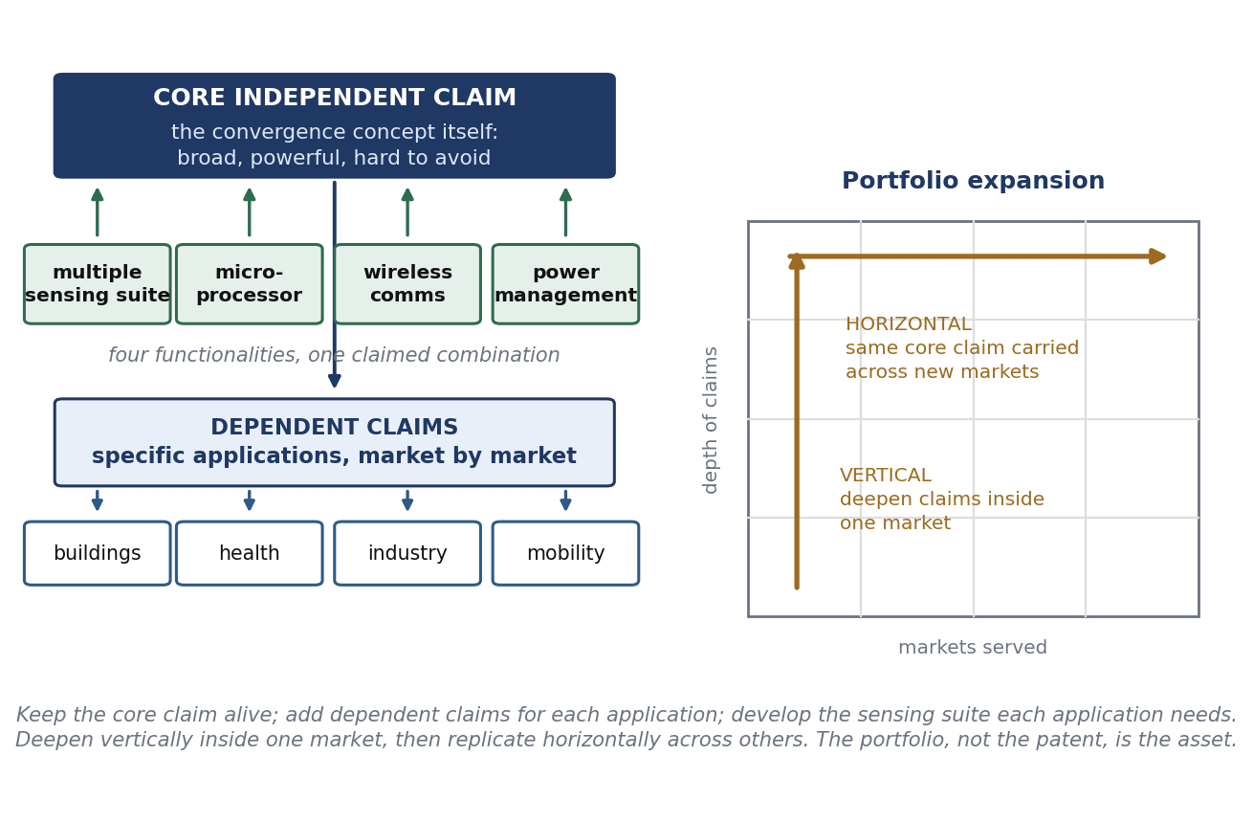
Figure 2.4 Core claim, dependent claims, and the two directions of portfolio growth.
- Core IP: develop a powerful, broad, independent claim on the overall concept and on the convergence of the four functionalities. This is the asset that cannot be designed around, and the one that gets litigated, licensed and traded.
- Applications are dependent claims. Each specific use — a building sensor, a medical monitor, an industrial node — is claimed in dependence on the core concept.
- Applications vary from market to market, so the dependent-claim layer is drafted market by market rather than once.
- Expand the portfolio by: keeping the core claim alive; adding dependent claims on specific applications for specific markets; developing the concept of the specific sensing suite each application needs; implementing the strategy vertically within one market, such as buildings; and developing patents horizontally across different markets.
The vertical–horizontal distinction is the operative idea. Vertical deepening inside one market makes a competitor’s entry expensive: to sell a competing building sensor they must avoid not only the core claim but a dense layer of application claims. Horizontal spreading multiplies the number of licensees who need the same core, which raises both the portfolio’s licensing value and its usefulness as cross-licensing currency.
Evidence from the book — why the architecture is necessary, not merely tidy
Asked how far each statement described the limitations of patents as protection for their technology (0 = not true, 4 = very true), the surveyed firms answered:

Limitation of patents | Score | Rank
Competitors can legally circumvent patent rights or invent ways around them | 2.58 | highest
Firms engage in cross-licensing with competitors | 2.04
Technological development is so rapid that patents become irrelevant | 1.96
Patents are probably not valid if contested | 1.75
Patent proceedings require a firm to disclose too much information | 1.71
New processes are not patentable | 1.52
New products are not patentable | 1.38
Firms do not try to enforce their patent rights | 1.13
Compulsory licensing can be imposed by courts or regulators | 1.00 | lowest
Table 2.3 In every industry the main limitation of a patent is invent-around. Scores are totals across the 24 firms.
In every industry the main limitation of patents is their inability to prevent competitors from finding a substitute invention — from inventing around. Note also that this limitation scores about the same as the inability to prevent copying in the previous section’s table, even though preventing copying is precisely what patents are for. Preventing or aggravating inventing-around through the broad scope of a patent therefore becomes critical, which is what the chapter says Japanese firms became renowned for under two names: blanketing, covering a technical area so densely that any route through it infringes something, and fencing, filing around a core invention to block the substitute solutions a rival would otherwise use. A single right can be circumvented; a field of rights cannot be circumvented economically. That is the same architecture the session recommends — broad core claim, dense application layer, deepened vertically and spread horizontally — arrived at from the opposite direction.
A note on the alternative: secrecy
Where an invention is not visible in the finished product and cannot be inferred from it, secrecy is a genuine option rather than a failure to file. But the book documents a squeeze on it: cheaper and more powerful reverse engineering (for example, chemical analysis that traces minute quantities in a product and lets the process be inferred) cuts both ways. The innovator’s secrecy barrier is penetrated more easily, so secrecy protects less; and the imitator’s barrier is also penetrated, so infringement becomes detectable and patents become more enforceable. Both effects raise the propensity to patent. The exception in the data was mechanical engineering, where process know-how still hides inside the factory and process secrecy scored highest.

2.6 Cross-licensing: converting conflict into freedom to operate
Cross-licensing is the mechanism by which two firms that each block the other stop paying lawyers and start selling products. The session’s use case is deliberately ordinary, because the pattern is ordinary.
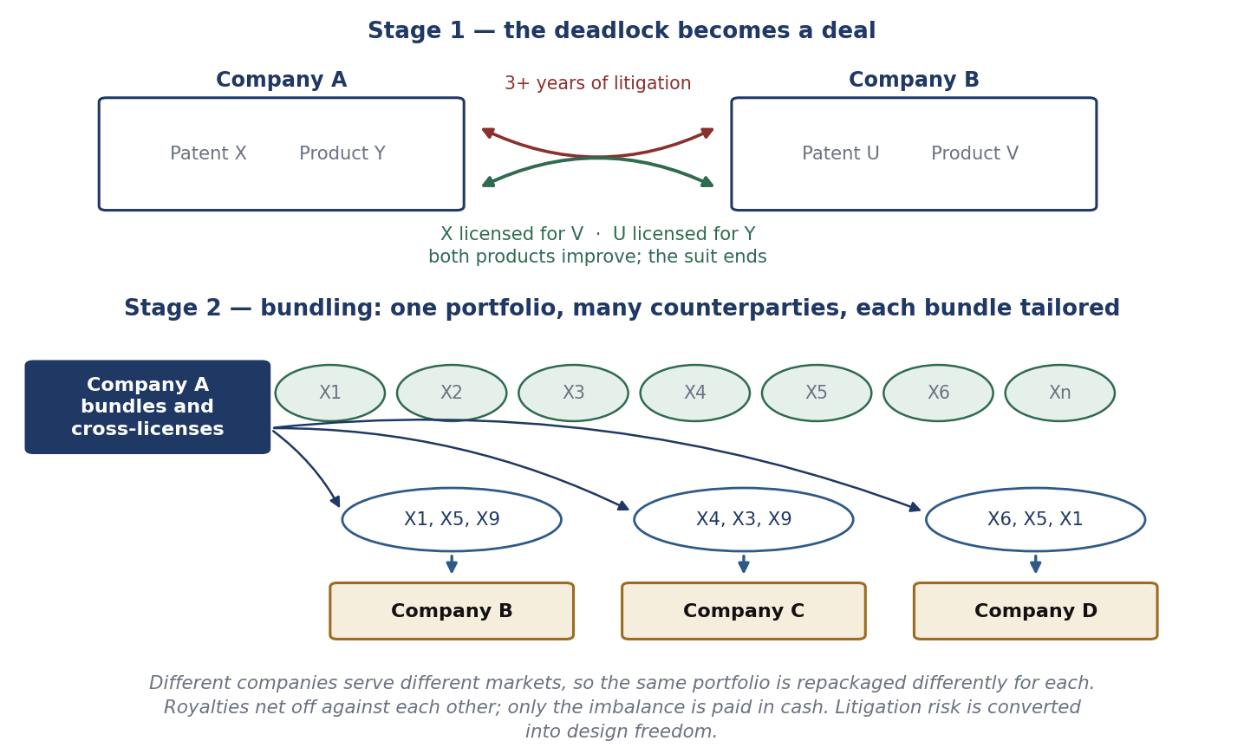
Figure 2.5 From litigation to cross-licence, and from single patents to bundles.
Company A obtains US Patent X. Company B sues A, alleging that A’s activity violates B’s Product V position. Litigation continues for more than three years. Later it is found that X can in fact enhance V, and that B’s Patent U can benefit A’s Product Y. A and B therefore cross-license: X for V, and U for Y. Both products improve and the litigation ends. Nothing about the patents changed; what changed was the recognition that each side valued the other’s right more than it valued the fight.
The second panel generalizes this into portfolio practice. Company A bundles its patents X1 through Xn and cross-licenses different bundles to different counterparties: X1, X5 and X9 to Company B; X4, X3 and X9 to Company C; X6, X5 and X1 to Company D. The bundles differ because those companies serve different markets and sectors and therefore need different subsets. Note that the same patent appears in several bundles — non-exclusive licensing lets one asset be sold many times, which is the closest thing to free money in the subject.
Why a firm cross-licenses rather than litigating or refusing
- Freedom to operate: in a multi-technology product somebody else always holds a relevant right, and a cross-licence buys the ability to ship.
- Cost and time: three years of litigation consumes management attention and produces no product.
- Royalty netting: payments offset each other and only the imbalance moves in cash, so a strong portfolio converts directly into a lower net royalty bill.
- Design freedom for engineers, who can then optimise the product rather than the claim chart.
- Option value: a portfolio held for trading is worth keeping even if it is never asserted — which is why defensive portfolios are rational.

Huawei: cross-licensing at scale
Huawei states the philosophy plainly: respecting and protecting intellectual property is the foundation of innovation, and while promoting its own growth the company also licenses to other industry players to promote shared success. Over the past twenty years it has conducted extensive cross-licensing negotiations with key patent holders in the ICT industry and has entered into more than 260 patent licence agreements with major global ICT companies across Europe, the United States, Japan and South Korea. Long-term investment in innovation, backed by respect for intellectual property, is presented as the driving force behind its business success and the cornerstone of its vision of a fully connected, intelligent world.
CNY 1.38 trillion | 21.8% | 7,000+ | 165,000+
Total R&D investment over the last decade | R&D as a share of total revenue in 2025 (CNY 192.3 billion) | Standards contributions submitted in 2025 in connectivity, computing, smart devices, IAS and other domains | Active patents held at the end of 2025
Table 2.4 Huawei by the numbers: enormous R&D input, a very large portfolio, and heavy standards participation — the three preconditions for cross-licensing from strength.
The third column explains the other two. A firm that contributes thousands of proposals to technical standards will inevitably hold patents essential to those standards; a firm holding standard-essential patents can obtain licences from everyone who implements the standard; and a firm that also manufactures at scale needs licences running in both directions. Standards, patents and cross-licensing are one subject rather than three. In modern practice the link is formalised: standards bodies require participants to disclose patents they believe essential to a draft standard and to commit in advance to licensing them on fair, reasonable and non-discriminatory (FRAND) terms, and patent pools let an implementer take one licence instead of hundreds.

2.7 Licensing: the most common route and the hardest to negotiate
Licensing is perhaps the most common approach to generating IP value, and perhaps the most complex issue to negotiate between buyer and seller. The reason is structural: the buyer wants to minimise the value and the seller wants to maximise it, and unlike a commodity there is no market price to appeal to. Agreeing the valuation of the IP — and getting both parties to accept the same number — is therefore fundamental, and it is the gate through which every other term passes.
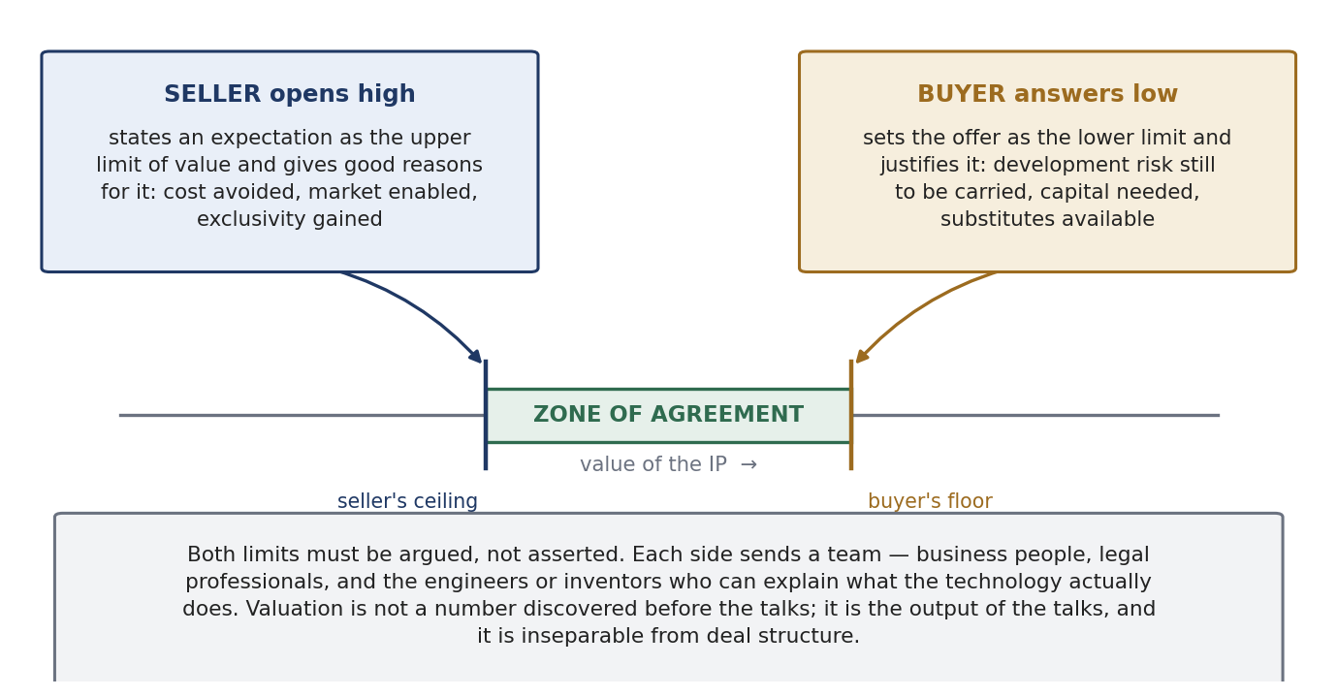
Figure 2.6 The negotiation architecture recommended in the session: two justified limits, then a zone of agreement.
The approach that often works is a disciplined exchange of justified limits. The seller sets an expectation as the upper limit of the IP’s value and states good reasons behind it. The buyer then sets an expectation for the offer, uses it as the lower limit, and provides clear justifications. What makes this work is not the numbers but the justifications: once both sides must argue, the conversation moves from posturing to evidence — comparable deals, the cost of independent development, the size of the market the IP unlocks, the remaining development risk, the availability of substitutes.
It is a best practice to form a team on each side comprising business experts, legal professionals, and engineers and inventors. Each is there for a reason. The business people own the commercial case and the budget; the lawyers own risk allocation, warranties and enforceability; the engineers and inventors are the only people who can say what the technology actually does, what it does not do, and what it would cost a competitor to do without it. A negotiation run by lawyers alone converges on a low-risk agreement with no upside; run by business people alone it produces commitments that cannot be performed.

Corporate versus academic licensing, USA and EU
In the USA, the process of licensing in the corporate world is not too different from the academic world as far as value assessment goes. The process may differ because of compliance and government regulations as well as other regulatory and boundary requirements — federal funding conditions, export controls, government march-in and government-use rights on federally funded inventions, and institutional conflict-of-interest rules. In the EU, by contrast, the process of licensing and the expectations in the academic world are quite different from those in the corporate world: the ownership regime in Section 2.3 makes the inventor a party with statutory rights rather than simply an employee, and institutional practice and national guidelines shape what a university may agree to.
What is actually being negotiated
Term | What it does | Where the value moves
Grant and exclusivity | Exclusive, sole or non-exclusive; defines the licensed rights | Exclusivity commands a premium but concentrates risk in one licensee's performance
Field of use and territory | Limits the licence to defined applications and countries | Lets the same IP be licensed many times without conflict
Financial structure | Upfront fee, milestones, running royalty, minimum annual royalties, equity | Upfronts price certainty; milestones share risk; minimums stop a licensee sitting on the right
Royalty base and rate | The denominator the percentage applies to | The base matters as much as the rate — see Section 2.8
Improvements and grant-back | Who owns improvements, and whether they flow back | A loose grant-back hands the next generation to the other side
Diligence obligations | Milestones the licensee must actually meet | The licensor's protection against a licence used to shelve a rival technology
Reporting and audit | Statements, records, audit rights, interest on shortfalls | Unauditable royalties are uncollectable royalties
Enforcement and defence | Who may sue infringers, who pays, who controls settlement | Decides whether exclusivity is real or nominal
Term and termination | Duration, breach, insolvency, change of control, reversion | Reversion is how a licensor recovers a stalled technology
Table 2.5 A licence is a bundle of decisions, not a price. Added to support the session's negotiation advice, which presupposes this structure.

2.8 Setting the number: the licensing-revenue thumb rule
There is no magic formula, and every situation is different. But where the IP is associated with a product, a rule of thumb can be applied.
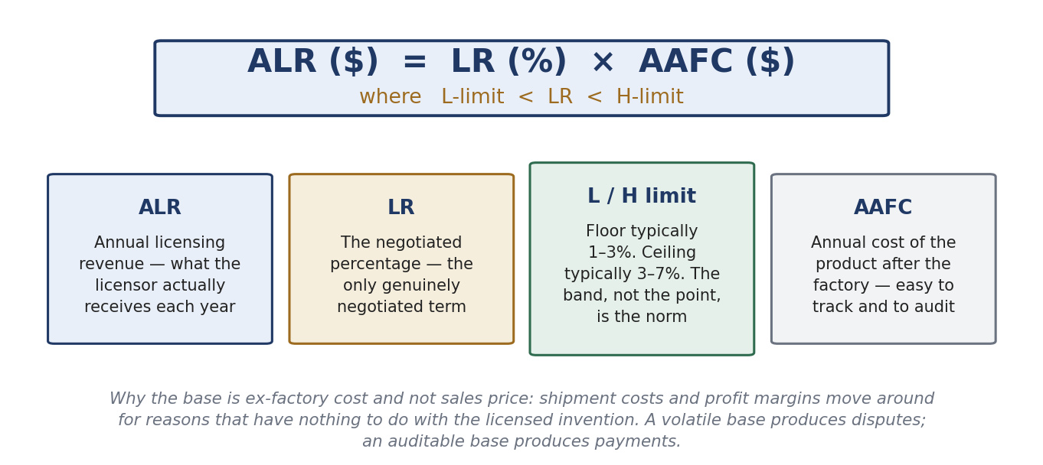
Figure 2.7 The thumb rule, term by term.
Annual licensing revenue equals the negotiated rate multiplied by the annual cost of the products after the factory, with the rate constrained to a band. ALR is the annual licensing revenue. LR is a negotiated percentage — the only genuinely negotiated variable in the expression. The lower limit of LR typically varies between 1 and 3, and the upper limit typically varies between 3 and 7. AAFC is the annual cost of products after the factory.
The choice of AAFC as the base is the sophisticated part of the rule and the part most often missed. AAFC is easy to track and to audit, and it deliberately does not add shipment cost or profit margin because of their variability. Freight moves with fuel and logistics markets; margins move with pricing strategy, discounting, channel mix and currency — none of which has anything to do with the licensed invention. Anchoring a royalty to a volatile base produces annual disputes; anchoring it to an auditable cost figure produces payments.
Worked example
Input | Conservative case | Aggressive case
Units sold per year | 400,000 | 400,000
Ex-factory cost per unit | USD 25 | USD 25
AAFC (annual cost after factory) | USD 10,000,000 | USD 10,000,000
Negotiated LR | 1.5% (near the lower band) | 6% (near the upper band)
ALR — annual licensing revenue | USD 150,000 | USD 600,000
Table 2.6 Same product, same base; a fourfold difference in revenue driven entirely by where LR lands in the band. This is why the justification exchange in Section 2.7 is worth doing properly.

3 Academic and Public-Sector Commercialization
Universities and public research organisations produce inventions but do not manufacture. Everything they commercialize must travel through somebody else, which makes the legal foundation, the filing sequence and valuation the whole of their practice.

3.1 The legal foundation: the Bayh–Dole Act of 1980
Enacted as Public Law 96-517 and codified at 35 U.S.C. §§ 200–212, the Act was Congress’s response to the poor commercialization record of federally funded technology.
- It awards title to inventions made with federal support to the contractor, where that contractor is a small business, a university or another nonprofit institution.
- A subsequent presidential memorandum extended the same policy to all federal government contractors, creating a uniform national rule.
- The contractor may therefore obtain and own a patent — which supplies the exclusivity a private partner needs to justify development investment.
- Prior to the Act there was no uniform patent policy across funding agencies, and the default rule vested ownership in the government itself.
The mechanism deserves a sentence of interpretation, because the Act is often described as a subsidy and is not one. Before 1980, federally funded inventions generally stayed with the government, which licensed them non-exclusively or not at all. A company asked to invest tens of millions in developing a technology that any competitor could equally license had no reason to do so, and the result was a large stock of unused government-owned patents. Bayh–Dole did not create money; it created assignable, exclusive rights, and thereby created a counterparty that could be negotiated with. The general lesson: exclusivity is less a reward for the inventor than an instrument for attracting the downstream investment without which nothing reaches a patient or a customer.
Seminar question — and how to answer it
Is the Act’s success best measured by licensing income, by products delivered, or by the counterfactual rate of non-commercialization it displaced?
A good answer refuses the first option and takes the third seriously. Licensing income is the weakest measure: it is dominated by a handful of blockbuster molecules, is highly skewed exactly as Section 1.4 predicts, and rewards institutions for extracting cash rather than for getting technology used. Products delivered is better, because it measures the public purpose in the constitutional clause — progress in the useful arts — but it under-counts platform technologies, research tools and know-how transferred through people rather than contracts. The counterfactual is the analytically correct measure and the hardest to observe: how many of these technologies would have reached the market anyway, through publication, consulting, faculty start-ups or industrial re-invention? The honest position is that Bayh–Dole demonstrably created an institutional apparatus — technology transfer offices, a licensing profession, a norm of university patenting — and that its marginal effect on outcomes remains contested.

3.2 The system in aggregate
United States academic technology transfer is a measurable, benchmarked activity. The AUTM Licensing Activity Survey has tracked it annually for more than thirty years, with figures self-reported by participating institutions.
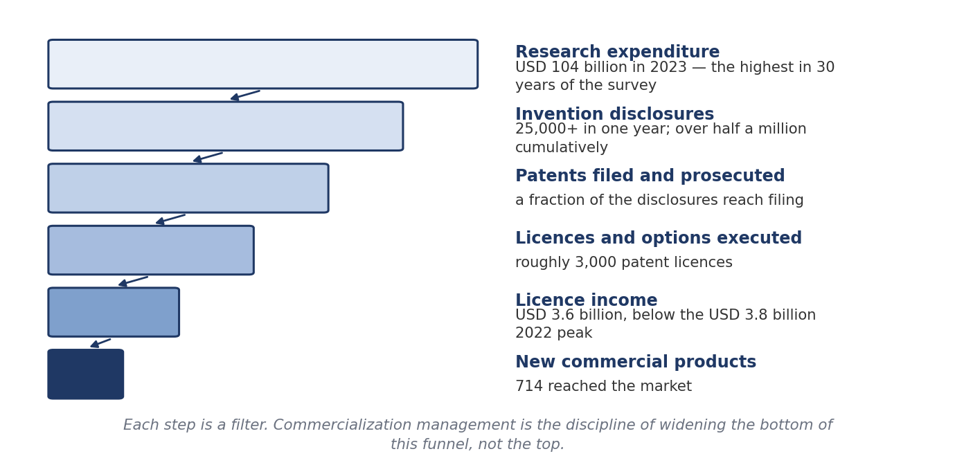
Figure 3.1 The academic commercialization funnel, 2023 reporting year. Source: AUTM 2023 U.S. Licensing Activity Survey.
Two readings are worth carrying. The optimistic one: a hundred billion dollars of research produced over seven hundred new products and billions of dollars of licence income in a single year, plus thousands of operating start-ups. The sober one: USD 3.6 billion of licence income against USD 104 billion of research spend is a ratio of about 3.5%, and income fell from its 2022 peak of USD 3.8 billion. Academic licensing is not a revenue strategy for a university; it is a public-mission strategy with a revenue by-product, and institutions that run it as a profit centre tend to over-price early-stage licences and lose the deal. Note also the funnel shape: the same survey reports roughly 3,000 patent licences executed, so disclosures outnumber licences by about eight to one.

3.3 Patent strategy I: the filing sequence
A university cannot afford to file everywhere on everything, and it usually does not yet know who the licensee will be. The standard filing sequence exists to buy time and defer cost while keeping the priority date.
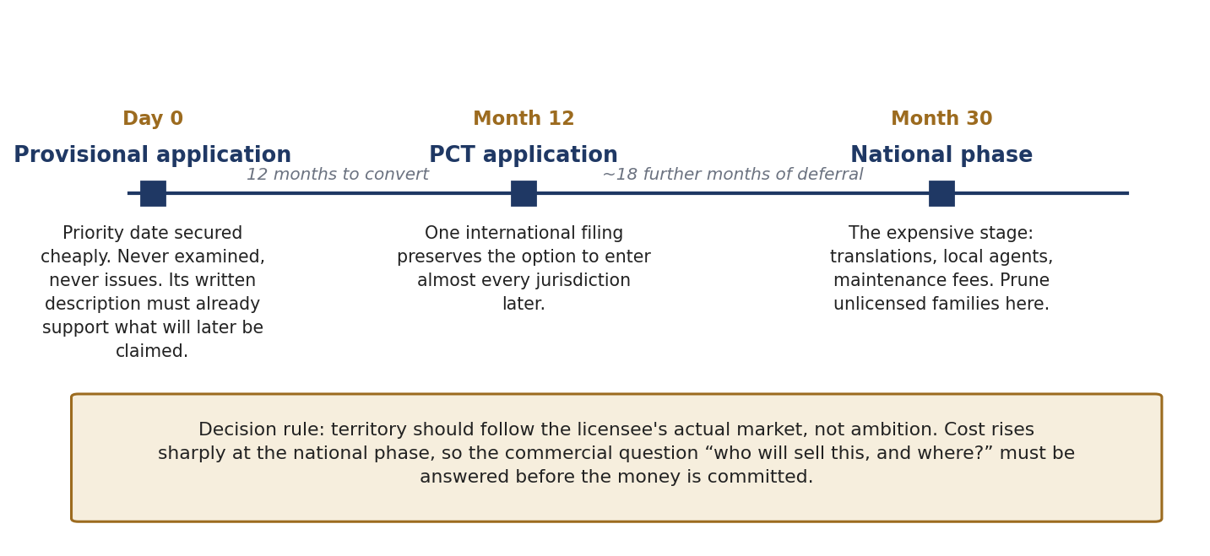
Figure 3.2 Provisional, PCT, national phase — a staged option on territory.
- Provisional application. Establishes a priority date at modest cost. Twelve months to convert; it is not examined and never issues. Its written description must support what is later claimed.
- PCT application. Preserves the option to enter the national phase in most jurisdictions, defers the large cost decision by roughly eighteen months, and buys time to find a licensee before committing to territory.
- National phase. The expensive stage — translation, local agents and maintenance fees. Territory should follow the licensee’s actual market, and unlicensed families are pruned here.
Notice what the sequence really is: a series of options, each bought for less than the sum it defers. The provisional buys a year for a filing fee; the PCT buys another eighteen months for one international filing; the national phase is where money becomes irreversible. That is the point at which a commercial question must be answered rather than postponed — who will sell this, and in which countries? Filing broadly to look impressive is the most common and most expensive mistake in academic IP management, and pruning is not a failure but the designed use of the last gate.
There is also a timing argument that runs the other way, and the book states it compactly: commercialization involves several races at once. Speed to technology (scanning, licensing in, collaboration) feeds speed to market, and between them sits speed to patent — a race in which the winner takes all, because a strategic patent does not merely slow a competitor down, it blocks them, and so creates market lead time. The three are complements rather than substitutes. Where patenting is seen as slowing a product down, the real impediment is usually an under-resourced patent department rather than patenting itself.
The cautionary case: CRISPR-Cas9
In the CRISPR-Cas9 interference the Federal Circuit agreed that the University of California’s earliest provisional application lacked adequate written description. A priority date is only as good as the disclosure that supports it — a provisional drafted thinly to save money can forfeit the very date it was filed to secure.
Research note, for accuracy: the decision is Regents of the University of California v. Broad Institute, Inc. (Fed. Cir., 12 May 2025). The court affirmed the written-description holding — UC’s first two provisionals, of May and October 2012, did not adequately describe the conditions for using single-guide CRISPR-Cas9 in eukaryotic cells, so UC was accorded priority only from its third provisional of January 2013. On the separate question of conception the court vacated and remanded, holding that the Board erred by conflating conception with reduction to practice and by requiring the inventors to know their invention would work. The priority dispute is therefore still unresolved. The lesson on provisionals stands, and gains a second edge: in unpredictable technologies, filing early with a thin disclosure and filing later with a full one are both risky, and the drafting effort at the provisional stage decides which risk you are running.

3.4 Valuation: heuristics, rules of thumb, and their limits
Two families of method dominate practice, and the deck presents them as a deliberate contrast: one quick and negotiable, one rigorous and hard to argue with.
The 25% rule
- Allocates roughly a quarter of the licensee’s expected operating profit on the product to the licensor.
- Attractive because it is quick, communicable, and produces a plausible opening number.
- Criticised for ignoring the IP’s relative contribution to the finished product — a patent covering one component of a thousand-component system is treated the same as one covering the whole.
- Best used as a sanity check on a negotiated rate, not as the derivation of one.
Monte Carlo and scenario analysis
- Replaces single-point forecasts with distributions over adoption, price and time to market.
- Well suited to staged technical and regulatory risk, where failure is probabilistic rather than binary — the characteristic shape of pharmaceutical and medical-device development.
- The output is a range and a confidence level, which is honest but harder to negotiate against than a single number.
- Only as good as the priors: precision is not accuracy.
The structural point — the most examinable idea in this section
Valuation of university IP is rarely the valuation of an asset in isolation. What is actually being priced is a bundle: the patent family, the inventor’s continued involvement, the institution’s willingness to accept milestones instead of cash, and the licensee’s cost of capital. Deal structure and valuation are the same conversation.
This is why a licensee will happily pay more in total for a structure weighted to milestones and royalties than for a smaller sum paid upfront: the upfront comes from scarce cash at the licensee’s highest cost of capital, whereas later payments come out of revenue the technology itself generates. A licensing officer who understands this can raise the total value of a deal while lowering its price.

Underneath both heuristics sit the three classical approaches. The cost approach asks what it would cost to recreate the asset — a floor, useful mainly for early-stage or internal transfers. The market approach looks for comparable transactions, the most persuasive evidence where comparables genuinely exist. The income approach discounts the cash flows attributable to the asset, and is the only method that can reflect exclusivity, remaining patent life and market size. Rules of thumb are shortcuts through the income approach; Monte Carlo is the income approach with its uncertainty made explicit.
Research note — a warning about the 25% rule
In Uniloc USA, Inc. v. Microsoft Corp. (Fed. Cir., 4 January 2011) the U.S. Court of Appeals for the Federal Circuit held the 25% rule of thumb to be a fundamentally flawed tool, and evidence relying on it inadmissible, because the rule says nothing about the particular technology, industry or parties. The court left the Georgia-Pacific factors intact as the framework for a reasonable royalty but required any evidence to be tied to the facts of the case. The lesson generalises to every rule of thumb in this document, including ALR = LR × AAFC: a heuristic is a negotiating aid and a sanity check. It is not a valuation, and in litigation it is not even admissible.

3.5 IP commercialization in the public research sector
The process is not too different from the private and academic sectors. What differs is the objective function, and therefore the terms a public body will and will not agree to. The stated priorities are:
- Accelerated market penetration — speed of deployment matters more than the size of the royalty.
- Providing some priority to SMEs, or promotion in underserved regions.
- Capacity development — building the skills and institutions that can absorb the technology.
- National security.
- Global competitiveness.
- Providing resiliency to national infrastructure.
- Preventing nefarious actors from accessing the technology and commercializing it with ill intentions.
- Creating harmonious relationships with the private sectors.
Read as a commercialization brief, these priorities explain a set of deal terms that would look irrational in a corporate context: non-exclusive licensing by default so that many firms can deploy quickly; field-of-use carve-outs and regional preferences for smaller domestic firms; obligations to manufacture or deploy locally; march-in and government-use rights retained; security screening of licensees and export-control conditions; and rates set below what the market would bear, because the objective is diffusion rather than income.
The comparison to remember
The corporation maximises appropriated value. The university maximises use, plus a share of the value. The public body maximises diffusion, subject to security. Each of those objectives produces a different licence from the same invention — which is why “what is this IP worth?” cannot be answered without first asking who owns it and what they are trying to achieve.

4 Revision

4.1 The whole topic on one page
Everything in Parts 1 to 3 fits into a single sequence of seven steps. If you can draw this from memory you can reconstruct almost any answer, because each step carries its own tools and its own failure mode.
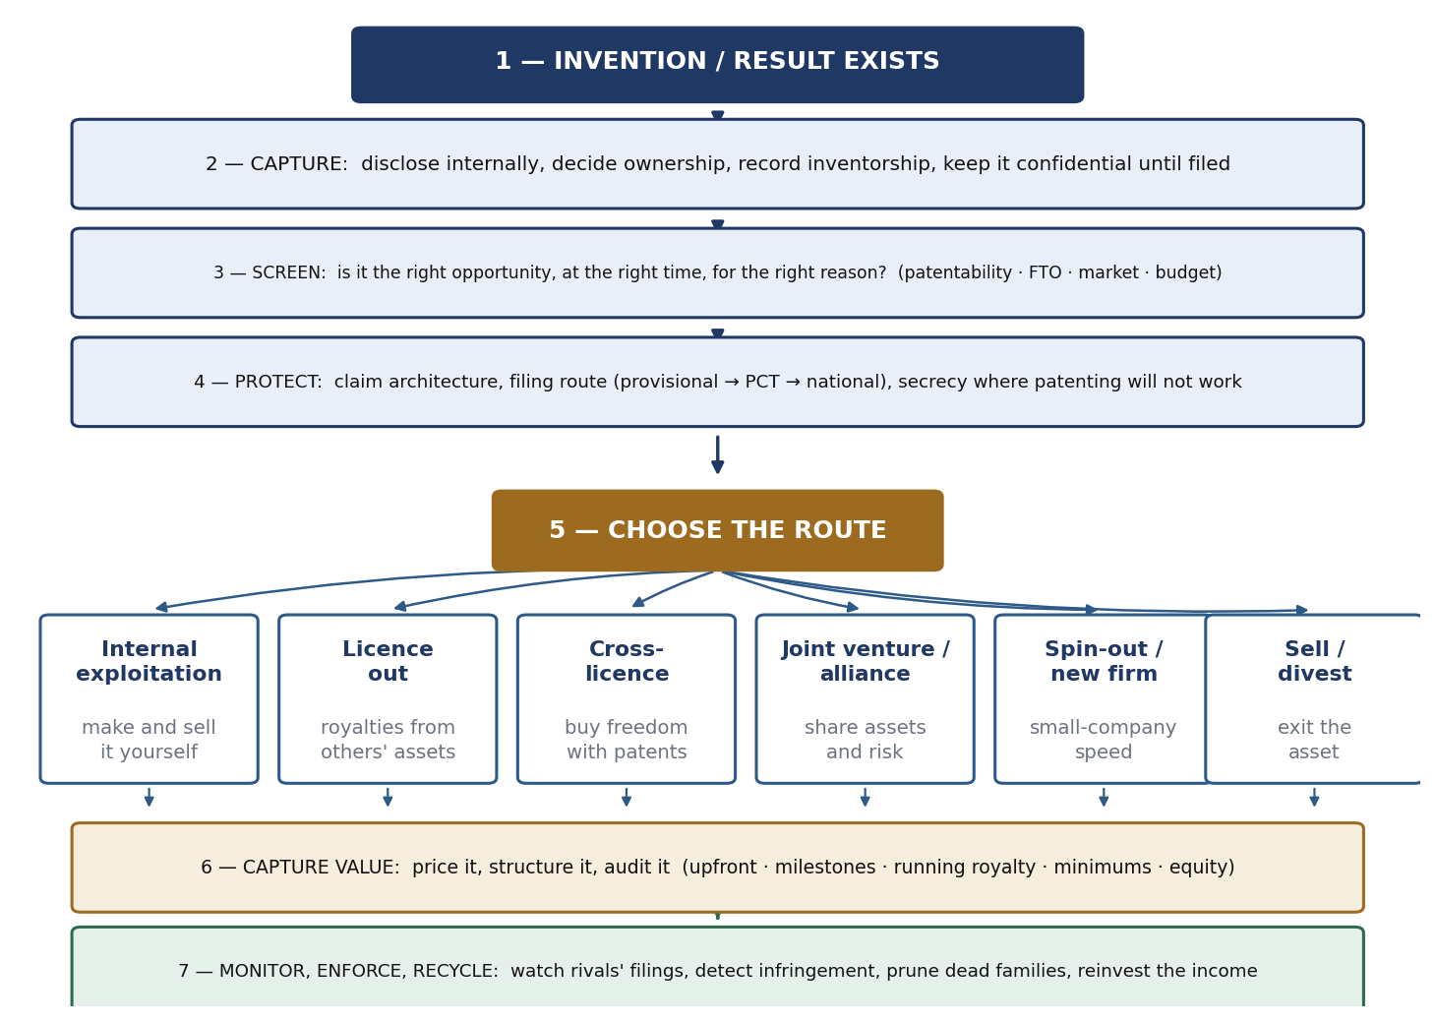
Figure 4.1 The IP commercialization roadmap.
Step | Decision | Tools and concepts | Failure mode if skipped
1–2 | Capture the invention | Invention disclosure, inventorship, assignment or statutory claim, confidentiality | Ownership defects; lost novelty through publication; inventors leave with the invention
3 | Screen the opportunity | Right opportunity, right time, right reason; patentability; freedom to operate; market size | Filing on everything; portfolios that cost more in fees than they earn
4 | Protect | Core claim plus dependent claims; blanketing and fencing; provisional → PCT → national phase; secrecy where patenting will not work | Thin disclosures that forfeit priority; claims a competitor can invent around
5 | Choose the route | Internal exploitation, licence out, cross-licence, joint venture, innovative firm, divestment | A patent with no business model attached
6 | Capture value | Justified limits and the zone of agreement; ALR = LR × AAFC; the 25% rule as a sanity check; milestones versus cash | Under-priced exclusivity; unauditable royalties; deals that cannot be performed
7 | Monitor and recycle | Monitoring competitors' filings, infringement detection, portfolio pruning, reinvestment | Value decays quietly: unused families maintained, infringement undetected
Table 4.1 The roadmap in words.

4.2 Choosing the route
Route | Use it when | What you capture | Main risk
Internal exploitation | You hold the complementary assets — production, distribution, brand — and the market is core | The whole margin, plus market position | Slow if the technology sits outside the existing divisions
Licence out | Others hold the complementary assets, or the market is outside your business areas | Royalties with no capital employed | Creating a competitor; the licensee shelves the technology
Cross-licence | You are blocked, or you need design freedom in a crowded field | Freedom to operate; litigation avoided; royalties netted | Giving away more than you receive if your portfolio is weak
Joint venture / alliance | Neither party alone has all the assets and both must invest | Shared risk and shared market access | Background and foreground IP disputes; divergent objectives
Create an innovative firm | The technology falls outside existing businesses, or an entrenched division would smother it | Small-company speed with retained ownership and control | Under-resourcing; loss of the parent's complementary assets
Sell / divest | The asset is off-strategy and somebody values it more than you do | Immediate cash; no maintenance burden | Selling the tail that turns out to hold the value
Keep secret | The invention is not detectable in the product and not independently reachable soon | Protection with no disclosure and no expiry | Reverse engineering; independent invention; no right to exclude
Table 4.2 Most real programmes use three or four of these at once on the same technology in different markets.

4.3 Ten points to remember
- Protection is a means; commercialization is the point. An unused patent is a liability with an annual fee.
- The market prices quality, not count. Value is log-normally skewed; the tail pays for everything, so pruning creates value.
- Exclusivity is an instrument, not a reward. That is the whole mechanism of Bayh–Dole: it created a counterparty who could justify development investment.
- Copying is not the biggest obstacle. Access to technology, timely production and marketing costs all rank at or above it, so a patent solves one problem out of six.
- The real limitation of a patent is invent-around. So build fields of rights, not single rights: core claim, dependent claims, blanketing and fencing, deepened vertically and spread horizontally.
- Lock out beats lock in. Firms consistently valued raising an imitator's costs above raising a customer's switching costs.
- A generic technology is what makes a portfolio worth building. Technological economies of scale, scope and speed come from carrying one competence into many applications.
- The base matters as much as the rate. AAFC is chosen because it is auditable; a volatile base produces disputes instead of payments.
- Deal structure and valuation are the same conversation. You are pricing a bundle: the family, the inventor, the payment timing and the licensee's cost of capital.
- The objective function decides the licence. Corporations maximise appropriated value, universities maximise use plus a share, public bodies maximise diffusion subject to security.

4.4 Key numbers
Figure | Value | What it is
First million U.S. utility patents | 121 years | Against three years for the eleventh million (2018–2021)
U.S. grants per year | ~70,000 → ~374,000 | 1976 compared with 2024
Global patent filings | 3.5m (2023) → 3.7m (2024) | WIPO; 2024 was +4.9%, the fastest growth since 2018
Intangibles share of S&P 500 | 17% → 92% | 1975 to the 2025 Ocean Tomo release
Extra citation per patent | +3% market value | Hall, Jaffe and Trajtenberg; 20+ citations ≈ 54% premium
U.S. academic research spend | USD 104 billion | 2023; highest in 30 years of the AUTM survey
Academic disclosures / products | 25,000+ / 714 | One year's disclosures against products reaching the market
Academic licence income | USD 3.6 billion | 2023, below the USD 3.8 billion 2022 peak
Royalty band in the thumb rule | LR floor 1–3%, ceiling 3–7% | Applied to AAFC, the annual ex-factory cost
The 25% rule | 25% of licensee operating profit | A sanity check only; inadmissible as evidence after Uniloc (2011)
Patents for commercializing products | Japan 3.3 / Sweden 1.9 / USA 2.0 | Book evidence: patents rank first in Japan, near-last in the West
Top limitation of patents | 2.58 of 4 | Competitors can legally invent around them
Huawei | 165,000+ patents, 260+ licences | Active patents at end-2025; cross-licence agreements over twenty years

4.5 Glossary
Term | Meaning
AAFC | Annual cost of products after the factory — the royalty base in the thumb rule, chosen because it excludes volatile shipment costs and margins and is easy to audit
ALR | Annual licensing revenue; ALR = LR% × AAFC
Bayh–Dole Act | U.S. statute of 1980 (P.L. 96-517; 35 U.S.C. §§ 200–212) vesting title to federally funded inventions in the university, nonprofit or small-business contractor
Blanketing / fencing | Covering an area so densely with patents that any route through it infringes / filing around a core invention to block the substitutes a rival would use
Complementary assets | The production, distribution, marketing and service capability without which an invention cannot reach a market
Core claim | The broad independent claim on the underlying concept, to which application-specific dependent claims are attached
Cross-licensing | Mutual grant of licences between two patent holders, usually to obtain freedom to operate and end or avoid litigation
FRAND | Fair, reasonable and non-discriminatory — the licensing commitment standards bodies require for standard-essential patents
Freedom to operate | The absence of third-party rights blocking commercialization of a product in a given market
Generic / trunk technology | A technology with many applications across products and businesses; the source of technological economies of scale and scope
Invent-around | Achieving the same function with a substitute invention that falls outside the claims — the limitation firms rank highest
Lock-in / lock-out | Raising customers' switching costs / raising imitators' costs of imitation, which is what a patent does
PCT application | A single international application preserving the option of national-phase entry in most jurisdictions and deferring the large cost decision
Provisional application | A low-cost filing that fixes a priority date, is never examined, and must already describe what will later be claimed
Run-in / squeeze-out | Being first to market / defeating incumbents through superior production or marketing
SEP | Standard-essential patent: a patent that cannot be avoided when implementing a standard
Speed to technology / patent / market | The three complementary races whose outcomes determine market lead time
Tobin's q | Market value divided by the replacement cost of assets — the dependent variable in the patent-value studies
X-patents | The roughly 9,957 unnumbered U.S. patents whose records burned in December 1836 and were reconstructed from inventors' copies

4.6 Practice questions
Short answer
- Why is a raw count of active patents a poor proxy for portfolio value? Support your answer with the citation evidence.
- State the four dates that set the architecture of the U.S. patent system, and say what each contributed.
- What does AAFC stand for, and why is it preferred to the sales price as a royalty base?
- Distinguish run-in, lock-in, lock-out and squeeze-out, and state which one a patent performs.
- Why did Bayh–Dole increase commercialization without spending money?
- Explain the difference between vertical and horizontal expansion of a patent portfolio.
- What are the three stages of the standard filing sequence, and what does each one buy?
Long answer
- Draw and explain the innovation ecosystem, and say what happens at each legal gate.
- Set out the seven requirements for robust corporate IP commercialization, and use the survey evidence on limitations to profit from innovation to explain why an IP strategy alone is insufficient.
- A company has developed a generic sensing technology with applications in four markets. Design its claim architecture and portfolio-expansion strategy, and justify it by reference to the limitations of patents.
- Compare the U.S. and German/EU employee-invention regimes and explain how each shapes a multinational's IP commercialization process.
- A university holds a promising platform invention, has no licensee and a limited budget. Design its filing and licensing strategy, using the CRISPR case as a cautionary reference.
- “Valuation and deal structure are the same conversation.” Discuss, using the 25% rule, Monte Carlo analysis and the structural point about bundles.
- Compare the objectives of corporate, academic and public-sector commercialization, and show how each produces different licence terms from the same invention.

4.7 Sources
- Class material (the spine of this document): seminar deck — First Principles of the U.S. Patent System; The Accelerating Pace of Patenting; Do Patents Show Up in the Share Price?; Global IP Facts and Global Patenting Trends; Guest Session by Dr Osman Ahmed, “IP Commercialization in the Corporate World”; The Bayh–Dole Act of 1980; The System in Aggregate; Patent Strategy I: The Filing Sequence; Heuristics, Rules of Thumb and Their Limits; IP Commercialization Strategy in the Public Research Sector.
- Explanatory material: Chapter 6, “Technology and Commercialization Strategies” (BIP) — used for the survey evidence on means of commercializing new technologies, limitations to profit from innovation, limitations of patents, strategies for exploiting technology, technological economies of scale, scope and speed, blanketing and fencing, secrecy and reverse engineering, and the three speed races.
- Cited in the deck: Hall, Jaffe and Trajtenberg, “Market Value and Patent Citations,” RAND Journal of Economics 36(1), 2005, pp. 16–38; Ocean Tomo Intangible Asset Market Value Study, 2025 release; USPTO patent milestone records and annual patent activity tables; WIPO World Intellectual Property Indicators; AUTM 2023 U.S. Licensing Activity Survey; Regents of the University of California v. Broad Institute (Fed. Cir., 12 May 2025).
- Added by research and marked in the text: WIPO World Intellectual Property Indicators 2025 (2024 filing data); German Employee Inventions Act mechanics and remuneration guidelines; Uniloc USA, Inc. v. Microsoft Corp., 632 F.3d 1292 (Fed. Cir. 2011) and the Georgia-Pacific factors; the full disposition of the CRISPR priority appeal; SEP and FRAND practice.
End of document.

