IP MANAGEMENT · IP61019
Mid-Sem Notes

Unit 1: Definitions, Concepts and Context · Unit 2: Intellectual Capital and Knowledge Economy · Unit 3: IP Commercialization

Contents

If this list is blank, click on it and press F9.

Unit 1 — Definitions, Concepts and Context

1(a) Introduction to Intellectual Property Management
IP law asks what a right is and how it is obtained. IP management asks what should be done with it: is it worth the money spent on keeping it alive, who should own it, and should it be used, licensed or sold?
Definition
IP management is the planned use of an organisation's intellectual property to create value. It combines technology, law and business, and it fails if any one of the three is missing — a good invention with no market, a market position with no protectable right, or a perfect patent with no business plan.

Management in general means using resources in a planned way to reach a goal. The usual aims, each of which reappears in IP:
- Increasing efficiency.
- Cost-benefit optimisation — in IP, whether to pay for protection in a country where nobody will sell.
- Resource optimisation.
- Minimising errors — in IP, not missing a deadline and not publishing before filing.
- Maximising shareholder value.
- Quality improvement.
- Balancing competing interests — inventor, employer, sponsor, licensee, public.

Administration and management
- Administration = the top level. Makes policy, decides, governs, thinks 10–20 years ahead. In IP this is IP strategy. Example: the board decides to enter automotive sensing.
- Management = the level below. Implements, executes, meets milestones, assesses risk step by step. In IP this is IP management. Example: the IP department decides what to file, where, with what claims, at what cost.
The order is business strategy → IP strategy → IP management, and only in that direction. IP management never leads: a portfolio that is excellent in law but wrong for the business is a managed failure. This does not make operational work minor — one word in a claim decides twenty years of coverage.
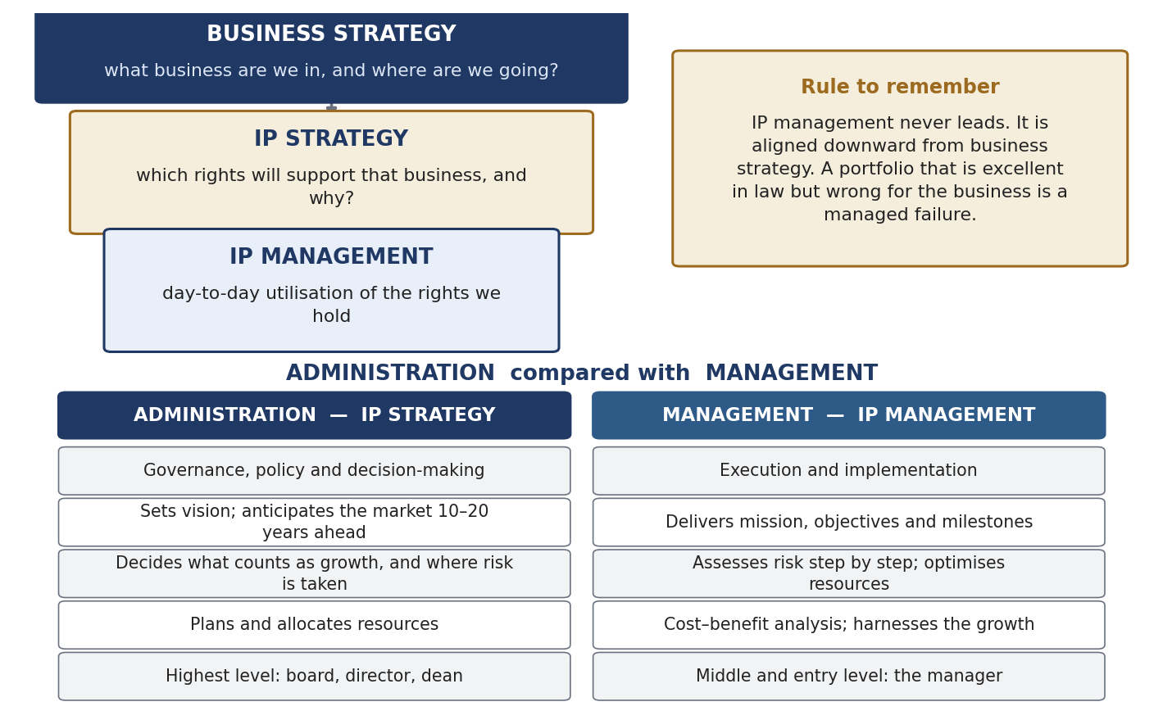
The hierarchy, and the administration–management contrast.

What the IP manager does
Sullivan (1998) listed the key responsibilities:
- Generation of IP.
- Portfolio management.
- Valuation.
- Converting intellectual assets into competitive assets.
- Strategic decision-making.
The practical four-stage cycle used in class:
- Recognise and categorise the IP — is it protectable, under which law, and how is it classified in business, technical and legal terms?
- Brand it — give it identity and communicable value.
- Grow and defend it — expand the portfolio, monitor, enforce, maintain.
- Value it — every decision above needs a number.

Why the discipline appeared in the 1980s–1990s: the pro-patent era
- 1883 — Paris Convention. Foundation of the international system: national treatment and the right of priority.
- 1980 — Bayh–Dole Act. US universities, nonprofits and small businesses can own federally funded inventions. Creates an owner who can licence exclusively, so a company has someone to negotiate with.
- 1980 — Diamond v. Chakrabarty, 447 U.S. 303. US Supreme Court, 5–4: a living genetically engineered organism is patentable subject matter.
- 1982 — CAFC created. All US patent appeals centralised; patents become much stronger and harder to invalidate.
- 1994 — TRIPS. Minimum standards binding on WTO members; the system goes global.
Once patents became enforceable, valuable and global, portfolios grew too large to leave to a filing clerk, and the dedicated function appeared. Management arrives only when there is a stock worth managing.
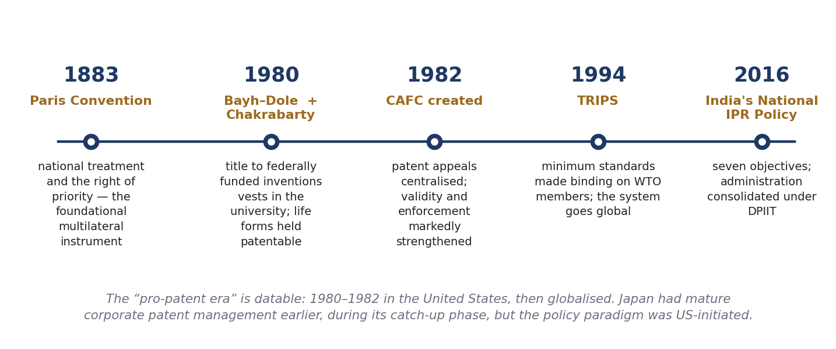
The dates that made IP management necessary.

1(b) Basic Definitions and Concepts

The four nested terms
- Intangible asset — anything of value with no physical form. Widest term. Includes goodwill, reputation, customer relationships, data.
- Intellectual capital / intellectual assets — the knowledge-based part: people, structures, relationships, documented know-how.
- Intellectual property — the part the law recognises as protectable subject matter.
- IP right — the enforceable right itself: patent, trademark, copyright, design.
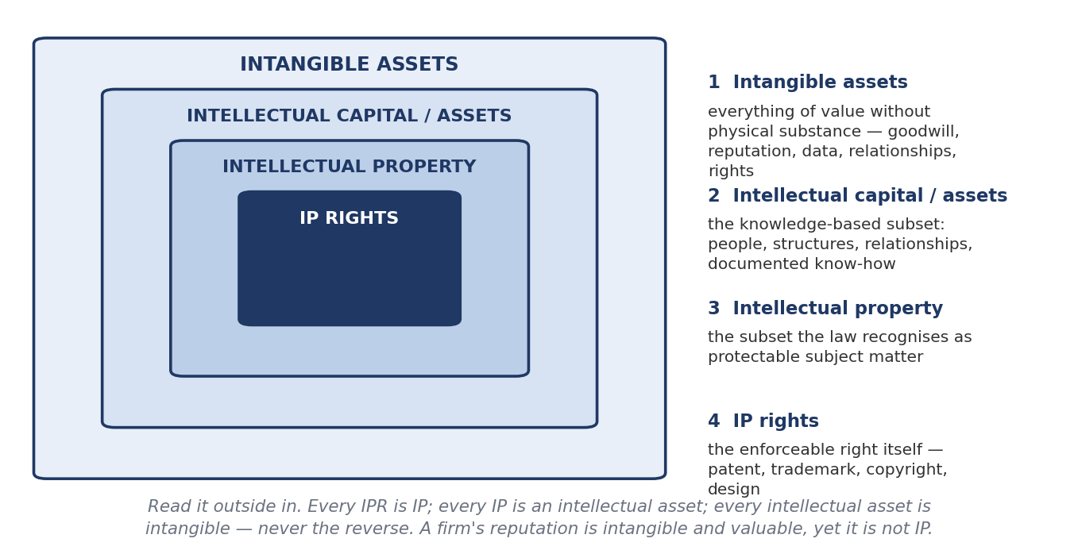
Read from outside to inside.
Two propositions that are always asked
1. IP is a subset of intangible property — never the reverse. Every IPR is IP; every IP is an intellectual asset; every intellectual asset is intangible.
2. IP has a dedicated protection regime (Patents Act, Trade Marks Act, Copyright Act, Designs Act). Other intangibles have only general law — contract, confidentiality, employment terms, passing off.

Contract law underlies the whole field. The patent bargain is itself an exchange: the applicant discloses and the State grants. Every licence, assignment, NOC and confidentiality undertaking is a contract.
Right | What it protects | Term | Role
Patent | New, non-obvious, industrially applicable invention, in exchange for full disclosure | 20 years from filing | Core exclusivity asset; currency of cross-licensing
Trademark | A sign distinguishing one undertaking's goods or services | 10 years, renewable indefinitely | Carries value after the patent expires
Copyright | Original expression — text, code, drawings, data compilations | Life + 60 years (India) | Arises automatically; dominant in software
Industrial design | The appearance of a product | 10 + 5 years | Protects the embodiment when function is unpatentable
Trade secret | Commercially valuable confidential information | As long as secrecy holds | No disclosure, but no right against reverse engineering
A single product usually carries several of these at once.

Classification of intangible assets
- Branch 1 — Intellectual property: protected by dedicated statute.
- Branch 2 — Intellectual capital: human capital (knowledge, skill, experience); structural or infrastructure capital (processes, systems, labs, databases); relational capital (networks with industry, government, alumni); innovation capital or potential (capacity to make the next asset); and three further dimensions — cognitive (how fast a problem is processed), conative (the will to act) and affective (how much people care).
Why intellectual capital is invisible in the accounts (IAS 38 / Ind AS 38)
Internally generated goodwill cannot be recognised at all. Internally generated brands, mastheads, titles and customer lists are expressly prohibited. All research spending must be written off; only development costs meeting strict conditions may be capitalised.
Result: a firm that builds a great portfolio shows almost nothing on its balance sheet, while a firm that buys one shows it at cost. The gap between market value and book value is where intellectual capital hides — and that gap is why value must be measured indirectly (section 1(c)).

The knowledge chain
Data → information → knowledge → idea → intellectual product. Data are unorganised signals; organised and placed in context they become information; interpreted, information becomes knowledge; applied to a problem, knowledge produces ideas; an idea developed and protected becomes an intellectual product.
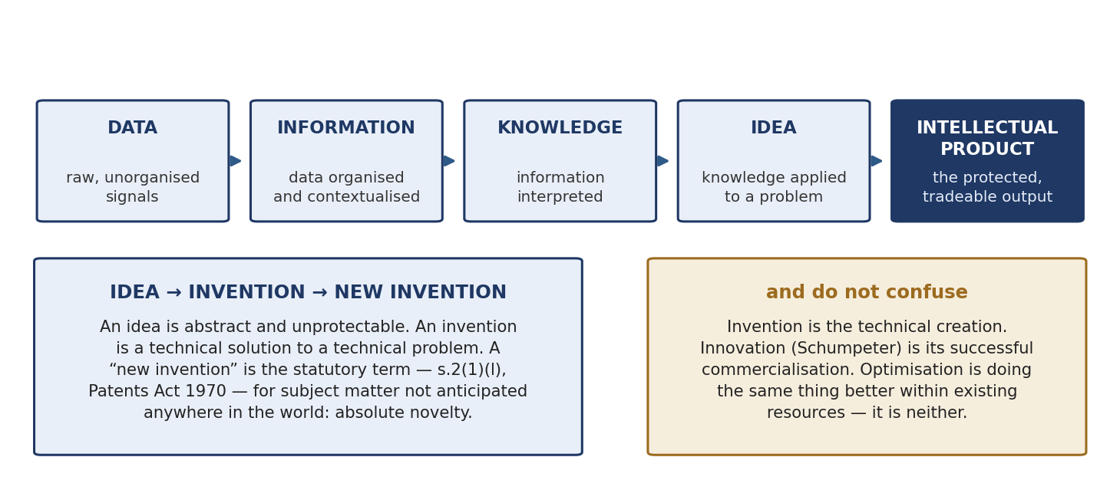
The chain, and the distinctions built on it.

Three distinctions that are constantly confused
- Optimisation — doing the same work better with the same resources. Class example: an operator realises after thirty years that a plate on a tobacco machine can be turned the other way, cutting time and cost. It may still be patentable, because trial-and-error discovery is not excluded.
- Invention vs innovation — an invention is the technical creation; an innovation (Schumpeter) is its successful commercialisation. An invention nobody sells is not an innovation.
- “New invention” is statutory — s.2(1)(l), Patents Act 1970: not anticipated by publication in any document, or used in India or elsewhere in the world, before the date of filing with complete specification. This is absolute novelty. Compare s.2(1)(j) (invention) and s.2(1)(ja) (inventive step).

Why a patent is a negative right
Section 48, Patents Act 1970 gives the patentee the right to prevent others from making, using, offering for sale, selling or importing the invention. It does not permit the patentee to do anything. 35 U.S.C. §154 is worded the same way.
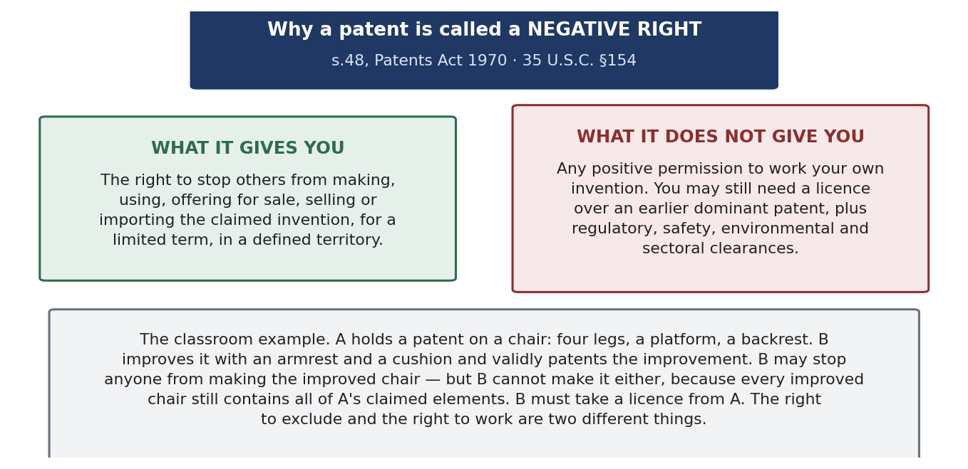
What it gives, what it withholds, and the example that settles it.
The chair example. A patents a chair with four legs, a platform and a backrest. B validly patents an improvement adding an armrest and cushion. B can stop everyone from making the improved chair, but cannot make it either, because every improved chair contains all of A's elements. B must licence from A. The right to exclude and the right to work are different questions; working also needs regulatory, safety and sectoral clearances that the Patents Act says nothing about.
Is it unique to patents? The usual argument: an author can always use his work and a trademark owner his mark, but a patentee may be blocked. The counter-argument: all exclusive rights are structurally rights against others. The difference is one of degree, because technology is cumulative and improvements necessarily contain what came before, whereas expression can be created independently.

Value and price
- Value = what the asset is worth in use, assessed by the holder or a valuer.
- Price = what is actually paid, set by bargaining power, urgency, alternatives and information.
- The gap is wide in IP because most patents are never sold, so there are no comparables.
- Trademark value is the volatile one — it rests on goodwill, which one event can destroy (Kingfisher Airlines; the Maggi recall of 2015). A patent's value rests on technology and claim scope and falls gradually as the term runs out.

Treaty, convention, protocol, agreement, contract
- Treaty — a binding agreement between States under international law.
- Convention — in substance a treaty; the word is used for multilateral instruments under an international organisation (Paris Convention).
- Protocol — a supplementary instrument attached to a parent treaty (Madrid Protocol).
- Agreement — the widest word; used internationally (TRIPS) and in private law.
- Contract — s.2(h), Indian Contract Act 1872: an agreement enforceable by law. Section 10 gives the conditions — competent parties, free consent, lawful consideration and object, not expressly void. Every contract is an agreement; not every agreement is a contract.

1(c) Context for the Development and Measurement of IP Culture and Value
Two separate questions. IP culture is about whether an organisation produces IP at all. IP value is about what the resulting assets are worth. Culture comes first; value follows from commercialisation.

What IP culture is, and how it is assessed
IP culture is the awareness, incentives, infrastructure and routines that make an organisation generate, protect and exploit IP. Ask a class to rank five institutions out of ten and everyone ranks them instantly and agrees — which proves the concept is real. The parameters behind that intuition:
- Research history and experience.
- Patent portfolio size and quality.
- Infrastructure and research facilities.
- Number of applications filed.
- Technology transfer and licences granted.
- Research funding and sponsorship.
- Infringement litigation record.
- Collaborations with industry.
- Add three that measure culture rather than output: invention-disclosure rate per researcher, inventor reward systems, and IP awareness training.
- Behind all of them sits one summary measure — wealth generated from intellectual assets.

Benchmarks
Institution | Figures | What it shows
Stanford | PageRank patent licensed to Google for 1.8 million shares, sold 2005 for about USD 336 million. Cohen–Boyer patents: 468 licensees, about USD 35 bn product sales, USD 255 million licensing revenue to end-2001 | A university can be a main actor. Equity beat a running royalty
MIT (FY2025) | 684 disclosures, 282 US patents issued, 137 licences, USD 60.9 million licence revenue; about 53% of the portfolio licensed or optioned | The 53% is the real measure — the portfolio is used, not stored
IIT Kharagpur | About 450 patents filed, 120 granted, 7 licensed, 40 copyrights, 60 technology transfers (cumulative) | Filing culture present; commercialisation neck is narrow
AUTM (USA, FY2024) | 26,196 disclosures; 9,507 licences; 775 products; 941 start-ups; USD 109.7 bn research | The standard benchmark survey
The diagnostic number is not filings but the ratio of licences to grants.
Cohen–Boyer — the case that shows the culture
Cohen (Stanford) and Boyer (UC) worked separately, one on a cutting enzyme, one on the joining technique, and had never collaborated.
Niels Reimers, head of Stanford's licensing office, read a press report of their conference talks, saw the two halves made a platform technology, and proposed patenting.
Scientists objected that the technology could be misused. Reimers neither overrode them nor dropped the filing — he convened them and produced a policy on genetic experiments. The objection dissolved and the patent was granted.
Commercialisation needed a different person: the venture capitalist Robert Swanson, whose persistence produced Genentech and the first recombinant human insulin, marketed by Eli Lilly.
The lesson for complementary assets: the university had the invention, Genentech the development capability, Eli Lilly the marketing. All three were needed.

Why value is hard to measure
- Value is extremely skewed, approximately lognormal. The top 10% of a portfolio holds roughly 80–85% of its value; the PatVal-EU study (2005) found only about 7% of patents worth over €10 million.
- There is usually no market. Most patents are never sold, so there are no comparable transactions.
- Value is contingent on things outside the asset — the holder's manufacturing and distribution, and the remaining term.
A valuation is therefore best given as a range with an explanation, not a single number.

Frameworks for measuring intellectual capital
Framework | Author, year | What it does
Skandia Navigator | Edvinsson & Malone, 1997 | First corporate IC report. Five focus areas: financial, customer, process, renewal and development, human
Tobin's q | James Tobin | Market value ÷ replacement cost of assets. A high q means the market is paying for intangibles the accounts omit
Intangible Assets Monitor | Sveiby | External structure, internal structure, individual competence
Balanced Scorecard | Kaplan & Norton, 1992 | Financial, customer, internal process, learning and growth. A management system, not a valuation
VAIC | Ante Pulic | Efficiency of human capital, structural capital and capital employed, from published accounts
Technology Broker | Brooking, 1996 | Market assets, human-centred assets, IP assets, infrastructure assets
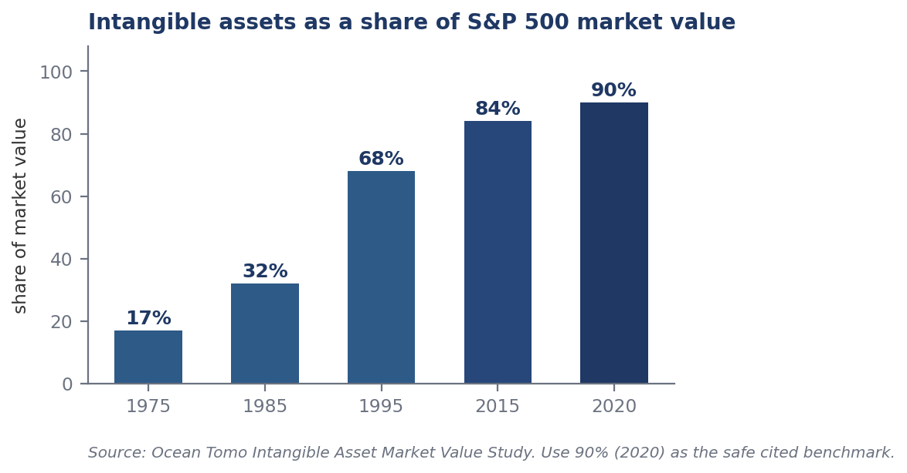
Intangibles as a share of S&P 500 market value: 17% (1975) → 68% (1995) → over 90% (2020).

What an IP culture costs
- One Indian patent: roughly ₹1 lakh in professional fees as a working average. Government fees are separate and tiered by applicant type.
- International cover: one PCT application keeps the options open; the money goes out at the national phase — translation, local agents, amendment to local practice. There are about 180 Paris Convention countries.
- Annuities: payable every year, in every country, for up to 20 years. This is what makes an unused patent a standing liability.
- Adjacent rights (design, trademark, copyright) usually travel with the same product; trade secrets cost money in security and process.

1(d) In Search of a Paradigm Shift from “Intellectual Property” to “Intellectual Capital”
Note the words “in search of”: this is a thesis with evidence, not a settled fact.
A paradigm is the standard accepted structure of assumptions and methods; the term in this sense is from Thomas Kuhn, The Structure of Scientific Revolutions (1962). A paradigm shift is when those assumptions are themselves replaced.

The four economic stages
- Agricultural — wealth is land, cattle, seed.
- Industrial — wealth is labour and machines; as technology displaces labour, value moves to machines and products.
- Information — wealth is data and computing.
- Intellectual capitalism — wealth is knowledge and the rights that fence it. Granstrand's term: an economy in which creating intellectual capital and intellectual properties is the heart of value creation. In many firms IP value now exceeds physical capital.
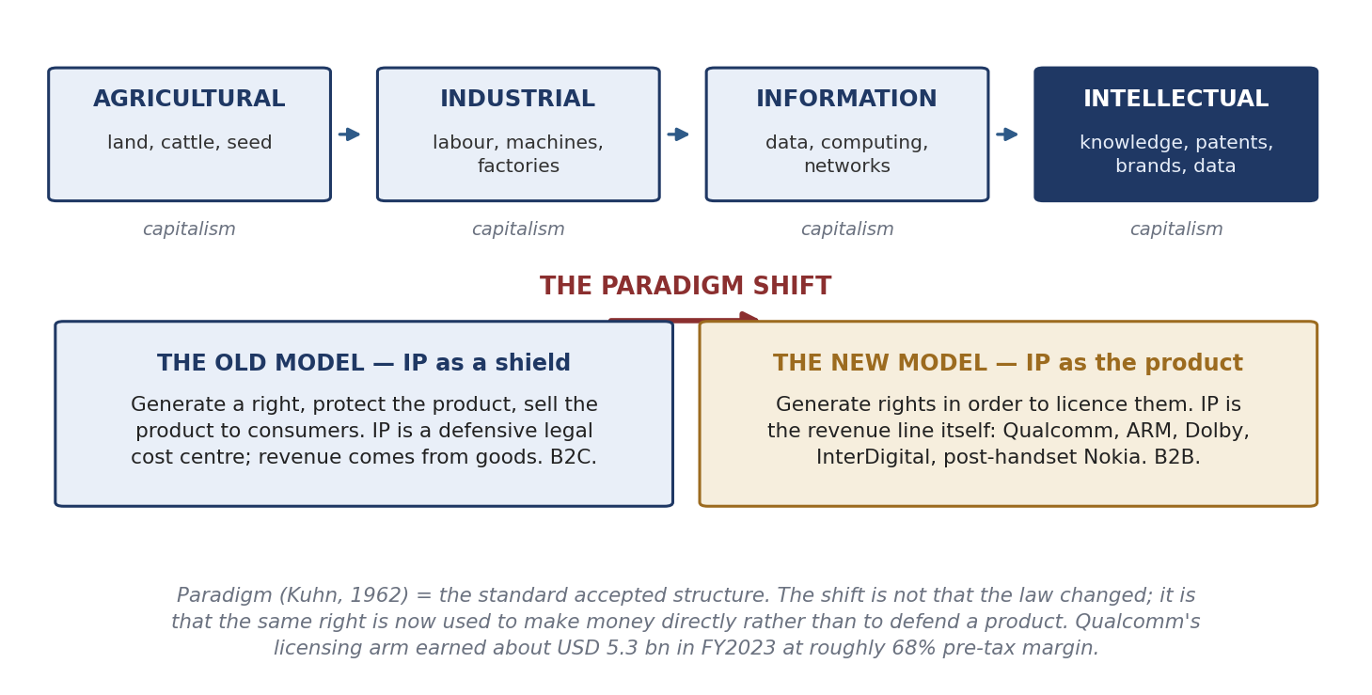
The four stages, and the shift inside the last one.

What actually changed
Not the law — no statute was amended. The purpose for which the same right is held changed.
- Old model: create IP to protect a product sold to consumers. IP is a defensive cost centre; revenue comes from goods. Business-to-consumer.
- New model: create IP in order to licence it. IP is the revenue line itself. Business-to-business.
- The class formulation: firms once generated property to protect themselves; now they generate property to make property.

Evidence
- Qualcomm's licensing segment earned about USD 5.3 billion in FY2023 — roughly 15% of revenue but at about 68% pre-tax margin, so it contributes far more profit than turnover.
- IBM's IP and licensing income averaged around USD 1 billion a year after 1996, peaking near USD 1.7 billion in 2000 (mixing patents, copyright, brand and know-how).
- ARM, Dolby, InterDigital, Texas Instruments and Nokia after handsets are further examples; Ericsson and Qualcomm rest on standard-essential portfolios.
- A second consequence: owners who make nothing — non-practising entities, patent assertion entities, brokers and IP marketplaces.
Keep the two senses of “intellectual capital” apart
Innovation sense — the stock of knowledge resources (people, structures, relationships) from which new value is created. This is the sense used in Unit 2.
Accounting sense — intangible capital expressed in financial terms for a valuation or balance sheet. Same words, different thing.

Unit 2 — Intellectual Capital and Knowledge Economy

2(a) Intellectual Capital and the Knowledge Economy
A knowledge economy is one in which wealth is created principally by knowledge rather than by land, labour or physical capital. The term was popularised by the OECD report The Knowledge-Based Economy (1996). Antecedents: Machlup (1962), Bell (1973), and Drucker, who coined “knowledge worker”.

The four pillars (World Bank Knowledge Economy Index)
- Economic incentive and institutional regime — does the system reward the creation of knowledge? This is where IP law sits.
- Education and skills — can people create knowledge and absorb it?
- Innovation system — firms, universities and labs that convert knowledge into use.
- ICT infrastructure — can knowledge move and be shared?
Strong on pillar 2 and weak on pillar 1 means the country exports its knowledge workers. Strong on pillar 1 and weak on pillar 3 means it holds rights nobody commercialises.
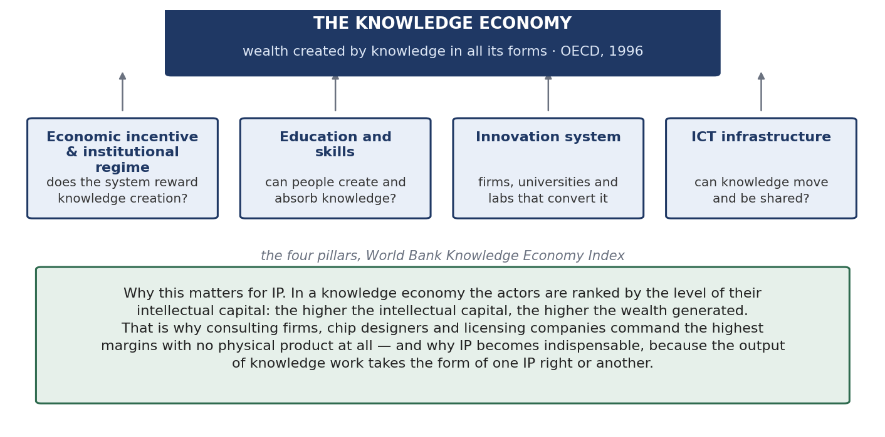
The four pillars.
Other economy labels, in one line each: a mixed economy combines private enterprise with State direction; a market economy leaves allocation to market forces; a command economy leaves it to the State; blue and green economies concern ocean resources and sustainable growth; a data economy is the sub-case where data are the main input.

The components of intellectual capital
Intellectual capital is the stock of knowledge-based resources from which an organisation creates value. All IP is intellectual capital; most intellectual capital is not IP.
- Human capital — knowledge, skill and experience of people: students, faculty, lab and library staff. Indian institutions are strong here.
- Structural / infrastructure capital — processes, systems, records, laboratories, instruments, databases. What remains when people go home. Also strong.
- Relational capital — value in networks with industry, government and alumni. Test: can one phone call produce a panel, an instrument or a dataset?
- Innovation capital / potential — the capacity to generate the next asset; the aggregate of the others working together.
- Cognitive capital — how fast and how well a problem is processed. A hundred people solve the same problem a hundred ways, some in two steps and some in ten.
- Conative capital — the will to act: drive, initiative, persistence.
- Affective capital — how passionate people are about the work.
The conclusion that matters
Everybody has human, structural and relational capital. What differentiates one organisation from another is the last three — cognitive, conative and affective — because they decide whether the first three are converted into output. The first three explain capacity; the last three explain conversion.
Also remember: organisational capital = intellectual capital + financial capital.

In a knowledge economy IP is indispensable most of the time, because the output of knowledge work almost always takes the form of some IP right. Not always, though — do not claim that everything must be governed by IP.

2(b) Transforming Intellectual Property into Intellectual Capital in a Competing Economy
The heading asks how IP is turned into capital, not how it is created. It is a pipeline with investment on one side and financial gain on the other.
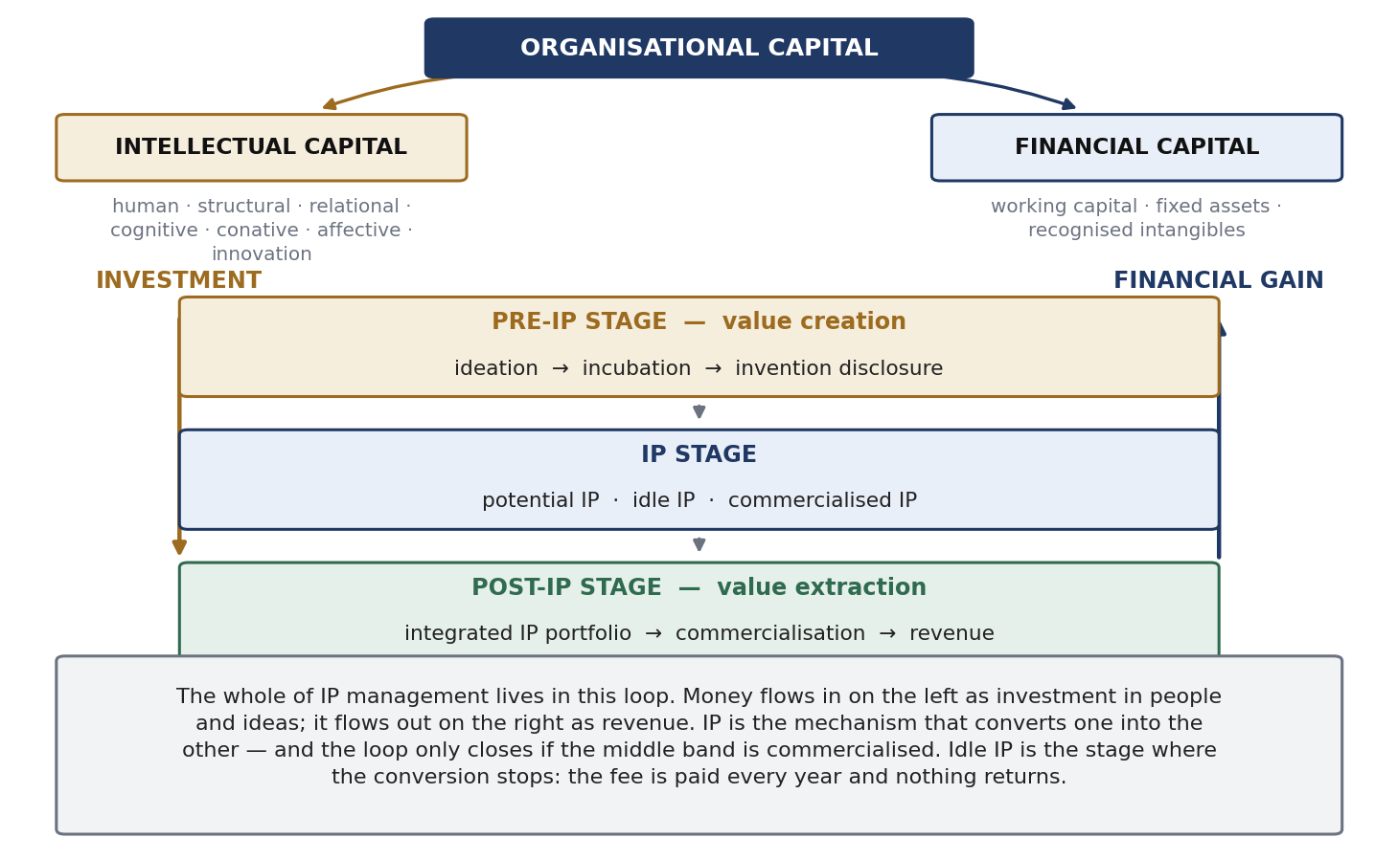
The pipeline and its three stages.

The three stages
- Pre-IP stage — value creation. Ideation, incubation, invention disclosure. Nothing is protected, nothing earns, money flows in one direction only.
- IP stage. The asset exists in one of three conditions: potential IP, idle IP, or commercialised IP.
- Post-IP stage — value extraction. Integrated portfolio → commercialisation → financial gain.
Where the conversion fails
Idle IP — protected but unused. The annuity is paid every year in every country and nothing returns. Creating IP is not the achievement; monetising it is.
Leakage — proprietary technology escaping through weak confidentiality, leaky suppliers and departing staff. Survey evidence suggests firms lose roughly as much technology as they deliberately sell.

Routes of conversion
- Internal exploitation; licensing out; cross-licensing; joint venture; creating an innovative firm; sale or divestment.
- Not all conversion is cash. Freedom to operate, bargaining power and the ability to net royalties against a competitor are real conversions of IP into capital.
- The portfolio, not the patent, is the unit of management. Because value is concentrated, integration and pruning create value rather than merely saving cost.

How it happens in practice: the funnel
- A brief arrives that may be a single word — “fibre”, “natural colour”, “carbon footprint” — with no explanation, because the team is expected to know the business.
- A patent landscape is built from patent literature: prior art, trends, applicants, classifications, jurisdictions; white space (under-explored) and red space (crowded).
- The landscape goes to R&D, marketing intelligence and senior officers who know the strategy and the budget; together they generate thousands of ideas.
- Ideas are filtered against a checklist confidential to the team.
- In a large firm, invention disclosures arrive at 3,000–4,000 a week. Only a handful are filed, fewer enter PCT, and about one in ten of those carries the value.
- Landscape vs FTO. A landscape is broad and strategic and a gap is survivable. A freedom-to-operate search asks whether one product can be sold in one market without infringing, and one missed reference can be fatal.
- Themescape renders patent clusters as a topographic map and reveals cross-pollination between fields. Databases used: Derwent/Clarivate, Questel Orbit, Delphion, STN.
- Direction of causation: business strategy is the umbrella. The IP function informs the decision but does not make it.

“In a competing economy” — India's gap
India is rich in intellectual capital but creates disproportionately little wealth from it. Three reasons, each matching a component of intellectual capital:
- Where the business sits. Wealth is created where the commercialising firm is located, so if the technology companies are abroad the first filings and the value are abroad. This is what the historically high non-resident share of Indian filings measures.
- Structural capital. A researcher who never had the instruments cannot produce the same output. The deficit is in the conditions for conversion, not in the capital.
- The type of innovation. More incremental and adaptive than frontier work — which follows from the first two.
The response is innovation infrastructure, not exhortation: internal collaboration platforms, cross-disciplinary contact, and deliberately informal occasions whose purpose is to break hierarchy so that ideas move.

2(c) Ideas and IPR in the Determination of Economic Growth
An economics question: do ideas and the rights over them cause growth, and by what mechanism? The canonical answer is Paul Romer, “Endogenous Technological Change”, Journal of Political Economy (1990).

The two properties of ideas
- Non-rival — my use of an idea does not consume your use. Any number of people can use the same design at once, at almost no extra cost.
- Partially excludable — others can be kept out, but imperfectly. Intellectual property is exactly what supplies the excludability.
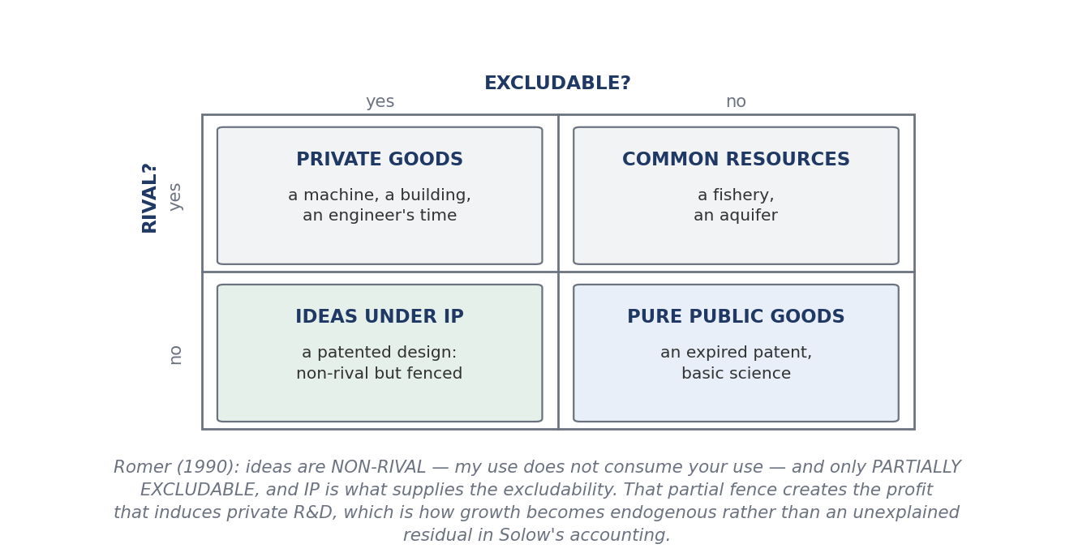
Rival and excludable: where ideas sit.

What follows
- A non-rival input can be used at near-zero marginal cost, so the economy is non-convex and perfect competition cannot hold. The equilibrium is monopolistic competition.
- Partial excludability creates the profit that makes private, profit-maximising research worthwhile.
- Growth therefore becomes endogenous — generated inside the model by deliberate investment in R&D — instead of appearing as the unexplained residual in Solow's growth accounting.
Arrow's information paradox (1962) and the patent bargain
A buyer cannot value information without seeing it; once he has seen it he already has it and need not pay. Information markets therefore fail without an institutional fix.
The patent bargain is one fix: full disclosure in exchange for a time-limited right to exclude. It serves two incentives at once — the incentive to invent and the incentive to disclose. The second is often the more socially valuable, because it puts the teaching into the public record.

The debate — present both sides
- For — Kitch (1977), prospect theory. A patent works like a mineral prospect: giving one party early control creates the incentive to coordinate and develop the downstream applications efficiently, avoiding wasteful duplicate racing.
- Against — Heller & Eisenberg (1998), Science 280: 698. The anticommons: too many fragmented overlapping upstream rights mean everyone can block, so the resource is underused — the mirror image of the tragedy of the commons, and a direct impediment to cumulative innovation.
- Against — empirical critics. Moser, Lerner, and Boldrin & Levine (Against Intellectual Monopoly, 2008) argue the historical evidence is much weaker than the theory assumes. The Park–Ginarte index and Kanwar & Evenson are the standard measurement attempts.

The empirical figures
- USPTO, 3rd edition (2022, using 2019 data): 127 IP-intensive industries accounted for USD 7.8 trillion, or 41% of US GDP, and 44% of employment.
- The earlier edition (2012, using 2010 data) put employment at 27.7% — so quote the movement from 27.7% to 44%, not either figure alone.
- The WIPO Global Innovation Index is the standard national benchmark and shows the expected correlation between IP intensity and income per head.
Growth also needs diffusion, not just invention. Adoption follows an S-curve: a few leaders adopt, the market observes, then adoption accelerates and saturates — or the product is rejected, since a technically excellent product can still fail. Two frictions: technology moves faster than law, so an Act can be obsolete before it is enforced; and the patent term is debated, the answer being that an expert reading an expired specification gets the detail, and the disclosure has been public since publication rather than expiry — though firms respond by keeping the critical layer secret and patenting only the periphery.

2(d) IP and Intellectual Capital: the Role of Non-Proprietary Technologies
The question: can technology create very large value without being exclusively owned? It plainly can, and working out why shows what ownership actually contributes.

Definitions
- Non-proprietary technology — not controlled by a private entity.
- Public domain — rights have expired, lapsed or never existed.
- Open source — licensed so anyone may use, study, modify and redistribute.
- Freeware — only free of cost; it may be entirely proprietary.
- Open standard — a specification available to all implementers on defined terms.
The distinction that decides marks
Non-proprietary does NOT mean unowned. Linux is copyrighted; Android is owned by Google; Wikipedia's content is licensed. What makes them non-proprietary is that the owner chose to license openly rather than exclude. Value lies in adoption, not ownership — and the same strong right can be used either to open a technology or to close it.

The access continuum
- Exclusive ownership — one owner, no access without permission.
- Controlled access — by licence, NDA or field of use.
- Shared access — pooled among a defined group: patent pools, and standard-essential patents licensed on FRAND terms.
- Open access — anyone may use, usually with conditions.
The same patent can be placed at any of the four. Governance is a dial, not a switch.

Examples, each paired with what it demonstrates
Technology | What it shows
Linux, Apache | Foundational infrastructure. Firms earn on top by selling support, distributions and services
GitHub | The asset is the network of contributors and the coordination it enables
Android / Open Handset Alliance | An open base created an entire device industry; the sponsor monetises the surrounding services
Raspberry Pi | Almost every IoT product is prototyped on it. The shipped product carries a custom controller, but the invention depended on the prototype stage
Wikipedia | Displaced a subscription encyclopaedia industry on volunteers and open licences — with a very careful governance and liability framework
Human Genome Project, Bermuda Principles | Enclosure was rejected in favour of daily public release. Open release accelerated an entire field
CSIR Open Source Drug Discovery | Open collaboration where the market fails — diseases of the poor attract little private investment
Tesla patent pledge, 2014 | An incumbent opening its portfolio to grow the ecosystem it depends on

The licences — describe them accurately
- Creative Commons: four elements combined into six licences. BY = attribution; NC = non-commercial only; SA = share-alike, derivatives carry the same licence; ND = no derivatives. So CC BY-NC-SA does not permit commercialisation.
- GPL — copyleft; reciprocity obligations pass to derivative works.
- MIT and Apache 2.0 — permissive, minimal conditions. Apache 2.0 also grants an express patent licence.
- Breaching an open licence condition is infringement, not discourtesy.

Five mechanisms of ecosystem value
- Open access — lower transaction costs and entry barriers.
- Rapid diffusion — adoption across industries and developer communities.
- Network effects — the technology becomes more valuable as more people use it, through interoperability.
- Collective innovation — pooled research effort and human-capital development.
- Complementary products — services, hardware and custom software built on top, usually at high margin.
For a firm, this cuts development time and research cost, so resources move to combination, adaptation and user experience. The open layer becomes structural capital and the contributor community becomes relational capital — both without any transfer of ownership.
- Chesbrough (2003), open innovation: the purposive use of inflows and outflows of knowledge to accelerate internal innovation and expand the market for external use of innovation. Firms use external ideas alongside internal ones.
- von Hippel (2005): users, not manufacturers, are frequently the source of the innovation.
- Business models without exclusivity: support and subscriptions, dual licensing, hardware, data, advertising, complementary services.
The limits, and the balancing principle
Open does not always work: free-riding is real, appropriability is weak (so returns flow to whoever holds the complementary assets), governance can fail, and most successful platforms keep a proprietary layer. Liability must be drafted for, which is why such platforms carry dense policy architectures.
The balancing principle: IP exists to deliver social benefit + the inventor's benefit + technological development. Where exclusivity serves all three, use it. Where it obstructs the first and third — genomic data, a neglected disease, an infrastructural standard — the open route serves the same purpose better. Non-proprietary technology is not the opposite of IP; it is a different setting of the same dial.

2(e) Identifying the Objectives, Purpose and Players
Three prior questions before any policy or licence: what are we trying to achieve with the IP, why are we managing it, and who has a stake?

Objectives — what a right is held for
The purpose decides how the claims are drafted and where the family is filed, so a right held for exclusion is drafted differently from one held for revenue.
- Exclusion — stop competitors selling a competing product. The classic use.
- Revenue — licence for royalties, or assign for a capital sum.
- Freedom to operate — hold rights so others' rights can be neutralised by exchange rather than litigation.
- Cross-licensing currency — hold a portfolio so an assertion can be met with a counter-assertion and royalties net off.
- Defensive publication — publish so nobody else can patent it, accepting that you cannot either.
- Signalling — demonstrate capability to investors, partners and ranking bodies.
- Standard setting — make every implementer of a standard need a licence.
- Blocking — deny a competitor a route you do not use yourself.
- Attracting funding — sponsors and investors need ownership clarity before committing.

Purpose differs by institution
- Corporation — wealth creation: value appropriated for shareholders.
- University — use of the technology plus a share of the value, plus ranking and reputation.
- Public research body — diffusion of the technology into national use, subject to security.

The players
Role | Internal | External
Create | Inventors, researchers, students, R&D | Collaborating institutions, consultants, users
Decide | Board, director or dean, IP cell or TTO | Sponsors, funding agencies, standard-setting bodies
Advise and process | IP legal, business development, finance | Patent agents and attorneys, patent offices, valuers
Exploit | Product divisions | Licensees, assignees, spin-outs, JV partners
Constrain | Compliance and conflict-of-interest committees | Competitors, regulators, courts, government, the public
- Mendelow's power–interest matrix (1991): classifies stakeholders by power and interest into manage closely, keep satisfied, keep informed, monitor.
- Salience model — Mitchell, Agle & Wood (1997): classifies by power, legitimacy and urgency. It explains why a legitimate claimant with no power — a student inventor, a research scholar — is ignored until a policy protects them.
Worked example — a hackathon. Players: tiered sponsors; the giver of the problem statement; participants from several institutions; the organising institute. Issues to settle in advance: prize money, ownership of the problem statement, ownership of the IP, incubation, resource use, and equity. The workable settlement attaches ownership consequences to incubation rather than to entry, on the accelerator model of taking a small equity stake in the company and no interest in the patent.

2(f) IP Policies — Top-Down and Bottom-Up Approach
Definition
A policy is the set of guiding principles by which an organisation decides in advance how it will answer its routine, recurring questions — so that when an issue arises the answer is given by reference to the policy rather than argued again.

Why an IP policy is required
- It sets out the vision and aim — in IP, usually maximum wealth creation from the institution's intellectual assets.
- It maintains consistency: actors and circumstances change, the process does not.
- It fixes the revenue-sharing model in advance, removing the most contentious question from case-by-case bargaining.
- It defines rights and duties: the inventor's duty is to disclose, the inventor's right is a share of what it earns.
- It communicates outward, telling industry and sponsors where the institution stands.
- It protects the institution's own investment — without it, the salaries, resources and infrastructure supplied are silently subsidising outcomes it has no claim to.

Where a policy sits among legal instruments
- Constitution / Act — binding law made by the competent authority.
- Policy — administrative intent; a guiding principle, not a mandatory rule. It changes when the person in charge changes.
- Guideline — mandatory or advisory; implements policy at the operational level.
- Agreement — records the consent of parties.
- Contract — an agreement enforceable by law: s.2(h) and s.10, Indian Contract Act 1872.
The chain runs: policy guides the agreement, and the enforceable agreement becomes a contract. So a well-drafted policy carries its documents as annexures — the NOC, the assignment deed, the licence, the confidentiality undertaking, the revenue-sharing schedule — and signature plus stamping is all that converts intent into obligation.

The two approaches
 | Top-down | Bottom-up
How it works | Administration decides, a circular is issued, everyone follows. No ratification, no consent | Stakeholders consulted first; draft, comment, redraft, deliberate, adopt
Typical user | Corporations — a clause can change within a week | Universities and research bodies, where faculty autonomy makes consent necessary
Merits | Speed, consistency, enforceability | Legitimacy and acceptance; those governed by it own it
Risks | Low buy-in; people never heard comply minimally | Slow; compromise clauses that satisfy nobody
Best used for | Compliance matters — confidentiality, disclosure duties, filing deadlines | Entitlement matters — ownership, revenue sharing, the start-up route
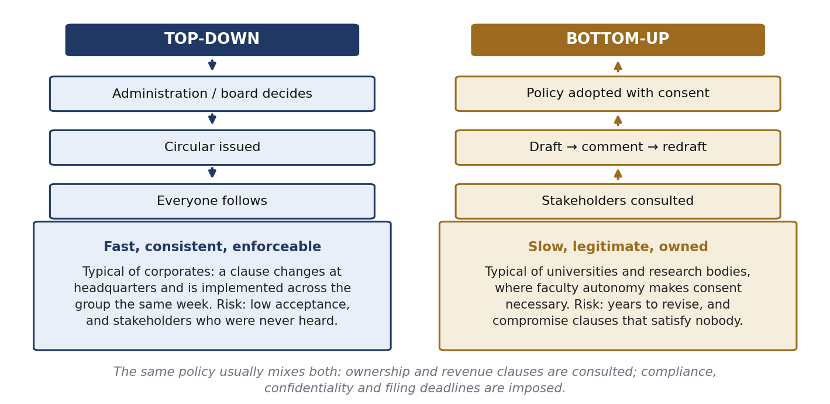
The two directions of policy formation.
These are clause-level choices, not institution types; most real policies mix both. A policy must also be versioned as law, technology and priorities change, which is why the right to regulate the policy is one of its standard clauses. And it must be written in language its stakeholders can actually read: a rule nobody understands is a rule nobody follows.

India's National IPR Policy 2016 — the seven objectives
- IPR awareness, outreach and promotion.
- Generation of IPRs.
- Legal and legislative framework.
- Administration and management.
- Commercialisation of IPR.
- Enforcement and adjudication.
- Human capital development.
Approved on 12 May 2016 under the slogan “Creative India; Innovative India”. IP administration was consolidated under what is now DPIIT. WIPO also publishes a model IP policy for universities, which is the standard drafting reference.

2(g) Defining IP Policy for a Corporation, a University and Research Organisations

The standard clauses
- Ownership of IP — title in every situation.
- Disclosure policy — who reports what, to whom, how fast; separate rules for students and inventors.
- Confidentiality and assignment — no publication before filing; how title moves.
- Assessment of inventions — who evaluates, on what criteria, within what time.
- Obtaining IPR — who decides to file, instructs counsel, pays.
- Renewal — who pays annuities; what happens if the institution stops.
- Foreign filing — which countries, and who bears PCT and national-phase costs.
- Contracts and agreements — the annexed templates and who may sign.
- Technology transfer — licence, assignment, spin-out, sponsored development.
- Revenue sharing — model, base, disbursement, reassignment, co-creator shares.
- Infringement, damages, indemnity insurance — who may sue, who pays, who bears loss.
- Conflict of interest and inventorship disputes.
- Dispute resolution — internal committee before any external forum.
- Right to regulate the policy — power to amend, and versioning.
- Jurisdiction — forum and governing law.

Clause 1: ownership — the scenarios a policy must name
- Main test: significant use of institutional resources. No significant use → the creator may own it. Significant use of labs, instruments, funded staff or infrastructure → the institution owns it.
- Sponsored and collaborative work — governed by the sponsoring agreement; the policy must state what happens if the sponsor does NOT claim (usually title reverts to the institution).
- Institute plus non-institute personnel — allocation between institutions agreed before work starts.
- Consultancy-generated IP — the consultancy agreement may allocate title differently from the research policy.
- Unprotected IP — know-how and data never filed still need allocation, because contract and confidentiality can protect what no statute does.
- The situations usually forgotten: student-created IP; theses and dissertations; examination answer scripts (the student's copyright); course material, books, blogs and lecture notes; software and source code; anything created at a fest, hackathon or competition.
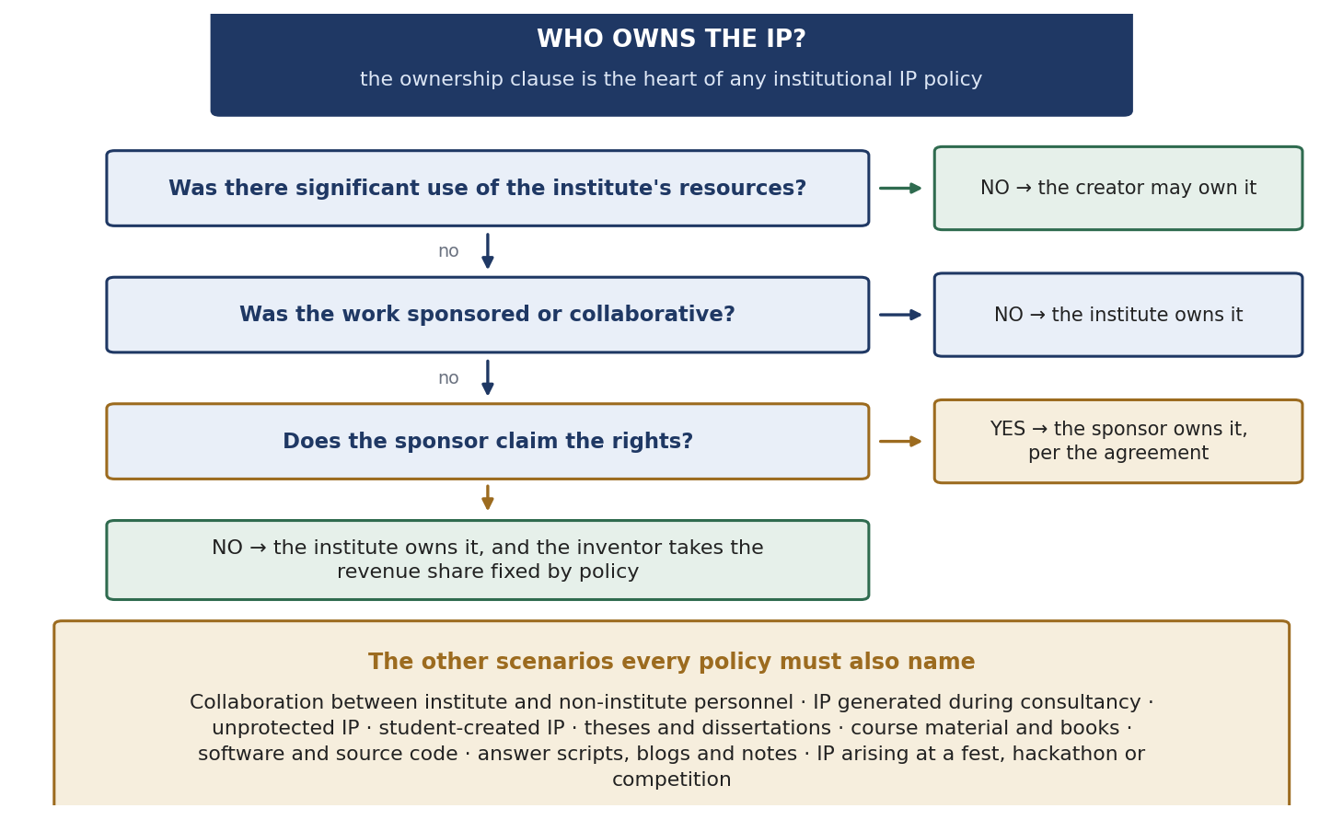
The ownership decision.

Clauses 2–9: disclosure, protection and cost
- Disclosure is the hinge — an institution cannot manage what it does not know about.
- Confidentiality bars publication before filing, which is the commonest cause of lost rights in academia.
- Assessment must be time-bound, with reassignment to the creator if the institution declines to protect.
- Foreign filing: a PCT application preserves the options; the national phase brings translation, agents and annuities. One workable model — the institute pays for an initial period, PCT costs are shared 50:50, and national-phase costs are borne by the inventor, which gives the inventor a stake in the family's quality.

Clause 10: revenue sharing
- The models: 70:30, 60:40 or 50:50 between inventor and institution, applied to NET profit — costs of creating and maintaining the right are deducted first. Net versus gross matters.
- Hybrid model: the ratio changes over the patent's life — for example one model for the first 10 years, another for the next 5, a third for the last 5.
- Progressive model: the share changes with the level of income.
- Continuation: the entitlement continues after graduation, retirement or resignation for IP created while eligible, and passes to legal heirs as succession law provides.
- Equity instead of royalty: where the inventor starts a company, the institution issues an NOC and takes either a revenue share or equity of about 1–3%. Do not confuse them — equity is a share in the whole company; revenue sharing is a share in one patent's income.
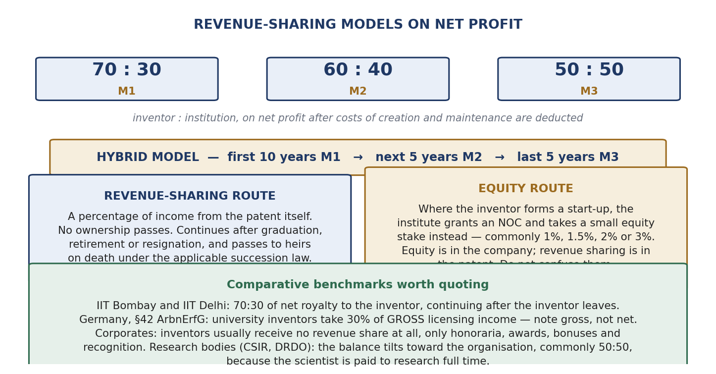
The models, the hybrid schedule, and the two routes for a start-up.

The three institutions compared
 | Corporation | University | Research organisation
Purpose | Value appropriated for shareholders | Use of the technology plus a share of value, and standing | Diffusion into national use, subject to security
Inventor's share | Usually none — honorarium, awards, bonus, recognition | Substantial: commonly 70:30 of net at IIT Bombay and IIT Delhi | Tilted to the institution, often about 50:50, as the scientist is paid to research
Policy direction | Mostly top-down; clauses change quickly | Mostly bottom-up on ownership and revenue | Mixed, with statutory and security limits
Start-ups by creators | Generally barred or tightly controlled | Allowed with an NOC and an equity or royalty election | Often restricted or not permitted
Why corporate inventors get no revenue share: a company cannot create an open-ended liability across tens of thousands of assets, so it substitutes recognition, honoraria and bonuses, and tightens employment terms so that work done in service belongs to the company.

Employee inventions in other countries
Country | Rule
USA | Ownership by contract (pre-invention assignment). Gaps filled by the hired-to-invent doctrine and by shop rights — a free non-exclusive licence to the employer where its resources were used
Germany / EU | Rights vest in the employee inventor first (Arbeitnehmererfindungsgesetz). The employee must notify; if the employer does not release within four months it is deemed claimed. The employee then has a non-waivable right to reasonable remuneration, with arbitration at the German Patent Office. Section 42 gives UNIVERSITY inventors 30% of GROSS licensing income
Japan | Article 35, Patent Act. The Nichia blue-LED case (Shuji Nakamura): ¥20 billion awarded by the Tokyo District Court in 2004; settled at ¥843 million in 2005. The case drove the 2004 reform
India | No dedicated statute. Ownership turns on the employment contract and common law — which is why the institutional policy carries so much weight here

2(h) When Rights of Trademark Owners and Domain Name Owners Collide

Why the collision is structural
Basis | Trademark | Domain name
Function | Identifies the SOURCE of goods or services | Identifies an INTERNET ADDRESS
Geography | Territorial — rights stop at the border | Global — accessible from anywhere
Exclusivity | Class-based; identical marks coexist for different goods | Absolute — one string, one registrant, worldwide
Acquisition | Registration plus use, after examination and publication for opposition | Availability alone; first come, first served, no examination
Regime and remedies | Trade Marks Act 1999; infringement and passing off; injunctions and damages | Contract with the registrar under ICANN rules; UDRP or INDRP; transfer or cancellation only
A class-based, territorial legal concept has been forced onto a global, first-come-first-served technical system. Three parties then point at the same string and each is telling the truth: the trademark owner has legal rights in the name, the registrant registered the address first, and the internet user associates the domain with the brand.
- The architecture: ICANN oversees the system; registries operate each top-level domain; registrars sell registrations. gTLDs are .com, .net, .org; ccTLDs are country codes such as .in.
- Cybersquatting — registering another's mark as a domain to profit from its goodwill or sell it back.
- Typosquatting — exploiting predictable misspellings.
- Domain parking — monetising traffic with no content.
- Reverse domain name hijacking — a trademark owner using the machinery to take a domain from a legitimate holder.

The UDRP — adopted by ICANN, 1999
Under paragraph 4(a) the complainant must prove ALL THREE:
- The domain name is identical or confusingly similar to a mark in which the complainant has rights.
- The registrant has no rights or legitimate interests in respect of the domain name.
- The domain name was registered AND is being used in bad faith.
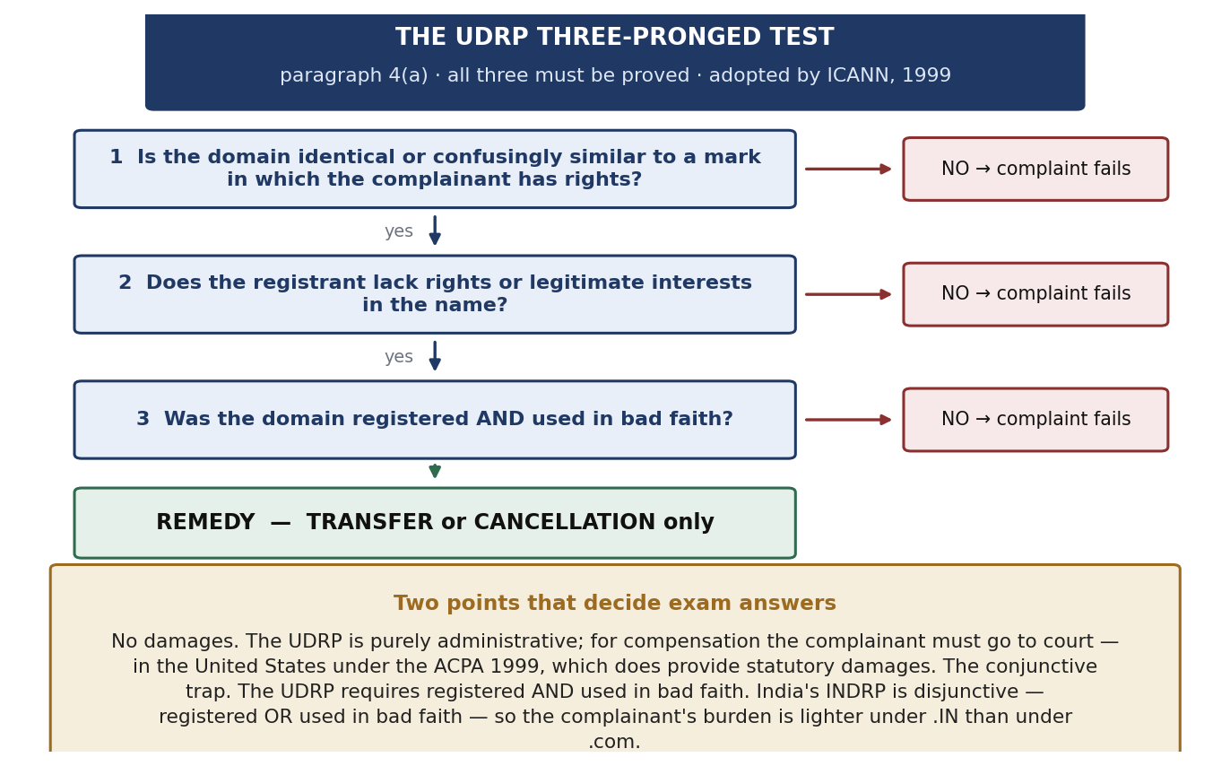
The three-pronged test and the remedies.
- Paragraph 4(b) — bad-faith indicators: acquisition primarily to sell to the mark owner above out-of-pocket cost; a pattern of blocking registrations; registration to disrupt a competitor; use to attract users for commercial gain by creating confusion.
- Paragraph 4(c) — defences: bona fide use or demonstrable preparations before notice of the dispute; being commonly known by the name; legitimate non-commercial or fair use.
Two features that decide most questions
No damages. Remedies are transfer or cancellation only. For compensation the complainant must go to court — in the USA under the ACPA 1999, which does provide statutory damages.
The conjunctive trap. The UDRP requires registered AND used in bad faith. India's INDRP (for .IN, run by NIXI) is disjunctive — registered OR used — so the complainant's burden is lighter. Complainant success rates under the UDRP run at about 80–85%.

Indian case law
Case | Court, year | Ratio
Yahoo! Inc. v. Akash Arora, 1999 PTC (19) 201 (Del) | Delhi HC, 1999 | India's first cybersquatting case. “yahooindia.com” restrained as passing off: a domain name is a business identifier entitled to the same protection as a trademark, and adding “India” did not distinguish it
Satyam Infoway v. Sifynet Solutions, (2004) 6 SCC 145 | Supreme Court, 2004 | The leading authority. No Indian statute governs domain names, but a domain name has the characteristics of a trademark and is protected by passing off. Domain names are global identifiers demanding exclusivity, so confusion is more likely
Tata Sons v. Manu Kosuri; Rediff v. Cyberbooth | Delhi HC; Bombay HC, 2000 | Well-known marks cannot be taken as domains; a domain name is a valuable corporate asset
Two further points
Trademark rights are not absolute. APPLE can be a technology company, a fruit seller and a restaurant at the same time. The formula: protection = distinctiveness + specific goods or services + likelihood of confusion.
The hard case — a domain registered in good faith BEFORE the trademark existed, and commercialised later. Under the UDRP the complaint fails, because bad faith must exist at registration and later use does not cure its absence (WIPO Jurisprudential Overview 3.0, with narrow exceptions for registration in anticipation of nascent rights). The trademark owner's better route is a court action for passing off, where reputation and confusion are weighed and damages are available.

Practical consequence: register the trademark and the matching domains together at launch, across the relevant extensions and markets, because buying a domain afterwards is a purchase from whoever arrived first. Domain names, data, software, social media handles and digital identities are now part of the portfolio an IP manager handles.

2(i) Profiting from Technology Innovation — Integration, Collaboration, Licensing and Public Policy
Identify the source
This heading is the title of an article: David J. Teece, “Profiting from Technological Innovation: Implications for Integration, Collaboration, Licensing and Public Policy”, Research Policy 15(6), 1986, pages 285–305. The four words in the title are the four implications.

The puzzle: innovating firms frequently fail to capture the returns from their own innovations, while imitators, followers, customers and suppliers profit. Teece's explanation is that when imitation is easy, markets do not work well, and the profits go to the owners of complementary assets rather than to the developer of the technology.

The three building blocks
- Appropriability regime — can the innovator capture the returns? Two determinants: the efficacy of legal protection, and the nature of the technology. Tacit knowledge protects itself because it cannot easily be transferred; codified knowledge travels and is copied. A regime is tight where both are strong.
- Dominant design paradigm (from Abernathy and Utterback) — before a standard emerges (pre-paradigmatic) competition is over designs. Once a dominant design appears (paradigmatic), competition shifts to price, scale and manufacturing, and complementary assets become decisive.
- Complementary assets — everything besides the invention needed to reach the customer: manufacturing, distribution, marketing, service, brand, regulatory approval.
Complementary assets are of three kinds: generic, which are general-purpose and can be bought on the market; specialised, which create one-way dependence; and co-specialised, which create two-way dependence and therefore the hold-up hazard, because a counterparty controlling such an asset can renegotiate at will.

The decision rule
- Weak appropriability + specialised or co-specialised assets → INTEGRATE (build or buy the assets), provided you have the time and capital.
- Generic assets, or strong appropriability → CONTRACT or LICENCE — faster, cheaper, less risky.
- Weak appropriability + no time and no assets → the innovator loses, and the holder of the complementary assets captures the value.
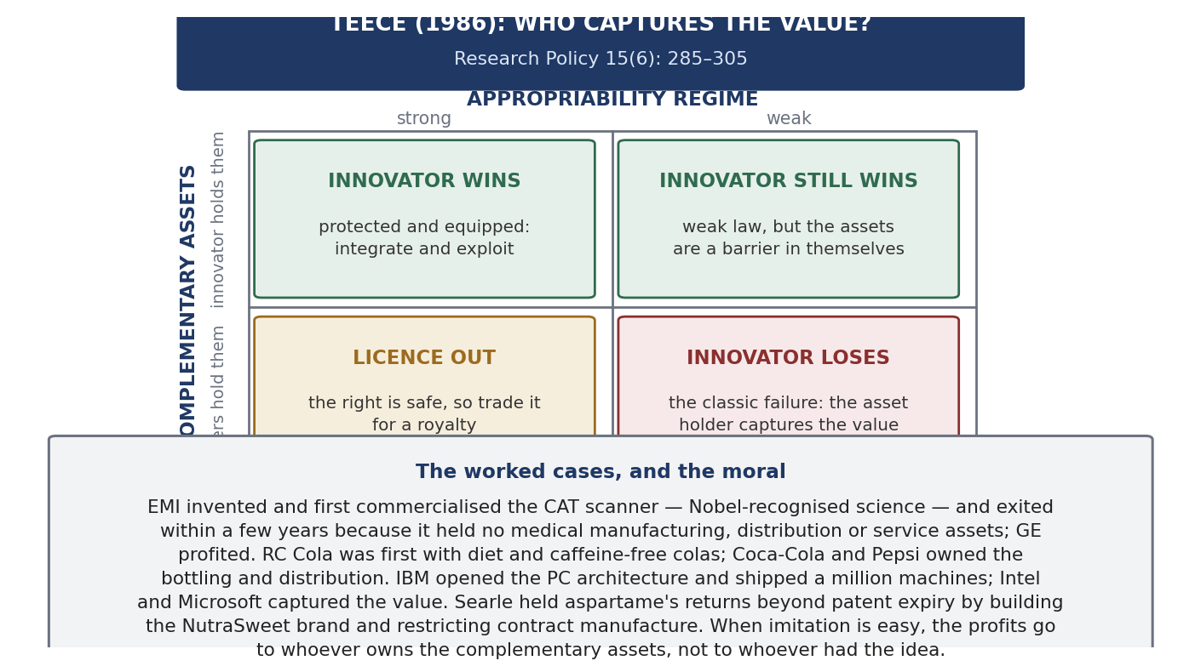
The framework as a grid.

The cases
- EMI and the CAT scanner — invented and first commercialised it, Nobel-recognised science, and exited within a few years because it had no medical manufacturing, distribution or service assets. GE and others took the market.
- RC Cola — first with diet and caffeine-free colas; Coca-Cola and Pepsi, who owned the bottling and distribution, captured the value.
- IBM's personal computer — opened the architecture and shipped over a million machines; Intel and Microsoft, holding co-specialised assets, captured the value.
- G.D. Searle and aspartame — the opposite: protected returns BEYOND patent expiry by building the NutraSweet brand, restricting contract manufacture and continuing research, with regulatory approval reinforcing all three.
- Also: Kodak and Polaroid in instant photography; Bowmar in calculators; Docutel in ATMs; Ampex in video recording.

The four implications
- Integration. Where appropriability is weak and assets are specialised, integrate rather than contract. Large firms therefore profit more from innovation, because they already own the assets — which is why, as Teece puts it, manufacturing often matters.
- Collaboration. The middle route when integration is too slow or costly. It must be drafted against hold-up: exclusivity, field-of-use limits, improvement and grant-back terms, diligence obligations, termination rights.
- Licensing. Maximises profit when appropriability is strong (so the licensee cannot expropriate you) and when you lack the complementary assets. It destroys value when appropriability is weak, because the disclosure needed to make the licence work equips the licensee to become a competitor.
- Public policy. If returns flow to holders of complementary assets, a country that lets its manufacturing and commercialisation capability decay cannot profit from its own inventions however strong its research. It also bears on antitrust, since integration and collaboration may be efficient responses rather than restraints of trade.
Teece updated the framework in “Profiting from Innovation in the Digital Economy”, Research Policy (2018), applying it to platforms, ecosystems and dynamic capabilities: the complementors are the complementary assets, so the 1986 variables matter more than ever.
Two closing points
Four ways to hold a position: RUN-IN (be first, so lead time is itself a temporary monopoly); LOCK-IN (raise the customer's switching cost); LOCK-OUT (raise the imitator's cost of imitation — this is what a patent does); SQUEEZE-OUT (beat rivals on production or marketing). Survey evidence rates locking competitors out above locking customers in.
Commercial success does not guarantee economic success. A firm may win the market and still fail to earn a return. What converts a right into a return is the position the holder occupies relative to everything else the customer needs.

Unit 3 — IP Commercialization
Definition
IP commercialization is choosing and executing the route by which an IP right becomes value — revenue, market position, freedom to operate or bargaining power — and then defending that route. Protection is the means; commercialization is the point. A patent left in a drawer costs a fee every year and earns nothing.
Because an IP right is a right to EXCLUDE, value can arise in only two ways: use the exclusivity yourself, by selling something nobody else may copy; or sell permission to others, by licensing, cross-licensing or assignment. Every route is one of those two.

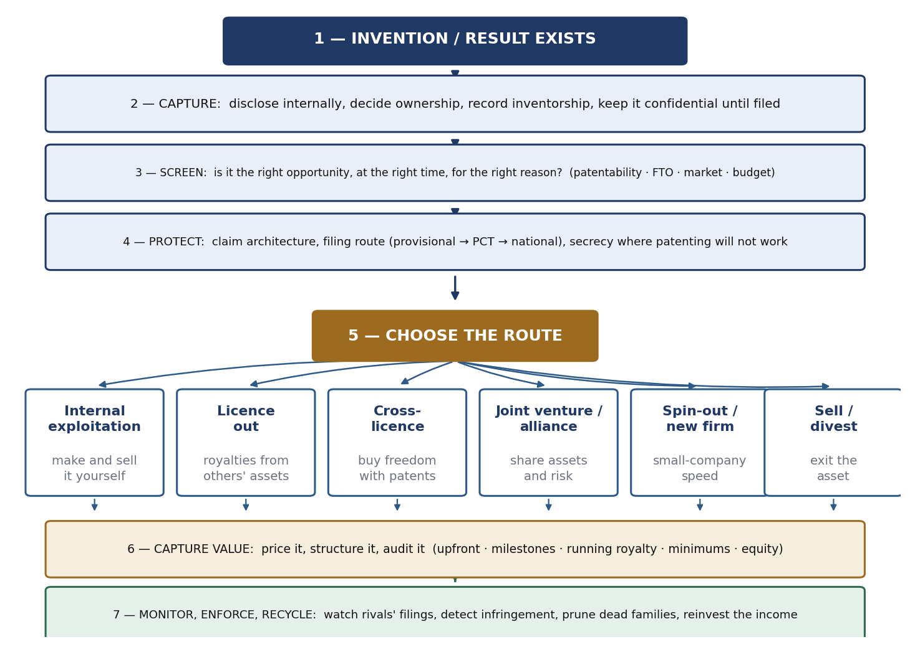
From invention to reinvestment, with the routes at the point of choice.

The innovation ecosystem
Commercialization is one loop inside a closed circulation of capital and knowledge, whose goal is to create wealth of two kinds at once — intellectual and financial. Company capital funds research; research feeds development and commercialization; these produce products, services, processes and licensing; these generate capital and growth, which returns to company capital and flows outward into collaboration and into acquiring and cross-licensing IP. Alongside runs IP generation, fed by both research and the product business, returning as licensing revenue, defensive strength and bargaining currency.
Every transfer in that loop passes a LEGAL GATE — who owns it, are we free to operate, what is filed and when, what the contract says. Where the gates are missing or late, value leaks: inventions that cannot be claimed because they were published first, collaborations where background and foreground IP were never separated, products found to infringe after the launch budget is spent.

The seven requirements for robust commercialization
- Management commitment to innovation and IP creation. The spend is discretionary and long-dated; cutting it shows up years later.
- Efficient and timely execution. Timing is substantive — a filing after a conference presentation may be void; one before the invention is properly described may be worthless.
- The right opportunity, at the right time, for the right reason. Three separate tests. The reason matters because it determines how claims are drafted and where you file.
- The right value proposition for the right market. One technology supports different propositions in different markets.
- Talented and motivated people. Steve Jobs's pirates-and-navy line — people willing to work outside the process, protected while they do, but who must eventually work with the unit that owns manufacturing and distribution.
- Open collaboration. No firm owns all the complementary assets it needs. IP makes collaboration safe through defined background and foreground rights, field-of-use limits and publication rules.
- A symbiotic and synergistic relationship between IP legal and R&D. Symbiotic because neither can work alone; synergistic because together they produce more — an engineer who understands claims designs inventions whose infringement can be detected; an attorney who knows the roadmap files a core claim broad enough to cover products that do not yet exist.
Evidence: the patent is not the biggest lever
Asked what limits their ability to profit from innovation (scale 0–4), large corporations answered: access to the technology needed 2.62; difficulties in marketing 2.57; getting into production on time 2.48; inability to prevent copying 2.48; cost of capital 2.20; lack of suppliers 1.80.
Copying is not the biggest obstacle. A patent addresses one limitation out of six. Its second job addresses the highest-ranked one directly: obtaining access to technology through cross-licensing.

Portfolio strategy: build around a core claim
- Core IP. One broad, powerful independent claim on the overall concept. This is the asset that gets litigated, licensed and traded.
- Applications are dependent claims, each specific use claimed in dependence on the core.
- Applications vary market by market, so the dependent layer is drafted separately for each market.
- Expand vertically — deepen the claims inside one market, so a competitor must avoid the core AND a dense application layer.
- Expand horizontally — carry the same core across markets, multiplying the licensees who need it.
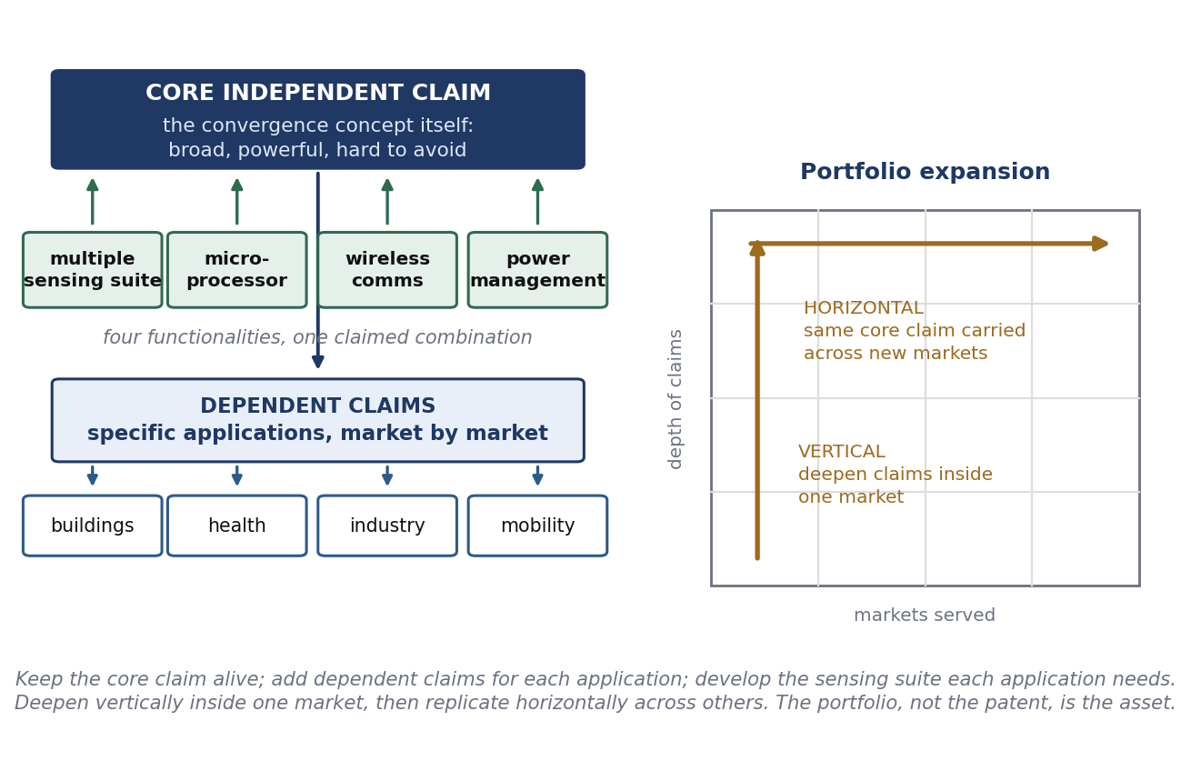
Core claim, dependent claims, and the two directions of growth.
Why this architecture is necessary
The limitation of patents that firms rate highest, at 2.58 out of 4, is that competitors can legally circumvent a patent by inventing around it. A single right can be circumvented; a field of rights cannot be circumvented economically.
Two named strategies: BLANKETING — covering an area so densely that any route through it infringes something; and FENCING — filing around the core to block the substitute solutions a rival would otherwise use.

Where an invention is not detectable in the product, secrecy is a genuine alternative. But cheaper reverse engineering cuts both ways: it breaks the innovator's secrecy barrier AND the imitator's, so infringement becomes detectable and patents more enforceable. Both effects raise the propensity to patent. The exception is mechanical engineering, where process know-how stays inside the factory.

Cross-licensing
The pattern: A obtains a patent; B sues over a product position; litigation runs years; it then emerges that each side's right improves the other's product, so they cross-license and the case ends. Nothing about the patents changed — only the recognition that each valued the other's right more than the fight. At portfolio scale, one company bundles its patents and grants different bundles to different counterparties serving different markets, and the same patent appears in several bundles, because non-exclusive licensing lets one asset be sold many times.
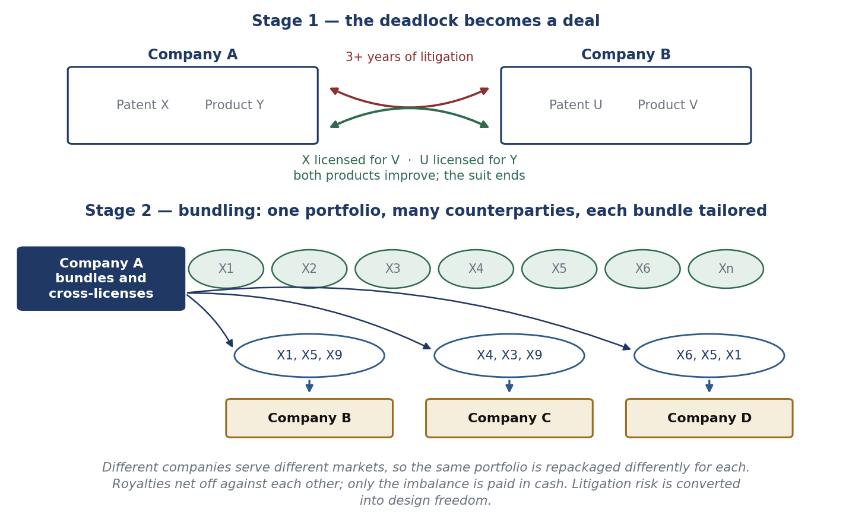
From litigation to cross-licence, and from single patents to bundles.
Why firms cross-license rather than litigate:
- Freedom to operate — in a multi-technology product somebody always holds a relevant right.
- Cost and time — litigation consumes management attention and produces no product.
- Royalty netting — payments offset and only the imbalance moves in cash.
- Design freedom — engineers optimise the product rather than the claim chart.
- Option value — a portfolio held purely for trading is worth keeping, which is why defensive portfolios are rational.
Huawei is the standard illustration: over 260 patent licence agreements in twenty years and over 165,000 active patents at end-2025, alongside heavy standards participation. The three facts are connected — a firm contributing thousands of proposals to standards holds standard-essential patents and can licence every implementer, while itself needing licences in return.

Licensing
The commonest route and the hardest to negotiate: the buyer wants to minimise the value, the seller to maximise it, and there is no market price. Agreeing the valuation is the gate through which every other term passes.
- The seller opens high — states an expectation as the UPPER limit and gives good reasons.
- The buyer answers low — sets the offer as the LOWER limit and gives clear justifications.
- What makes it work is the justifications, not the numbers: comparable deals, the cost of independent development, the size of the market unlocked, the remaining risk, the substitutes available.
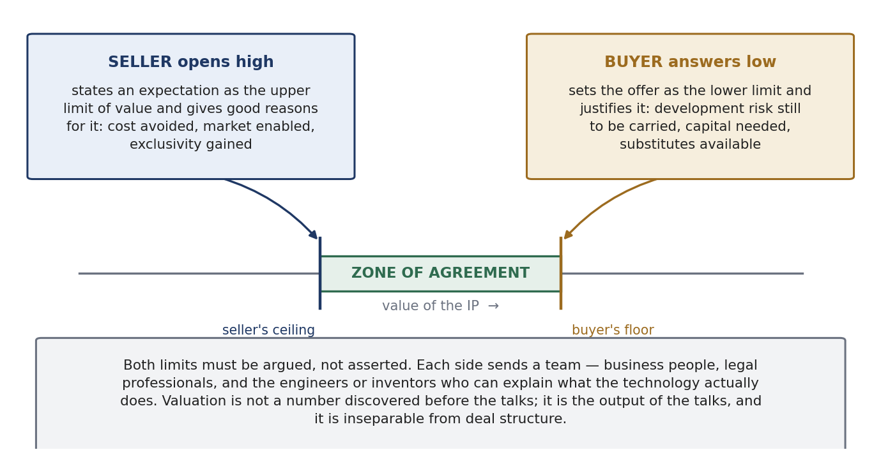
Two justified limits, and the zone of agreement.
Each side should send a team of business experts, legal professionals, and engineers or inventors — business owns the commercial case and budget, legal owns risk and enforceability, and only the engineers can say what the technology does and what it would cost a competitor to work around it.
The terms actually negotiated: the grant and its exclusivity; field of use and territory (which allow the same right to be licensed many times without conflict); the financial structure of upfront, milestones, running royalty, minimum annual royalty and equity; the royalty base and rate; diligence obligations (protecting against a licence taken to shelve the technology); reporting and audit rights, since unauditable royalties are uncollectable; and term, termination and reversion, by which a licensor recovers a stalled technology.

Setting the number: the royalty thumb rule
Annual licensing revenue = the negotiated percentage × the annual cost of the products after the factory, with the percentage in a band whose lower limit is typically 1–3 and whose upper limit is typically 3–7.
- ALR = annual licensing revenue.
- LR = the negotiated percentage — the only genuinely negotiated variable.
- AAFC = annual cost of products AFTER the factory.
- Why AAFC and not the sales price: it is easy to track and audit, and it deliberately excludes shipment cost and profit margin, which move with fuel, discounting, channel mix and currency for reasons unconnected with the invention. A volatile base produces disputes; an auditable base produces payments.
- The band matters: on the same product and base, a rate near the floor and one near the ceiling differ fourfold in revenue.
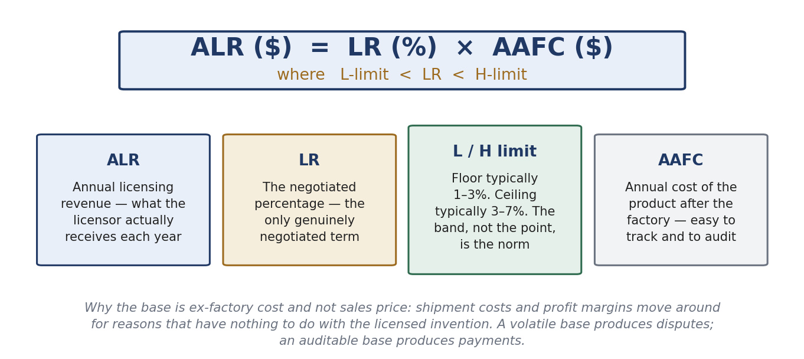
The thumb rule, term by term.

Commercialization by universities and public bodies
They produce inventions but do not manufacture, so everything must travel through somebody else. The legal foundation in the USA is the Bayh–Dole Act 1980 (P.L. 96-517; 35 U.S.C. §§200–212):
- Title to inventions made with federal support goes to the contractor, where that contractor is a university, nonprofit or small business.
- A later presidential memorandum extended the rule to all federal contractors, making it uniform.
- The contractor may therefore own a patent, which gives a private partner the exclusivity it needs to justify development investment.
- Before the Act there was no uniform policy and ownership generally stayed with the government.
The mechanism is often mistaken for a subsidy and is not one. It created no money; it created assignable exclusive rights and therefore a counterparty a company could negotiate with. The general lesson: exclusivity is less a reward for the inventor than an instrument for attracting the downstream investment without which nothing reaches a customer.
AUTM's figures for the 2023 reporting year: USD 104 billion of academic research expenditure, over 25,000 invention disclosures, USD 3.6 billion of licence income (below the 2022 peak of USD 3.8 billion) and 714 new products. Licence income is about 3.5% of research spend, so academic licensing is a public-mission strategy with a revenue by-product, not a revenue strategy.
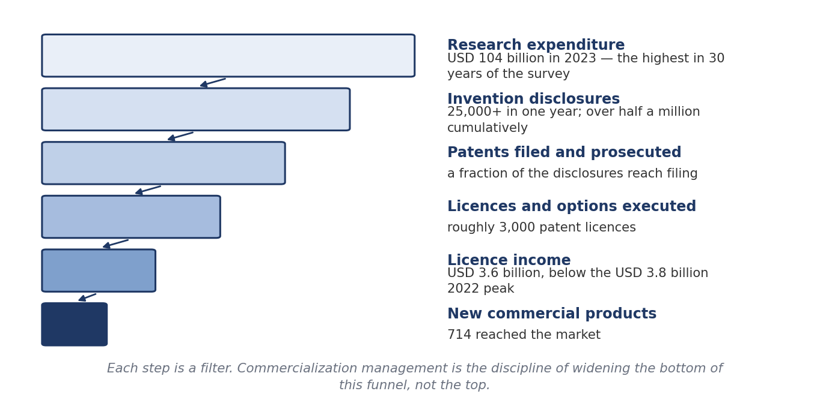
The academic commercialization funnel.

Patent strategy: the filing sequence
- Provisional application. Fixes a priority date cheaply. Twelve months to convert; never examined, never issues; its written description must already support what will later be claimed.
- PCT application. Preserves the option of entering most jurisdictions and defers the large cost decision by about eighteen months — time to find a licensee.
- National phase. The expensive stage: translation, local agents, annuities. Territory should follow the licensee's actual market; unlicensed families are pruned here.
The sequence is a series of options, each bought for less than the sum it defers. The national phase is where money becomes irreversible, so that is where the commercial question — who will sell this, and where — must be answered. The cautionary case is CRISPR-Cas9: the Federal Circuit agreed that the University of California's earliest provisional lacked adequate written description. A priority date is only as good as the disclosure supporting it, and a thin provisional can forfeit the very date it was filed to secure.
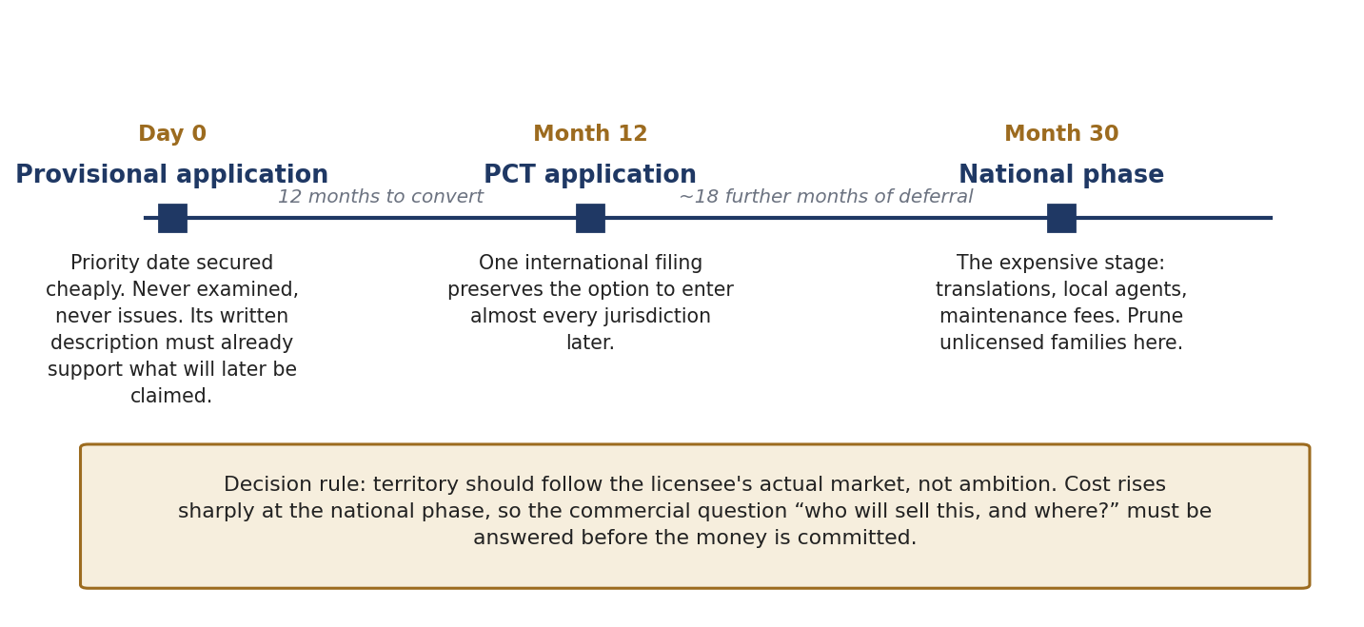
Provisional, PCT, national phase.

Valuation heuristics
- The 25% rule — gives the licensor about a quarter of the licensee's expected operating profit. Quick and communicable, but it ignores the IP's relative contribution, treating a patent on one component of a thousand like one covering the whole. Use it as a sanity check, not a derivation. In Uniloc USA v. Microsoft, 632 F.3d 1292 (Fed. Cir. 2011) the rule was held fundamentally flawed and evidence relying on it inadmissible.
- Monte Carlo and scenario analysis — replaces single-point forecasts with distributions over adoption, price and time to market. Suited to staged technical and regulatory risk. The output is a range and a confidence level: honest, but harder to negotiate against, and only as good as the priors.
- The three classical approaches — cost (what it would take to recreate it; a floor), market (comparable transactions; persuasive where comparables exist), and income (discounted cash flows; the only one reflecting exclusivity, remaining term and market size).
The structural point
Valuation of university IP is rarely the valuation of an asset in isolation. What is priced is a BUNDLE: the patent family, the inventor's continued involvement, the institution's willingness to take milestones instead of cash, and the licensee's cost of capital. Deal structure and valuation are the same conversation.
This is why a licensee will pay more in total for a structure weighted to milestones and royalties than a smaller sum upfront — the upfront comes from scarce cash at the highest cost of capital, while later payments come out of the revenue the technology generates.

The public research sector
The process is similar; the priorities differ, and they determine the terms:
- Accelerated market penetration.
- Priority to SMEs, or promotion in underserved regions.
- Capacity development.
- National security.
- Global competitiveness.
- Resilience of national infrastructure.
- Preventing bad actors from obtaining the technology and commercialising it with ill intent.
- Harmonious relationships with the private sector.
These explain terms that would look irrational in a company: non-exclusive licensing by default so many firms can deploy quickly; carve-outs and regional preferences for smaller domestic firms; local manufacturing or deployment obligations; march-in and government-use rights retained; security screening and export controls; and rates below what the market would bear, because the objective is diffusion rather than income.
The comparison that closes the syllabus
The corporation maximises appropriated value. The university maximises use, plus a share of the value. The public body maximises diffusion, subject to security. The same invention therefore produces three different licences — which is why the question of what a piece of IP is worth cannot be answered until you know who owns it and what they are trying to achieve.

End of document.

