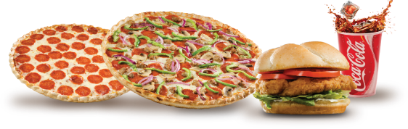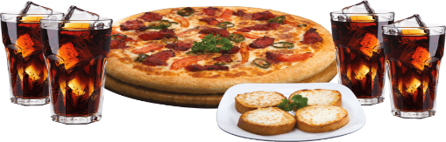

1. **Steam Momos 65/-**
2. **Fried Momos 75/-**
3. **Veg Pizza Momos 105/-**

**₹160**

**₹45, 80**

₹**65, 75**

**₹69**

**₹99**

1. **Veg Chowmin 99/-**
2. **Tandoori Chowmin 100/-**
3. **Makhani Chowmin 100/-**
4. **Mushroom Chowmin 140/-**
5. **Singapore Chowmin 140/-**
6. **Paneer Chowmin 150/-**
7. **Chilli Garlic Noodles 140/-**
8. **Hakka Bakka Noodles 180/-**
9. **Chilli Potato 140/-**
10. **Honey Chilli Potato 140/-**
11. **Mushroom Chilli 140/-**
12. **Chilli Paneer 160/-**
13. **Veg Manchurian 130/-**
14. **Paneer Manchurian 150/-**
15. **Veg Fried Rice 110/-**
16. **Mushroom Fried Rice 140/-**
17. **Paneer Fried Rice 150/-**
18. **Mix Fried Rice 160/-**

**CHINESE DISHES MIX COMBO**

**Chilli Paneer 4pc, Fried Rice 160/-**

**Chilli Paneer 8pc, Fried Rice, 1 Small Pizza, Cold Drink 299/-**

**1 Lagre Pizza, Veg Noodles, 1 Cold Drink 399/-**

**1 Medium Pizza, Chilli Paneer, Noodles, 1 Cold Drink 449/-**

**THANK YOU**

**Party Hall For**

***Birthday party, Kitty***

***Party, Engagement Party***



स्वाद ऐसा, जो अपना बना ले



स्वाद ऐसा, जो अपना बना ले

***Elite Plus***

**Veg Creamy Special**

**7 Wonders**

**Celebrations Special**

**With Cheese Burst**

**& Extra Cheese**

**550 630**

**SUPREMO/SPICY**

**1 Large Pizza, 1 Garlic Bread, 1 Cold Drink 399/-**

**1 Large Pizza, 1 Medium Pizza, 1 Cold Drink 559/-**

**2 Lagre Pizza, 1 Garlic Bread, 1 Cold Drink 689/-**

**SIMPLY VEG**

**1 Large Pizza, 1 Garlic Bread, 1 Cold Drink 339/-**

**1 Large Pizza, 1 Medium Pizza, 1 Cold Drink 479/-**

**2 Lagre Pizza, 1 Garlic Bread, 1 Cold Drink 569/-**

***Elite***

**Makhani Pizza** (Onion, Green Capsicum, Red Paprika, Paneer)

**Veggie Deluxe** (Onion, Capsicum, Mushroom, Paneer, Golden Corn)

**Veggie Feast** (Pineapple, Jalapenos, Golden Corn)

**Normal**

**With Extra Cheese**

**With Cheese Burst**

**205 390 480**

**225 420 520**

**490 560**

** Extra Cheese & Cheese Burst upgrade available**

**FREE HOME DELIVERY**

**8795362000 / 9044715606**

**Kailash Tower Mandenala Pul, Ambedkar Chowraha, Gonda**

**Veg Family Combo**

**Momos**

**Meals**

1. **Meal For 1**

**1 Veg Burger, French Fries, Cold Drink 110/-**

**1 Cheese Burger, French Fries, Cold Drink 130/-**

**1 Regular Pizza, 1 Pasta, 1 Cold Drink 220/-**

1. **Meal For 2**

**2 Regular Pizza, 1 Pasta, 1 Cold Drink 290/-**

1. **Meal For 3**

**2 Regular Pizza, 2 Pasta, 1 Cold Drink 375/-**

1. **Meal For 4**

**3 Regular Pizza, 2 Pasta, 1 Cold Drink 470/-**

***Supremo Veg***

**Farm House** (Onion, Capsicum, Tomato & Mushroom)

**Tandoori Paneer** (Onion, Capsicum & Tandoori Paneer)

**Italian Pizza** (Black Olives, Jalapenos & Sweet Corn)

**Peppy Paneer** (Onion, Capsicum, Paneer, Red Paprika)

**Veggie Lover** (Onion, Tomato, Green Capsicum, Red Paprika)

**Normal**

**With Extra Cheese**

**With Cheese Burst**

**135 230 300**

**155 260 340**

**300 390**

***Spicy Veg***

**Mexican Green Wave** (Onion, Tomato, Green Olive, Mexican Herbs)

**Chilli Paneer** (Onion, Capsicum, Paneer)

**5 Pepper** (Green bell, Yellow bell, Jalapenos, Red Paprika, Spicy)

**Spicy Desi** (Onion, Capsicum, Red Paprika, Jalapenos, Green chilli, Spicy)

**Normal**

**With Extra Cheese**

**With Cheese Burst**

**160 250 330**

**180 280 370**

**310 420**

***Simply Veg***

**Margherita** (Single Cheese Topping)

**Veg Single** (Onion // Capsicum // Tomato // Corn)

**Veg Double** (Onion// Capsicum // Tomato // Jalapenos // Paneer // Corn)

**Veg Mix** (Onion // Capsicum // Tomato // Corn)

**Normal**

**With Extra Cheese**

**With Cheese Burst**

**110 180 230**

**130 200 270**

**280 360**

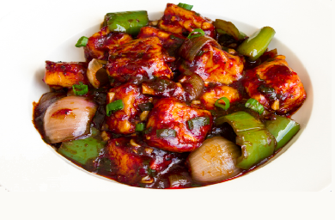

**Chilli Paneer**

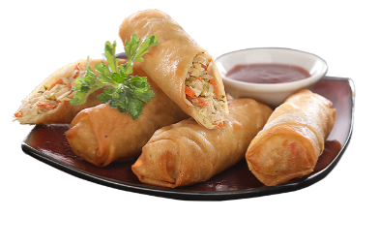

**Spring Rolls**

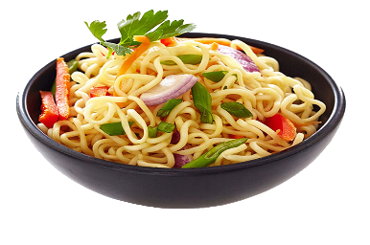

**Noodles**

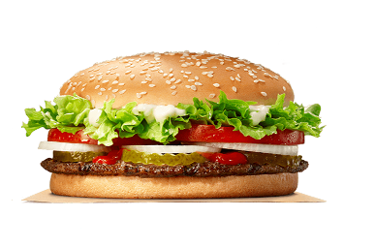

**Cheese Burger**

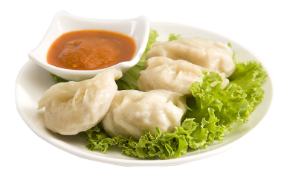

**Momos**

**Veg Pizza**

**Chinese Dishes**

Serves 1

PERSONAL

MEDIUM

Serves 2

LARGE

Serves 3