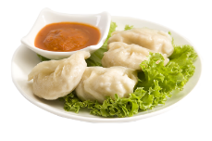

* **Steam Momos 55/-**
* **Fried Momos 65/-**
* **Veg Pizza Momos 80/-**

**Momos**

**Chinese Dishes**

**Momos**

**₹120**

**₹59**

**₹99**

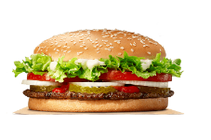

**Burger**

**₹35, 45**

₹**55, 65**

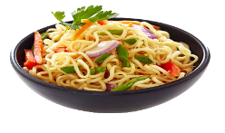

**Noodles**

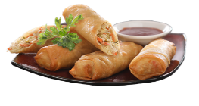

**Spring Rolls**

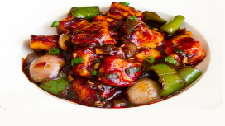

**Chilli Paneer**

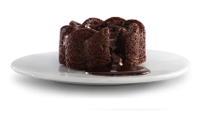

**Choco Lava**

**₹55, 65**

**HALF FULL**

1. **Veg Chowmin 50/- 99/-**
2. **Tandoori Chowmin 55/- 100/-**
3. **Makhani Chowmin 55/- 100/-**
4. **Mushroom Chowmin 60/- 120/-**
5. **Singapore Chowmin 60/- 120/-**
6. **Paneer Chowmin 70/- 130/-**
7. **Chilli Garlic Noodles 70/- 130/-**
8. **Hakka Bakka Noodles --- 150/-**
9. **Chilli Potato --- 120/-**
10. **Honey Chilli Potato --- 130/-**
11. **Mushroom Chilli --- 120/-**
12. **Chilli Paneer 70/- 120/-**
13. **Veg Manchurian --- 90/-**
14. **Paneer Manchurian 70/- 120/-**
15. **Veg Fried Rice 55/- 99/-**
16. **Mushroom Fried Rice --- 110/-**
17. **Paneer Fried Rice --- 120/-**
18. **Mix Fried Rice --- 150/-**
19. **Meal For 1**

**1 Cheese Burger, French Fries, Cold Drink 120/-**

**1 Regular Pizza, 1 Pasta, 1 Cold Drink 199/-**

1. **Meal For 2**

**2 Regular Pizza, 1 Pasta, 1 Cold Drink 290/-**

1. **Meal For 3**

**2 Regular Pizza, 2 Pasta, 1 Cold Drink 350/-**

1. **Meal For 4**

**3 Regular Pizza, 2 Pasta, 1 Cold Drink 450/-**

1. **CHINESE DISHES MIX COMBO**

**Chilli Paneer, Fried Rice 125/-**

**Chilli Paneer, Fried Rice, 1 Small Pizza, Cold Drink 299/-**

**1 Lagre Pizza, Veg Noodles, 1 Cold Drink 399/-**

**1 Medium Pizza, Chilli Paneer, Noodles, 1 Cold Drink 449/-**

**1 Large Pizza, 1 Medium Pizza, 1 Cold Drink 479/-**

**2 Lagre Pizza, Veg Chowmin, 1 Cold Drink 689/-**

**Meals**

**Red Pasta 90/- White Pasta 100/-**

**Luggage Pasta 120/- Mushroom Pasta 125/-**

**Extra Cheese Pasta 135/-**

**Spring Rolls 59/- Cheese Rolls 70/-**

**Spicy Cheese Rolls 80/- Makhani Rolls 90/-**

**Chilli Paneer Rolls 90/-**

**Cold Drink 25/- Tandoori Chai 30/-**

**Coffee 35/- Ice Tea 40/-**

**Cold Coffee 60/- Cold Coffee 80/-**

**with Ice Cream**

**Mango 65/- Kiwi 65/-**

**Strawberry 65/- Vanilla shake 65/-**

**Blue Berry 75/- Butter Scotch 75/-**

**Masala Lemon Tea 55/- Watermelon 55/-**

**Green Apple 75/- Mojito Mint 75/-**

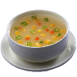

Soups

**Sweet Corn Soup 55/- Hot & Sour Soup 60/-**

**Mushroom Soup 85/-**

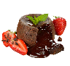

Lava Cake

**Choco Lava 55/- Nutty Choco Lava 65/-**



Mocktails



Shakes



Beverages

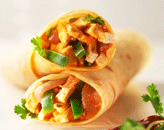

Rolls

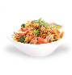

Pasta

**Aloo Tikki Burger 35/- Veg Patty Burger 45/-**

**Veg Cheese Burger 65/- Spicy Treat Burger 70/- Maxican Burger 80/- Spicy Paneer Burger 90/-**

**Maharaja Burger 100/-**

**French Fries 60/- Masala French Fries 70/-Italian French Fries 80/- Spicy Cheese French Fries 90/-**

**Veg Grilled Sandwich 60/- Sweet Corn Grill Sandwich 60/-**

**Makhani Sandwich 60/- Pizza Grilled Sandwich 60/-**

**Corn Pineapple Sandwich 100/-**

**Garlic Bread Six 80/- Garlic Bread 80/-**

**With Cheese Dip With Cheese**

**Garlic Bread 90/- Garlic Bread 90/-**

**With Cheese Chilli With Cheese Jalapenos**

**Stuffed Garlic Bread 115/-**

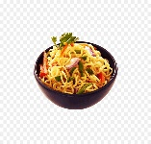

Maggie

**Maggie 50/- Vegetable Maggie 60/-**

**Dry Maggi 70/- Cheese Chilli Maggie 90/-**

**Schezwan Cheese Maggie 110/-**

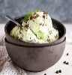

Ice Cream

**Vanilla 40/- Butter Scotch 40/-**

**Chocolate 40/- Strawberry 40/-**

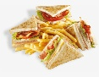

Sandwich

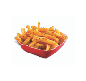

French Fries

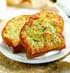

Garlic Breads



Burgers

