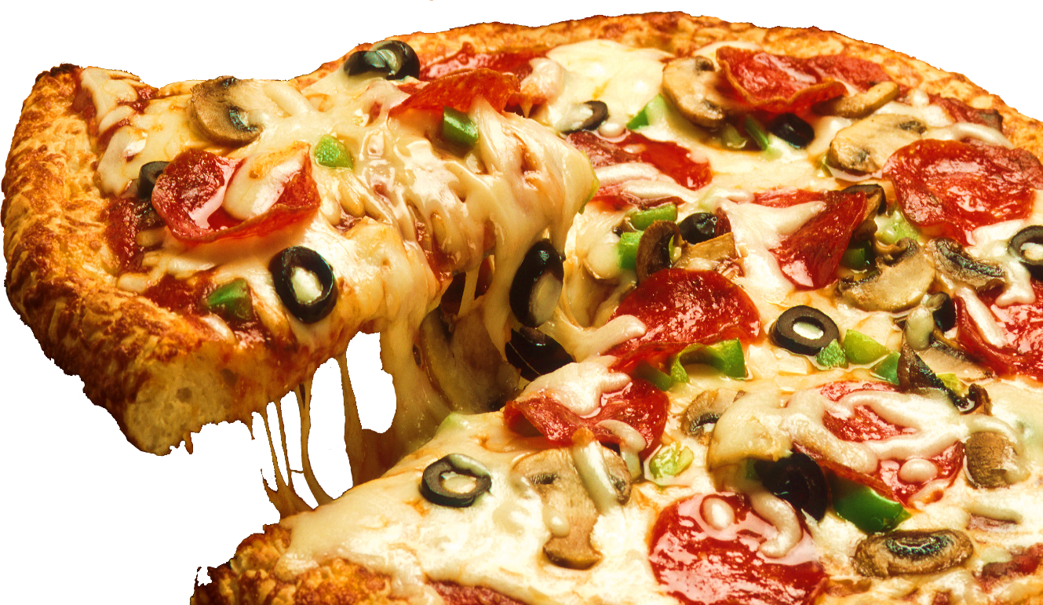

**FREE HOME DELIVERY: 8795362000 / 9044715606**

**Add: Kailash Tower Mandenala Pul, Ambedkar Chowraha, Gonda**

**Veg simple**

**Margherita** (Single Cheese Topping) **90 170 210**

**Single Topping** (Onion/ Capsicum/ Tomato/ Corn) **99 199 249**

**Double Topping** (Onion/ Capsicum/ Tomato/ Jalapenos/ Corn) **99 199 249**

**Single Topping** (Onion/ Capsicum/ Tomato/ Corn) **99 199 249**

**Veg simple**

**Margherita** (Single Cheese Topping) **90 170 210**

**Single Topping** (Onion/ Capsicum/ Tomato/ Corn) **99 199 249**

**Double Topping** (Onion/ Capsicum/ Tomato/ Jalapenos/ Corn) **99 199 249**

**Single Topping** (Onion/ Capsicum/ Tomato/ Corn) **99 199 249**

**Veg simple**

**Margherita** (Single Cheese Topping) **90 170 210**

**Single Topping** (Onion/ Capsicum/ Tomato/ Corn) **99 199 249**

**Double Topping** (Onion/ Capsicum/ Tomato/ Jalapenos/ Corn) **99 199 249**

**Single Topping** (Onion/ Capsicum/ Tomato/ Corn) **99 199 249**

**Veg simple**

**Margherita** (Single Cheese Topping) **90 170 210**

**Single Topping** (Onion/ Capsicum/ Tomato/ Corn) **99 199 249**

**Double Topping** (Onion/ Capsicum/ Tomato/ Jalapenos/ Corn) **99 199 249**

**Single Topping** (Onion/ Capsicum/ Tomato/ Corn) **99 199 249**

**Veg simple**

**Margherita** (Single Cheese Topping) **90 170 210**

**Single Topping** (Onion/ Capsicum/ Tomato/ Corn) **99 199 249**

**Double Topping** (Onion/ Capsicum/ Tomato/ Jalapenos/ Corn) **99 199 249**

**Single Topping** (Onion/ Capsicum/ Tomato/ Corn) **99 199 249**

**Build Your Own Pizza with Unlimited Toppings**

**Pure**

**Veg**

**Menu**



Serves 1

PERSONAL

MEDIUM

Serves 2

LAGRE

Serves 3