Online Resume Builder (MySQL Only)

📁 Project Structure
| File/Folder | Description |
|------------------------|-----------------------------------------------|
| schema.sql | DDL script to create all tables |
| sample_data.sql | Sample data insertions |
| views.sql | Views for resume export and version comparison |
| procedures.sql | Stored procedures for creating resumes, etc. |
| functions.sql | Reusable functions like get_latest_version() |
| triggers.sql | Triggers for audit logs |
| README.md | Project explanation and usage |
| er_diagram.png | Entity-Relationship Diagram |
| improvement_procedure.sql | Suggests missing resume sections |

🧠 Core Features Implemented
- ✅ User Management: User registration with username, email, and password hash.
- ✅ Templates: Support for multiple resume templates.
- ✅ Section Management: Dynamic sections like Education, Skills, Experience.
- ✅ Resume Creation: Create and manage resume content and layout.
- ✅ Data Input: Store user data for each section and resume.
- ✅ Versioning: Save multiple versions of resumes.
- ✅ Resume Export: Simulated via SQL view (resume_export_view).
- ✅ Audit Logging: Tracked via triggers on section entries.

🏗️ Bonus Features
- Multi-language support with Languages and Resume_Languages tables.
- Tagging using Tags and Entry_Tags tables.
- Collaborative editing via Collaborators table.
- Soft delete support using is_deleted flags.
- Resume improvement suggestions using suggest_resume_improvements procedure.

🔧 How to Use
1. Setup
Run the scripts in this order:
SOURCE schema.sql;
SOURCE sample_data.sql;
SOURCE functions.sql;
SOURCE procedures.sql;
SOURCE triggers.sql;
SOURCE views.sql;
SOURCE improvement_procedure.sql;
2. Sample Usage
- CALL create_resume(1, 1);
- CALL add_section_to_resume(1, 2, 1);
- CALL save_resume_version(1);
- SELECT * FROM resume_export_view WHERE username = 'john_doe';
- CALL suggest_resume_improvements(1);

🗂️ ER Diagram
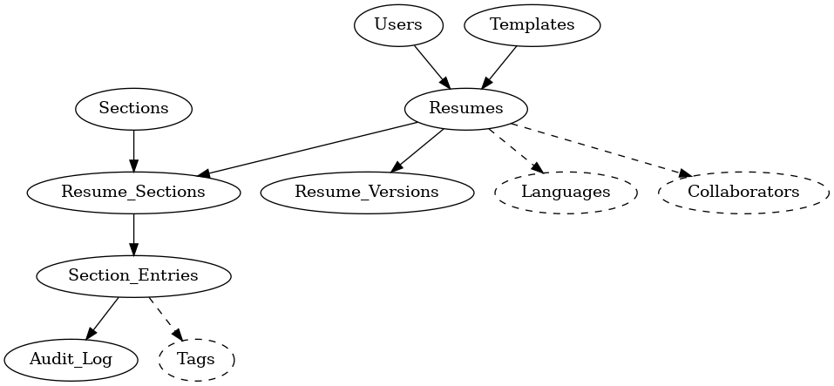

🧠 Tech Requirements
• MySQL 8.0 or above
• No frontend/backend code
• SQL only (DDL, DML, SPs, triggers, views)

