**REMOTE VISIT: FIND NEARBY**

**RESOURCES AT YOUR FINGERTIPS**

**COMMUNITY SERVICE PROJECT REPORT**

**Submitted by**

**M.SANTHOSH - 99220040115**

**P.SAI SURENDRA - 99220040373**

**P.SHANMUKHA - 99220040336**

**B.MUNIKANTA - 99220040463**

**in partial fulfillment for the award of the degree**

**of**

**BACHELOR OF TECHNOLOGY**

**IN**

**COMPUTER SCIENCE AND ENGINEERING**



**SCHOOL OF COMPUTING**

**COMPUTER SCIENCE AND ENGINEERING**

**KALASALINGAM ACADEMY OF RESEARCH**

**AND EDUCATION**

**KRISHNANKOIL 626 126**

November 2024

**DECLARATION**

We affirm that the project work titled **“REMOTE VISIT: FIND NEARBY RESOURCES AT YOUR FINGERTIPS”** being submitted in partial fulfillment for the award of the degree of **Bachelor of Technology in Computer Science and Engineering** is the original work carried out by us. It has not formed part of any other project work submitted for the award of any degree or diploma, either in this or any other University.

M.SANTHOSH

99220040115

P.SAI SURENDRA

99220040373

P.SHANMUKHA

992220040336

B.MANIKANTA

99220040463

This is to certify that the above statement made by the candidate is correct to the best of my knowledge.

Date:

Signature of supervisor

**Dr.N.C.BRINTHA**

**Associate Professor**

**Department of Computer Science and Engineering**



**BONAFIDE CERTIFICATE**

Certified that this project report **“REMOTE VISIT: FIND NEARBY RESOURCES AT YOUR FINGERTIPS”** is the bonafide work of “**M.SANTHOSH (99220040115),P.SAI SURENDRA (99220040373), P.SHANMUKHA (99220040336), B.MUNIKANTA (99220040463)”** who carried out the project work under my supervision.

|  |  |
| --- | --- |
| **Guide Name** | **Dr. N. Suresh Kumar** |
| **Dr.N.C.BRINTHA** | **HEAD OF THE DEPARTMENT** |
| **Associate Professor** | **Professor & Head** |
| Computer Science and Engineering | Computer Science and Engineering |
| Kalasalingam Academy of Research and  Education | Kalasalingam Academy of Research and Education |
| Krishnankoil 626126 | Krishnankoil 626126 |
| Virudhunagar District. | Virudhunagar District. |

Submitted for the Project final review and Viva-voce held on …………………….

**Internal Examiner External Examiner**

**ACKNOWLEDGEMENT**

We would like to begin by expressing our heartfelt gratitude to the Supreme Power for the immense grace that enabled us to complete this project.

We are deeply grateful to the late **"Kalvivallal" Thiru T. Kalasalingam,** Chairman of the Kalasalingam Group of Institutions, and to "**Illayavallal" Dr. K. Sridharan**, Chancellor, as well as **Dr. S. Shasi Anand**, Vice President, who has been a guiding light in all our university’s endeavours.

Our sincere thanks go to our Vice Chancellor, **Dr. S. Narayanan**, for his inspiring leadership, guidance, and for instilling in us the strength and enthusiasm to work towards our goals.

We would like to express our sincere appreciation to **Dr. P. Deepa Lakshmi**, Professor & Dean-(SoC), Director Accreditation & Ranking, for her valuable guidance. Our heartfelt gratitude also goes to our esteemed Head of Department, **Dr. N. Suresh Kumar**, whose unwavering support has been crucial to the successful advancement of our project.

We are especially thankful to our Project Supervisor, **Dr. N. C. BRINTHA**, for his patience, motivation, enthusiasm, and vast knowledge, which greatly supported us throughout this work.

Our sincere thanks to our Reviewer, **Dr. N. V. S. NATTESHAN,** for their valuable feedback which have significantly enhanced the quality of our project.

Our sincere gratitude also goes to overall CSP Coordinators, for their constant encouragement and support in completing this Community Service Project.

Finally, we would like to thank our parents, faculty, non-teaching staff, and friends for their unwavering moral support throughout this journey.



**SCHOOL OF COMPUTING**

**COMPUTER SCIENCE AND ENGINEERING**

**PROJECT SUMMARY**

|  |  |  |
| --- | --- | --- |
| Project Title | REMOTE VISIT: FIND NEARBY RESOURCES AT YOUR FINGERTIPS | |
| Project Team Members (Name with Register No) | M.SANTHOSH(99220040115),  P.SAI SURENDRA (99220040373), P.SHANMUKHA (99220040336), B.MANIKANTA (99220040463) | |
| Guide Name/Designation | Dr. N. C. BRINTHA/Assosciate Professor | |
| Program Concentration Area | Resource optimization and community accessibility are the main issues of the Remote Visit initiative. | |
| Technical Requirements | The Remote Visit platform uses Python frameworks (such as Gradio, OpenCV, PIL) and employs HTML5, CSS3, JavaScript, and Bootstrap in the front-end. To be fully functional and secure, it requires secure databases (MySQL/SQLite), HTTPS, and scalable server infrastructure. | |
| Engineering standards and realistic constraints in these areas | | |
| **Area** | **Codes & Standards / Realistic Constraints** | **Tick** ✓ |
| Economic |  |  |
| Environmental |  |  |
| Social | To ensure usability and inclusivity for diverse cultures, the project complies with WCAG 2.1 accessibility criteria and ISO/IEC 25010 software quality standards. | ✓ |
| Ethical |  |  |
| Health and Safety |  |  |
| Manufacturability |  |  |
| Sustainability |  |  |

**ABSTRACT**

This is the remote a geolocation-based technological innovation that connects people to vital community resources. The web technology of the geodatabase assures users that they can easily locate and avail of local resource services during both regular and emergency situations. Users have access in real time to food, health, transportation, and other services tailored for the needs of modern society.

Dynamic elements have been added to the platform to enhance customer delight and engagement. Users can create profiles so that their interactions may be customized, and authentication ensures safe and customized access. Navigating through the platform is easy and effective with personal inputs such as user-defined regions and service categories chosen. Apart from streamlining the customer journey, it enhances dependability and trust.

Of course, one of the most important attributes of Remote Visit is its deep service browsing. Only a profile-verified user can inspect the resources available to them organized by category and including contact information and detailed ratings. All this openness helps users have better experiences-ones built on knowledge and judgment. Reviews and comments on their experiences can further empower the environment of the site, contributing to an atmosphere of accountability and continuous improvement.

By adding community features, Remote Visit invites users to comment and give recommendations. Additionally, such input increases the ability of the platform to create functionality according to adaptive needs from its community. This cooperative approach allows the platform to act as a platform for mutual aid and contribution from the community.

Beyond this identification of proximal resources, the remote visits have a significant impact in that it may meet the needs of people in critical situations, either emergencies or in resource-scarce periods. This application brings accessibility to a welcoming and powerful experience for all its users by encouraging social interaction and cooperation among the people in the community.

Remote Visit is actually the tool to make communities strong-not just a technological fix. It is one of the means through which technology manifests and strives to make life more livable by filling in holes in terms of access to resources and creating opportunities for groups to develop. In short, it is a proof of innovation's capability of creating empowered and interconnected civilizations.

**TABLE OF CONTENTS**

|  |  |  |
| --- | --- | --- |
| **TITLE** | | **PAGE NO.** |
| **ABSTRACT** | | **6** |
| **LIST OF TABLES** | | **8** |
| **LIST OF FIGURES** | | **9** |
| **CHAPTER I** | **INTRODUCTION** | **10** |
| **CHAPTER II** | **LITERATURE REVIEW** | **11-14** |
| **CHAPTER III** | **PROBLEM DEFINITION AND PROJECT OBJECTIVES** | **15-16** |
| **CHAPTER IV** | **PROPOSED METHODOLOGY** | **17-19** |
| **CHAPTER V** | **REQUIREMENTS AND MODULE DESCRIPTION** | **20-22** |
| **CHAPTER VI** | **SYSTEM IMPLEMENTATION** | **23-27** |
| CHAPTER VII | RESULTS AND DISCUSSION | **28-29** |
| CHAPTER VIII | COMMUNITY IMPACT | **30-32** |
| **CHAPTER IX** | **CONCLUSION AND FUTURE SCOPE** | **33** |
| **CHAPTER X** | **PROOF OF PAPER SUBMISSION** | **34** |
| **REFERENCES:** List of books, articles, research papers, and other resources used | | **35** |
| **Proof of Submitted Paper/Filed Patent (If Any)** | | |
| **Certification (If Any)** | | |
| **Plagiarism Report** | | |

**LIST OF TABLES**

|  |  |  |
| --- | --- | --- |
| **TABLES** | **DETAILS** | **PAGE NO.** |
| **Table 1** | Letarture Review | 13-14 |

**LIST OF FIGURES**

|  |  |  |
| --- | --- | --- |
| **FIGURES** | **DETAILS** | **PAGE NO.** |
| Figure 1 | Flow chart | 27 |
| Figure 2-5 | RESULTS AND DISCUSSION | 28-29 |
| Figure 6 | PROOF OF PAPER SUBMISSION | 34 |

**CHAPTER –I**

**INTRODUCTION**

Through the "Remote Visit," a new ground-breaking, user-centric, location-based service interface is set to define a way of increasing the convenience of access towards vital community resources. Resources and trust, today in the fast-changing world, have become very hard to find. Normally, local services such as food, medical supplies, transport, among many others, are often direly needed by people. By overcoming the problem of real-time resource discovery, "Remote Visit" allows customers to find help exactly when and where they need it, thereby forming a reliable resource for emergency situations.

"Remote Visit" employs cutting-edge web technology which seamlessly integrates geographical information. Due to the simplicity of this state-of-the-art web-based user interface, being accessible and intuitive, people from all walks of life would be easily able to interact with it. Whether a user wants to find a pharmacy or arrange travel accommodations, or seek out a restaurant, the platform would make things incredibly easy to achieve by reconciling the gap between user demands and resource availability.

More impressive about the system is the secure authentication process by which it provides confidence to the users and data privacy. After verification, customers may choose service categories best that can suit their requirements and demand for information related to their location, in order to perfect the interaction experience. Services have been arranged in simple manners, so consumers find it easy to locate and retrieve information without needing complexity.

With its integrated rating, reviewing, and commenting tools, "Remote Visit" not only improves resource accessibility but also cultivates community involvement and trust. Users can rate the quality of services, suggest improvements, and express their experiences. This participative approach leads to a transparent ecosystem so that users can rely on information from the community in making decisions. "Remote Visit" provides a shared responsibility and accountability to improve the resources that are there while creating a mutual trust by allowing users to add to the platform.

Beyond the mere the list of resources, the platform promotes a collaborative environment for everybody's benefit. "Remote Visit" encourages mutual development and increases the reliability of services offered by encouraging users to share their insights and recommendations. The platform is flexible and future-friendly because of its community-driven approach for feedback which will ensure that it continues evolving according to emerging demands.

**CHAPTER-II**

**LITERATURE REVIEW**

**1.Geolocation and Proximity-Based Services**

Geolocation technologies transformed the possibility of digital interaction. They allowed information to be specified in terms of the actual locations of users. Proximity-based services proved to enhance user enjoyment and interest by relevantifying information. According to Lee and Kwan (2015), real-time location tracking serves to help offer context-aware services that are always right on track. Adding web mapping services provides real-time location tracking with better access to locative resources, particularly in high-demand applications involving different emergency services and healthcare APIs. Based on these facts, "Remote Visit's" fundamental functionality is a priority of real-time accessibility of resources based on a user's location.

**2. Community Resource Platforms and Accessibility**

In filling knowledge gaps about basic needs services-food, transportation, and health-access to community resources has much reliance on platforms for resource access. Research so far into access to community resources underlines the urge for streamlined, user-friendly system-based digital platforms that compile available services. Based on this consideration, this research attempt aims at making service access easier through putting into use one centralized and easy-to-navigate interface classification of resources according to the needs of different users. According to McKeown et al. (2019), centralized community resource platforms have proven effectiveness in increasing the accessibility of local services to the greater population, mainly to the most vulnerable, thus lowering barriers to information.

**3. User Authentication and Privacy in Community Platforms**

Systems offering services with location and private data should have safe user authentication processes. For instance, research indicates that secure login methodologies be institute because they play a crucial role in building trust, especially for systems that contain confidential information. A study by Cao and Zhang (2020) has indicated that putting privacy first while using secure authentication techniques such as encryption and multi-factor authentication does not only protect user data but also enhance user trust and engagement. The emphasis placed on safe authentication in the said literature, "Remote Visits," helps in the preservation of user confidence and integrity of the data.

**4. User Engagement Through Ratings, Reviews, and Social Features**

Useful user feedback tools, such as reviews, ratings, and comments, are very effective in the development of legitimacy and community engagement for online resources. In fact, given sites like Yelp and Google Maps, content created by users leads to a healthy, self-policing community in which users feel more connected and informed. As a matter of fact, Sweeney et al. (2018) proved that users do contribute to the correctness and relevancy of the platform, so the reliability of service increases along with community ownership. Social elements of "Remote Visit" enable users to rate, review, and recommend products, keeping up a cooperative community environment and helping future users in choosing the right one.

**5. User-Centric Design and Interface Usability**

The usability of location-based service platforms depends primarily on its user-centric nature and intuitive design. Nielsen's usability principles (2005) suggest that the effectiveness and user satisfaction will increase when tasks can be completed easily, interfaces are easy to navigate, and the required information can be easily obtained. Platforms, when focused on a user-friendly interface, are used more frequently and with higher engagement levels. Taking from these concepts, "Remote Visit" has created a User-friendly interface that makes resource searches easier by allowing users to look for services based on relevance, category, and even distance.

**6. Community Engagement and Social Impact**

Research analysis states that promotion of social responsibility and group contribution is very effective for community-oriented websites. The websites that allow people to interact and collaborate have a positive social effect according to Putnam's (2000) studies and subsequent studies done on it. "Remote Visit" encourages users to engage with other people, provide comments, and maions to enhance a feeling of support from the local community. This social component adds to the utility of the platform, allowing for this resource to be used for cultivating community and resilience besides the value of finding a service.

|  |  |  |  |  |  |
| --- | --- | --- | --- | --- | --- |
| **S.No** | **author** | **Implementation** | **year** | **Methodology** | **Limitations** |
| **1.** | Andi Leo.. Eta | The implementation of the Dorm Finder system | 2023 | Quantitative approach using online surveys  MAUT for decision making on housing attributes | Potential data accuracy issues  Limited geographical scope, challenges in data integration and maintenance. |
| **2.** | I Komang Su giartha..Eta | The application consits of a mobile side for android with four main pages and a web admin side for managing restaurant data and news. | 2022 | The research used the system development life cycle (SDLC) method and questionnaire-based user testing | Improvement include adding indonesian language support integrating data from supporting applications |
| **3.** | Ferdinand V. Dalisay | Android mobile application for locating hotels in dagupan city | 2020 | Agile methodology with iterative development | Limited to hotels in dagupan city only |
| **4.** | Zhejing Luo | Developed a web-based application, healthcare price finder | 2020 | Utilized Medicare data(2012-2017) and applied machine learning(XGBoost regression) for predicting medical prodcedure costs | Initial implementation limited to california data, challenges in data quality and scalability to cover the entire united states |
| **5.** | Shoba patil.. Eta | Study conducted by analyzing websites of health service providers in vijayapura city | 2016 | Review of online health information sources and an advanced google search( google dorking) to evaluate the availability and qualith of healthcare service informatio on the internet. | Limited qulaitative information, language barriers and low usability of online health information in vijayapura. |
| **6.** | Ayush Mahesh Wari | Enttity Resolution and location disambiguation in the ancient hindu temples domain using web data | 2018 | Using web data from sources like google maps and youtube, with text processing and clustering techniques | The approach faces challenges such as data scarcity, usr content subjectivity, and difficulties in accurately disambiguating temple locations |

**CHAPTER-III**

**PROBLEM DEFINITION AND PROJECT OBJECTIVES**

**Problem Definition:**

In many communities, access to reliable information on local resources, whether food, medical supplies, transportation, and other services is usually difficult to obtain. This situation may become a very pressing problem when demand is high, which could be in response to a crisis, or when individuals are new to an area. Other than many platforms with location-based information, there still remains a deficiency in interactive functions encouraging community engagement, immediate updates, and relevant recommendations. More importantly, existing systems often cannot help but struggle in the area of augmenting user involvement and trust through their feedback mechanism, such as reviews and ratings. Without intuitive, simplified search for local resources, most people would be unable to find the services they seek in the location they want, and they would miss community-driven ideas to better their experience.

**Project Objectives:**

The "Remote Visit" portal addresses these challenges by offering accessible, location-specific service interfaces as a fast and simple way to connect users to necessary community resources. The project objectives are as follows:

1. **Resource Availability Support in Real-Time About Geographic Location:** Design a platform with geolocation facilities to help effectively locate resources within one's area based on the current location. In this perspective, there is the development of an interactive mapping feature with services such as food, healthcare, transport, and other provisions of essence.
2. **Promote a Safe yet Personalized User Experience:** Authenticated user safely from the side of access of sensitive information but enable the saving of preferences, creation of profiles and get customized recommendations based on past interactions. The objective behind this would be user trust and increasing engagement through personal resource exploration.
3. **Engage the Community and Gather Customer Feedback:** Develop mechanisms that enable users to review, rate, and comment on services they have availed in order to build a crowd-sourced feedback and recommendation process. This goal will allow the customers to make informed decisions while at the same time building.
4. **Simplifying and Enriching Search functions for Resources:**Provide an interface that should not only be user-friendly but also allow features such as search and filter options through which the results are presented to users within their choice, rating, proximity, and categories. An efficient search of resources should save users precious time and energy.
5. **Foster Common Engagement and Social Feedback:** The quality of the developed resources can be enhanced if users are encouraged to communicate with each other on site; provide inputs about the material and suggest how the site can be made better. This goal captures part of the aspiration of the project to become a resource tool that fosters mutual support and social bonding.
6. **Scalable and Maintainable System:** The design should be such that the platform is scalable to accommodate a higher user base and a larger resource database. "Remote Visit" is assured by this objective.

**CHAPTER-IV**

**PROPOSED METHODOLOGY**

The Remote Visit platform utilizes a holistic approach that seeks to create convenient experiences for users, protects information, and delivers pertinent community resources.

1. **User Registration and Authentication:** The first feature of this application is a secure module for user registration and authentication. New users type their details in any form where basic information about them can be provided. Passwords are hashed before being stored to prevent any illegitimate access to the user's details. Injection attacks are avoided, and authentication checks prevent illegal access through checking the inputs for forms and allowing smooth navigation since effective login finds visitors ready for the next step following an easy way forward.

• User Account Configuration: A new user is required to fill up a sign-up form at the very moment of joining the website in order to have a secure profile. This phase picks up all the necessary credentials, which may include a username, email address, and password, and subsequently verifies these for security and correctness purposes.

• Password Protection: The passwords, before inclusion in the database are hashed by secure methods. The hash method prevents passwords, even when the database falls into unauthorized hands.

• Authentication Process: every user will have to undergo the authentication check every time he logs in to use his/her account after registration; credentials must be validated for no unwanted access. Those who log in successfully are moved to the main dashboard, thus assuring easy navigation.

• It guards against injection attacks in that the system sanitizes inputs which guard the platform from vulnerabilities, and imperils user data.

**2.Location-Based Resource Identification:** Users are asked to enter their location when they log in, either manually or, if authorized, through a device location service. The results are customized to each user's unique region by filtering and prioritizing local community resources based on this location data. Remote Visit guarantees accessibility and ease for individuals looking for instant resource availability in their area by including geolocation.

• **Geolocation Integration:** Users are prompted to provide their location after logging in, either manually or, if permitted, via device-based geolocation. This makes the experience easier to access, particularly for those who need help right now where they are.

• Proximity Filtering The system highlights and identifies the nearest services with the nearest services appearing at the forefront by using contextual location data. This is possible by guaranteeing that outcomes delivered to users are targeted outcomes of their context, like local dining establishments, healthcare facilities, and transportation alternatives.

• **Convenience and Accessibility:** Since Remote Visit avoids the role of availability of local services, it improves the convenience of users mainly in accessing resources on an emergency or urgent situation. This saves time and effort since it allows viewing accessible resources.

**3. Classified Resource Directories:** The website has a well-organized resources that can be accessed from categories such as transport, medical support, provision of food, and education done as a tailored module to provide a user with a direct link to any of these services. It presents a list of current resources related to the selected service on a click of one of the categories. All entries provide contact information, average ratings, hours of operation, and current real-time reviews to make your decision-making process even more effortless.

• **Classification of Services:** Resources are clearly categorized into classifications of services like transportation, medical assistance, provision of foods, and educational resources. Thus, users can easily navigate and group services that will concern their current needs.

• **Information of All the Resources:** User gets all the options available for each type that they decide to opt for.

**• Multiline Description for Every Resource:** Users are provided with a catalog of resources available in selected categories along with contact information, average score, and hours of opening. Structured alignment makes it easy for any user to pick everything he may need in quick succession.

• Live Integration Feedback-Using recent interactions, people can make a decision based on knowing, as every listing is updated with user reviews and comments. It forms a transparent and dynamic resource structure according to the choice of the user.

**4. Mechanism for User Feedback and Evaluation:** It enables a feedback system in which users can add comments about specific resources to understand how much opinions from the community matter. It portrays user input in an interactive manner hence leading to a dynamic database of user experiences. To avoid exploitation and ensure constructive criticism, reviews are monitored to assist other users in making informed decisions.

• **Community Feedback Collection:** Remote Visit allows users to review and comment on any resources which they have accessed; hence it engages the community. Such a system, supposed to be representing the most updated user experience should preferably be frequently revised.

• **Real-Time Review Display:** The published reviews are viewed live and moderated for relevance as well for the helpfulness, thus maintaining highly quality and credible information.

• **Informed Decision-Making:** People may select resources based on real reviews when they have access to real user experiences, which increases confidence in the platform and its services.

* Besides event handling, JavaScript event listeners enable a dynamic user interface that updates itself in addition to other functions like category selection, entry of location, and sending of feedback. The program refreshes the interface through direct content with AJAX that comes without page reloads in the background, and thus the user interface appears real-time and continuous. This further enhances the scalability of the platform to high user numbers since loads on the servers are reduced.
* It is the JavaScript event listeners which actually make the user-friendly interface responsive because they capture all different interactions with the user, including category selection, entry of location details, and submitting comments.
* **Real-time Updates through AJAX:** Since AJAX makes content on the network update without having to reload pages, this technology, therefore, saves loading time as people are able to switch between different sections seamlessly.
* Optimized server load. The fact that in real-time updates the server loads new content only when demanded makes this platform highly scalable and heavy user traffic is tolerated without any lag.
* **Real-time Updates through AJAX:** Since AJAX makes content on the network update without having to reload pages, this technology, therefore, saves loading time as people are able to switch between different sections seamlessly.
* Optimized server load. The fact that in real-time updates the server loads new content only when demanded makes this platform highly scalable and heavy user traffic is tolerated without any lag.

6.It also brings in some levels of protection to ensure that the information of the users would never be accessed and the most common cyber attacks will be stopped. SQL injection prevention steps exist in database queries, and anti-XSS protection processes prevent any kind of malicious code injection. User data is encrypted for confidentiality, and sessions are held with safety measures. These safety features enable people to believe in the integrity of the platform and create a user-friendly safe experience.

Taken together, these design elements ensure that Remote Visit works as a reliable, safe, and responsive system that is both user-centered in its approach and user-centric in the connections that it enables to all community resources for its users. This systematic framework ensures that it will scale, bend with change, and adapt to absorb newly envisioned enhancements as it adapts to the emerging needs of its user population.

**• XSS Resistance:** It provides a cross-site scripting resistant platform that limits bad scripts being performed in a user's browser and therefore protecting the user against unauthorized changes of his data.

• **SQL Injection Prevention:** SQL injection protection prevents unauthorized access to sensitive information held in the database. Database queries are further sanitized and parameterized to take care of data integrity.

• **Session security and encryption:** Sensitive user data is maintained with proper safety, and sessions are managed safely. In this manner, user data privacy is maintained on the platform by applying robust methods of encryption in order to easily form a safe and trusted user experience.

**CHAPTER-V**

**REQUIREMENTS AND MODULE DESCRIPTION**

In order to directly reach the users, an online location-based application called "Remote Visit" was developed. Below are specifications and module descriptions for the code implementation of this application:

1.**Core Competencies:**

The "Remote Visit" platform code should include at least the following developments:

1. **Authentication of Users:**JWT-based authentication should require the convenience of safe registration, login, and authentication for users.It is recommended to hash the passwords and keep them safely in the backend.For all users, there has to be one unique profile consisting of preferences, personal data, and previous interactions with resources.
2. **Geographic Location-Based Service Discovery:**Depending on where they stay, these users should access food, health care, and modes of transport.It should make use of geolocation APIs (like Google Maps and browser geolocation), in order to facilitate determining the user's location and show the user the services that exist in their vicinity.The graphical interface must display the services location relative to the user in an interactive map.
3. **Description of the Resources:**Full information should be there regarding every service or resource which users may scrutinize, name, description, address, phone number, and services offered.Users should be able to see the average rating and reviews for every resource.
4. **Reviews and rating:**There needs to be room for registered users to give reviews and ratings on services they have availed.
5. **Resource Management for Administrator:** The system should make it possible that an administrator may add, update, or delete a resource- health care facilities, food providers, or transportation services, etc.Administrators should check the resources so that data is accurate and up to date.
6. **Real-time Information:**It should be updated immediately anytime a new service is included and updated or even a review is published.Service ready, available, or change in existing service through WebSocket-based updates or even push notifications.
7. **Filter and Search:**Resources should be searchable and filterable by categories, ratings, service type, and proximity.To be updated directly as one inputs his data, and must apply filters in real time.The system must allow any other user to see ratings and reviews about any resource.

**2.** **Requirements That Are Not Functional:**

The service would contain features such as

1. **Scalability:**The system should be able to handle and accommodate the growing resources and users.More users and services should be added to the backend without penalizing performance.
2. **Safety:**Users need to have their profile and sensitive data encrypted - for example, password hashing via bcrypt.Implement safe user authorization and authentication, such as role-based access control and JWT+ session management.
3. **Performance**:It needs to be fine-tuned so that it can load in a page quickly, especially search-based and geolocation-based queries.Real-time updates with minimal delay are thus provided to create a user experience as fluid as possible.
4. **Usability:** The interface of the system should be easy to use and user-friendly.This means it also has to be responsive on mobile devices for it to be accessible through all devices.
5. **Maintainability:** That is to say, the codebase should be maintainable and modular with separate frontend and backend components.Use clear and consistent naming conventions and, where appropriate, comment the code.

**3. Description of the Module:**Some of the main elements of the "Remote Visit" platform are depicted below.

**3.1 Module for user authentication**

**Description:** The module handles user profiles and authentication.

**Important characteristics:**

* **User Registration:** Accepts user registration with a password and an e-mail address along with basic personal details.
* **Login/Logout:** This allows users to safely log out, manage sessions with JWT, and log in using their credentials.
* **Profile Management:** Users can view earlier search words or view history and edit personal details, including name and e-mail address.
* **Password Reset:** Ability to securely change the password.
* **Technologies:** MongoDB, JWT, Node.js, and bcrypt to hash passwords.

**3.2 The Module for Location and Geolocation**

**Description:** It deals with geolocation operations of every type.

**Key features:**

* User Location Retrieval: This method determines the user's current location by making use of the geolocation API offered by the browser.
* Display of Resources on the Map: It uses API from Google Maps or OpenStreetMap to display services as markers on a map.
* Distance Calculation: Calculates how far the filtered proximity resources are from the user's location.
* Technologies: OpenStreetMap, JavaScript, Google Maps API and geolib for distance computation.

**3.3 Service Discovery and Search Module**

**Description:** This module allows one to search and filter for services.

* **Notable features:**Search by Category: This allows an individual to seek products such as food, transport, and health services.
* **Filtering:** It categorizes the search results by type of service, rating, or location.
* **Service Details:** For a selected service, users can be provided with full information including address, phone number, and description.
* **Technologies:** MongoDB at the database level; Axios for API call performance of resource data retrieval; Front-end application of React.

**3.4 Module of Ratings and Reviews**

**Description:** This module provides the feature of rating and commenting the services.

**Key features:**

* **Give Rating:** A module having stars rating, like 1–5 stars could be used.
* **Post reviews:** It will enable the customer to post reviews for services provided to him.
* **Show Reviews:** Easy to get individual and a general rating score for any service.
* **Technologies:** Express manages the backend API, MongoDB handles ratings and reviews, and React manages the frontend.

**3.5 Module Admin Resource Management**

**Description:** This module enables admin user to administer service resources.

**Key Features:**

* **Add/Edit/Delete Resources:** Admins can manage a list of resources by adding, editing or deleting services.Admins are enabled to moderate and sort out inappropriate reviews or feedback.
* **Technologies :** Backend using Node.js, Express, MongoDB. The frontend for admin dashboard is done by React.

**3.6 Module Real-time updates and notifications**

**Description:**This module makes sure that users get real-time updates about new reviews or resources that are available in proximity to them.

**Key features:**

* **Real-Time Notifications:** Notify users regarding creation of new resources or a review of their favorite services.
* **Support for WebSockets:** Use WebSockets to provide resource and review updates in real time.
* **Technologies used include:** Node.js on the backend, react for Frontend Alerts, Socket.IO handles the real time changes.

**3.7 Interface Module for the frontend**

**Description:** This module by managing the presentation layer ensures that the interface to the user is real-time responsive and sensitive.

**Key attributes:**

* **Search Interface:** It should have the results and search box
* **Map Interface:** The map should be interactive having all the information related to the services next doors.
* **Service Details Page:** It should provide info about the selected service i.e. ratings and reviews.
* **Responsive Design:** It shall be responsive, thus working out well on all available devices and being mobile-friendly.
* **Technologies:** Style – use Bootstrap or CSS; State management – Redux; React.

**CHAPTER-VI**

**SYSTEM IMPLEMENTATION**

One part of the "Remote Visit" platform system implementation is to transform design specifications and features into a workable web application. Such a platform includes backend and frontend elements along with third-party services, for example, mapping and geolocation APIs. Here follows the outline of the system implementation procedure without code:

**1. Frontend Configuration:** The frontend interfaces the users with the "Remote Visit" framework. Therefore, the frontend provides the user interface; it controls user actions such as checking in, viewing service details, searching for services, posting reviews, and even maps interaction.

**1.1 Used technologies**

* React.js to establish the building blocks of the UI elements.
* Redux for component-to-component application state management.
* Bootstrap for styling and responsive design.
* One uses OpenStreetMap and the Google Maps API in order to present the map together with services near and user's location.

**1.2 Features and Their Implementation**

**1.User authentication:**

* To presents opportunities for users to register and receive access to the interface.
* Use JWT tokens for authentication to also securely ensure login sessions.
* Users can view their history of searches made, their saved services and reviews amongst other personalized information after login.

**2.Position-Based Search:**

* The browser's geolocation API is utilized by the service to obtain the current location of the user.
* Services based on maps, whereby services like Google Maps or OpenStreetMap map services to a user's location on a map.
* The platform is able to select and present results based upon distance, such that users can find services such as food, medical supplies, or transportation.

**3.** Interactive Map Services are shown as markers on an interactive map. Depending on the visitor's location, the services can update live and appear on the map for local services.Whenever a marker is clicked, it displays the broad details about the service including the name, description, contact details, and services offered.

**4.** **Reviews and Ratings:**Registered users can leave reviews and ratings between 1 and 5 with respect to the services they have used.Besides the ratings from the individual users, the site also does include a general average rating for each service.

**5.** **Responsive Design:**The platform is usable on a variety of platforms, including as PCs, tablets, and smartphones, thanks to the responsive user interface.

**2. Backend Implementation**

User identification, data management, and request processing are handled by the "Remote Visit" platform's backend. It manages user registration, geolocation, service management, reviews, and business logic implementation.

**2.1 Technologies Used**

Built server-side with Node.js and Express for routes on a RESTful API.

* Database management: MongoDB. Connects it all together using Mongoose for ODM.
* Implemented JSON Web Tokens for secure user authentication.
* MongoDB is used in geospatial queries where services are filtered by proximity.
* Utilized Socket.IO for the sending of notifications and in-real-time updates, such as new services or reviews.

**2.2 Features Implementation**

1. **User Authentication:**

* Backend uses JWT to control user authentication. Backend provides an API that returns a token once the user has logged in. The token is sent towards frontend that holds this token and uses it for secure API access.
* Sensitive information is also protected using bcrypt to hash user passwords securely.

1. **Service Management:**

* A MongoDB database houses the services, each of which has geolocation (latitude and longitude), name, description, address, and category data.
* An API that is secure allows admin users to add, edit, or remove services.

1. **Proximity search and geolocation:**

* The platform makes use of GeoJSON for registration of service locations in MongoDB as geographic data.
* The backend executes a geospatial query when a user searches for services. The query returns services located within a certain distance of the user's location.
* The backend calculates how far away the services are from the user's location, and it filters the results accordingly.

1. **Ratings and Reviews:**

* API endpoints will allow users to rate and review services.
* The database stores reviews, which are linked to the related service. The backend sends requests based on user input to retrieve the average rating of any service.
* Users can edit or delete their own reviews through the system.

**5.Real-Time Updates:**

* It makes use of Socket.IO to implement real-time functionality. It updates/notify users who are currently active that a new service is introduced or that a review has been filed.
* This makes sure that users are always seeing the latest information about the services that are available.

3. **Database Implementation**: The database is designed to store all the necessary data for users, services, reviews, and locations. MongoDB is chosen for its flexibility in storing both structured and unstructured data, including geospatial data for services.

**3.1 Assemblies**

1. **Users:**A collection of data related to an user, such as his name, email, hashed password, authentication tokens, and preferences.
2. **Services:**Be able to keep track of the services offered. The information includes name, category, description, address, phone number, and also geospatial information (location).
3. **Reviews:**To have ratings, comments and related user and service references. All reviews are related to one particular service and user.
4. **Admin:**Stores user data for administrational issues to manage the services and to review users.

**3.2 geographic Data**

• Location-based searches are made efficient by the GeoJSON format, which stores services with geographic coordinates (latitude and longitude).

**4. Integration with Third-Party Services:**

**4.1 Mapping Services:**To be able to provide a map interface that displays a customer's position and surrounding services, the platform interacts with a mapping service such as OpenStreetMap or Google Maps API.

•Users can interact with the map, zoom in and out, and click on service markers to read detailed information. •Frontend communicates with the backend about retrieving geospatial data, namely, the latitude and longitude of services, and displays this information on the map.

**4.2 Notification System:** Socket.IO is used to enable real-time notifications. When new reviews are posted, new services are added, or any other pertinent event takes place, users are notified.

**5. Security and Privacy Concerns**

* **Authentication:** JWT for session management secures user authentication, making sure every API request is approved and verified.
* **Password security:** The password of the user is hashed using bcrypt right before saving them into the database.
* **Encryption:** the data sensitive in nature-most importantly, the geolocation of the user or any information about the user-is dealt with utmost security to maintain the anonymity of the users.
* That is, normal users could only see and interact with services, but they could see and govern services as an administrator through role-based access control, or RBAC.

**6. Quality Assurons and Evaluation**

• **Unit testing:** The crucial features such as authentication, service management, and rating functionality can be verified by performing unit testing of the entire system in isolation.

• **Integration Testing:** That data is flowing properly would be ensured through the end-to-end testing that would guarantee the proper interaction of the frontend and the backend.

• **User testing:** Through a beta version of the platform with the users, the usability problems and improvement ideas would be identified.

**7. Installation and Maintenance**

* It would deploy the service on any of the following cloud services-Heroku, AWS or DigitalOcean for scaling up and guaranteeing reliability.
* CI/CD Pipeline: The continuous integration and deployment procedures will be used to have CI/CD for automated testing and deployment.
* The system will be observed by utilizing New Relic for backend performance monitoring and Google Analytics for frontend tracking.

**Fig.1: Fow chart of the project How it works**

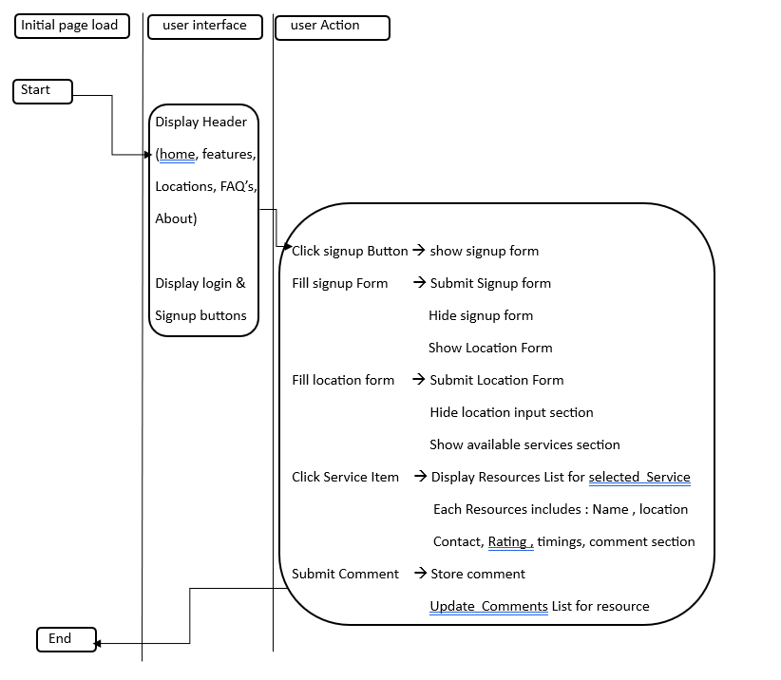

**RESULTS AND DISCUSSION-VII**

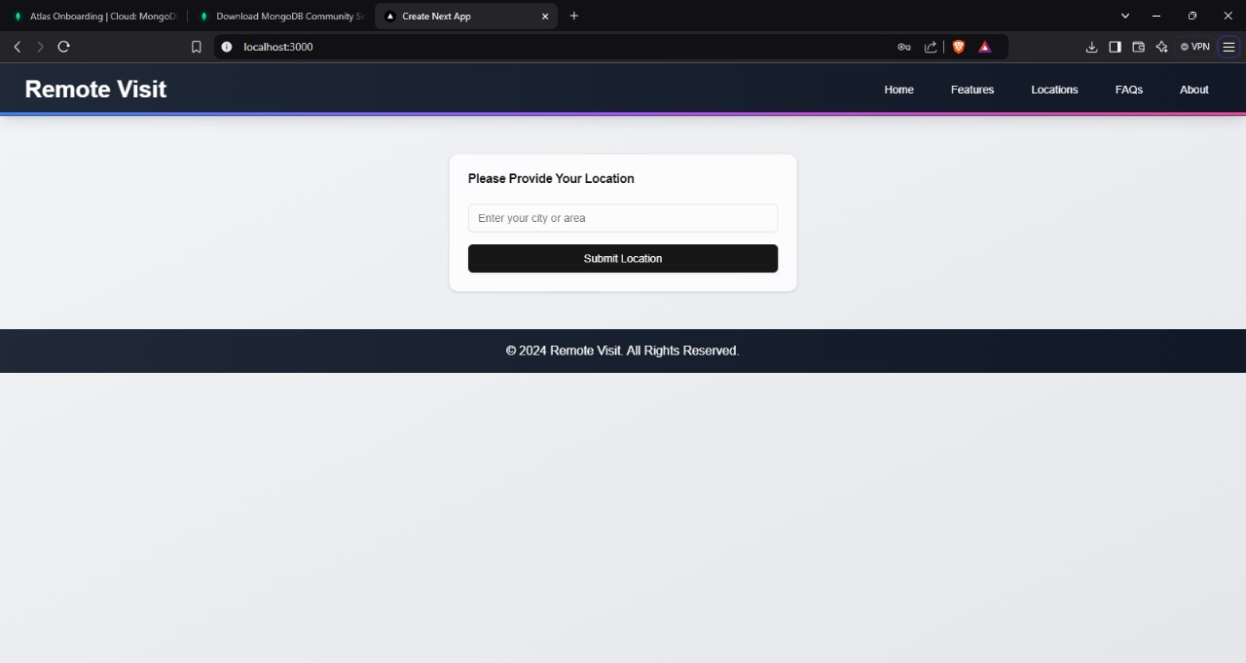

**Fig.2: Provide the location name which you need to know**

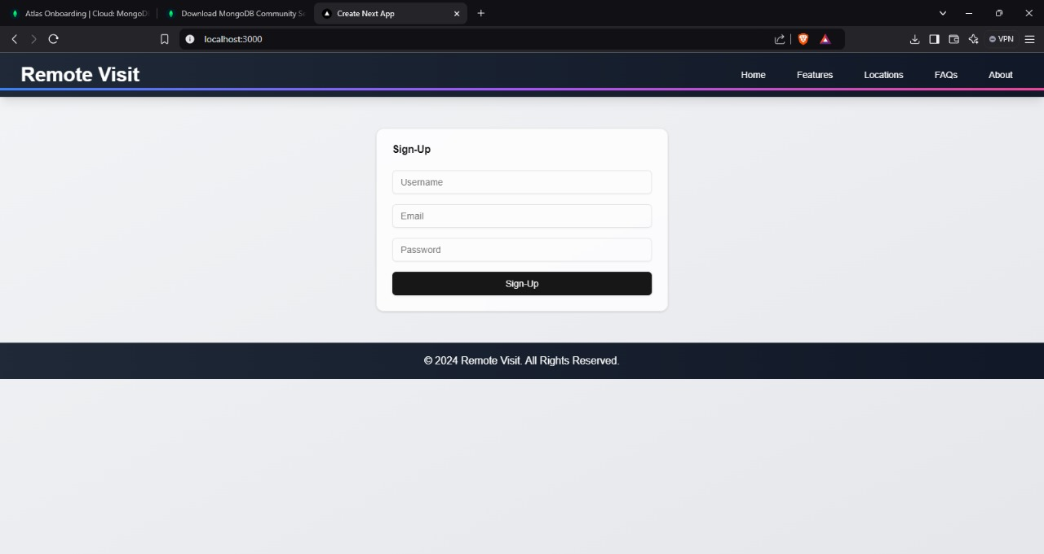

**Fig.3: signup to the website with email ,username and password**

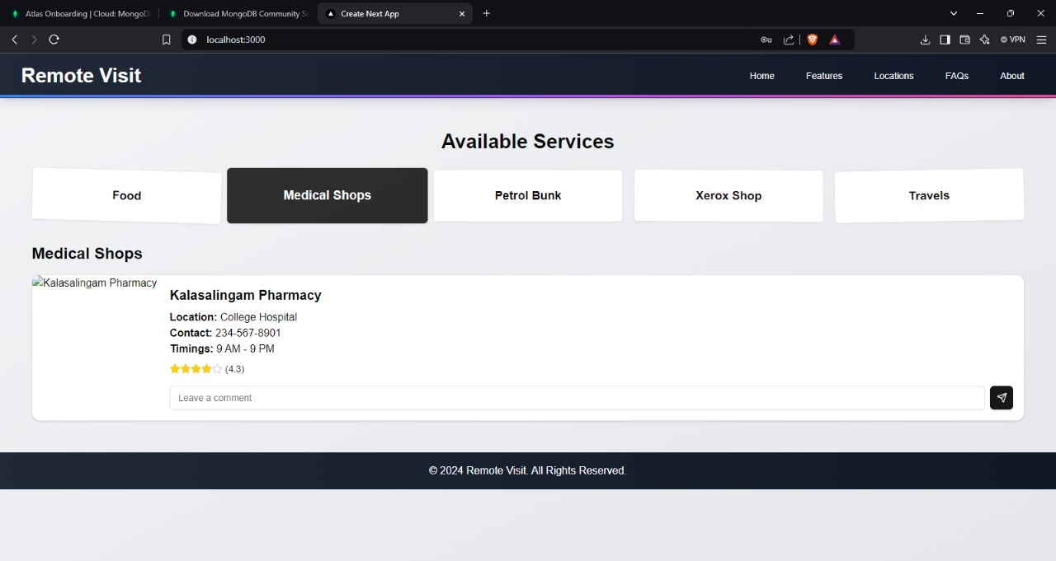

**Fig.4: This figure shows available services in the location you entered like above image**

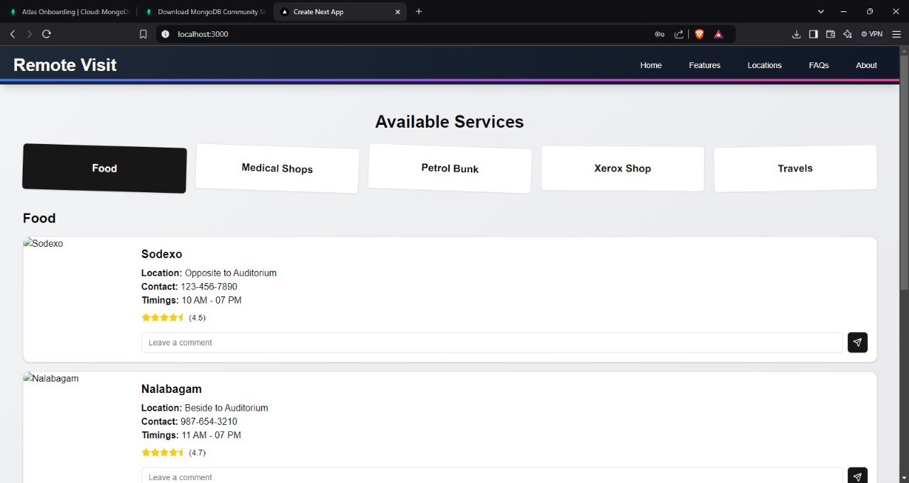

**Fig.5: Above we can see Food places and Medical shops and xerox shops in kalasalingam university**

**CHAPTER-VIII**

**COMMUNITY IMPACT**

The "Remote Visit" service looks forward to bridging the distance between local communities and necessary services through a state-of-the-art, location-based interface. Other than enriching access for an individual to services, this service looks forward to instilling a sense of community support and involvement. The areas through which the potential of this platform impacts a community are several and important:

**1. Improvement in Access to Life-Sustaining Services**

The fundamental impacts of the "Remote Visit" include greater access to life-sustaining services, especially in disadvantaged or hard-to-reach areas. Location-based technologies ensure that users will easily locate services such as:

* Sources of food, including supermarket delivery services and food banks
* Provisions for medical care; these can be seen in pharmacies and medical facilities, among others
* Transportation; it refers to public transportation as well as ride-sharing
* For instance, there are social services community centers and shelters

Vulnerable populations-the elderly, people with disabilities, low-income families, and those without reliable transportation-are especially advantaged in this regard. The site ensures that customers can receive the services they need on time by making service location-finding processes easy to follow, thus improving their quality of life but also reducing barriers to such life-supporting resources.

**2. Promoting Social Inclusion and Equity**

* It ensures everyone has equal chances at accessing resources in terms of socioeconomic status or location. The applications are ensuring that solutions happen locally. This means they have various services available to the user that one may not even know there is something for them in their locality. In a bid not to leave anybody behind, the platform connects its users with their local services.
* Helping to poor communities: People who inhabit rural, isolated, or economically underdeveloped areas often face severe challenges in their quest to access services. In general, by focusing on proximity, the platform reduces the need for long travel times and improves the discovery of nearby resources.
* In this way, social inclusion is enhanced because people may depend on their very neighborhoods to cater to their primary needs without going very far or paying more.

**3. Encouraging Community Participation and Collaboration**

It features community-driven content as its main focus "Remote Visit". In this respect, to assist others to make the right judgment, users can rate, review, and even suggest services. This encourages teamwork in an atmosphere where:

* **Community-driven enhancements:** Users' input about services can be used by businesses to enhance their products. For example, a pharmacy that sells medical supplies could implement the suggested improvements if it receives a below-average score on customer service.
* **Community support networks:** the chance to share personal experiences, offer alternatives, or recommend new services, all of which contribute to an increased sense of support and community. It offers an open line of communication, based upon which people can help those in need improve their local community.

The "Remote Visit" thus boosts community relationship by providing an active participation channel to the users and thus creating a sense of responsibility among them.

1. **Strengthening Regional Groups**

It caters to small businesses and local organizations including non-profits and charities, besides individual clients. This is achieved in the following ways:

* **Increasing visibility:** The service being offered by the local organizations on the platform increases their visibility to people who otherwise would not have known of their existence.The platform, through giving different types of service providers -food banks, medical aid, etc- a place, facilitates the service providers' cooperation so that the various efforts can be coordinated in a better manner to meet the needs of the community.
* **Building sustainability:** In that it fosters a direct relationship between citizens and the local service operators, "Remote Visit" encourages local entrepreneurship and community-oriented initiatives; in this respect, it establishes robust local economies.

**5. Emergency Help and Crisis Management**

Local resources may represent the first line of defense in assistance for those in need in times of crisis or emergency, such as pandemics and natural disasters. Crisis management greatly benefits from the Remote Visit platform's features:

* Enables current information The software may enable giving information in real-time about available resources like food distribution centers, shelters, and emergency medical treatment.
* Volunteer groups: This can also help the coordination of volunteers' work to assist in offering resources or services to those in need, especially during times of peak demand or reduced mobility.
* Building community resilience ensures that through its provision of resources, arranged and accessible, the platform ensures communities grow more resilient about problems.

**6. Advocate for sustainability in the environment**

"Remote Visit" minimizes the need to travel far away by encouraging them to avail of local services, which in turn reduces carbon footprints associated with transportation. By minimizing transportation emissions, the users find local solutions to their needs; hence there are fewer journeys and a lower total demand for transportation with its environ corollary. Such a strategy is green-friendly in the quest for sustainability.

• **Strengthening local food systems:** Less long-distance transportation requirements may mean access for people who would otherwise get their meals from food banks or farms closer to the community.

**7. Making Decisions Based on Data**

Such information from the platform on customer preferences, trends in service consumption, and community needs will help inform businesses, organizations, and local governments about choosing their development. For example, this could be:

**• Identification of empty spaces of services:** The local authorities or organizations can focus developing a type of service that often is searched by a customer but does not exist in the area.

**• Resource optimization allocation:** Analysis of the pattern will help the platform point out areas that need more resources or services and thus can better allocate aid or support.

**8. Social Capital and Credibility Building**

In building social trust in the community, "Remote Visit" review, rating, and feedback mechanisms are critical. The customers are more likely to look for services recommended by others in their community, which then leads to:

**• Trust in the local services:** Since more reviews and comments are produced that create confidence among users for the use of services, their trust in the local service providers increases.

**CHAPTER-XI**

**CONCLUSION AND FUTURE SCOPE**

**CONCLUSION:**

The "Remote Visit" platform provides a very efficient way through which people can be instantly connected to vital community services by using its user-friendly, location-based interface. Geolocation technology and verification of users as well as community-driven feedback are employed by the platform to empower its users to find local resources such as food, transportation, medical supplies, and more, quickly. Accessibility is thus improved using this slick and user-centric approach mainly for vulnerable populations such as the elderly, low-income families, and distant-living people.

Real-time user engagement, feedback, and suggestions strengthen the dynamics of the flexible responsiveness of the platform to community needs, whereas the system's backend, driven by Node.js, MongoDB, and React.js technologies, provides guaranteed scalability and security with smooth interaction. The platform creates an environment where the community can work together and participate, engaging users to share comments and ideas that add value to their services. It is a good website that has the benefits both for individuals and for organizations because it lets people support each other, which fosters social inclusion and community cohesion.

All in all, Remote Visit is a very robust and scalable approach that can boost community cooperation, increase access to necessary resources and promote positive social impact. It deals with severe issues such as resource scarcity and geographical isolation, hence turning out to be of utmost importance to boost personal wellbeing and overall welfare of the commune.

**FUTURE SCOPE:**

To meet better demands from the community and enhance its functionality, Remote Visit has much room for improvement. The future developments of this facility may look into scalability by upgrading to cloud-based infrastructures with more reliability and can support potentially larger user bases with more processing capacity and greater storage. There's room for improvement in advanced AI integration; machine learning algorithms may offer one of the best options for more unique and individualized resource suggestions based on the preferences, locations, or behavior of the users.

Another feature like multi-factor authentication, or real-time threat detection, can add to the dedication of the service towards user privacy. New types of resources will add great value to the service because they enable users to obtain access to so much more specific local resources.

**CHAPTER-X**

**PROOF OF PAPER SUBMISSION**

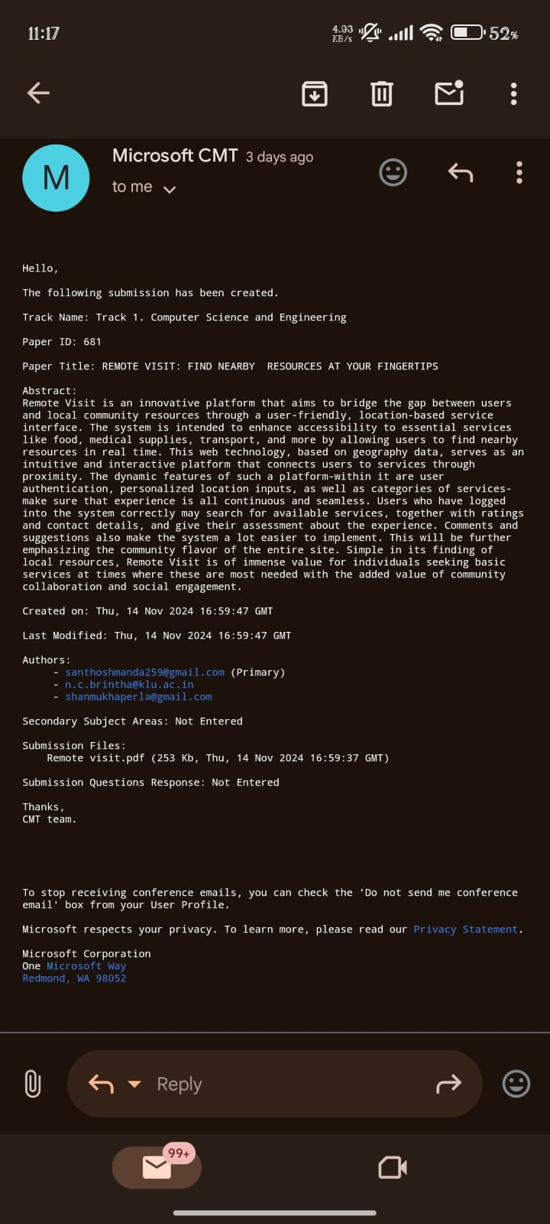

**Fig.6: Above image is the proof that submitted the Research paper in the conference**

**REFERENCES**

• Lee, J., & Kwan, M. (2015). *Location-based services and the importance of proximity in emergency management.* Journal of Geography and Planning.

• McKeown, R., et al. (2019). *Community resource platforms and digital accessibility: A systematic review.* Journal of Community Informatics.

• Cao, S., & Zhang, Y. (2020). *Privacy and authentication in location-based applications.* Journal of Data Security.

• Sweeney, J., et al. (2018). *User engagement and community feedback in online resource platforms.* Journal of Interactive Technology.

• Nielsen, J. (2005). *Usability principles for web-based applications.* Journal of User-Centric Design.

• Putnam, R. (2000). *Bowling Alone: The Collapse and Revival of American Community.*



**INTERNAL QUALITY ASSURANCE CELL**

**PROJECT AUDIT REPORT**

This is to certify that the project work entitled “**REMOTE VISIT: FIND NEARBY RESOURCES AT YOUR FINGERTIPS**” categorized as an internal project done by **M.SANTHOSH(99220040115),P.SAI SURENDRA(99220040373), P.SHANMUKHA (99220040336), B.MUNIKANTA (99220040463)** of the Department of Computer Science and Engineering, under the guidance of **Dr. N.C.BRINTHA** during the Even semester of the academic year 2023 - 2024 are as per the quality guidelines specified by IQAC.

(Office use)

**Quality Grade**

**Deputy Dean (IQAC)**

**Administrative Quality Assurance Dean (IQAC)**